

*Geophysical Research Letters*

Supporting Information for

**Non-breaking swell dissipation estimated from ASAR ENVISAT wave mode 2003-2012**

Justin E. Stopa1, Fabrice Ardhuin1,2, Romain Husson3, Haoyu Jiang4, Bertrand Chapron1, and Fabrice Collard5

1 Ifremer, Laboratorie d’Oceanographie Spatiale (LOS)

2 Ifremer, Laboratorie de Physique des Oceans (LPO)

3 Collecte Localisation Satellites

4 College of Information Science and Engineering, Ocean University of China

5 Ocean Data Lab

**Contents of this file**

Text S1

Figure S1

**Introduction**

The purpose of the supporting information is to give a more detailed description of our methodology to estimate the decay parameters from the SAR observations. The examples here are synthesized using a prescribed theoretical exponential decay. Three different SAR precisions are used to demonstrate the impact on the accuracy of the calculated swell decay parameter.

Text S1.

Statistical modeling of the SAR observations is necessary to account of the low precision of the SAR *Hss*. The SAR observations have minimal bias after applying the correction

 (eqn. S1)

proposed by *Collard et al.*, [2009] where the U10 is the wind speed estimated from SAR. The *Hss* errors closely follows a Rayleigh distribution with the standard deviation

. (eqn. S2)

Therefore to account for the SAR’s low precision, each observation is perturbed using the above equations and the following fits are computed (, μa), (, μ) or (, *fe*) for each track simulation. This process is repeated 100 times and the median values are reported in the manuscript. Two standard deviations contain approximately 70% of the cases and give an estimate of the variability of the computed dissipation rate and *Hss0*.

Numerical tests demonstrate how the SAR *Hss* variability affects the computed estimate of the dissipation rate μ. An exponential decay following equation 2 with an *Hss0* of 4 m and μ = 1x10-7 m-1 is assumed. The wavelength was assumed to be 325 m and was randomly varied assuming a uniform distribution from the interval [300 350]. Each data point is then perturbed using the Rayleigh distribution and equations S1 and S2. The wave steepness (*Hss0*/*L*) versus the dissipation (μ) is presented in Figure S1. The median of the simulations is given as the black square and the error bars in the x and y directions are given as two standard deviations of the 100 cases. The percent error varies for each group of 100 simulations but was always less than 3% of the prescribed value. If the number of cases is increased to 400 the percent error reduces to ~1%.

The results using the standard deviation in Equation S2 are the plotted in the top panel. The error bar is typically ~1x10-7 m-1 and the same magnitude as the estimate of μ. Notice the relationship between the wave steepness (*Hss0*/*L*) and μ. This suggests that the variability in the SAR data and numerical fit cause an inherit relationship between *Hss0*/*L* and μ. However, as long as there are a sufficient number of Monte-Carlo simulations the results should be precise enough to estimate μ and *Hss0*.

A representative precision of the new Sentinnel-1A mission is presented in the middle panel using the standard deviation of Hss as

. (eqn S3)

The error bar is reduced and on the order of ~0.5x10-7 m-1. Finally a precision closer to the estimates of significant wave heights from altimeters is presented in the bottom panel with the standard deviation of

. (eqn S4)

Now the precision is ~1x10-8 m-1. Viscous dissipation of Dore (1978) given in equation 3 is typically less than 1x10-8 m-1 so at least this level of precision is needed to specifically differentiate between the turbulent dissipation (~1x10-7 m-1) in equation 4. Once this precision is attained by future missions it might be possible to accurately determine the transition point (e.g critical Reynolds number) between the viscous and turbulent regimes. The current SAR precision in equation S2 displayed in the top panel creates a large variability in the calculated dissipation rate limiting our interpretation of the physical processes.

Figure S1.

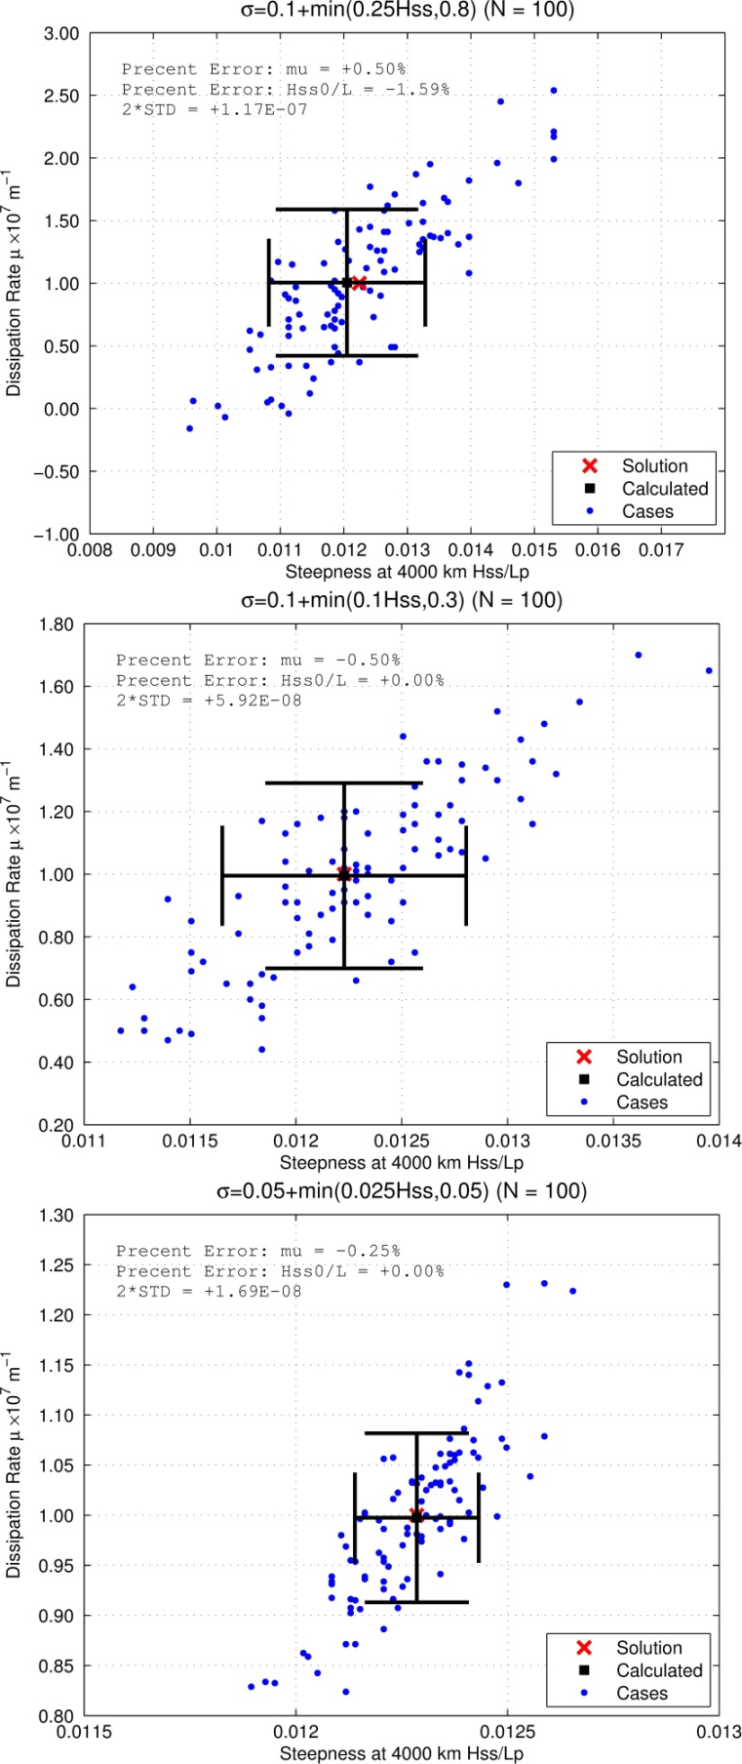

Figure S1: Swell steepness (*Hss0*/*L*) versus the dissipation rate μ for synthetic cases using different standard deviations of the *Hss* biases.