Sequestration efficiency in the iron limited North Atlantic: Implications for the mode of iron supply in fertilized blooms
Frédéric A.C. Le Moigne^{1*}, C. Mark Moore², Richard J. Sanders¹, Maria Villa-Alfageme³, Sebastian Steigenberger², Eric P. Achterberg^{2,4}
¹National Oceanography Centre, Southampton, UK. ²Univerity of Southampton, Southampton, U.K. ³Departmento. Físíca Aplicada II, Universidad de Sevilla, Spain. ⁴GEOMAR, Helmholtz Centre for Ocean Research Kiel, Germany.
*: Corresponding author, Frédéric A.C. Le Moigne, f.lemoigne@noc.ac.uk; National Oceanography Centre, European Way, SO143ZH, Southampton, U.K.

Supplementary material
Seasonal carbon export
We combined nutrient stocks and ²³⁴Th derived carbon export to estimate seasonally integrated carbon export in a similar manner to previous estimates for the CROZEX study [Pollard et al., 2009]. The nitrogen budget itself was closed by evaluating net removal as the difference between mixed layer depth integrated winter (nitrate) and summer (nitrate + PON) stocks. Figure 2 shows ²³⁴Th flux, POC and PON export fluxes, the nitrogen budget, the duration of export and the seasonal carbon export in the western IRB and IB. Average daily POC export fluxes (7.0 ± 5.7 mmol m⁻² d⁻¹ for the IRB and 10.2 ± 4.1 mmol m⁻² d⁻¹ for the IB) were not different between the basins whereas PON export (0.8 ± 0.6 mmol m⁻² d⁻¹ for the IRB and 1.5 ± 0.6 mmol m⁻² d⁻¹ for the IB) was slightly higher in the IRB (Fig. 2a). However, the net deficit in nitrate was greater in the IB (287 ± 9.0 mmol m⁻²) relative to the IRB (201± 25.2 mmol m⁻²) (Fig 2b). Thus we estimated roughly equivalent bloom durations in the two basins, with the IB (130 days) slightly shorter than the IRB (111 days) (Fig 2b). These estimates are consistent with bloom durations observed in the IB in 2010 [Achterberg et al., 2013].

Iron sources and inputs
A combined approach of modeling (for volcanic ash derived Fe inputs [Achterberg et al., 2013]) and aerosol measurements (for typical background deposition [Painter et al., 2014]) was adopted for estimating atmospheric inputs. Ash derived Fe inputs of 550 kmoles (1800 kmoles) (best estimate and upper bounds) were determined over an area of 10,000 km² (42,000km²) during the 2010 volcanic eruption in addition to the normal background atmospheric flux.[Achterberg et al., 2013]. Combined with estimated Fe solubility of 0.042% (0.143%), equivalent atmospheric DFe inputs equated to an annual enhancement of the dissolved Fe flux of 2310 nmol m⁻² (6128 nmol m⁻²).
The background atmospheric flux was determined from aerosol collection during spring and summer 2010 in both IB and IRB [Achterberg et al., 2013; Painter et al., 2014]. Dry deposition fluxes of Fe in the IRB were calculated by averaging all the measurements made in the IRB in spring and summer 2010 [Painter et al., 2014]. The atmospheric input of Fe was 3.2 nmol m⁻² d⁻¹ or 1168 nmol m⁻² per year. The impact of the volcano was reduced in the IRB [Achterberg et al., 2013], we thus considered this value as being the background atmospheric input for both basins. Overall, the annual atmospheric fluxes of Fe (including the volcano eruption in the IB) were 1168 nmol m⁻² for the IRB and 3478 nmol m⁻² (6128 nmol m⁻²) for the IB.
Vertical diffusive fluxes of Fe and fluxes of Fe from winter mixing reported in [Painter et al., 2014] and presented for both IRB/IB in Table 1 correspond to averages of diffusive of Fe fluxes calculated for both the IRB and IB [Painter et al., 2014]. The reasons for a greater winter convective flux of Fe in the IB compared with the IRB is explained and investigated in greater detail in [Painter et al., 2014]. In essence, the winter mixed layer depth (WMLD) in the IB was 350 m compared with 200 m in the IRB [Painter et al., 2014], resulting in a greater supply of Fe to the surface layer (Table 1).

Supply of Fe to the Iceland basin
To estimate the DFe flux from the Icelandic shelf, we used 21 DFe data points (surface and within the mixed layer) from 63.5ºN to 60.0ºN (~350 km) from the surface and MLD (0-40 m) along the transect C (Figure S1) and obtained the relationship DFe_{surface} = -0.0028 x distance (km) + 1.045, r² = 0.53 (Figure S2), resulting in an offshore DFe gradient of 0.003 nM km⁻¹. In the HLNA, horizontal diffusivities determined from drifters and the Parallel Ocean Program model that includes eddy-induced mixing, varied from 0-3 x10⁷ cm² s⁻¹ in both North/South and West/East components [Mc Clean et al., 2002]. The product of the exponential gradient and the diffusivity estimated by Mc Clean et al., [2002] yielded a horizontal DFe flux of 90 nmol m⁻² s⁻¹. Assuming a summer MLD of 40 m and that the length of the Icelandic shelf that supplies Fe to the IB is 200 km, the flux of DFe from the Icelandic shelf was 363 mol d⁻¹. This was subsequently normalized to the length of the gradient, the width of the shelf (length of Greenland shelf X length of the gradient; ~350 km X ~200 km) and the surface area of the IB (100000 km²) to provide a final horizontal DFe flux of 4 nmol m⁻² d⁻¹ to the IB.
Similarly, we estimated the flux of DFe from the Rekjanes Ridge by taking three surface datapoints (surface only) on transect A from -29.8ºW to -23.7 ºW (~360 Km with --29.8ºW as starting point, see Figure S3) yielding DFe = -0.0004 x distance (km) + 0.2113, r² = 0.62, giving an offshore DFe gradient of 0.0004 nM km⁻¹ providing a final horizontal DFe flux of 0.5 nmol m⁻² d⁻¹ supplied to the IB from the Reykjanes ridge.
We assumed that the flux of PFe was negligible based on the absence of high PFe concentration above the Reykjanes Ridge. Also we did not measure PFe along transect C preventing us to determining the flux of PFe from the Icelandic shelf to the IB.

Supply of Fe to the Irminger basin
No discernable gradient from the underway DFe data was observed on transect B. We therefore assumed that the fluxes of DFe or PFe from the North or South of the IRB were negligible. However, on transect A, eastward and westward gradients were observed in surface DFe concentrations (Figure S3) highlighting the role of both the Greenland shelf and potentially the Reykjanes Ridge or the IB as supplier of Fe to the IRB.
We took 18 points of surface DFe from -43.0ºW to -41.2 ºW (~70 Km) along transect A (Figure S2) to calculate the input of DFe from the Greenland shelf to the IRB. The resulting relationship (DFe_{surface} = -0.0065 x distance (km) + 0.4298, r² = 0.62) equated to an offshore DFe gradient of 0.0065 nM km⁻¹. The product of this gradient and the diffusivity reported by [Mc Clean et al., 2002] yielded to a flux of DFe of 280 µmol m⁻² d⁻¹. Assuming a summer MLD of 40 m and that the length of the Greenland shelf fuelling the IRB is 1000 km, the flux of DFe from the Greenland shelf was 11232 mol d⁻¹. Normalizing this flux to the surface area influenced by the shelf (length of Greenland shelf X length of the gradient; ~1000 km X ~100 km, i.e. 100,000 km²) provides a final horizontal DFe flux of 112 nmol m⁻² d⁻¹ supplied to the IRB.
We estimated the horizontal flux of PFe based on the horizontal diffusivity quoted above [Mc Clean et al., 2002] and North/South-West/East gradients of PFe in the IRB along the meridional and zonal transects presented in Figure S1 and Figure S3. We took two points from -42.0ºW to -41.2 ºW (~45 Km) and derived the following relationship: PFe_{surface} = -0.1259 x distance (km) + 5.6 which leads to an offshore DFe gradient of 0.1259 nM km⁻¹. Assuming a summer MLD of 40 m, a Greenland shelf length of 1000 km, and that the surface of the area influenced by the shelf is 100,000 km² (length of Greenland shelf X length of the gradient; ~1000 km X ~100 km) , the horizontal flux of PFe was 2175 nmol m⁻² d⁻¹.
The westward flux of DFe from the Reykjanes Ridge to the IRB was determined by taking three datapoints on transect A from -29.8ºW to -32.6 ºW (~190 km) yielding DFe_{surface} = -0.009 x distance (km) + 0.22399, r² = 0.91 and an offshore DFe gradient of 0.0009 nM km⁻¹, hence providing a final horizontal DFe flux of 15 nmol m⁻² d⁻¹ supplied to the IRB from the Reykjanes Ridge. We assumed that the flux of PFe was negligible based on the absence of high PFe concentration above the Reykjanes Ridge.

Calculation of Carbon sequestration efficiencies
In order to estimate seasonal carbon export, we calculated the duration over which thorium derived PON export would have to occur in order to match the observed seasonal nitrogen removal. The resulting duration was then applied to the ²³⁴Th derived POC flux. For each basin (+Fe and -Fe), the carbon sequestration efficiency (C_{eff} in mol mol⁻¹) is then defined as the ratio of exported carbon to the Fe supplied, calculated as in Equation 1 on a mol per mol basis:
$C_{eff} = \frac{\overline{{POC}_{ex} } × \frac{\overline{ N deficit}}{\overline{PONex}}}{{Fe}_{inputs}}$ Equation 1
where $\overline{{POC}_{ex}}$ is the area averaged ²³⁴Th derived POC export (in mmol m⁻² d⁻¹), $\overline{{PON}_{ex}}$ is the area averaged ²³⁴Th derived PON export (mmol m⁻² d⁻¹),$\overline{N deficit}$ is the net annual removal of nitrogen (mmol m⁻², nitrate deficit – PON integrated standing stock) (Table S2) and ${Fe}_{inputs}$ is the sum of Fe supply as described above (in mmol m⁻²). Nitrogen deficit is calculated as the difference between the integral from the surface to 100m of [nitrate] (z) – [nitrate] (100m) and PON integrated at 100m. Additionally, the “excess” carbon sequestration efficiency Ceffx is defined as in Equation 2 similarly to the following references [Blain et al., 2007; Pollard et al., 2009].
$C_{effx} = \frac{{\left(\overline{{POC}_{ex} } × \frac{\overline{N defcit}}{\overline{PONex}}\right)}_{+Fe}-{\left(\overline{{POC}_{ex} } × \frac{\overline{N deficit}}{\overline{{PON}_{ex}}}\right)}_{-Fe}}{{Fe}_{input+Fe} -{ Fe}_{inputs-Fe}}$ Equation 2
Where the IB and IRB are here assumed to correspond respectively to conditions of relatively low (-Fe) and high (+Fe) Fe availability [Achterberg et al., 2013; Painter et al., 2014]..
Bloom duration
KEOPS displayed the longest bloom starting around late October (0.5 µg Chl-a l⁻¹), reaching its maximum in December (~3.5 µg Chl-a l⁻¹) and finishing in late February [Blain et al., 2007] (~120 days). The CROZEX bloom started in early September, peaked in early October (~3.0µg Chl-a l⁻¹) and finished in late November [Pollard et al., 2009] (75 days). During IBIS (IB), the bloom started in early April and finished in late June [Achterberg et al., 2013] (100 days), this estimate being slight shorter than the estimated export duration (130 days). However estimated variability between experiments was consistent for both bloom duration and export duration (supplementary table S3).
Table S1: Surface nutrient, chlorophyll-a, DFe concentrations.
Basinª | Station | Date | Nitrate + nitrite^{b} | Silicate^{b} | Chl-a^{b} | DFe
 |  | 2010 | µM | µM | µg l⁻¹ | nM
IB | 6 | 15-Jul | 0.21 | 0.69 | 1.31 | 0.24
IB | 28 | 04-Aug | 0.43 | 0.50 | 1.27 | 0.64
IB | 33 | 05-Aug | 0.28 | 0.28 | 1.64 | 0.11
IRB | 10 | 19-Jul | 6.18 | 4.30 | 1.26 | 0.25
IRB | 16 | 22-Jul | 4.38 | 2.0 | 1.06 | 0.06
a: See figure 1
b: Nutrients concentration presented in Ryan-Keogh et al., [2013]
b: Chlorophyll-a concentrations presented in Ryan-Keogh et al., [2013]
Table S2: Carbon export and Nitrogen deficit.
Basinª | Station | C export^{b} | N export^{b} | Nitrate drawdown^{c} | PON standing stock | Net N deficit
 |  | mmol m⁻² d⁻¹ | mmol m⁻² d⁻¹ | mmol m⁻² | mmol m⁻² | mmol m⁻²
IB | 6 | 6.2 | 0.9 | 293.0 | 102.7 | 190.3
IB | 28 | 10.1 | 1.5 | 292.0 | 75.9 | 216.0
IB | 33 | 14.4 | 2.2 | 276.9 | 84.6 | 192.2
IRB | 10 | 11.1 | 1.2 | 183.8 | 98.5 | 85.3
IRB | 16 | 3.0 | 0.4 | 219.4 | 121.3 | 98.2
a: See figure 1 in the main text
b: See methods
c: Nitrate deficit is the integral from the surface to 100m of nitrate (z) - nitrate (100m). The difference of nitrate deficit and PON integrated standing stock is net N deficit.

Table S3: Export duration and estimated bloom duration for +Fe regions.

 | KEOPS | CROZEX | IBIS
 | days | days | days
Export duration | 198 | 61 | 130
Bloom duration | ~120 | ~75 | ~100

Table S4: Source and flux of DFe and PFe in the Iceland and the Irminger basins. * DFe and PFe fluxes from the Greenland shelf to the Irminger basin do not propagate further than the shelf itself.
 | Irminger basin |  | Iceland basin
Source (nmol m⁻² d⁻¹) | DFe | PFe | DFe | PFe
Greenland Shelf | 112* | 2175* | - | -
Reykjanes Ridge | 15 | 0 | 0.5 | 0
Iceland shelf | - | - | 4 | not measured
Total | 127 | 2175 | 4.5

Figure S1: Sampling area of D350/351 (diamonds) during May 2010 and D354 (circles) during July and August 2010. Transects A, B and C are marked in red

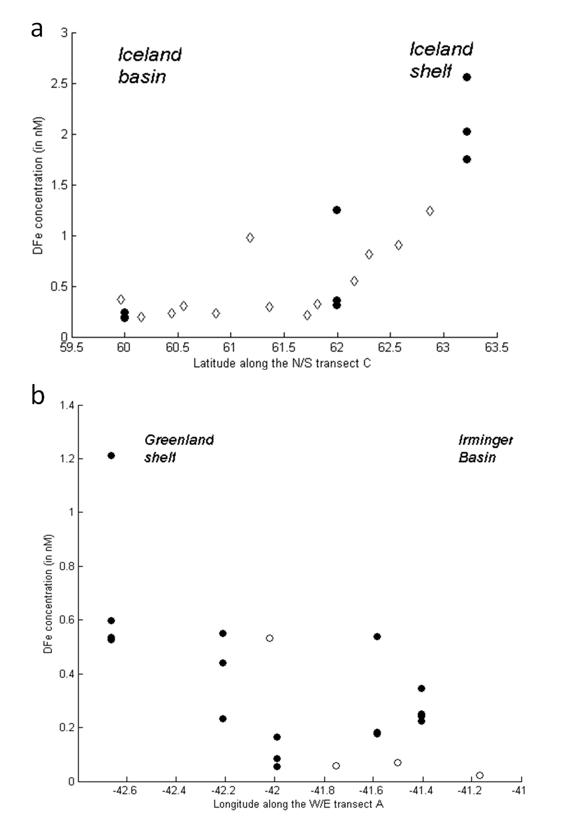

Figure S2: (a) Surface underway DFe concentration (open diamonds) and MLD DFe concentrations (full circles) in nM along transcet C (N/S). Converted in Km, this distribution yields to a relationship of DFe = -0.0028 x distance + 1.045, r² = 0.53, n=21. (b) Surface underway DFe concentration (open diamonds) and MLD DFe concentrations (full circles) in nM along transcet A (W/E). Converted in Km, this distribution yields to a relationship of DFe_{surface} = -0.0065xdistance + 0.4298, r² = 0.62, n=18.

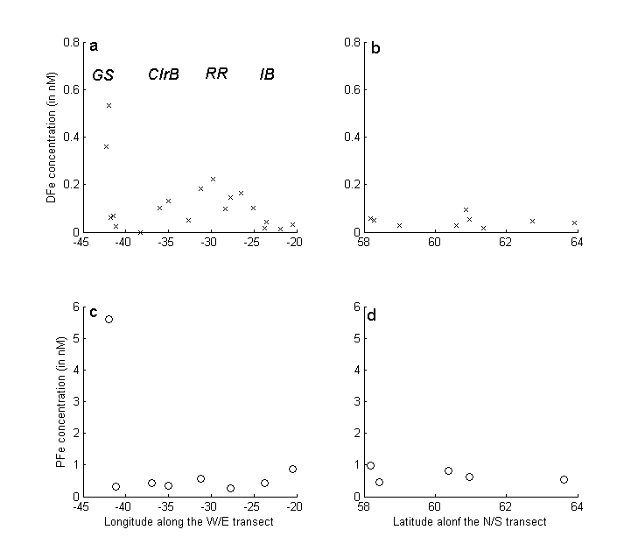
Figure S3: Surface underway (a, b) DFe and (c, d) PFe concentration (in nM) along transects A (W/E) and B (N/S) (see Figure A) during D354. GS: Greenland shelf; CIS: Central Irminger Sea; RR: Reykjanes Ridge, IB: Iceland basin.

References

Achterberg, E. P., et al. (2013), Natural Iron Fertilisation by the Eyafjallojokull eruption, Geophys. Res. Lett., doi:10.1002/grl.50221.
Blain, S., et al. (2007), Effect of natural iron fertilization on carbon sequestration in the Southern Ocean, Nature, 446(7139), 1070-1074.
Mc Clean, J. L., P. M. Poulain, J. W. Pelton, and M. E. Maltrud (2002), Eulerian and Lagrangian Statistics from Surface Drifters and a high-Resolution POP Stimulation in the North Atlantic, Journal of Oceanography, 32, 2472-2491.
Painter, S. C., S. A. Henson, A. Forryan, S. Steigenberger, J. Klar, M. Stinchcombe, N. Rogan, A. Baker, E. P. Achterberg, and C. M. Moore (2014), An assessment of the vertical diffusive flux of iron and other nutrients to the surface waters of the subpolar North Atlantic Ocean, biogeosciences 11, 2113-2130.
Pollard, R. T., et al. (2009), Southern Ocean deep-water carbon export enhanced by natural iron fertilization, Nature, 457(7229), 577-U581.
Ryan-Keogh, T. J., A. I. Macey, M. C. Nielsdo´ttir, M. I. Lucas, S. S. Steingenberger, M. C. Stinchcombe, E. P. Achterberg, T. S. Bibby, and C. M. Moore (2013), Spatial and temporal development of phytoplankton iron stress in relation to bloom dynamics in the high latitude North Atlantic Ocean., Limnology and Oceanography, 58(2), 533-545.

