Supplementary information
‘Holocene variations in productivity associated with changes in glacier activity and freshwater flux in the central basin of the Strait of Magellan’

Claudia Aracena^{a,b,*}, Rolf Kilian^{c,d}, Carina B. Lange^{b,e}, Sebastien Bertrand^{f}, Frank Lamy^{g}, Helge W. Arz^{h}, Ricardo De Pol-Holz^{e}, Oscar Baeza^{c}, Silvio Pantoja^{b,e}, Catherine Kissel^{i}
ªInstituto de Ciencias Marinas y Limnológicas. Universidad Austral de Chile, Campus Isla Teja. Edificio Emilio Pugin,Valdivia, Chile.
^{b}Centro COPAS, Programa COPAS Sur-Austral, Universidad de Concepción, Casilla 160-C, Concepción, Chile.
^{c}Lehrstuhl für Geologie, Fachbereich VI, Geowissenschaften, Universität Trier, D-54286 Trier, Germany
^{d}Dirección de Programas Antárticos y Subantárticos, Universidad de Magallanes. Avenida Bulnes 01855/casilla 113 D, Punta Arenas, Chile.
^{e}Departamento de Oceanografía, Universidad de Concepción, Casilla 160-C, Concepción, Chile.
^{f}Renard Centre of Marine Geology, Ghent University, Krijgslaan 281 S8, 9000 Gent, Belgium
^{g}Alfred Wegener Institut für Polar- und Meeresforschung, Am Alten Hafen 26, 27568 Bremerhaven, Germany
^{h}Leibniz Institute for Baltic Sea Research Warnemünde, Marine Geology, Seestraße 15, D-18119 Rostock, Germany
^{i}Laboratoire des Sciences du Climat et de l'Environnement/IPSL, UMR 8212 CEA/CNRS/UVSQ, Avenue de la Terrasse, 91198 Gif-sur-Yvette Cédex, France

Corresponding Author: Claudia Aracena, claudia.aracena@uach.cl
This file includes:
Figs. S1 to S3:
Figure S1. Lithology of core MD07-3132
Figure S2. Photograph of the 15 core sections from sediment core MD07-3132
Figure S3. Paleosalinity interpretation of sediment core MD07-3132
Text
Paleosalinity inferred from chlorine content.
Holocene glacial clay contribution.
References

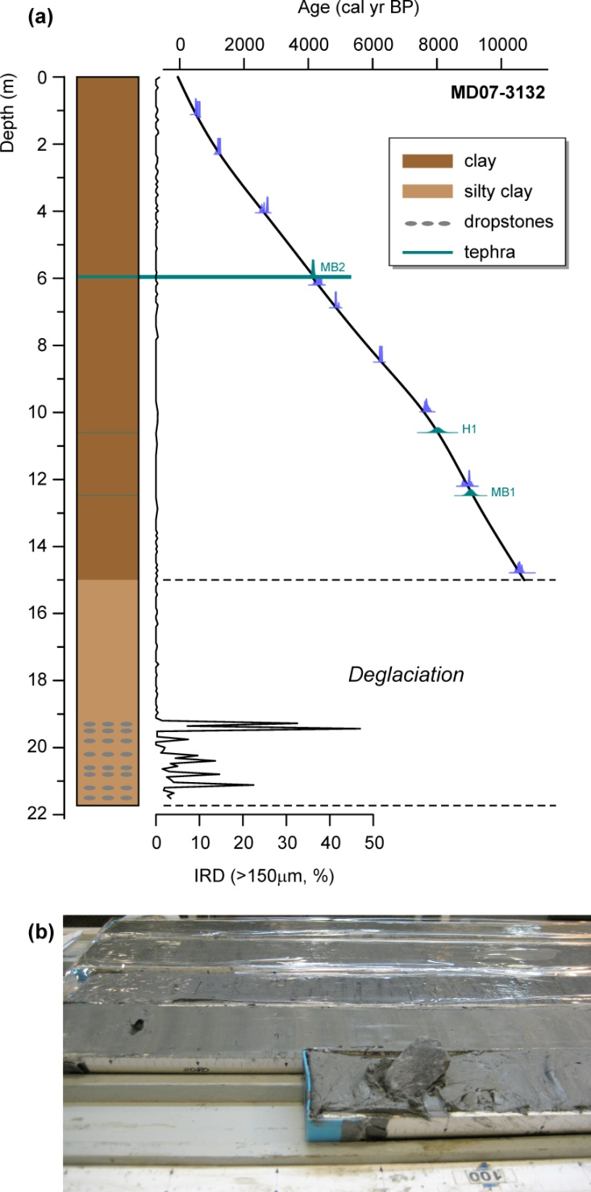
Figure S1. (a) Core MD07-3132 lithology, age-depth model, and ice-rafted debris (IRD) content. The 21.73 m long core is composed of grayish olive glacial clays from 21.73 to 15.00 m. The lowermost 2 m are laminated sediments and contain abundant dropstones, and are devoid of biogenic components, suggesting a diamicton facies that evidences a very proximal location to the glaciers of Cordillera Darwin. This lower unit gradually evolves into homogeneous grayish olive black clay with occasional bioturbation which is more pronounced in the uppermost 1.5 m. Due to the absence of shell fragments suitable for dating in the lower sedimentary unit, the chronology is limited to the upper 15 m. The basal sediments (14.68–21.73 m) were most likely deposited during the latest part of Stage E (11.7–15.5 kyr BP; Sugden et al., 2009). (b) Photograph of the lowermost section showing a large dropstone and sediments with typical cm-thick laminae (Kissel, 2007) which we suggest as proglacial sediments of Stage E.
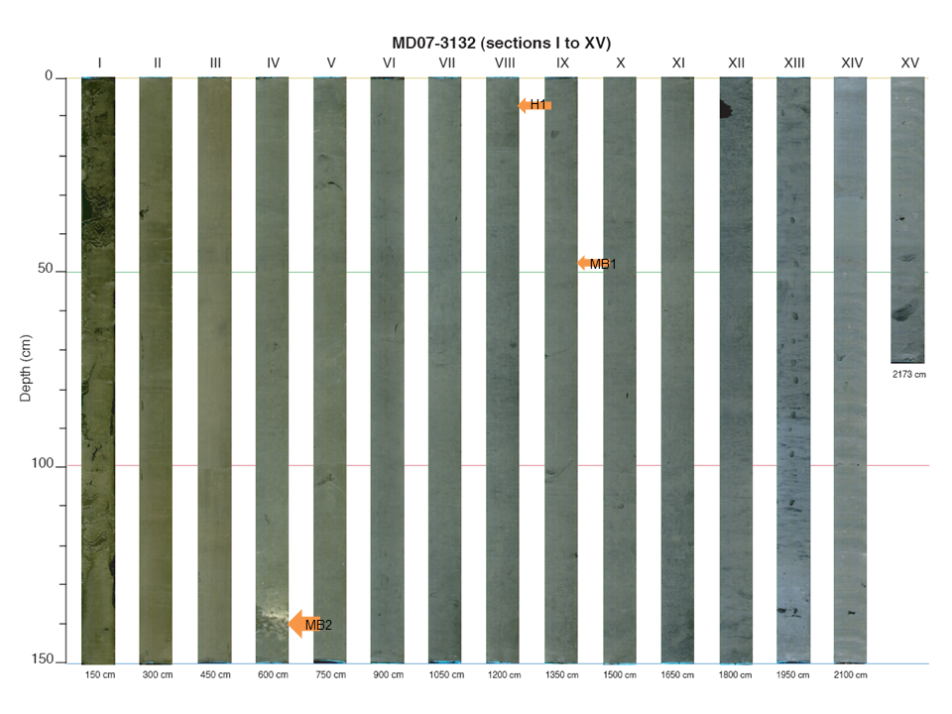
Figure S2. Photograph of the 15 core sections of sediment core MD07-3132. Three tephra layers were identified at 1248cm (MB1), 1060 cm (H1) and 592–600 cm (MB2). The position of these layers is indicated by the orange arrows. Figure modified from Kissel 2007 (MD159-PACHIDERME-IMAGES XV. Data report).
Paleosalinity inferred from Chlorine content. . Since Chlorine (Cl) is a conservative element of sea water, we use the Cl XRF core scanner counts divided by the sediment water content as a paleosalinity proxy. Our interpretation of the data is that salinity changes occur by an increase in meltwater input. It has been shown by Kilian et al. (2014) that qualitative changes in Cl content of the pore water are preserved in several sediment cores from the Magellan fjord system since the Late Glacial and that these changes in chlorinity are typically associated with changes in the mineralogical and lithogenic chemical composition of the sediments. However, in sediment core MD07-3132, Cl is significantly positively correlated with water content (r=0.8; Fig. S3a). This means that most of the variations in Cl counts reflect changes in the water content of the sediment, except for the bottom section of the core where Cl and water content vary independently (Fig. S3b), suggesting that not all of the Cl signal is due to water content. The differences between Cl and water content can be interpreted as past changes in bottom water salinity. High Cl values at the base of the core may reflect a first marine transgression to the fjord bottom water together with a highly stratified water column and restricted superficial meltwater input from limited glacier melting during glacial Stage E. The low Cl values at ~1350–1400 cm core depth may correspond to an interval of increased freshwater input due to either enhanced glacier melting (McCulloch et al., 2005), and/or a proglacial lake drainage, and/or increased precipitation together with strong winds (Lamy et al., 2010), all of which prevent mixing of superficial freshwater with bottom water. According to our age model, this time interval from 9.7 to 10.3 kyr BP coincides with the Holocene Climate Optimum.

(a)
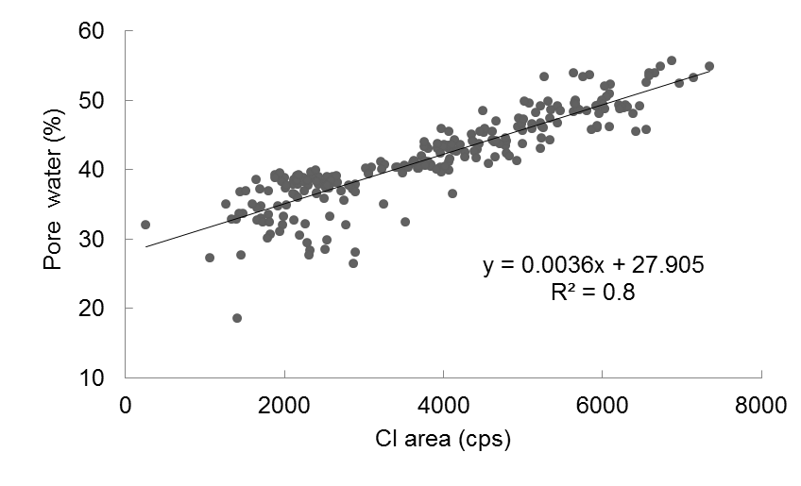
(b)
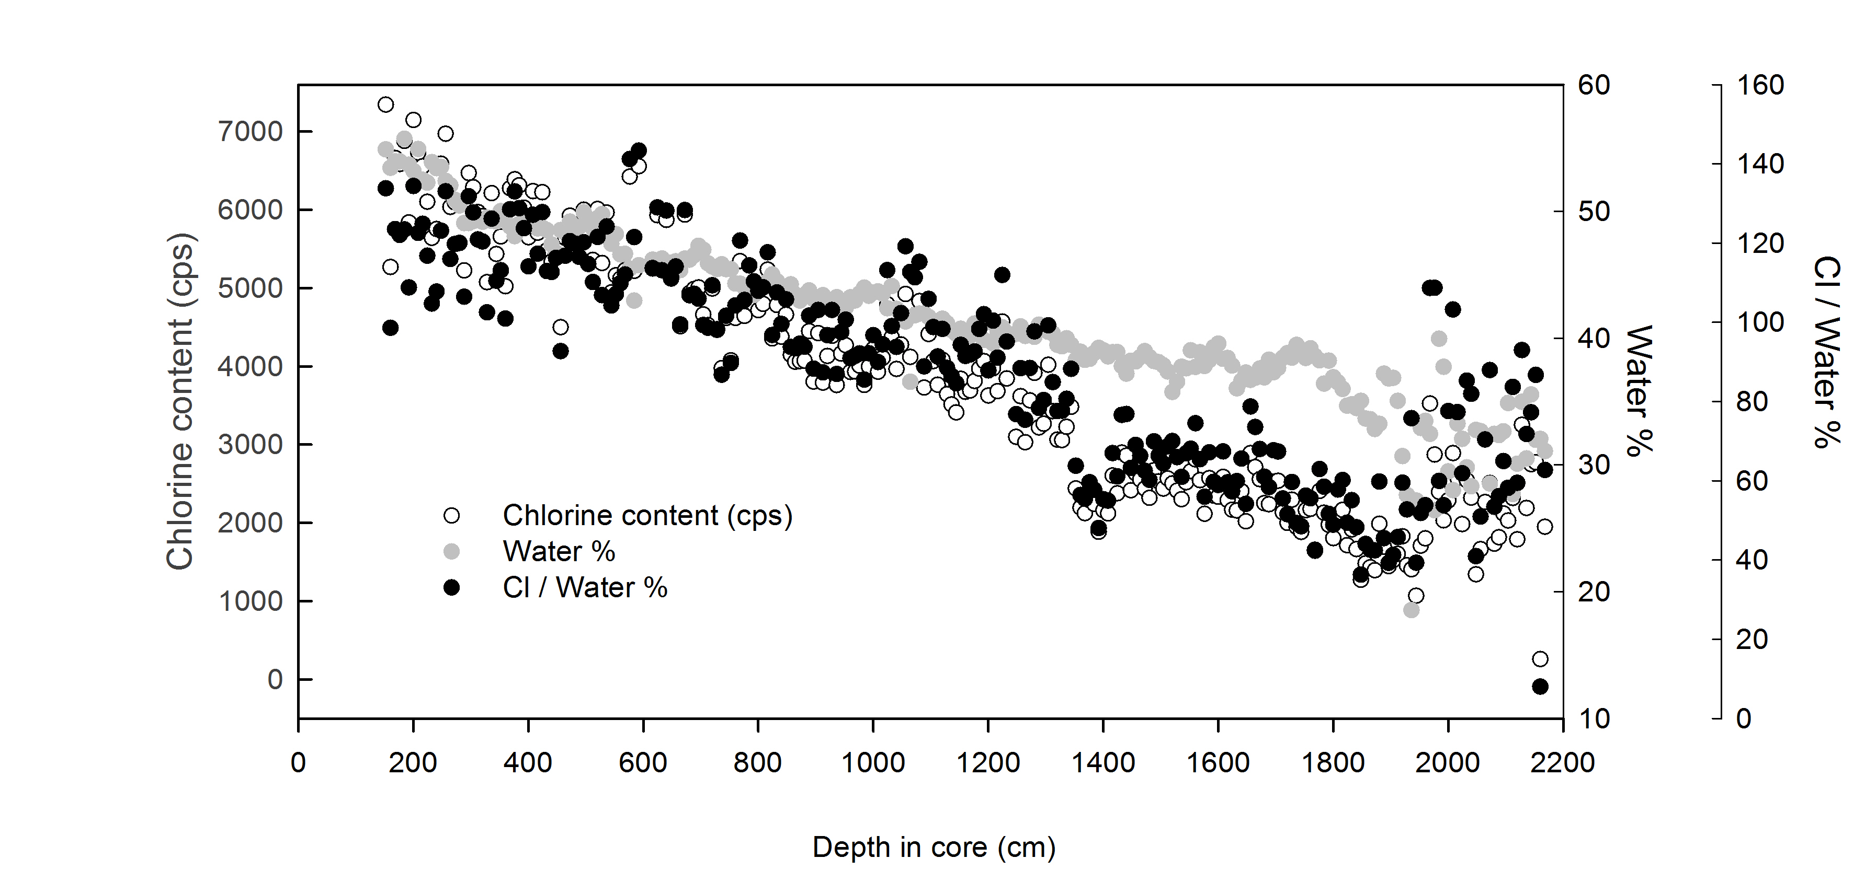

Figure S3. Paleosalinity interpretation of sediment core MD07-3132. (a) Linear regression between Chlorine (Cl in cps) and pore water (%) content. Chlorine is significantly positively correlated with water content (r²=0.8). (b) Chlorine ratio (black dots), pore water content % (grey dots) and Chlorine content (Cl in cps) (white dots) vs depth in core.

Holocene glacial clay contribution. We use the K/Si ratio to distinguish more authochtonous from allochtonous sediment sources. Sediments from local costal sources have lower K/Si and lower Illite chlorite ratios compared to glacial clay-dominated sediments. The latter are mainly derived from Cordillera Darwin where Potassium-bearing granites lead to higher K/Si and Illite/Chlorite ratios (Kilian et al., 2013b).
Here, we describe chemical signals in the base of the core in terms of depth (see supplementary information, figure S1). Basal sediments are characterized by a diamicton unit which shows the largest input of allochtonous glacial clay (K/Si ratio > 1.5), between 2173 and 1800 cm, suggesting an extended sediment supply from the granitoid basement of Cordillera Darwin (Fig. 3f) that is likely related with deglaciation processes occurring in the area. These results are correlated with high depositions of coarse clastic mineral particles (IRD >150 μm up to 47%; e.g. quartz and feldspar from granitoids; Fig. 3g) until ~1920 cm, and the highest magnetic susceptibility signal (>180; Fig 3h). After this period, at the early Holocene, we observe a second peak in the K/Si ratio between 1370 and 1420 cm (10 ̶ 9.6 kyr BP) which is coincident with a drastic drop in the Cl / Water % (Fig. 5f and g, respectively). During the mid Holocene (8.2 ̶ 4.2 kyr BP) the K/Si ratio remains relatively low (~1) and indicates, in general, little glacial clay input (Fig. 5f), whereas the Cl / Water % increases (from 90 to 140; Fig. 5g). Finally, late Holocene sediments between 3.2 and 2.2 kyr BP show a slight increase in the glacial clay input (K/Si >1.2) which parallels a rise in the AR of _{terr}OC and siliciclastics (Fig. 5d and e, respectively) but a drastic drop in accumulation rates of biogenic CaCO₃ (Fig. 5b).
REFERENCES
Kilian R., Baeza O., Breuer S., Ríos F., Arz H., Lamy L., Wirtz J., Baque D., Korf P., Kremer K., Ríos C., Mutschke E., Michels S., De Pohl-Holz R., Arévalo M., Wörner G., Schneider C., Casassa G., Late Glacial and Holocene paleogeographical and paleoecological evolution of the Seno Skyring and Otway fjord systems in the Magellan region. An. Ins. Patagonia 1(2), 2013b, 5–26.
Kissel C., The Shipboard Scientific Party. MD159-PACHIDERME-IMAGES XV. In: Cruise report, Les rapports de campagne à la mer, Réf. OCE/2007/01, Institut Paul-Emile Victor, 2007.
Lamy F., Kilian R., Arz H., Francois J., Kaiser J., Prange M., Steinke T., Holocene changes in the position and intensity of the southern westerly wind belt. Nat. Geosci. 3, 2010, 695–699.
McCulloch R., Bentley M., Tipping R.M. and Clapperton C., Evidence for late-glacial ice dammed lakes in the central Strait of Magellan and Bahía Inútil, southernmost South America. Geogr. Ann. Ser. A Phys. Geogr. 87, 2005, 335–362.

