Supporting information for
Pushing the boundaries: Glacial/Interglacial variability of intermediate- and deep-waters in the southwest Pacific over the last 350,000 years

Thomas A. Ronge¹, Silke Steph¹, Ralf Tiedemann¹, Matthias Prange², Ute Merkel², Dirk Nürnberg³, Gerhard Kuhn¹

¹ Alfred Wegener Institute Helmholtz Center for Polar and Marine Research, Bremerhaven, Germany
² University of Bremen – MARUM and Geoscience Department, Bremen, Germany
³ GEOMAR Helmholtz Center for Ocean Research, Kiel, Germany
Correspondence to: T. Ronge, Thomas.Ronge@awi.de

Content of this file
Figures S1 and S2; Tables S1 – S3

Introduction
This supporting information provides the datasets used in the main article as well as additional information about the calculation of %AAIW.

Calculation of %AAIW
In order to visualize the alternating influence of AAIW and UCDW on the core location of MD97-2120, we calculated an AAIW-UCDW fractionation index after Raymo et al. (1990).
%AAIW = (δ¹³C_{MD97-2120} – δ¹³C_{MD06-2986}) / (δ¹³C_{MD06-2990} – δ¹³C_{MD06-2986}) * 100
In this equation, MD06-2990 and MD06-2986 represent the endmembers for the AAIW and UCDW, respectively. High %AAIW values in figure 8 a indicate a strong influence of AAIW on MD97-2120, while low values indicate a stronger influence of UCDW. We assume that minor isotopic differences in AAIW west (MD06) and east (MD97) of New Zealand caused values higher than 100% and lower than 0%. However, as we showed in figure 4, we assume that these differences do not influence our interpretation.

Carbon isotopes (δ¹³C)
Following the method of McCave et al. (2008) we transformed values measured on U. peregrina into C. wuellerstorfi equivalent:
Δδ¹³C_{Cib-Uvi} = 0.464δ¹⁸O_{Uvi} – 2.753 (r=0.629; n=57)
A comparison of C. wuellerstorfi to U. peregrina values is shown in figure S1.

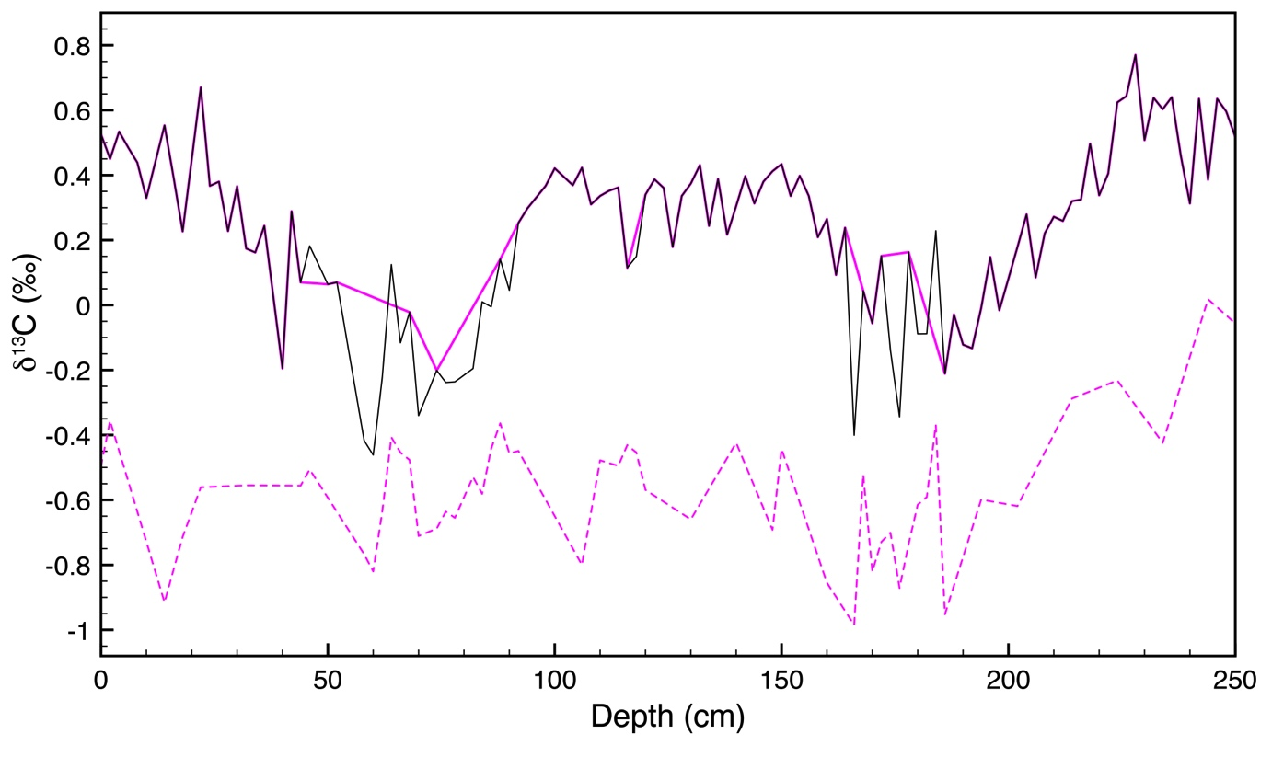
Figure S1: Comparison of benthic δ¹³C values in sediment core SO213-82-1. Raw data of C. wuellerstorfi (pink line) and U. peregrina (stippled pink line). The black line shows a combination of C. wuellerstorfi and corrected U. peregrina values.

Climate modeling

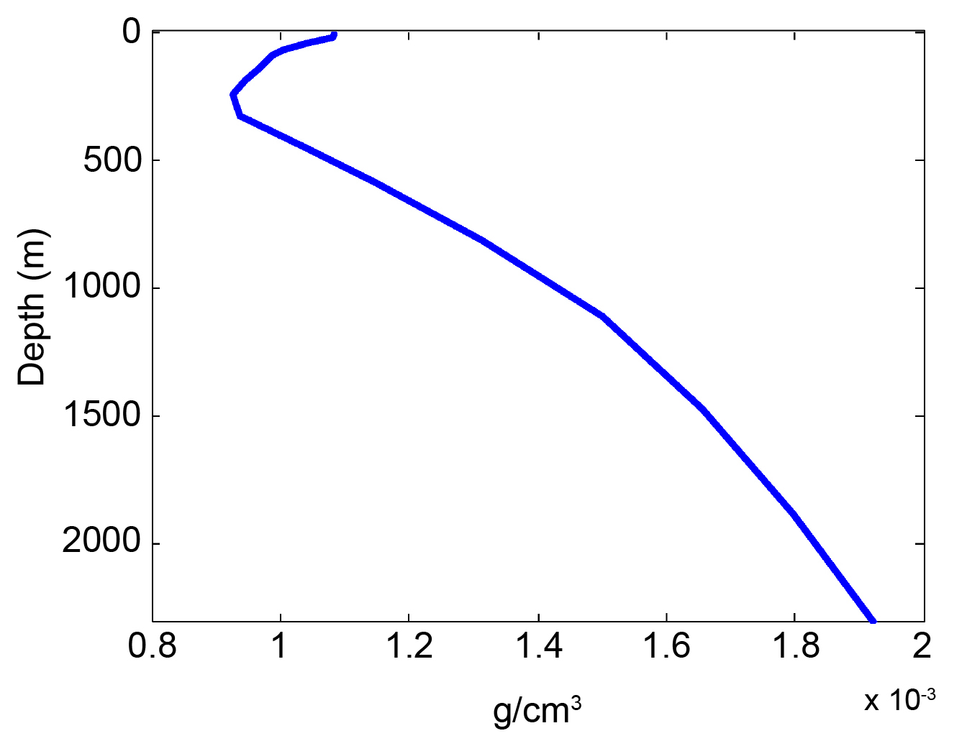

Figure S2: Vertical profile of modeled LGM in-situ density anomaly relative to pre-industrial, zonally averaged across the South Pacific at 30°S (annual mean; 100-yr average).

Table S1: Radiocarbon-details for sediment cores SO136-003, MD06-2986, SO213-82-1 and SO213-84-1.

Core | Depth (cm) | ¹⁴C age BP | ±¹⁴C age BP | δ¹³C (‰) | Cal. Age BP | Lab. Number
SO136-003 | 0-5 | 3425 | 30 | -0.4 | 3354 | ETH-38749
SO136-003 | 6-8 | 4340 | 30 | -0.7 | 4499 | ETH-38750
SO136-003 | 14-16 | 8755 | 35 | -2.2 | 9477 | ETH-38751
SO136-003 | 24-26 | 12450 | 40 | -0.0 | 13934 | ETH-38752
SO136-003 | 34-36 | 16500 | 55 | 0.7 | 19326 | ETH-38753
SO136-003 | 72-74 | 21805 | 80 | -2.6 | 25851 | ETH-38754
MD06-2986 | 2-5 | 1390 | 20 | 0.79 | 983 | -
MD06-2986 | 94-96 | 8885 | 45 | 2.42 | 9541 | -
MD06-2986 | 127-129 | 11240 | 50 | -0.28 | 12826 | -
MD06-2986 | 138-140 | 11955 | 50 | 1.4 | 13520 | -
MD06-2986 | 167-169 | 15080 | 70 | -1.09 | 17661 | -
MD06-2986 | 221-223 | 21040 | 120 | 1.71 | 24744 | -
MD06-2986 | 251-253 | 23950 | 160 | 1.83 | 28341 | -
MD06-2986 | 403-405 | 34710 | 550 | 0.59 | 39773 | -
SO213-84-1 | 55 | 17700 | 70 | -1.19 | 20255 | OS-106834
SO213-84-1 | 68 | 20700 | 140 | -0.61 | 23721 | OS-101445
SO213-84-1 | 126 | 25200 | 260 | -0.04 | 29128 | OS-101446
SO213-82-1 | 10 | 6680 | 55 | 0.35 | 6931 | OS-102929
SO213-82-1 | 26 | 8405 | 30 | - | 8657 | UCIAMS-133187
SO213-82-1 | 38 | 12350 | 55 | 0.13 | 13557 | OS-102930
SO213-82-1 | 54 | 14850 | 65 | -0.75 | 17284 | OS-103141
SO213-82-1 | 72 | 18050 | 95 | 0.09 | 20424 | OS-103143
SO213-82-1 | 90 | 25600 | 110 | 0.34 | 29580 | OS-106669

Table S2: Average isotopic values for marine isotope stages (MIS) 1 – 10.

Core | Depth (mbsl) | Holocene |  | LGM |  | MIS 3 |  | MIS 4 |  | MIS 5
 |  | mean δ¹³C (‰) | mean δ¹⁸O (‰) | mean δ¹³C (‰) | mean δ¹⁸O (‰) | mean δ¹³C (‰) | mean δ¹⁸O (‰) | mean δ¹³C (‰) | mean δ¹⁸O (‰) | mean δ¹³C (‰) | mean δ¹⁸O (‰)
MD06-2990 | 943 | 1.14 | 2.82 | 0.85 | 4.44 | 0.92 | 4.08 | 0.82 | 4.07 | 1.02 | 3.38
SO213-84 | 972 | 1.14 | 3.16 | 0.74 | 4.5 | 1.01 | 4.15 | - | - | - | -
MD97-2120 | 1210 | 0.9 | 3.14 | 0.32 | 4.85 | 0.6 | 4.43 | 0.31 | 4.47 | 0.72 | 3.71
MD06-2986 | 1477 | 0.67 | 3.35 | 0.22 | 4.76 | 0.25 | 4.48 | 0.1 | 4.41 | 0.35 | 3.83
SO213-82 | 2066 | 0.4 | 3.65 | 0 | 5.12 | 0.25 | 4.63 | 0.01 | 4.68 | 0.46 | 4.21
offset MD06-2990 - MD97-2120 |  | 0.24 | -0.32 | 0.53 | -0.41 | 0.32 | -0.35 | 0.51 | -0.4 | 0.3 | -0.33
offset MD97-2120 - MD06-2986 |  | 0.23 | -0.21 | 0.1 | 0.09 | 0.35 | -0.05 | 0.21 | 0.06 | 0.37 | -0.12
Core | Depth (mbsl) | MIS 6 |  | MIS 7 |  | MIS 8 |  | MIS 9 |  | MIS 10
 |  | mean δ¹³C (‰) | mean δ¹⁸O (‰) | mean d¹³C (‰) | mean δ¹⁸O (‰) | mean δ¹³C (‰) | mean δ¹⁸O (‰) | mean δ¹³C (‰) | mean δ¹⁸O (‰) | mean δ¹³C (‰) | mean δ¹⁸O (‰)
MD06-2990 | 943 | 0.69 | 4.13 | 0.76 | 3.69 | 0.8 | 3.74 | 0.9 | 3.22 | 0.64 | 4.26
MD97-2120 | 1210 | 0.15 | 4.41 | 0.53 | 3.63 | 0.22 | 4.25 | 0.51 | 3.5 | - | -
MD06-2986 | 1477 | -0.03 | 4.48 | 0.19 | 3.84 | -0.04 | 4.33 | 0.1 | 3.87 | -0.11 | 4.55
offset MD06-2990 - MD97-2120 |  | 0.54 | -0.28 | 0.23 | 0.06 | 0.58 | -0.51 | 0.39 | -0.28 | - | -
offset MD97-2120 - MD06-2986 |  | 0.18 | -0.07 | 0.34 | -0.21 | 0.26 | -0.08 | 0.41 | -0.37 | - | -

Table S3: Total organic carbon (TOC) and paleoproductivity (PP) values for sediment cores SO213-82-1 and SO213-84-1.

Core | depth (top cm bsf) | Age (kyr) | Average Sed Rate (cm/kyr) | TOC % | TOC % sc | dry bulk density (g cm-3) | TOCAR (g/cm2/kyr) | PP (gC/m2/y)
SO213-82-1 | 1 | 2.70 | 4.63 | 0.16 | 0.16 | 0.90 | 0.41 | 46.25
SO213-82-1 | 10 | 5.72 | 4.63 | 0.14 | 0.14 | 1.02 | 0.47 | 46.18
SO213-82-1 | 20 | 8.60 | 4.31 | 0.18 | 0.19 | 1.00 | 0.43 | 55.53
SO213-82-1 | 30 | 11.25 | 3.41 | 0.35 | 0.36 | 0.88 | 0.30 | 79.01
SO213-82-1 | 40 | 14.11 | 5.28 | 0.26 | 0.27 | 1.06 | 0.56 | 75.66
SO213-82-1 | 50 | 16.73 | 5.50 | 0.30 | 0.30 | 1.06 | 0.58 | 83.19
SO213-82-1 | 60 | 19.52 | 5.28 | 0.24 | 0.25 | 0.92 | 0.49 | 64.95
SO213-82-1 | 71 | 23.66 | 3.96 | 0.23 | 0.23 | 0.96 | 0.38 | 62.91
SO213-82-1 | 80 | 27.05 | 3.96 | 0.28 | 0.29 | 1.00 | 0.40 | 74.96
SO213-82-1 | 90 | 30.82 | 2.68 | 0.15 | 0.16 | 1.05 | 0.28 | 49.05
SO213-82-1 | 101 | 35.51 | 2.68 | 0.14 | 0.14 | 1.02 | 0.27 | 45.26
SO213-82-1 | 110 | 39.76 | 2.68 | 0.14 | 0.15 | 1.03 | 0.28 | 46.16
SO213-82-1 | 120 | 44.49 | 2.68 | 0.21 | 0.22 | 1.00 | 0.27 | 60.13
SO213-82-1 | 130 | 49.21 | 2.68 | 0.16 | 0.17 | 1.08 | 0.29 | 52.19
SO213-82-1 | 141 | 53.12 | 2.68 | 0.13 | 0.14 | 1.00 | 0.27 | 42.88
SO213-82-1 | 150 | 55.58 | 3.04 | 0.11 | 0.12 | 1.03 | 0.31 | 39.43
SO213-82-1 | 160 | 58.31 | 3.04 | 0.15 | 0.15 | 1.07 | 0.32 | 49.46
SO213-82-1 | 170 | 61.31 | 3.04 | 0.20 | 0.21 | 1.07 | 0.33 | 61.26
SO213-82-1 | 181 | 64.86 | 3.04 | 0.17 | 0.17 | 1.04 | 0.32 | 52.56
SO213-82-1 | 190 | 67.76 | 3.04 | 0.17 | 0.17 | 1.06 | 0.32 | 52.88
SO213-82-1 | 200 | 70.99 | 3.04 | 0.22 | 0.23 | 1.03 | 0.31 | 63.89
SO213-82-1 | 211 | 74.55 | 3.04 | 0.18 | 0.18 | 1.00 | 0.30 | 53.32
SO213-82-1 | 220 | 77.48 | 3.04 | 0.26 | 0.26 | 1.00 | 0.30 | 68.86
SO213-82-1 | 230 | 80.72 | 3.04 | 0.14 | 0.14 | 0.95 | 0.29 | 43.28
SO213-82-1 | 241 | 84.30 | 3.04 | 0.09 | 0.09 | 0.95 | 0.29 | 31.28
SO213-82-1 | 250 | 87.22 | 3.04 | 0.09 | 0.09 | 0.92 | 0.28 | 30.09
SO213-84-1 | 5 | 6.45 | 7.45 | 0.19 | 0.20 | 1.22 | 0.91 | 48.80
SO213-84-1 | 15 | 8.23 | 7.45 | 0.25 | 0.26 | 1.17 | 0.87 | 57.18
SO213-84-1 | 25 | 11.18 | 7.45 | 0.26 | 0.27 | 1.14 | 0.85 | 57.63
SO213-84-1 | 35 | 16.77 | 3.75 | 0.26 | 0.27 | 1.10 | 0.41 | 53.89
SO213-84-1 | 45 | 18.92 | 3.75 | 0.32 | 0.32 | 1.01 | 0.38 | 58.39
SO213-84-1 | 55 | 20.90 | 3.75 | 0.27 | 0.28 | 1.06 | 0.40 | 54.18
SO213-84-1 | 65 | 22.88 | 10.73 | 0.31 | 0.32 | 0.96 | 1.03 | 59.34
SO213-84-1 | 75 | 24.37 | 10.73 | 0.25 | 0.26 | 1.02 | 1.09 | 53.90
SO213-84-1 | 85 | 25.11 | 10.73 | 0.24 | 0.25 | 1.06 | 1.14 | 53.19
SO213-84-1 | 95 | 25.85 | 10.73 | 0.21 | 0.22 | 1.12 | 1.20 | 51.15
SO213-84-1 | 105 | 26.58 | 8.80 | 0.28 | 0.28 | 1.01 | 0.89 | 56.18
SO213-84-1 | 115 | 27.32 | 8.80 | 0.26 | 0.26 | 1.07 | 0.94 | 55.74
SO213-84-1 | 125 | 28.09 | 8.80 | 0.22 | 0.23 | 1.07 | 0.94 | 49.95
SO213-84-1 | 135 | 29.25 | 8.80 | 0.26 | 0.27 | 1.14 | 1.01 | 58.73
SO213-84-1 | 145 | 30.35 | 8.80 | 0.14 | 0.15 | 1.19 | 1.04 | 39.52
SO213-84-1 | 155 | 31.18 | 8.80 | 0.20 | 0.21 | 1.16 | 1.02 | 49.36
SO213-84-1 | 165 | 31.99 | 8.80 | 0.20 | 0.20 | 1.15 | 1.01 | 48.72
SO213-84-1 | 175 | 32.81 | 11.22 | 0.18 | 0.18 | 1.19 | 1.33 | 46.31
SO213-84-1 | 185 | 33.62 | 11.22 | 0.16 | 0.16 | 1.19 | 1.33 | 43.19
SO213-84-1 | 195 | 34.65 | 11.22 | 0.21 | 0.21 | 1.21 | 1.36 | 53.04
SO213-84-1 | 205 | 35.89 | 11.22 | 0.19 | 0.20 | 1.21 | 1.36 | 50.07
SO213-84-1 | 215 | 37.74 | 11.22 | 0.23 | 0.24 | 1.16 | 1.30 | 55.75
SO213-84-1 | 225 | 41.27 | 11.22 | 0.18 | 0.18 | 1.24 | 1.39 | 48.67
SO213-84-1 | 235 | 43.23 | 5.99 | 0.18 | 0.18 | 1.27 | 0.76 | 47.14
SO213-84-1 | 245 | 44.50 | 5.99 | 0.32 | 0.32 | 1.27 | 0.76 | 70.76
SO213-84-1 | 255 | 45.73 | 5.99 | 0.20 | 0.20 | 1.19 | 0.72 | 47.96
SO213-84-1 | 265 | 46.73 | 7.64 | 0.22 | 0.23 | 1.27 | 0.97 | 55.72
SO213-84-1 | 275 | 47.50 | 7.64 | 0.20 | 0.20 | 1.26 | 0.96 | 50.80
SO213-84-1 | 285 | 48.36 | 7.64 | 0.24 | 0.24 | 1.16 | 0.89 | 55.19
SO213-84-1 | 295 | 49.46 | 6.54 | 0.23 | 0.24 | 1.18 | 0.77 | 54.07
SO213-84-1 | 305 | 50.55 | 6.54 | 0.25 | 0.25 | 1.18 | 0.77 | 56.28
For the extensive stable isotope datasets, please refer to: http://doi.pangaea.de/10.1594/PANGAEA.835498
References

McCave, I. N., L. Carter, and I. R. Hall (2008), Glacial–interglacial changes in water mass structure and flow in the SW Pacific Ocean, Quaternary Science Reviews, 27, 1886-1908.
Raymo, M. E., W. F. Ruddiman, N. J. Shackleton, and D. Oppo (1990), Evolution of Atlantic-Pacific δ¹³C gradients over the last 2.5 m.y., Earth and Planetary Science Letters, 97, 353-368.

