Habitat suitability of the Atlantic bluefin tuna by size class: an ecological niche approach

Supplementary Information

Presence data by size class
The presence data for small ABFT are mainly distributed across temperate latitudes in the north-east and north-west Atlantic Ocean and in the northern Mediterranean Sea (Figure SI- 1a). Large ABFT presence data are distributed across a much larger range of latitudes from the sub-tropical seas to the sub-Arctic ocean (Figure SI- 1b).

a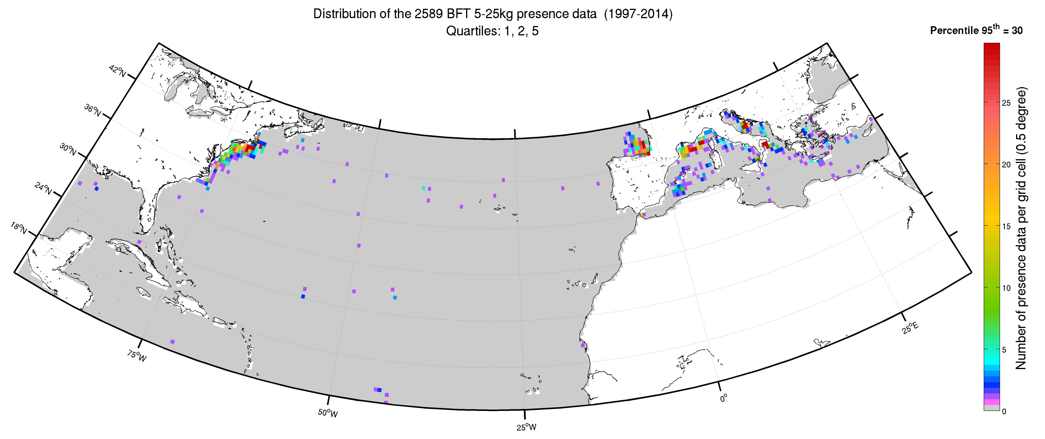
b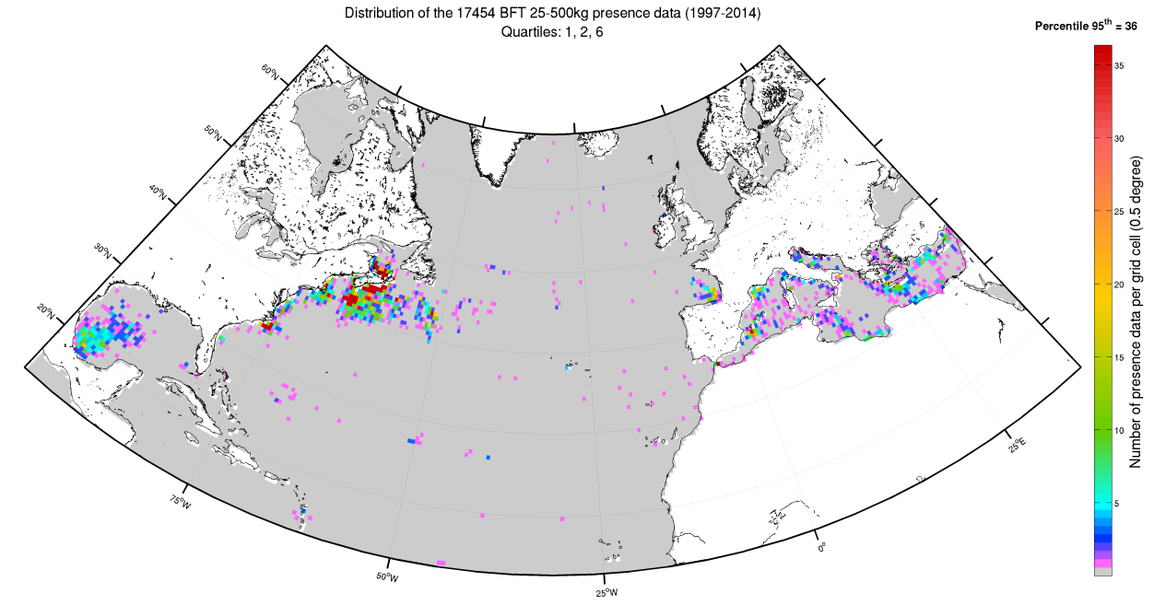
c 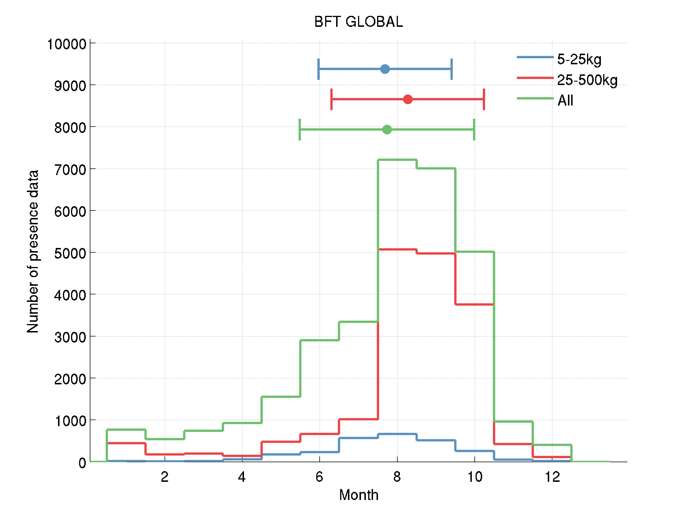
Figure SI- 1 Geographical distribution of a) small and b) large ABFT presence data collected in the period from 1997 to 2014 (in number of observations by 0.5 degree grid cells) as well as c) monthly distribution including data without weight information (mean and standard deviation are shown).

Distribution of the physical variables
No substantial seasonal variability of SSHa occur in the North Atlantic while lower and mostly negative SSHa levels were observed only in winter and spring in the Gulf of Mexico. Note that ABFT was identified to prefer negative SSHa levels, which is permanently the case in the Mediterranean Sea (not shown).
The distribution of SST and ΔSST_{30days} during the spawning season highlights higher levels of ΔSST_{30days} and lower SSTs in the Mediterranean Sea than in the Gulf of Mexico. The retained thresholds (Table 3) are consistent with this geographical variability.
a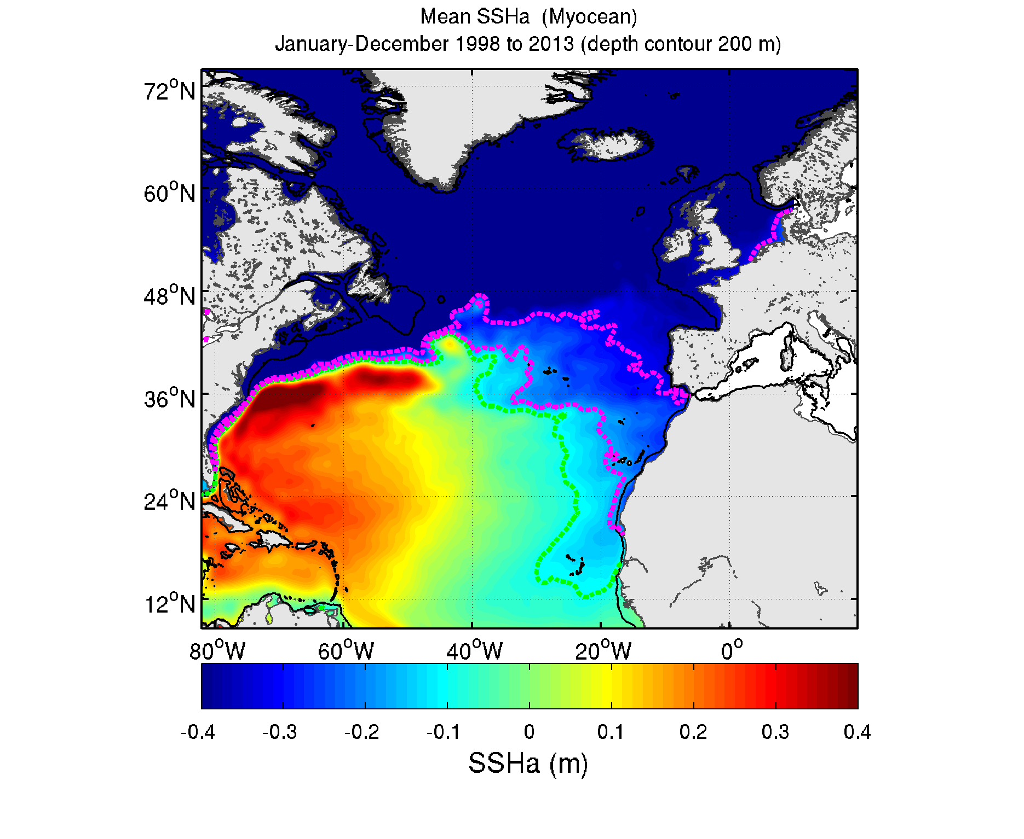
b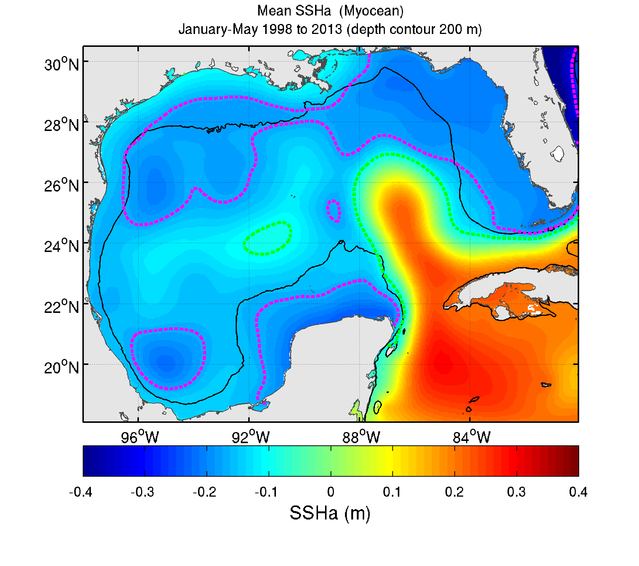c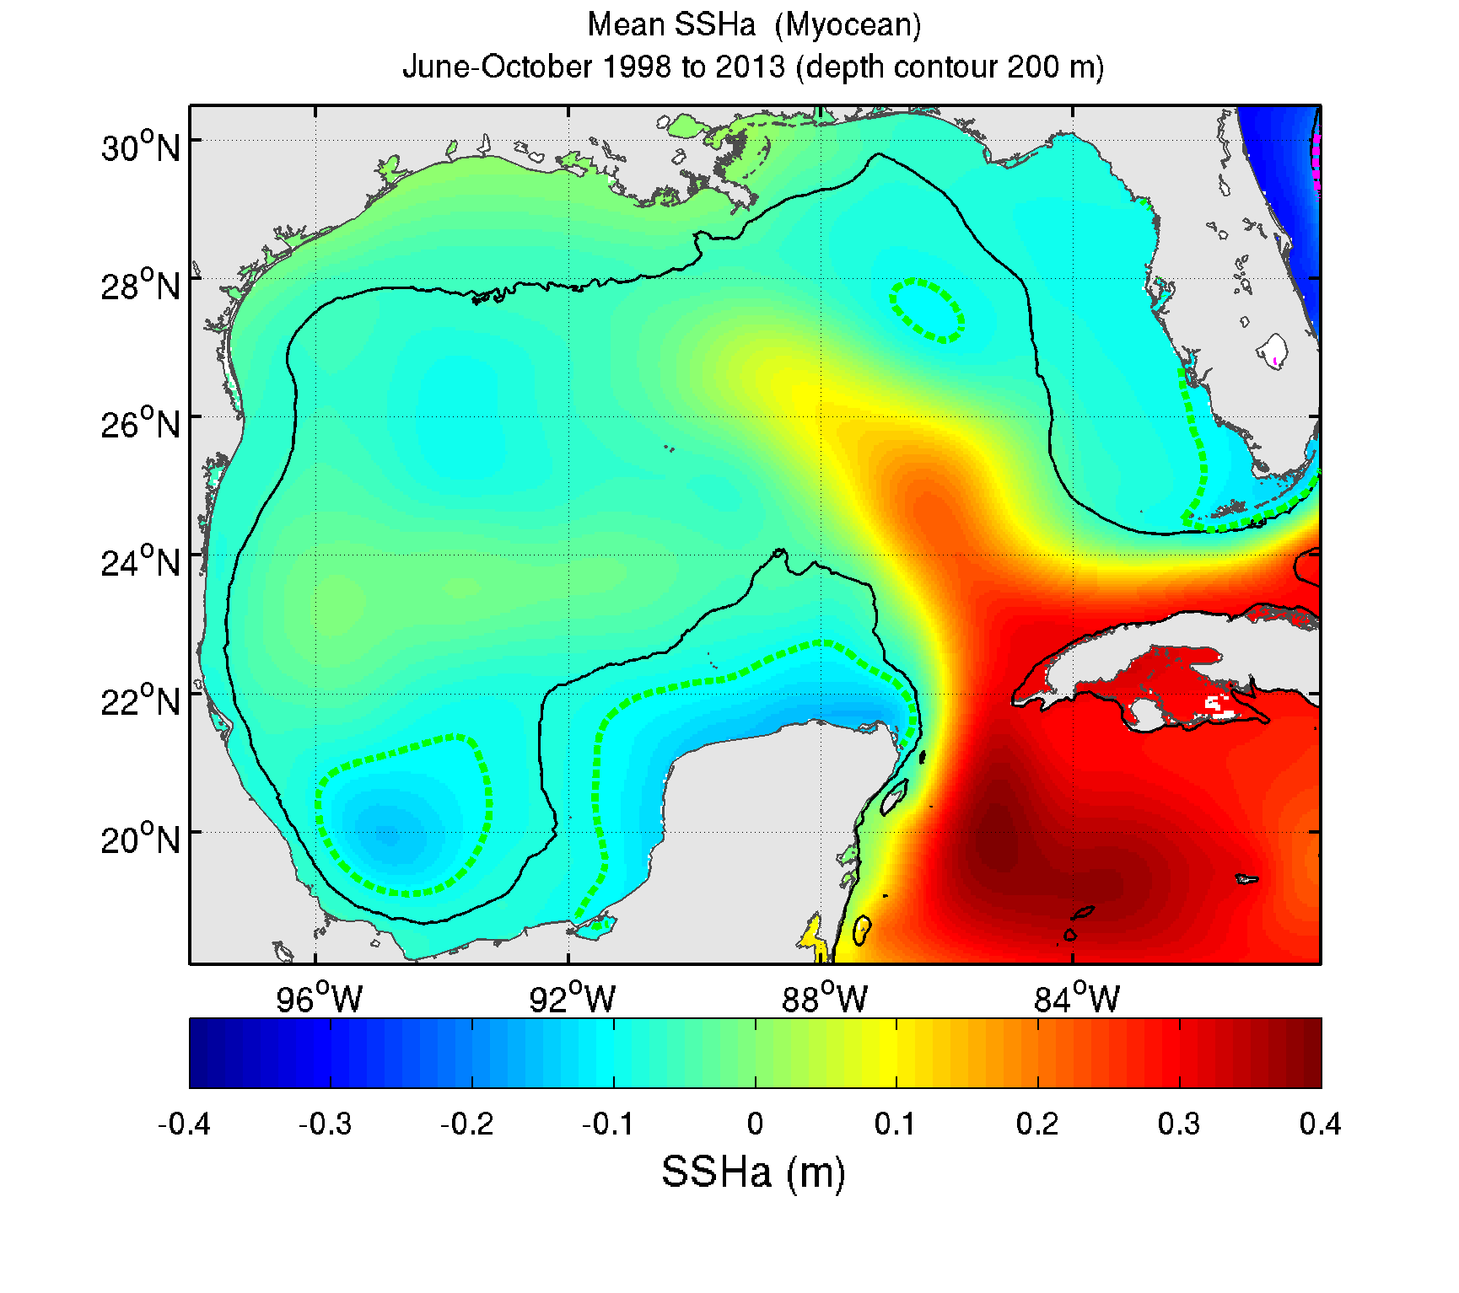
d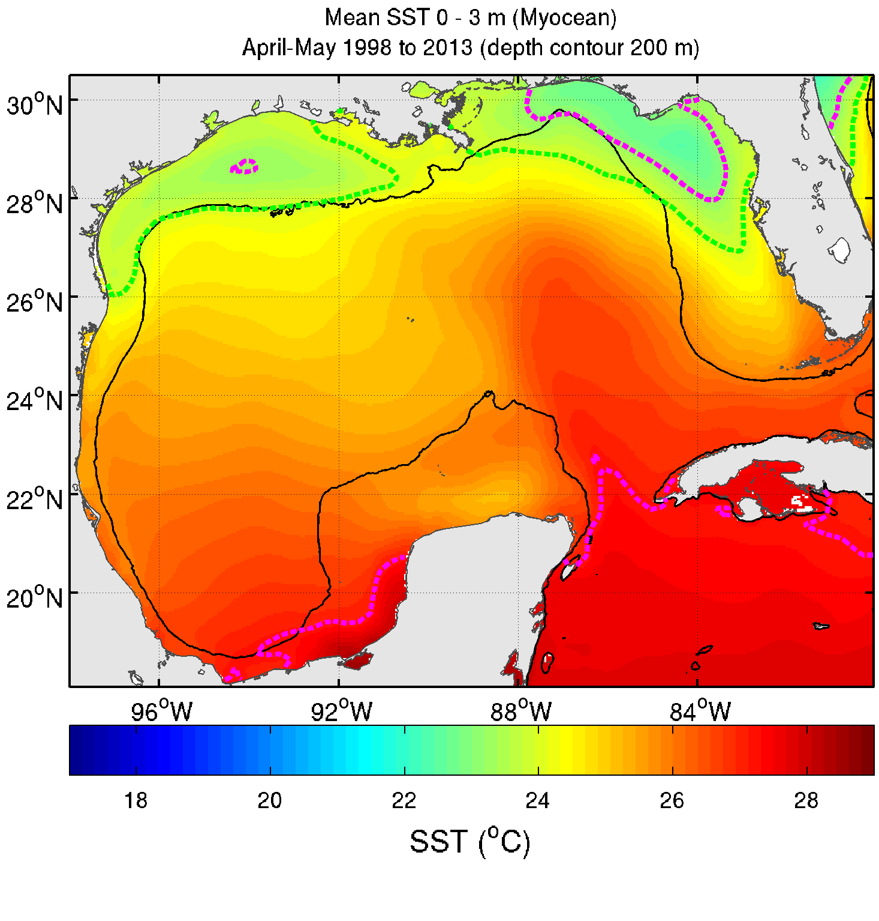e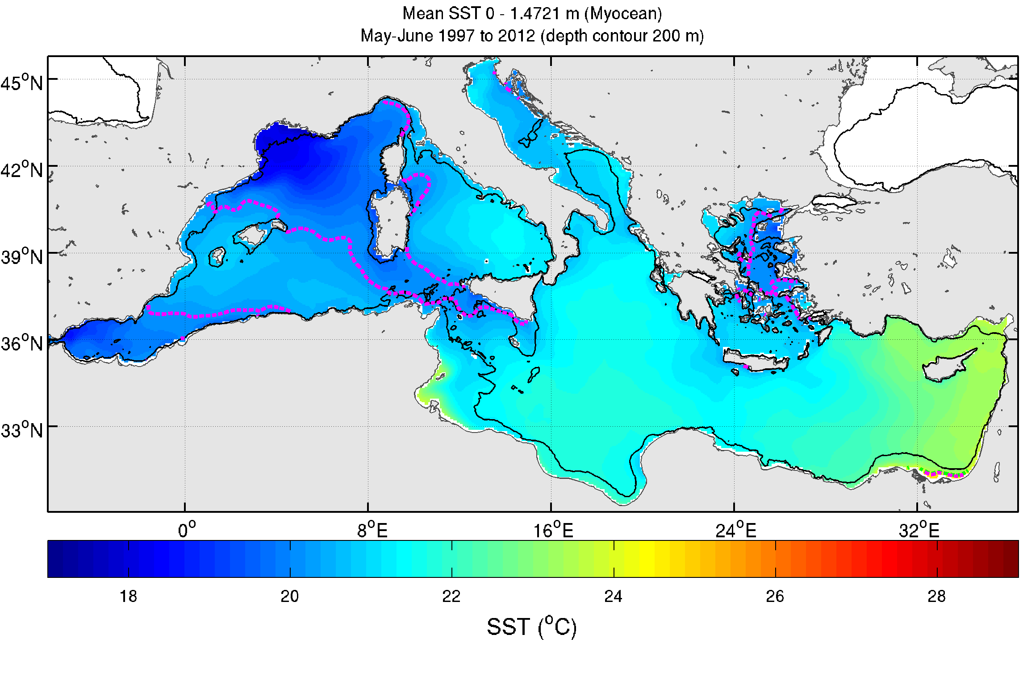
f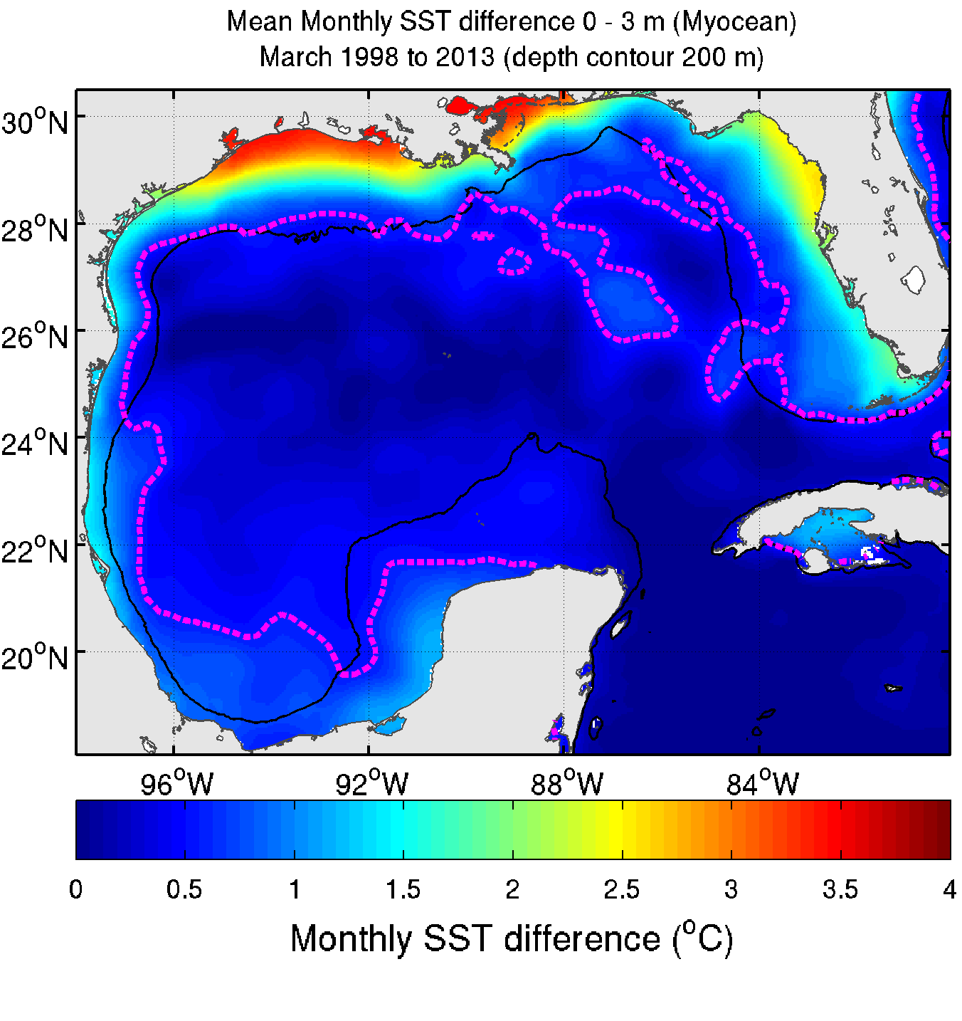g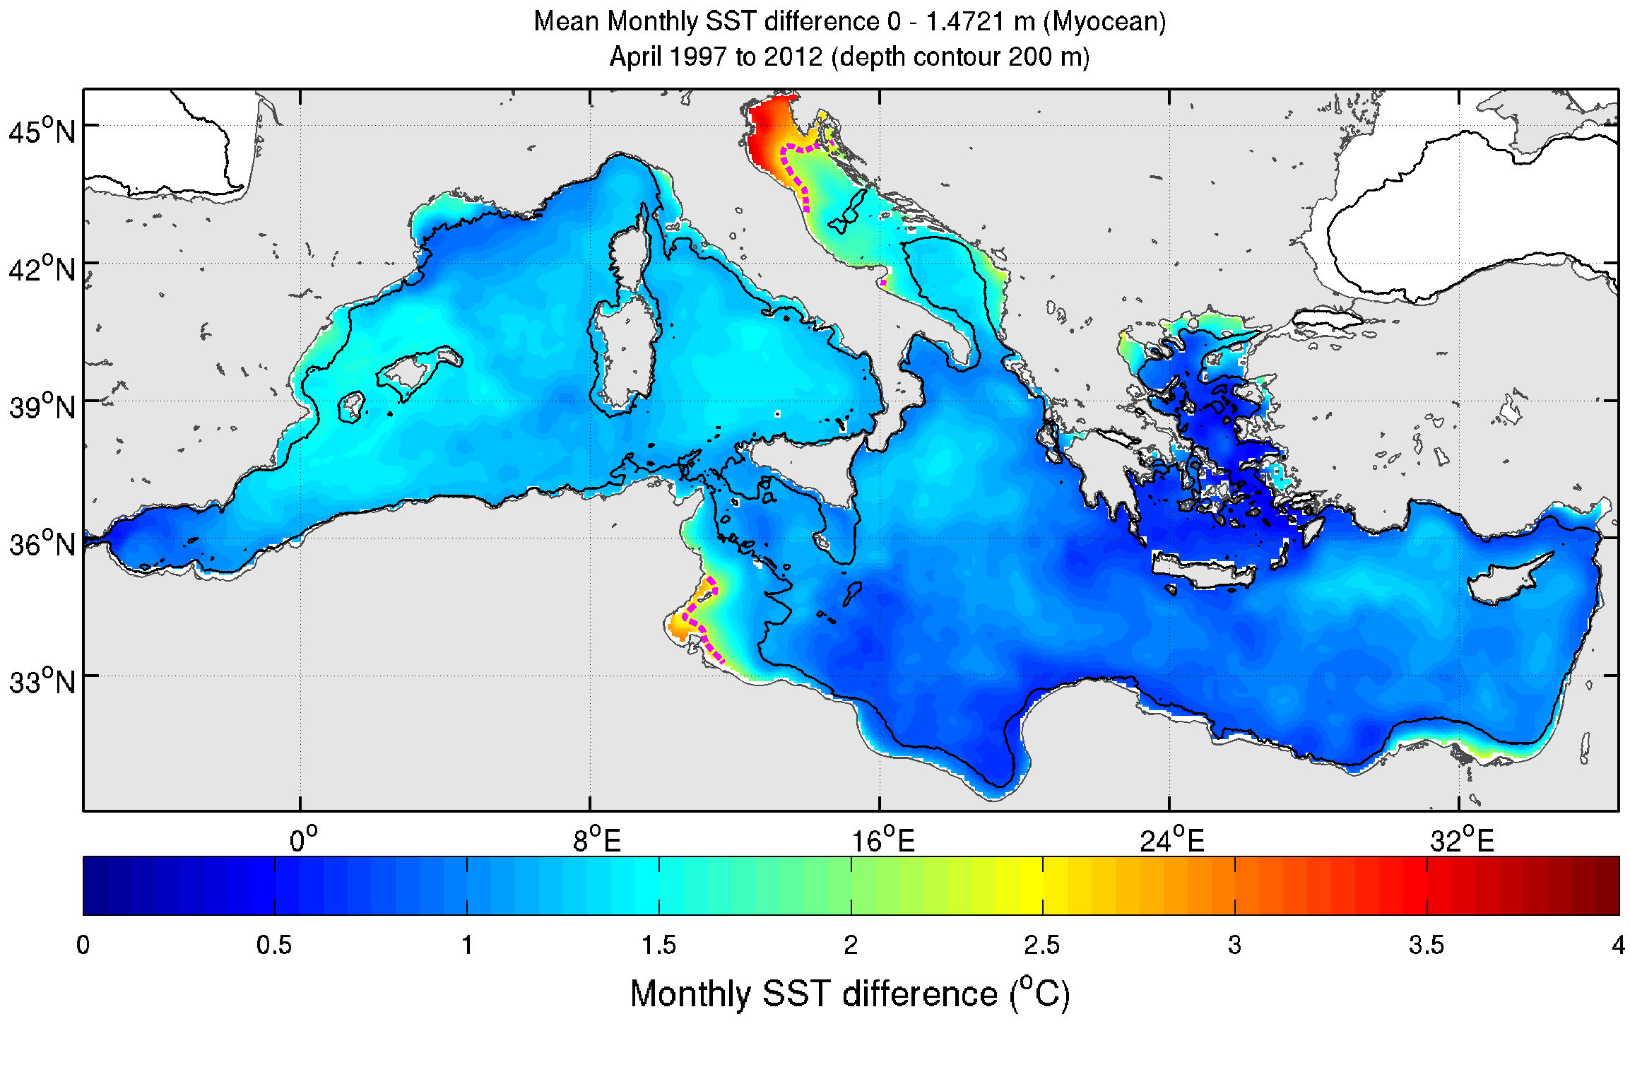
h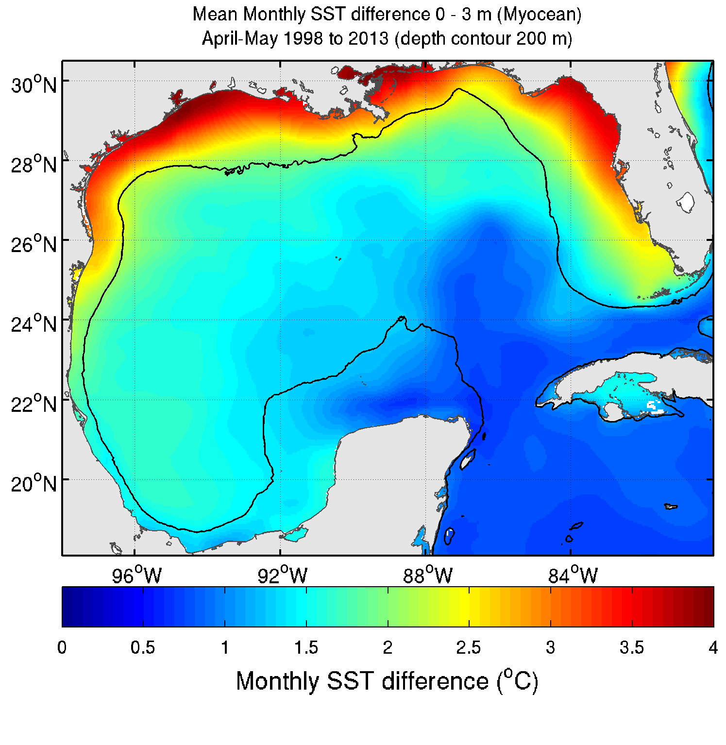i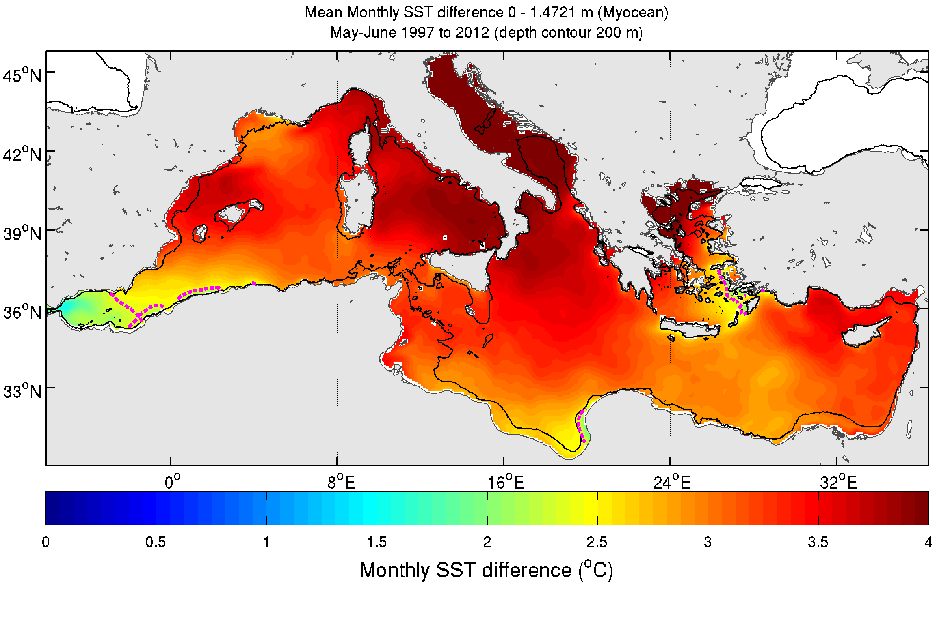
Figure SI- 2 Mean distribution of physical variables for relevant months of the spawning and feeding habitats (1997-2012 for the Mediterranean Sea and 1998-2013 for the Gulf of Mexico and North Atlantic): sea surface height anomaly in the North Atlantic (a- January-December) and Gulf of Mexico (b- January-May and c- June-October), sea surface temperature in d - Gulf of Mexico (April-May) and e- Mediterranean Sea (May-June) and monthly increase of SST in the Gulf of Mexico (f- March and h- April-May) and the Mediterranean Sea (g- April and i- May-June). The thick dash lines correspond to the contour of the selected model thresholds in magenta colour for the spawning habitat and green colour for the feeding habitat (see Table 3 for values), while the thin solid black line is the 200m-depth contour.

Cluster analysis method and results by area for small and large ABFTs
K-means clustering (MacQueen, 1967) based on Euclidean distance was used to estimate the similarity of data points between clusters and minimize the within-cluster sum of square errors. In k-means clustering, the number of clusters k was first chosen and the cluster centres are initialised randomly. Each data point was then assigned to the closest cluster based on a selected distance measure (similarity) and updated cluster centre. At each iteration step, the new cluster centres are computed as the mean vectors of the assigned data points. These two steps, data point assignment and cluster centre update, are repeated until the cluster centres do not change any more or until a sufficient number of iterations are performed. Matlab’s k-means function was used with 500 iterations/restarts and the Euclidian distance setting. The z-score-transformation (Berthold et al., 2010) was performed before clustering, where each data variable was normalised to zero mean and unit variance to guarantee that each selected variable has had equal influence on the minimization of the within-cluster sum of squares objective function (Berthold et al., 2010).

a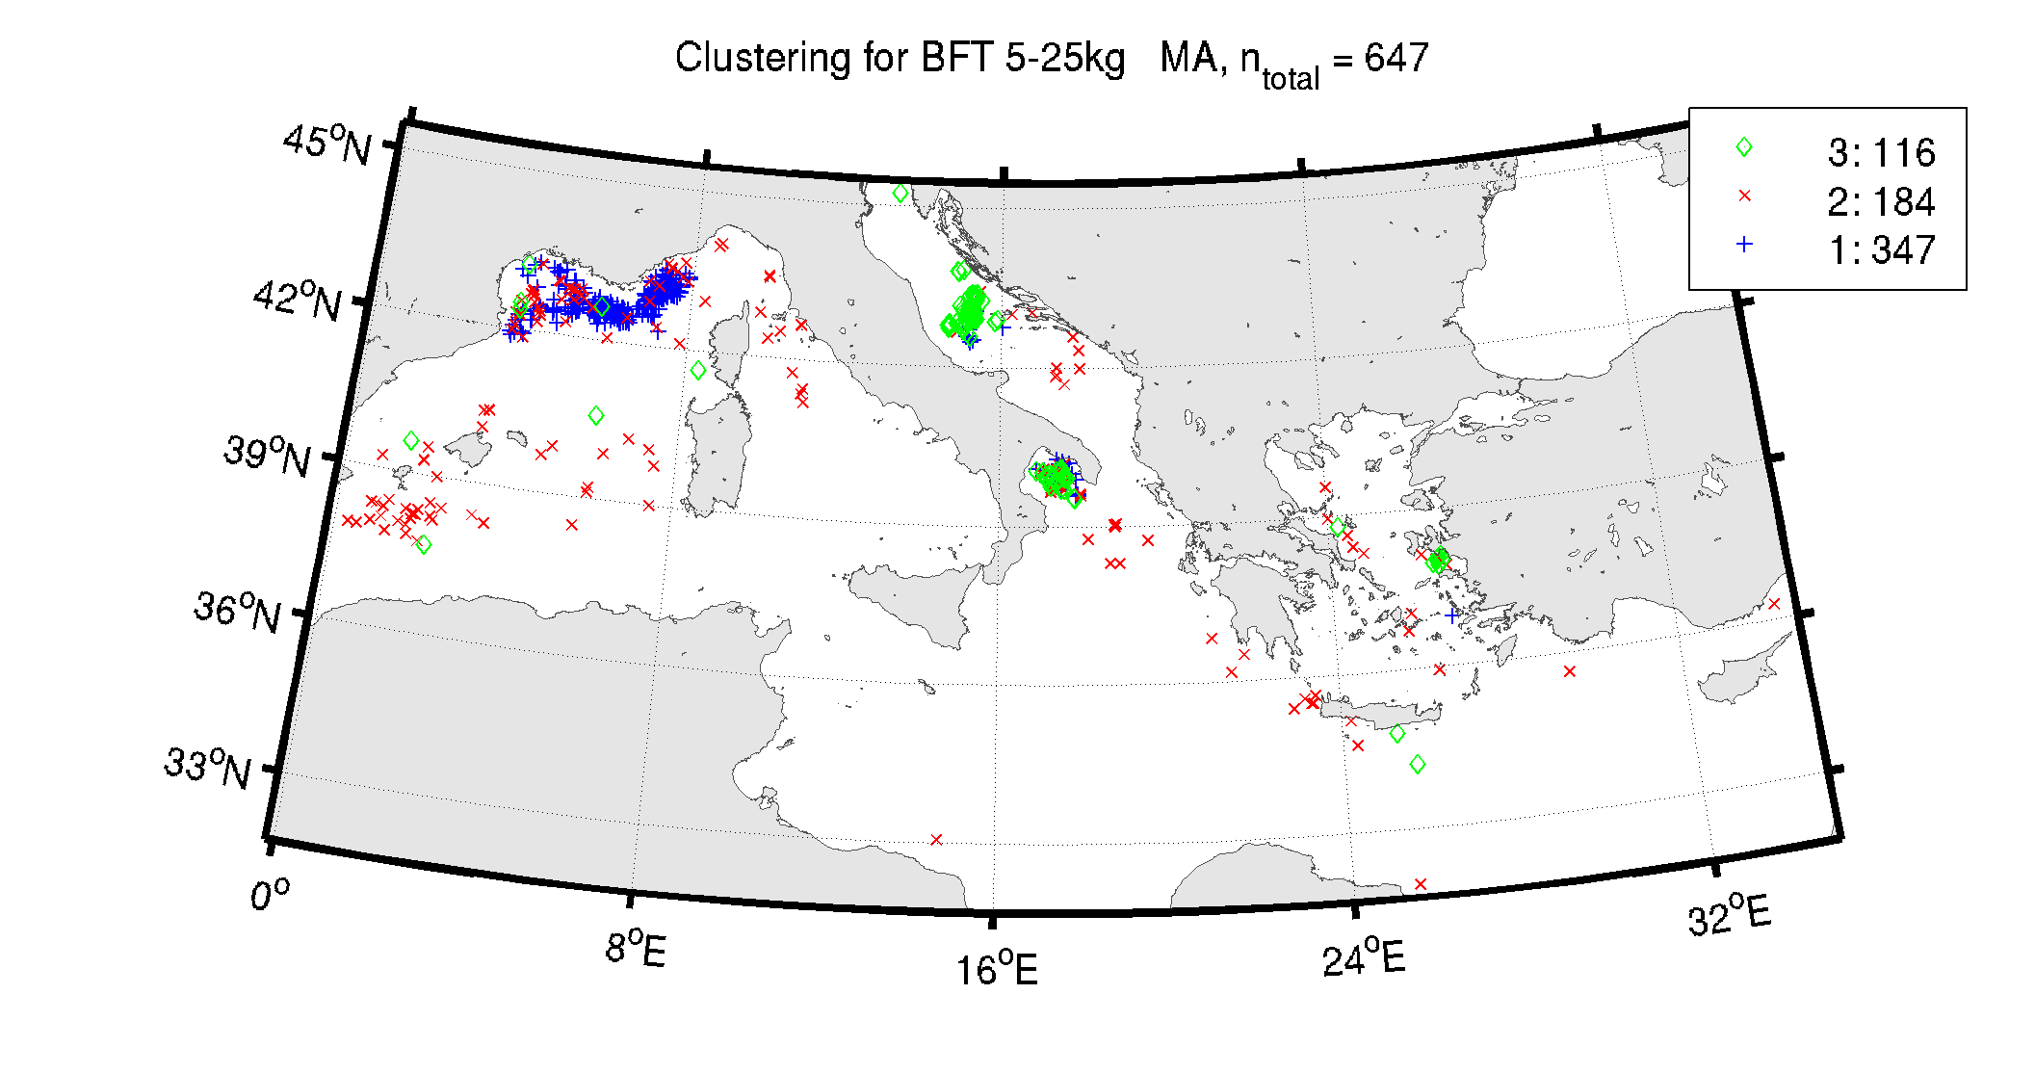
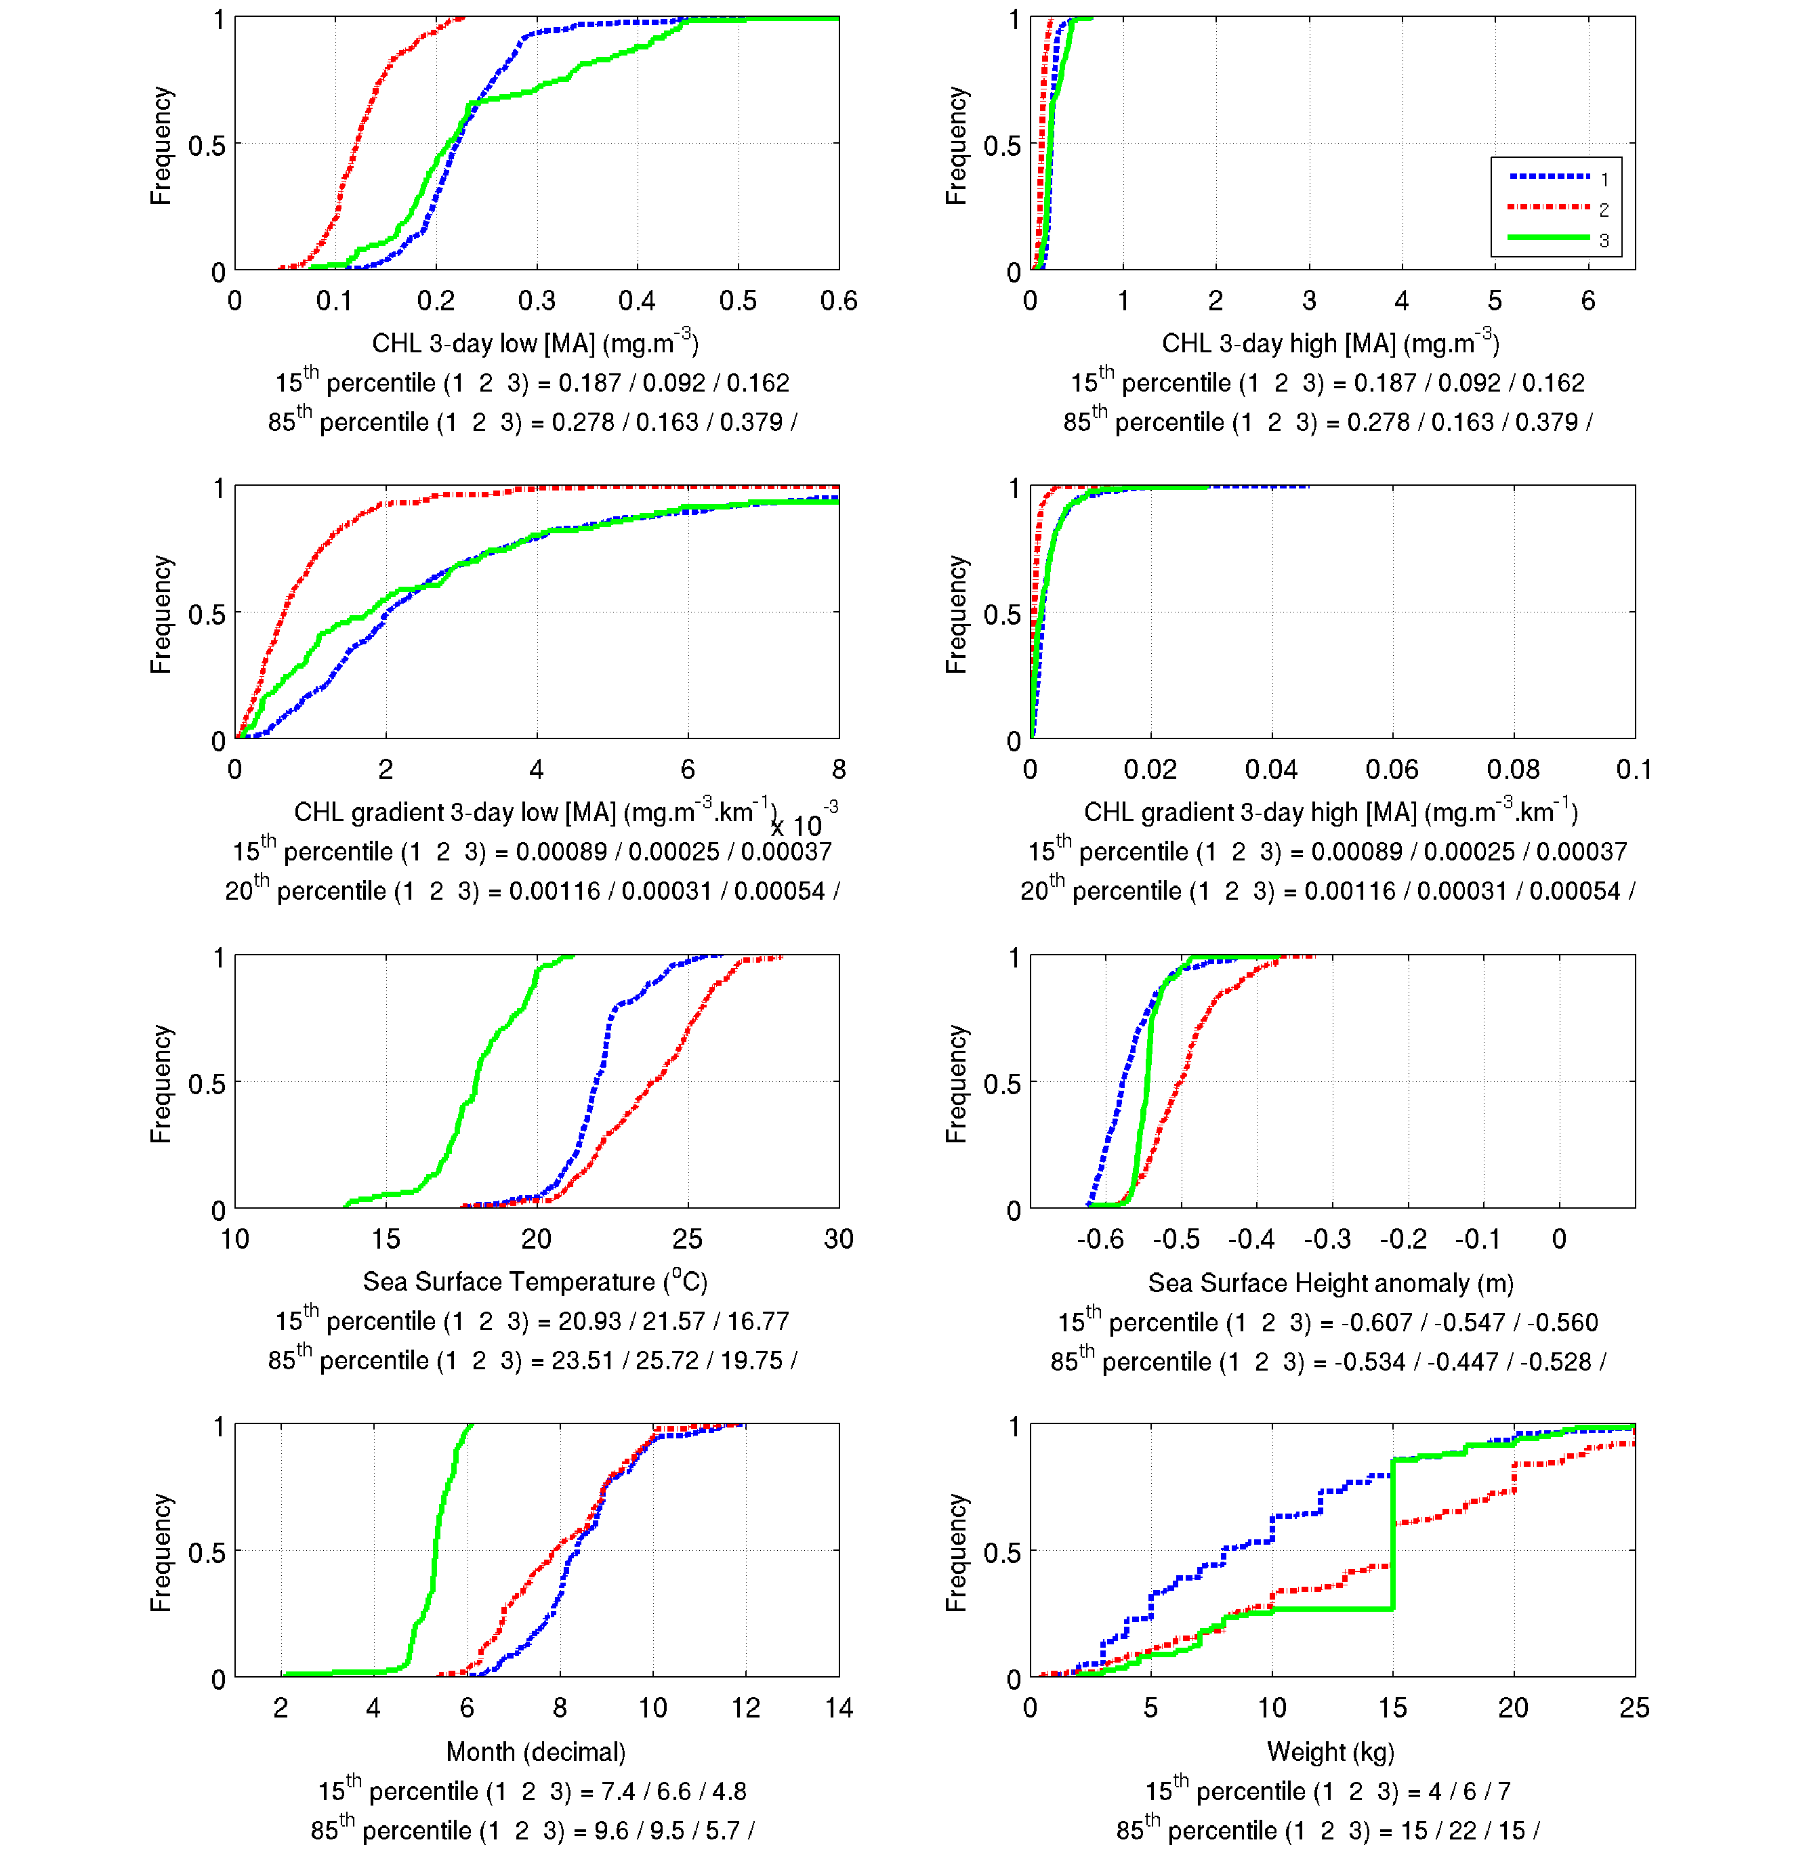
b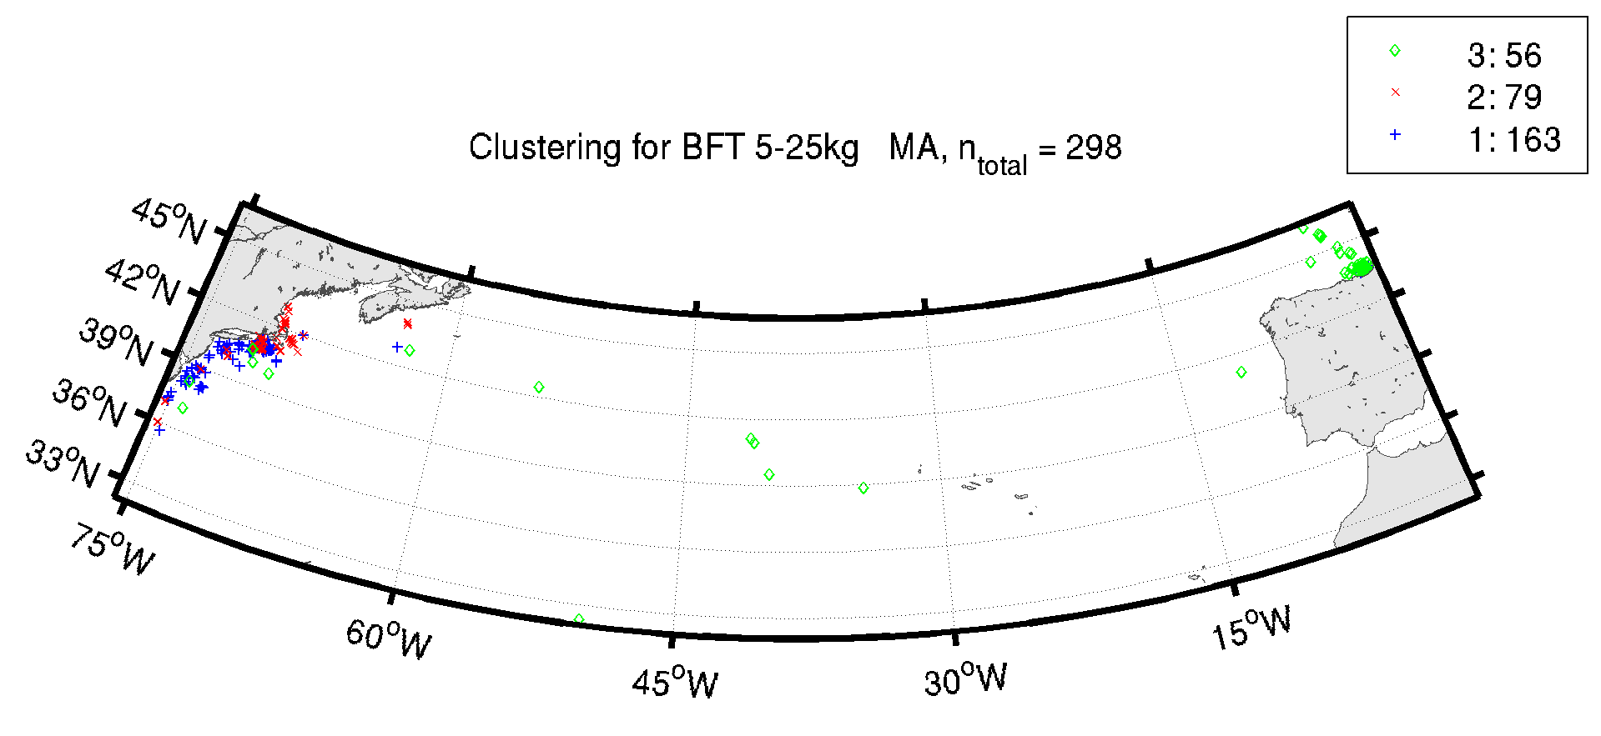
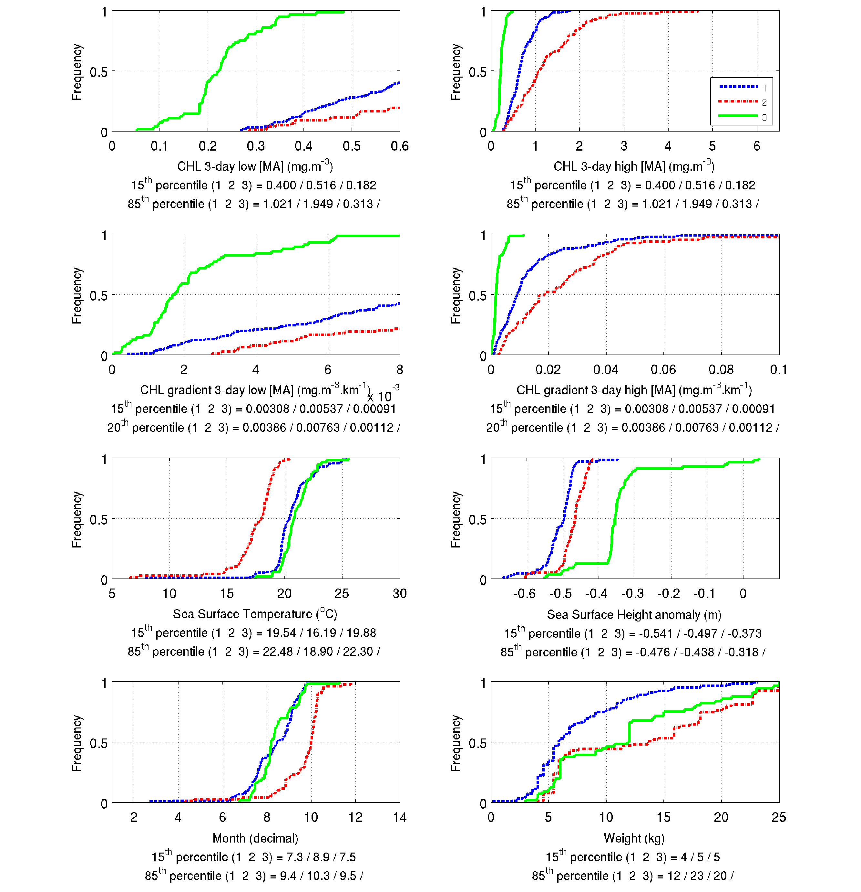
Figure SI- 3 Location and cumulative distribution of environmental conditions (CHL, gradCHL, SST, SSHa, month of observation, individual weight) for small ABFT observations as a result of the clustering analysis in a) the Mediterranean Sea and b) the North Atlantic. CHL and gradCHL were processed using the logarithm form and are shown with two plots of different scales. Cluster 1 has always the largest number of observations.

a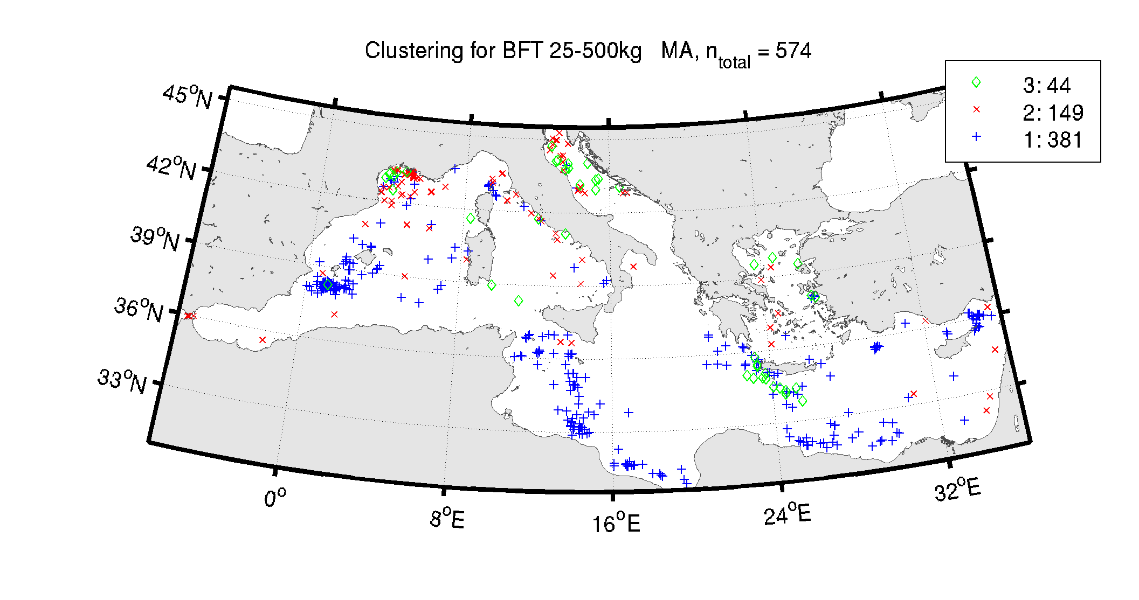
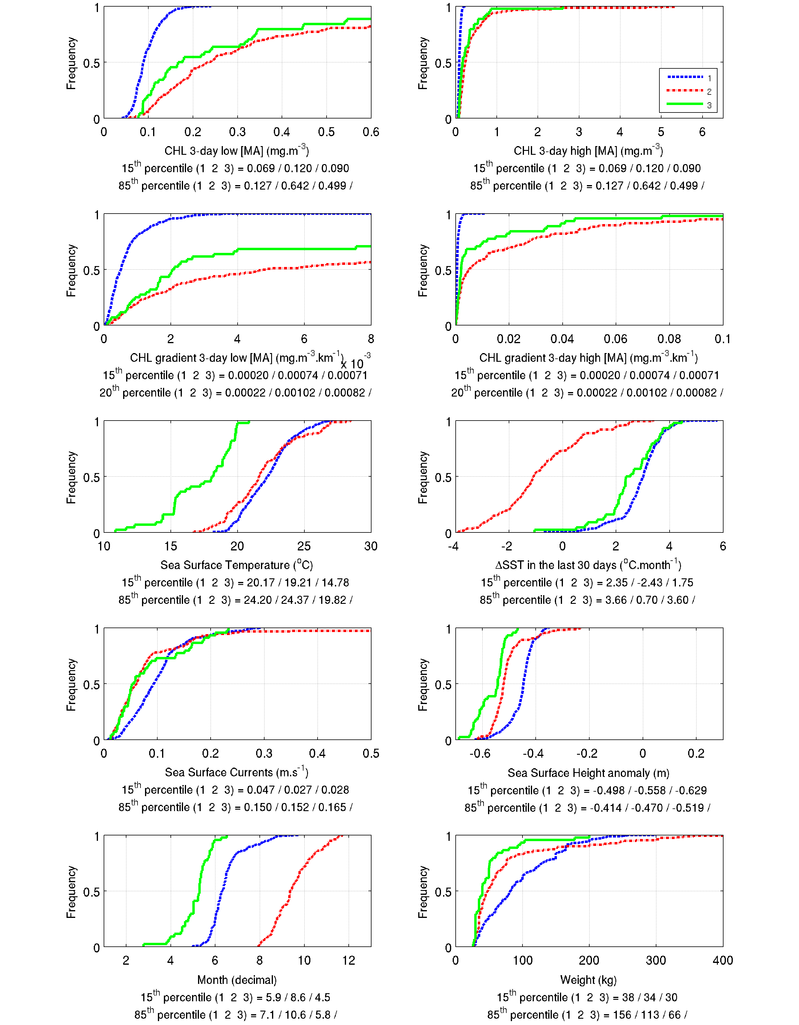
b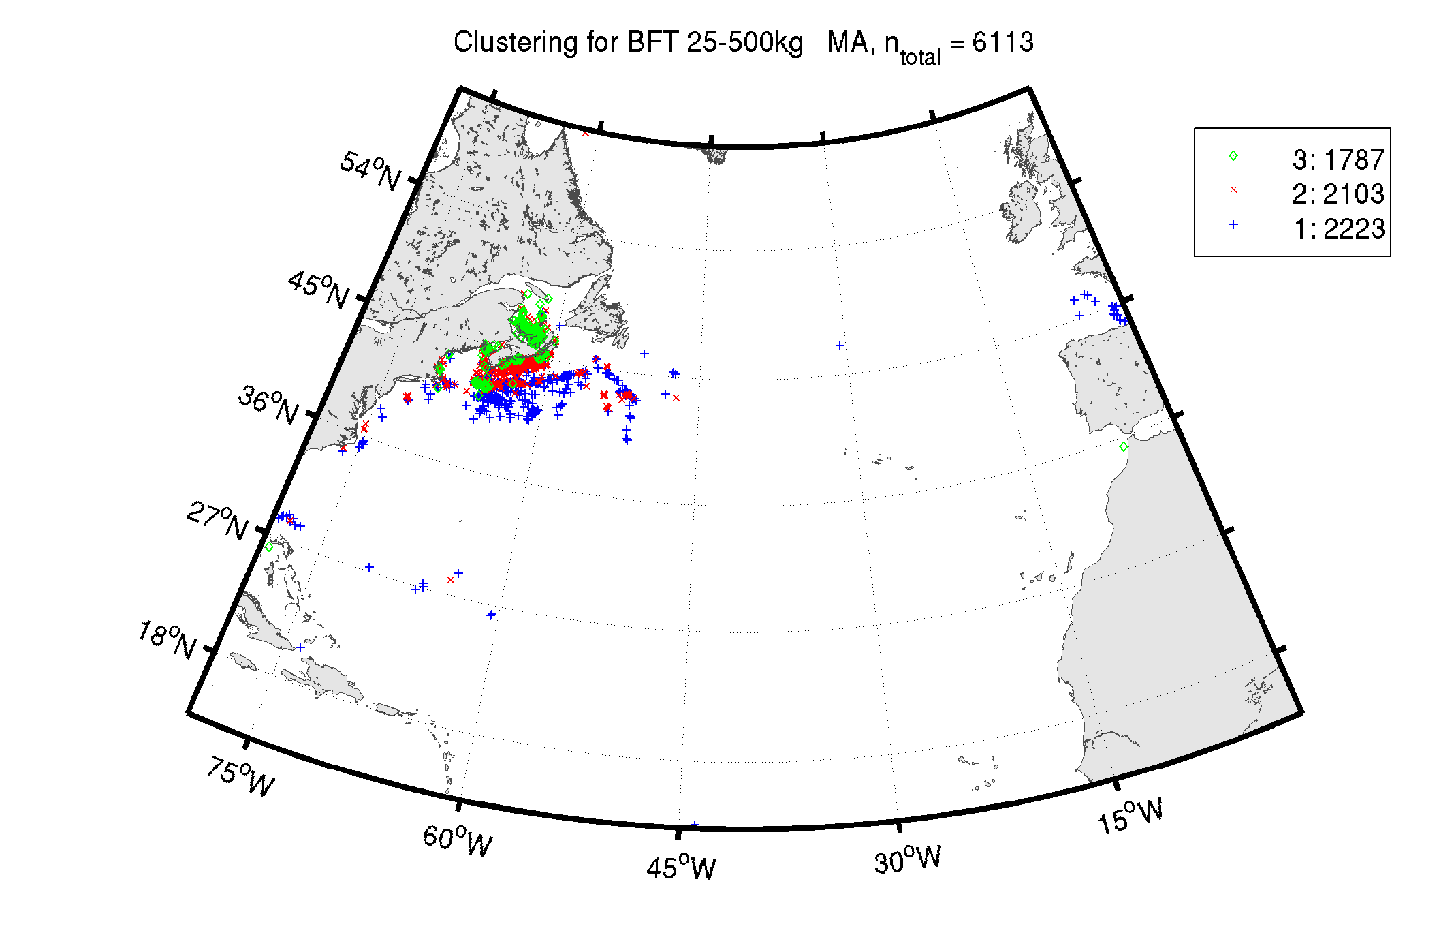
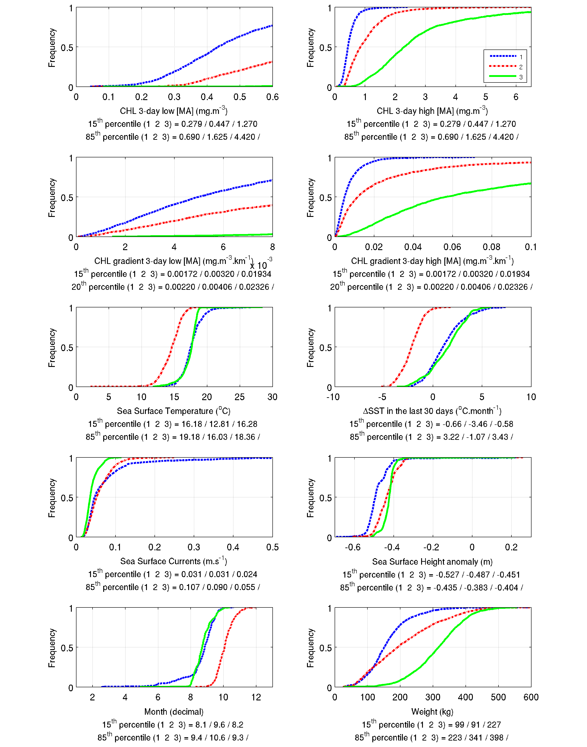
c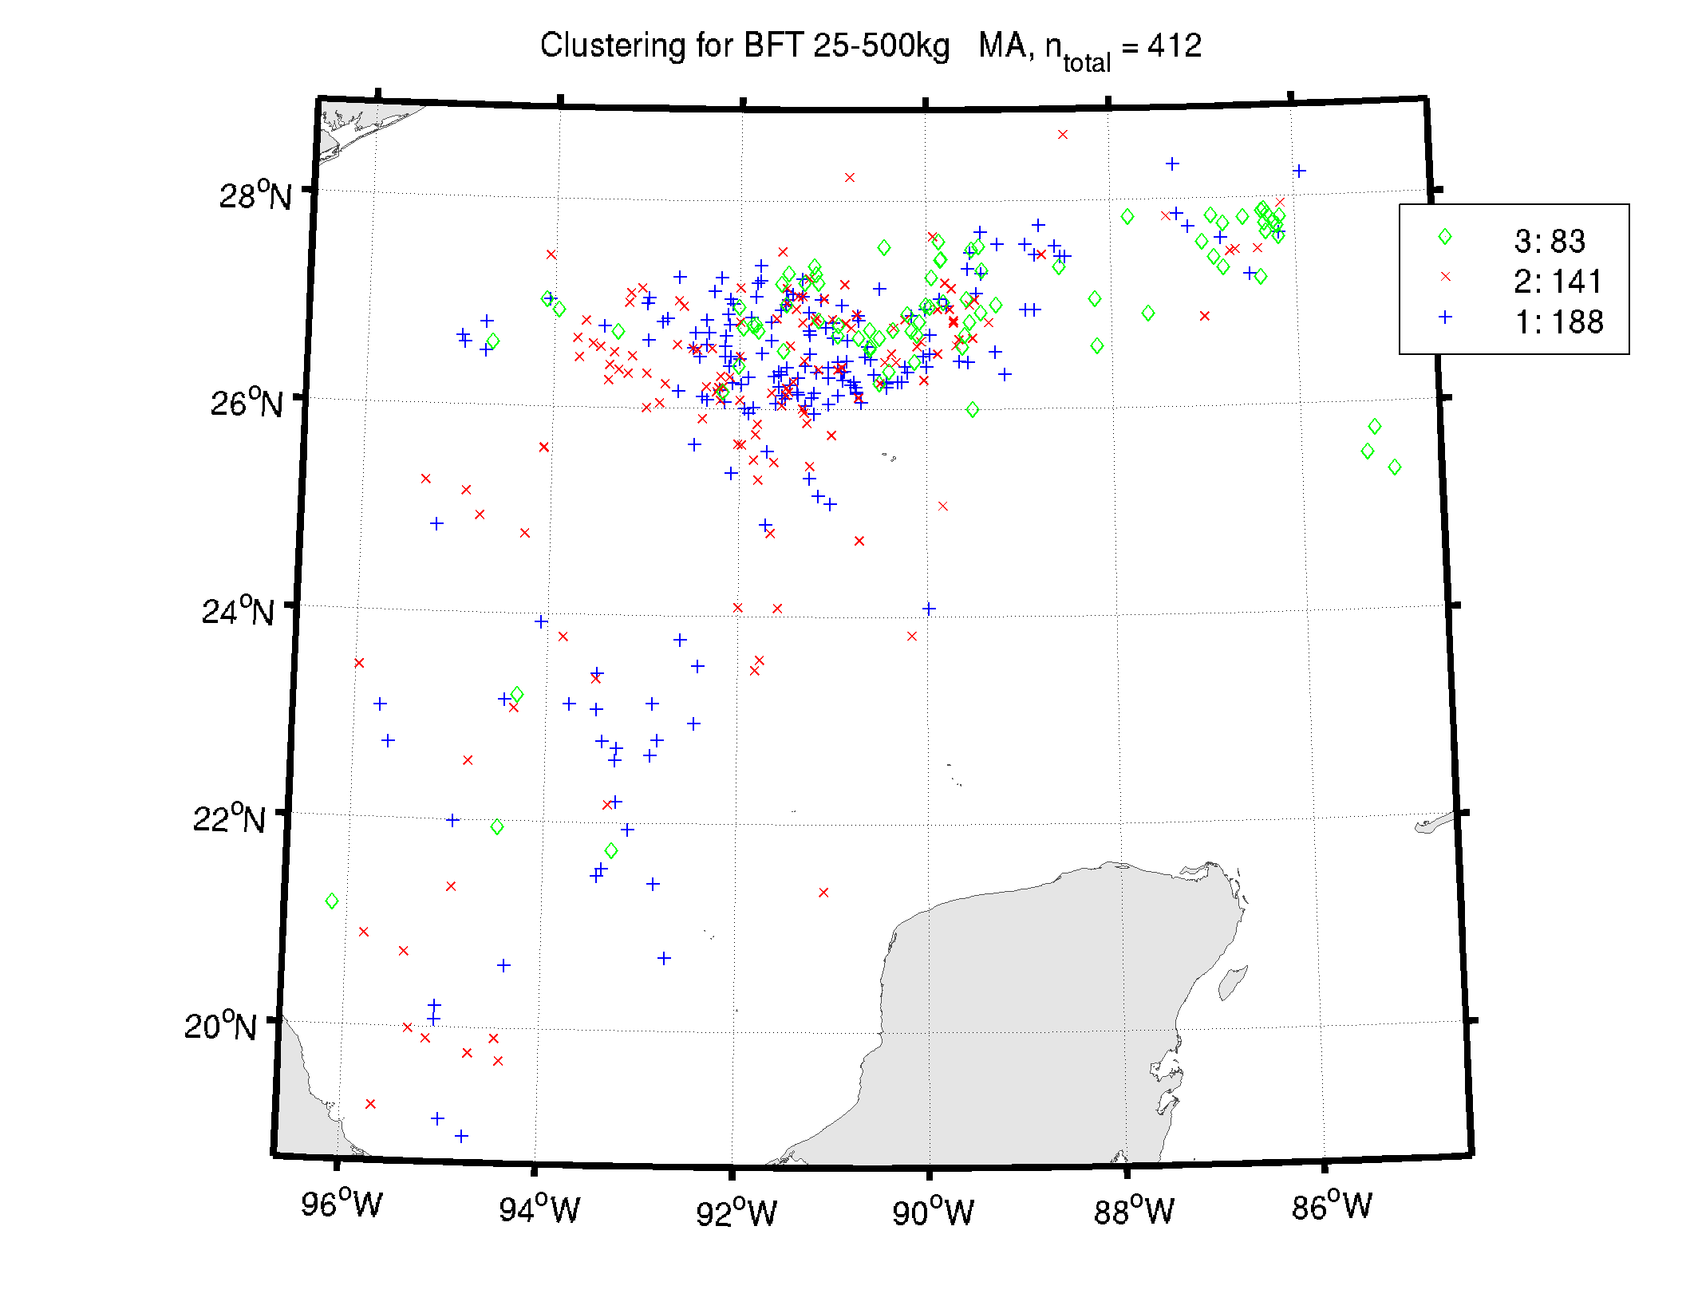
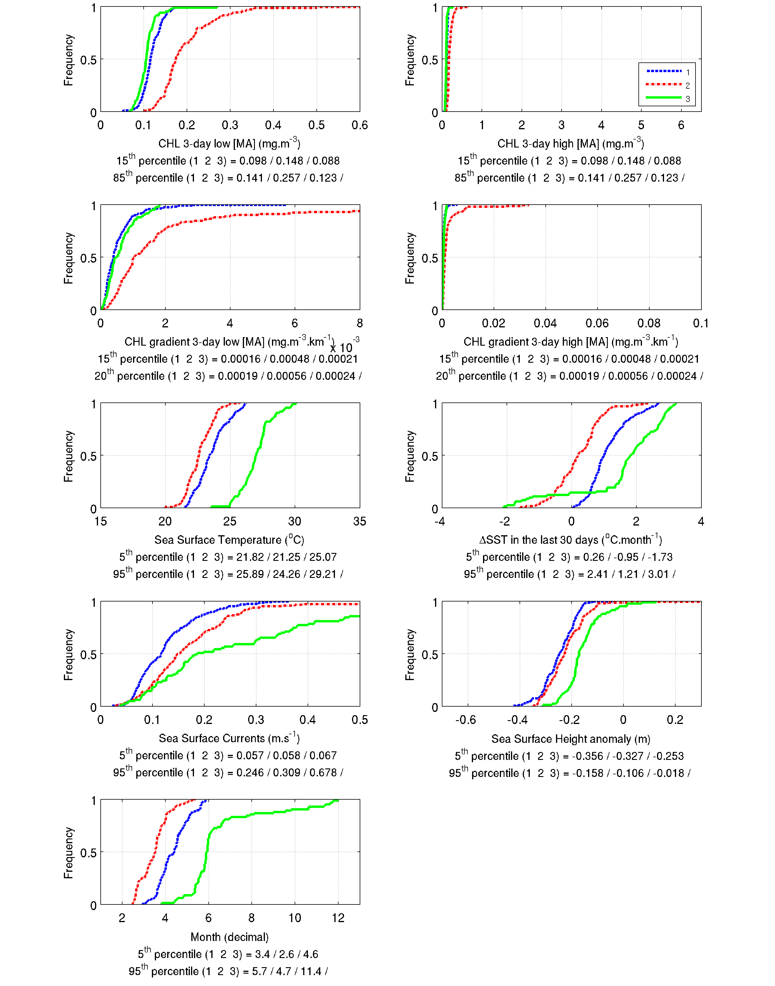
Figure SI- 4 Location and cumulative distribution of environmental conditions (CHL, gradCHL, SST, ΔSST_{30days}, SSCV, SSHa, month, individual weight) for large ABFT observations as a result of the clustering analysis in a) the Mediterranean Sea, b) the North Atlantic and c) the Gulf of Mexico. CHL and gradCHL were processed using the logarithm form and are shown with two plots of different scales. Cluster 1 has always the largest number of observations.

Levels of productive habitat and model equations
Three levels of potential feeding habitats were introduced to account for the diversity of environments in which ABFT feed. We link here the size of CHL front with the potential presence of preys stating that intermediate trophic levels require stable primary productivity. The highly productive habitat was represented by the larger frontal systems which, by their size and persistence, contain productive water masses with potentially well-developed food webs and high number of preys (e.g. in the North Atlantic). The moderately productive habitat refers to smaller – less productive – frontal systems which may still represent regional forage hot spots, e.g. summer feeding of small ABFT in parts of the Mediterranean Sea or winter feeding of large fish in parts of the Gulf of Mexico. We defined three threshold values for CHL and two for gradCHL that delimit the highly and moderately productive from the unfavourable feeding habitat (Figure SI- 5). The daily values of the highly and moderately productive feeding habitat were set to 1 and 0.3 respectively. The value of 0.3 was chosen as an ad-hoc value for the moderately productive habitat as it represented a substantially less favourable feeding habitat (about 3-fold) than the highly productive conditions (of value 1) and was markedly above 0. The value of the productive habitat was then weighted by the abiotic limitations. A similar approach was recently followed to model hake nurseries in the Mediterranean Sea (Druon et al., 2014).
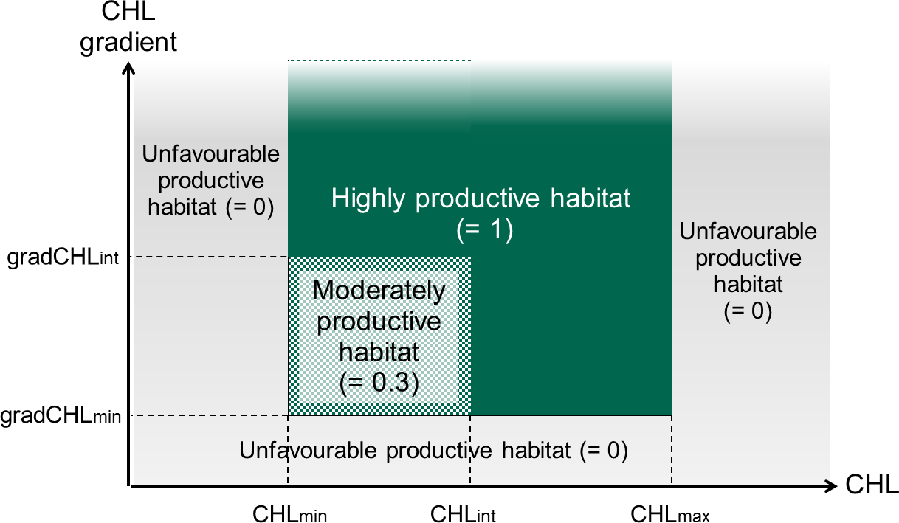
Figure SI- 5 Definition of the three productive habitats (unfavourable, moderate and high of value 0, 0.3 and 1 respectively in the model) based on levels of surface chlorophyll content (CHL) and horizontal chlorophyll gradient (gradCHL), thus referring to small and large productive fronts.
The productive habitat, as well as the feeding and spawning habitats, are thus defined by the model grid cells that daily satisfy the suitable environmental conditions as follows (for instance the daily feeding habitat of a cell is set to 1 if CHL_{int}<CHL<CHL_{max}, gradCHL>gradCHL_{int}, SST_{min}<SST<SST_{max} and SSHa<SSHa_{max}):
$${Productive Habitat}_{0/0.3/1}={{CHL}_{min/int/max}}_{0/0.3/1}*{{gradCHL}_{min/int}}_{0/1}$$
$${ABFT Feeding Habitat}_{Day,Cell}={Productive Habitat}_{0/0.3/1}*{SST_{range}}_{0/1}*{SS{Ha}_{max}}_{0/1}$$
${ABFT Spawning Habitat}_{Day,Cell}={{CHL}_{range}}_{0/1}*{{ΔSST_30days}_{min}}_{0/1}*{{SST}_{min}}_{0/1}*{SSC_{range}}_{0/1}$ $*{SS{Ha}_{range}}_{0/1}$

Each habitat type was attributed a daily value of 0 or 1 for spawning and 0 or 0.3 or 1 for feeding and the integration in time resulted in a habitat expressed in frequency of occurrence (sum of daily habitat values over the number of days for which the habitat was effectively estimated).

Model evaluation
The third quartile (75th) distance of presence data to the closest habitat was chosen to provide information on model performance as migration between the feeding and spawning grounds is not simulated (see the correspondence of the monthly highest values with known migration in each area in Figure SI- 6). The 50th and 90th percentile values and number of presence data are shown by size class (Table SI- 1) and by month and area (Figure SI- 6) for a better description of the model evaluation. The distances in the last row of Table SI- 1 include the independent presence data which was without fish weight as compared to the broadest potential habitat of large ABFT. The distance of presence data to favourable habitat is to be related with the habitat size as described in section 8.6 (e.g. 90% of large ABFT are closer than 3 km of potential feeding habitat in the North Atlantic, the latter representing from 1 to 6% of the ocean surface; or 75% of large ABFT are closer than 23 km of potential spawning habitat in the Gulf of Mexico, the latter representing 2 ±1.5% of the ocean surface from March to May).
Table SI- 1. 75th percentile distance between presence data (small and large fish and all data) and closest 3-day favourable habitat (km) by area and behaviour. The median distance is shown between parenthesis for high values while the 90th percentile value is shown for low values.
Distance to 3-day preferred habitat (km) |  | Gulf of Mexico |  | North Atlantic |  | Mediterranean
 |  | n | 75th distance  (50th distance) | n | 75th distance  (90th distance) | n | 75th distance  (50th distance)
Small ABFT  5-25kg | Feeding |  |  | 313 | 0 (61) | 639 | 1
Large ABFT  >25kg | Feeding | 353 | 16 (0) | 5608 | 0 (3) | 309 | 133 (0)
 | Spawning | 273 | 23 (1) |  |  | 309 | 6
All ABFT  (including data  without weight) | Feeding | 353 | 16 (0) | 7923 | 0 (3) | 2278 | 4
 | Spawning | 273 | 23 (1) |  |  | 485 | 1

a) Gulf of Mexico 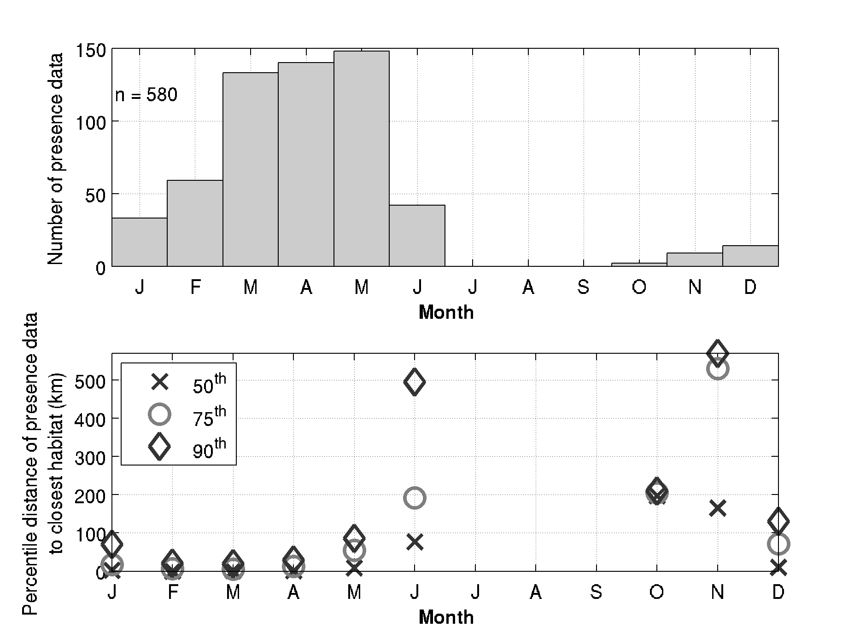
b) North Atlantic 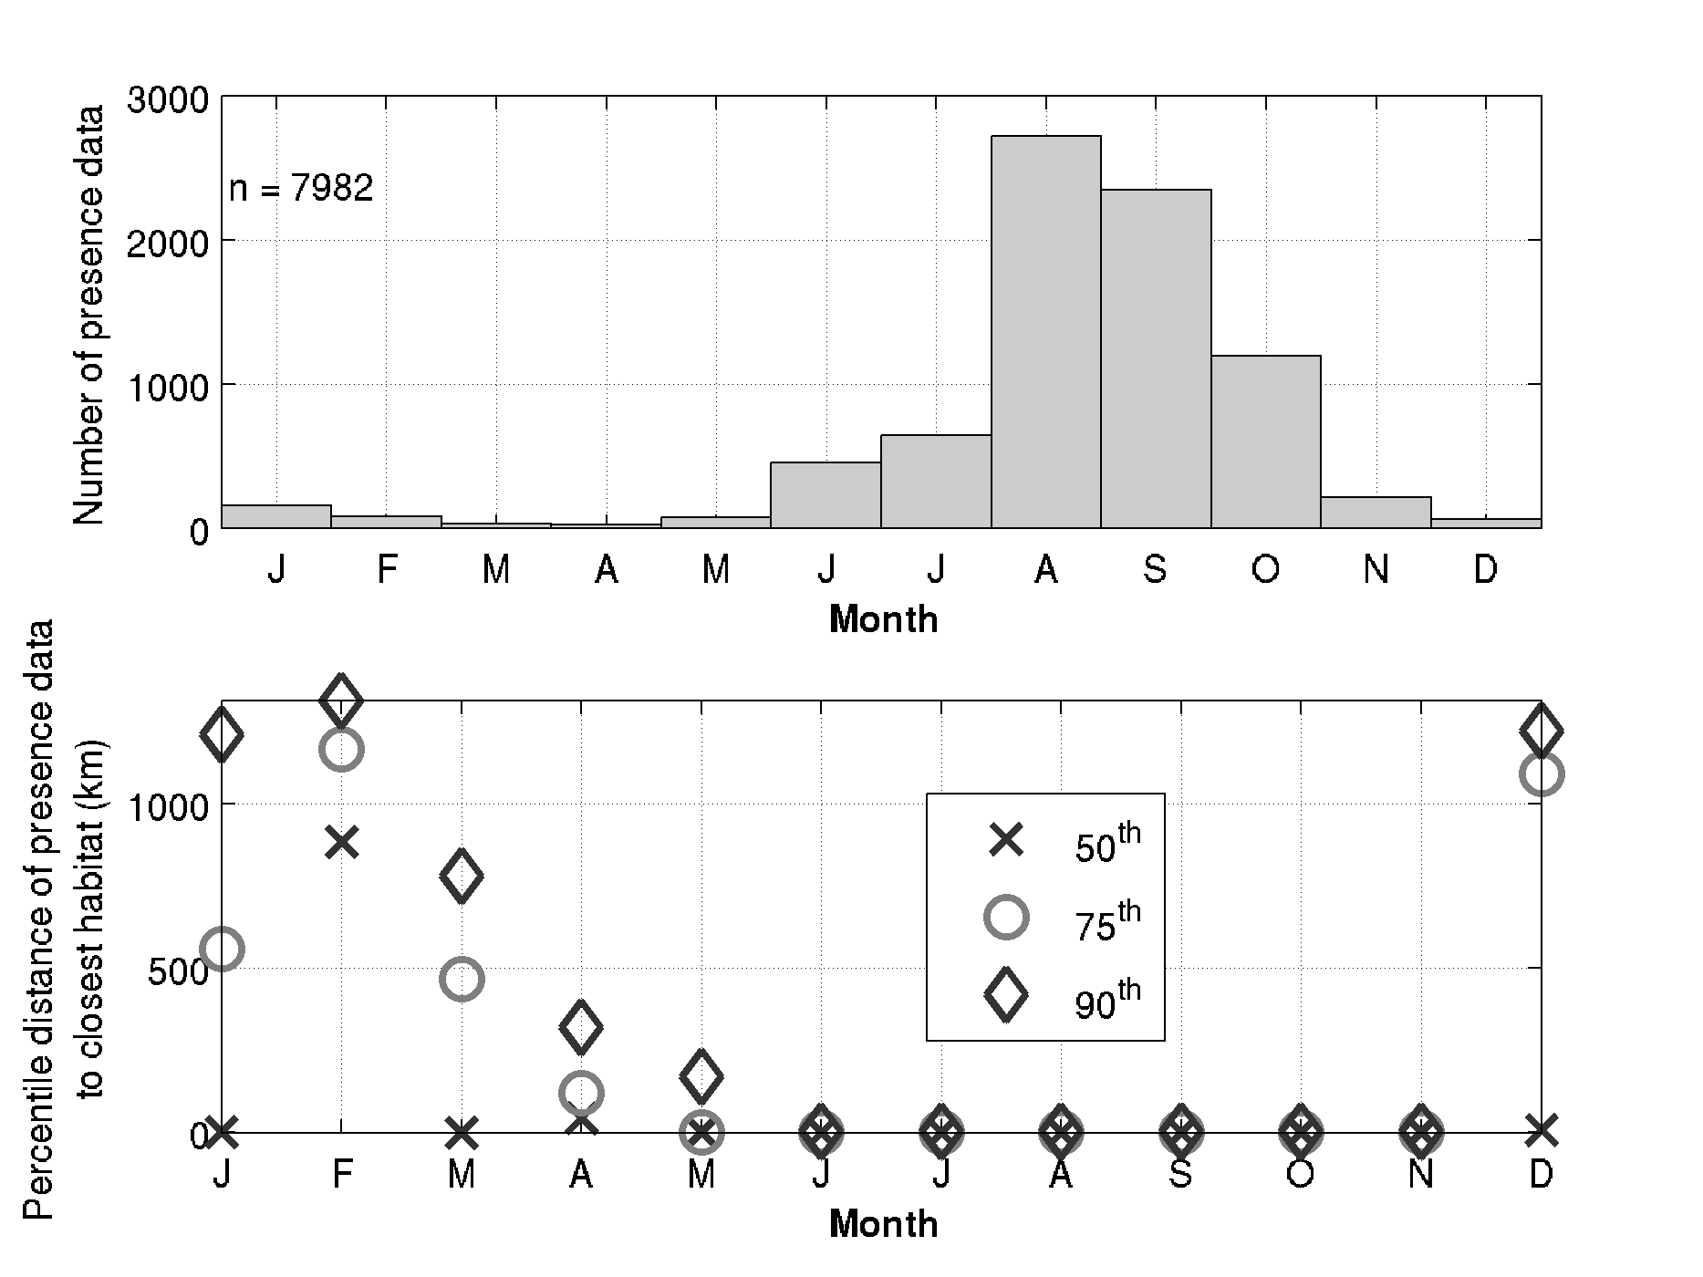
c) Mediterranean Sea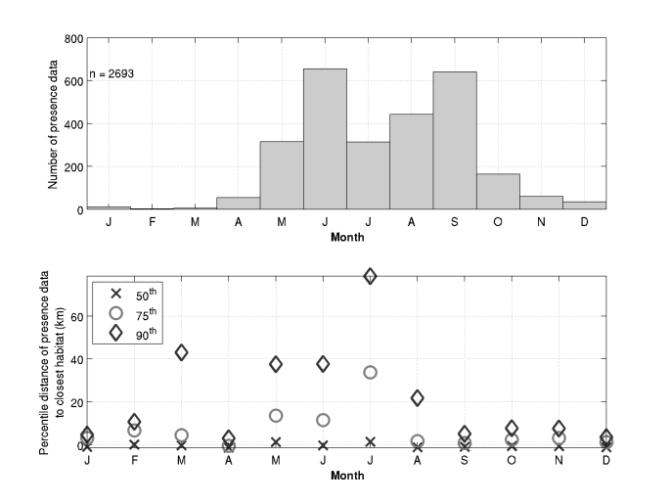
Figure SI- 6 Monthly distribution (from mid-2002 to 2012) of all ABFT presence data and corresponding 50th, 75th and 90th percentile distances to closest habitat boundary (km) for a) the Gulf of Mexico, b) the North Atlantic and c) the Mediterranean Sea.

Monthly variability of habitat size
The relative size of potential feeding and spawning habitats of large ABFT (Figure SI- 7) show similar patterns in the two main spawning grounds (Gulf of Mexico and Mediterranean Sea) with high levels in winter and low levels in summer for feeding and, in between, a limited period favourable for spawning in spring. The potential feeding habitat in the North Atlantic is instead at maximum levels from spring to mid-autumn in agreement with the observed dynamics of ABFT migration from the Canadian waters to the Gulf of Mexico (e.g. Galuardi et al., 2010; Wilson et al., 2015). In particular, the entry and exit time of ABFT in the Gulf of Mexico estimated by Wilson et al. (2015) correspond to the large extent of the potential feeding and spawning habitats (Figure SI- 7 a and b) with mean dates of 14 January ± 42 days and 22 May ± 18 days respectively (mean residency of 123 ± 49 days). The entry and exit dates in the Gulf of Saint Lawrence (28 June ± 11 days and 14 October ± 13 days) also correspond to the maximum extent of habitat in the North Atlantic during the warmest months, i.e northwards (Figure SI- 7 c). The inter-annual variability of size of potential habitats can reach up to ± 50% with the highest differences in the last three years from 2010 to 2012.

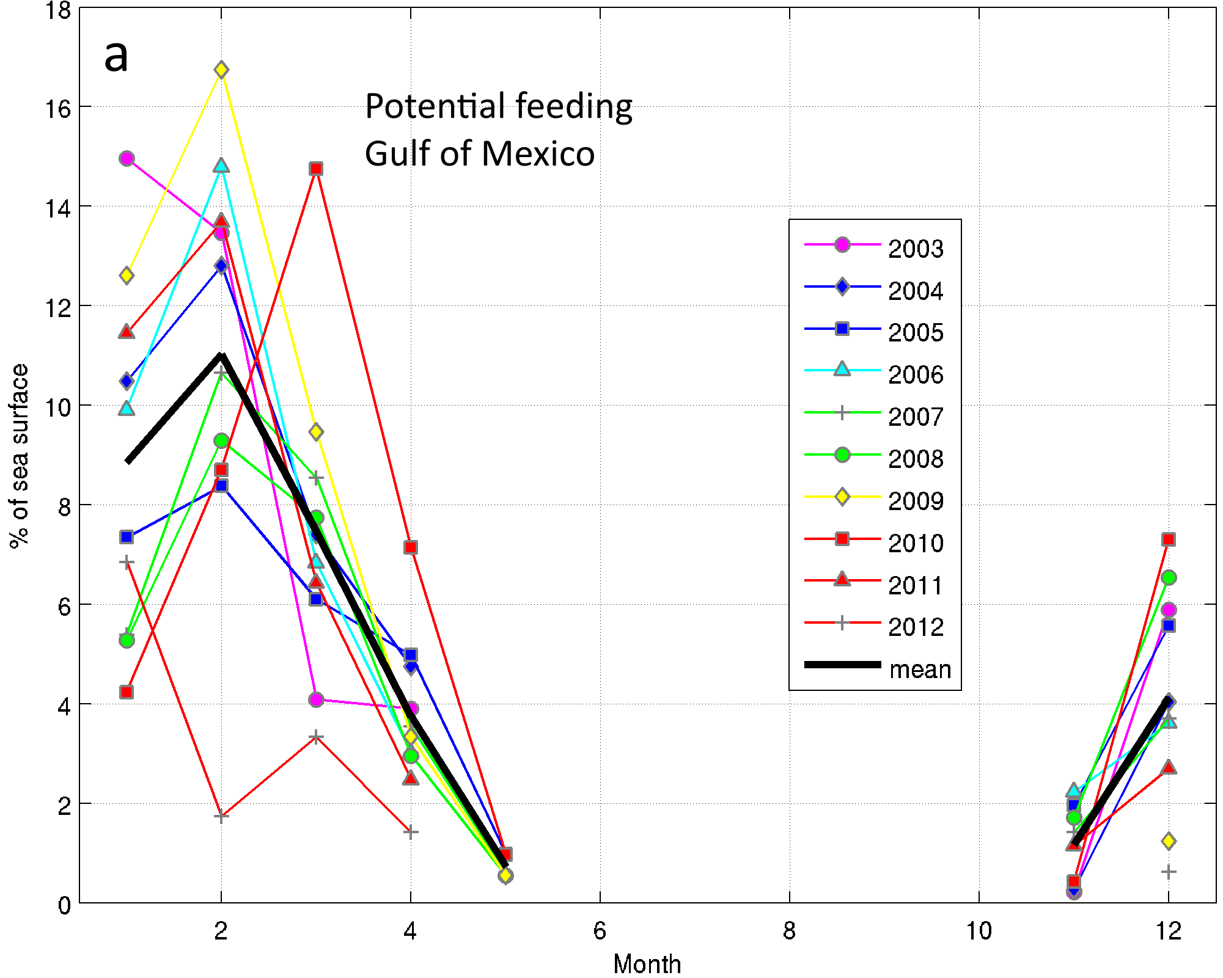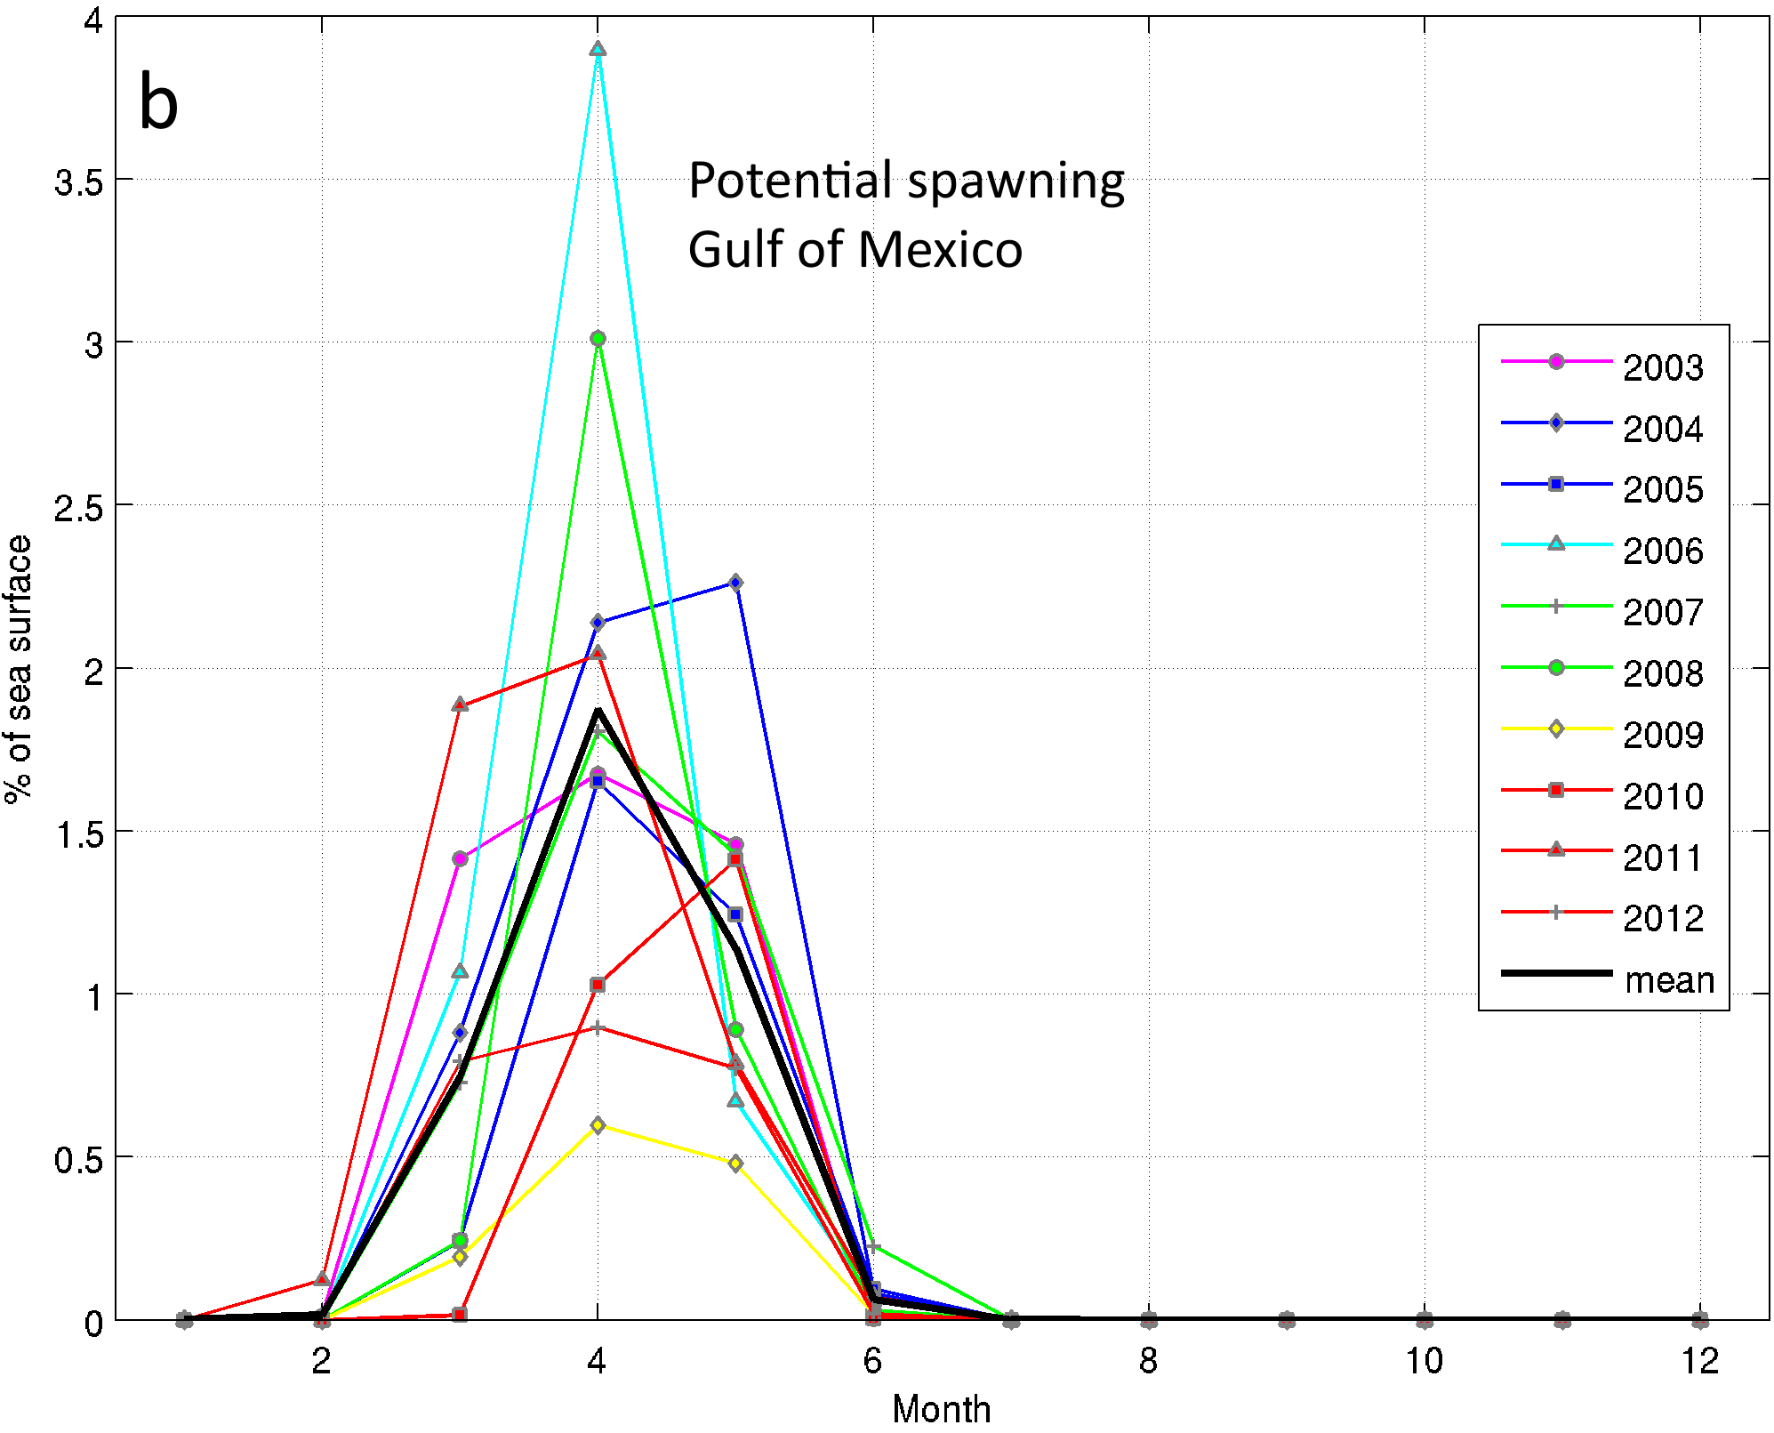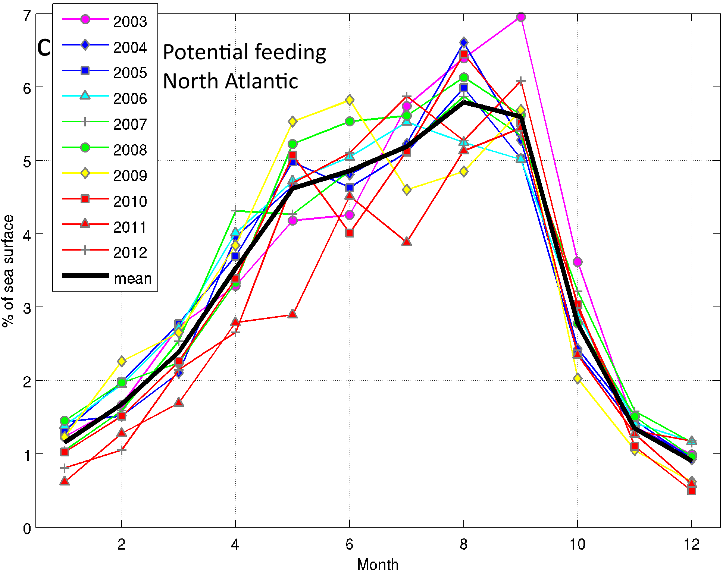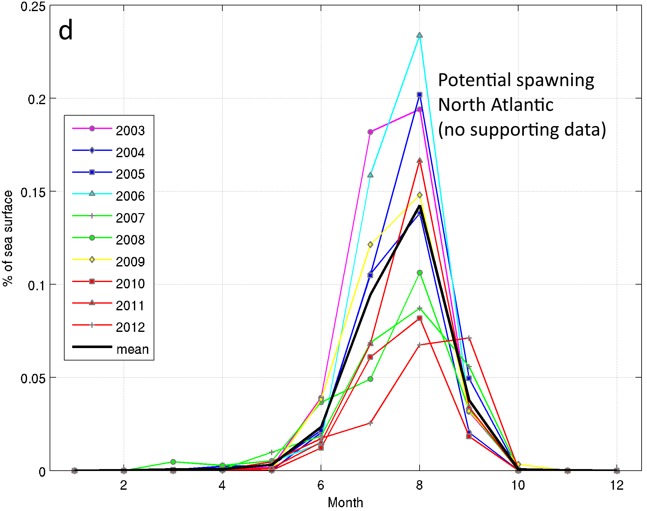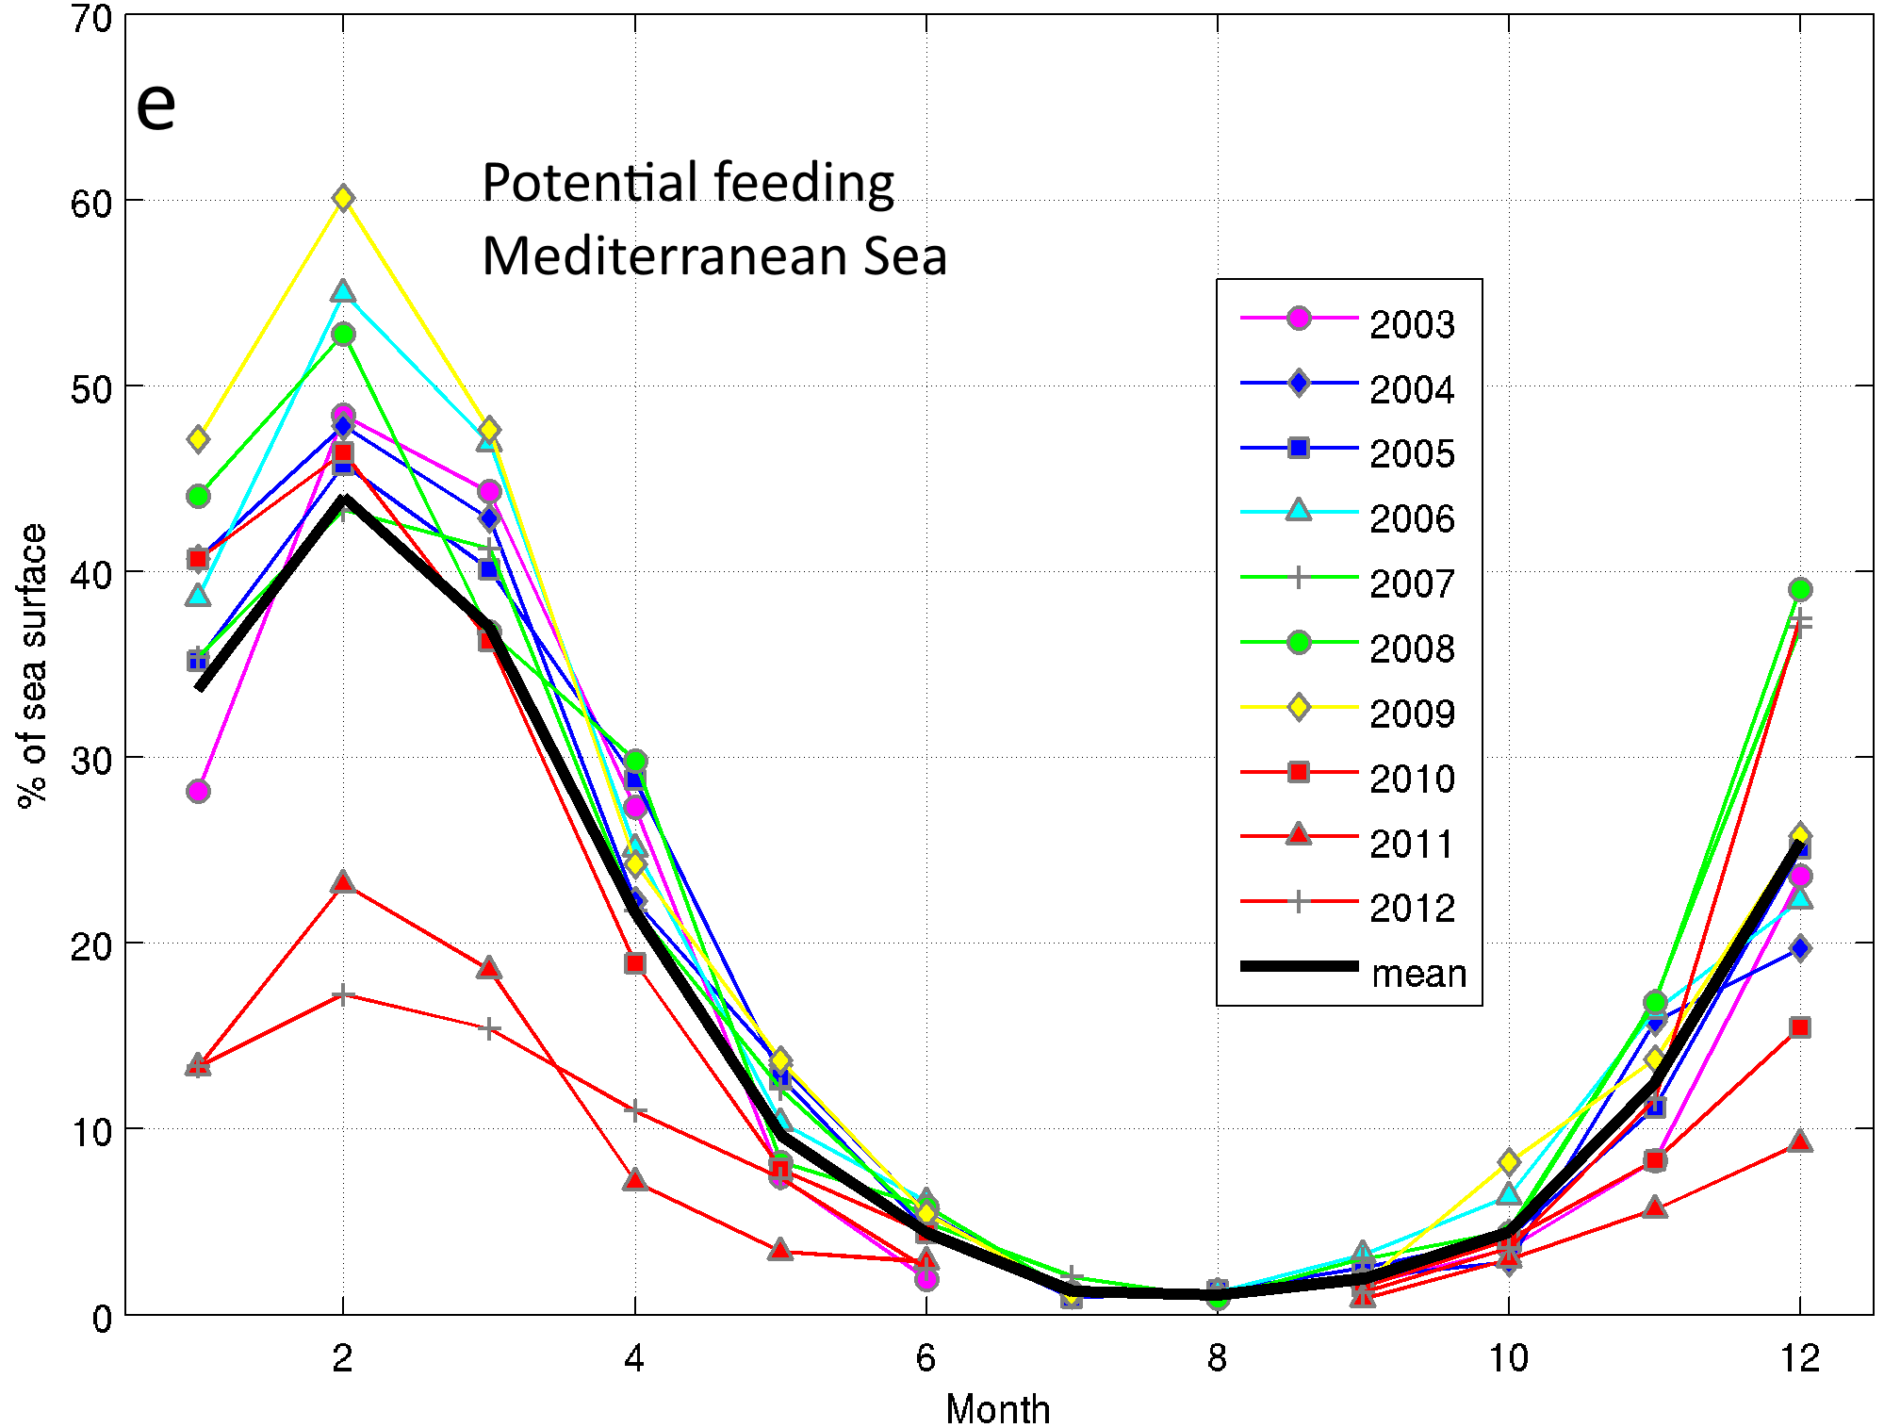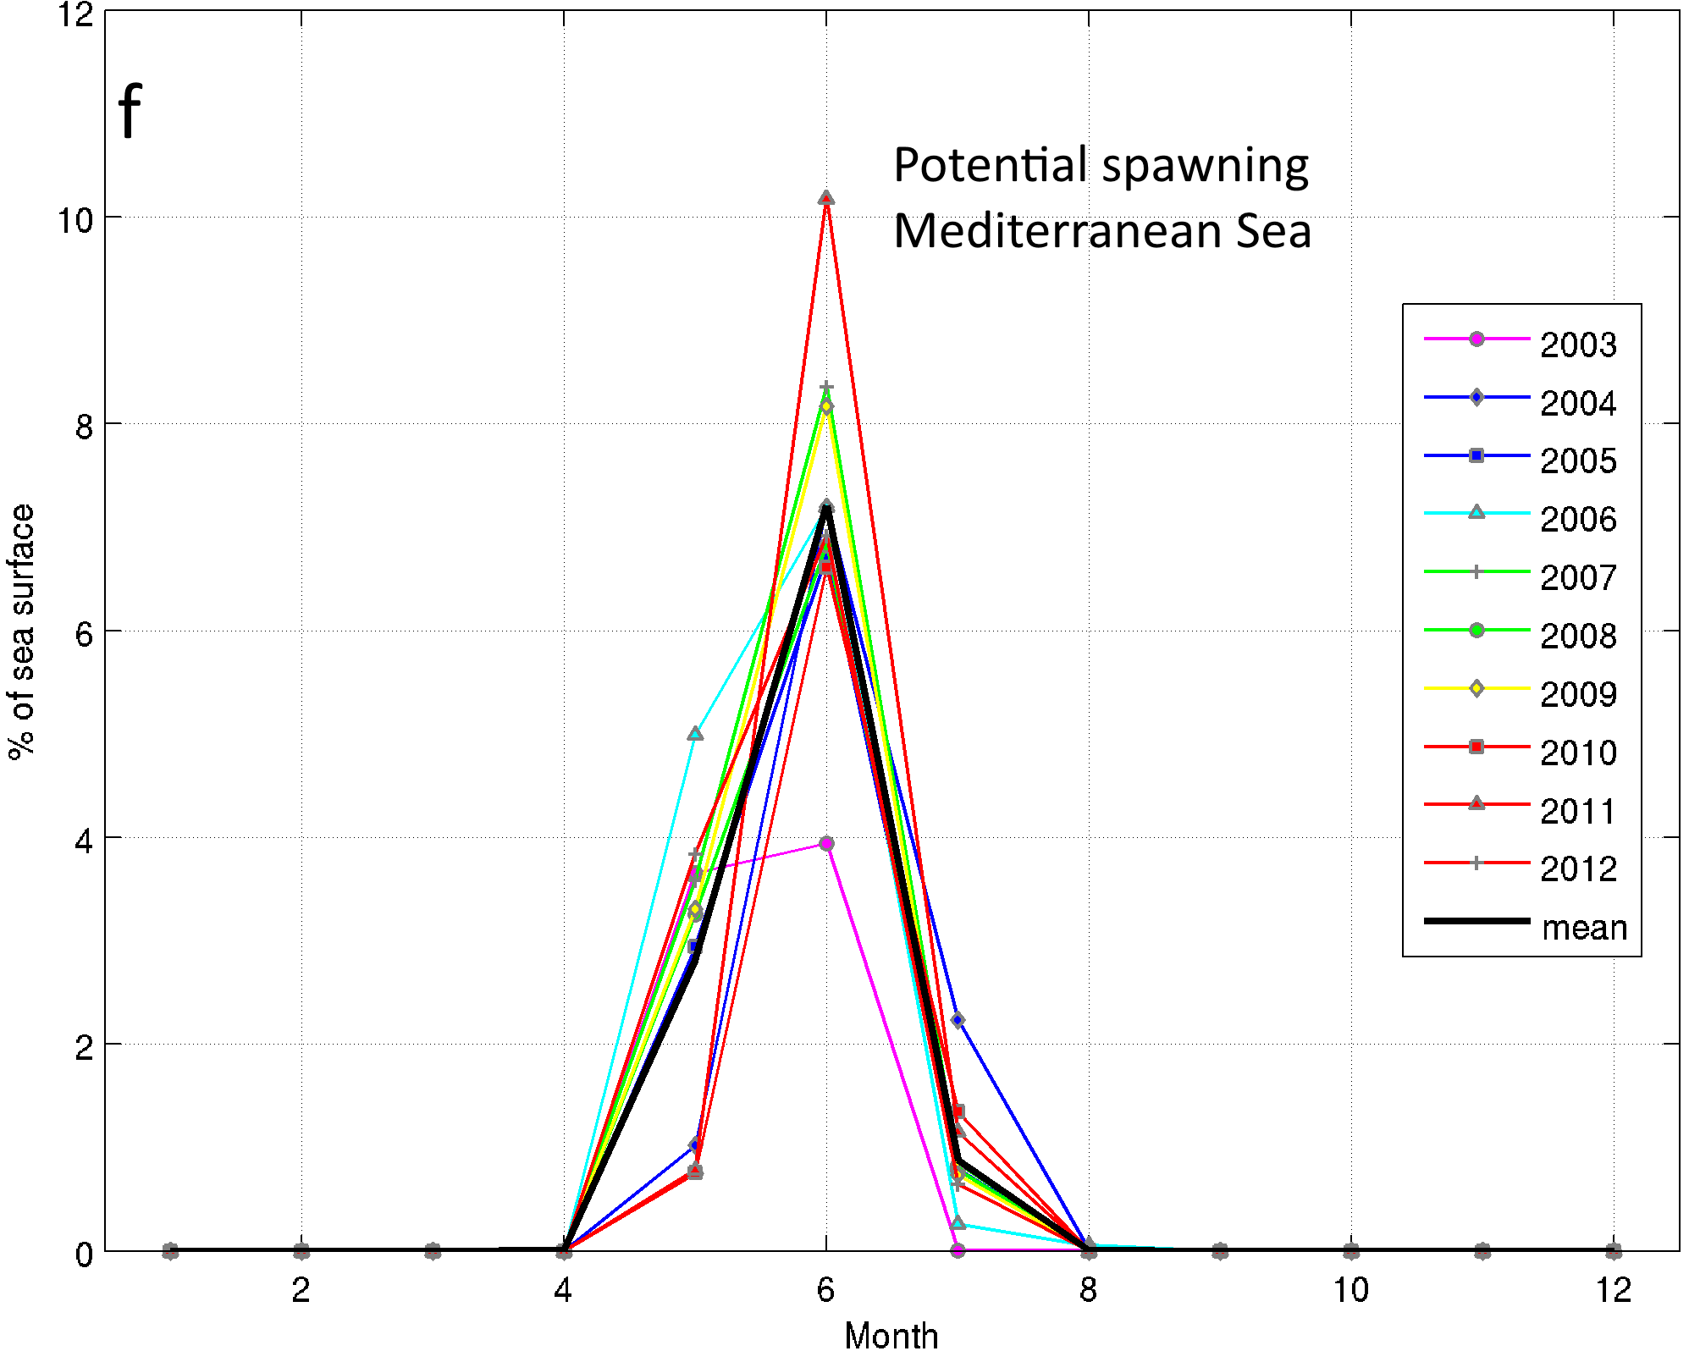
Figure SI- 7 Monthly relative size of potential feeding (a, c, e) and spawning (b, d, f) habitats for the large Atlantic bluefin tuna in the Gulf of Mexico (a, b), North Atlantic (c, d) and Mediterranean Sea (e, f) expressed in percentage of sea surface of each area from 2003 to 2012 (mean value is the black thick line). The potential spawning habitat in the North Atlantic (panel d) uses the parameterization from the Gulf of Mexico area and is not supported by presence data.

References
Berthold, M., Borgelt, C., Höppner, F., 2010. Guide to intelligent data analysis. Springer, pp. 394.
Druon, J.-N., Fiorentino, F., Murenu, M., Knittweis, L., Colloca, F., Osio, C., Mérigot, B., Garofalo, G., Mannini, A., Jadaud, A., others, 2014. Modelling of European hake nurseries in the Mediterranean Sea: an ecological niche approach. Prog. Oceanogr. 130, 188–204. doi:10.1016/j.pocean.2014.11.005
Galuardi, B., Royer, F., Golet, W., Logan, J., Neilson, J., Lutcavage, M., 2010. Complex migration routes of Atlantic bluefin tuna (Thunnus thynnus) question current population structure paradigm. Can. J. Fish. Aquat. Sci. 67, 966–976.
MacQueen, J., 1967. Some methods for classification and analysis of multivariate observations, in: Proceedings of the Fifth Berkeley Symposium on Mathematical Statistics and Probability. p. 14.
Wilson, S.G., Jonsen, I.D., Schallert, R.J., Ganong, J.E., Castleton, M.R., Spares, A.D., Boustany, A.M., Stokesbury, M.J., Block, B.A., Trenkel, V., 2015. Tracking the fidelity of Atlantic bluefin tuna released in Canadian waters to the Gulf of Mexico spawning grounds. Can. J. Fish. Aquat. Sci. 72, 1–18.

