Supplementary material for: **Estimating seafloor pressure from demersal trawls, seines and dredges based on gear design and dimensions**

Ole R. Eigaard1*, Francois Bastardie1, Michael Breen2, Grete E. Dinesen1, Niels T. Hintzen3, Pascal Laffargue4, Lars. O. Mortensen1, J. Rasmus Nielsen1 Hans Nilsson5,Finbarr G. O’Neill6, Hans Polet7, Dave Reid8, Antonello Sala9, Mattias Sköld5, Chris Smith10, Thomas K. Sørensen1, Oliver Tully8, Mustafa Zengin11, Adriaan D. Rijnsdorp3.

*1National Institute for Aquatic Resources, Technical University of Denmark, Charlottenlund Castle, 2920 Charlottenlund, Denmark. 2Institute of Marine Research, P.O. Box 1870, 5817 Bergen, Norway. 3 IMARES, P.O. Box 68, 1970 AB Ijmuiden, the Netherlands, 4IFREMER, Nantes, France. 5Department of Aquatic Resources, Swedish University of Agricultural Sciences, Turistgatan 5, Lysekil 45330, Sweden. 6Marine Scotland Science, 375 Victoria Rd, AB11 9DB, Aberdeen, Scotland. 7Institute for Agricultural and Fisheries Research, Animal Sciences Unit - Fisheries and Aquatic Production, Ankerstraat 1, 8400 Oostende, Belgium. 8Marine Institute, Galway, Ireland. 9CNR, Ancona, Italy. 10Hellenic Centre for Marine Research, Crete, Greece, 11Central Fisheries Research Institute, Kasüstü, Trabzon, 61100, Turkey.* . *Corresponding Author: tel: +45 35883374; fax: +45 35883333; e-mail: ore@aqua.dtu.dk

The following supplementary material is available at ICESJMS online: a methods section detailing the estimation of demersal seine gear footprints based on total seine rope length and summarizing available information of seine speed over ground (Table S1, Figures S1, S2 and S3, and Equations S1, S2, S3 and S4); a list detailing the species abbreviations integrated in the BENTHIS metier names (Table S2); a full review table of the studies estimating penetration depth of gear components (Table S3); a table of typical ground gear composition and associated impact severity of the BENTHIS metiers (Table S4); the format of the industry questionnaires for the four major gear types (Figures S4-S7); a figure of the geometrical principals underlying the estimations of component path widths of otter trawl metiers (Figure S8); and a list of the literature referred to in the supplementary material (Supplementary Reference list).

**Methodology used for estimating the haul geometry and gear footprints of demersal seines**

*Danish/anchored seining*

Vessel track plots from two Danish seiners operating in the period between the 17th of September 2014 and 12th of April 2015 formed the basis of establishing haul geometry and gear footprints of anchored seines. The two vessels were part of the Danish national project MINIDISC (Minimization of Discards) and were equipped for fully documented fisheries, using a BlackBox data collection system from Anchorlab ([www.Anchorlab.dk](http://www.Anchorlab.dk)), including Closed-Circuit Television (CCTV) recordings and a Global Positioning System with loggings every 10 seconds.

From visual inspection of fully documented seine tracks a typical seine operation pattern was identified (Figure S1). Once the anchor and buoy is released, approximately half the total seine rope length is set in a straight line from the anchor at around 7-9 knots. The seine itself is set at speeds around 1-2 knots while the vessel turns about 100 degrees before setting roughly ¼ of the total seine rope length at about 6-8 knots. Then it turns another 100 degrees before setting the last quarter of the trawl line at about the same speed, leaving still some distance back to the anchor, which is completed while towing the gear at speeds of 2-2.5 knots. Once back at the anchor the seine ropes are hauled with gradually increasing winch speed (Sainsbury, 1996), resulting in seine speed over ground gradually increasing from 0 to about 2 - 3 knots towards the end of the haul. Seine and rope speeds depend mainly on target species; lower speeds for flatfish and higher speeds for round fish (Rays Vodbinderi and Nordsøtrawl, pers. comm.).

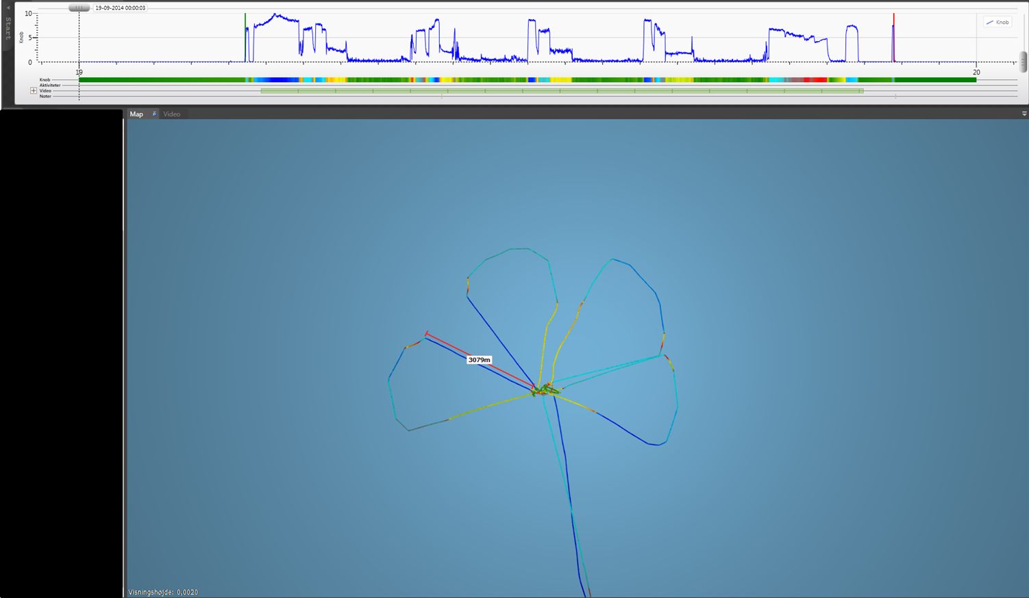

**Figure S1**. Example of a fishing trip by a Danish seine vessel. The trip is comprised of 4 hauls, resulting in the flower pattern around the anchor point. Color gradient represent vessel speed, with dark-green as 0 knots, yellow as 2-3 knots red as 3-6 knots, bright blue as 6-8 knots and dark blue as 9 knots. Top profile of the figure displays the speed patterns of the vessel covering 4 hauls as well as steaming to and from the fishing ground. Red line with endpoints represents distance measure (3079 meters) to illustrate size of gear footprints.

Based on this generally observed pattern, idealized haul geometry was derived; an isosceles triangle, with the top of the triangle located in the anchor point (Figure S2). It is further assumed that half of total seine rope length is deployed at one hypotenuse of the triangle (gear deployment (a), Figure S2) and the remaining trawl line is distributed with ¼ of trawl line at the base of the isosceles triangle (gear deployment (b)) and ¼ on the other hypotenuse (gear deployment (c)). The remaining distance to the anchor point is completed while towing the gear (towing distance (t)). These assumptions are supported by Sainsbury (1996) who also reports a triangular shape of anchored seining operations and a fishing operation pattern along the lines described above with the full gear (full rope lengths and seine) being towed at some distance back to the anchor.

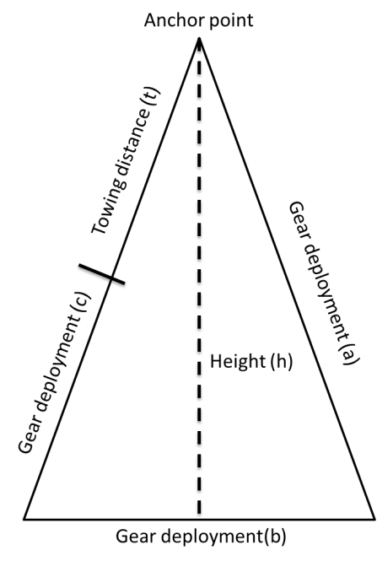

**Figure S2**. Idealized Danish seine haul, showing the anchor point, which is the start and end point of the fishing operation. Gear deployment (a) is where the first half of the seine rope is set and gear deployment (b + c) shows how the second half of the seine rope is set. Towing distance (t) shows where the gear is towed back to the anchor point. The total distance covered (triangle circumference) of a seine operation is (a + b + c + t).

Assuming an isosceles shape of the anchored seine operation, the height of the isosceles triangle (the gear footprint) is:

S1) $h=\sqrt{{\left(\frac{L}{2}\right)}^{2}-\frac{{\left(\frac{L}{4}\right)}^{2}}{4}}$,

where *L* is the total length of the seine rope of the vessel and *h* is the height of the gear footprint. Thus, to estimate the total area affected by a Danish seine haul, the area is calculated by:

S2) $S=\frac{1}{2}*\left(\frac{L}{4}\right)*$*h,*

where *S* is the area of the gear footprint, *L* is the total length of the seine rope and *h* is the calculated height of the gear footprint.

*Scottish seining/fly shooting*

Based on directed interviews and relevant literature (Table 1) the assumption is made that during a typical Scottish seining/flyshooting operation, the gear is first set out in the shape of an equilateral triangle with a circumference equal to the total seine rope length of the vessel, and secondly that the subsequent towing of the gear takes place over a distance equal to the height (h) of the initial equilateral triangle (Figure S3). Based on these assumptions, the following equations can be used to calculate the total seafloor area affected by one flyshooting operation. In equation (3) the height (*h*) of the equilateral triangle is calculated from total seine rope length (*L*):

S3) $h=\frac{\sqrt{3}}{2}*\left(\frac{1}{3}L\right)$

Since the towing distance is assumed equal to the height of the equilateral triangle (*h*), the overall footprint area (*S*) will equal that of an isosceles triangle (Figure S3) and can be calculated as:

S4) $S=\frac{1}{2}*\left(\frac{L}{4}\right)*(2h)$

**Table S1**. Characteristics Scottish seine/flyshooting operations obtained from literature and from interviews with fishermen and net makers.

|  |  |  |  |  |  |  |  |
| --- | --- | --- | --- | --- | --- | --- | --- |
| **Source** | **Observation year** | **Geometrical shape of seine operations** | **Typical vessel speed (knots)** | **Typical winch speed (knots)** | **Seine speed over ground (knots)** | **Towing distance (relative to total seine rope length)** | **Towing duration (minutes)** |
| Danish SSC#1* | 2015 |  | 0,5 - 1,0 |  | 2,0 - 2,5 |  |  |
| Dutch SSC#1* | 2015 |  | 0,5 - 2,0 |  | 1,0 - 3,0 |  |  |
| Dutch SSC#2* | 2015 |  | 0,5 - 1,5 |  | 1,0 - 3,0 |  |  |
| Galbraith and Kynoch, 1990 | 1986 - 1989 | Triangular | 0,5 - 1,0 | 0,4 gradually increasing to about 4,0 | 0,0 gradually increasing to about 3,0 | 1 * height of equilateral triangle | 35 - 114 |
| Ingolfsson, 2014 | 2014 | Circular | 1,4 - 1,7 |  | 2,0 - 2,7 |  |  |
| Nordsø trawl*  [www.nordsotrawl.dk](http://www.nordsotrawl.dk) | 2015 | Triangular and circular | 0,5 - 1,0 |  | 1,0 - 3,0 |  |  |
| Prado and Dremiere, 1990 | 1990 | Triangular | 0,5 - 2,0 |  |  |  |  |
| Rays Vodbinderi*  [www.rays.dk](http://www.rays.dk) | 2015 | Triangular and circular |  |  | 1,0 - 2,5 |  |  |
| Sainsbury, 1996 | 1996 | Approx. Triangular | 1,0 - 3,0 | 0,5 increasing gradually to about 3,0 |  |  |  |
| SEAFISH, 2005 | 2005 | Triangular | 1,0 - 2,0 | 0,5 increasing gradually to about 3,0 |  |  |  |

*\* Interviews conducted with Dutch and Danish Scottish Seiner/flyshooter vessels (SSC) and* *net makers in April 2015*

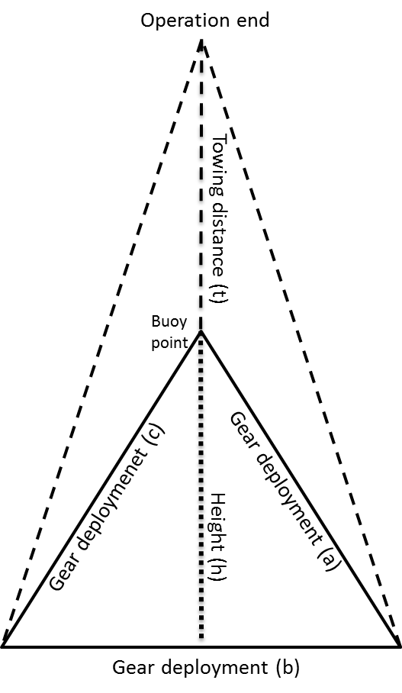

**Figure S3**: Conceptualized Scottish Seine/flyshooter gear footprint. Gear deployment (a) is where the first third of the seine rope is set from the buoy point, gear deployment (b) shows how the second third of the seine rope is set after turning 60°, and gear deployment (c) illustrates how the remaining third of the seine rope is set all the way back to the buoy point after turning another 60° to complete an equilateral triangle with the height (h). After having set the gear it is assumed that gear is towed the length (t), which is equal to h, thus assuming the full operation to have the shape of an isosceles triangle (dashed line).

*Seine speed over ground in demersal seining*

In Scottish seining the seine speed over ground was informed to gradually increase during the fishing operation to a maximum somewhere between 2.5 and 3 knots depending on target species (lower speeds for flatfish, higher speeds for roundfish) (Table S1). In Galbraith and Kynoch (1990) seine speed over ground was documented in detail in a controlled experiment using speed loggers mounted on the gear, which demonstrated a general pattern of an almost linear increase from about 0 to about 3 knots.

For Danish seining no literature results on seine speed were found, but the net makers interviewed on flyshooting (Table S1) also informed that Danish/anchored seine speed over ground was comparable to that observed in flyshooting, but generally in the lower range (end speed approx. 2.5 knots) because flatfish are the most frequent target species in this type of demersal seining.

**Table S2.** Proportion of ground gear path width with impact at the surface and the sub-surface level, respectively, based on a combination of questionnaire information, available (sparse) scientific literature and expert opinions (BENTHIS gear technologists).

|  |  |  |  |  |
| --- | --- | --- | --- | --- |
| Metier | Typical target species | Typical ground gear informed in questionnaire | Surface impact (%) | Surface & Subsurface impact (%) |
|
| OT_SPF | Sprat or sandeel | Cookie | 100 | 0 |
| OT_MIX_DMF_PEL | Bentho-pelagic fish | Cookie, Roller | 50 | 50 |
| OT_CRU | Nephrops or shrimps | Bobbin, Roller, Chain | 0 | 100 |
| OT_MIX_CRU_DMF | Nephrops and mixed demersal | Bobbin, Roller | 25 | 75 |
| OT_MIX_CRU | Shrimp | Chain | 0 | 100 |
| OT_DMF | Cod or plaice or Norway pout | Bobbin, Cookie | 50 | 50 |
| OT_MIX_DMF_BEN | Benthic fish | Rockhopper, Bobbin | 50 | 50 |
| OT_MIX | Individual species not informed | Bobbin, Roller, Cookie | 50 | 50 |
| TBB_CRG | Crangon | Bobbin | 46 | 54 |
| TBB_DMF | Sole and plaice | Chain | 0 | 100 |
| TBB_MOL | Thomas' Rapa whelk | Chain | 0 | 100 |
| DRB_MOL | Scallops, mussels | Sheering edge | 0 | 100 |
| SDN_DMF | Plaice, cod | Cookie | 100 | 0 |
| SSC_DMF | Cod, Haddock, flatfish | Roller, Chain | 50 | 50 |

**Table S3.** Species list

|  |  |  |
| --- | --- | --- |
| FAO code | Scientific name | Common name |
| NEP | *Nephrops norvegicus* | Norway lobster |
| PRA | *Pandalus borealis* | Northern prawn |
| TGS | *Penaeus kerathurus* | Caramote prawn |
| ARA | *Aristeus antennatus* | Blue and red shrimp |
| DPS | *Parapenaeus longirostris* | Deep-water rose shrimp |
| SAN | *Ammodytes spp* | Sandeels (=Sandlances) nei |
| SPR | *Sprattus sprattus* | European sprat |
| CAP | *Mallotus villosus* | Capelin |
| COD | *Gadus morhua* | Atlantic cod |
| PLE | *Pleuronectes platessa* | European plaice |
| SOL | *Solea solea* | Common sole |
| LEM | *Microstomus kitt* | Lemon sole |
| WHG | *Merlangius merlangus* | Whiting |
| POK | *Pollachius virens* | Saithe (=Pollock) |
| PDS | *Pseudobarbus asper* | Smallscale redfin |
| HAD | *Melanorgammus aeglefinus* | Haddock |
| HKE | *Merluccius merluccius* | European hake |
| MON | *Lophius piscatorius* | Angler (=Monk) |
| MUS | *Mytilus Edulis* | Blue mussel |
| MUT | *Mullus barbatus* | Red mullet |
| CSH | *Crangon crangon* | Common shrimp |
| CTC | *Sepia officinalis* | Common cuttlefish |
| OCC | *Octopus vulgaris* | Common octopus |
| TUR | *Psetta maxima* | Turbot |
| SHC | *Alosa pontica* | Pontic shad |
| BLU | *Pomatomus saltatrix* | Bluefish |
| HMM | *Trachurus mediterraneus* | Mediterranean horse mackerel |
| BLL | *Scophthalmus rhombus* | Brill |
| SAL | *Salmon salar* | Atlantic salmon |
| RPW | *Rapana venosa* | Thomas'rapa whelk |
| OYF | *Ostrea Edulis* | European flat oyster |
| SCE | *Pecten maximus* | Great Atlantic scallop |

**Table S4.** Full penetration depth review

|  |  |  |  |  |  |  |  |  |
| --- | --- | --- | --- | --- | --- | --- | --- | --- |
| **Gear** | **Gear component** | **Area** | **Target species** | **Sediment** | **Penetration depth** | **Sediment mobilisation** | **Sediment displacement** | **Reference** |
| DRB | Whole-gear | West Scotland | Scallop | Sand | 1 cm | 1 mm (1.04 kg/m2) | Flattening of ripples | O’Neill et al. 2008, 2013 |
| OTB | Trawl doors | Mediterranean | Deep water shrimp and *Nephrops* | Mud | 25 – 35 cm |  | Irregular furrows of approx. 35 to 45 cm width | Luchetti et al. 2012 |
| OTB | Trawl doors | Mediterranean | Mixed demersal:  Hake, mullet, monk | Mud | 15 – 25 cm |  | Irregular furrows of approx. 25 to 35 cm width | Luchetti et al. 2012 |
| H-DRB | Whole-gear | Adriatic Sea | Infauna bivalve: *Chamelea gallina* | Sand | 5 – 15 cm |  | Regular furrows corresponding to gear width (3 m) | Luchetti et al. 2012 |
| TBB | Whole-gear | Adriatic Sea | Flatfish: Sole, turbot, brill | Mud | 5 – 15 cm |  | Regular furrows corresponding to gear width (4 m) | Luchetti et al. 2012 |
| OTB | Trawl doors | Irish Sea (ICES div. VIIa) | *Nephrops* | Mud | ≤ 15 cm |  | Pull at an oblique angle thus furrows ≤ width of gear | Kaiser et al. 1996 (ref. to Krost et al. 1990) |
| OTB | Bobbins | Irish Sea | *Nephrops* | Mud | 0 cm |  | Displace/damage boulders/epifauna | Kaiser et al. 1996 |
| OTB | Net | Irish Sea | *Nephrops* | Mud | 0 cm |  | Scour the surface of the sediment | Kaiser et al. 1996 |
| OTB | Tickler chains (1-3) | Irish Sea | Flatfish | Soft-rough sediments | 2-5 cm |  | Penetrate the upper few cm of the substrate | Kaiser et al. 1996 |
| TBB | Shoes | Irish Sea (ICES div. VIIa) | Flatfish, some by-catch species | Soft-rough sediment | ≤ 5-10 cm |  | Penetrate the upper few cm of the substrate | Kaiser et al. 1996 (ref. to Anon. 1991 table 1, de Groot & Lindeboom 1994) |
| TBB | Tickler chains | Irish Sea | Flatfish, some by-catch species | Soft sediments | ≤ 10 cm |  |  | Kaiser et al. 1996 (ref to Bridger 1972, de Groot & Lindeboom 1994) |
| TBB | Ticklers, longitudinal chains | Irish Sea | Flatfish, | Rough sediments | ≤ 3 cm |  | Displace boulders (prevent them from entering the net) | Kaiser et al. 1996 (ref. to Bridger 1972, de Groot & Lindeboom 1994) |
| TBB | Net, groundrope | Irish Sea | Flatfish | Soft-firm sediment | 0 cm |  | Scour the surface of the sediment | Kaiser et al. 1996 |
| DRB | Tooth bar, belly rings | (Irish Sea) | Scallops | Rough grounds | ≤ 10 cm |  | Teeth rake through the sediment and disturb the partly buried scallops lifting them into the bag | Kaiser et al. 1996 |
| TBB | Tickler chains & chain matrix | UK coastal waters | Flatfish (*Solea solea*, *Pleuronectes platessa*) | Sandy-firm sediment | < 5-10 cm |  | Penetrate the upper few cm of the seabed, displace rocks and damage/dug out some components of infauna and epifauna | Kaiser & Spencer 1996, Kaiser et al. 1998 ref. to Cruetzberg et al. 1987, Bergman & Hup 1992, Kaiser & Spencer 1994, 1995) |
| OTB | Trawl doors | Scottish waters | Whitefish | Muddy sand | 5-6 cm |  | Dug in about 5-6 cm, and displaced sediment deposited at the door heel in a 6-8 cm mount | Ivanovic et al. 2011 |
| OTB | Roller clump of a twin trawl (300 hp Jackson trawl with rock-hopper ground gear) | Scottish waters | Whitefish | Muddy sand | 10-15 cm |  |  | Ivanovic et al. 2011 |
| OTB | Roller clump of a twin trawl (300 hp Jackson trawl with rock-hopper ground gear) | Scottish waters | Whitefish | Sand | 3-4 cm |  | Flattened ripples and smoothed the seabed | Ivanovic et al. 2011 |
| OTB | Roller clump of a twin trawl (300 hp Jackson trawl with rock-hopper ground gear) | Scottish waters | Whitefish | Sand | ~0 cm |  | Rolled and compacted ripples of a 4-5 cm amplitude. | Ivanovic et al. 2011 |
| OTB | Trawl door | Simulated north-eastern Grand Bank of Newfoundland |  | Sand | 2cm (0-5cm) |  | Model experiment | Gilkinson et al. 1998 (ref. to Krost et al. 1990) |
| OTB | Trawl path (trawl with bobbins & rock hopper gear) | Gulf of Alaska | Commercial rock fish | Hard bottom (pebble, cobble, boulders) | 1-8 cm |  | Boulders displaced, density decreased of some epifauna (anthozoans, vase-shaped and morel-shaped sponges) | Freese et al. 1999 |
| DRB | Rapido trawl/dredge | Adriatic Sea | Scallops (offshore), fish (inshore) | Sand (offshore), mud (inshore) | 6 cm |  | Tracks visible on side-scan sonar images after at least one week. | Pranovi et al. 2000 |
| OTB | Trawl doors (demersal trawl with bobbin 6 rock hopper gear) | Gulf of Lion | Demersal fish | Mud | 30 cm (trawl doors) | 1 mm |  | Durrieu de Madron et al. 2005 |
| OTB | Trawl doors (demersal trawl without bobbin but with ticklers) | Gulf of Lion | Demersal fish | Mud | 30 cm (trawl doors) | 1 mm |  | Durrieu de Madron et al. 2005 |
| OTB | Near-bottom pelagic trawl | Gulf of Lion | Demersal fish | Mud | ~0 cm | 1 mm |  | Durrieu de Madron et al. 2005 (ref. to Jones 1992) |
| OTB | Trawl doors | Barents Sea |  | Hard packed sand/mud, sand & gravel | 10 cm |  | Increased roughness (increase in surface relief), decreased sediment hardness | Humborstad et al. 2004 |
| OTB | Ground gear (rock hopper) | Barents Sea |  |  | Tracks visible on sidescan sonar images, but depth uncertain |  | Depressions from rock hopper gear was visible on sidescan sonar images | Humborstad et al. 2004 |
| OTB | Trawl ground gear | North Tyrrhenian Sea | Demersal fish at depth < 150 m |  | Not visible |  |  | De Biasi 2004 |
| OTB | Trawl roller clump | Inshore Scottish waters |  | Muddy sand | ~ 12 cm |  |  | O’Neill et al. 2009 |
| OTB | Trawl door | Inshore Scottish waters |  | Gravel | 5-6 cm |  | Deposit 4-5 cm mound at door heel | O’Neill et al. 2009 |
| DRB | Scallop dredge | Inshore Scottish waters |  | Fine –medium sand | 2-4 cm |  | Reduced amplitude of sand ripples from 1.5-2 cm to ≤ 1 cm. | O’Neill et al. 2009, Dale et al. 2011 |
| OTB | Trawl doors | Varangerfjord, Norway |  | Mud | 10-20 cm |  | 10 cm in Scottish waters | Buhl-Mortensen et al. 2013 (ref to DEGREE 2010) |
| OTB | Sweeps |  |  | Sand | 0-2 cm |  | Impact limited to top of ripples | Buhl-Mortensen et al. 2013 |
| OTB | Sweeps |  |  | Mud | 0 cm |  |  | Buhl-Mortensen et al. 2013 |
| OTB | Sweep chains |  |  | Mud | 2-5 cm |  |  | Buhl-Mortensen et al. 2013 |
| OTB | Ground gear (rock hopper trawl) |  |  | Mud | 5-10 cm |  |  | Buhl-Mortensen et al. 2013 |
| OTB | Trawl doors |  |  | Sand | 2-5 cm |  |  | Buhl-Mortensen et al. 2013 |
| OTB | Sweep chains |  |  | Sand | 0-2 cm |  |  | Buhl-Mortensen et al. 2013 |
| OTB | Ground gear (rock hopper trawl) |  |  | Sand | 0-2 cm |  |  | Buhl-Mortensen et al. 2013 |
| OTB | Trawl doors | Bay of Fundy, Canada | Flounder |  | 1-5 cm |  |  | Løkkeborg 2005 (ref. to Brylinsky et al. 1994) |
| TBB | Beam trawl groundgear | North Sea | Flatfish | Sand | 1-8 cm |  |  | Valdemarsen et al. 2007 (ref. to Paschen et al. 2000) |

**Gear types:** Demersal otter trawl (OTB), Beam trawl (TBB), Dredge (DRB) and Hydro-dredge (H-DRB)

**Gear components-OTB:** whole-gear, Sweeps and bridles, trawl doors, ground gear, clump

**Gear components-TBB:** whole-gear, beam shoes, tickler chains/mats, ground gear

**Gear components-DRB:** whole-gear

**Area information**: ICES Area level

**Sediment type**: coarse, sand, mud

**Penetration depth:** Quantitative (e.g. depth average or range in cm)

**Sediment displacement:** Optional

**Sediment mobilisation**: Preferably quantitative (e.g. kg sediment per m2 impacted)

**Reference:** Authors and Year (full reference in list below)

**Figure S4.** Industry questionnaire (demersal otter trawl).



**Figure S5.** Industry questionnaire (beam trawls)

. 

**Figure S6.** Industry questionnaire (demersal seines)



**Figure S7.** Industry questionnaire (dredges)



**Figure S8.** Otter trawl geometry theory used for estimating path widths for the main gear components (sweeps/bridles, ground gear and doors). Abbreviations: WES = wingend spread, BA = bridle/sweep angle, PW = path width, GG = ground gear, SW= sweeps+bridles, DO = doors. Assumptions: PW_GG = 0.4 * GG_Length, PW_ SW = sinus (13°) * SW_length, PW_DO = 0.4 * DO_length. These assumptions are based on Valdemarsen et al. 2007 and SEAFISH 2010.



SW length

**Supplementary Reference list**

Anonymous 1991. Report of the study group on ecosystem effects of fishing activities. International Council for the Exploration of the Sea. C.M. 1991/G:7 (see table 1)

Bergman, M.J.N., and Hup, M.1992. Direct effects of beam trawling on macrofauna in a sandy sediment in the southern North Sea. ICES Journal of Marine Science 49:5-13

Bridger, J.P. 1972. Some observations on the penetrations into the sea bed of tickler chains on a beam trawl. International Council for the Exploration of the Sea. C.M. 1972/B:7, 9pp

Brylinsky, M., Gibson, J., and Gordon, D.C. Jr. 1994. Impact of flounder trawls on the intertidal habitat and community of the Minas Basin, Bay of Fundy. Canadian Journal of Fisheries and Aquatic Science 51:650-661

Buhl-Mortensen, L., Aglen, A., Breen, M., Buhl-Mortensen, P., Ervik, A., Husa, V., Løkkeborg, S., Røttingen, I., Stockhausen, H.H. 2013. Impacts of fisheries and aquaculture on sediments and benthic fauna: suggestions for new management approaches. Fisken og Havet 3, 69 pp.

Creutzberg, F., Duineveld, G.C.A., and van Noort, J.G. 1987. The effect of different numbers of tickler chains on beam trawl catches. Journal du Conseil International pour l’Exploration de la Mer 43:159-168

Dale, A.C., Boulcott, P., and Sherwin, T.J. 2011. Sedimentation patterns caused by scallop dredging in a physically dynamic environment. Marine Pollution Bulletin 62:2433-2441

De Biasi, A.M. (2004). Impact of experimental trawling on the benthic assemblage along the Tuscany coast (north Tyrrhenian Sea, Italy). ICES Journal of Marine Science 61:1260-1266

DEGREE 2010. Development of fishing gears with reduced effects on the environment. DEGREE EU Contract 022576 Final Publishable Activity Report

Durrieu de Madron, X., Ferre, B., Le Corre, G., Grenz, C., Conan, P., Pujo-Pay, M., Buscail, B., et al. 2005. Trawling-induced resuspension and dispersal of muddy sediments and dissolved elements in the Gulf of Lion (NW Mediterranean). Continental Shelf Research 25:2387-2409

Freese, L., Auster, P.J., Heifetz, J., and Wing, B.L. 1999. Effects of trawling on seafloor habitat and associated invertebrate taxa in the Gulf of Alaska. Marine ecology Progress Series 182:119_126

Galbraith, R.D., and Kynoch, R.J. 1990. Seine net engineering performance trials. Scottish Fisheries Working Paper 2/90, 78 pp.

Gilkinson, K., Paulin, M., Hurley, S., and Schwinghamer, P. 1998. Impacts of trawl doors scouring on infaunal bivalves: results of a physical door model/dense sand interaction. Journal of Experimental marine Biology and Ecology 224:291-312

de Groot, S.J., and Lindeboom, H.J. 1994.Environmental impact of bottom gears and benthic fauna relation to natural resources management and protection of the North Sea. Netherlands Institute for Fisheries Research Report No. 1994-11, Texel, The Netherlands, 257 pp

Humborstad, O.B., Nøttestad, L., Løkkeborg, S., and Rapp, H.T. 2004. RoxAnn bottom classification system, sidescan sonar and video-sledge: spatial resolution and their use in assessing trawling impacts. ICES Journal of Marine Science 61:53-63

Ingolfsson, O.A. 2014. Pers. Comm. with researcher Olafur Arnar Ingolfsson, Institute of Marine Research, Norway. E-mail: [olafur.arnar.ingolfsson@imr.no](mailto:olafur.arnar.ingolfsson@imr.no)

Ivanovic, A., Neilson, R.D., and O’Neill, F.G. 2011. Modelling the physical impact of trawl components on the seabed and comparison with sea trials. Ocean Engineering 38:925-933

Jones, J.B. 1992. Environmental impact of trawling on the seabed: a review. New Zealand Journal of Marine and Freshwater Research 26:59-67

Kaiser, M.J., and Spencer, B.E. 1994. Fish scavenging behaviour in recently trawled areas. Marine Ecology Progress Series 112:41-49

Kaiser, M.J., and Spencer, B.E. 1995. Survival of by-catch from a beam-trawl. Marine Ecology Progress Series 126:31-38

Kaiser, M.J., and Spencer, B.E. 1996. The effects of beam-trawl disturbance on infaunal communities in different habitats. Journal of Animal Ecology 65:348-358

Kaiser, M.J., Hill, A.S., Ramsay, K., Spencer, B.E., Brand, A.P., Veale, L.O., Prudden, K., et al. 1996. Benthic disturbance by fishing gear in the Irish Sea: a comparison of beam trawling and scallop dredging. Aquatic Conservation: Marine and Freshwater Ecosystems 6:269-285

Kaiser, M.J., Edwards, D.B., Armstrong, P.J., Radford, K., lough, N.E.L., Flatt, R.P., and Jones, H.D. 1998. Changes in megafaunal benthic communities in different habitats after trawling disturbance. ICES Journal of Marine Science 55:353-361

Krost, P., Bernhard, M., Werner, F., and Hukriede, W. 1990. Otter trawl tracks in Kiel Bay (Western Baltic) mapped by side-scan sonar. Helgolander Meeresuntersuchungen 32:344-353

Lucchetti, A., and Sala, A. 2012. Impact and performance of Mediterranean fishing gear by side-scan sonar technology. Canadian Journal of Fishery and Aquatic Sciences 69: 1–11

Løkkeborg, S. 2005. Impacts of trawling and scallop dredging on benthic habitats and communities. FAO Fisheries Technical Paper 472:1-58

Nordsø trawl. 2015. [www.nordsotrawl.dk](http://www.nordsotrawl.dk) [accessed 2404-2014]

O’Neill, F.G., Summerbell, K., and Breen, M. 2008. The suspension of sediment by scallop dredges. Fisheries Research Service Internal Report.

O’Neill, F.G., Summerbell, K., and Breen, M. 2009. An underwater laser stripe seabed profiler to measure physical impact of towed gear components on the seabed. Fisheries Research 99:234-238

O’Neill, F.G., Robertson, M., Summerbell, K., Breen, M., and Robinson, L.A. 2013. The mobilisation of sediment and benthic infauna by scallop dredges. Marine Environmental Research 90:104-112

Paschen, M., Richter, U., and Köpnick, W. 2000. TRAPESE – Trawl penetration in the seabed. Final Report EI Contract 96-006, University of Rostock, ASBN 3-86009-185-9

Prado, J., and Dremiere, P.Y. 1990. Fisherman's workbook. FAO, Rome, Fisheries Department. 187 pp.

Pravoni, F., Raicevich, S., Franceschini, G., Farrace, M.G., and Giovanardi, O. 2000. Rapido trawling in the northern Adriatic Sea: effects on benthic communities in an experimental area. ICES Journal of Marine Science 57:517-524

Rays Vodbinderi. 2015. [www.rays.dk](http://www.rays.dk) [accessed 2404-2014]

Sainsbury, J.C. 1996. Commercial fishing methods, an introduction to vessels and gears. Fishing News Books, Blackwell Science Ltd, Oxford, 359 pp.

SEAFISH 2005. Basic fishing methods. SEAFISH Fisheries Development Centre, Manchester Street, Hull, 39 pp.

SEAFISH 2010. Bridle angle and wing end spread calculations. SEAFISH Research & Development. Catching sector Fact Sheet January 2010, 6 pp.

Valdemarsen, J.W., Jørgensen, T., and Engås, A. 2007. Options to mitigate bottom habitat impact of dragged gears. FAO Fisheries Technical Paper 506:1-29