Supplementary materials

Fig. S1. Average wind patterns over the 11 breeding seasons.
(Top panel) Superposed to daily wind speed histogram in red is a normal distribution fitted with the same properties as the real dataset. The dotted red line shows the limit between usual winds and strong winds. (Middle panel) Daily direction from which the wind blows, and the size of the triangles represent the number of events in that direction. (Bottom panel) Wind speed depending on wind direction (direction from which the wind blows). Red boxplots indicate main wind directions in terms of number of events according to the middle panel.
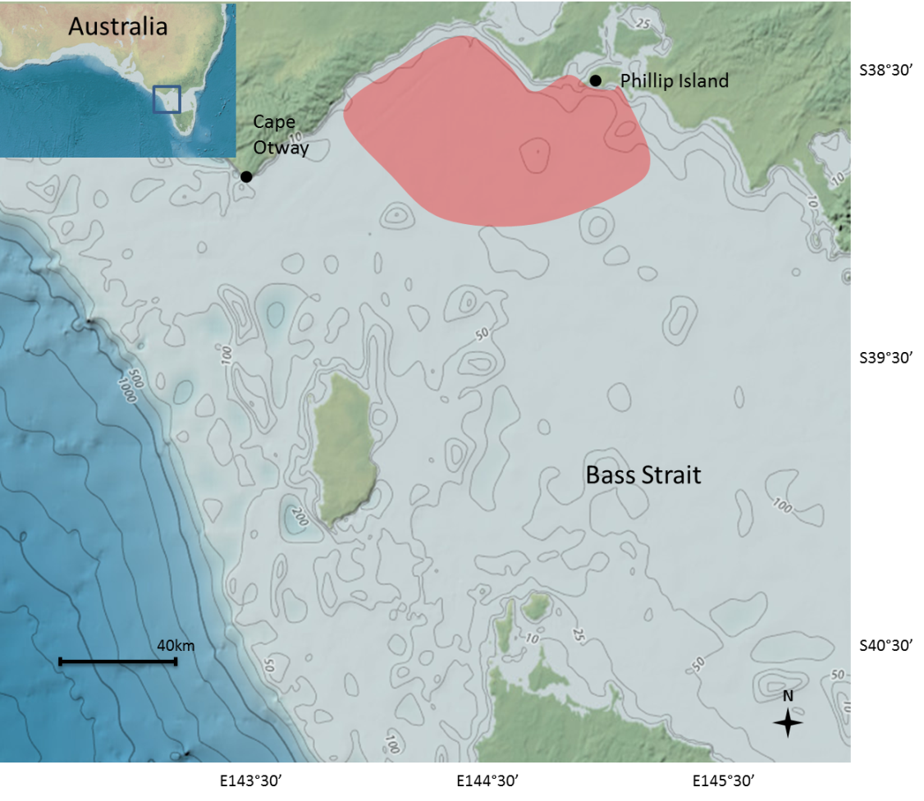
Fig. S2. Foraging area (red shade) of Phillip Island Little penguins during chick rearing in the northern Bass Strait, Australia (extracted from Collins et al. 1999 and Pelletier et al. 2014). Bathymetry from GEBCO in meters available online: http://maps.ngdc.noaa.gov/viewers/bathymetry/
Fig. S3. Additive decomposition of monthly wind time series from 1861 to 2013 in trend, random, and seasonal signals. For clarity purposes, the seasonal signal is shown over 10 years only.

