# ICES Journal of Marine Science

The fisheries history of small pelagics in the Northern Mediterranean.

Elisabeth Van Beveren, Jean-Marc Fromentin, Tristan Rouyer, Sylvain Bonhommeau, Pablo Brosset, Claire Saraux

# **Supplementary material: Figure S2**

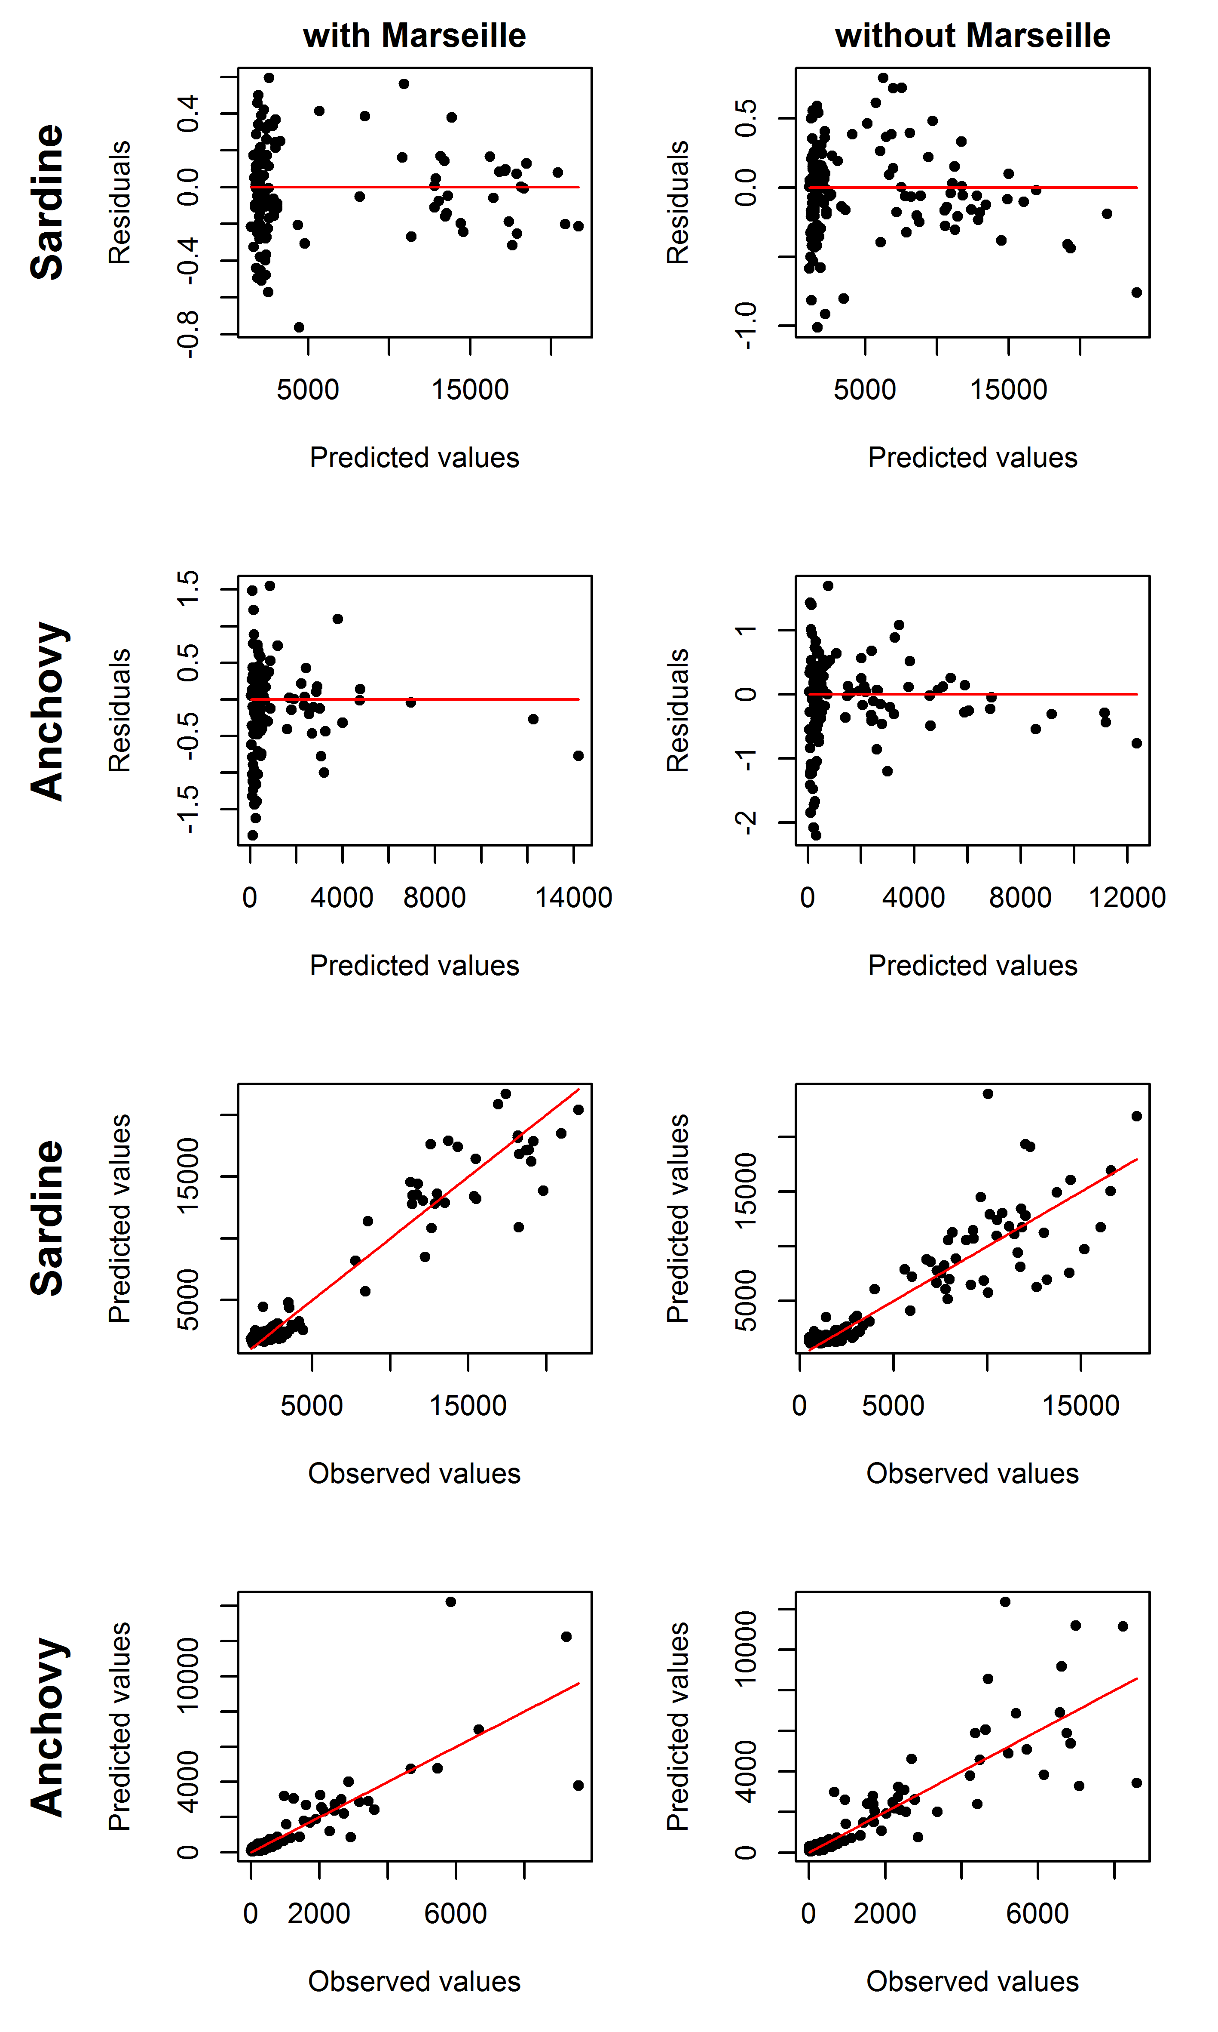

Fig. S2 Residual and observed vs. predicted plots of the GAM models for sardine and anchovy, with and without Marseille.