# ICES Journal of Marine Science

The fisheries history of small pelagics in the Northern Mediterranean.

Elisabeth Van Beveren, Jean-Marc Fromentin, Tristan Rouyer, Sylvain Bonhommeau, Pablo Brosset, Claire Saraux

# **Supplementary material: Figure S3**

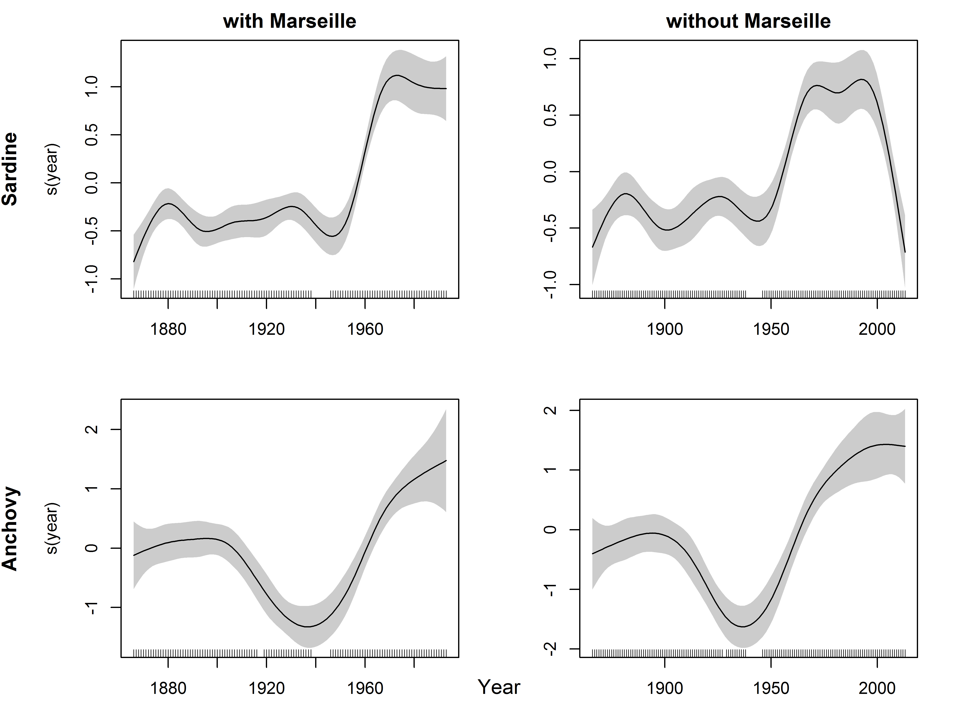

Fig. S3 Effect of year on sardine and anchovy landings, with or without Marseille in a GAM model. The cubic smoother (solid line) is given with its 95% CI (shaded area).