# ICES Journal of Marine Science

The fisheries history of small pelagics in the Northern Mediterranean.

Elisabeth Van Beveren, Jean-Marc Fromentin, Tristan Rouyer, Sylvain Bonhommeau, Pablo Brosset, Claire Saraux

# **Supplementary material: Figure S4**

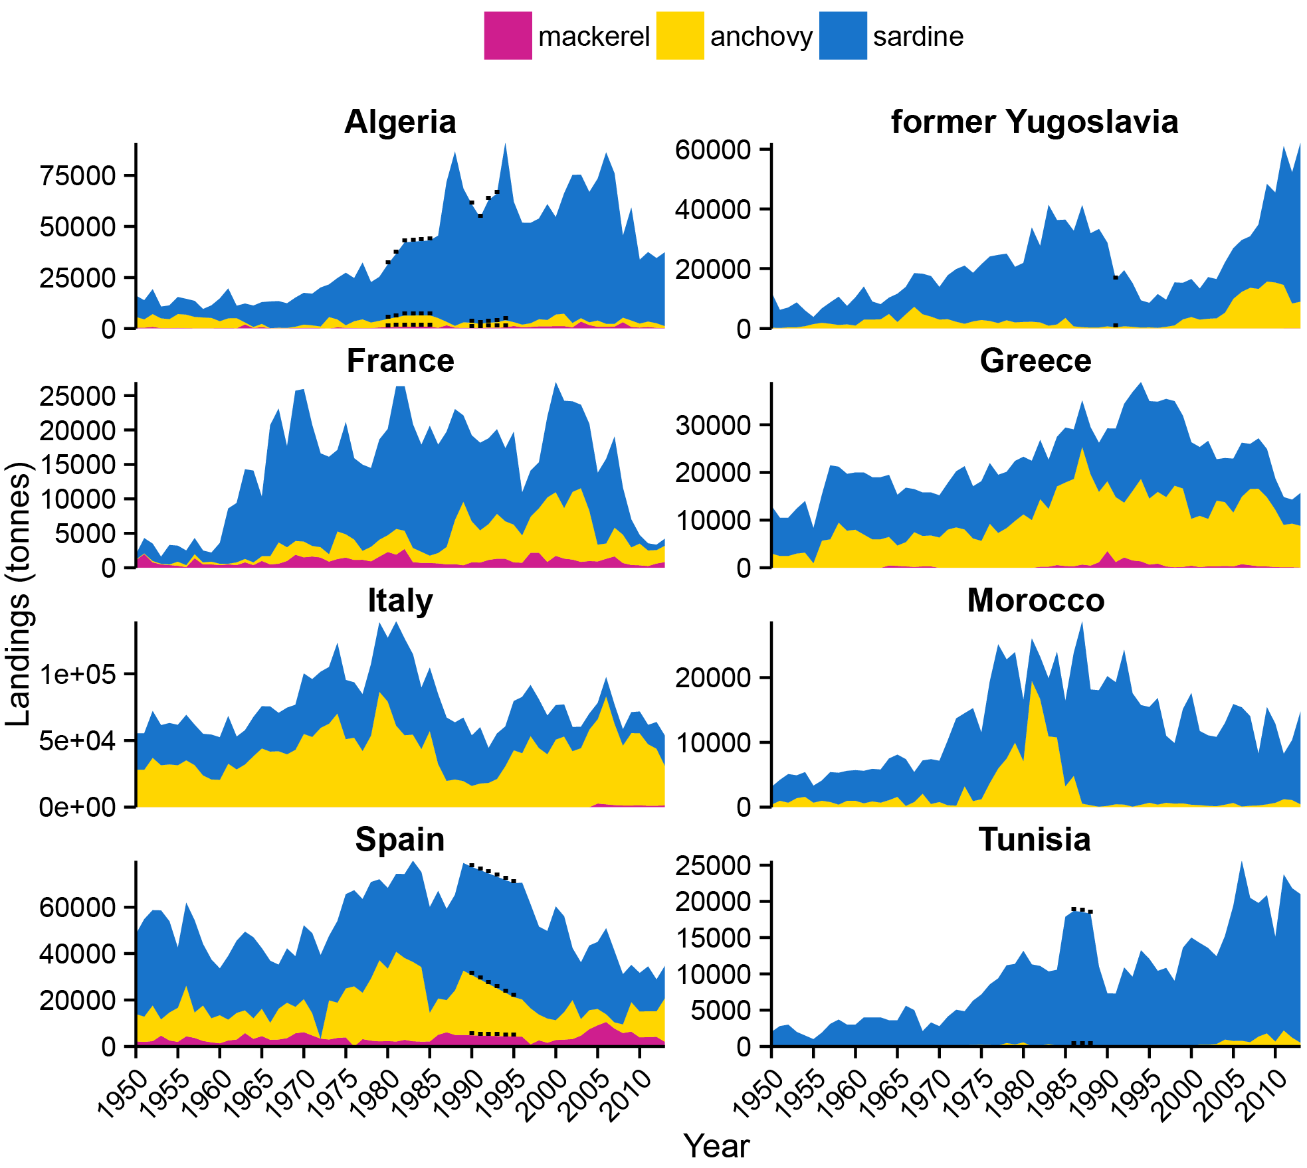

Fig. S4 Mediterranean landings of European sardine, European anchovy and Atlantic mackerel by country (only the 9 most important were considered, that had the highest landings and a complete time series). Data are from the FAO (FAO-FIGIS, 2015), even for France. Black dots indicate FAO-estimated values. Former Yugoslavia is the sum of the landings from Croatia, Slovenia, Montenegro, Serbia and Montenegro (1992-2013) and Yugoslavia SFR (1950-1991).

FAO-FIGIS. 2015, April 23. FAO - Fisheries and Aquaculture Information and Statistics Service, Global Capture Production dataset. http://www.fao.org/fishery/statistics/global-capture-production/en.