Geochemistry, Geophysics, Geosystems
Supporting Information for
Mg/Ca Thermometry in Planktic Foraminifera: Improving Paleotemperature Estimations for G. bulloides and N. pachyderma left
VÁZQUEZ RIVEIROS, Natalia^{a,*}; GOVIN, Aline ª; WAELBROECK, Claire ª; MACKENSEN, Andreas^{b}; MICHEL, Elisabethª; MOREIRA, Santiago ª; BOUINOT, Thomasª; CAILLON, N.^{a,c,d}; ORGUN, A.ª; BRANDON, M.ª
ªLaboratoire des Sciences du Climat et de l'Environnement, LSCE/IPSL, CNRS-CEA-UVSQ, Université Paris-Saclay, F-91198, Gif-sur-Yvette, France
^{b}Alfred Wegener Institute, Helmholtz Center for Polar and Marine Research, Am Alten Hafen 26, 27568, Bremerhaven, Germany
^{c}Now at Univ. Grenoble Alpes, Laboratoire de Glaciologie et Géophysique de l'Environnement, Grenoble, France
^{d}CNRS, Laboratoire de Glaciologie et Géophysique de l'Environnement, Grenoble, France

Contents of this file

Figure S1
Table S3

Additional Supporting Information (Files uploaded separately)

Captions for Tables S1 to S3 (if larger than 1 page, upload as separate file)
Introduction
This supplementary file includes Figure S1, containing plots of Mg/Ca versus Fe/Ca, Al/Ca and Mn/Ca. It contains also two caption tables: Table S1 shows Mg/Ca and calcite δ¹⁸O data averaged per site, as well as seawater δ¹⁸O and calculated isotopic temperature at each site (table uploaded on a separate file). Table S2 includes replicas of Mg/Ca, Al/Ca, Fe/Ca and Mn/Ca at each site (table uploaded on a separate file). Finally, Table S3 contains the correlation coefficients between Mg/Ca and different contaminating phases. Description of the analytical techniques used can be found in the main manuscript.
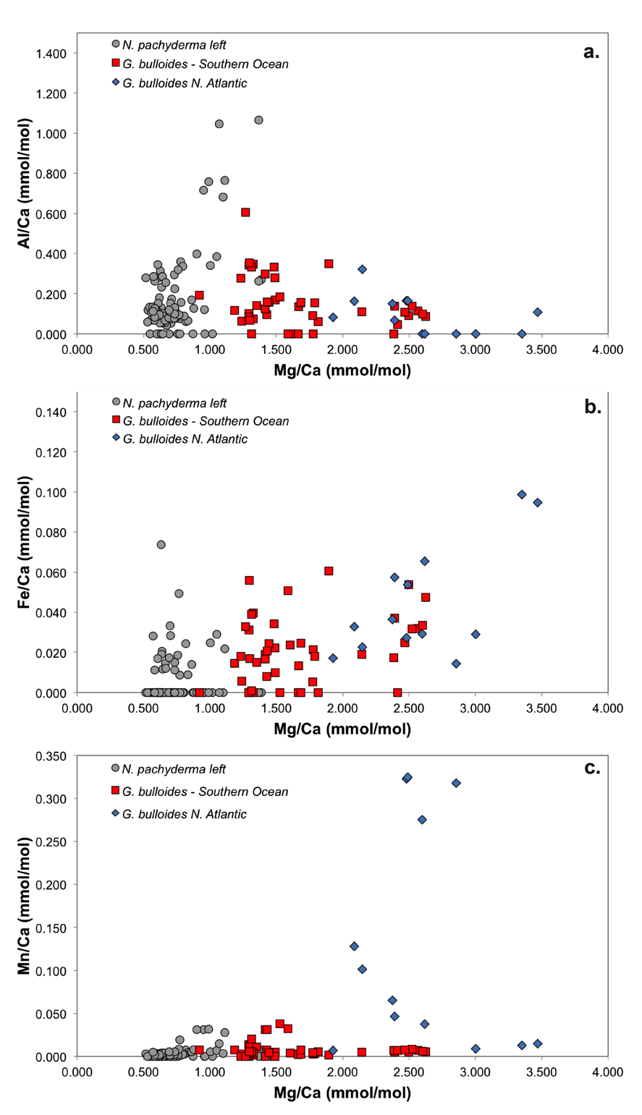

Figure S1. Mg/Ca versus a.) Fe/Ca, b.) Al/Ca and c.) Mn/Ca, for each measurement. Red squares: Southern Ocean G. bulloides sites; blue diamonds: North Atlantic G. bulloides sites; grey circles: Southern Ocean N. pachyderma left measurements.

Table S1. Average and standard deviation of measured Mg/Ca and d¹⁸O_{c}, and d¹⁸O_{sw}, T_{iso} and annual SST data at each site. (n) = number of replicas per analysis. - = levels with no replicas due to scarcity of foraminifera.

Table S2. Mg/Ca, Al/Ca, Fe/Ca and Mn/Ca values for replicas at each core site.

R² | Mg/Ca vs Al/Ca | Mg/Ca vs Fe/Ca | Mg/Ca vs Mn/Ca
G. bulloides S. Atlantic | 0.11 | 0.10 | 0.01
G. bulloides N. Atlantic | 0.25 | 0.46 | 0.02
N. pachyderma left | 0.33 | 0.00 | 0.18

Table S3. Correlation coefficients bewteen Mg/Ca and Al/Ca, Mn/Ca and Fe/Ca, and Mg/Ca and Mn/Ca for each dataset (South Atlantic G. bulloides, North Atlantic G. bulloides and N. pachyderma left).

