Table A1. Fishing effort regulations introduced and simulated in the Atlantic and Indian Oceans.
Ocean | Regulation | Area | Approximate size (km²) | Year | Period
Atlantic | Moratorium on FAD | 4°S–5°N  20°W–African Coast | ~3 500 000 | 1997–2004 | November to January
 | No-take zone | 0–5°N  20–10°W | ~600 000 | 2004–2011 | November
 | Moratorium on FAD | 10°S–African Coast  5°W–5°E | ~2 000 000 | 2012–2014 | January to February
 | Simulated Moratorium on FAD | Piccolo, N.E Equator and S.E Equator sub-regions | ~8 500 000 |  | October to March
Indian | No-take zone | 0–10°N  40–60°E | ~1 500 000 | 2010–2014 | November
 | Simulated Moratorium on FAD | N. Somalia and S. Somalia sub-regions | ~5 500 000 |  | June to November

Table A2. Summary of the logbook and scientific onboard observer data, over the 2005–2014 period, used to compile the probabilities used for the Monte Carlo simulations.
 |  | Atlantic Ocean |  | Indian Ocean
 |  | French | Spanish | French | Spanish
Logbooks | Total number of vessels | 20 | 53 | 36 | 36
 | Mean nb. of vessel per year | 11 ±0.4 | 30 ±1.0 | 17 ±0.9 | 25 ±1.9
 | Total nb. of fishing sets | 19,210 | 37,675 | 36,028 | 59,958
 | FAD (% total nb. of sets) | 28.1 | 46.4 | 52.1 | 65.3
 | FSC (% total nb. of sets) | 68.4 | 51.9 | 44.3 | 33.6
 | WHA (% total nb. of sets) | 2.4 | 0.7 | 2.7 | 0.3
 | WHS (% total nb. of sets) | 0.9 | 0.7 | 0.4 | 0.4
 | Total tuna catch (t) | 330,658 | 847,000 | 776,780 | 1,693,233
 | Catch <10kg (% total catch)* | 41.5 | 66.4 | 56.5 | 75.6
 | Catch >10kg (% total catch)* | 55.5 | 30.0 | 41.8 | 22.5
Observer | Total nb. of fishing sets | 10466 |  | 5137
 | FAD (% total nb. of sets) | 32.5 |  | 50.4
 | FSC (% total nb. of sets) | 65.0 |  | 47.0
 | WHA (% total nb. of sets) | 1.8 |  | 1.8
 | WHS (% total nb. of sets) | 0.7 |  | 0.4
 | Total bycatch chondrychtians (t) | 268 |  | 238
 | Total bycatch other fishes (t) | 883 |  | 1599
 | Total bycatch billfishes (t) | 140 |  | 159
 | Total bycatch turtles (kg) | 14,753 |  | 2120
*Catches with no size category reported (i.e. “unknown”) were not included, explaining the remaining percentage of the tuna catch.
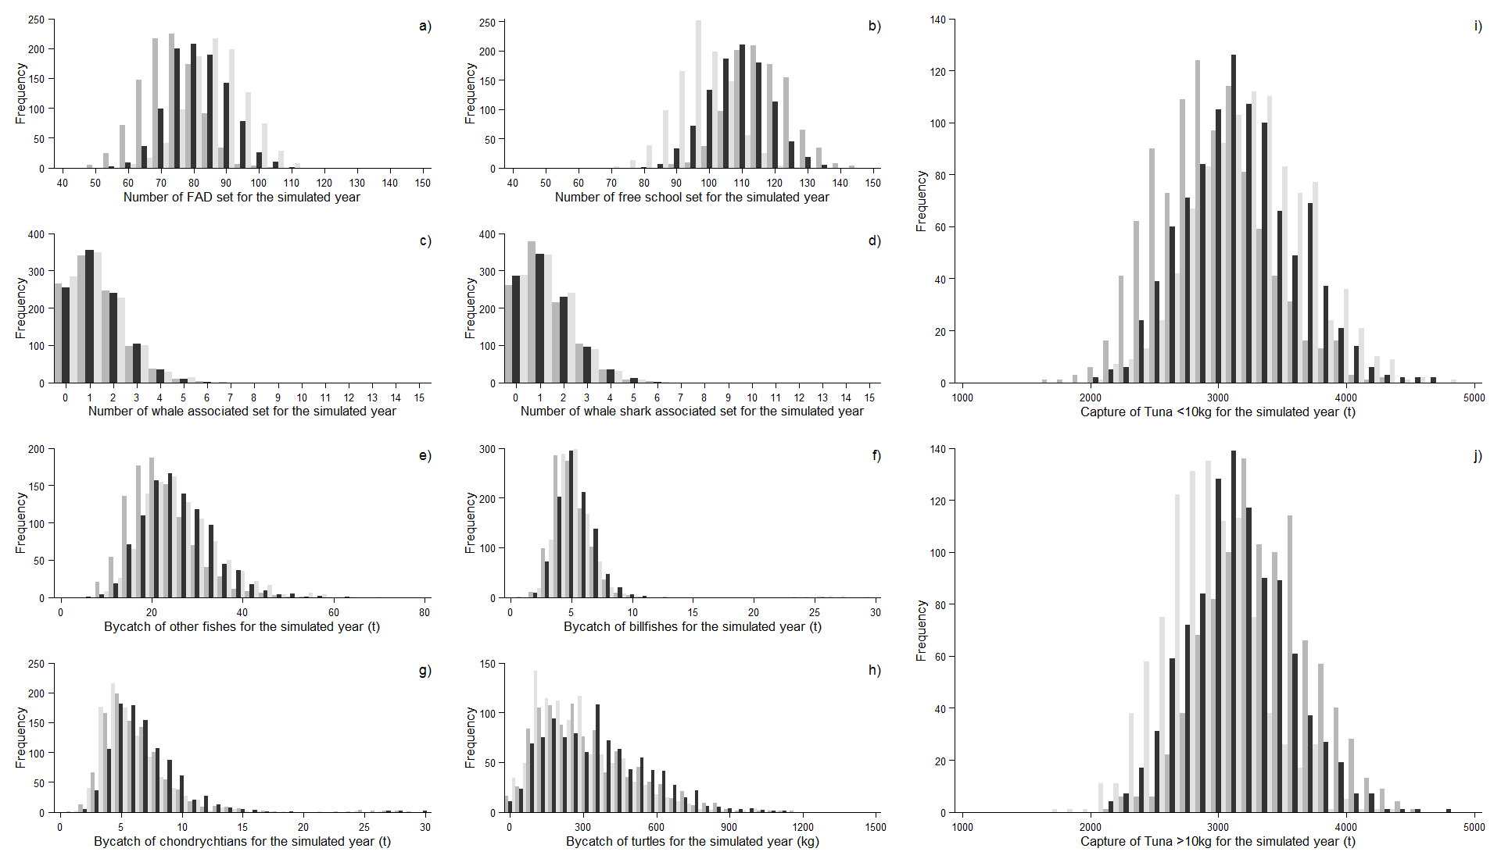Figure A1. Simulated fishery indices: a) FAD set, b) free school set, c) whale associated set, d) whale shark associated set, e) bycatch of other bony fishes, f) bycatch of billfishes, g) bycatch of sharks, h) bycatch of turtles, i) catch of tuna < 10 kg and j) catch of tuna ≥ 10 kg, for one Spanish purse-seiner over one fishing year with a moratorium on FAD during season 1 and 4 (dark grey = scenario 1; black = scenario 2) in the Atlantic Ocean, compared to the baseline (light grey).
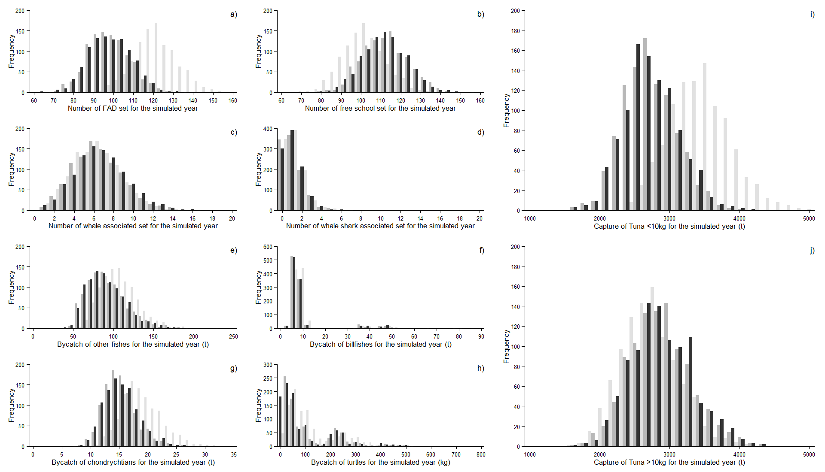Figure A2. Simulated fishery indices: a) FAD set, b) free school set, c) whale associated set, d) whale shark associated set, e) bycatch of other bony fishes, f) bycatch of billfishes, g) bycatch of sharks, h) bycatch of turtles, i) catch of tuna < 10 kg and j) catch of tuna ≥ 10 kg, for one French purse-seiner over one fishing year with a moratorium on FAD during SW and INE monsoon periods (dark grey = scenario 1; black = scenario 2) in the Indian Ocean, compared to the baseline (light grey).
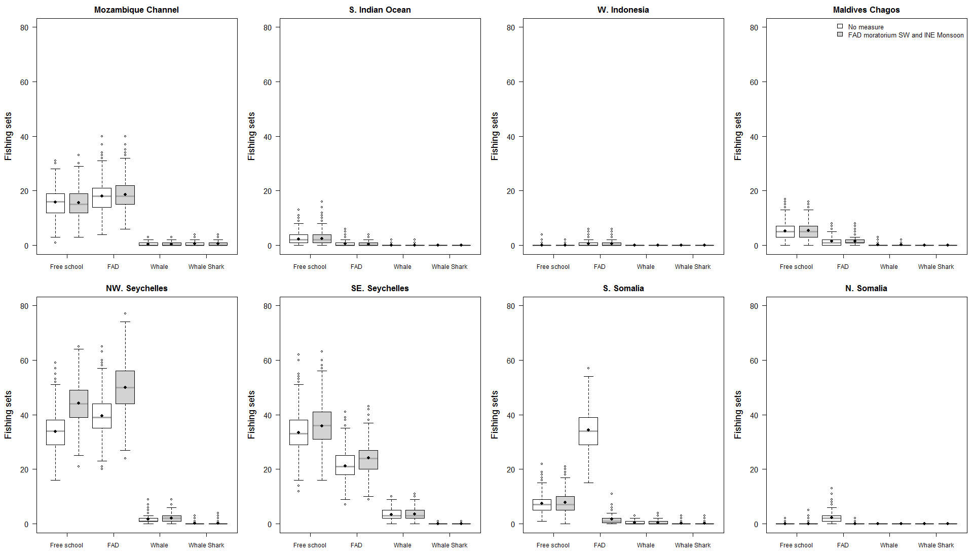 Figure A3. Number of sets per fishing mode for the simulation of one French purse-seiner over one fishing year in the Indian Ocean, for the baseline scenario (white) and for the scenario 1 of a moratorium on FAD during SW and INE monsoon periods (grey).

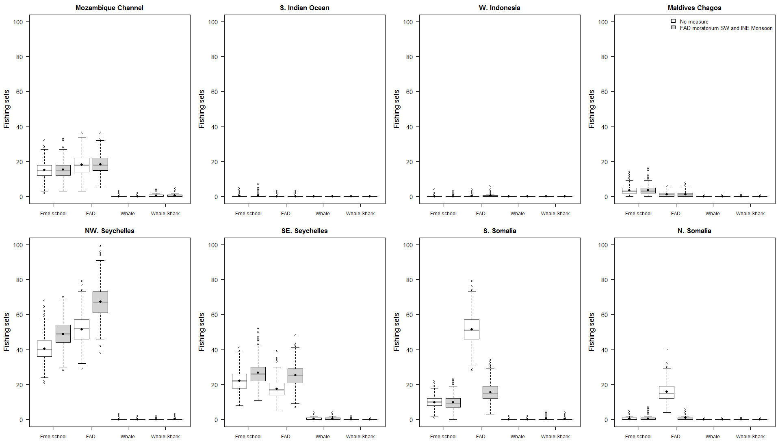 Figure A4. Number of sets per fishing mode for the simulation of one Spanish purse-seiner over one fishing year in the Indian Ocean, for the baseline scenario (white) and for the scenario 1 of a moratorium on FAD during SW and INE monsoon periods (grey).

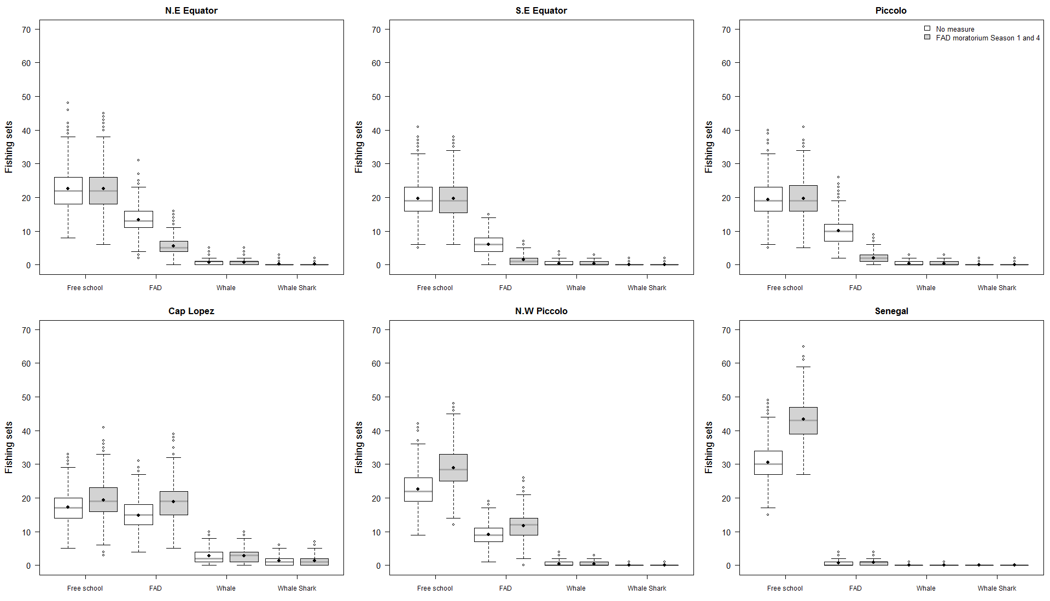Figure A5. Number of sets per fishing mode for the simulation of one French purse-seiner over one fishing year in the Atlantic Ocean, for the baseline scenario (white) and for the scenario 1 of a moratorium on FAD during seasons 1 and 4 (grey).

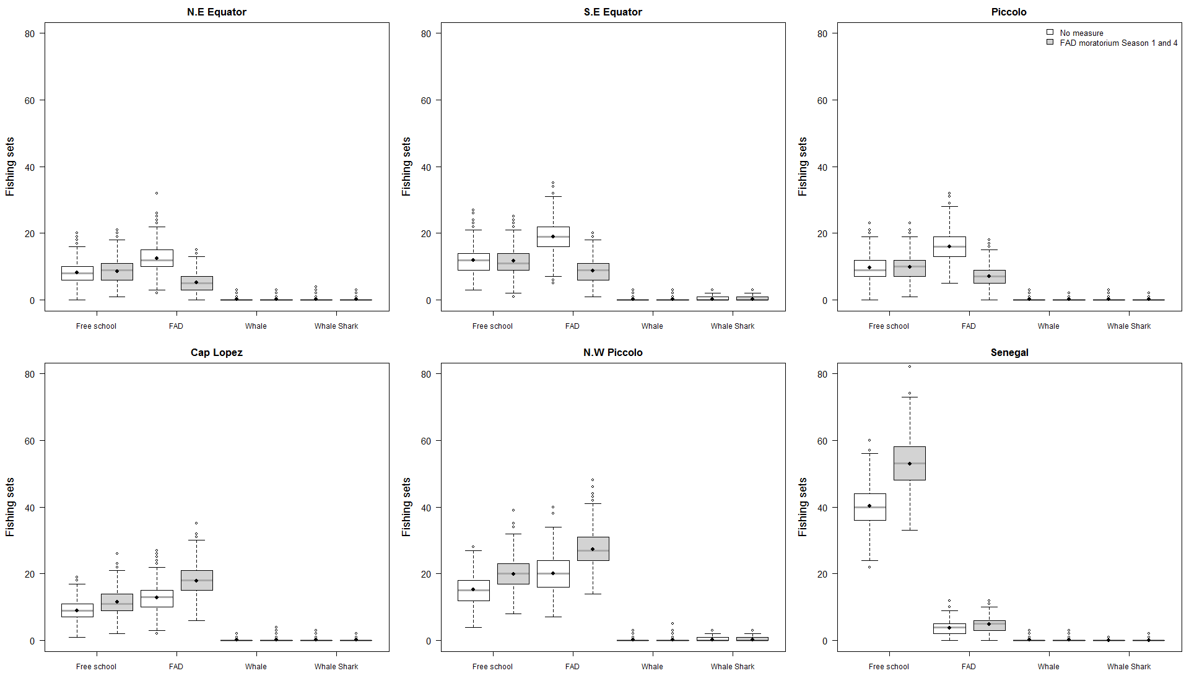Figure A6. Number of sets per fishing mode for the simulation of one Spanish purse-seiner over one fishing year in the Atlantic Ocean, for the baseline scenario (white) and for the scenario 1 of a moratorium on FAD during seasons 1 and 4 (grey).

