Tectonics
Supporting Information for
Seismic Imaging of an Intracrustal Deformation in the Northwestern Margin of the South China Sea: the Role of a Ductile Layer in the Crust
Haibo Huang^{1,3}, Frauke Klingelhoefer², Xuelin Qiu^{1,3,4}, Yuhan Li^{1,4}, Ping Wang^{1,3}
¹Key Laboratory of Ocean and Marginal Sea Geology, South China Sea Institute of Oceanology, Innovation Academy of South China Sea Ecology and Environmental Engineering, Chinese Academy of Sciences, Guangzhou 511458, P.R. China.
²Department of Marine Geosciences, IFREMER, Plouzané 29280, France.
³South Marine Science and Engineering Guangdong Laboratory (Guangzhou), Guangzhou 511458, P.R. China
⁴University of Chinese Academy of Sciences, Beijing 100049, P.R. China

Contents of this file

Figures S1 to S25
Introduction
The supporting information contains the figures of the tomographic inversion model and the different plot between the forward and the inversion model (Figure S1). It also contains the figure of the checkerboard tests (Figure S2). Figure S3 to S25 show the forward modeling of each OBS profile. In each figure of the forward modeling, the upper panel shows the original seismic profile, the middle panel shows the profile overlain by the calculated traveltimes for the picked phases, and the lower panel shows the velocity model with the seismic ray paths. The phases in each figure are named in the following way: direct water phase (Pw), refracted phases in the sediments (Ps), the crust (Pg) and the upper mantle (Pn), sedimentary reflections (PsP1, PsP2), reflections from the basement (PsP3), reflections from the mid-crustal interface (PcP) and the Moho (PmP).

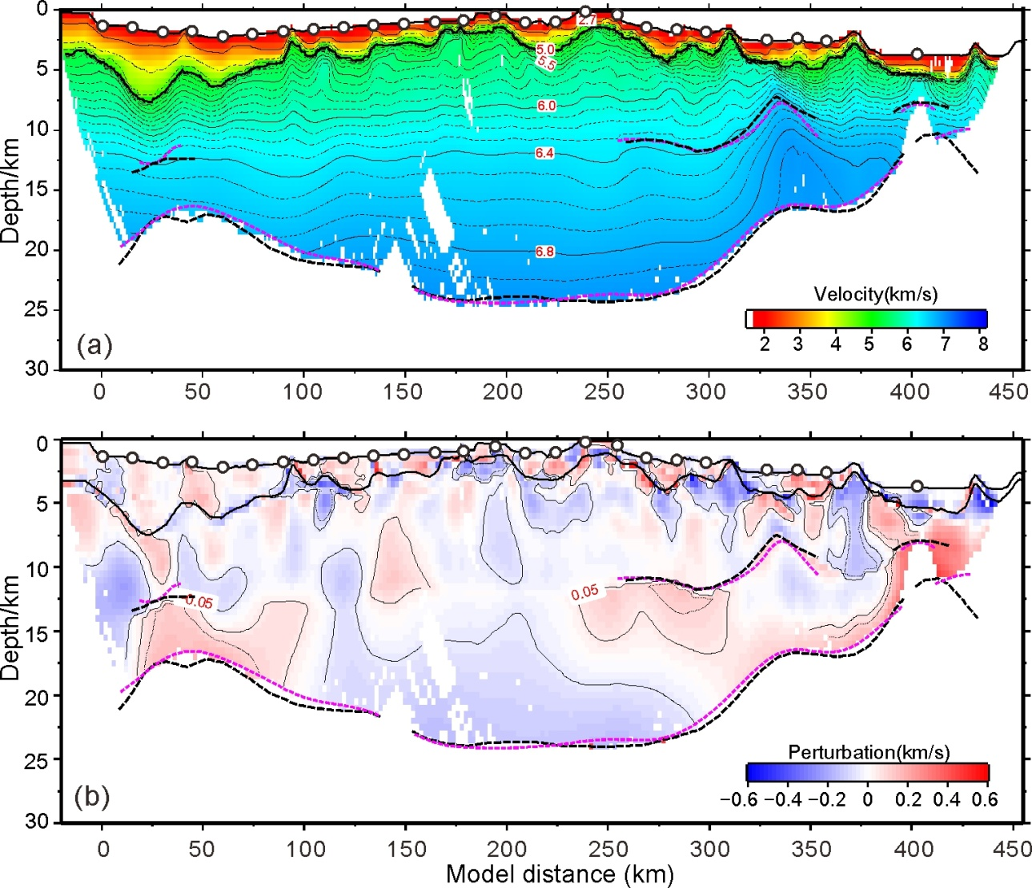
Figure S1. (a) The tomographic inversion model. (b) The different plot between the forward and the inversion model. The red and blue colors indicate that the velocity in the forward model is larger and smaller than that in the inversion model, respectively. In both panels, the purple dashed lines are the inverted velocity interfaces while the black dashed lines are the forward velocity interfaces.
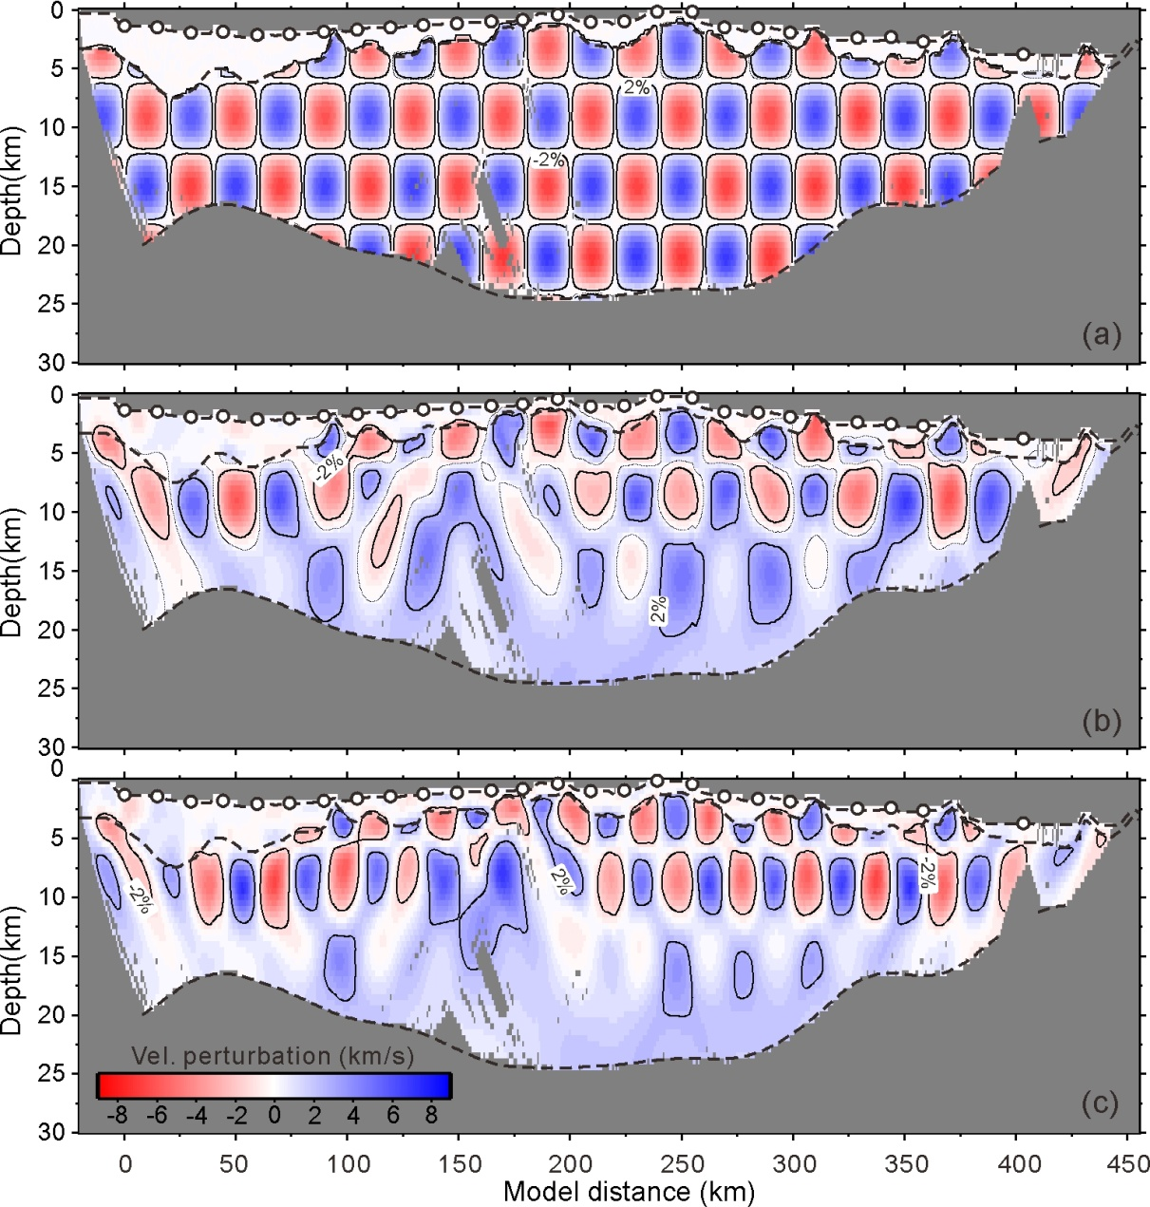
Figure S2. Results of the checkerboard tests for the velocity model. The amplitude of the velocity perturbation is 8%. (a) Original perturbed forward model, with anomaly size in 25 km × 6 km. (b) Recovered anomalies in 25 km × 6 km. (c) Recovered anomalies in 15 km × 6 km.

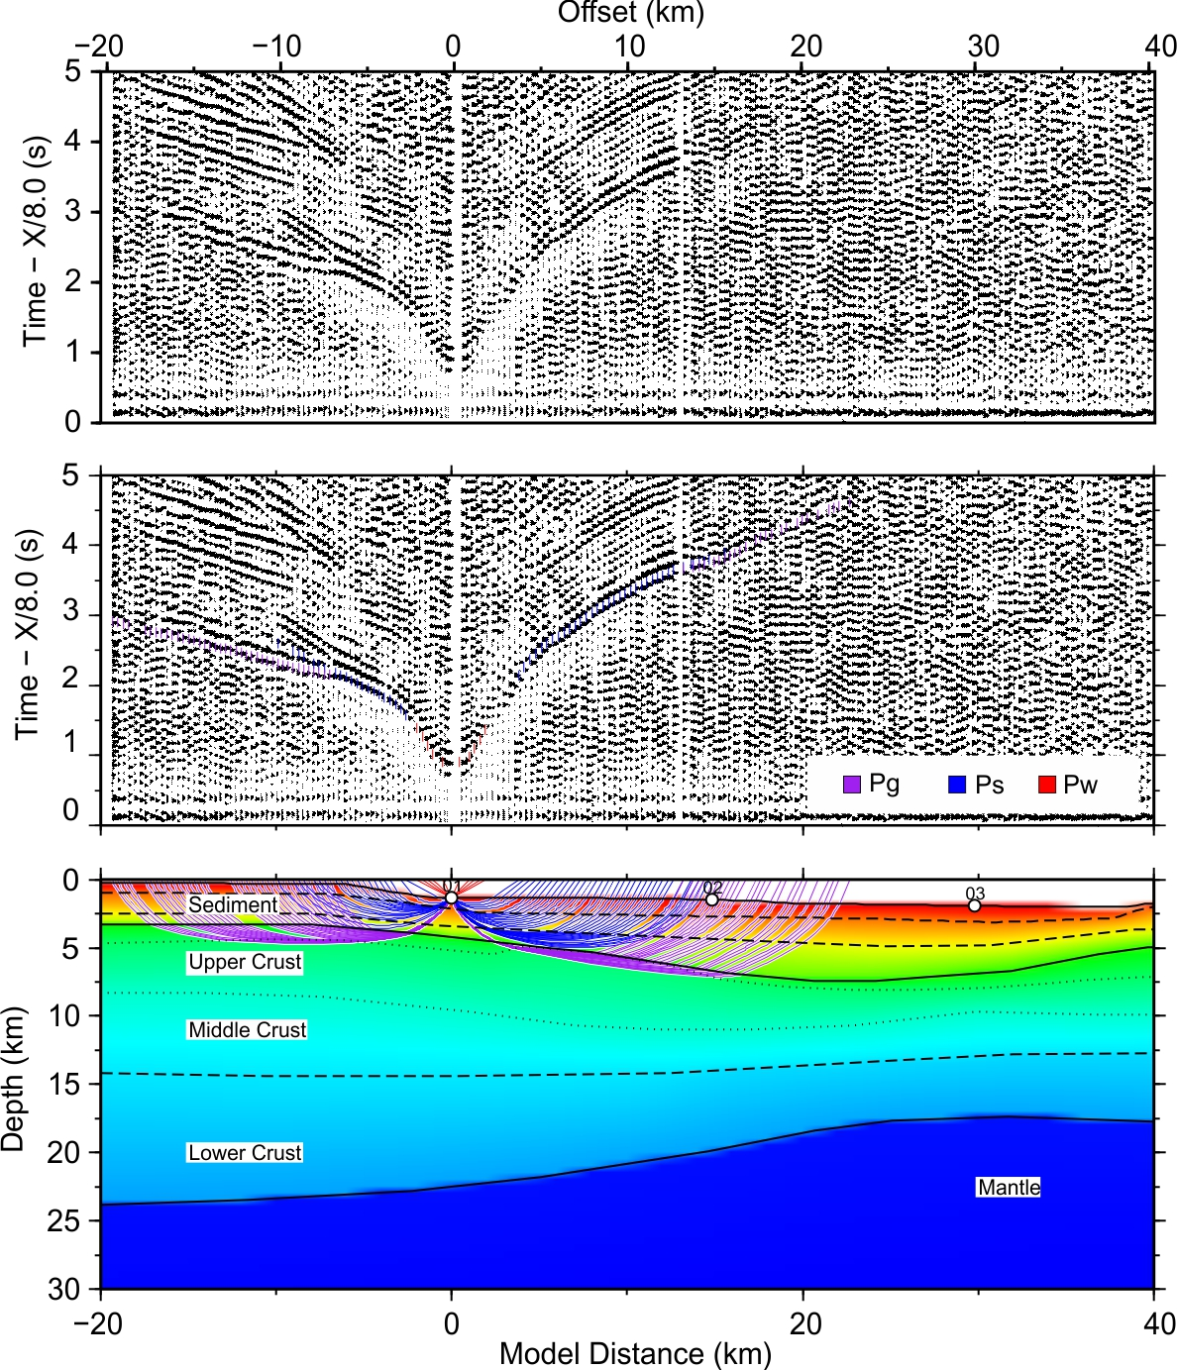

Figure S3. Seismic profile and forward modeling of OBS01

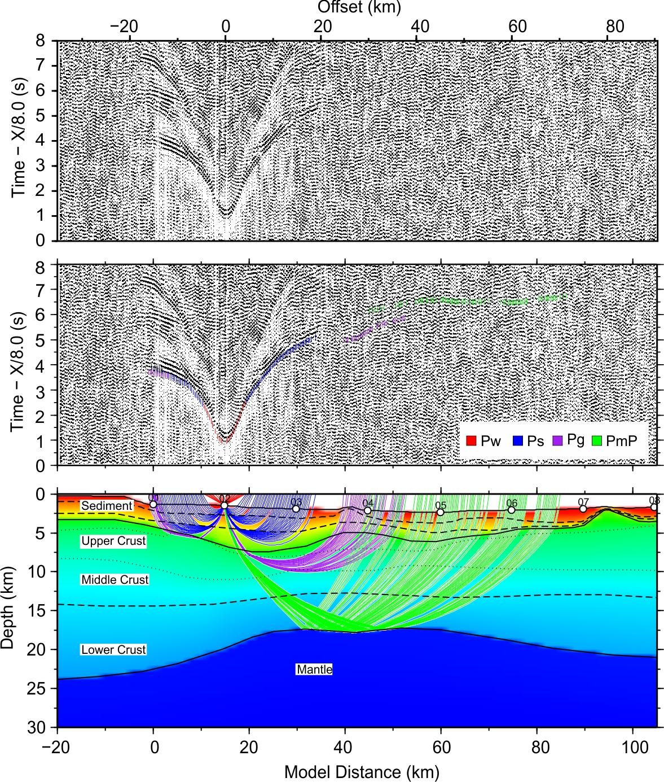

Figure S4. Seismic profile and forward modeling of OBS02

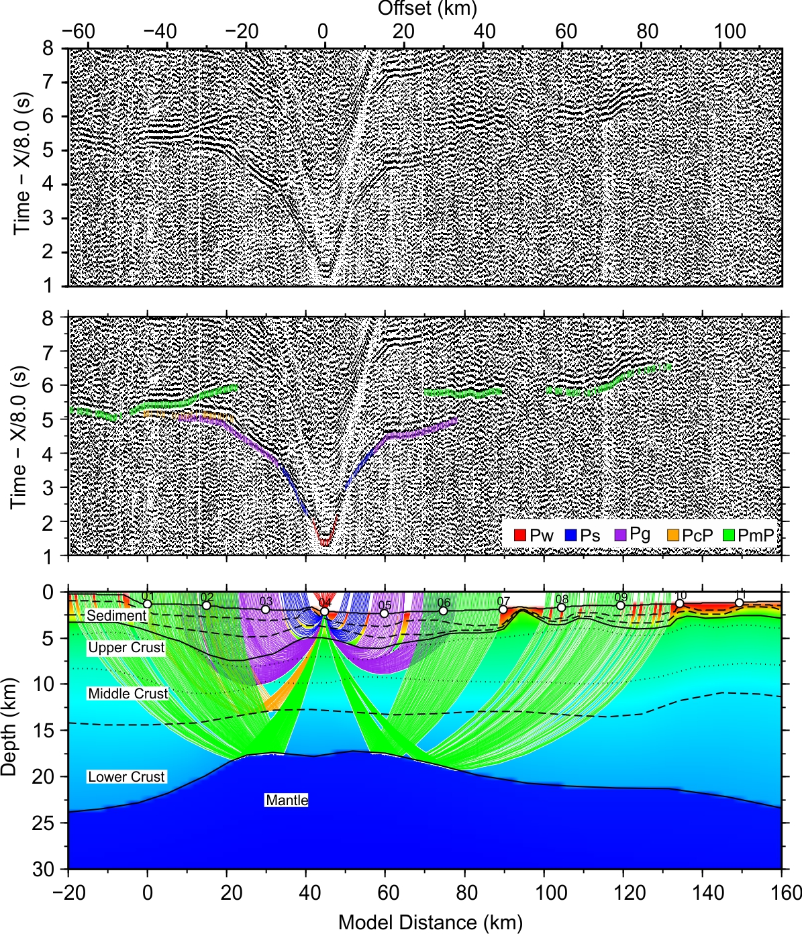

Figure S5. Seismic profile and forward modeling of OBS04

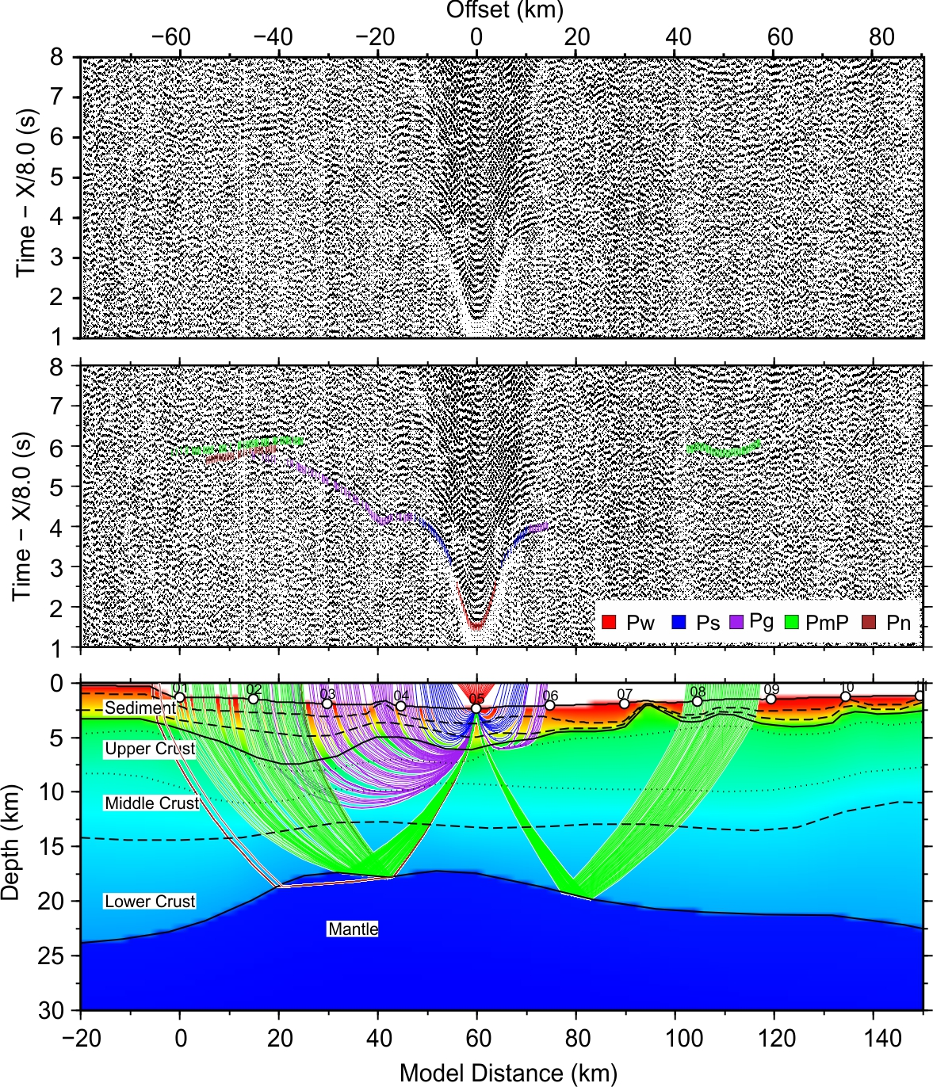

Figure S6. Seismic profile and forward modeling of OBS05

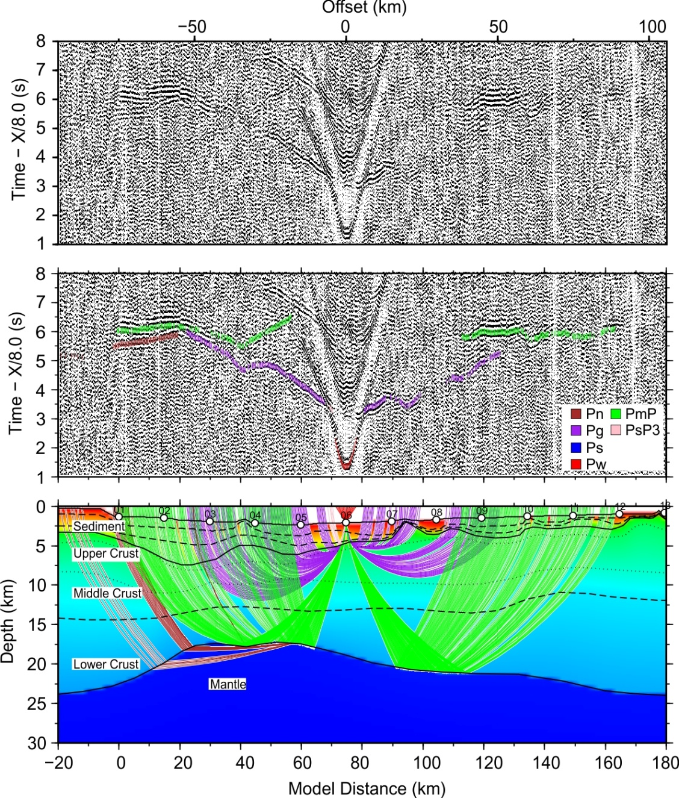

Figure S7. Seismic profile and forward modeling of OBS06

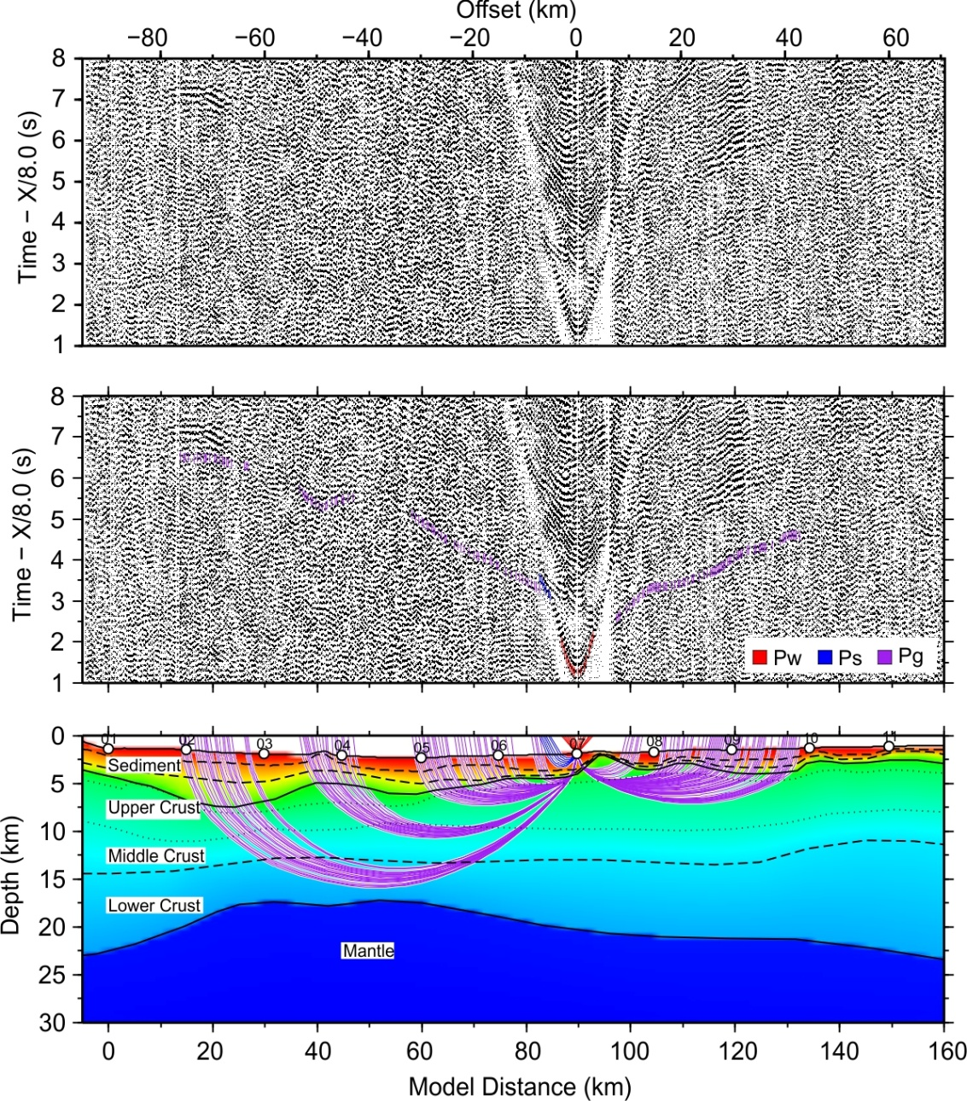

Figure S8. Seismic profile and forward modeling of OBS07

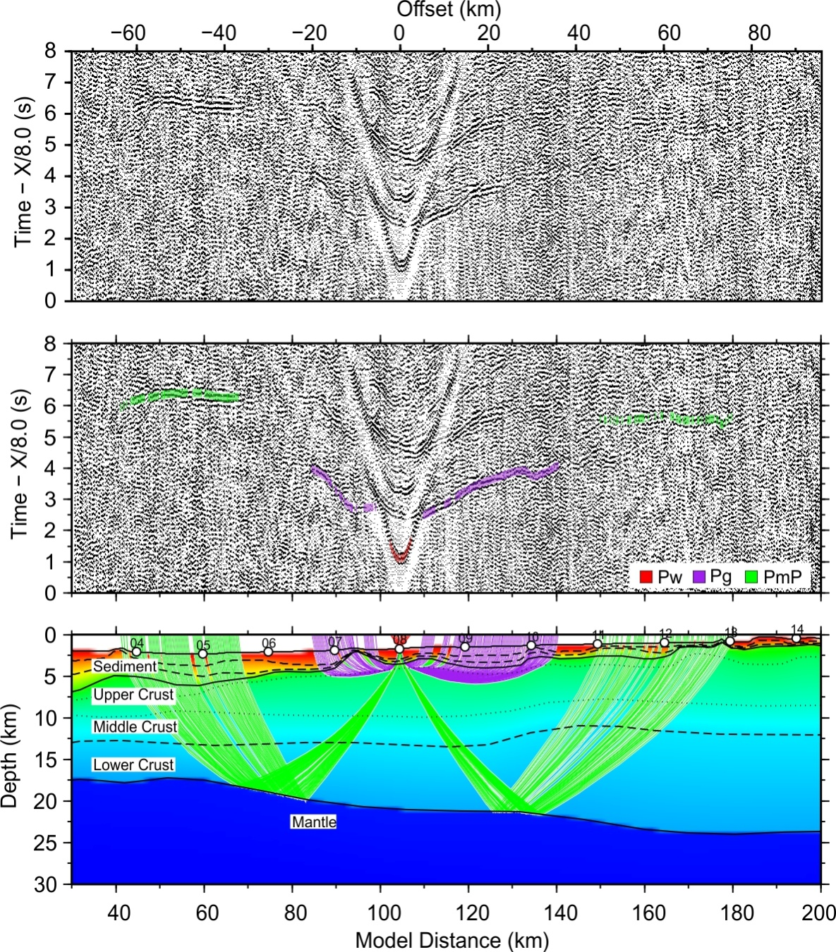

Figure S9. Seismic profile and forward modeling of OBS08

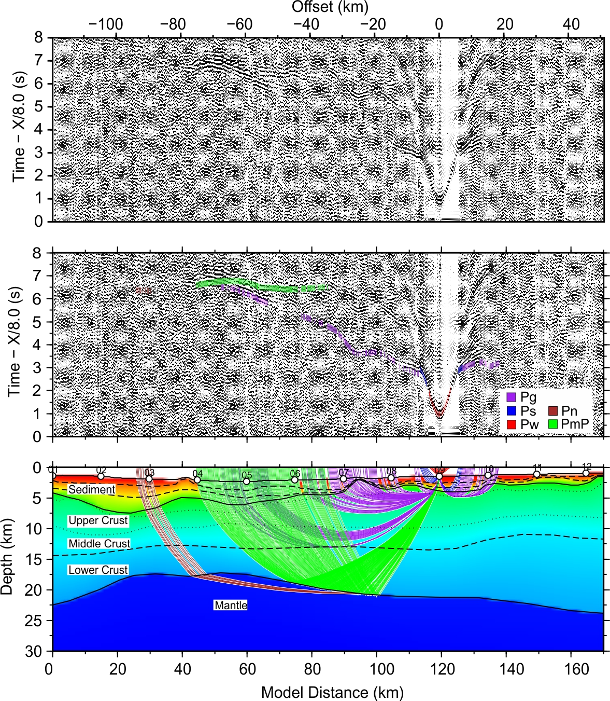

Figure S10. Seismic profile and forward modeling of OBS09

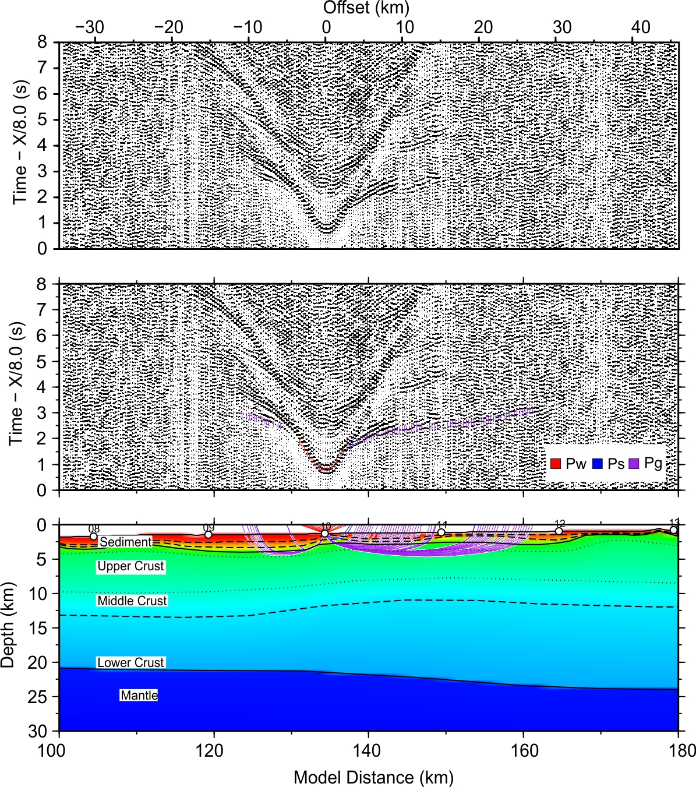

Figure S11. Seismic profile and forward modeling of OBS10

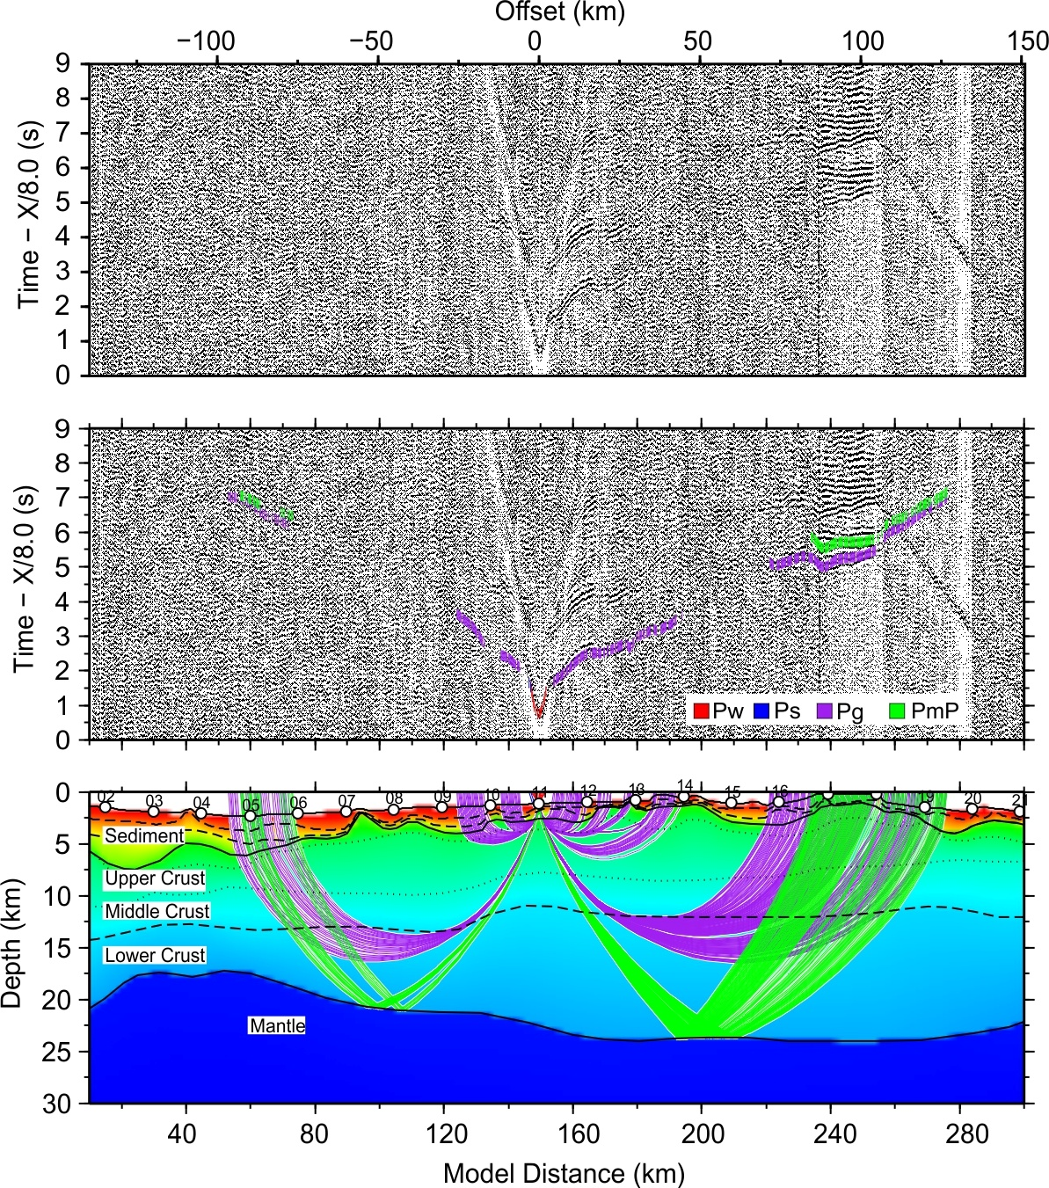

Figure S12. Seismic profile and forward modeling of OBS11

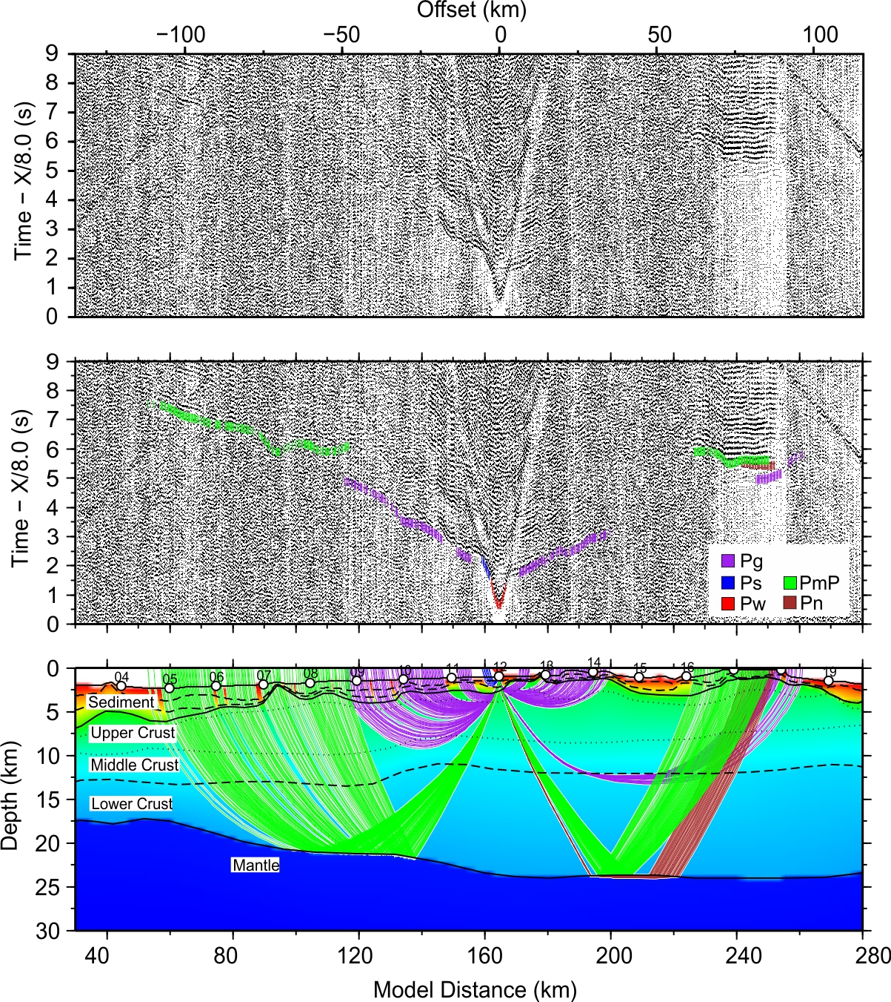

Figure S13. Seismic profile and forward modeling of OBS12

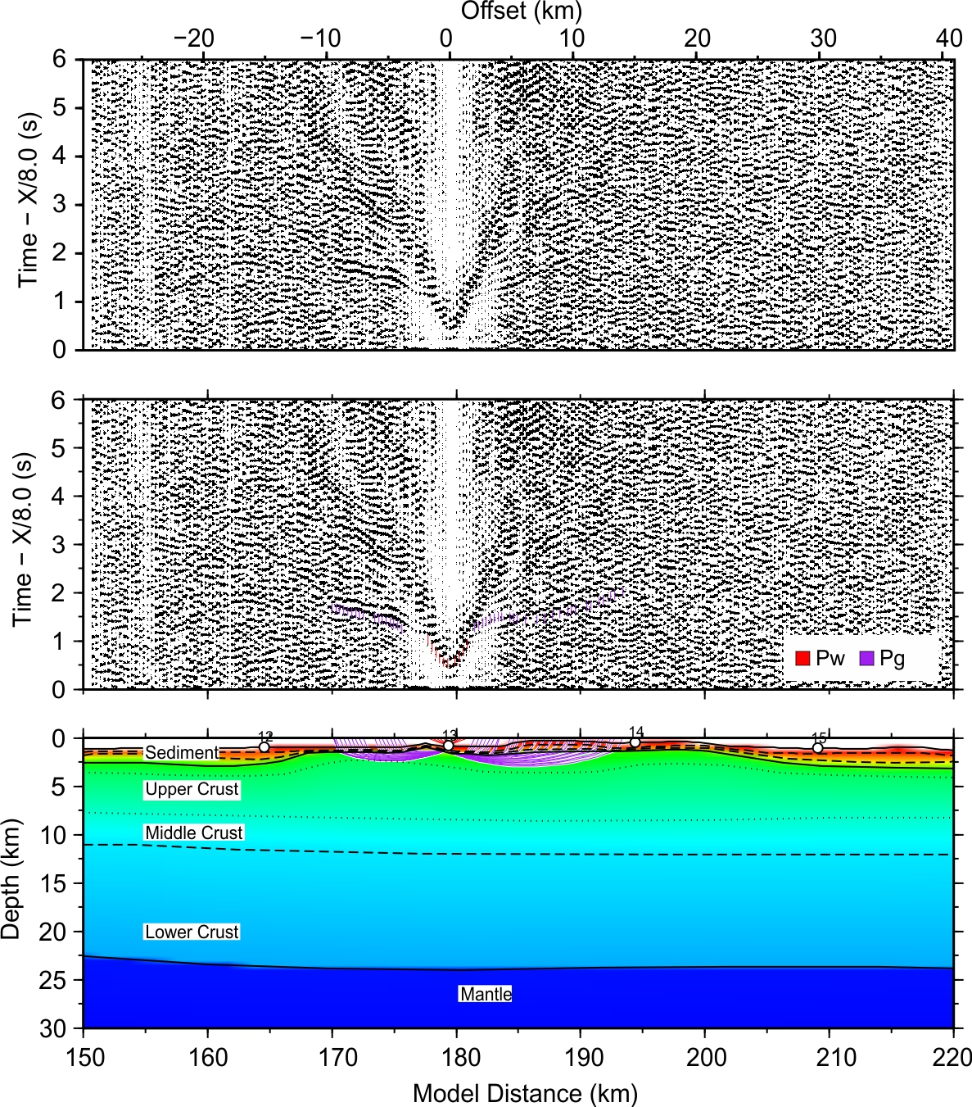

Figure S14. Seismic profile and forward modeling of OBS13

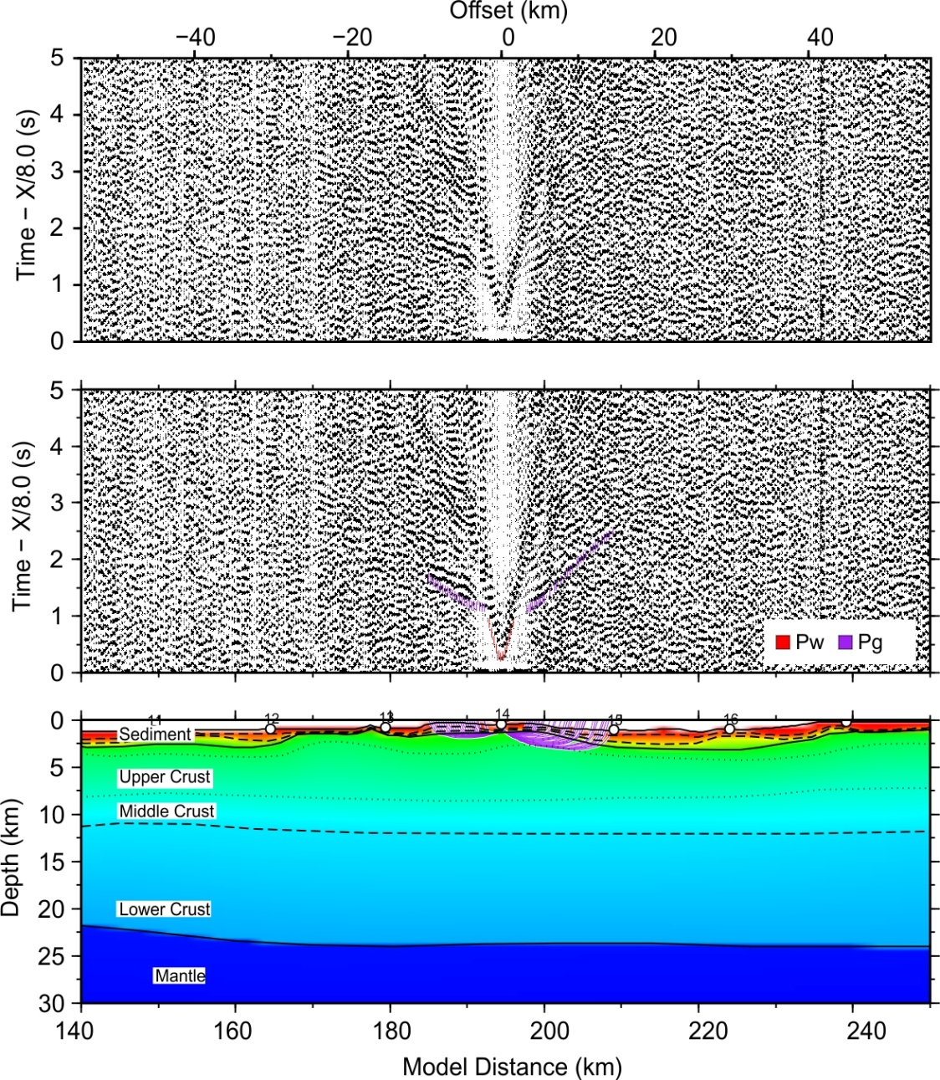

Figure S15. Seismic profile and forward modeling of OBS14

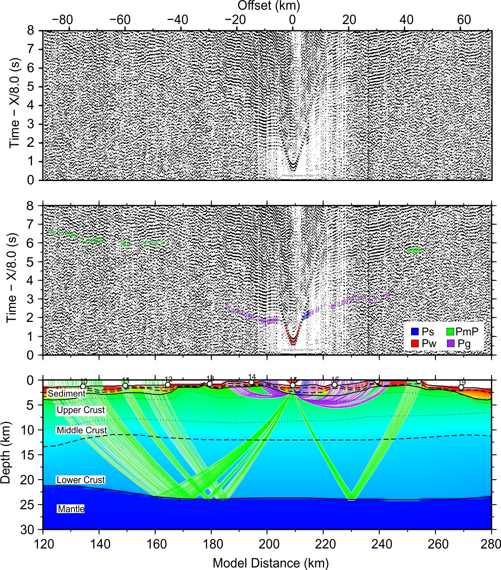

Figure S16. Seismic profile and forward modeling of OBS15

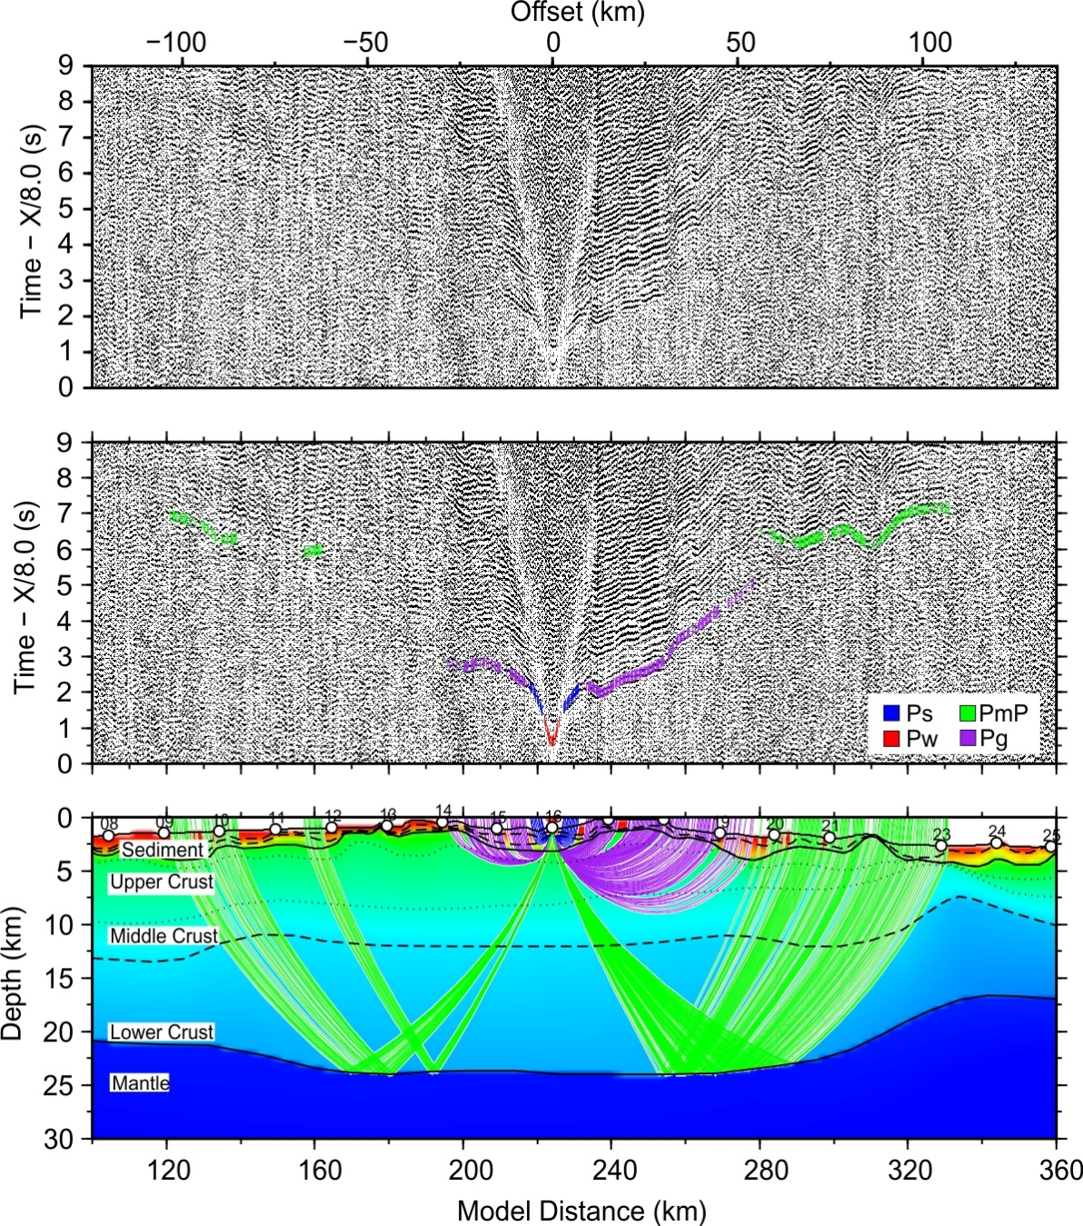

Figure S17. Seismic profile and forward modeling of OBS16

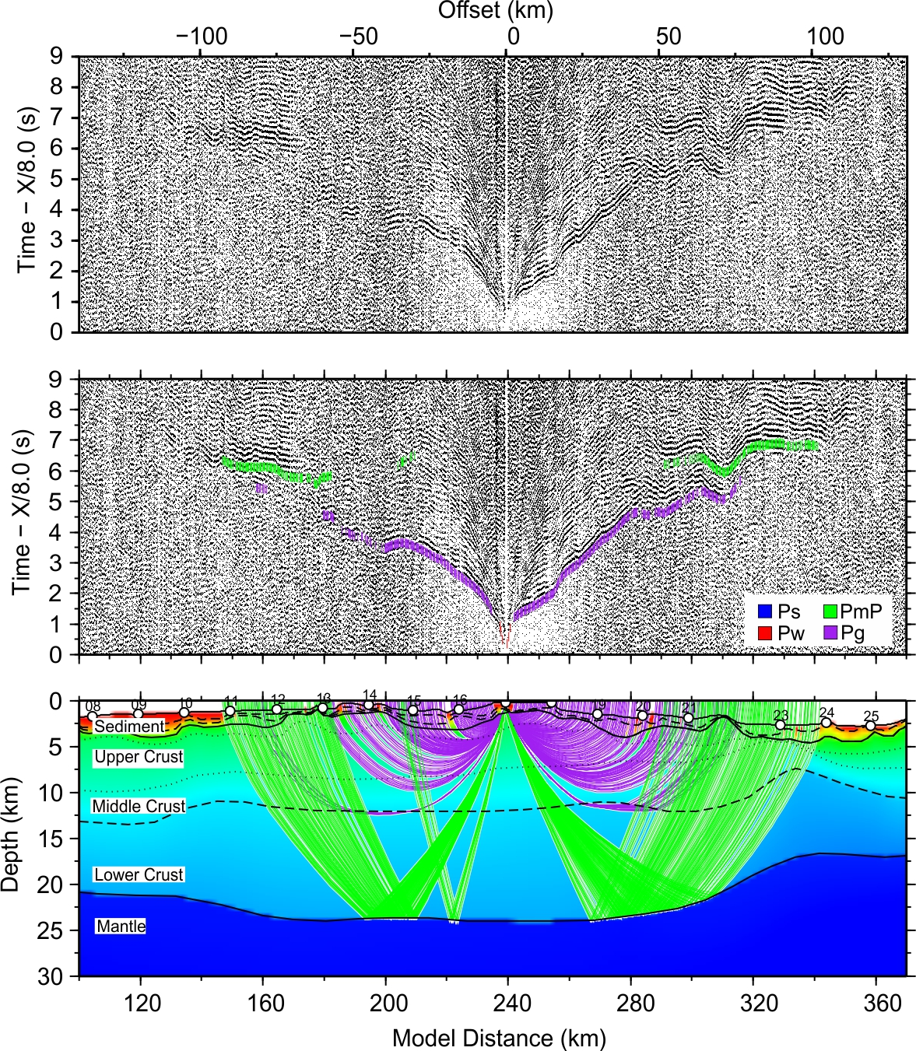

Figure S18. Seismic profile and forward modeling of OBS17

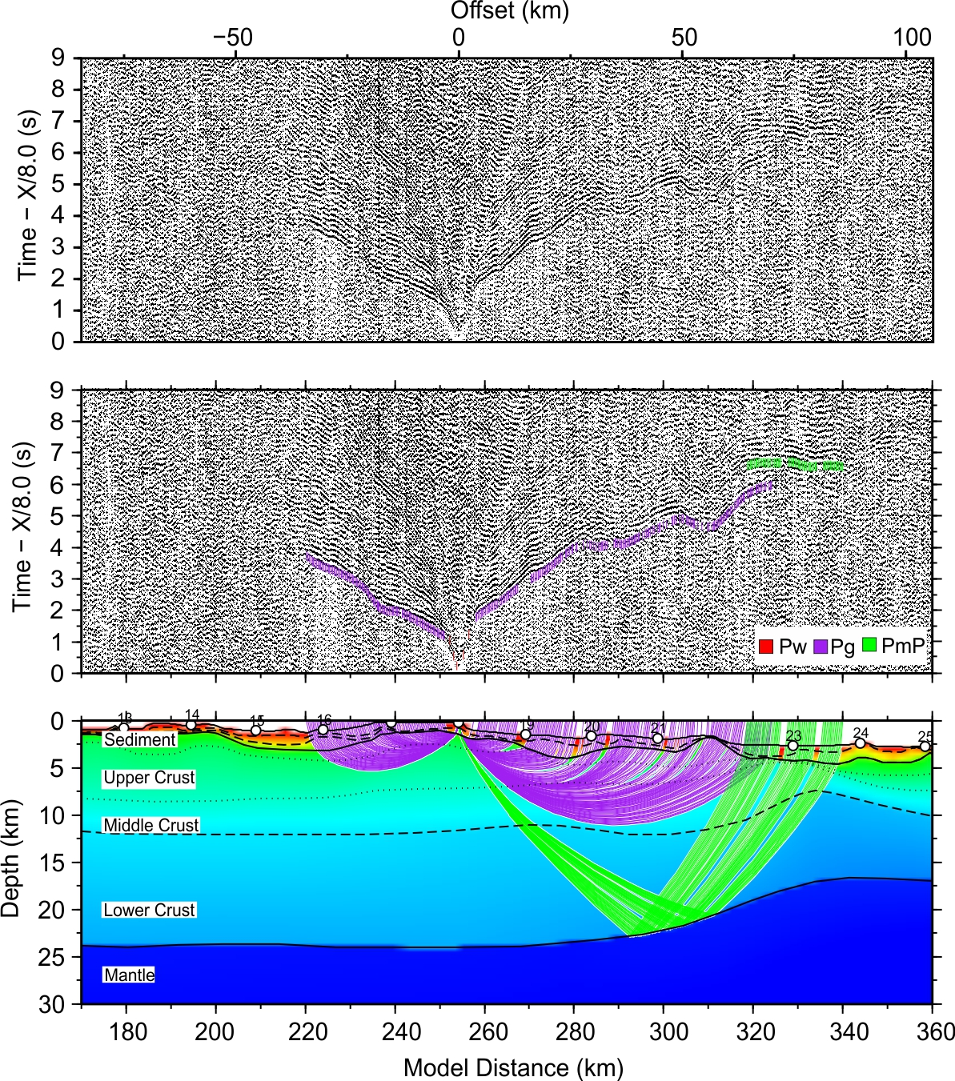

Figure S19. Seismic profile and forward modeling of OBS18

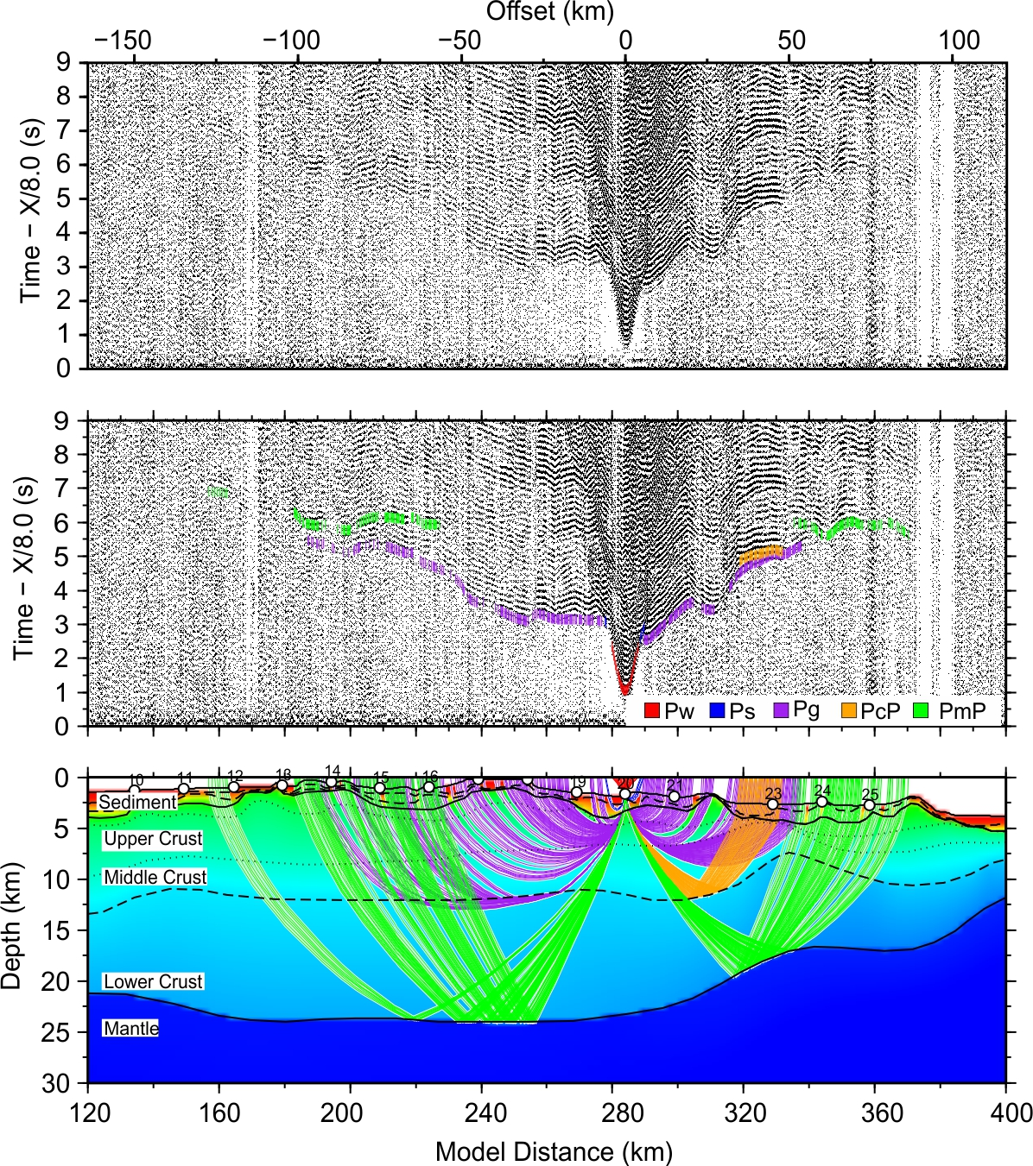

Figure S20. Seismic profile and forward modeling of OBS20

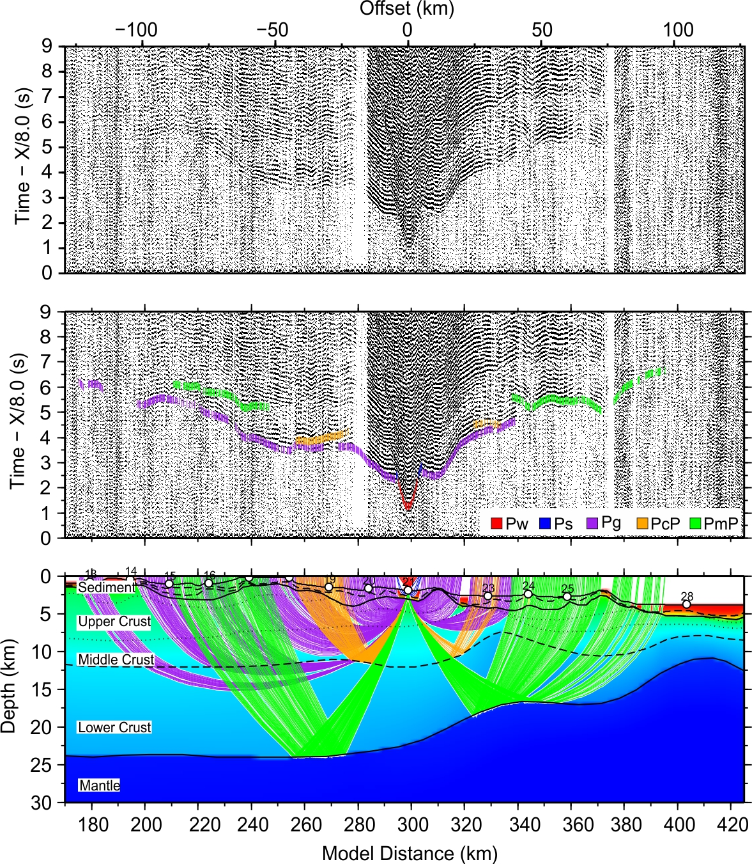

Figure S21. Seismic profile and forward modeling of OBS21

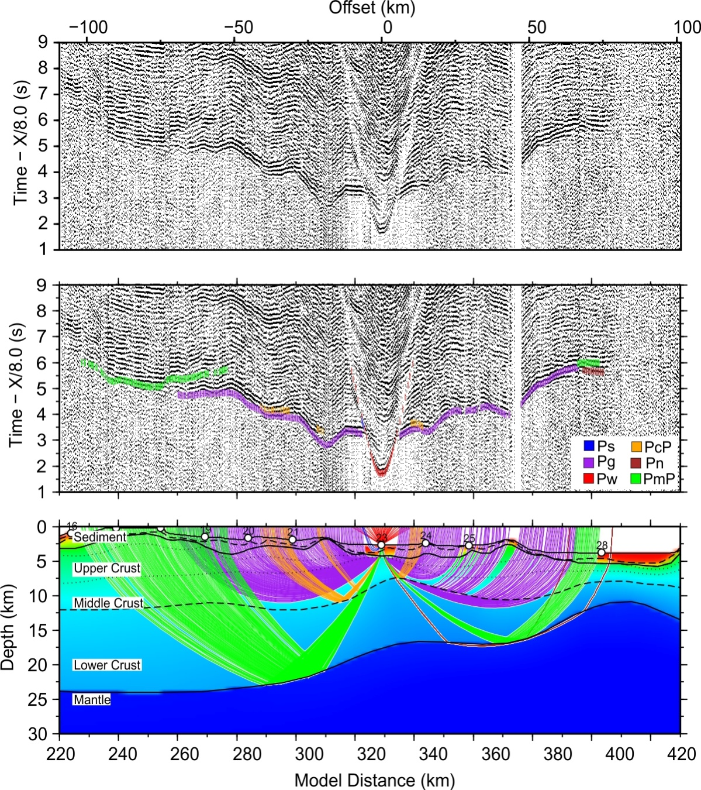

Figure S22. Seismic profile and forward modeling of OBS23

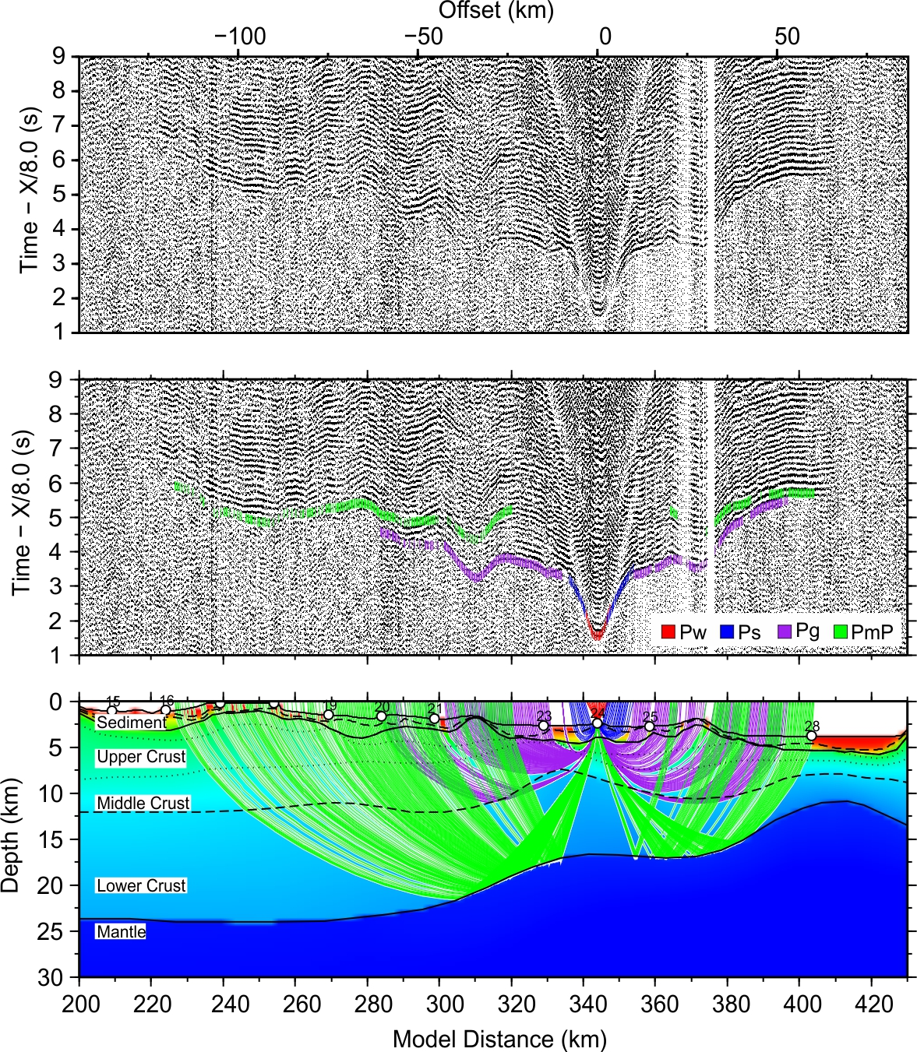

Figure S23. Seismic profile and forward modeling of OBS24

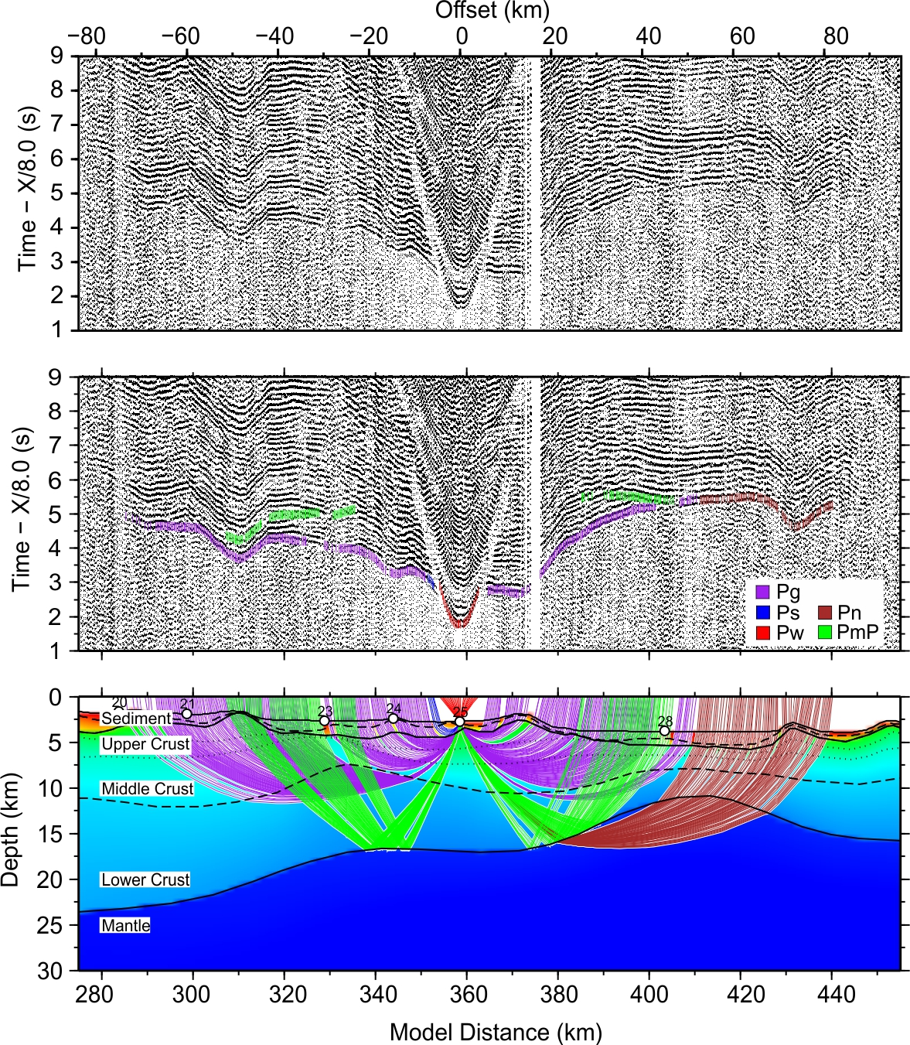

Figure S24. Seismic profile and forward modeling of OBS25

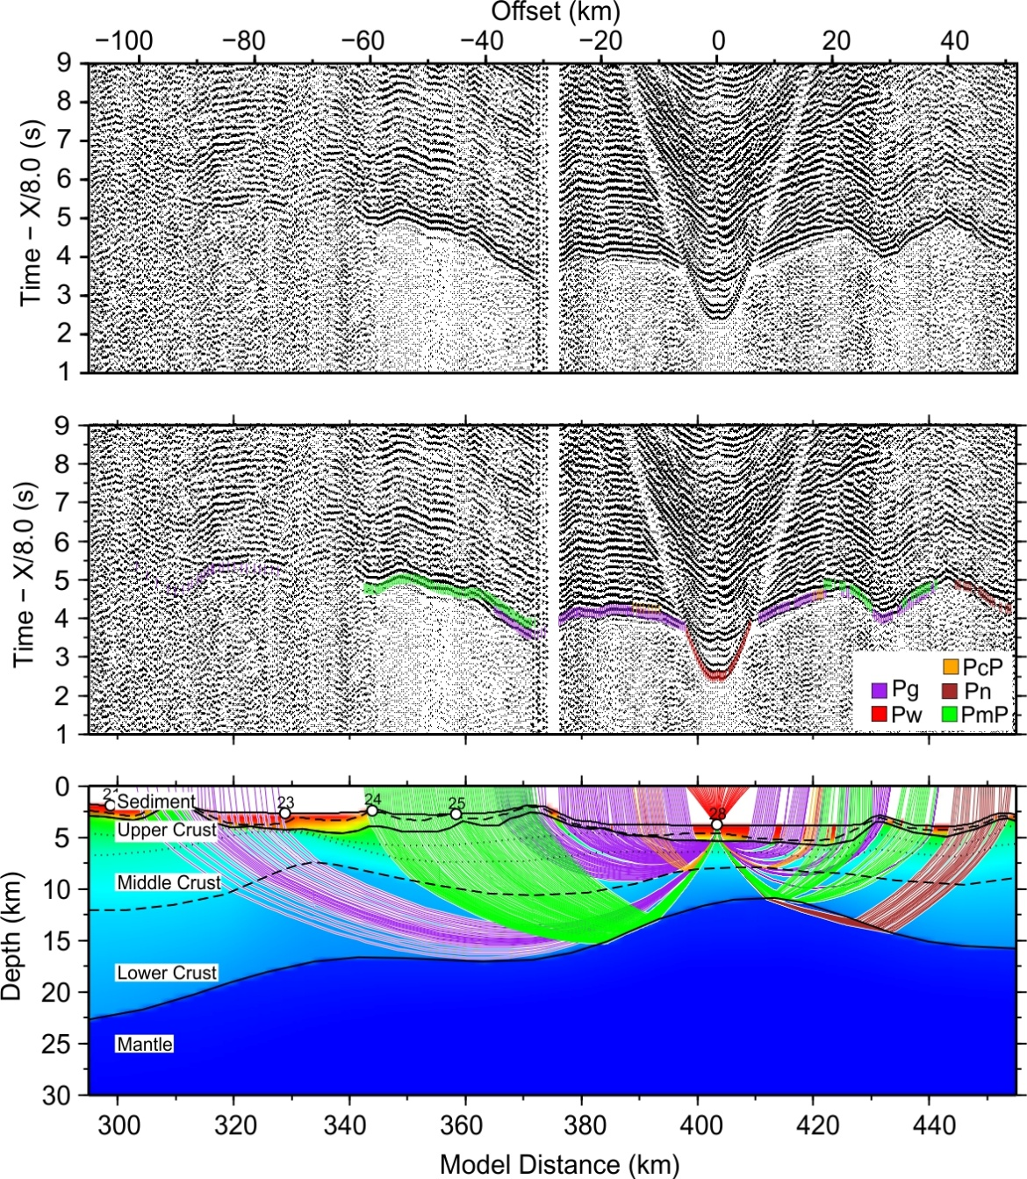

Figure S25. Seismic profile and forward modeling of OBS28

