Appendix A. Supplementary material – Details on habitat sampled

Table A.1 : Number of MEDITS’ observations in each habitat and corresponding abrasion ranges.
The three abrasion values represent the minimum value, the median and the maximum value in the Gulf of Lion (GoL) and eastern Corsica. Grey shading indicates habitats sufficiently covered by the available observation (more than 40 observations). A5.46 and A5.47 in GoL and Corsica had to be merged.
Habitats | Areas | Number of observations | Number of un-trawled stations | Abrasion range  (SAR.y⁻¹) | Sampled abrasion range (SAR.y⁻¹)
A5.38 | GoL | 49 | 0 | 0 – 10.79 – 38.18 | 2.70 – 17.22 – 29.15
A5.39 |  | 129 | 0 | 0 – 5.59 – 29.66 | 2.06 – 5.25 – 13.79
A5.46 |  | 24 | 0 | 0 – 4.02 – 28.49 | 0.20 – 3.81 – 20.77
A5.47 |  | 170 | 0 | 8×10⁻⁴ – 3.49 – 20.22 | 0.08 – 3.64 – 11.07
A5.46 | Corsica | 56 | 9 | 0 – 0.34 – 5.74 | 0 – 0.11 – 2.03
A5.47 |  | 12 | 0 | 0 – 0.15 – 3.46 | 0.08 – 0.75 – 2.03

Table A.2 : Number of IBTS’ observations in each North Sea habitat and corresponding abrasion ranges.
The three abrasion values ​​represent the minimum value, the median and the maximum value. Grey shading indicates habitats sufficiently covered by the available observation (more than 40 observations)
Habitats | Number of observations | Number of un-trawled stations | Abrasion range  (SAR.y⁻¹) | Sampled abrasion range (SAR.y⁻¹)
A5.13 | 7 | 0 | 0 – 1.91 – 8.42 | 1.59 – 1.98 – 2.14
A5.14 | 15 | 0 | 0 – 0.62 – 31.53 | 0.0001 – 1.06 – 7.64
A5.15 | 108 | 11 | 0 – 1.15 – 32.70 | 0 – 3.43 – 16.51
A5.25/26 | 121 | 0 | 0 – 1.61 – 51.27 | 0.11 – 2.02 – 11.14
A5.27 | 226 | 10 | 0 – 0.98 – 62.76 | 0 – 1.17 – 16.15
A5.37 | 84 | 0 | 0.004 – 1.30 – 26.47 | 0.60 – 1.74 – 13.41
A5.44 | 1 | 0 | 0 – 0.15 – 5.45 | 0.007
A5.45 | 3 | 0 | 0.002 – 0.95 – 18.24 | 6.94 – 7.08 – 7.08

Habitats | Season | Number of observations | Number of un-trawled stations | Abrasion range  (SAR.y⁻¹) | Sampled abrasion range (SAR.y⁻¹)
A4.1 | Autumn | 9 | 0 | 0 – 0.14 – 5.16 | 0.98 – 1.06 – 1.06
A4.2 |  | 2 | 0 | 0 – 0.17 – 6.20 | 0.30 – 0.75 – 1.20
A5.13 |  | 2 | 0 | 0 – 1.09 – 25.21 | 5.47 – 6.22 – 6.97
A5.14 |  | 264 | 3 | 0 – 0.86 – 36.72 | 0 – 4.60 – 29.58
A5.15 |  | 495 | 0 | 0 – 3.40 – 78.71 | 0.03 – 14.00 – 74.15
A5.23/24 |  | 29 | 0 | 0.04 – 2.69 – 22.58 | 0.65 – 6.21 – 14.10
A5.25/26 |  | 140 | 0 | 0 – 1.51 – 33.40 | 0.03 – 3.75 – 21.42
A5.27 |  | 42 | 0 | 0.05 – 2.98 – 35.67 | 1.29 – 11.98 – 26.14
A5.33 |  | 3 | 0 | 0.008 – 1.81 – 16.40 | 9.29
A5.35 |  | 4 | 0 | 6×10⁻⁴ – 0.21 – 18.16 | 1.16 – 6.46 – 9.29
A5.37 |  | 11 | 0 | 0.76 – 1.71 – 16.88 | 2.61 – 2.61 – 5.91
A5.45 |  | 5 | 0 | 0 – 3.55 – 18.46 | 2.50 – 2.90 – 8.85
A4.2 | Winter | 1 | 0 | 0 – 0.17 – 6.20 | 1.20
A5.13 |  | 1 | 0 | 0 – 1.09 – 25.21 | 6.97
A5.14 |  | 60 | 1 | 0 – 0.86 – 36.72 | 0 – 5.29 – 29.58
A5.15 |  | 71 | 0 | 0 – 3.40 – 78.71 | 1.55 – 10.41 – 72.34
A5.25/26 |  | 10 | 0 | 0 – 1.51 – 32.09 | 0.46 – 1.16 – 8.52
A5.27 |  | 5 | 0 | 0.05 – 2.98 – 35.67 | 9.41 – 18.83 – 26.14
A5.37 |  | 3 | 0 | 0.76 – 1.71 – 16.88 | 2.61
Table A.3 : Number of observations in each English Channel habitat and corresponding abrasion ranges for the two sampling season.
The three abrasion values ​​represent minimum, median and maximum value. Grey shading indicates habitats with a good representativeness in the sampling (more than 40 observations)

Appendix B - Details on selected models in each studied areas

Mediterranean Sea
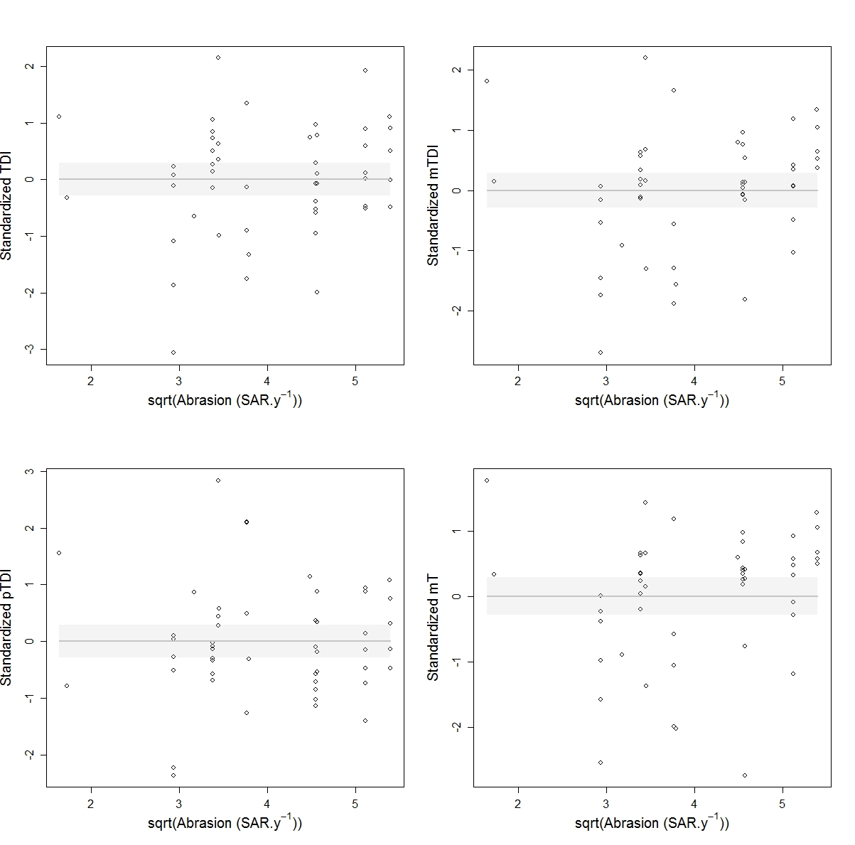

Figure B.1: Indices modelled relationships to fishery abrasion in habitat A5.38: Mediterranean communities of muddy detritic bottoms. Null models (grey lines and 95% confidence interval in grey shading) were the only fitting models for all indices. No negative significant relationship and no thresholds could be detected.

Table B.1: Summary of the modelling results in the habitat A5.38
Grey shading indicates the index and the model selected for this habitat
Indices | Models | Slope | AdjR² | RMAE
TDI | Null | - | 0 | 0.14
 | Neglinear | 0.13 | - | -
mTDI | Null | - | 0 | 0.15
 | Neglinear | 0.18 | 0.01 | -
pTDI | Null | - | 0 | 0.14
 | Neglinear | 0.02 | - | -
mT | Null | - | 0 | 0.17
 | Neglinear | 0.18 | 0.01 | -

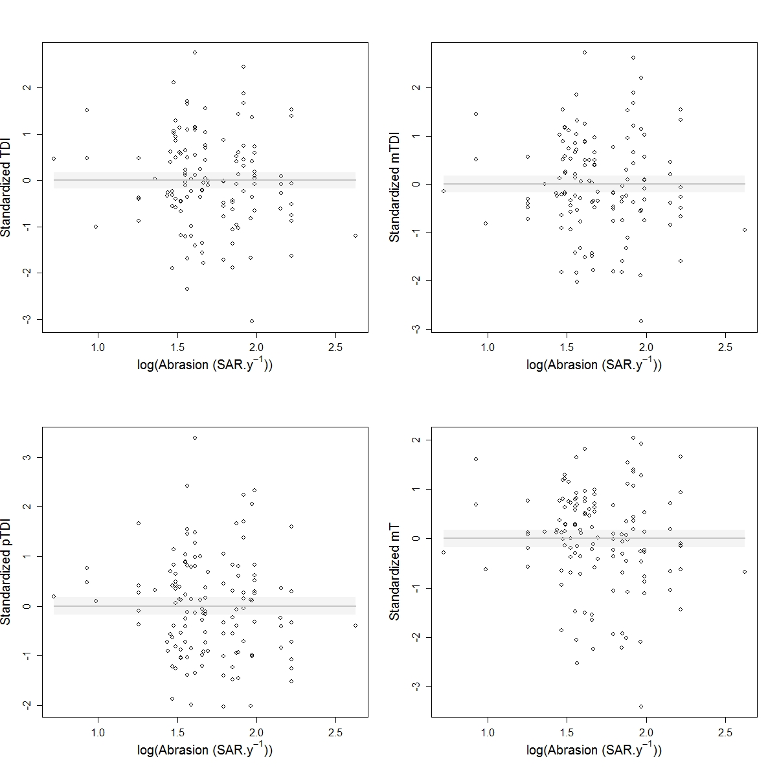
Figure B.2: Indices modelled relationships to fishery abrasion in habitat A5.39: Mediterranean communities of coastal terrigenous muds. Null models (grey lines and 95% confidence interval in grey shading) were the only fitting models for all indices. No negative significant relationship and no thresholds could be detected.

Table B.2: Summary of the modelling results in the habitat A5.39
Grey shading indicates the index and the model selected for this habitat
Indices | Models | Slope | AdjR² | RMAE
TDI | Null | - | 0 | 0.13
 | Neglinear | -0.35 | 2.10⁻³ | -
mTDI | Null | - | 0 | 0.14
 | Neglinear | -0.18 | - | -
pTDI | Null | - | 0 | 0.15
 | Neglinear | -0.30 | - | -
mT | Null | - | 0 | 0.14
 | Neglinear | -0.42 | 0.01 | -

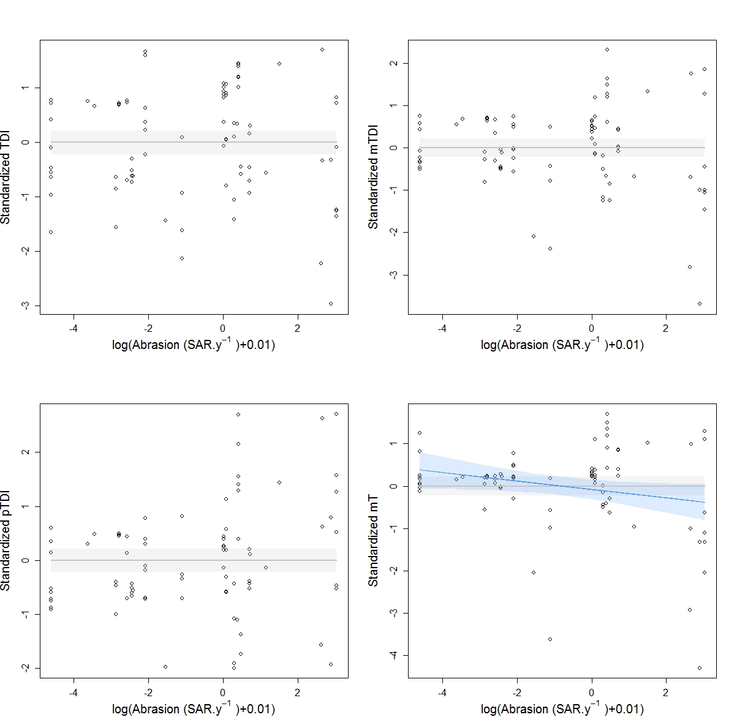
Figure B.3: Indices modelled relationships to fishery abrasion in habitat A5.46: Mediterranean communities of coastal detritic bottoms. Null models (grey lines and 95% confidence interval in grey shading) were the only fitting models for TDI, mTDI and pTDI but neglinear model (blue line and 95% confidence interval in blue shading) was more suited for mT index. No significant thresholds could be detected.

Table B.3: Summary of the modelling results in the habitat A5.46
Grey shading indicates the index and the model selected for this habitat. * indicates that P<0.05 ; ** indicates that P<0.01
Indices | Models | Slope | AdjR² | RMAE
TDI | Null | - | 0 | -
 | Neglinear | -0.02 | - | -
mTDI | Null | - | 0 | -
 | Neglinear | -0.05 | - | -
pTDI | Null | - | 0 | -
 | Neglinear | 0.10* | 0.04 | -
mT | Null | - | 0 | -
 | Neglinear | - 0.10* | 0.04 | 0.11

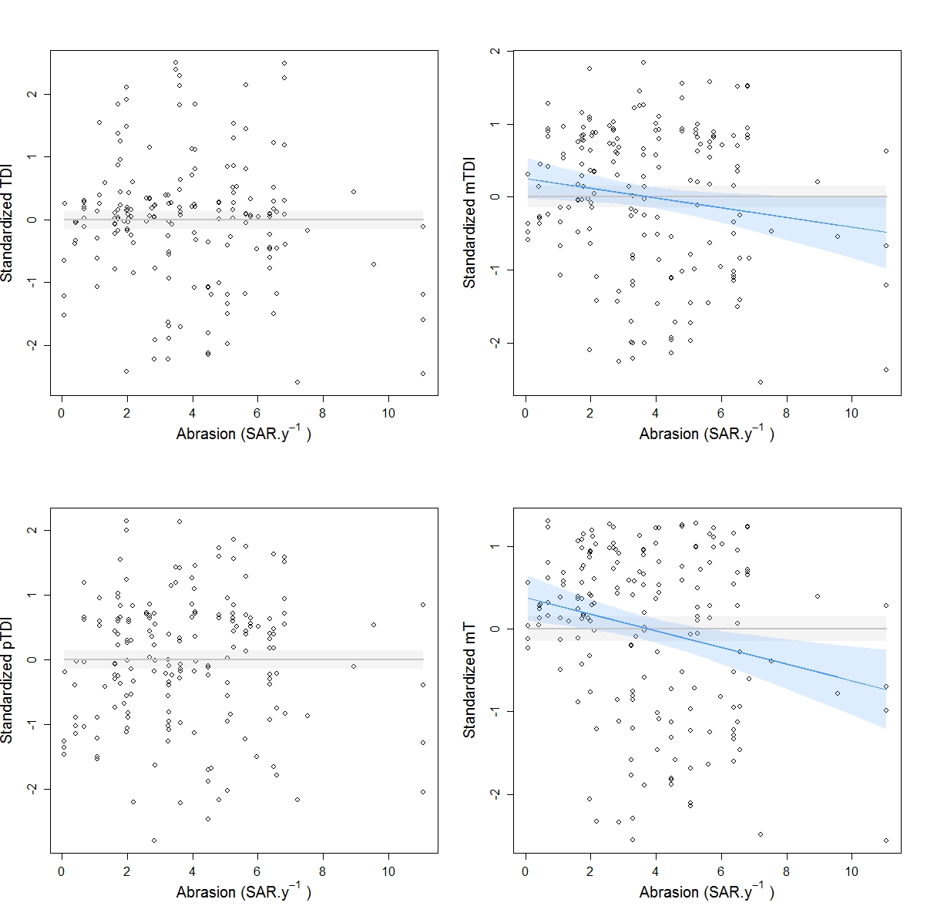
Figure B.4: Indices modelled relationships to fishery abrasion in habitat A5.47: Mediterranean communities of coastal detritic bottoms. Null models (grey lines and 95% confidence interval in grey shading) were the only fitting models for TDI and pTDI but neglinear models (blue lines and 95% confidence interval in blue shading) were more suited for mTDI and mT index. No significant thresholds could be detected.

Table B.4: Summary of the modelling results in the habitat A5.47
Grey shading indicates the index and the model selected for this habitat. * indicates that P<0.05 ; ** indicates that P<0.01
Indices | Models | Slope | AdjR² | RMAE
TDI | Null | - | 0 | -
 | Neglinear | -0.05 | 7.10⁻³ | -
mTDI | Null | - | 0 | -
 | Neglinear | -0.09** | 0.04 | 0.19
pTDI | Null | - | 0 | -
 | Neglinear | 0.01 | - | -
mT | Null | - | 0 | -
 | Neglinear | - 0.10** | 0.05 | 0.21

North Sea
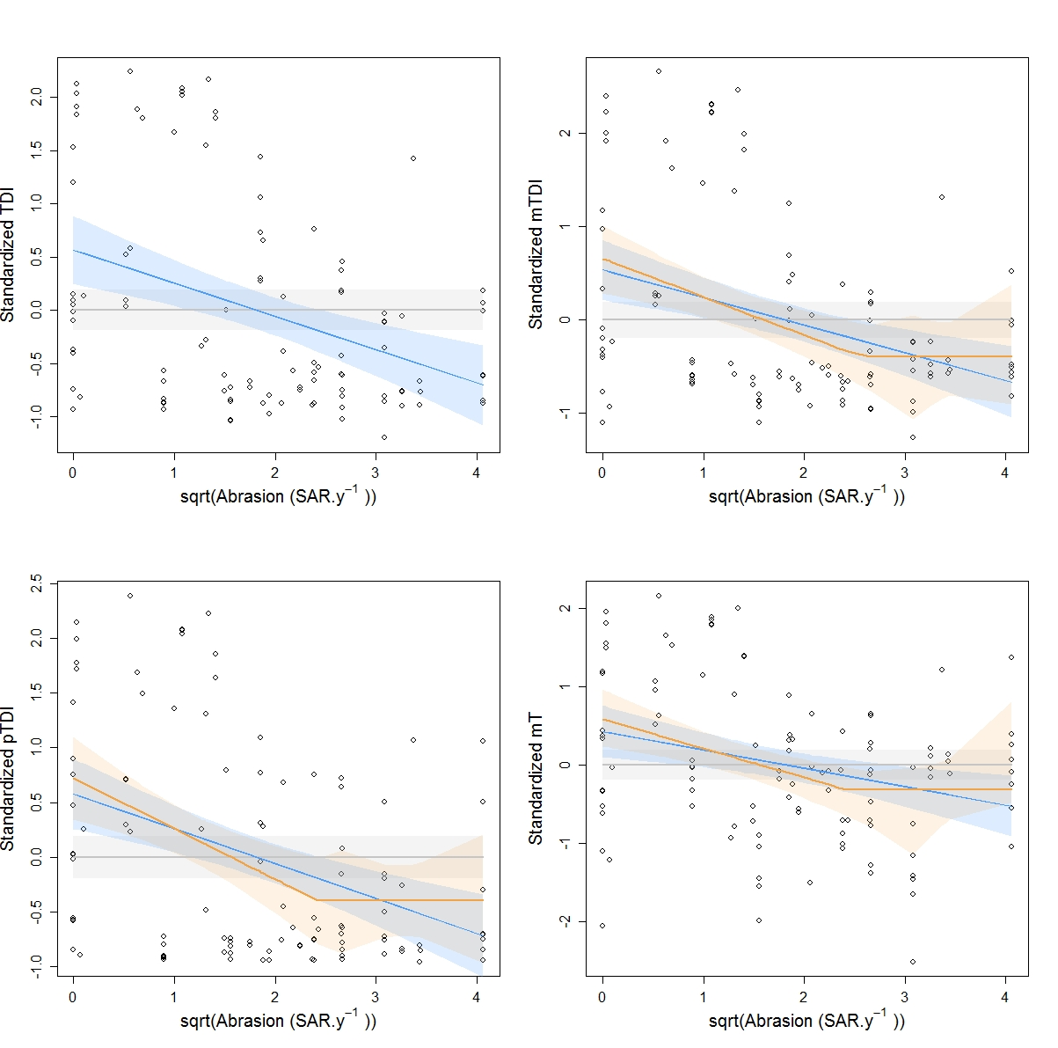
Figure B.5: Indices modelled relationships to fishery abrasion in habitat A5.15: Deep circalittoral coarse sediment. Null models (grey lines and 95% confidence interval in grey shading) and neglinear models (blue lines and 95% confidence interval in blue shading) fitted for all indices but segmented2 (orange lines and 95% confidence interval in orange shading) model was more suited for mTDI, pTDI and mT.
Table B.5: Summary of the modelling results in the habitat A5.15
Grey shading indicates the index and the model selected for this habitat. * indicates that P<0.05 ; ** indicates that P<0.01 ; *** indicates that P<0.001
Indices | Models | Slope | Threshold 1 | Threshold 2 | AdjR² | RMAE
TDI | Null | - | - | - | 0 | -
 | Neglinear | -0.31*** | - | - | 0.14 | -
mTDI | Null | - | - | - | 0 | -
 | Neglinear | -0.29*** | - | - | 0.12 | -
 | Segment2 | -0.41** | - | 6.52** | 0.13 | -
pTDI | Null | - | - | - | 0 | -
 | Neglinear | -0.32*** | - | - | 0.14 | -
 | Segment2 | -0.46** | - | 5.91** | 0.15 | -
mT | Null | - | - | - | 0 | -
 | Neglinear | -0.23* | - | - | 0.07 | -
 | Segment2 | -0.37* | - | 5.90* | 0.09 | 0.16
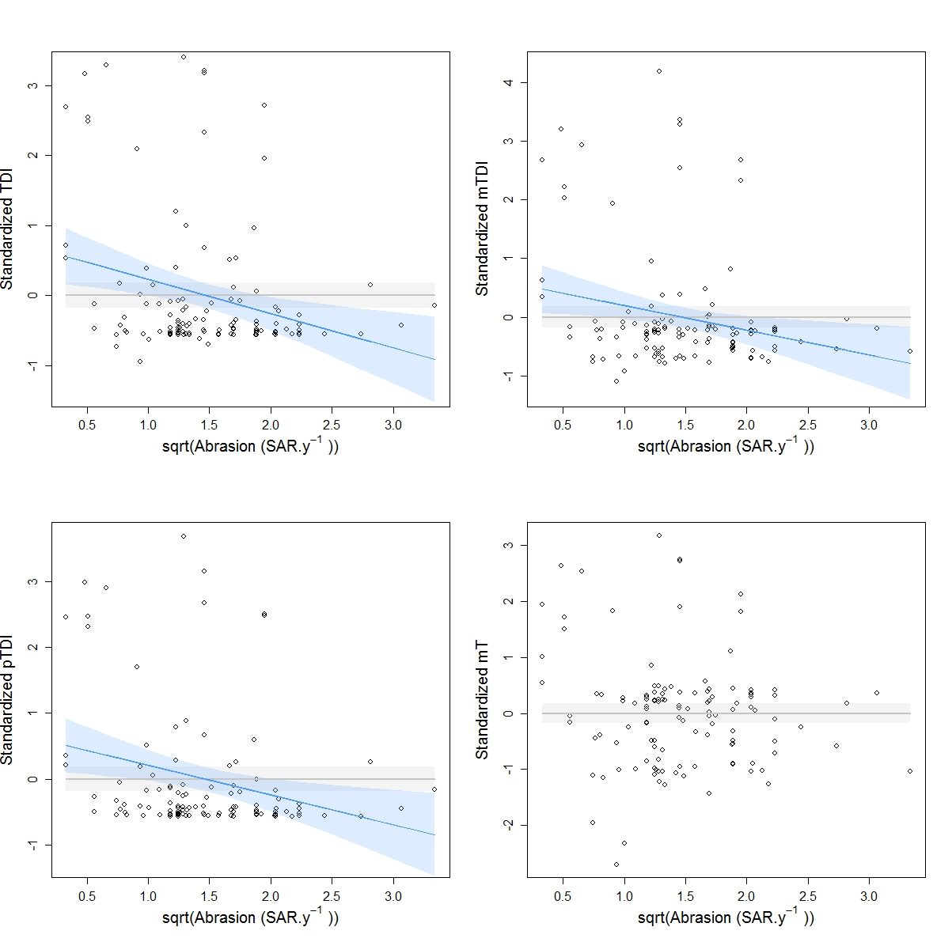
Figure B.6: Indices modelled relationships to fishery abrasion in habitat A5.25/26: Circalittoral fine sand/muddy sand. Null model (grey lines and 95% confidence interval in grey shading) was the only fitting model for mT but neglinear models (blue lines and 95% confidence interval in blue shading) were more suited for TDI, mTDI and pTDI. No significant thresholds could be detected.

Table B.6: Summary of the modelling results in the habitat A5.25/26
Grey shading indicates the index and the model selected for this habitat. * indicates that P<0.05 ; ** indicates that P<0.01 ; *** indicates that P<0.001
Indices | Models | Slope | AdjR² | RMAE
TDI | Null | - | 0 | -
 | Neglinear | -0.49** | 0.07 | 0.15
mTDI | Null | - | 0 | -
 | Neglinear | -0.42* | 0.05 | -
pTDI | Null | - | 0 | -
 | Neglinear | -0.45** | 0.06 | 0.15
mT | Null | - | 0 | -
 | Neglinear | - 0.24 | 0.01 | -

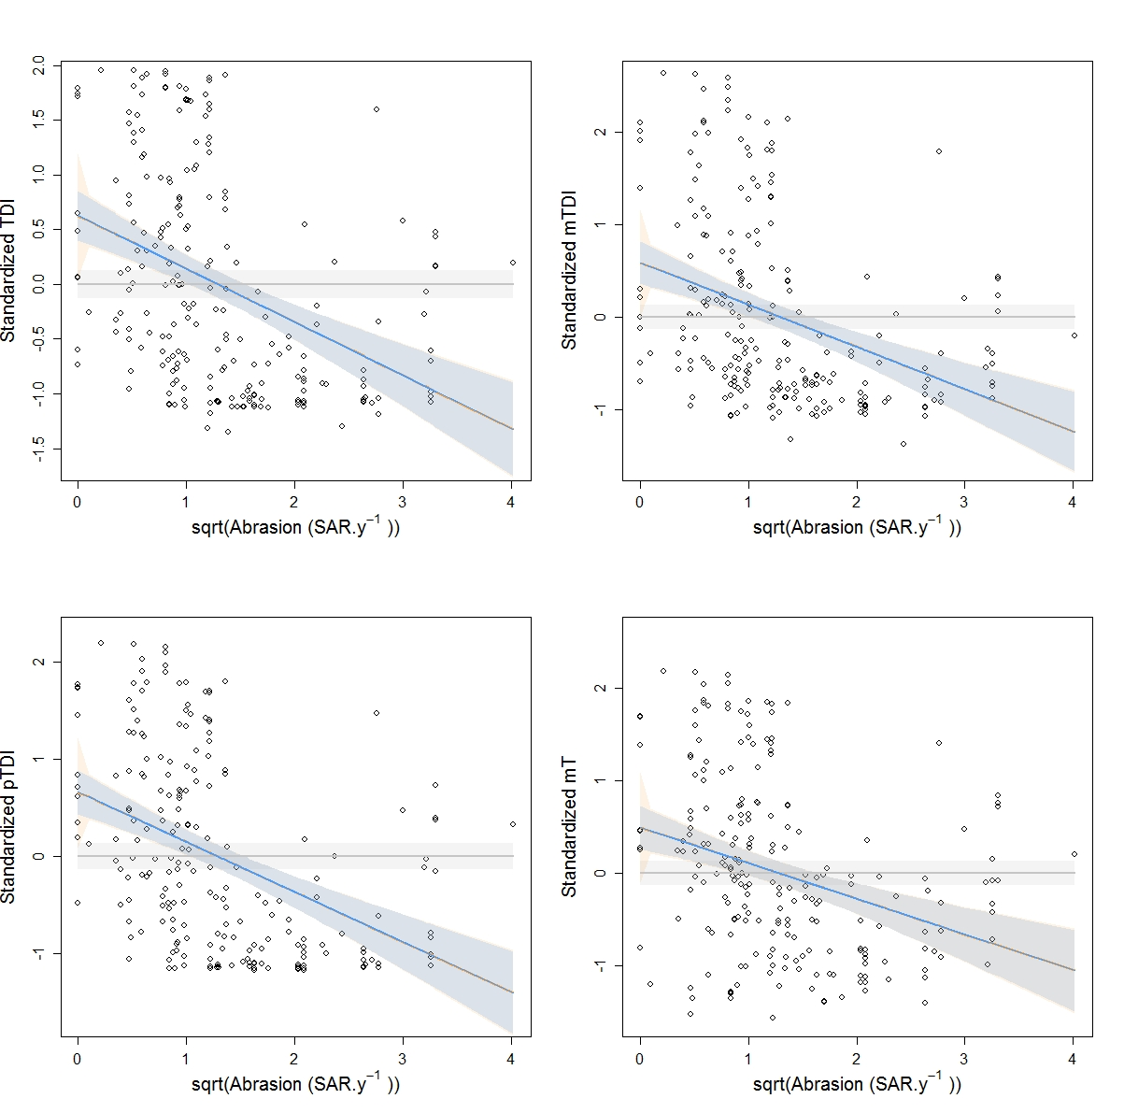
Figure B.7: Indices modelled relationships to fishery abrasion in habitat A5.27: Deep circalittoral mud.
Null models (grey lines and 95% confidence interval in grey shading), neglinear (blue lines and 95% confidence interval in blue shading) and segment1 (orange) models fitted all indices. In all cases neglinear and segment1 models were so similar that their graphic representation fully overlapped but neglinear models were more suited (higher adjusted R-squared) for all of these. Significant threshold could be detected in all cases but were not retained here.
Table B.7: Summary of the modelling results in the habitat A5.27
Grey shading indicates the index and the model selected for this habitat. * indicates that P<0.05 ; ** indicates that P<0.01 ; *** indicates that P<0.001
Indices | Models | Slope | Threshold 1 | Threshold 2 | AdjR² | RMAE
TDI | Null | - | - | - | 0 | -
 | Neglinear | -0.49*** | - | - | 0.15 | -
 | Segment1 | -0.48*** | 3.10⁻³*** | - | 0.15 | -
mTDI | Null | - | - | - | 0 | -
 | Neglinear | -0.46*** | - | - | 0.13 | -
 | Segment1 | -0.44*** | 1.6.10⁻⁵*** | - | 0.13 | -
pTDI | Null | - | - | - | 0 | -
 | Neglinear | -0.51*** | - | - | 0.18 | 0.23
 | Segment1 | -0.49*** | 1.10⁻⁶*** | - | 0.17 | -
mT | Null | - | - | - | 0 | -
 | Neglinear | -0.39*** | - | - | 0.09 | -
 | Segment1 | -0.37*** | 3.10⁻⁴*** | - | 0.09 | -

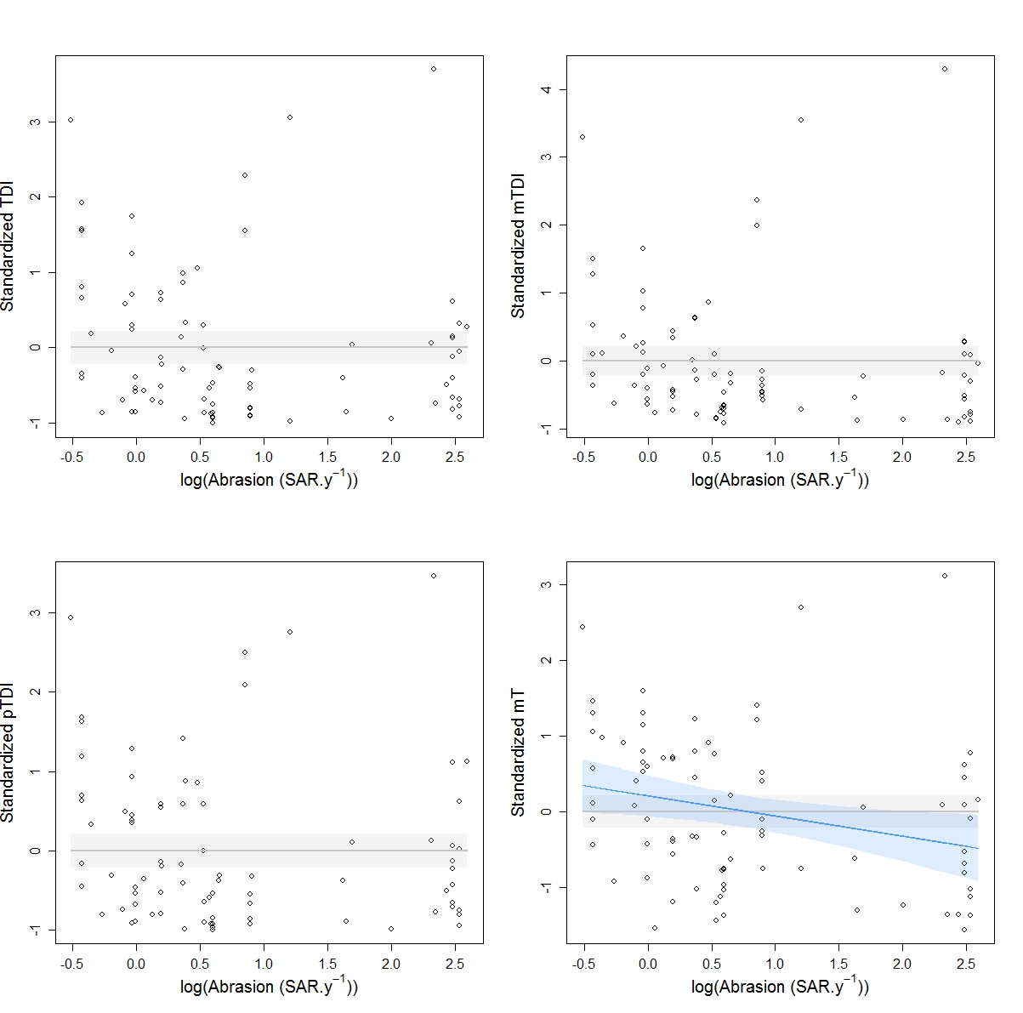
Figure B.8: Indices modelled relationships to fishery abrasion in habitat A5.37: Deep circalittoral mud.
Null model (grey lines and 95% confidence interval in grey shading) fitted all indices but neglinear models (blue lines and 95% confidence interval in blue shading) were more suited for mT. No significant thresholds could be detected.

Table B.8: Summary of the modelling results in the habitat A5.37
Grey shading indicates the index and the model selected for this habitat. * indicates that P<0.05 ; ** indicates that P<0.01 ; *** indicates that P<0.001
Indices | Models | Slope | AdjR² | RMAE
TDI | Null | - | 0 | -
 | Neglinear | -0.15 | 0.01 | -
mTDI | Null | - | 0 | -
 | Neglinear | -0.16 | 0.01 | -
pTDI | Null | - | 0 | -
 | Neglinear | -0.10 | - | -
mT | Null | - | 0 | -
 | Neglinear | - 0.27* | 0.06 | 0.17

English Channel

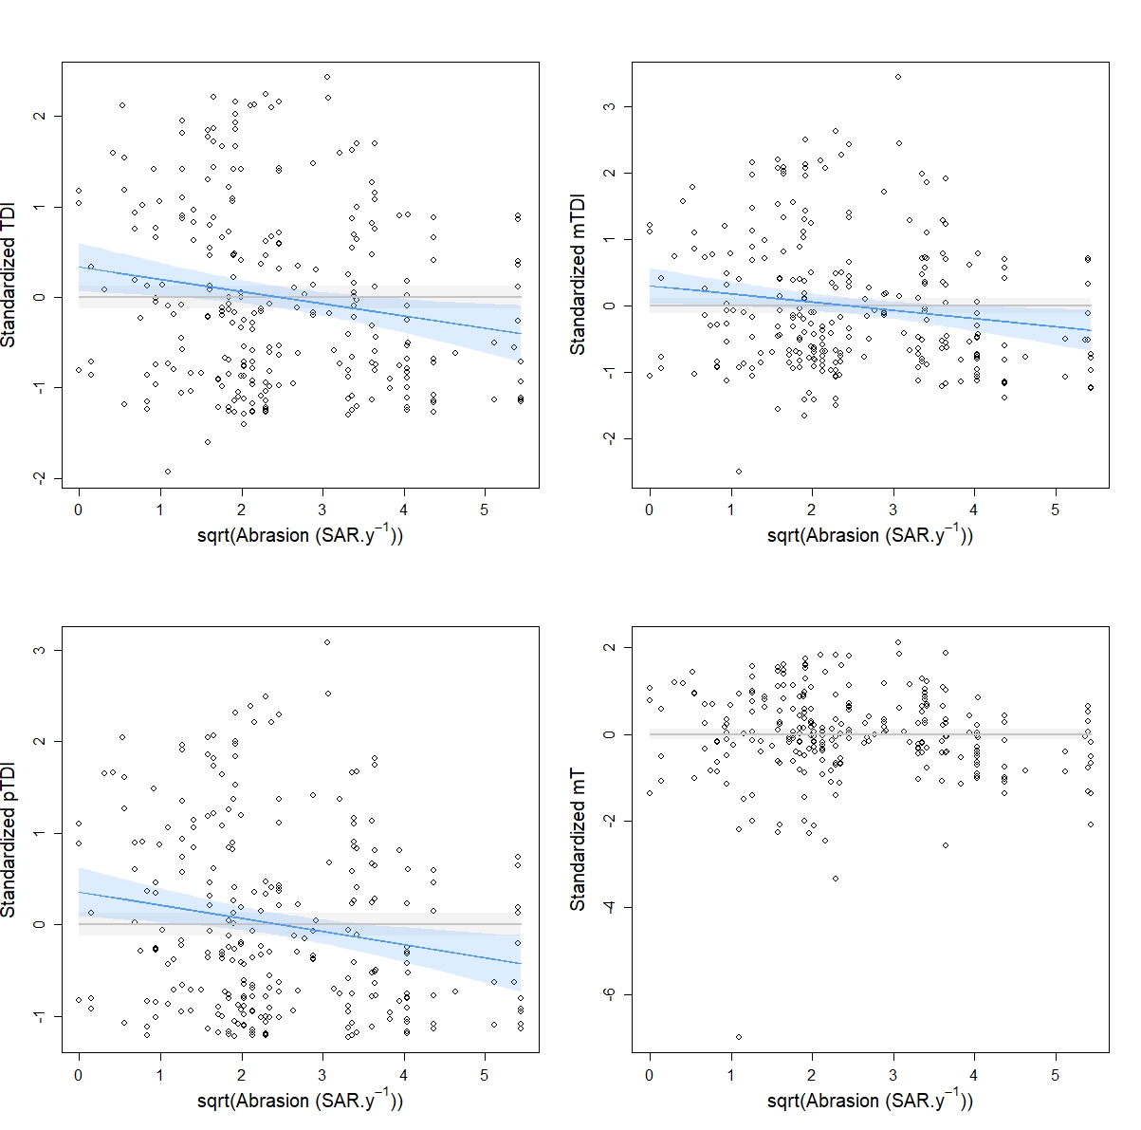
Figure B.9: Indices modelled relationships to fishery abrasion in habitat A5.14 (in autumn): Circalittoral coarse sediment. Null model (grey lines and 95% confidence interval in grey shading) was the only fitting model for mT index and neglinear models (blue lines and 95% confidence interval in blue shading) were more suited for TDI, mTDI and pTDI. No significant thresholds could be detected.

Table B.9: Summary of the modelling results in the habitat A5.14 in autumn
Grey shading indicates the index and the model selected for this habitat. * indicates that P<0.05 ; ** indicates that P<0.01
Indices | Models | Slope | AdjR² | RMAE
TDI | Null | - | 0 | -
 | Neglinear | -0.13** | 0.02 | 0.19
mTDI | Null | - | 0 | -
 | Neglinear | -0.12* | 0.02 | -
pTDI | Null | - | 0 | -
 | Neglinear | -0.14** | 0.03 | 0.19
mT | Null | - | 0 | -
 | Neglinear | - 0.08 | 6.10⁻³ | -

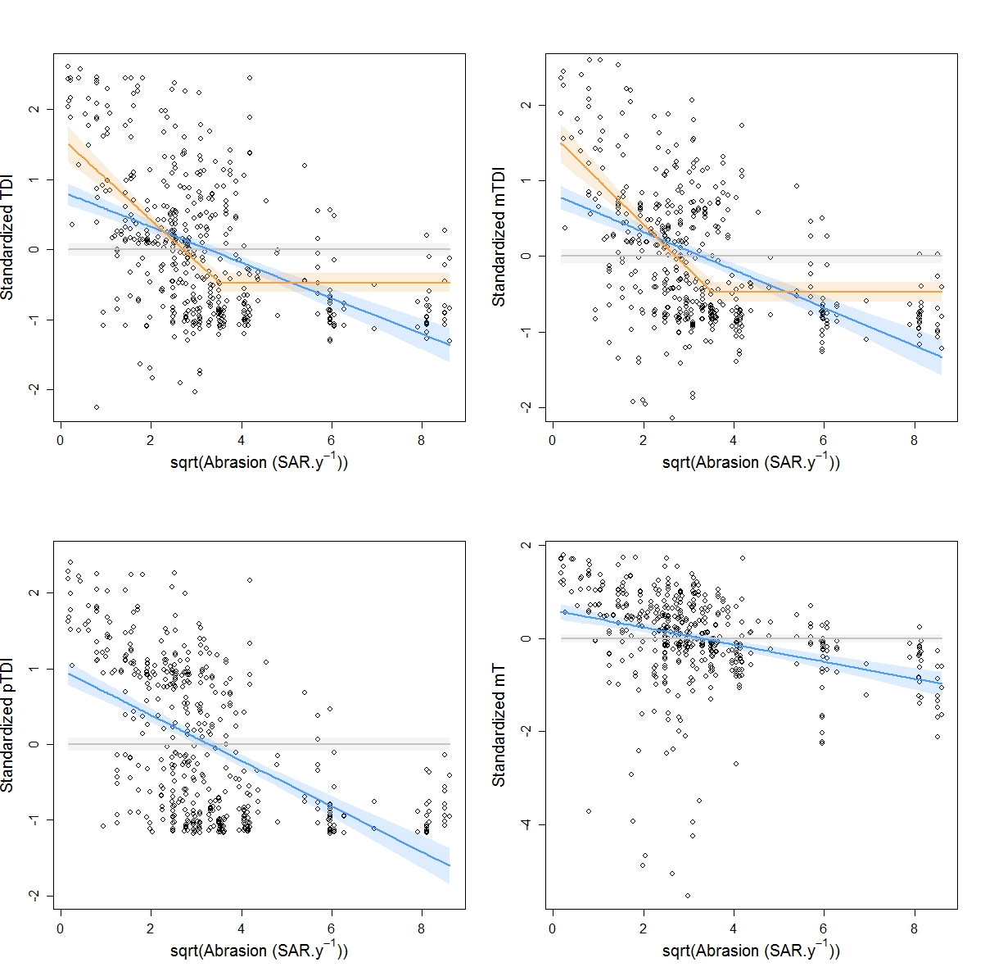
Figure B.10: Indices modelled relationships to fishery abrasion in habitat A5.15 (in Autumn): Deep circalittoral coarse sediment. Null models (grey lines and 95% confidence interval in grey shading) and neglinear models (blue lines and 95% confidence interval in blue shading) fitted for all indices but segment2 models (orange lines and 95% confidence interval in orange shading) were more suited for TDI and mTDI indices.

Table B.10: Summary of the modelling results in the habitat A5.15 in autumn
Grey shading indicates the index and the model selected for this habitat. ** indicates that P<0.01 ; *** indicates that P<0.001
Indices | Models | Slope | Threshold 1 | Threshold 2 | AdjR² | RMAE
TDI | Null | - | - | - | 0 | -
 | Neglinear | -0.26*** | - | - | 0.21 | -
 | Segment2 | -0.59*** | - | 12.34** | 0.28 | -
mTDI | Null | - | - | - | 0 | -
 | Neglinear | -0.25*** | - | - | 0.20 | -
 | Segment2 | -0.58*** | - | 12.34*** | 0.27 | 0.15
pTDI | Null | - | - | - | 0 | -
 | Neglinear | -0.30*** | - | - | 0.29 | -
mT | Null | - | - | - | 0 | -
 | Neglinear | -0.18*** | - | - | 0.10 | -

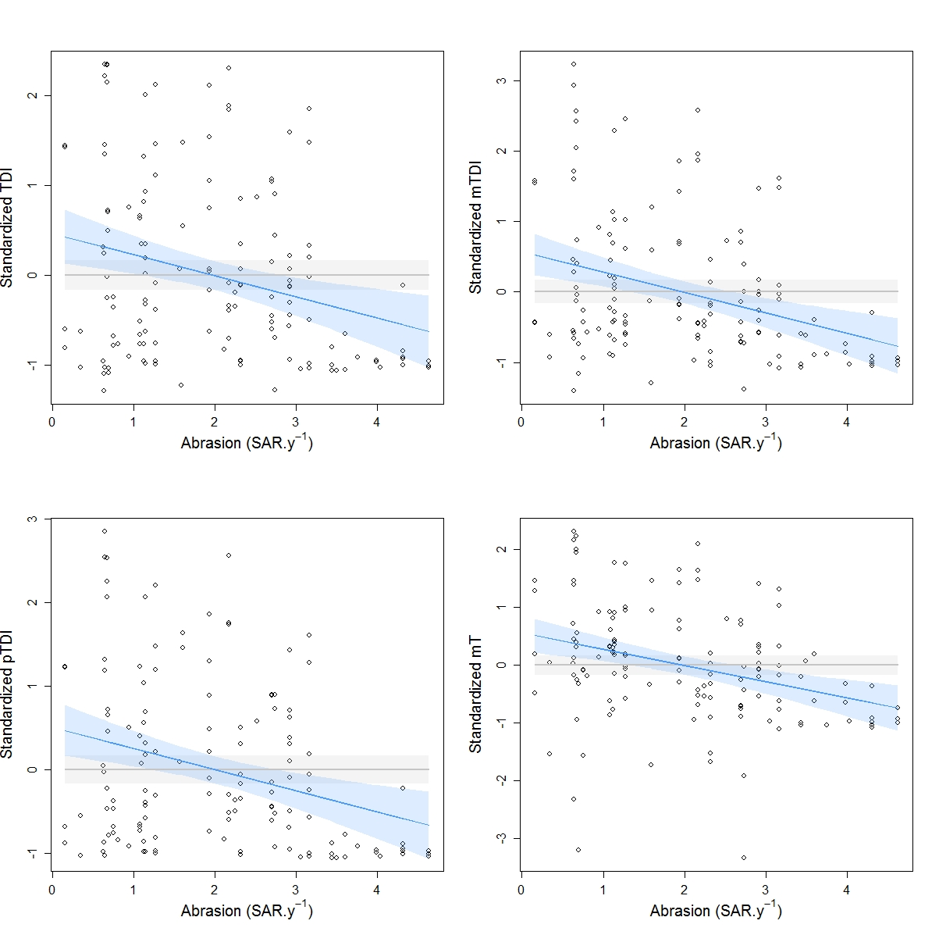
Figure B.11: Indices modelled relationships to fishery abrasion in habitat A5.25/26: Circalittoral fine sand/muddy sand. Null models (grey lines and 95% confidence interval in grey shading) and neglinear models (blue lines and 95% confidence interval in blue shading) fitted all indices but neglinear models were more suited in all case.. No significant thresholds could be detected.

Table B.11: Summary of the modelling results in the habitat A5.25/26
Grey shading indicates the index and the model selected for this habitat. ** indicates that P<0.01 ; *** indicates that P<0.001
Indices | Models | Slope | AdjR² | RMAE
TDI | Null | - | 0 | -
 | Neglinear | -0.24** | 0.07 | 0.21
mTDI | Null | - | 0 | -
 | Neglinear | -0.29*** | 0.10 | 0.15
pTDI | Null | - | 0 | -
 | Neglinear | -0.25*** | 0.08 | 0.20
mT | Null | - | 0 | -
 | Neglinear | - 0.28*** | 0.10 | 0.12

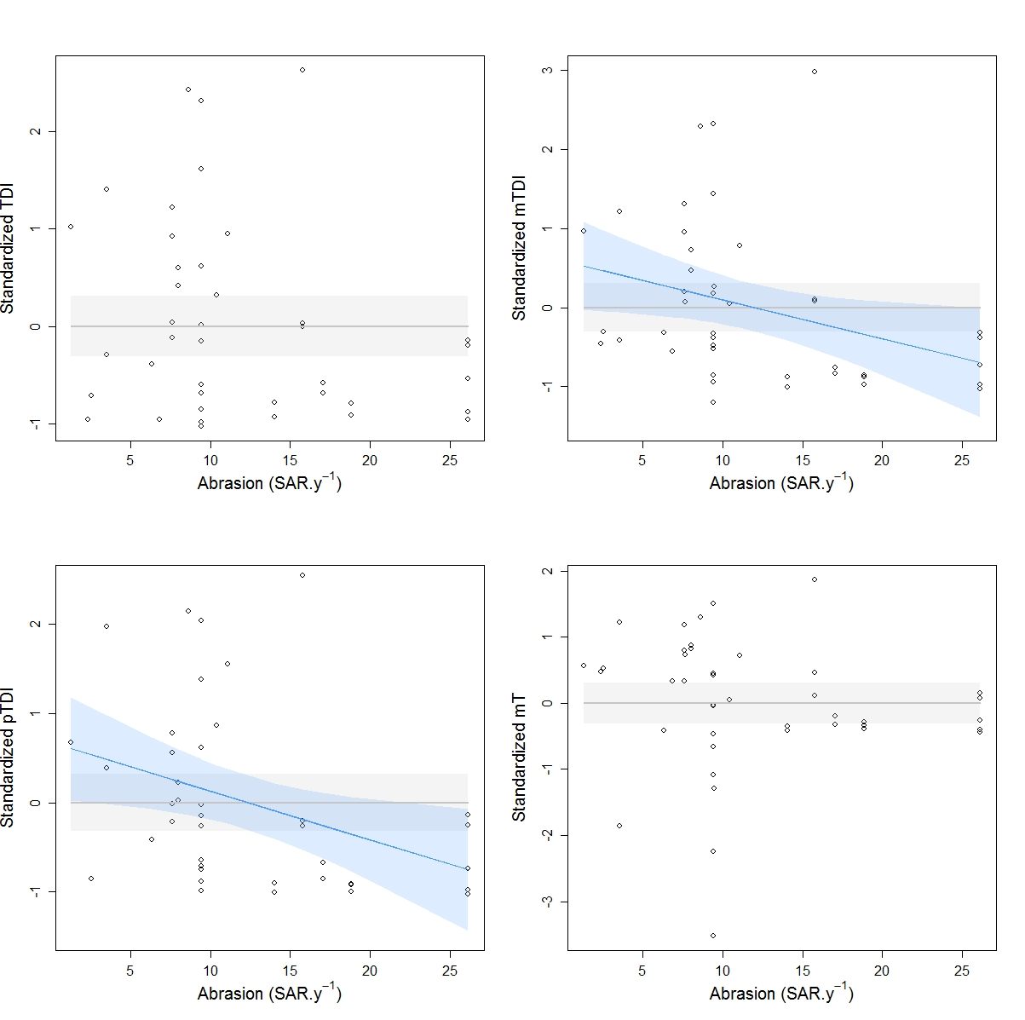
Figure B.12: Indices modelled relationships to fishery abrasion in habitat A5.27: Deep circalittoral sand.
Null models (grey lines and 95% confidence interval in grey shading) were the only fitting models for TDI and mT indices but neglinear model (blue lines and 95% confidence interval in blue shading) was more suited for mTDI and pTDI indices. No significant thresholds could be detected.

Table B.12: Summary of the modelling results in the habitat A5.27
Grey shading indicates the index and the model selected for this habitat. *indicates that P<0.05
Indices | Models | Slope | AdjR² | RMAE
TDI | Null | - | 0 | -
 | Neglinear | -0.04 | 0.04 | -
mTDI | Null | - | 0 | -
 | Neglinear | -0.04* | 0.08 | 0.17
pTDI | Null | - | 0 | -
 | Neglinear | -0.05* | 0.11 | 0.20
mT | Null | - | 0 | -
 | Neglinear | - 0.02 | -0.01 | -

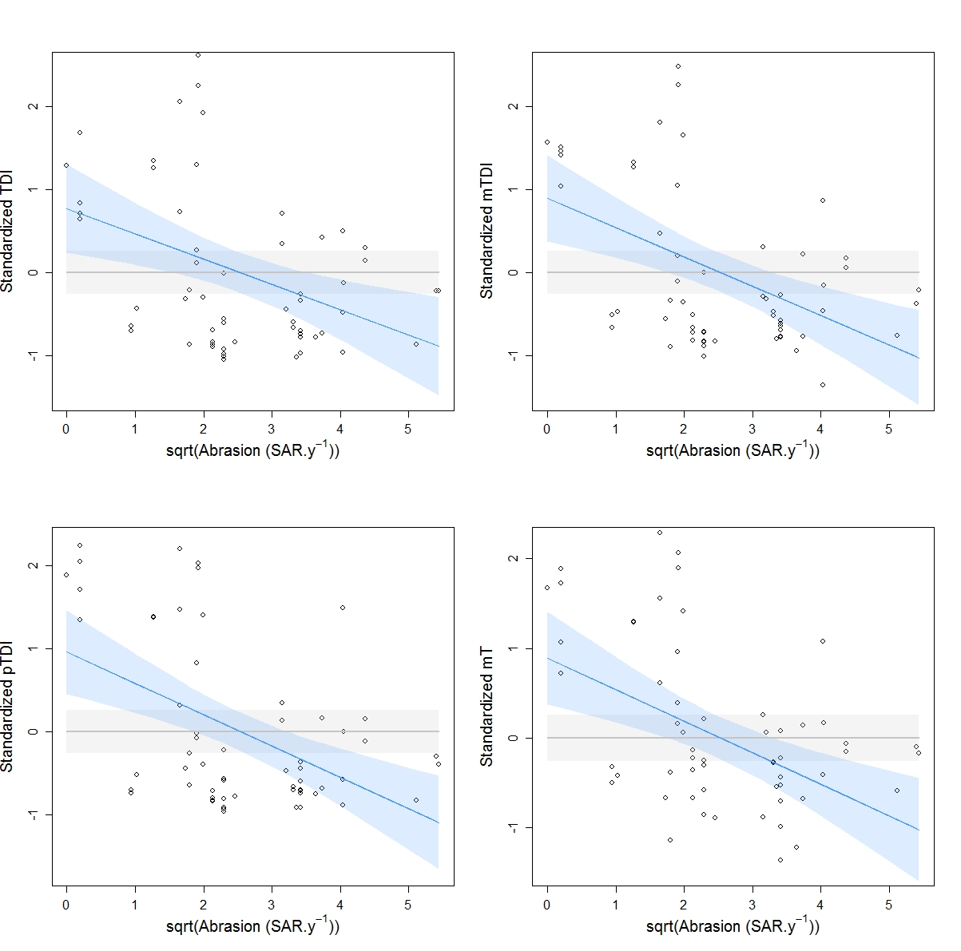
Figure B.13: Indices modelled relationships to fishery abrasion in habitat A5.14 (in Winter): Circalittoral coarse sediment. Null models (grey lines and 95% confidence interval in grey shading) and neglinear models (blue lines and 95% confidence interval in blue shading) fitted all indices but neglinear models were more suited in all case. No significant thresholds could be detected.

Table B.13: Summary of the modelling results in the habitat A5.14 in winter
**indicates that P<0.01 ; ***indicates that P<0.001
Indices | Models | Slope | AdjR² | RMAE
TDI | Null | - | 0 | -
 | Neglinear | -0.31** | 0.14 | -
mTDI | Null | - | 0 | -
 | Neglinear | -0.23** | 0.08 | -
pTDI | Null | - | 0 | -
 | Neglinear | -0.38*** | 0.22 | -
mT | Null | - | 0 | -
 | Neglinear | - 0.35*** | 0.19 | -

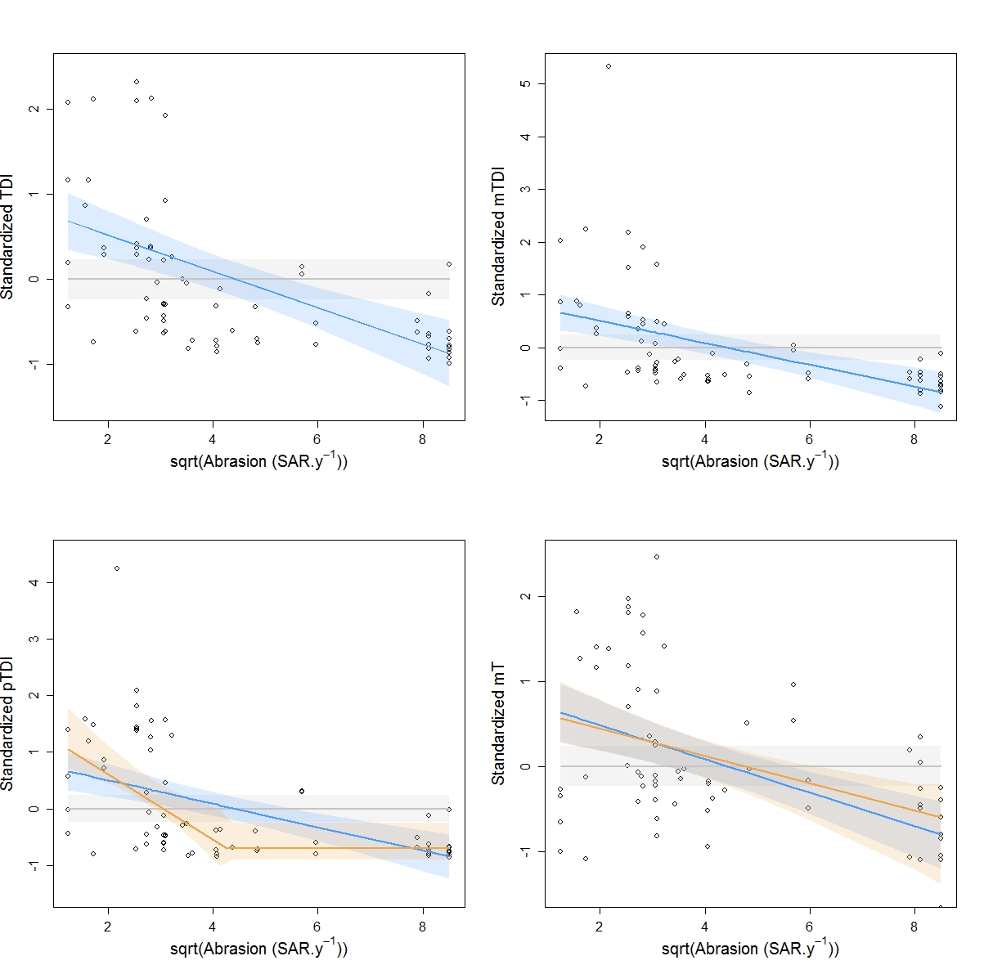
Figure B.14: Indices modelled relationships to fishery abrasion in habitat A5.15 (in Winter): Deep circalittoral coarse sediment. Null models (grey lines and 95% confidence interval in grey shading) and neglinear models (blue lines and 95% confidence interval in blue shading) fitted for all indices but segment2 models (orange lines and 95% confidence interval in orange shading) were more suited for pTDI and mT indices.

Table B.14: Summary of the modelling results in the habitat A5.15 in winter
*indicates that P<0.05 ; **indicates that P<0.01 ; ***indicates that P<0.001
Indices | Models | Slope | Threshold 1 | Threshold 2 | AdjR² | RMAE
TDI | Null | - | - | - | 0 | -
 | Neglinear | -0.21*** | - | - | 0.28 | -
mTDI | Null | - | - | - | 0 | -
 | Neglinear | -0.20*** | - | - | 0.24 | -
pTDI | Null | - | - | - | 0 | -
 | Neglinear | -0.21*** | - | - | 0.26 | -
 | Segment2 | -0.60** | - | 18.13* | 0.32 | -
mT | Null | - | - | - | 0 | -
 | Neglinear | -0.20*** | - |  | 0.23 | -
 | Segment2 | -0.16** | - | 71.1* | 0.22 | -

