Supplementary Information of
New insights into the distributions of nitrogen fixation and diazotrophs revealed by high-resolution sensing and sampling methods

Weiyi Tang^{1,2}, Elena Cerdán García³, Hugo Berthelot⁴, Despo Polyviou³, Seaver Wang¹, Alison Baylay³, Hannah Whitby⁴, Hélène Planquette⁴, Matthew Mowlem⁵, Julie Robidart^{5,*}, Nicolas Cassar^{1,4,*}

¹Division of Earth and Ocean Sciences, Nicholas School of the Environment, Duke University, Durham, NC 27708, USA
²Now at Department of Geosciences, Princeton University, NJ 08544, USA
³Department of Ocean and Earth Sciences, National Oceanography Centre, University of Southampton, European Way, SO14 3ZH, Southampton, United Kingdom
⁴Laboratoire des Sciences de l'Environnement Marin (LEMAR), UMR 6539 UBO/CNRS/IRD/IFREMER, Institut Universitaire Européen de la Mer (IUEM), Brest, France
⁵Ocean Technology and Engineering Group, National Oceanography Centre, European Way, SO14 3ZH, Southampton, United Kingdom

*Corresponding to j.robidart@noc.ac.uk and Nicolas.Cassar@duke.edu

Supplementary Table 1. Primer and probe sequences used in nifH sequencing, qPCR and RT-qPCR analyses
Target | Forward primer (5’-3’) | Probe (5’-3’) | Reverse primer (5’-3’) | Sources
nifH1-illumina | TCG TCG GCA GCG TCA GAT GTG TAT AAG AGA CAG TGY GAY CCN AAR GCN GA |  |  | (1) and this study
nifH2-illumina |  |  | GTC TCG TGG GCT CGG AGA TGT GTA TAA GAG ACA GAD NGC CAT CAT YTC NCC | (1) and this study
nifH Trichodesmium | GACGAAGTATTGAAGCCAGGTTTC | CATTAAGTGTGTTGAATCTGGTGGTCCTGAGC | CGGCCAGCGCAACCTA | (2)
nifH  UCYN-A | AGCTATAACAACGTTTTATGCGTTGA | TCTGGTGGTCCTGAGCCTGGA | ACCACGACCAGCACATCCA | (2)
nifH  Crocosphaera | CGTAATGCTCGAAGGGTTTGA | CAAGTGTGTAGAATCTGGTGGTCCTGAGCC | CACGACCAGCACAACCAACT | (2)
pstS Trichodesmium | ATGCACAAAACCCTGCCGAC | YAACCCYCTATACCCATATTCTCA | GAAATGCTAGAACTTCTSGAGAGG | This study
pstS  UCYN-A | ACGTTTACTTTGATTCGTCCC | AGCGTACTCGATCATGGTCTCCA | ATGAMCCTAAAAAAGCAATTG | This study

Supplementary Table 2. Mean (standard deviations) of nifH gene copies, nifH transcripts and pstS transcripts of Trichodesmium and UCYN-A from 9 discrete noon samples. Standard deviations in the brackets. BD: below detection limits.

Stations | Latitude (°N) | Longitude (°W) | Trichodesmium (copies L⁻¹) |  |  | UCYN-A (copies L⁻¹)
 |  |  | nifH gene | nifH transcript | pstS transcript | nifH gene | nifH transcript | pstS transcript
1 | 35.28 | -64.26 | 68798 (4118) | 34598 (10277) | 377 (216) | 617 (500) | BD (/) | BD (/)
2 | 38.28 | -63.74 | 366702 (2684) | 4423684 (812297) | 17227 (3181) | 660 (268) | 7775 (758) | 1320 (/)
3 | 41.88 | -64.94 | 184833 (18072) | 44156 (15748) | BD (/) | 734417 (46193) | 1018981 (398145) | 2453 (932)
4 | 42.26 | -67.83 | 7503 (2105) | BD (/) | BD (/) | 1919667 (135665) | 1288149 (26483) | 2544 (/)
5 | 40.17 | -71.32 | 988 (867) | BD (/) | BD (/) | 137658 (11592) | 3225045 (364139) | 5485 (3561)
6 | 38.73 | -74.49 | 1522 (341) | BD (/) | BD (/) | 798778 (41485) | 1716301 (419210) | BD (/)
7 | 36.21 | -71.7 | 397 (56) | 46029 (1570) | BD (/) | 750 (806) | 1161 (915) | 337 (/)
8 | 34.84 | -68.02 | 1354 (/) | 1535 (369) | BD (/) | 336 (236) | BD (/) | BD (/)
9 | 32.81 | -65.01 | 392 (112) | 8005 (3985) | BD (/) | 432 (110) | BD (/) | BD (/)

Supplementary Table 3. nifH gene copies from 34 RoCSI samples. BD: below detection limits.

Locations |  | Trichodesmium (copies L⁻¹) |  | UCYN-A (copies L⁻¹)
Latitude (°N) | Longitude (°W) | nifH gene | standard deviation | nifH gene | standard deviation
32.55 | -64.38 | 20820 | 5165 | 1914 | /
33.85 | -64.44 | 19852 | 3327 | 261 | 142
34.19 | -64.49 | 37128 | 10673 | BD | /
34.78 | -64.38 | 77889 | 5320 | 277 | 380
35.57 | -64.15 | 80182 | 18112 | BD | /
36.23 | -63.93 | 229870 | 24067 | 250 | 224
36.63 | -63.77 | 47018 | 13114 | BD | /
37.08 | -63.70 | 63910 | 872 | 276 | /
37.44 | -63.61 | 83591 | 5319 | 797 | 276
37.84 | -63.67 | 38337 | 3326 | BD | /
38.59 | -63.90 | 193602 | 13245 | 5173 | 813
39.06 | -64.12 | 153122 | 5196 | 1158 | 281706
42.92 | -66.56 | 76033 | 5196 | 1109644 | 281706
42.74 | -67.12 | BD | / | 461600 | 41947
42.52 | -67.43 | BD | / | 4976690 | 1108460
42.55 | -67.57 | 2840 | / | 3127298 | 185226
42.17 | -67.89 | BD | / | 1206545 | 581922
41.33 | -68.67 | BD | / | 254921 | 65990
40.93 | -68.99 | 15992 | 9200 | 408588 | 128904
40.62 | -69.49 | BD | / | 701648 | 112049
40.53 | -70.19 | 29719 | 2020 | 765909 | 260956
40.34 | -70.77 | 80950 | 7380 | 339202 | 68401
40.11 | -71.61 | 61977 | 7606 | 597229 | 89011
40.00 | -72.03 | 19911 | 2622 | 90756 | 31837
39.79 | -72.87 | BD | / | 4645482 | 149798
39.40 | -73.78 | BD | / | 40202944 | 2791211
39.22 | -73.95 | BD | / | 30262500 | 2103643
38.99 | -74.23 | BD | / | 10822610 | 1267333
38.61 | -74.44 | BD | / | 919038 | 97930
37.78 | -73.64 | 33178 | 0 | 44713 | 9016
37.43 | -73.34 | 22000 | 7376 | 49082 | 12979
36.57 | -72.48 | 163150 | 20025 | 122 | 151
36.32 | -71.96 | 173360 | 10267 | BD | /

Supplementary Figure 1. Comparison between nifH gene and pstS gene copy numbers of UCYN-A measured by qPCR in the same samples.

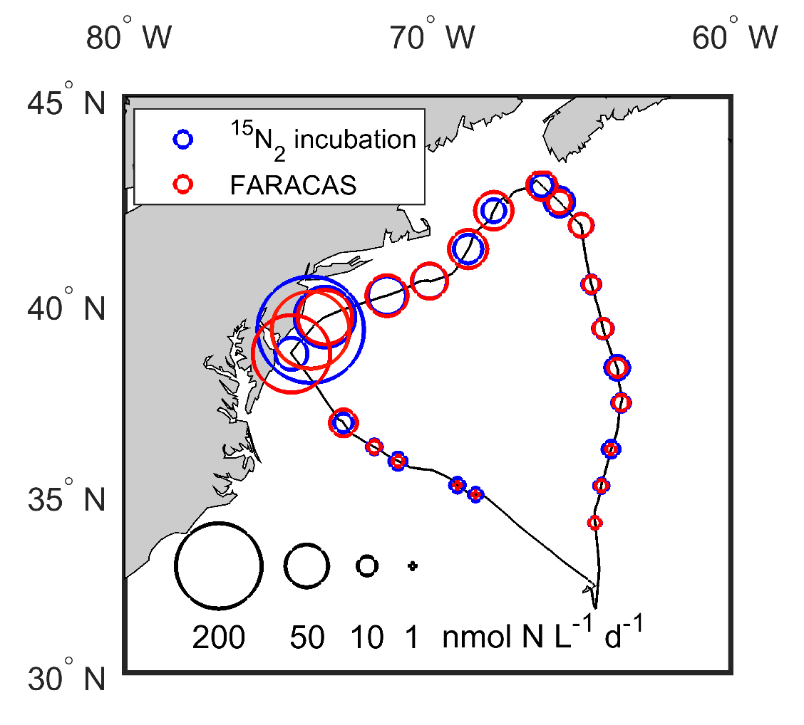
Supplementary Figure 2. Comparison of N₂ fixation rates measured by FARACAS and by the dissolved ¹⁵N₂ addition method.

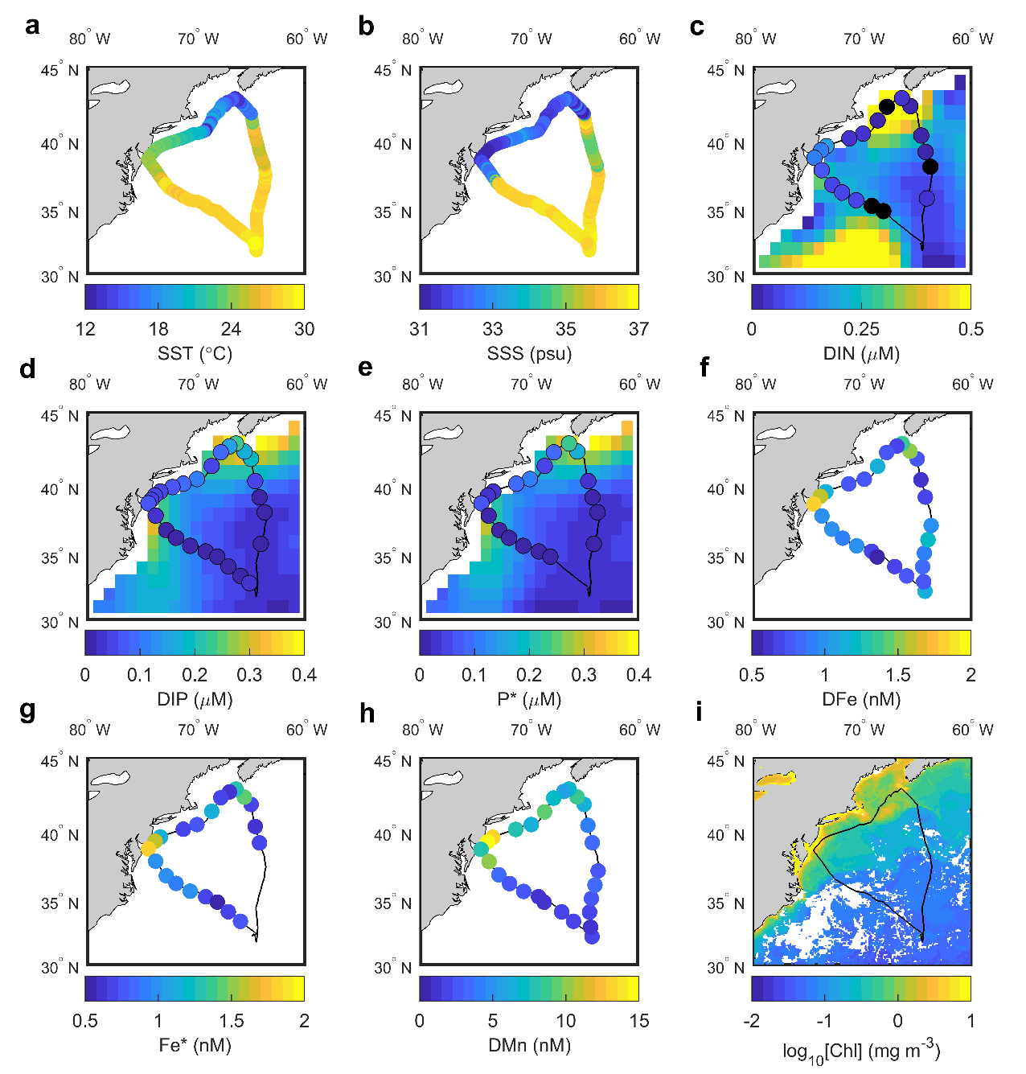
Supplementary Figure 3. Maps of surface properties. (a) sea surface temperature (SST), (b) sea surface salinity (SSS), (c) dissolved inorganic nitrogen concentrations (DIN = nitrate + nitrite) overlaid on climatology of DIN in August, (d) dissolved inorganic phosphorus concentrations (DIP) overlaid on climatology of DIP in August, (e) calculated excess phosphorus (P*=DIP-DIN/16) overlaid on climatology of P* in August, (f) dissolved iron concentrations (DFe), (g) excess DFe (${Fe}^{*}=DFe-R_{Fe}*DIP$; where $R_{Fe}=0.47 mmol DFe:1 mol DIP$) calculated at stations where both DIP and DFe concentrations are available (3), (h) dissolved manganese concentrations (DMn), and (i) averaged chlorophyll-a concentration [Chl] observed by MODIS-Aqua during the cruise period. Samples below detection limits are shown as black circles. Nutrient climatologies were obtained from World Ocean Atlas 2013 (4).

Supplementary Figure 4. Spearman’s rank correlation analyses between surface daily N₂ fixation rates and environmental properties. N₂ fixation rates vs (a) surface DIN climatology in August (r = 0.46, p<0.01), (b) DIN:DIP ratio (r = 0.09, p=0.73), (c) surface P* (r = 0.47, p=0.04), (d) surface P* climatology in August (r = 0.72, p<0.01), (e) surface DCu (r = 0.82, p<0.01) (f) satellite observed chlorophyll-a concentrations (r = 0.84, p<0.01).

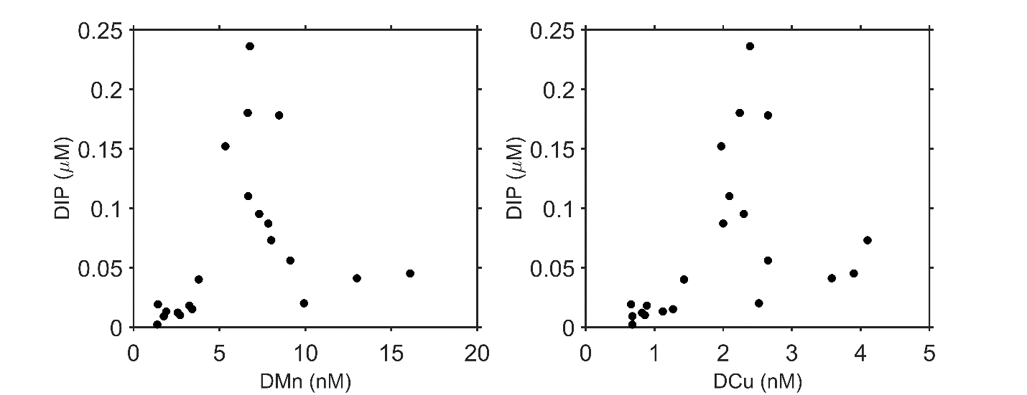
Supplementary Figure 5. Spearman’s rank correlation analyses between DMn, DCu and DIP concentrations. DIP is correlated to DMn (n=21, r=0.62, p<0.01) and DCu (n=21, r=0.67, p<0.01).

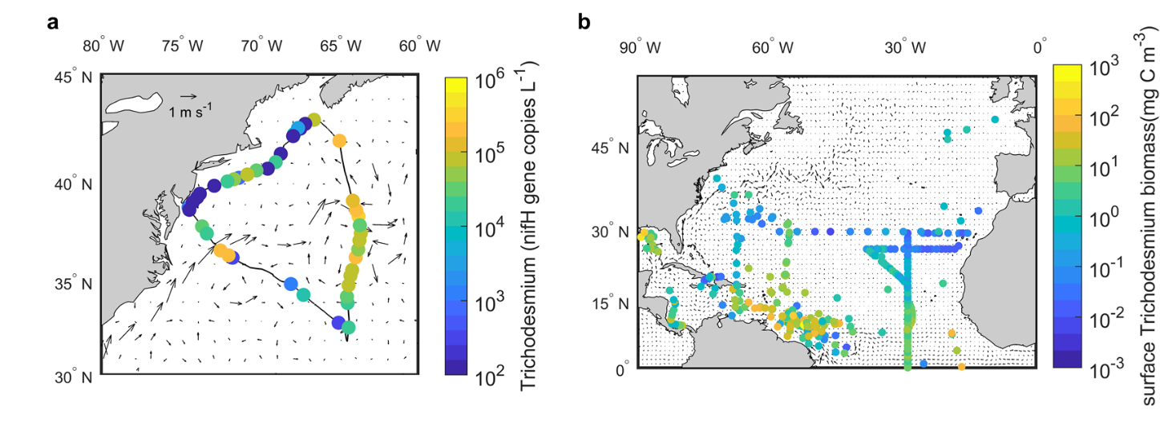
Supplementary Figure 6. (a) Color coded Trichodesmium nifH gene abundance measured in this study and (b) Trichodesmium biomass obtained from Luo et al., 2012 overlaid on surface currents (5).
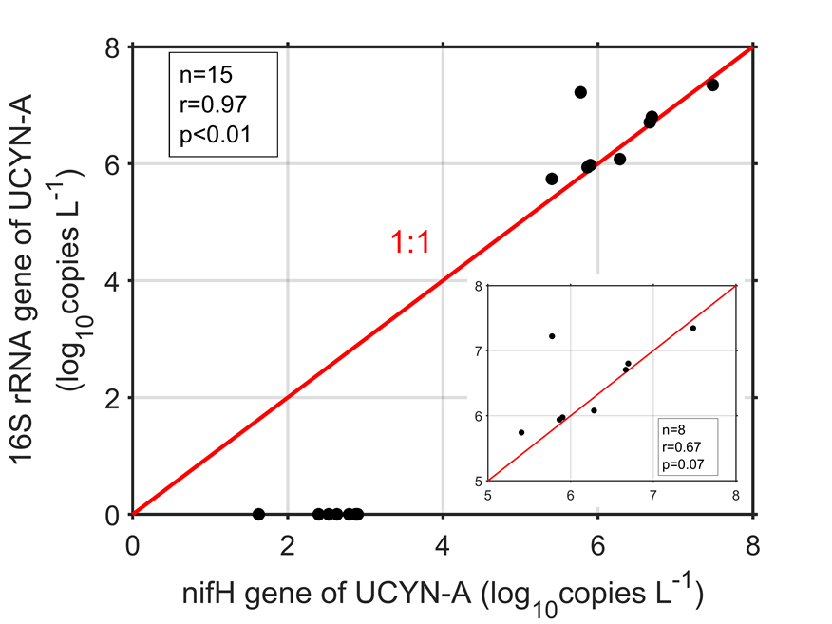
Supplementary Figure 7. Comparison of UCYN-A abundance estimated by qPCR and quantitative 16 rRNA amplicon sequencing. UCYN-A abundance below the detection limit of quantitative 18S rRNA gene sequencing are shown as 0 on y-axis.

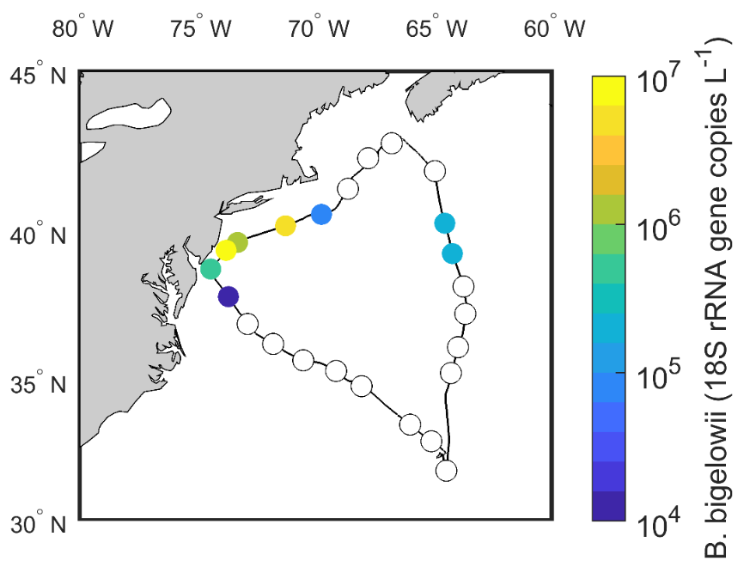
Supplementary Figure 8. Distribution of Braarudosphaera bigelowii. The white circles denote stations where B. bigelowii abundance was below the detection limit of quantitative 18S rRNA gene sequencing (Wang et al., unpublished) (6).
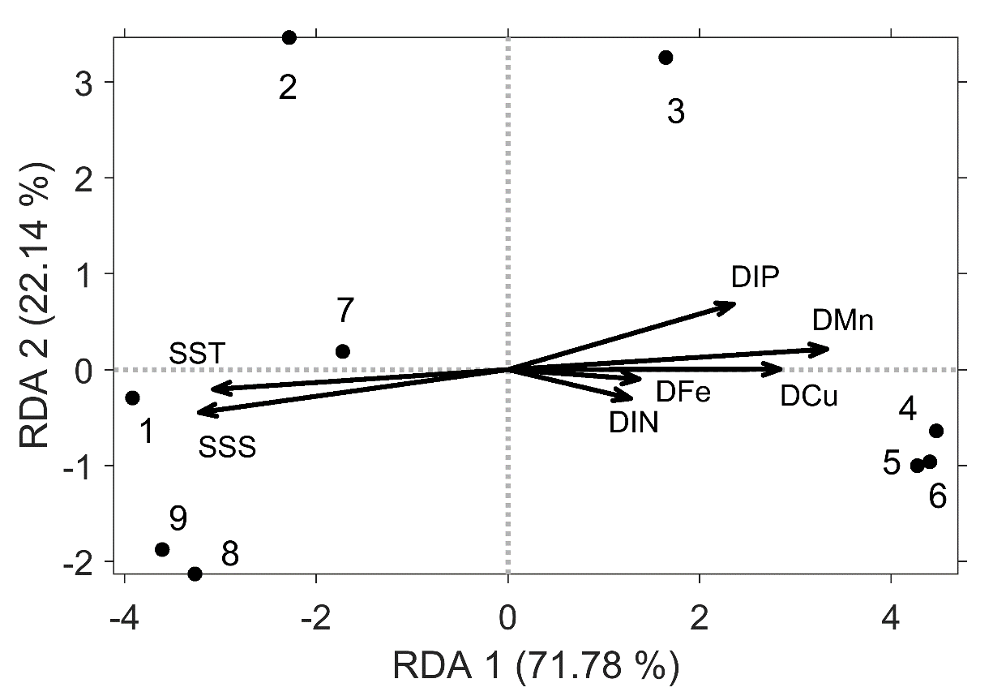
Supplementary Figure 9. Redundancy analysis (RDA) biplot of the relationship between the nifH gene abundances of Trichodesmium and UCYN-A and environmental properties at 9 discrete daily noon stations. The numbers and points represent discrete stations.

References:
1. Zehr J, Turner P. Nitrogen Fixation: Nitrogenase Genes and Gene Expression. Method in Microbiology. 2001;30:271-86.
2. Church MJ, Jenkins BD, Karl DM, Zehr JP. Vertical distributions of nitrogen-fixing phylotypes at Stn ALOHA in the oligotrophic North Pacific Ocean. Aquatic Microbial Ecology. 2005;38(1):3-14.
3. Parekh P, Follows MJ, Boyle EA. Decoupling of iron and phosphate in the global ocean. Global Biogeochemical Cycles. 2005;19(2):GB2020.
4. Boyer TP, Antonov JI, Baranova OK, Coleman C, Garcia HE, Grodsky A, et al. NOAA Atlas NESDIS 72. World Ocean Database. 2013.
5. Luo YW, Doney SC, Anderson LA, Benavides M, Berman-Frank I, Bode A, et al. Database of diazotrophs in global ocean: abundance, biomass and nitrogen fixation rates. Earth System Science Data. 2012;4(1):47-73.
6. Wang S, Tang W, Delage E, Gifford S, Whitby H, Aridane G, et al. Patterns of North Atlantic microbial community structure in relation to net community production, nitrogen fixation, and nutrient availability. Unpublished.

