Journal of Geophysical Research: Solid Earth
Supporting Information for

Active faulting, submarine surface rupture and seismic migration along the Liquiñe-Ofqui fault system, Patagonian Andes
A. Villalobos¹, G. Vargas Easton¹, A. Maksymowicz², S. Ruiz², G. Lastras³, G. P. De Pascale¹, H. Agurto-Detzel⁴
¹Departamento de Geología, Facultad de Ciencias Físicas y Matemáticas, Universidad de Chile, Plaza Ercilla 803, Santiago, Chile, ² Departamento de Geofísica, Facultad de Ciencias Físicas y Matemáticas, Universidad de Chile, Av. Blanco Encalada 2002, Santiago, Chile, ³ Grup de Recerca Consolidat en Geociències Marines, Universitat de Barcelona, Barcelona E-08028, Spain, ⁴ Université Côte d’Azur, IRD, CNRS, Observatoire de la Côte d’Azur, Géoazur, Nice, France.

Contents of this file
Text S1 to S2
Figures S1 to S16
Tables S1 to S5
Equation S1

Introduction

This supporting information provides some of the figures seen in the main article (seismic reflection profiles) with the vertical scale transformed to distance (m). Also provides extra figures where some points of the discussion are summarized.

A general overview of the kind of files;

- Information of the data obtained from the seismic reflection and bathymetry data. Where was collected or created.
- Any known error associated to the data, and other uncertainties.
- Tables with measurements and calculations made on the geophysical data.

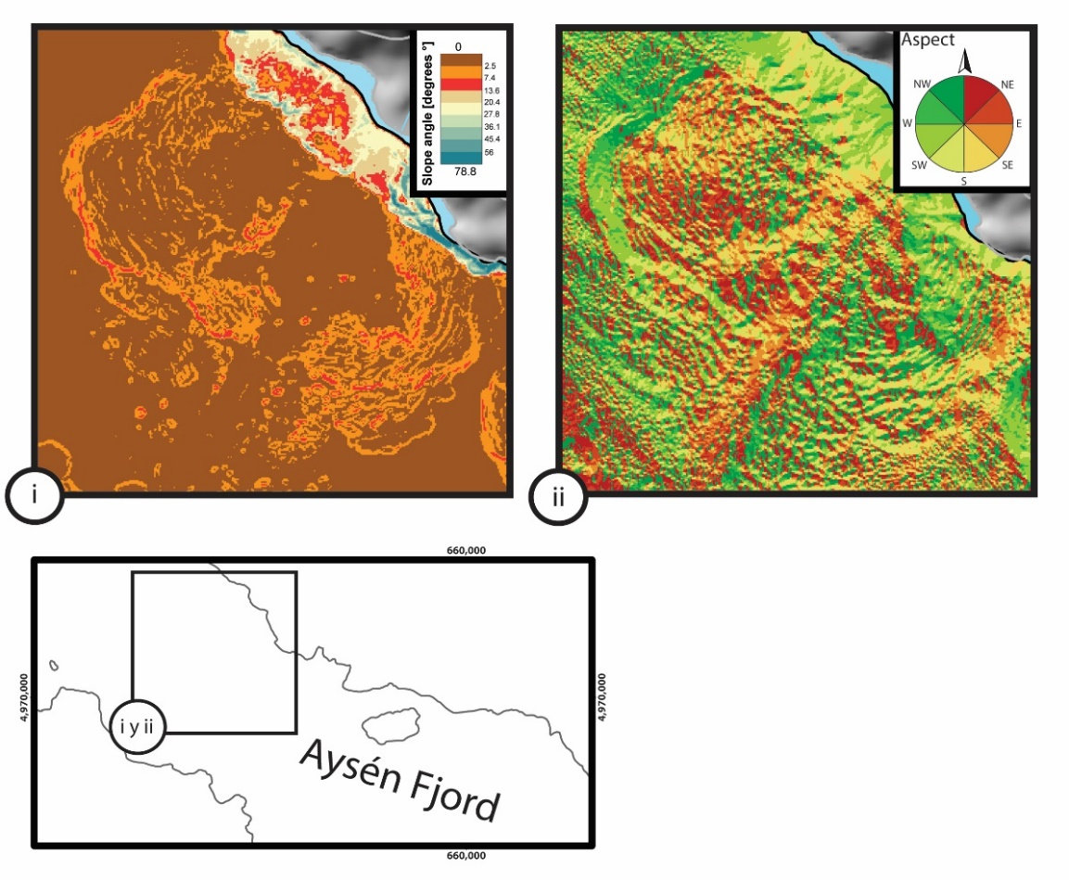

Figure S1. Geomorphological analysis of Punta Cola Bulge. (i) Slope map. (ii) Aspect map. Mini map shows inset location.

Text S1. P-wave velocity in Aysén fjord

We decided to use a P-wave velocity (V_{P}) = 2,000 m/s for migration from time (TWT) to distance (m) because it corresponds to an average value for shallow marine sediments located in the trench of the Nazca beneath the South American plates along Central-Southern Chile [e.g., Maksymowicz et al., 2012]. These sediments have been classified as fluvial and glaciomarine in origin [e.g. Thornburg & Kulm, 1987; Bangs & Cande, 1997].

Slow values for P-wave velocities in sediments from fjord-type environments

P-wave values (V_{P}) ~1,500 m/s are widely and normally used in research conducted in environments where glaciomarine sediments are abundant, such as in channels and fjords [e.g. Breuer et al., 2013, Fernández et al., 2011; St-Onge et al., 2012]. The use of this standard velocity value is often justified by theory. Empirical velocity-porosity sediment relationships such as those proposed by Erickson & Jarrard [1998], relate V_{P}, fractional porosity and other empirical constants (Eq. S1 and Fig. S2).
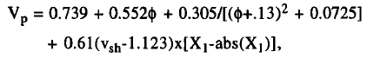

Equation S1. Empirical equation determined by Erickson & Jarrard [1998] where V_{P} is expressed by a function controlled by fractional porosity (Φ), fine fraction of sediments (shale fraction, v_{sh}), and a consolidation history.

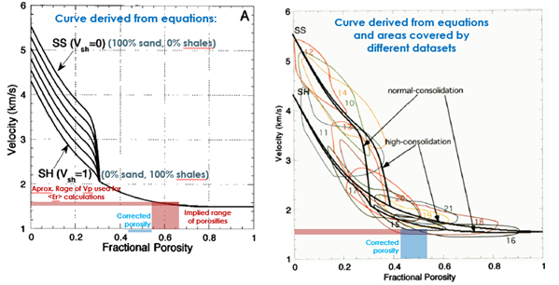

Figure S2. (Left) Curve function derived from Empirical Eq. S1 for sediments and siliciclastic rocks. The range of porosity normally used for glaciomarine sediments is indicated. (Right) Different curves derived from databases are observed.

The use of V_{P} value ~ 1,500 m/s is justified in the shallower part of the sedimentary infill of a basin dominated by muddy grain size fraction (green arrow in Fig. S3 and Table S1). This approach does not adjust to our study area, to support an appropriate time-distance interpretation of our seismic reflection data, because:

- The total sedimentary column exceeds 300 m, so it is acceptable to wait for an important sediment compaction. Changes in porosity and density would vary the P wave velocity, increasing this value usually used. Recent research from fjords associated with the Marinelli Glacier at Darwin Mountain Range in the Southern Patagonian Andes, have worked with this approach, by applying a depth-dependly sediment compaction model [Fernández et al., 2011; Fig. S4].

- The observation of our seismic profiles at the first order gives information suggesting that the sedimentary infill in the Aysén fjord is not uniform. The distinction of seismic facies allows the identification of at least three sedimentary units (MU: Moraine Unit, PLU: Parallel Laminated Unit, MDU: Mass Deformed Units). The oldest and deepest has been interpreted as a moraine.

In the literature, glacial moraines have been characterized with "high" velocities (see Table S1). As an example of the application of this range of speeds, in the work of Stoker & Holmes [1991], in the case of moraines, the authors propose a value of V_{P} = 1,800 m/s. The overlying sedimentary infill in the Aysén fjord can be differentiated into two units (PLUT and PLUP, which are interpreted as postglacial in age).

- The section interpreted in the seismic profiles as a postglacial sedimentary infill (PLU) is characterized by the presence of high contrast acoustic impedance changes, from which we interpret reflectors with high amplitude associated with sediments with high density-changes [Veeken, 2006]. According our interpretation, this section -of postglacial sedimentary infill- represents a period with high input of dominantly coarse grain size fraction sediments (sand-gravel). The lower section of PLUT that ends approximately at the first 0.5 s is characterized by reflectors of great amplitude with a greater spacing between them, with respect to the overlying sediments. This package could corresponds to deposits associated with the first stages of the glacial retreat at this portion of the Aysén fjord, driving high sedimentation rates and the deposition of coarse grain size fraction sediments. Overlying this last package in the seismic images, an intercalation of packages with different amplitude, lateral continuity and impedance change can be observed within the PLUT, which could be associated to different periods of transport with more or less sediment discharge from rivers, as well as to volcanic and tectonic events.
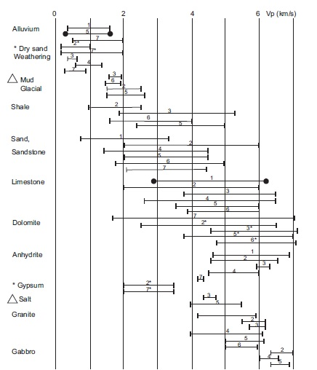

Figure S3. P wave velocities for sediments and common rocks [Zhaou, 2014]. This figure has been compiled from data based on many investigations. Green arrow indicates the range of velocities for mud type sediments, red arrow indicates the range for glacial sediments.

Based on the arguments previously exposed and considering that most of the sedimentary infill would be of glacial origin (moraine and outwash in addition to fluvial sediments), we decided to use a V_{P} = 2,000 m/s (see Fig. S3, red arrow).

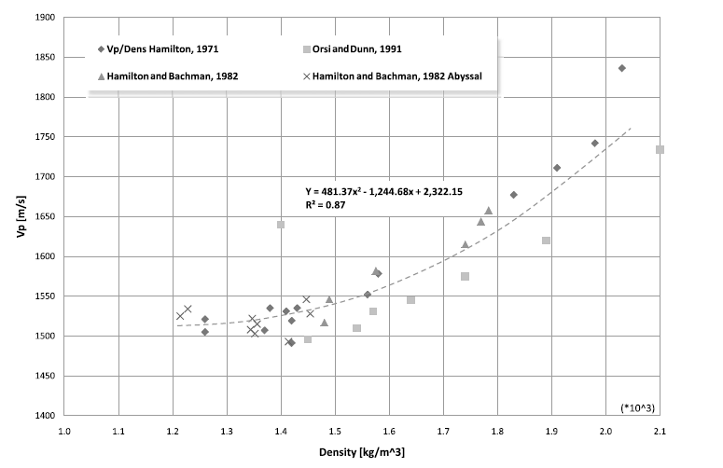
Figure S4. P-wave velocities related to density values from muddy marine sediments based on the data recovered by several authors (see legend). These data also correspond to a wide range of densities. Model proposed by Fernández et al. [2011].

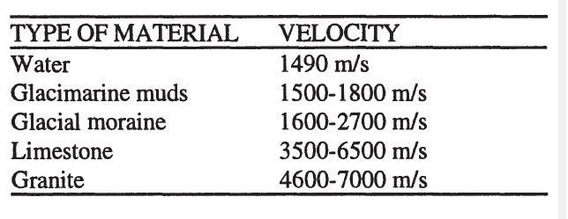

Table S1. Geomorphological analysis of Punta Cola Bulge. (i) Slope map. (ii) Aspect map. Mini map shows inset location.

Calculation of errors

Once chosen a P-wave velocity of 2,000 m/s, we migrated the seismic profiles to convert time in distance, by considering an error associated to the receiver-emitter geometric arrangement. This equation links the velocities within water and sediments, the thickness of the sedimentary fill, and the emitter-receiver distance. We evaluated three cases for P-wave velocities: 1,800; 2,000; and 2,300 m/s.

Fig. S5 shows the results where a maximum error of ~33 cm in the case of V_{P} = 2,300 m/s, can be observed between ~120 and 163 m depth, under the sea bottom. This error does not significantly affect our inferences of sedimentation rates or sedimentary package-thickness estimations.
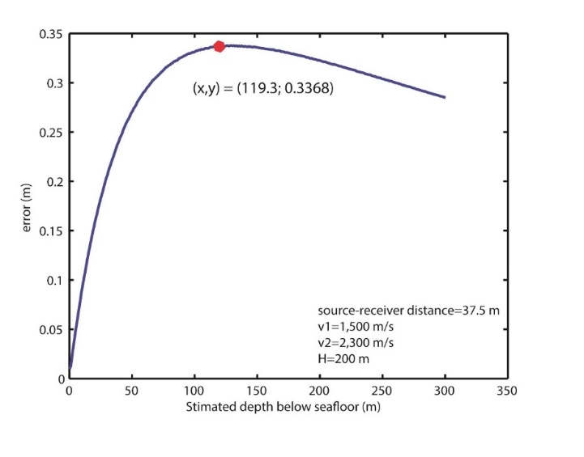
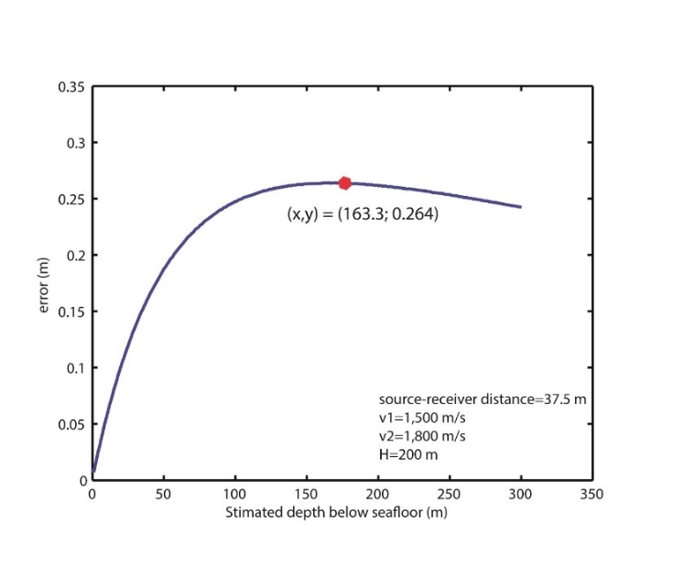
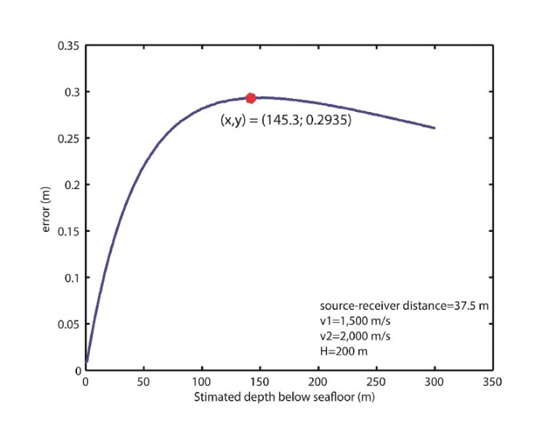

Figure S5. Error curves associated with the geometric arrangement as a function of the thickness of the sedimentary fill. Three V_{P} values were used: 1,800; 2,000 and 2,300 m/s.

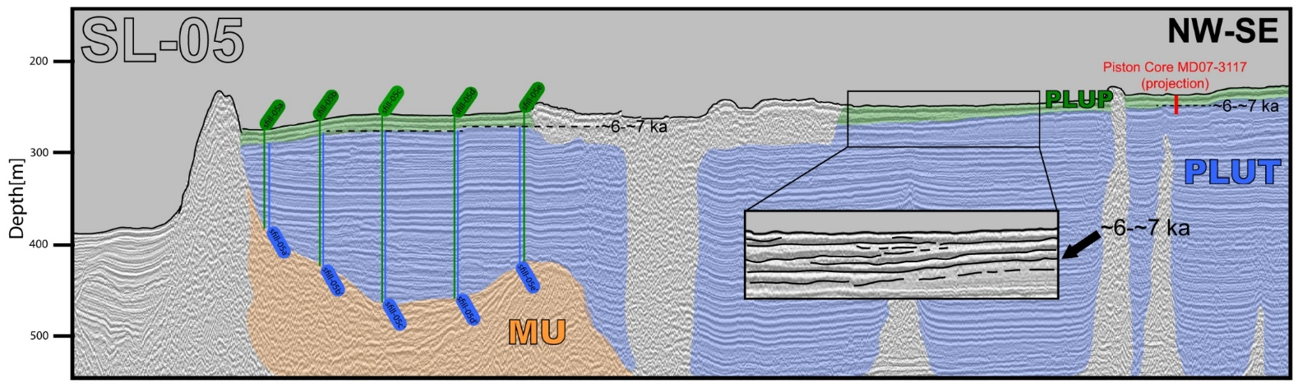

Figure S5. Seismic reflection profile (SL-05) migrated to distance [m] using V_{P}= 2,000 m/s, showing the measurement sites in the Parallel Laminated Unit (PLU) above the Moraine Bank Unit (MU, orange). PLU (post-glacial sedimentary infill) contains two sub-units: a lower one corresponding to a transgressive phase (PLUT, blue) and overlying strata corresponding to the progradational phase (PLUP, green). Green measurement sites (sfill-05-nn) correspond to the total of the sedimentary column. Blue measurement sites (sfill-05-nn’) correspond to a partial sedimentary column limited by the ~6-~7 kyrs (found in Piston Core MD07-3117) when the sea level stabilized in the area during the early to mid-Holocene [Lambeck et al., 2002; 2014]. Inset (i) shows a top-lap inside the sedimentary infill that matches with the sea level stabilization limit.

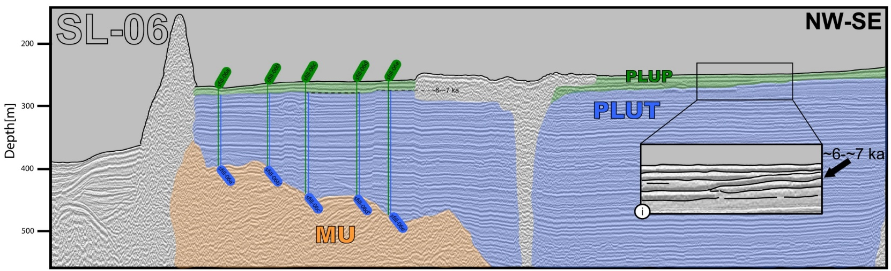

Figure S7. Seismic reflection profile (SL-06), showing the measurement sites in the Parallel Laminated Unit (PLU) above the Moraine Bank Unit (MU, orange). Green measurement sites (sfill-06-nn) correspond to the total of the sedimentary column. Blue measurement sites (sfill-06-nn’) correspond to a partial sedimentary column limited by the ~6-~7 kyrs [Lambeck et al., 2002; 2014]. Inset (i) shows a top-lap inside the sedimentary infill that matches with the sea level stabilization limit.

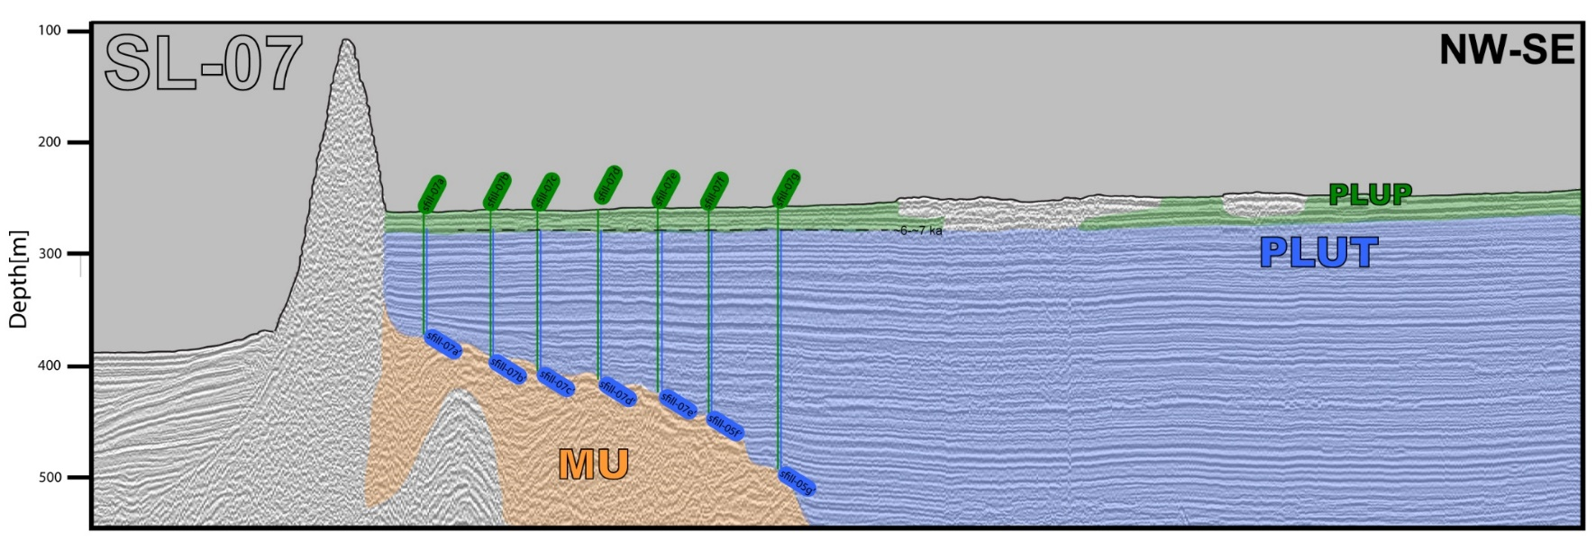

Figure S8. Seismic reflection profile (SL-06), showing the measurement sites in the Parallel Laminated Unit (PLU) above the Moraine Bank Unit (MU, orange). Green measurement sites (sfill-06-nn) correspond to the total of the sedimentary column. Blue measurement sites (sfill-06-nn’) correspond to a partial sedimentary column limited by the ~6-~7 kyrs [Lambeck, 2002; 2014].

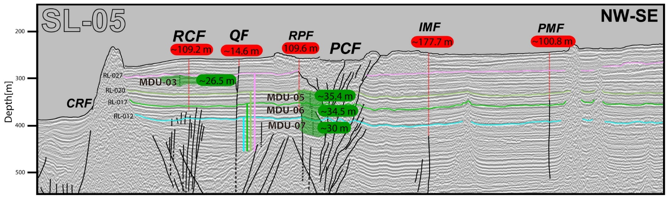

Figure S9. Seismic reflection profile (SL-05) migrated to distance [m] using V_{P}: 2,000 m/s, showing the distances from the seafloor to the tip faults observed in the Aysén fjord (red labels). Mass Deformed Units (MDU) are highlighted in green, its thickness is shown in green labels. Reflectors (R-012, R-017, R-020 and R-027) interpreted as paleo-seafloor (MDU’s upper limit) are shown.

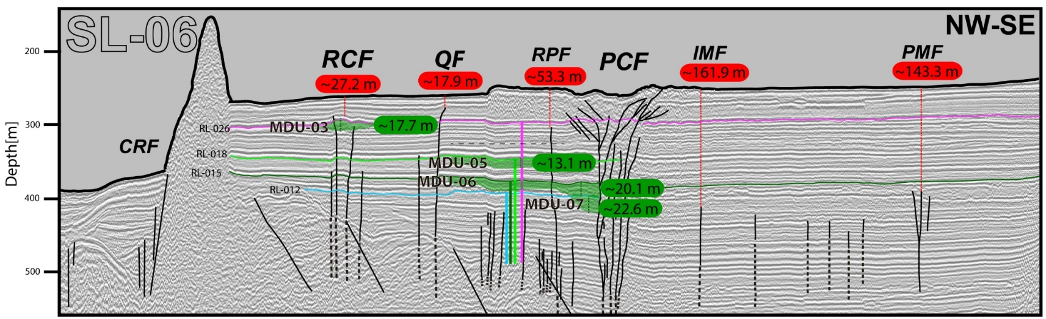

Figure S10. Seismic reflection profile (SL-06) migrated to distance [m] using V_{P}: 2,000 m/s, showing the distances from the seafloor to the tip faults observed in the Aysén fjord (red labels). Mass Deformed Units (MDU) are highlighted in green, and corresponding thicknesses are shown in green labels. Reflectors (R-012, R-015, R-018 and R-026) interpreted as paleo-seafloor (MDU’s upper limit) are shown.
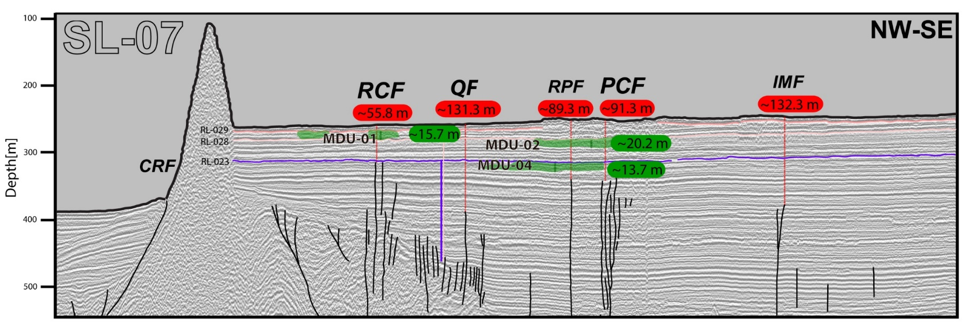

Figure S11. Seismic reflection profile (SL-07) migrated to distance [m] using V_{P}: 2,000 m/s, showing the distances from the seafloor to the tip faults observed in the Aysén fjord (red labels). Mass Deformed Units (MDU) are highlighted in green, and corresponding thicknesses are shown in green labels.

Measurement site | Infill thickness [m] | Measurement site | pre-6-7 kyrs Infill thickness [m] | Sedimentation rates [m/yr]
sfill-05a | 109.0 | sfill-05a' | 93.9 | 0.016
sfill-05b | 160.6 | sfill-05b' | 147.2 | 0.025
sfill-05c | 206.3 | sfill-05c' | 189.0 | 0.031
sfill-05d | 201.5 | sfill-05d' | 184.8 | 0.031
sfill-05e | 167.2 | sfill-05e' | 149.5 | 0.025

Table S2. Measurement results using SL-05. Thickness of sedimentary infill are expressed in meters and sedimentation rates are in meters per year. First considering a constant deposition of the entire sedimentary column, until ~6 kyrs.

Measurement site | Infill thickness [m] | Measurement site | pre-6-7 kyrs Infill thickness [m] | Sedimentation rates [m/yr]
sfill-06a | 126.5 | sfill-06a' | 114.7 | 0.019
sfill-06b | 134.5 | sfill-06b' | 119.3 | 0.020
sfill-06c | 181.0 | sfill-06c' | 164.7 | 0.027
sfill-06d | 183.9 | sfill-06d' | 166.6 | 0.028
sfill-06e | 217.1 | sfill-06e' | 202.1 | 0.034

Table S3. Measurement results using SL-06. Thickness of sedimentary infill are expressed in meters and sedimentation rates are in meters per year. First considering a constant deposition of the entire sedimentary column, until ~6 kyrs.

Measurement site | Infill thickness [m] | Measurement site | pre-6-7 kyrs Infill thickness [m] | Sedimentation rates [m/yr]
sfill-07a | 111.5 | sfill-07a' | 95.7 | 0.016
sfill-07b | 134.4 | sfill-07b' | 117.2 | 0.020
sfill-07c | 145.6 | sfill-07c' | 127.6 | 0.021
sfill-07d | 153.8 | sfill-07d' | 134.8 | 0.022
sfill-07e | 166.5 | sfill-07e' | 146.0 | 0.024
sfill-07f | 188.1 | sfill-07f' | 168.1 | 0.028
sfill-07g | 237.0 | sfill-07g' | 216.7 | 0.036

Table S4. Measurement results using SL-07. Thickness of sedimentary infill are expressed in meters and sedimentation rates are in meters per year. First considering a constant deposition of the entire sedimentary column, until ~6 kyrs.

 | Sed. rates [mm/yr]
Using 12 kyrs as MU's top age and 6 kyrs as upper limit
SL-05 | 25.48
SL-06 | 25.58
SL-07 | 23.96
Average sed. rate | 25.00
Using 12 kyrs as MU's top age and 7 kyrs as upper limit
SL-05 | 30.57
SL-06 | 30.69
SL-07 | 28.75
Average sed. rate | 30.01
Using 17.3 Kyr as MU's top age and 6 kyrs as upper limit
SL-05 | 13.53
SL-06 | 13.58
SL-07 | 12.72
Average sed. rate | 13.28
Using 17.3 Kyr as MU's top age and 7 kyrs as upper limit
SL-05 | 14.84
SL-06 | 14.90
SL-07 | 13.96
Average sed. rate | 14.57

Table S5. Sedimentation rates estimated for four possible scenarios from the last glacial maximum to the current sea level stabilization in Aysén fjord. These scenarios are based on C¹⁴ ages obtained by Vargas et al. [2013] from local moraines (Aysén fjord’s proximities); late-glacial glacier advancements in southernmost South America [Patagonian Andes; Sugden et al., 2005; Hein et al., 2010; Glasse et al., 2012]; and the sea level stabilization during the early to mid-Holocene [Lambeck et al., 2002; 2014].

Text S2. Reflectors offsets correlation with Buried MDU

By studying the relative position of fault markers in stratigraphic sequences, it is common to observe an increase in their separation further from the fault tip. In active faults, this feature is attributed to coseismic and postseismic slip distribution. Faults that cut Quaternary sediment have important implications, since as layers become older, a greater number of seismic events have displaced it. This principle considers the concept of accumulated offset, and it is often used along normal faults in postglacial sediment due to its potential to identify an accumulated displacement history across multiple seismic cycles [e.g., Bull et al., 2006; Barnes & Pondard, 2010; Pondard & Barnes, 2010]. Optimal conditions established by Barnes & Pondard [2010] for carrying out these studies are that the sedimentation rate exceeds vertical displacement rates along a fault for extended time periods covering multiple seismic cycles and that active faulting can generate surface ruptures. This produces a tectonic depression filled with sediment during the aseismic phase, which preserves fault scarps between successive ruptures.

In the Aysén fjord, the modern sedimentation rate is estimated as being between ~1.9 and ~3.0 m/ka [Salamanca & Jara, 2003; Van Daele et al., 2013], which are considered medium-low sedimentation rates for fjords and inlets [Syvitski et al., 1987] but high sedimentation rates with respect to tectonics. On the Quitralco Fault (QF), growth strata are observed near the surface, indicating a slip rate higher than the deposition rates at least for the last thousands of years (Figs. S12b and S12c).

Although Punta Cola Fault (PCF) corresponds to a dextral-inverse fault, the remarkable reflectors offsets size (Figs. S12e and S12f) allows us to propose that slip rates on this fault are also greater than the depositional rates since the last deglaciation.

We used depth-converted seismic profiles to assess vertical accumulated offsets caused by PCF and QF, using up to 28 reflectors, covering almost the entire postglacial sedimentary infill. As expected, the offset increases with depth and within the curves, and offset peaks escape this general tendency, as can be observed from the comparison of reflectors’ position versus the vertical offset for each fault analyzed, and the accumulated offsets curves. (Figs. S12h and S12i).

Considering that PCF activity during 2007-AYSS generated surface submarine rupture associated with a medium magnitude earthquake (M_{w} 6.2), and that other structures were activated at depth as well, it is possible to interpret the occurrence of peaks within the vertical separation curves of stratigraphic horizons as surface ruptures associated with paleo-earthquakes (Fig. S12).

We propose that buried MDUs were formed in the same way as MDU-00 (i.e., the 2007 submarine rockslides). The hypothesis is based on the geometry, the presence of thrust structures, and mainly in their thickness, due to the relationship between larger vertical and horizontal distances from the source, higher impact velocities, and the energy transfer that results in clear seabed deformation [Van Daele et al., 2013]. Considering the upper limit of buried MDU as paleo-seafloors (Figs. S9, S10 and S11), these sedimentary wedges are approximately coeval with the offset-peaks and represent additional evidence for paleoearthquakes with similar characteristics to the 2007 M_{w} 6.2 event (Figs. S12h and S12i).

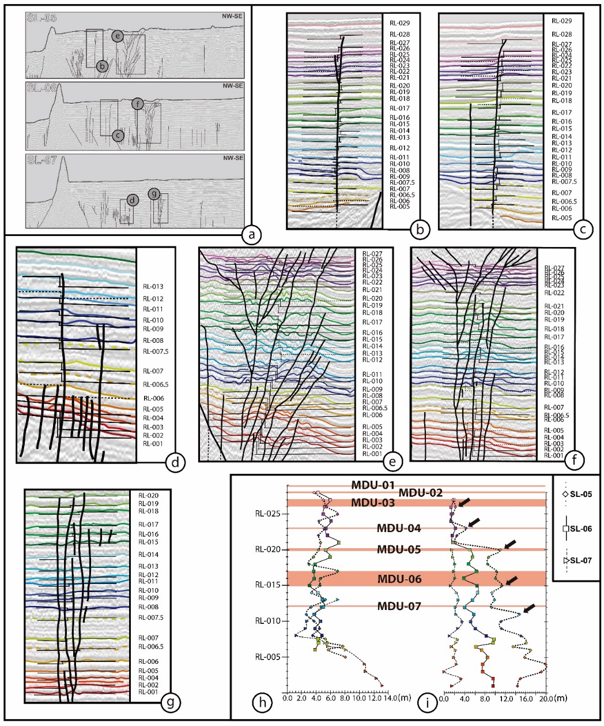

Figure S12. Detail of the displaced reflectors for the Punta Cola fault and Quitralco fault in the SL-05, SL-06 and SL-07 seismic profiles. Migration to distance using a velocity of 2.000 m/s. (a) The figure shows the insets for the calculation for each fault and its vertical offsets. (b) QF in SL-05. (c) QF in SL-06. (d) QF in SL-07. (e) PCF in SL-05. (f) PCF in SL-06. (g) PCF in SL-07. (h) and (i) offset vs. reflector position graph showing QF and PCF (respectively) accumulated offset for each seismic profile. MRDUs top reflector positions (red stripes). Offsets peaks, which we correlate to the horizon events associated with MRDUs top reflector.
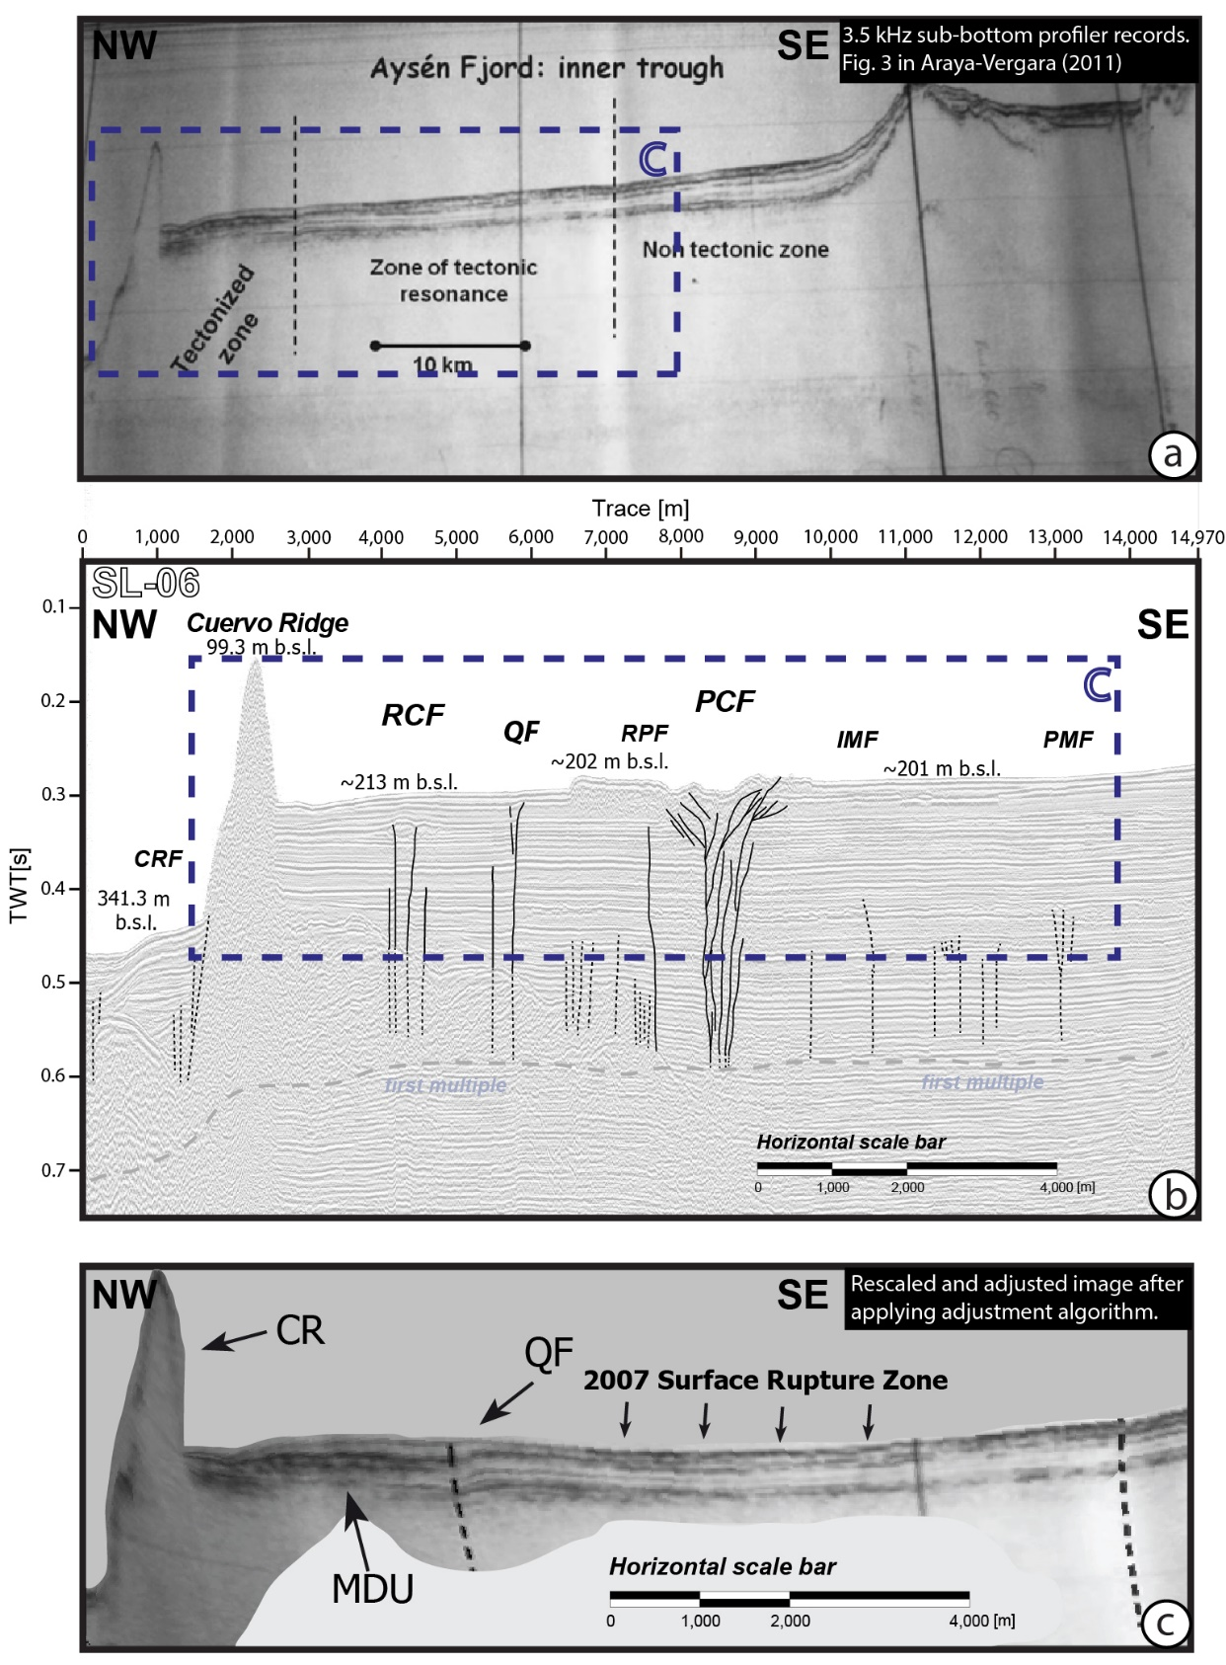

Figure S13. Seismic reflection profile (inner-fjord segment), subparallel to our seismic lines. (a) The original 1995 seismic profile form CIMAR-01 survey [from Araya-Vergara, 2011]. (b) Our SL-06 profile works as a reference framework. Segmented inset indicates the segment that we compared. Our interpreted structures were also added as reference points. (c) Part is the post-processed image. QF: Quitralco Fault; MDU: Mass Deformed Unit; CR: Cuervo Ridge.
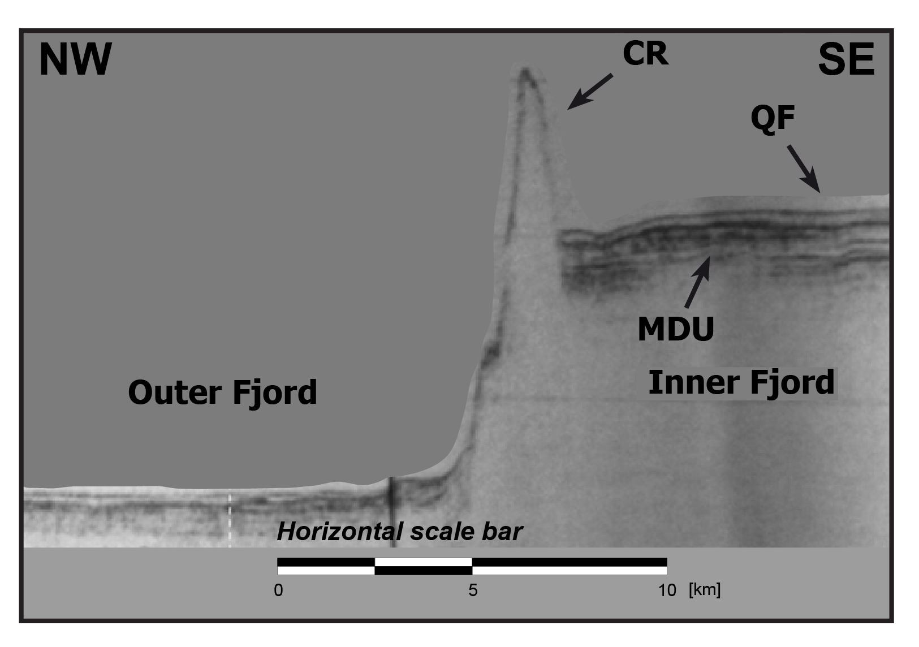
Figure S14. Seismic reflection profile (western segment), subparallel to our seismic lines [modified from Araya-Vergara, 2011]. QF: Quitralco Fault; MDU: Mass Deformed Unit; CR: Cuervo Ridge.
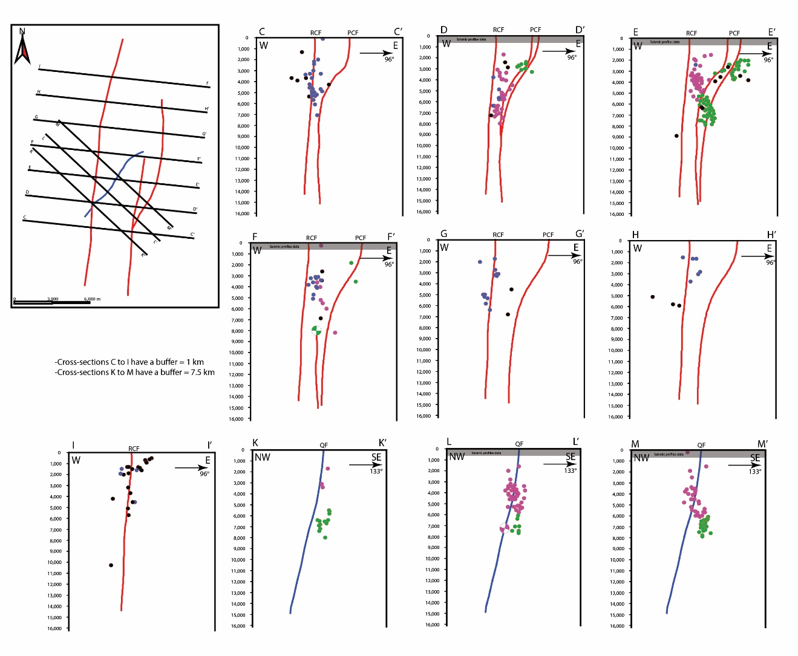
Figure S15. Cross sections used in the construction of the 3d geometric model of the Liquiñe-Ofqui Fault System in the Aysén Fjord. Vertical scale is in meters.
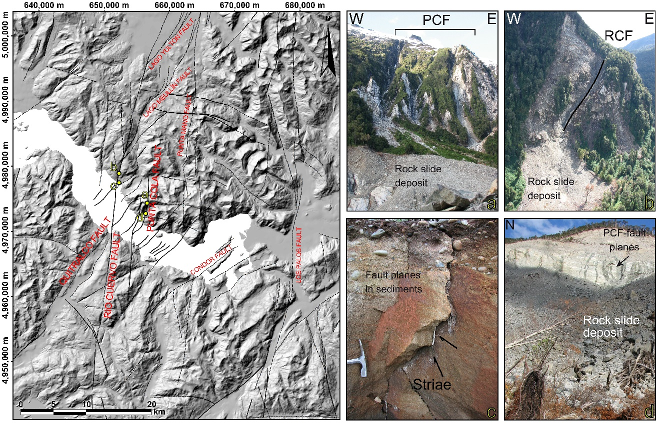

Figure S16. Left: Tectonic map showing fault traces, interpreted from the observation of aerial photographs, satellite images, topographic and bathymetric data, sub-bottom profile data and field recognition [modified from Vargas et al., 2013]. The main structures are Río Cuervo Fault and Punta Cola Fault. This faults are interpreted as the main branch of the Liquiñe-Ofqui Fault System in the area. Punta Mano Fault, Los Palos Fault, Lago Meullín Fault, Lago Yulton Fault, and Río Cóndor Faul are equivalent to Río Mañihuales Fault [Thomson, 2002; Cembrano et al., 2002], Quitralco Fault [Cembrano et al., 1996, 2002; Thompson, 2002], and Río Blanco Fault. Yellow points indicate the location of four photos highlighting recent activity in the faults investigated in this work [from Vargas et al., 2013]. (a), (d) Punta Cola Fault. (b), (c) Rio Cuervo Fault

