Supplementary data

Amazon River propagation evidenced by a CO₂ decrease at 8ºN, 38ºW in September 2013

Nathalie Lefèvre¹, Pedro Tyaquiçã¹, Doris Veleda², Coralie Perruche³, Simon Jan van Gennip³

¹LOCEAN, Sorbonne Université (Université P. et M. Curie-IRD-CNRS-MNHN), Paris, France
²Department of Oceanography, DOCEAN, Federal University of Pernambuco (UFPE), Recife, Brazil
³Mercator-Ocean, Ramonville, Saint-Agne, Haute Garonne, France

The method of Foltz et al. (2015) is used to reconstruct the SSS. There is good agreement between observed and reconstructed SSS from 2006 to 2017 (Figure S1). Gaps remain when no data are available.
Figure S1. Comparison of daily SSS measured at 8ºN, 38ºW with the reconstructed SSS (from daily observations of SSS and salinity at 20 m depth) over the years 2006 to 2017.

The Lagrangian experiment confirms that the particles released at 8ºN, 38ºW come from the Amazon shelf during the second part of the year. Figure S2 shows the monthly trajectories for the year 2013.

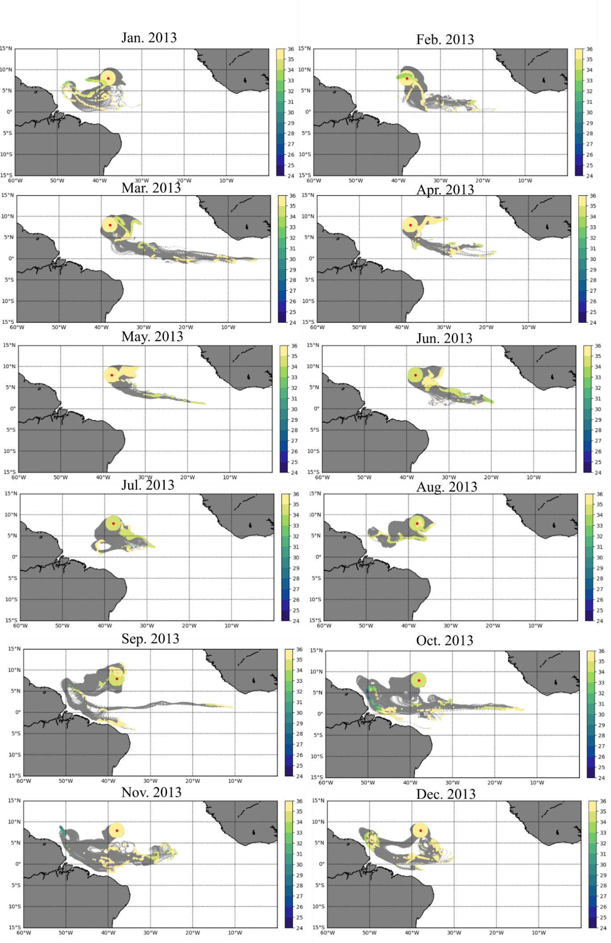Figure S2. Surface pathways of ocean model particles released uniformly within 1.75º from the station 8ºN, 38ºW in 2013. Particles are backtracked in time for 90 days with trajectories represented in grey and particles position of origin colored according to the salinity value.

The salinity values observed 90 days before the release of the particles exhibit the same patterns as the salinity observed at 8ºN, 38ºW (Figure S3) with the lowest values in 2009 and highest SSS in 2014.
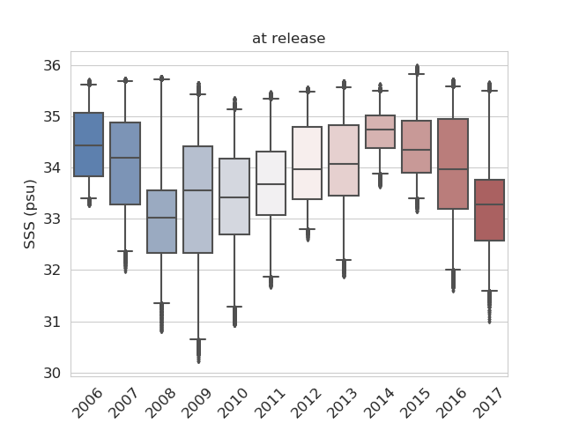
Figure S3. Box plot of the interannual variability of salinity levels for particles at 8ºN, 38ºW, the release site of the particles.

This confirms that the interannual variability of the SSS observed at 8ºN, 38ºW is related to ocean circulation, and especially to the conditions in the SEC and in the Amazon outflow.

