Supplementary Information: Population genetic structure of the vase sponge Ircinia campana in the Greater Caribbean is shaped by oceanographic features and limited dispersal
S.M. Griffiths, M.J. Butler IV, D.C. Behringer, T. Pérez & R.F. Preziosi

Number of loci | 1 | 2 | 3 | 4 | 5 | 6 | 7 | 8 | 9 | 10
Average null allele frequency | 0.000 | 0.042 | 0.059 | 0.069 | 0.097 | 0.200 | 0.236 | 0.239 | 0.250 | 0.323
Global F_{ST} without ENA | 0.035 | 0.126 | 0.162 | 0.127 | 0.132 | 0.152 | 0.141 | 0.128 | 0.134 | 0.141
Global F_{ST} with ENA | 0.035 | 0.140 | 0.162 | 0.127 | 0.130 | 0.143 | 0.133 | 0.120 | 0.123 | 0.126
Difference in F_{ST} with and without ENA | 0.000 | -0.014 | 0.000 | 0.000 | 0.002 | 0.009 | 0.008 | 0.008 | 0.011 | 0.015
Table S1: Cumulative average null allele frequency and global F_{ST} calculated with and without ENA correction for null alleles. Beginning with all ten loci, global F_{ST} was calculated with and without ENA correction for null alleles (Chapuis and Estoup 2007). The locus with the highest null allele frequency was then removed from the analysis, after which the global F_{ST} statistics were recalculated. This process was repeated sequentially until one locus remained.

Table S2: Number of alleles and null allele frequency per locus
 | Icam 3 | Icam 4 | Icam 10 | Icam 18 | Icam 23 | Icam 24 | Icam 26 | Icam 31 | Icam 32 | Icam34
Number of alleles | 32 | 19 | 19 | 96 | 97 | 83 | 21 | 21 | 4 | 58
Null allele frequency | 0.097 | 0.042 | 0.250 | 0.069 | 0.236 | 0.239 | 0.200 | 0.059 | <0.001 | 0.323

Table S3: Inbreeding coefficient (F_{IS}) values per locus per site for Ircinia campana (without null allele correction).

 | Icam3 | Icam4 | Icam10 | Icam18 | Icam23 | Icam24 | Icam26 | Icam31 | Icam32 | Icam34
GR | - | - | 1.000 | -0.118 | 0.009 | 1 | 1 | 0.294 | -0.125 | 1.000
LK | -0.120 | 0.000 | 0.92 | 0.268 | 0.420 | 0.927 | 0.543 | 0.219 | -0.086 | 0.906
BK | -0.103 | - | 0.82 | 0.412 | 0.699 | 0.543 | 0.585 | 0.755 | -0.250 | 0.797
KC | 0.631 | - | 0.781 | 0.049 | 0.579 | 0.657 | 0.592 | 0.437 | - | 1.000
WK | 0.141 | - | 0.783 | 0.306 | 0.611 | 0.480 | 0.685 | 0.432 | -0.067 | 1.000
BC | 0.489 | - | 1.000 | 0.226 | 0.327 | 0.740 | 0.676 | 0.088 | -0.062 | 0.705
LP | 0.282 | - | 0.591 | 0.166 | 0.350 | 0.745 | 0.626 | 0.525 | -0.056 | 0.793
TA | -0.137 | 0.304 | 0.919 | 0.148 | 0.846 | 0.432 | 0.704 | 0.148 | -0.115 | 1.000
SC | 0.166 | 0.191 | 0.599 | 0.363 | 0.131 | 0.619 | 0.719 | -0.004 | -0.007 | 0.734
PAN1 | 0.084 | -0.054 | 0.649 | -0.090 | 0.696 | 0.423 | 0.347 | -0.037 | -0.217 | 0.718
PAN2 | 0.182 | -0.119 | 0.672 | 0.225 | 0.570 | 0.066 | 0.350 | 0.160 | -0.340 | 0.629
PAN3 | -0.155 | -0.071 | - | 0.030 | 1 | 0.567 | 0.306 | 0.125 | -0.111 | 0.479
MAY | 0.342 | 0.398 | 0.688 | 0.135 | 0.584 | 0.482 | 0.451 | 0.026 | -0.295 | 0.692
BEQ | 0.437 | 0.116 | 0.575 | 0.154 | 0.694 | 0.277 | 0.343 | -0.025 | -0.163 | 0.643
STV | 0.651 | 0.198 | 0.299 | -0.008 | 0.535 | 0.432 | 0.460 | -0.124 | -0.183 | 0.775
STL | 0.170 | 0.696 | 0.672 | 0.132 | 0.480 | 0.489 | 0.619 | 0.227 | -0.048 | 0.953
MAR1 | 0.092 | -0.043 | 0.281 | 0.196 | 0.310 | 0.629 | -0.295 | -0.007 | -0.103 | 1.000
MAR2 | 0.094 | -0.020 | 0.660 | 0.274 | 0.640 | 0.380 | 0.516 | -0.036 | -0.064 | 0.811
GU | 0.536 | 0.659 | 0.649 | 0.046 | 0.726 | 0.561 | 0.591 | -0.008 | -0.016 | 0.694

Significant p values after Benjamini-Yekutieli correction for multiple tests highlighted in bold (p < 0.05)

Site | Model
 | nfb | nf | nb | bf | n | b
GR | 291.989 | 293.466 | 290.59 | - | 292.542 | -
LK | 1067.314 | 1090.907 | 1065.222 | 1097.398 | 1081.915 | 1227.870
BK | 664.063 | 675.292 | 666.018 | 666.089 | 675.697 | 762.715
KC | 926.179 | 925.259 | 926.460 | 946.704 | 925.147 | 1056.005
WK | 672.205 | 672.110 | 676.515 | 684.412 | 677.906 | 738.229
BC | 857.693 | 862.754 | 857.453 | 867.695 | 862.041 | 957.969
LP | 972.074 | 971.871 | 971.097 | 986.096 | 971.113 | 1056.805
TA | 1485.159 | 1483.566 | 1488.071 | 1551.031 | 1488.037 | 1683.175
SC | 2141.152 | 2150.320 | 2146.490 | 2181.035 | 2154.532 | 2314.246
PAN1 | 487.430 | 496.328 | 486.003 | 497.951 | 495.728 | 515.232
PAN2 | 703.262 | 713.151 | 701.930 | 721.475 | 711.647 | 731.595
PAN3 | 806.103 | 813.974 | 805.861 | 814.440 | 813.670 | 829.725
MAY | 1246.373 | 1247.470 | 1249.000 | 1256.874 | 1248.051 | 1338.043
BEQ | 1720.730 | 1730.438 | 1718.836 | 1739.943 | 1728.436 | 1852.124
STV | 2389.176 | 2428.908 | 2387.637 | 2448.622 | 2427.530 | 2635.384
STL | 2596.634 | 2605.839 | 2594.866 | 2644.272 | 2603.508 | 2894.867
MAR1 | 1020.657 | 1019.150 | 1020.065 | 1044.973 | 1019.061 | 1120.244
MAR2 | 1406.457 | 1406.817 | 1405.281 | 1438.552 | 1405.035 | 1504.624
GU | 1677.984 | 1674.430 | 1676.310 | 1705.252 | 1673.548 | 1900.984
Table S4: Deviance information criterion (DIC) using various combinations of parameters in inbreeding coefficient (F_{IS}) estimation models in Ircinia campana.

n: null alleles; f: inbreeding; b: genotyping error. Lowest DIC values are highlighted in bold; these correspond to the best-fitting model for the data.

Table S5 – Pairwise F_{ST} (below diagonal, shaded) and Jost’s D (above diagonal) calculated from 8 loci dataset
 | GR | LK | BK | KC | WK | BC | LP | TA | SC | PAN1 | PAN2 | PAN3 | MAY | BEQ | STV | STL | MAR1 | MAR2 | GU
GR | - | 0.202 | 0.086 | 0.201 | 0.332 | 0.197 | 0.236 | 0.432 | 0.598 | 0.427 | 0.377 | 0.276 | 0.507 | 0.437 | 0.470 | 0.390 | 0.277 | 0.304 | 0.303
LK | 0.112 | - | 0.057 | 0.036 | 0.066 | 0.009 | 0.032 | 0.322 | 0.477 | 0.237 | 0.185 | 0.186 | 0.324 | 0.206 | 0.258 | 0.179 | 0.124 | 0.105 | 0.189
BK | 0.059 | 0.027 | - | 0.116 | 0.167 | 0.065 | 0.111 | 0.379 | 0.509 | 0.329 | 0.261 | 0.230 | 0.390 | 0.291 | 0.324 | 0.291 | 0.226 | 0.172 | 0.229
KC | 0.138 | 0.022 | 0.069 | - | 0.012 | 0.075 | 0.080 | 0.378 | 0.526 | 0.328 | 0.314 | 0.276 | 0.403 | 0.281 | 0.295 | 0.266 | 0.231 | 0.150 | 0.261
WK | 0.221 | 0.039 | 0.100 | 0.008 | - | 0.100 | 0.112 | 0.376 | 0.548 | 0.343 | 0.349 | 0.309 | 0.385 | 0.250 | 0.274 | 0.330 | 0.295 | 0.209 | 0.307
BC | 0.118 | 0.005 | 0.032 | 0.046 | 0.062 | - | 0.030 | 0.282 | 0.446 | 0.254 | 0.223 | 0.180 | 0.316 | 0.212 | 0.239 | 0.243 | 0.148 | 0.124 | 0.166
LP | 0.139 | 0.016 | 0.056 | 0.048 | 0.068 | 0.016 | - | 0.369 | 0.501 | 0.298 | 0.272 | 0.251 | 0.397 | 0.269 | 0.299 | 0.250 | 0.181 | 0.159 | 0.243
TA | 0.247 | 0.16 | 0.191 | 0.207 | 0.21 | 0.148 | 0.185 | - | 0.463 | 0.294 | 0.341 | 0.275 | 0.337 | 0.231 | 0.261 | 0.322 | 0.273 | 0.287 | 0.247
SC | 0.243 | 0.172 | 0.185 | 0.213 | 0.225 | 0.17 | 0.185 | 0.19 | - | 0.410 | 0.431 | 0.421 | 0.558 | 0.503 | 0.559 | 0.501 | 0.413 | 0.492 | 0.406
PAN1 | 0.237 | 0.112 | 0.157 | 0.176 | 0.188 | 0.124 | 0.144 | 0.154 | 0.156 | - | 0.091 | 0.085 | 0.465 | 0.332 | 0.360 | 0.256 | 0.149 | 0.212 | 0.250
PAN2 | 0.194 | 0.080 | 0.115 | 0.153 | 0.172 | 0.099 | 0.119 | 0.159 | 0.148 | 0.044 | - | 0.064 | 0.399 | 0.293 | 0.356 | 0.218 | 0.155 | 0.182 | 0.208
PAN3 | 0.164 | 0.086 | 0.110 | 0.148 | 0.167 | 0.087 | 0.118 | 0.142 | 0.153 | 0.045 | 0.030 | - | 0.317 | 0.225 | 0.257 | 0.245 | 0.195 | 0.145 | 0.193
MAY | 0.205 | 0.115 | 0.138 | 0.166 | 0.162 | 0.116 | 0.145 | 0.141 | 0.163 | 0.165 | 0.129 | 0.111 | - | 0.060 | 0.104 | 0.212 | 0.382 | 0.296 | 0.381
BEQ | 0.211 | 0.089 | 0.124 | 0.137 | 0.126 | 0.094 | 0.118 | 0.113 | 0.171 | 0.142 | 0.114 | 0.096 | 0.022 | - | 0.032 | 0.192 | 0.269 | 0.194 | 0.248
STV | 0.239 | 0.118 | 0.147 | 0.152 | 0.146 | 0.114 | 0.14 | 0.134 | 0.202 | 0.165 | 0.148 | 0.118 | 0.043 | 0.015 | - | 0.234 | 0.311 | 0.219 | 0.315
STL | 0.165 | 0.069 | 0.109 | 0.115 | 0.141 | 0.094 | 0.097 | 0.135 | 0.154 | 0.099 | 0.077 | 0.090 | 0.066 | 0.070 | 0.092 | - | 0.117 | 0.160 | 0.251
MAR1 | 0.183 | 0.056 | 0.100 | 0.118 | 0.150 | 0.069 | 0.084 | 0.134 | 0.145 | 0.07 | 0.065 | 0.085 | 0.127 | 0.108 | 0.134 | 0.043 | - | 0.125 | 0.129
MAR2 | 0.147 | 0.055 | 0.091 | 0.089 | 0.123 | 0.067 | 0.085 | 0.153 | 0.189 | 0.111 | 0.087 | 0.076 | 0.118 | 0.091 | 0.109 | 0.067 | 0.063 | - | 0.168
GU | 0.171 | 0.092 | 0.111 | 0.141 | 0.164 | 0.084 | 0.119 | 0.131 | 0.159 | 0.123 | 0.095 | 0.094 | 0.143 | 0.111 | 0.147 | 0.100 | 0.062 | 0.088 | -

Significant values following Benjamini- Yekutieli correction for multiple tests in bold (p < 0.05), calculated using 50,000 bootstrap replications

Table S6 – Pairwise F_{ST} with ENA correction for null alleles between Ircinia campana sites, calculated from 10 loci dataset
 | GR | LK | BK | KC | WK | BC | LP | TA | SC | PAN1 | PAN2 | PAN3 | MAY | BEQ | STV | STL | MAR1 | MAR2 | GU
GR | -
LK | 0.111 | -
BK | 0.053 | 0.023 | -
KC | 0.135 | 0.017 | 0.055 | -
WK | 0.214 | 0.049 | 0.112 | 0.030 | -
BC | 0.104 | 0.006 | 0.028 | 0.033 | 0.055 | -
LP | 0.119 | 0.020 | 0.045 | 0.039 | 0.072 | 0.016 | -
TA | 0.226 | 0.166 | 0.171 | 0.172 | 0.219 | 0.158 | 0.176 | -
SC | 0.222 | 0.167 | 0.167 | 0.182 | 0.215 | 0.166 | 0.173 | 0.154 | -
PAN1 | 0.233 | 0.160 | 0.176 | 0.175 | 0.225 | 0.165 | 0.168 | 0.139 | 0.142 | -
PAN2 | 0.165 | 0.107 | 0.118 | 0.135 | 0.186 | 0.113 | 0.127 | 0.150 | 0.138 | 0.058 | -
PAN3 | 0.190 | 0.161 | 0.167 | 0.173 | 0.235 | 0.158 | 0.168 | 0.139 | 0.150 | 0.046 | 0.054 | -
MAY | 0.204 | 0.132 | 0.143 | 0.162 | 0.183 | 0.136 | 0.154 | 0.152 | 0.146 | 0.186 | 0.135 | 0.161 | -
BEQ | 0.198 | 0.096 | 0.119 | 0.122 | 0.140 | 0.103 | 0.118 | 0.121 | 0.153 | 0.163 | 0.125 | 0.143 | 0.024 | -
STV | 0.218 | 0.128 | 0.143 | 0.138 | 0.162 | 0.127 | 0.139 | 0.122 | 0.172 | 0.163 | 0.141 | 0.139 | 0.048 | 0.016 | -
STL | 0.157 | 0.090 | 0.109 | 0.110 | 0.160 | 0.107 | 0.110 | 0.122 | 0.126 | 0.121 | 0.091 | 0.120 | 0.060 | 0.067 | 0.079 | -
MAR1 | 0.127 | 0.065 | 0.086 | 0.095 | 0.152 | 0.071 | 0.085 | 0.113 | 0.128 | 0.090 | 0.074 | 0.112 | 0.119 | 0.094 | 0.113 | 0.051 | -
MAR2 | 0.151 | 0.068 | 0.089 | 0.079 | 0.135 | 0.075 | 0.090 | 0.145 | 0.169 | 0.128 | 0.099 | 0.116 | 0.120 | 0.089 | 0.102 | 0.075 | 0.060 | -
GU | 0.167 | 0.110 | 0.124 | 0.122 | 0.180 | 0.099 | 0.124 | 0.140 | 0.149 | 0.160 | 0.119 | 0.151 | 0.153 | 0.123 | 0.151 | 0.107 | 0.057 | 0.098 | -

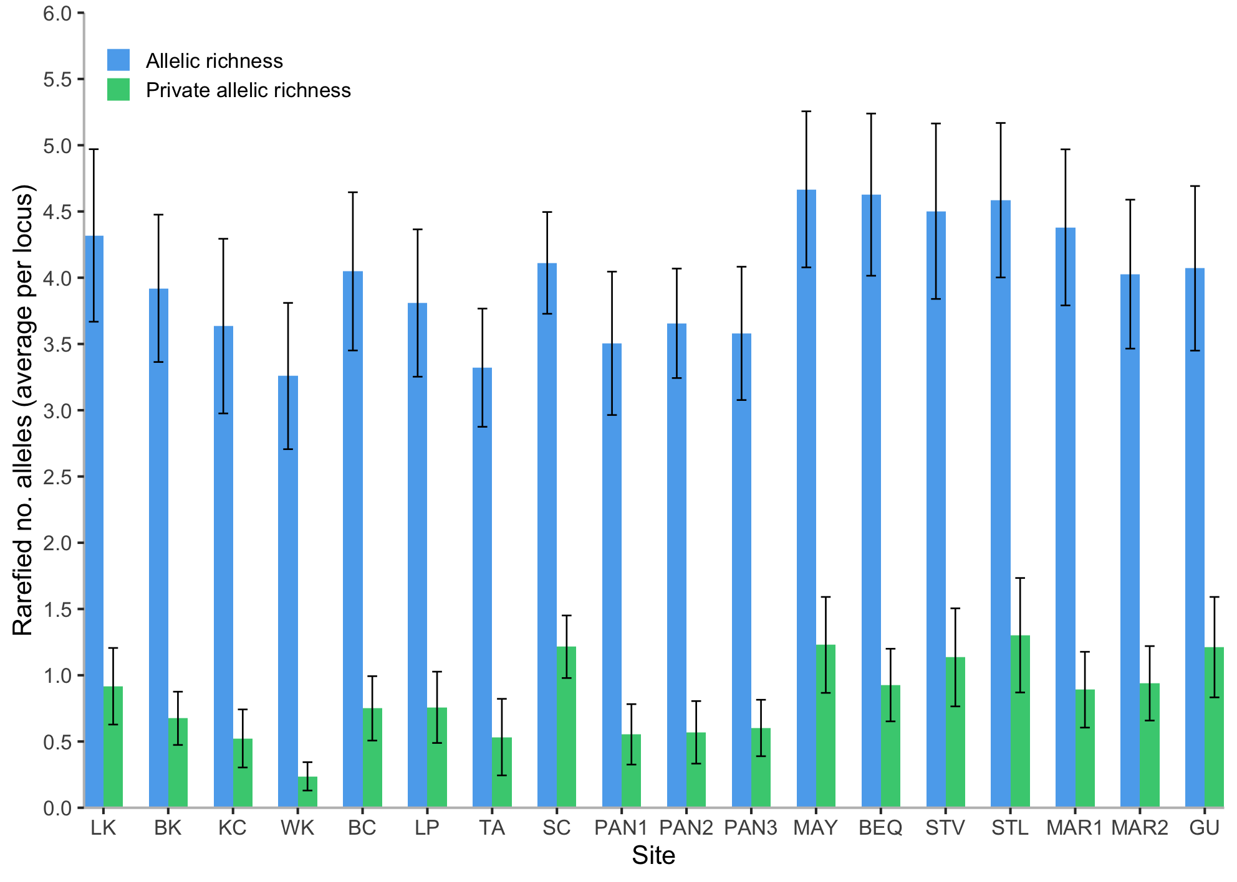

Fig. S1: Rarefied allelic richness and rarefied private allelic richness (maximum standardised sample size [max g] = 8) in Ircinia campana sites. Error bars +/- 1 SE.

