Supplementary materials: Elasmobranch bycatch distributions and mortality: the case of the European tropical tuna purse-seine fishery
Lyndsay Clavareau^{1,}*, Philippe S. Sabarros¹, Lauriane Escalle², Pascal Bach¹, Francisco J. Abascal³, Jon Lopez⁴, Hilario Murua⁴, Pedro J. Pascual Alayon³, Maria Lourdes Ramos ³, Jon Ruiz⁴, Bastien Mérigot¹
¹MARBEC, Univ. Montpellier, CNRS, Ifremer, IRD, Ob7, Avenue Jean Monnet, CS 30171, 34203 Sète cedex, France

²The Pacific Community SPC, B.P. D, 98848 Nouméa, Nouvelle Calédonie

³Instituto Español de Oceanografía, Dársena Pesquera PCL8, 38180 Santa Cruz de Tenerife, Spain.
⁴AZTI Tecnalia, Herrera Kaia, Portualde z/g, 20110 Pasaia (Gipuzkoa), Spain
*Email: l.clavareau@gmail.com
*Phone number : +33635938082
Appendix S1:
Table S1. Number of individuals caught and percentage of these individuals measured and sexed by ocean for the main species caught as bycatch by the purse-seine fishery in the Atlantic and Indian Oceans

 | Atlantic Ocean |  |  | Indian Ocean
Scientific name (FAO code) | Number of individuals | % measured | % sexed | Number of individuals | % measured | % sexed
Prionace glauca (BSH) | 531 | 64.0 | 90.9 | 35 | 45.7 | 68.7
Mobula mobular (RMM) | 343 | 77.8 | 70.4 | 88 | 56.8 | 52.00
Manta birostris (RMB) | 79 | 87.3 | 65.2 | 111 | 54.1 | 56.7
Sphyrna mokarran (SPK) | 212 | 95.7 | 79.8 | - | - | -
Carcharhinus longimanus (OCS) | 119 | 87.4 | 93.3 | 706 | 50.4 | 66.3
Pteroplatytrygon violaeca (PLS) | 298 | 77.2 | 41.7 | 258 | 62.8 | 55.5
Sphyrna lewini (SPL) | 1491 | 67.5 | 90.2 | 3 | 66.7 | 0.00
Isurus oxyrinchus (SMA) | 110 | 86.4 | 93.7 | 11 | 63.6 | 71.4
Carcharhinus falciformis (FAL) | 14722 | 58.7 | 89.3 | 31332 | 66.3 | 87.9
Sphyrna zygaena (SPZ) | 979 | 52.1 | 94.7 | - | - | -

Table S2. Maturity range in centimeter of each elasmobranch observed in catch and size maturity shift used (TL for shark and WD for ray). Species presenting more than 120 individuals caught, and therefore studied in more detail, are highlighted in bold.
Scientif name | L50 (cm) | references
Aetobatus narinari | 110 – 120 (99.8) | White et al., 2006
Alopias pelagicus | 260 – 292 (276) | Weigmann, 2016
Alopias superciliosus | 154 – 341 (250) | Cervigón et al., 1992
Alopias vulpinus | 226 – 400 (303) | Weigmann, 2016
Carcharhinus falciformis | 202 – 260 (225) | Compagno and Niem, 1998
Carcharhinus longimanus | 180 - 200 (190) | Compagno et al., 1995; Bacchet et al., 2006
Carcharhinus obscurus | 220 – 300 (235) | Compagno et al., 1989; Sanches, 1991
Carcharhinus plumbeus | 126 – 183 (150) | Frimodt, 1995; Murdy et al., 1997
Galeocerdo Cuvier | 210 – 350 (300) | Schneider, 1990; Vidthayanon, 2005
Isurus oxyrinchus | 275 – 285 (280) | Cervigón et al., 1992; Weigmann, 2016
Lamna nasus | 170- 219 (237) | Muus and Dahlström, 1978; Scott and Scott, 1988
Manta alfredi | 370 – 390 (380) | Marshall et al., 2009
Manta birostris | 380 – 460 (420) | Stehmann, 1981; White et al., 2006
Megachasma pelagios | 540 - ¿ (540) | Dulvy et al., 2008
Mobula mobular | UNK (200) | McEachran and Seret, 1990
Mobula tarapacana | UNK (200) | White et al., 2006
Mobula thurstoni | 150 – 154 (152) | Eschmeyer et al., 1983; McEachran and Notarbartolo di Sciara, 1995
Pteroplatytrygon violaeca | 40 – 50 (45) | Ebert, 2003; McEachran, 1995
Prionace glauca | 170 – 221 (221) | Cervigón et al., 1992; Muus and Nielsen, 1999
Sphyrna lewini | 140 – 273 (230) | Smith, 1997; Compagno, 1998
Sphyrna mokarran | 210 – 300 (275) | Compagno, 1984; Compagno, 1998
Sphyrna zygaena | 265 - ¿ (265) | Compagno, 1998; Muus and Nielsen, 1999
Table S3. Total number of individuals caught in the Atlantic and Indian Oceans. Species presenting more than 120 individuals caught, and therefore studied in more detail, are highlighted in bold
Scientific name | IUCN status () | Atlantic Ocean | Indian Ocean
Aetobatus narinari | NT | 0 | 1
Alopias pelagicus | VU | 1 | 0
Alopias superciliosus | VU | 6 | 0
Alopias vulpinus | VU | 1 | 0
Carcharhinus falciformis | NT | 14722 | 31332
Carcharhinus longimanus | VU | 119 | 706
Carcharhinus obscurus |  | 0 | 1
Carcharhinus plumbeus | VU | 1 | 0
Galeocerdo cuvier | NT | 2 | 6
Isurus oxyrinchus | VU | 110 | 11
Lamna nasus | VU | 2 | 1
Manta birostris | VU | 79 | 113
Mobula mobular | EN | 343 | 88
Mobula tarapacana | VU | 55 | 13
Mobula thurstoni | NT | 1 | 0
Pteroplatytrygon violaeca | LC | 298 | 258
Prionace glauca | NT | 531 | 35
Sphyrna lewini | EN | 1491 | 3
Sphyrna mokarran | EN | 212 | 0
Sphyrna zygaena | VU | 979 | 0
IUCN classification: EX = Extinct, EW = Extinct in the Wild, CR = Critically Endangered, EN = Endangered, VU = Vulnerable, NT = Near Threatened, LC = Least Concern, DD = Data Deficient, NE = Not Evaluated

Table S4. Percentage of sets with at least one individual elasmobranch caught by season (Atlantic Ocean by quarter: 1= January–March; 2= April–June; 3= July–September and 4= October–December and Indian Ocean by monsoon: 1= December–March; 2= April–May; 3= June–September; 4 = October–November). Fishing modes: FAD= Fish Aggregating Devices; FSC=free-swimming tuna schools
 | Atlantic Ocean |  | Indian Ocean
Season | FAD | FSC | FAD | FSC
1 | 21.5 | 4.0 | 67.5 | 12.9
2 | 46.9 | 26.6 | 68.0 | 17.0
3 | 50.2 | 25.7 | 68.4 | 11.7
4 | 34.8 | 12.1 | 67.3 | 9.1

Table S5. Percentage of juveniles, females, and apparent mortality rates by species and ocean for the main species captured as bycatch by the purse-seine fishery in the Atlantic and Indian Oceans.
 | Atlantic Ocean |  |  |  | Indian Ocean
Scientific name (FAO code) | N caught | % juvenile | % female | Mortality rate | N caught | % juvenile | % female | Mortality rate
Prionace glauca (BSH) | 531 | 50.00 | 13.27 | 34.83 | 35 | 62.50 | 36.36 | 57.14
Mobula mobular (RMM) | 343 | 30.71 | 50.53 | 46.94 | 88 | 36.00 | 57.69 | 30.68
Manta birostris (RMB) | 79 | 94.20 | 66.67 | 43.03 | 111 | 80.00 | 35.29 | 24.32
Sphyrna mokarran (SPK) | 212 | 98.52 | 41.13 | 58.96 | - | - | - | -
Carcharhinus longimanus (OCS) | 119 | 54.81 | 56.70 | 41.17 | 706 | 83.15 | 57.20 | 27.19
Pteroplatytrygon violaeca (PLS) | 298 | 37.39 | 48.96 | 33.22 | 258 | 37.78 | 73.46 | 63.95
Sphyrna lewini (SPL) | 1491 | 71.27 | 57.99 | 45.20 | 3 | 0.00 | 0.00 | 33.33
Isurus oxyrinchus (SMA) | 110 | 100 | 61.79 | 60.00 | 11 | 100.00 | 60.00 | 63.63
Carcharhinus falciformis (FAL) | 14722 | 93.11 | 51.26 | 51.73 | 31332 | 99.50 | 51.93 | 59.98
Sphyrna zygaena (SPZ) | 979 | 97.65 | 63.77 | 60.36 | - | - | - | -

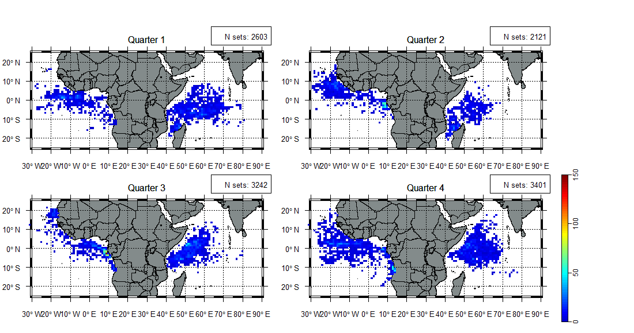
Figure S1. Quarterly distribution of fishing effort (i.e. number of fishing sets) on Fish Aggregating Devices (FAD) sets per 1° square. N sets is the number of sets. Each quarter correspond to a trimestral division in the Atlantic Oceans and to monsoon and inter-monsoon seasons in the Indian Ocean.

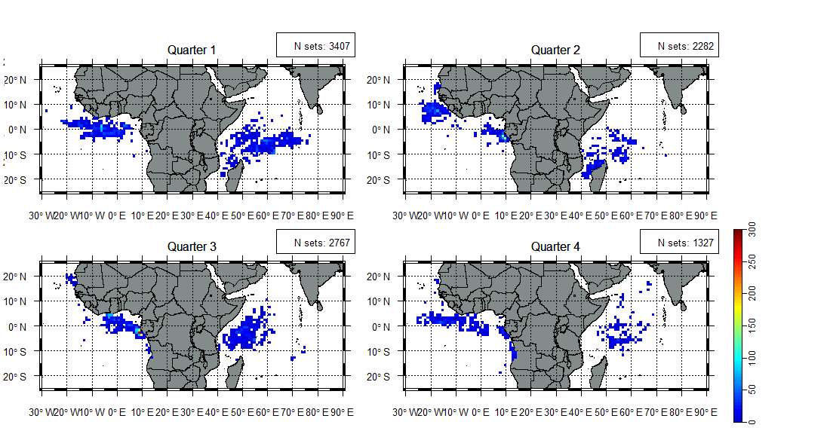
Figure S2. Quarterly distribution of fishing effort (i.e. number of fishing sets) on free-swimming tuna schools (FSC) sets per 1° square. N sets is the number of sets. Each quarter correspond to a trimestral division in the Atlantic Oceans and to monsoon and inter-monsoon seasons in the Indian Ocean each quarter.

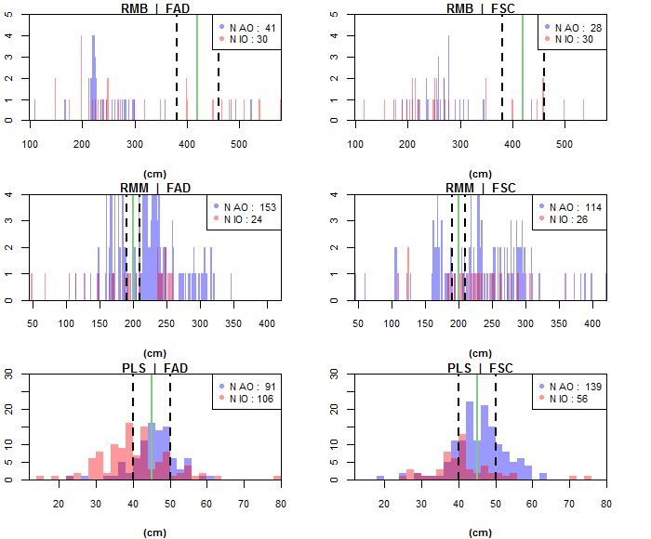
Figure S3. Size distribution of the Manta birostris (RMB), Mobula mobular (RMM) and Pteroplatytrygon violacea (PLS) in Fish Aggregating Devices (FAD) sets versus Free school (FSC) sets in the Atlantic Ocean (AO; blue distribution) and in the Indian Ocean (IO; red distribution). N AO and N IO correspond to the number of individuals caught in the Atlantic and Indian Oceans, respectively. The green line corresponds to L50 sexual maturity length and black dashed line corresponds to the range of first and last length of sexual maturity
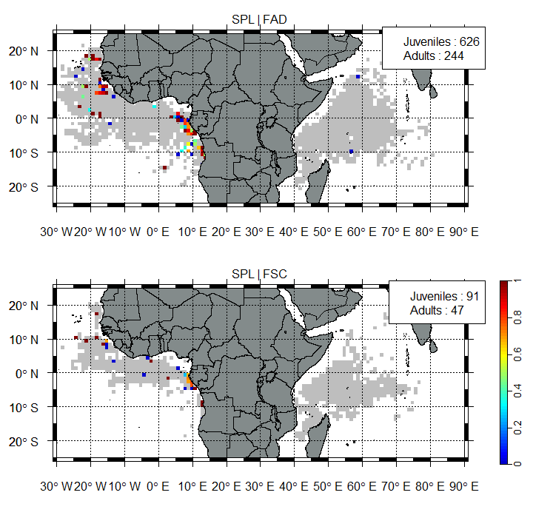
Figure S4. Juvenile proportion of scalloped hammerhead (SPL) in function of fishing mode (Fish Aggregating Devices (FAD) and free-swimming tuna schools (FSC)) per 1° square. Color gradient correspond to the juvenile proportion. Number of juveniles and adults caught are mentioned in the up-right corner of the Figure. Grey cells correspond to fishing effort distribution.

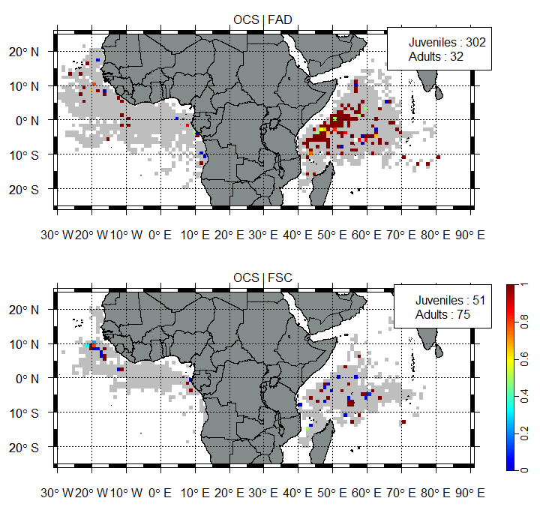

Figure S5. Juvenile percentage of Carcharhinus longimanus (OCS) as a function of fishing mode per 1° square. Color gradient corresponds to the juvenile percentage (0 = 0% juvenile, 1=100% juvenile), grey cells correspond to fishing effort distribution

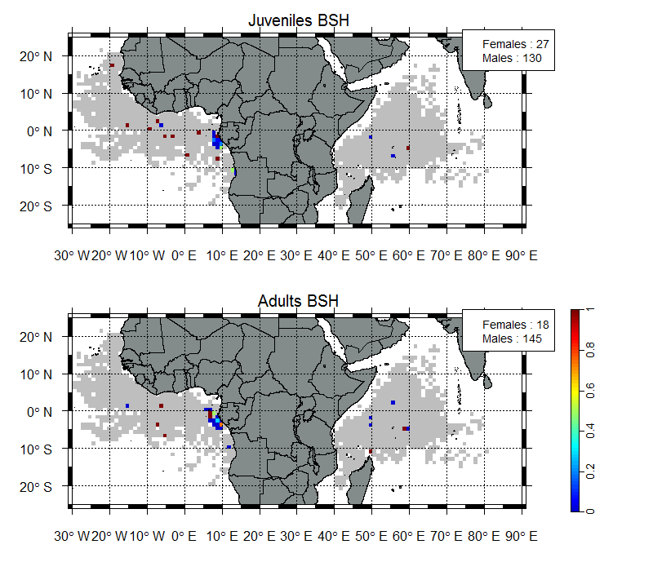
Figure S6. Sex-ratio distribution of Prionace glauca (BSH) as a function of life stage per square of 1°. Color gradient corresponds to the percentage of females (0 = 0% and 1 = 100%), grey cells correspond to fishing effort distribution

Appendix S2: Biodiversity indices

In this study, elasmobranch assemblages were studied using complementary diversity indices: i) species Richness Per Unit of Effort (RPUE) computed such as CPUE (see Materials and method of the article) from the number of elasmobranch species caught, ii) unbiased Simpson's diversity, also known as Probability of Interspecific Encounter (Hurlbert, 1971) and iii) Simpson's equitability (Smith and Wilson, 1996). Contrarily to species richness, Simpson’s diversity has been shown being relatively stable to sample size variation (here number of sets) (Lande, 1996), as observed for the studied data set during preliminary analyses. Thus, the initial value of this index was considered (i.e. not adjusted by number of sets).

Indices were computed as follows:

- Simpson diversity: (N/N-1) x 1-D
With D = $\sum_{i=1}^{Nsp}{{p_{i}}^{2}}$, with p_{i}=n_{i}/N; n_{i} : number of individuals for each species i; N : total number of individual of elasmobranch, N_{sp} the total number of species

- Species Richness Per Unit of Effort: RPUE = N_{sp} / N_{set}
With N_{set} the sets number.

- Simpson’s equitability: E = 1-D / (1-1/N_{sp})

Indices were computed for each 1° grid cell and for each fishing mode separately for juveniles and for adults. Simpson diversity and equitability were highly correlated (adult: r= 0.89; juvenile: r = 0.96). Thus, only Simpson’s equitability was considered for further analyses. Simpson’s equitability appears higher in Gabon, Angola and Mauritania’s coasts for both fishing modes and life stages (Figures. S7 and 8, Kruskal Wallis Tests, p<0,05). But juveniles simpson’s equitability appears higher in FSC (Figure. S9, Kruskal Wallis Test, p<0,05).
Juveniles RPUE are higher than adults RPUE (i.e. between 0 and 1 for adults, and 0 and 2 for juveniles, Figures. S9, Kruskal Wallis Tests, p<0,05). Highest value of RPUE for both life stages are localised in the Atlantic Ocean along the 5°S latitude line (Figures. S10 and 11).
Biodiversity indices are more heterogeneous in the Atlantic Ocean compared to the Indian Ocean, such as for fishing effort or bycatches CPUE.

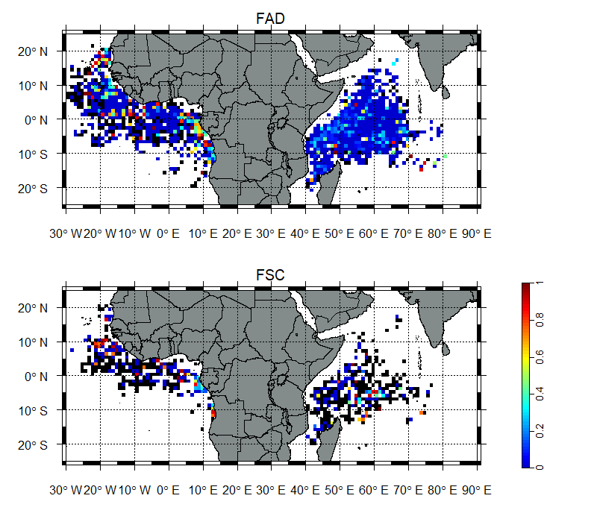
Figure S7. Juvenile Simpson’s equitability distribution per fishing mode (Fish Aggregating Devices (FAD) and free-swimming tune schools (FSC)) per 1° square. Black squares correspond to sets without elasmobranches captured, and colour gradient corresponds to values of Simpson’s equitability.
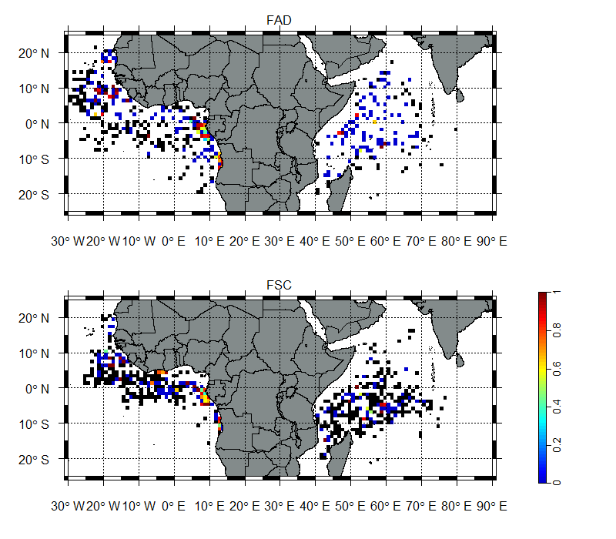
Figure S8. Adult Simpson’s equitability distribution per fishing mode (Fish Aggregating Devices (FAD) and free-swimming tune schools (FSC)) per 1° square. Black squares correspond to sets without elasmobranches captured and colour gradient corresponds to values of Simpson’s equitability.

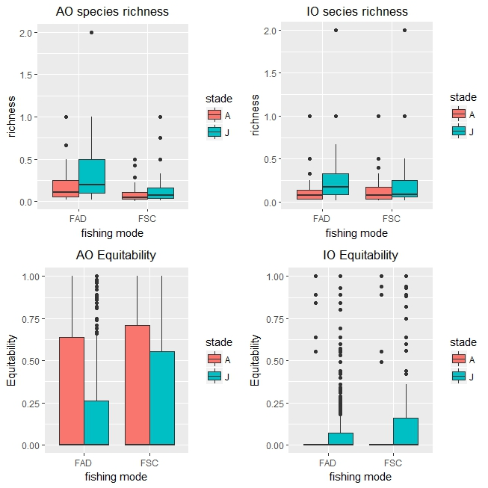
Figure S9. Boxplots of Species Richness per Unit of Effort (left column) and Simpson’s equitability (right column) in function life stage (juvenile (J), blue; adult (A), red) in the Atlantic Ocean (AO) and in the Indian Ocean (IO).

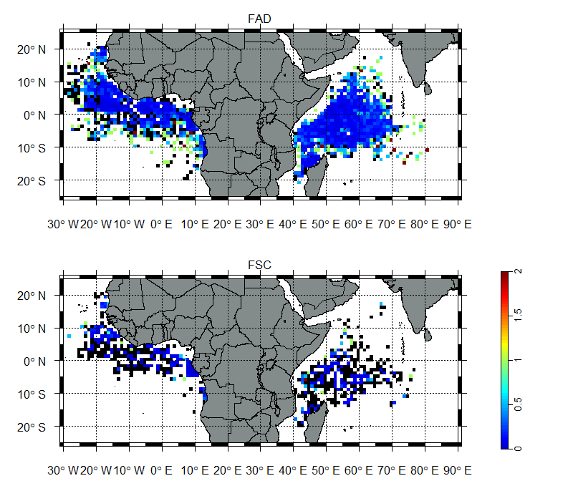
Figure S10. Juvenile Species Richness Per Unit of Effort distribution per fishing mode (Fish Aggregating Devices (FAD) and free-swimming tune schools (FSC)) per 1° square. Black squares correspond to sets without elasmobranches captured and colour gradient corresponds to RPUE values.
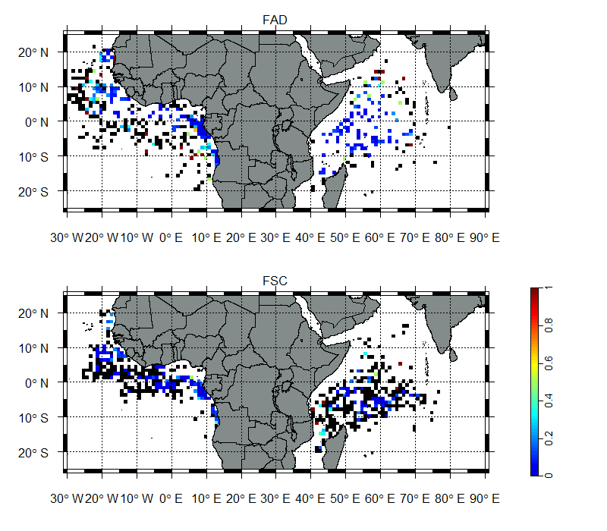
Figure S11. Adult Species Richness Per Unit of Effort distribution per fishing mode (Fish Aggregating Devices (FAD) and free-swimming tune schools (FSC)) per 1° square. Black squares correspond to sets without elasmobranches captured and colour gradient corresponds to RPUE values.

References:
Bacchet, P., Zysman, T., Lefèvre, Y., 2006. Guide des poissons de Tahiti et ses îles. Tahiti (Polynésie Francaise) : Éditions Au Vent des Îles. 608 p.
Cervigón, F., Cipriani, R., Fischer, W., Garibaldi, L., Hendrickx, M., Lemus, A.J., Márquez, R., Poutiers, J. M., Robaina, G., Rodriguez, B., 1992. Fichas FAO de identificación de especies para los fines de la pesca. Guía de campo de las especies comerciales marinas y de aquas salobres de la costa septentrional de Sur América. FAO, Rome. 513 p. Preparado con el financiamento de la Comisión de Comunidades Europeas y de NORAD.
Compagno, L. J. V., 1984. FAO Species Catalogue. Vol. 4. Sharks of the world. An annotated and illustrated catalogue of shark species known to date. Part 2 - Carcharhiniformes. FAO Fish. Synop. 125(4/2):251-655. Rome: FAO.
Compagno, L. J. V., Ebert, D. A., Smale, M. J., 1989. Guide to the sharks and rays of southern Africa. New Holland (Publ.) Ltd., London. 158 p.
Compagno, L. J. V., Krupp, F., Schneider, W., 1995. Tiburones. p. 647-744. In W. Fischer, F. Krupp, W. Schneider, C. Sommer, K.E. Carpenter and V. Niem (eds.) Guia FAO para Identification de Especies para los Fines de la Pesca. Pacifico Centro-Oriental. 3 Vols. FAO, Rome.
Compagno, L. J. V., 1998. Sphyrnidae. Hammerhead and bonnethead sharks. p. 1361-1366. In K.E. Carpenter and V.H. Niem (eds.) FAO identification guide for fishery purposes. The Living Marine Resources of the Western Central Pacific. FAO, Rome.
Compagno, L. J. V., Niem, V. H., 1998. Carcharhinidae. Requiem sharks. p. 1312-1360. In K.E. Carpenter and V.H. Niem (eds.) FAO Identification Guide for Fishery Purposes. The Living Marine Resources of the Western Central Pacific. FAO, Rome.
Dulvy, N. K., Baum, J. K., Clarke, S., Compagno, L.J.V., Cortés, E., Domingo, A., Fordham, S., Fowler, S., Francis, M.P., Gibson, C., Martínez, J., Musick, J.A., Soldo, A., Stevens, J.D., Valenti, S., 2008. You can swim but you can't hide: the global status and conservation of oceanic pelagic sharks and rays. Aquatic Conservation.: Marine Freshwater Ecosystem.
Ebert, D. A., 2003. Sharks, rays and chimaeras of California. California Natural History Guides No. 71. University of California Press. 284 p.
Eschmeyer, W. N., Herald, E. S., Hammann, H., 1983. A field guide to Pacific coast fishes of North America. Boston (MA, USA): Houghton Mifflin Company. xii+336 p.
Frimodt, C., 1995. Multilingual illustrated guide to the world's commercial warmwater fish. Fishing News Books, Osney Mead, Oxford, England. 215 p.
Hurlbert, S. H., 1971. The Nonconcept of Species Diversity: A Critique and Alternative Parameters. Ecology, 52(4), 577-586
Lande, R., 1996. Statistics and Partitioning of Species Diversity, and Similarity among Multiple Communities. Oikos, 76, 5. doi:10.2307/3545743.
Marshall, A. D., Compagno, L. J. V., Bennett, M. B., 2009. Redescription of the genus Manta with resurrection of Manta alfredi (Krefft, 1868) (Chondrichthyes; Myliobatoidei; Mobulidae). Zootaxa 2301:1-28.
McEachran, J. D., Séret, B., 1990. Mobulidae. p. 73-76. In J.C. Quero, J.C. Hureau, C. Karrer, A. Post and L. Saldanha (eds.) Check-list of the fishes of the eastern tropical Atlantic (CLOFETA). JNICT, Lisbon; SEI, Paris; and UNESCO, Paris. Vol. 1.
McEachran, J. D., 1995. Dasyatidae. Rayas-látigo. p. 752-755. In W. Fischer, F. Krupp, W. Schneider, C. Sommer, K.E. Carpenter and V. Niem (eds.) Guia FAO para Identification de Especies para los Fines de la Pesca. Pacifico Centro-Oriental. 3 Vols. FAO, Rome.
McEachran, J. D., Notarbartolo di Sciara, G., 1995. Mobulidae. Mantas, diablos. Guia FAO para Identification de Especies para los Fines de la Pesca. Pacifico Centro Oriental, 3, 759-764.
Muus, B., Dahlström, P., 1978. Meeresfische der Ostsee, der Nordsee, des Atlantiks. BLV Verlagsgesellschaft, München. 244 p.
Muus, B. J., Nielsen, J. G., 1999. Sea fish. Scandinavian Fishing Year Book, Hedehusene, Denmark. 340 p.
Murdy, E. O., Birdsong, R. S., Musick, J. A., 1997. Fishes of Chesapeake Bay. Smithsonian Institution Press Washington and London. 324 p.
Sanches, J. G., 1991. Catálogo dos principais peixes marinhos da República de Guiné-Bissau. Publ. Avuls. Inst. Nac. Invest. Pescas 16:429 p.
Schneider, W., 1990. FAO species identification sheets for fishery purposes. Field guide to the commercial marine resources of the Gulf of Guinea. Prepared and published with the support of the FAO Regional Office for Africa. Rome: FAO. 268 p.
Scott, W. B., Scott, M. G., 1988. Atlantic fishes of Canada. Canadian Journal of Fisheries Aquatic Sciences 219:731 p.
Smith, L. C., 1997. National Audubon society field guide to tropical marine fishes. Caribbean, Gulf of Mexico, Florida, Bahamas, Bermuda (No. 597.092 S6).
Smith, B., Wilson, J. B., 1996. A Consumer’s Guide to Evenness Indices. Oikos 76, 70. doi:10.2307/3545749
Stehmann, M., 1981. Mobulidae. In W. Fischer, G. Bianchi and W.B. Scott (eds.) FAO species identification sheets for fishery purposes. Eastern Central Atlantic (fishing areas 34, 47 (in part). Vol. 5.
Vidthayanon, C., 2005. Thailand red data: fishes. Office of Natural Resources and Environmental Policy and Planning, Bangkok, Thailand. 108 p.
Weigmann, S., 2016. Annotated checklist of the living sharks, batoids and chimaeras (Chondrichthyes) of the world, with a focus on biogeographical diversity. Journal of Fish Biology, 88(3), 837-1037.
White, W. T., Last, P. R., Stevens, J. D., Yearsly, G. K., 2006. Economically important sharks and rays of Indonesia (No. 435-2016-33677).

