Mangrove-derived organic and inorganic carbon exchanges between the Sinnamary estuarine system (French Guiana, South America) and the Atlantic Ocean
Running title: Mangrove-derived C exchanges with the Atlantic Ocean
Raghab Ray^{1*}, Gérard Thouzeau¹, Romain Walcker², Vincent Vantrepotte^{3,4}, Gerd Gleixner⁵, Sylvain Morvan⁴, Jeremy Devesa¹, Emma Michaud¹
- CNRS, Univ Brest, IRD, Ifremer, LEMAR, UMR 6539, F-29280 Plouzane, France
*Corresponding author: raghab.ray@aori.u-tokyo.ac.jp, raghab.ray@gmail.com (R. Ray)
Currently at: Department of Chemical Oceanography, Atmosphere and Ocean Research Institute, The University of Tokyo, Japan
- EcoLab, Univ Toulouse, CNRS, INPT, UPS, 31062 Toulouse, France
- LOG, UMR 8187 CNRS, Univ Lille, ULCO, Univ du Littoral Côte d'Opale, 32 avenue Foch, BP 80, 62930 Wimereux, France
- LEEISA, USR 3456 CNRS, Univ Guyane, Ifremer, Centre de recherche de Montabo, BP 70620, 97334 Cayenne cedex, Guyane Française
- Department of Biogeochemical Processes, Max Planck Institute for Biogeochemistry, Hans, Knoell Str. 10, 07745 Jena, Germany

Supplementary materials

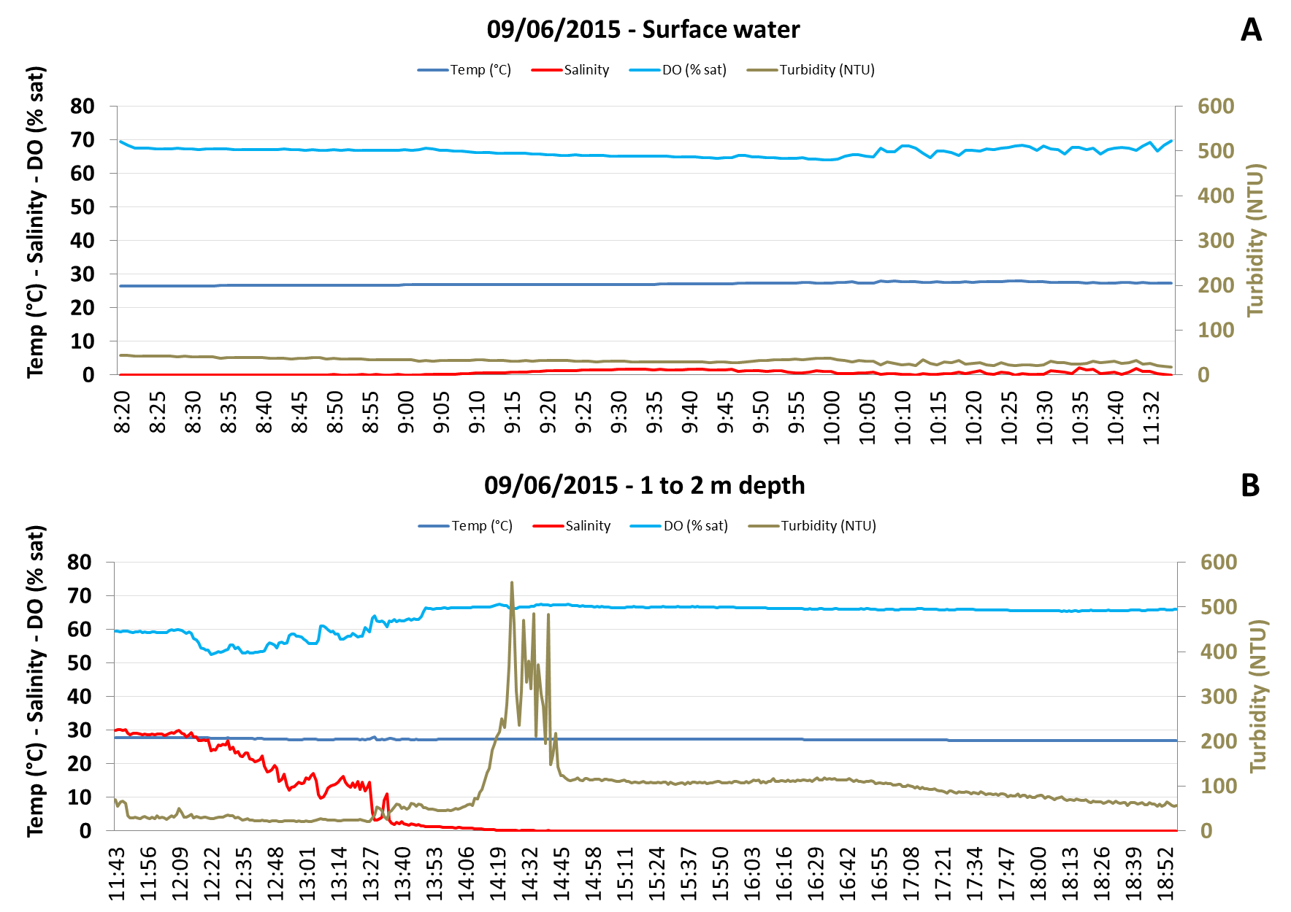
(wet season)

Fig. S1. Physicochemical parameters recorded at station W in surface (A) and near bottom (B) water on June 9, 2015. Temperature (°C), salinity, DO (% saturation), turbidity (NTU) and water depth (data not shown) were recorded with YSI 6920v2 multi-parameter probes (see paragraph 2.2).

(dry season)
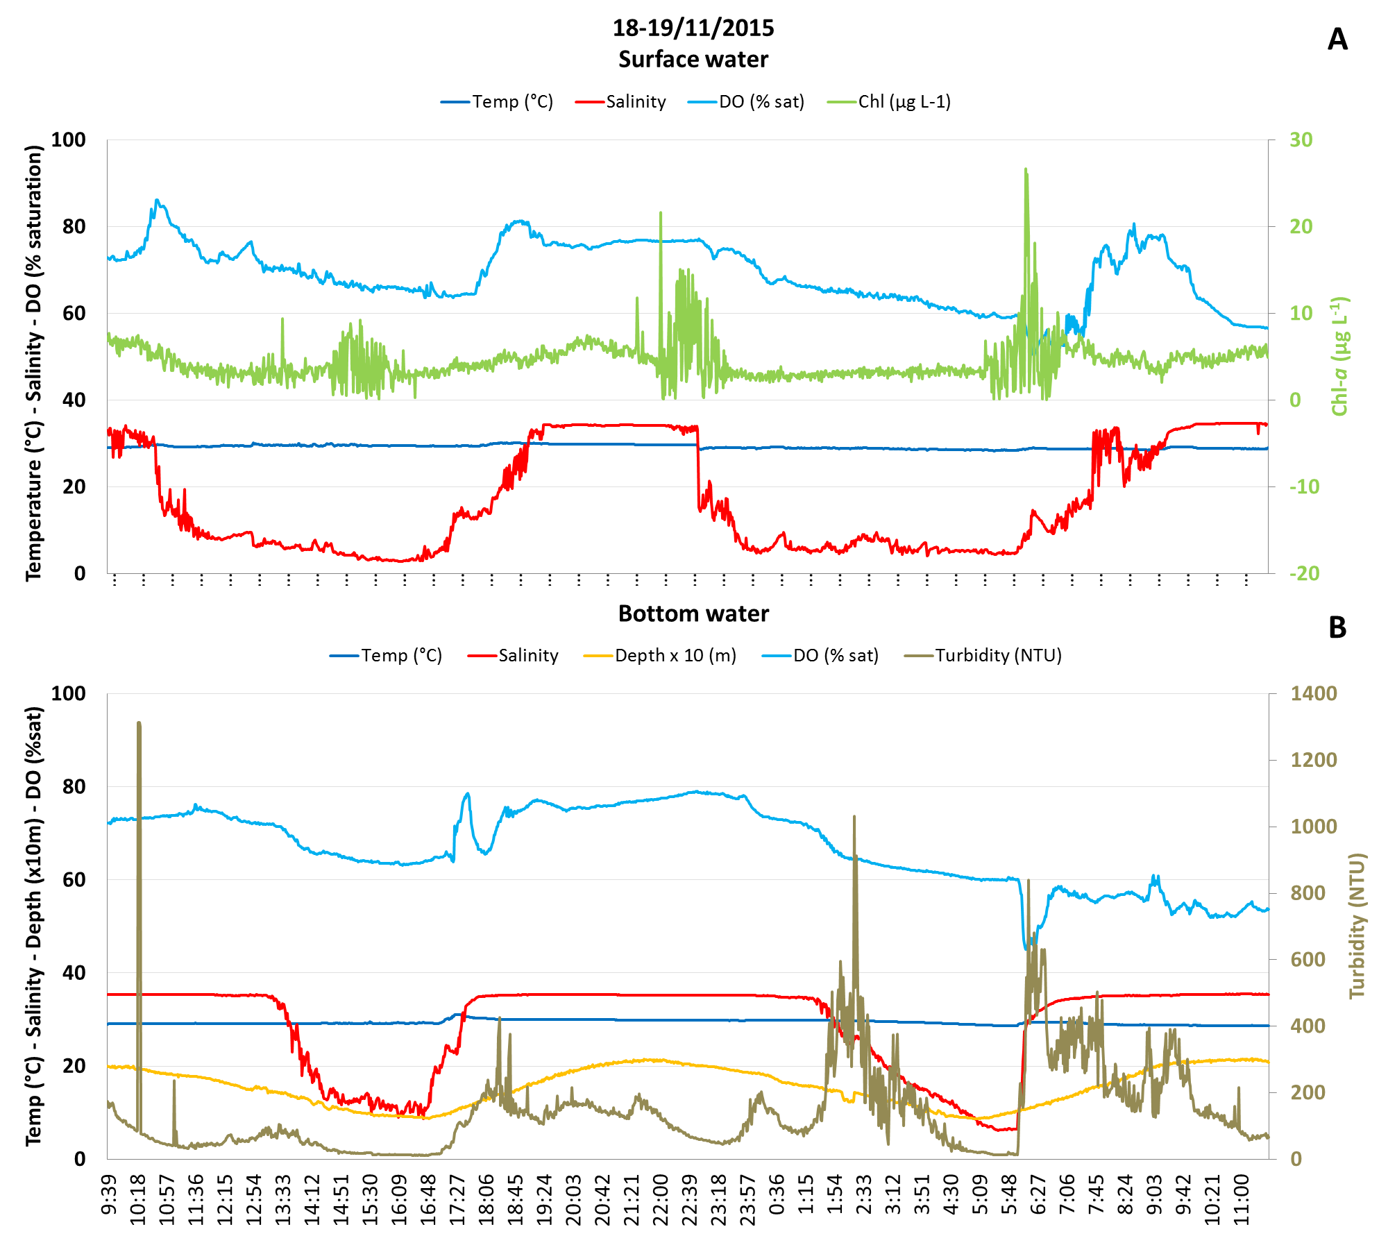

Fig. S2. Physicochemical parameters recorded at station D in surface (A) and bottom (B) water on November 18-19, 2015. Temperature (°C), salinity, DO (% saturation), Chl-a (µg L⁻¹), turbidity (NTU) and water depth (x 10m) were recorded with two YSI 6920v2 multi-parameter probes placed on a mooring line (see paragraph 2.2).

