Supplementary Material
Appendix A: Photophysiological parameters measurement by PAM fluorometry
Materials and Methods
Photophysiological parameters were measured continuously (every 5 to 10 min) using a Water-PAM fluorometer (Fiber version, Walz®, Effeltrich, Germany) during in situ and laboratory experiments by applying the fiber optic probe to the sediment surface, using a home-made guide to keep the contact between the probe and the sediment and avoid the sinking of the probe into the sediment. The fluorescence of Chl a was estimated by applying non-actinic light and saturating pulses (3000 μmol photons m⁻² s⁻¹) of blue light (460 nm) under dark or light conditions to measure the different Chl a fluorescence levels F₀, F_{m}, F and F_{m}’, respectively (see the Table A1 for the definition and physiological meaning of all photophysiological parameters). F and F_{m}’ were used for the calculation of F_{v}’/F_{m}’ as an estimation of the photophysiological state of MPB under current PAR. For each RLC, eight successive increasing light intensities (E) were provided by the internal blue LED of the Water-PAM. RLCs generated relative electron transport rate (rETR) of PSII vs. E (Table A1) and were fitted following Eilers and Peeters (1988) to retrieve photophysiological parameters: rETRm, α, and E_{k} (Table A1). RLCs setting were controlled using the WinControl software: as previously recommended (Perkins et al., 2006; Lefebvre et al., 2011), 10s-steps RLCs were used to estimate α (with a minimal activation of the Non-Photochemical Quenching, NPQ, avoiding α underestimation), and 30s-steps RLCs in the aim to saturate rETR vs. E curves, allowing a better estimation of rETRm and E_{k}. Es started at step 1 (to increase from 34 to 538 μmol photons m⁻² s⁻¹ during the 8 RLC successive steps) for α estimation, and at step 3 (from 73 to 1065 μmol photons m⁻² s⁻¹) or step 5 (from 161 to 2593 μmol photons m⁻² s⁻¹) for rETRm and E_{k} estimation depending on MPB acclimation to current PAR. Each RLC was measured on a new MPB spot.

Table A1. Photophysiological parameters estimated by PAM-fluorimetry used in this study, their meaning and measurement method and conditions. Abbreviations: Chl a, Chlorophyll a; E, irradiance in the PAR (Photosynthetic active radiations) domain; MPB, microphytobenthos; PSII, Photosystem II; RLC Rapid light curve.
Parameter | Unit | Definition and photophysiological meaning | Measurement conditions
F₀ | No units | Minimum PSII Chl a fluorescence yield | After 5 min of dark condition, after the last measurement of F_{m}’ of a RLC. For details see Lefebvre et al. (2011).
F_{m} | No units | Maximum PSII Chl a fluorescence yield | During a saturating pulse, after 5 min of dark condition, after the last measurement of F_{m}’ of a RLC
F_{v}/F_{m} | No units | Maximum photsynthetic efficiency of PSII with F_{v}=F_{m}-F₀ | See the above conditions for F₀ and F_{m} measurement
F | No units | Steady-state PS II Chl fluorescence yield at a specific E | After 10 or 30 s of illumination at a specific E
F_{m}’ | No units | Maximum PSII Chl fluorescence yield at a specific E | During a saturating pulse after 10 or 30 s of illumination at specific E
F_{v}’/F_{m}’ | Relative units | Photophysiological state of MPB under current PAR, with F_{v}’= F_{m}’-F | F and F_{m}’ measured immediately after the positioning of the PAM-fiber
rETR | µmol electron m⁻² s⁻¹ | Relative electron transport rate of PSII  rETR= F_{m}’-F/F_{m}’$×$E | Measured with RLCs
α | Relative units | rETR-E curve initial slope;  Maximum light efficiency use | Derived from fitted rETR-E curves measured with RLCs (Eilers and Peeters, 1988)
rETRm | µmol electrons m⁻² s⁻¹ | rETR-E curve asymptote; Maximum light-saturated rETR | Derived from fitted rETR-E curves measured with RLCs (Eilers and Peeters, 1988)
E_{k} | µmol photons.m⁻².s⁻¹ | E_{k} = rETRm / α; Light saturation coefficient | Derived from fitted rETR-E curves measured with RLCs (Eilers and Peeters, 1988)

Results
There was no significant difference for F_{v}’/F_{m}’ and α measured in situ between the three campaigns (KW tests, respectively p = 0.18 and p = 0.28, Figure A1a and b), but there was an effect on rETRm (KW test p $≤$ 0.001, Figure A1c) with the highest values measured in July (462 ± 14 µmol electrons m⁻² s⁻¹). This induced a seasonal effect on E_{k} (i.e. E_{k} = rETRm / α) which increased from March to July (KW p $≤$ 0.001, Figure A1d). At the tidal time scale, α always decreased with time and light dose with significant r values up to 0.58 (Table A2), except in March (r = 0.28, p = 0.81). The duration of light exposure (=emersion period) seemed to be more impactful than the immediate PAR, which was not correlated with α, except on July 3 (r = -0.51, p $≤$ 0.05). rETRm never changed at the time scale of the emersion period (Table A2), whereas E_{k} increased with time and light dose on May 5 with significant r values up to 0.62, but it decreased with the same parameters and MST on March 5 (Table A2).
During laboratory experiments, biomass (NDVI and Chl a, see main text for details) was higher in March, whereas all photophysiological parameters measured by PAM fluorimetry were higher in July, except E_{k} (Table A3). E_{k} increased with PAR while F_{v}’/F_{m}’ and α decreased. Only NDVI and α changed between the beginning and the end of each light incubation.
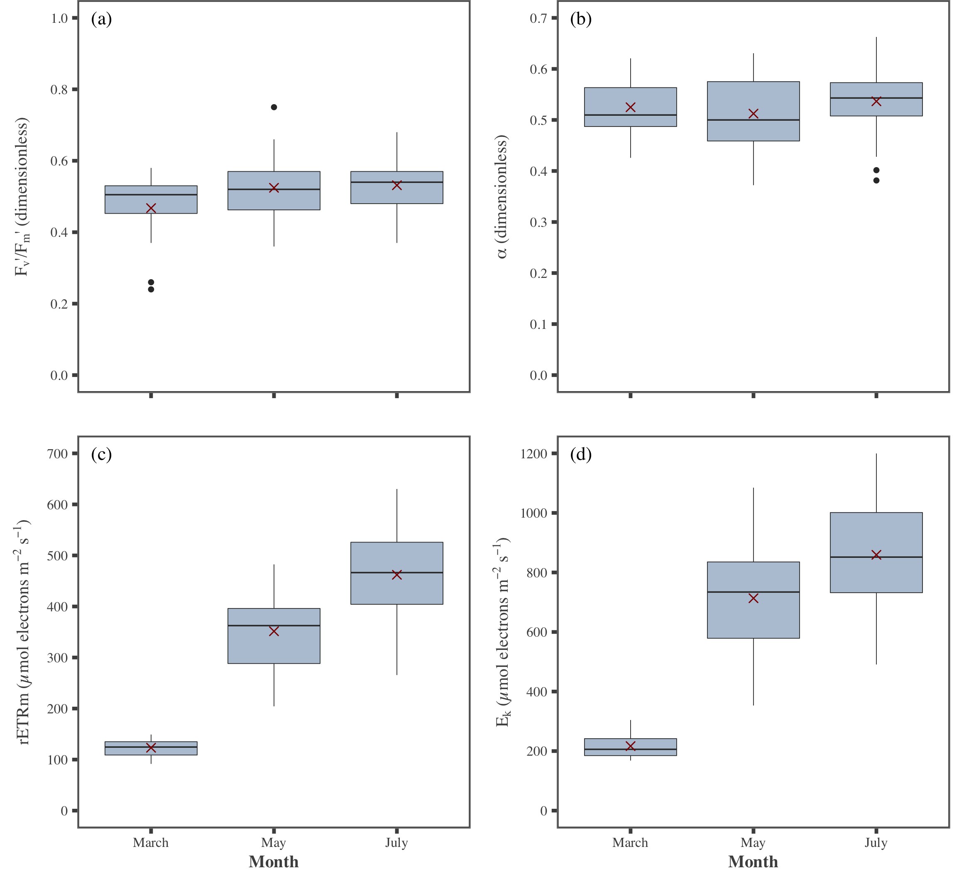
Figure A1. Monthly variations of MPB photophysiological parameters measured in situ by PAM fluorimetry. Red crosses correspond the mean values for the corresponding period.

Table A2. Correlation coefficient, r, and their respective p-value (p) between biomass (NDVI and Chl a) and photophysiological parameters measured by PAM-fluorimetry (α, rETRm and E_{k}) of MPB, and abiotic parameters (emersion time, PAR, light dose and MST) measured in situ. Bold values show significant correlations. Units: NDVI (dimensionless); Chl a (mg m⁻²); F_{v}’/F_{m}’ (dimensionless); α (relative units); rETRm (µmol electrons m⁻² s⁻¹) and E_{k} (µmol photons m⁻² s⁻¹); Emersion time (sec from the first PAM-fluorimetry measurement); PAR measured in situ (μmol photon m⁻² s⁻¹); Light dose (μmol photons m⁻²) derived from PAR and emersion time; MST measured in situ (°C).
Date | Parameters | Emersion time | PAR | Light dose | MST
5 May | NDVI (n=0)  Chl a (n=12)  F_{v}’/F_{m}’ (n=15)  α (n=15)  rETRm (n=15)  E_{k} (n=15) | n.d  -0.22 (0.49)  -0.67 ($≤$0.05)  -0.8 ($≤$0.001)  0.21 (0.6)  0.62 ($≤$0.05) | n.d  -0.033 (0.92)  -0.08 (0.78)  0.21 (0.46)  0.16 (0.5)  0.016 (0.64) | n.d  -0.29 (0.36)  -0.71 ($≤$0.005)  -0.8 ($≤$0.001)  0.21 (0.45)  0.66 ($≤$0.05) | n.d  -0.0074 (0.98)  0.14 (0.62)  0.41 (0.14)  0.11 (0.61)  -0.16 (0.98)
6 May | NDVI (n=34)  Chl a (n=8)  F_{v}’/F_{m}’ (n=15)  α (n=15)  rETRm (n=15)  E_{k} (n=15) | -0.21 (0.24)  -0.34 (0.41)  -0.41 (0.13)  -0.58 ($≤$0.05)  0.073 (0.8)  0.29 (0.3) | 0,18 (0.3)  -0.28 (0.5)  0.19 (0.50)  -0.23 (0.41)  -0.34 (0.22)  -0.17 (0.55) | -0.22 (0.2)  -0.34 (0.41)  -0.43 (0.11)  -0.59 ($≤$0.05)  0.054 (0.85)  0.27 (0.33) | 0.33 (0.06)  -0.11 (0.79)  0.04 (0.89)  -0.33 (0.23)  -0.3 (0.28)  -0.12 (0.67)
2 July | NDVI (n=32)  Chl a (n=16)  F_{v}’/F_{m}’ (n=15)  α (n=20)  rETRm (n=20)  E_{k} (n=20) | -0.28 (0.12)  -0.57 ($≤$0.05)  -0.64 ($≤$0.005)  -0.67 ($≤$0.01)  0.013 (0.96)  0.35 (0.14) | 0.23 (0.21)  0.15 (0.59)  -0.30 (0.19)  -0.2 (0.41)  r <0.001  0.12 (0.62) | -0.28 (0.12)  -0.58 ($≤$0.05)  -0.62 ($≤$0.01)  -0.68 ($≤$0.001)  0.025 (0.92)  0.36 (0.12) | 0.46 ($≤$0.01)  -0.053 (0.85)  0.46 ($≤$0.01)  -0.43 (0.06)  0.059 (0.81)  0.27 (0.25)
3 July | NDVI (n=23)  Chl a (n=14)  F_{v}’/F_{m}’ (n=20)  α (n=20)  rETRm (n=20)  E_{k} (n=20) | 0.34 (0.11)  0.84 ($≤$0.001)  -0.86 ($≤$0.001)  -0.63 ($≤$0.01)  0.18 (0.46)  0.43 (0.06) | 0.4 (0.06)  0.043 (0.88)  -0.56 ($≤$0.05)  -0.51 ($≤$0.05)  0.13 (0.58)  0.33 (0.16) | 0.34 (0.11)  0.85 ($≤$0.001)  -0.87 ($≤$0.001)  -0.65 ($≤$0.05)  0.15 (0.52)  0.42 (0.07) | 0.56 ($≤$0.01)  r <0.001  -0.92 ($≤$0.001)  -0.71 ($≤$0.001)  0.19 (0.41)  0.48 ($≤$0.05)
5 March | NDVI (n=48)  Chl a (n=39)  F_{v}’/F_{m}’ (n=15)  α (n=15)  rETRm (n=15)  E_{k} (n=15) | 0.41 ($≤$0.01)  -0.15 (0.35)  0.50 (<0.05)  0.28 (0.81)  -0.55 (0.81)  -0.63 ($≤$0.05) | 0.35 ($≤$0.05)  -0.24 (0.15)  0.12 (0.67)  0.45 (0.78)  -0.33 (0.38)  -0.51 (0.51) | 0.39 ($≤$0.01)  -0.15 (0.35)  0.51 (<0.05)  0.25 (0.86)  -0.53 (0.9)  -0.59 ($≤$0.05) | 0.51 ($≤$0.001)  -0.13 (0.44)  0.32 (0.23)  0.52 (0.58)  -0.36 (0.51)  -0.65 ($≤$0.05)

Table A3. Changes in biomass (NDVI and Chl a), photophysiological parameters (F_{v}’/F_{m}’, α, rETRm and E_{k}) due to sampling campaign date (Month), PAR and incubation time, detected by three ways ANOVAs. Significant differences are shown in bold. p-values (p): * p$≤$0.05; ** p$≤$0.01; *** p$≤$0.001. -: minimum value, +: maximum value. Units: NDVI (dimensionless); Chl a (mg m⁻²); α (relative units); rETRm (µmol electrons m⁻² s⁻¹) and E_{k} (µmol photons m⁻² s⁻¹); Incubation time (comparison between values measured at the start and at the end of the light incubation using benthic chambers); PAR (μmol photons m⁻² s⁻¹).
Parameters | Month | PAR | Incubation time
NDVI (n=56) | - May  + March** | p=0.33 | *
Chl a (n=56) | - May  + March*** | p=0.42 | p=0.19
F_{v}’/F_{m}’ (n=75) | - March  + July *** | *** | p=0.08
α (n=79) | - March  + July *** | *** | **
rETRm (n=60) | - May  + July ** | p=0.23 | p=0.67
E_{k} (n=60) | p=0.52 | *** | p=0.08

Discussion
All photophysiological parameters measured by PAM-fluorimetry changed at the seasonal and tidal time scales. α (see Table A1 for the definition of parameters) is expected to be higher in low light acclimated algae, reflecting the higher capacity for harvesting light, and lower in high light acclimated algae (Falkowski and Raven, 2007). It supports the change in α with seasons: high in winter and low in summer (Serôdio et al., 2012; Pniewski et al., 2015). Besides, E_{k} is expected to follow an inverse trend (Serôdio et al., 2012; Pniewski et al., 2015). This has led some authors to consider α and E_{k} measured by PAM fluorimetry as representative of MPB seasonal photosynthetic capacity and as reliable parameters for model input, as for instance proposed by Daggers et al. (2018). However, in the current study, whereas E_{k} values followed the expected trend, it was not the case with α. As shown before by Serôdio et al. (2006) α measured by PAM-fluorimetry is highly sensitive to the activation of the non-photochemical quenching (NPQ), hindering the expected seasonal response. The direct consequence in the context of the present study is the unreliability in using empirical values of α or other PAM-derived photophysiological parameters to be representative of a given season to predict C-fixation. To overcome this issue, we suggest to directly calibrate the P-E model with C-fixation estimated by benthic chamber incubations.

Appendix B: P-E model selection to remotely map GPP
For the three campaigns (March, May and July), GPP was measured during laboratory experiments and it was standardized by NDVI to compute the biomass specific productivity: P^{b}, expressed in mg C m⁻² h⁻¹ ndvi⁻¹. This parameter was fitted using several P-E models:
Platt et al. (1980):
${\text{P}}^{\text{b}} \text{=} {\text{P}}_{\text{s}}^{\text{b}} \text{×} \left(\text{1-}{\text{e}}^{\left({\text{-αE}}/{{\text{P}}_{\text{s}}^{\text{b}}}\right)}\right) \text{×} \left({\text{e}}^{\left({\text{-βE}}/{{\text{P}}_{\text{s}}^{\text{b}}}\right)}\right)$ Eq. S1

Eilers and Peeters (1988):
${\text{P}}^{\text{b}} \text{=} \frac{\text{E}}{\frac{{\text{E}}^{\text{2}}}{\text{α} \text{×} {{\text{E}}_{\text{opt}}}^{\text{2}}} \text{+} \frac{\text{E}}{{\text{P}}_{\text{max}}^{\text{b}}} \text{–} \frac{\text{2} \text{×} \text{E}}{\text{α} \text{×} {\text{E}}_{\text{opt}}} \text{+} \frac{\text{E}}{\text{α}}}$ Eq. S2

Steele (1962):
${\text{P}}^{\text{b}} \text{=} {\text{P}}_{\text{max}}^{\text{b}} \text{×} \left(\frac{\text{E}}{{\text{E}}_{\text{opt}}} \text{×} {\text{e}}^{\text{1} \text{-} \left({\text{E}}/{{\text{E}}_{\text{opt}}}\right)}\right)$ Eq. S3

Platt and Jassby (1976):
${\text{P}}^{\text{b}} \text{=} {\text{P}}_{\text{max}}^{\text{b}} \text{×} \text{tanh}\left(\frac{\text{E}}{\text{Ek}}\right)$ Eq. S4

Modified Platt and Jassby (1976):
${\text{P}}^{\text{b}} \text{=} {\text{P}}_{\text{max}}^{\text{b}} \text{×} \text{tanh}\left(\frac{\text{αE}}{{\text{P}}_{\text{max}}^{\text{b}}}\right) \text{×} \text{1} \text{-} \text{tanh}\left(\frac{\text{βE}}{{\text{P}}_{\text{max}}^{\text{b}}}\right)$ Eq. S5
where ${\text{P}}_{\text{s}}^{\text{b}}$ was the light-saturated biomass specific productivity in the absence of photoinhibition, ${\text{P}}_{\text{max}}^{\text{b}}$ was the maximal biomass specific productivity (i.e. asymptote of the P-E curve), α was the initial slope of the curve illustrating the maximum light efficiency use, β was the photoinhibition parameter, E was the PAR, E_{opt} was the optimum irradiance E at which ${\text{P}}_{\text{max}}^{\text{b}}$ was reached and E_{k} was the irradiance E at which light saturation started (i.e. intersection between α and ${\text{P}}_{\text{max}}^{\text{b}}$).
Validation and selection:
The differential evolution algorithm (DE) implemented in the R package "DE-optim" (Ardia et al., 2016) was used to minimise the difference between predicted and observed P^{b} to obtain the photophysiological parameters from the five P-E models. DE algorithm did not require arbitrary initial parameter values which can result in errors in optimisation of light-response models (Chen et al., 2016). Moreover, the parameter values were explored within a range of given values based on observed data. After fitting the five P-E models to estimate P^{b} using DE, the best model was selected, based on the comparison of simulations with observations using the determination coefficient (r²) and the residual standard deviation (RSD) using R-software.
All parameters retrieved from the models varied with seasons (Table B1). Because it was the best fitting model, the Eilers and Peeters (1988) model was the one selected to estimate and map remotely-sensed GPP using the GPP-algorithm (Table B2).

Table B1: Parameters from the P-E curves fitted with five different models and with the differential evolution (DE) method for the three sampling periods. The interval gives the lower and upper bound of the explored values, respectively used for the DE algorithm (see the text above for details). ${\text{P}}_{\text{s}}^{\text{b}}$, the light-saturated biomass specific productivity in the absence of photoinhibition; ${\text{P}}_{\text{max}}^{\text{b}}$, the maximal biomass specific productivity; α, the maximum light efficiency use; β, the photoinhibition parameter; E_{opt}, the optimum irradiance E at which ${\text{P}}_{\text{max}}^{\text{b}}$ was reached.
 | March |  | May |  | July
 | Interval | Value | Interval | Value | Interval | Value
Platt et al. (1980)
$${\text{P}}_{\text{s}}^{\text{b}}$$ | [0; 150] | 108.2 | [0; 250] | 250 | [0; 200] | 108.67
Α | [0; 10] | 0.27 | [0; 10] | 0.9 | [0; 10] | 0.57
Β | [0; 50] | 0.03 | [0; 50] | 0.21 | [0; 50] | 0.02
Eilers and Peeters (1988)
$${\text{P}}_{\text{max}}^{\text{b}}$$ | [0; 150] | 70.41 | [0; 250] | 154.2 | [0; 200] | 95.82
α | [0; 10] | 0.34 | [0; 10] | 0.43 | [0; 10] | 0.64
E_{opt} | [0; 1000] | 922.3 | [0; 1000] | 415.75 | [0; 1000] | 784.68
Steele (1962)
$${\text{P}}_{\text{max}}^{\text{b}}$$ | [0; 150] | 77.89 | [0; 250] | 145.93 | [0; 200] | 106.68
α | [0; 10] | 0.08 | [0; 10] | 0.29 | [0; 10] | 0.12
Platt and Jassby (1976)
$${\text{P}}_{\text{max}}^{\text{b}}$$ | [0; 150] | 65.77 | [0; 250] | 122.83 | [0; 200] | 89.87
α | [0; 10] | 0.24 | [0; 10] | 0.71 | [0; 10] | 0.5
Modified Platt and Jassby (1976)
$${\text{P}}_{\text{max}}^{\text{b}}$$ | [0; 150] | 92.73 | [0; 250] | 250 | [0; 200] | 100.43
α | [0; 10] | 0.21 | [0; 10] | 0.66 | [0; 10] | 0.46
β | [0; 50] | 0.02 | [0; 50] | 0.17 | [0; 50] | 0.01

Table B2: Scores of the P-E models fitted with the DE method for the three periods of investigation (March, May, July). r², the determination coefficient; RSD, the residual standard deviation.
P-E models | March |  | May |  | July
 | r² | RSD | r² | RSD | r² | RSD
Platt et al. (1980) | 0.88 | 8.4 | 0.92 | 16.26 | 0.95 | 6.37
Eilers and Peeters (1988) | 0.88 | 8.33 | 0.96 | 10.71 | 0.96 | 5.86
Steele (1962) | 0.86 | 8.94 | 0.96 | 11.54 | 0.77 | 13.81
Platt and Jassby (1976) | 0.82 | 10.25 | 0.58 | 36.11 | 0.92 | 8.27
Modified Platt and Jassby (1976) | 0.85 | 9.36 | 0.96 | 10.67 | 0.94 | 7.19

References:
Ardia, D., Mullen, K., Peterson, B., Ulrich, J., Boudt, K., and Mullen, M. K. (2016). Package “DEoptim.”
Chen, L., Li, Z.-B., Hui, C., Cheng, X., Li, B.-L., and Shi, P.-J. (2016). A general method for parameter estimation in light-response models. Sci. Rep. 6, 27905.
Daggers, T. D., Kromkamp, J. C., Herman, P. M. J., and van der Wal, D. (2018). A model to assess microphytobenthic primary production in tidal systems using satellite remote sensing. Remote Sens. Environ. 211, 129–145. doi:10.1016/j.rse.2018.03.037.
Eilers, P. H. C., and Peeters, J. C. H. (1988). A model for the relationship between light intensity and the rate of photosynthesis in phytoplankton. Ecol. Model. 42, 199–215.
Falkowski, P. G., and Raven, J. A. (2007). Aquatic Photosynthesis - Second Edition. Princeton: Princeton University Press.
Lefebvre, S., Mouget, J.-L., and Lavaud, J. (2011). Duration of rapid light curves for determining the photosynthetic activity of microphytobenthos biofilm in situ. Aquat. Bot. 95, 1–8.
Perkins, R. G., Mouget, J. L., Lefebvre, S., and Lavaud, J. (2006). Light response curve methodology and possible implications in the application of chlorophyll fluorescence to benthic diatoms 10.1007/s00227-005-0222-z. Mar. Biol. 149, 703–712.
Platt, T., Gallegos, C., and Harrison, W. (1980). Photoinhibition of photosynthesis in natural assemblages of marine phytoplankton. J. Mar. Res. USA.
Platt, T., and Jassby, A. D. (1976). The relationship between photosynthesis and light for natural assemblages of coastal marine phytoplankton. J. Phycol. 12, 421–430.
Pniewski, F. F., Biskup, P., Bubak, I., Richard, P., Latala, A., and Blanchard, G. (2015). Photo-regulation in microphytobenthos from intertidal mudflats and non-tidal coastal shallows. Estuar. Coast. Shelf Sci. 152, 153–161. doi:10.1016/j.ecss.2014.11.022.
Serôdio, J., Ezequiel, J., Barnett, A., Mouget, J.-L., Méléder, V., Laviale, M., et al. (2012). Efficiency of photoprotection in microphytobenthos: role of vertical migration and the xanthophyll cycle against photoinhibition. Aquat. Microb. Ecol. 67, 161–175.
Serôdio, J., Vieira, S., Cruz, S., and Coelho, H. (2006). Rapid light-response curves of chlorophyll fluorescence in microalgae: relationship to steady-state light curves and non-photochemical quenching in benthic diatom-dominated assemblages. Photosynth. Res. 90, 29–43.
Steele, J. H. (1962). Environmental control of photosynthesis in the sea. Limnol. Oceanogr. 7, 137–150. doi:10.4319/lo.1962.7.2.0137.

