Supplementary File
Examples for each of the 6 approaches used in the setup of boundary values:
- A1: In the Rockall Bank the boundary values for the indicator “Abundance of non-commercial demersal fish and cephalopods” were set by the case study leader using a 32-year times series data. The lowest value in the time series was set as “worst”, the 80% of the maximum as “good” and the maximum values in the time series as “best” environmental status.
- A2: In the Mingulay Reef Complex the boundary values for the indicator “Ratio of live versus dead/overgrown coral cover” were set using case-study leader expertise and information available in the scientific literature (Vad et al., 2017; De Clippele et al., 2017). 0 was set as “worst”, the 70% of the maximum as “good” and the maximum value in Vad et al. (2017) as “best” environmental status.
- A3: In the Mingulay Reef Complex the boundary values for the indicator “Areal extent of human affected area” were set using case-study leader expertise and national legislation. 100% of affected areas was set as “worst”, 75% as “good” and 0% as “best” environmental status.
- A4: In the Faroe-Shetland Channel the boundary values for the indicator “Density of biogenic reef forming species” were set using case-study leader expertise and information found in the OSPAR (2010) “Background document for deep-sea sponge aggregations”. 0 sponge individuals/m² was set as “worst”, 0.25 ind./m² as “good” and 0.50 ind./m² as “best” environmental status.
- A5: In the Reykjanes Ridge the boundary values for the indicator “Areal extent of protected sea areas” were set using case-study leader expertise and guidance from the United Nations Framework Convention on Climate Change Decision VII/15. 0% was set as “worst”, 10% was set as “good” and 15% as “best” environmental status.
- A6: In the Azores the boundary values for the indicator “Body length distribution of fish” was based on regional legislation and expert judgement based on survey data. For the species Helicolenus dactylopterus 14cm of total length was set as “worst”, 25cm as “good” and 42cm as “best” environmental status.

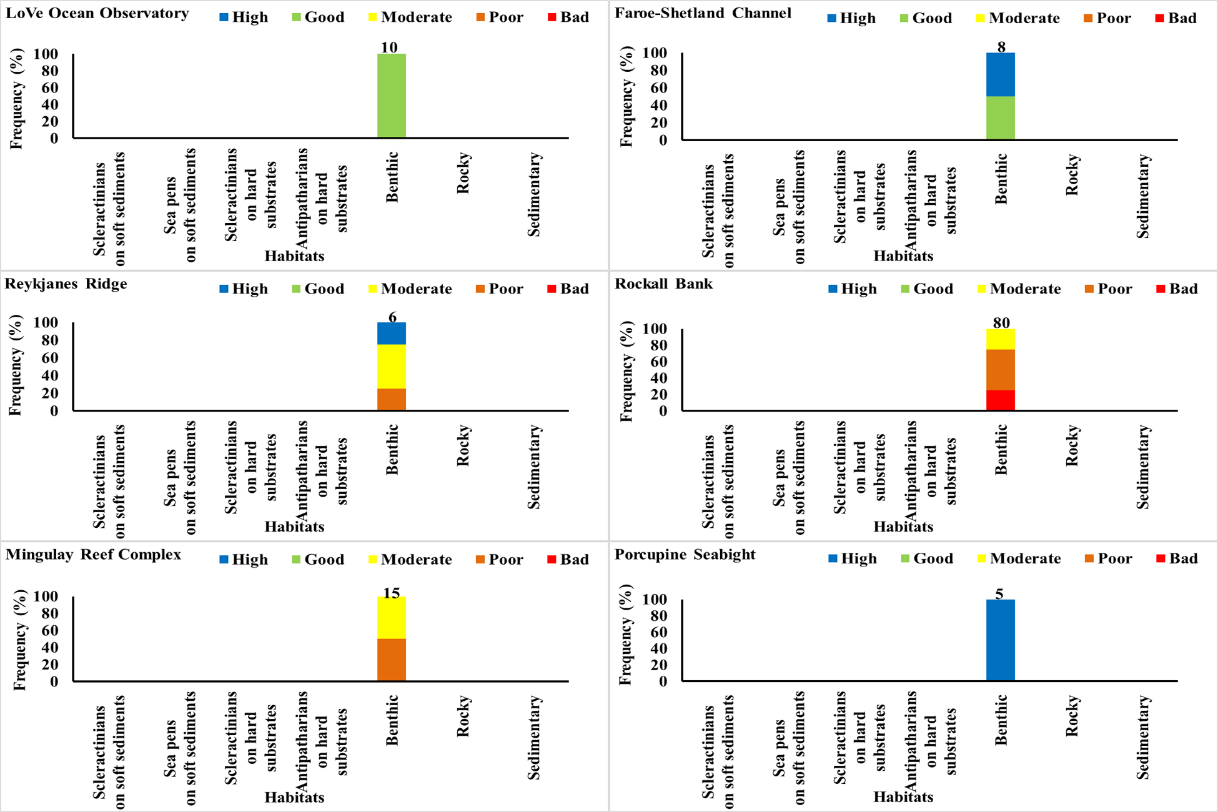
Fig. 1. Environmental status for the seven types of habitats across the study areas. The numbers of indicator values are shown on the top of the bars.
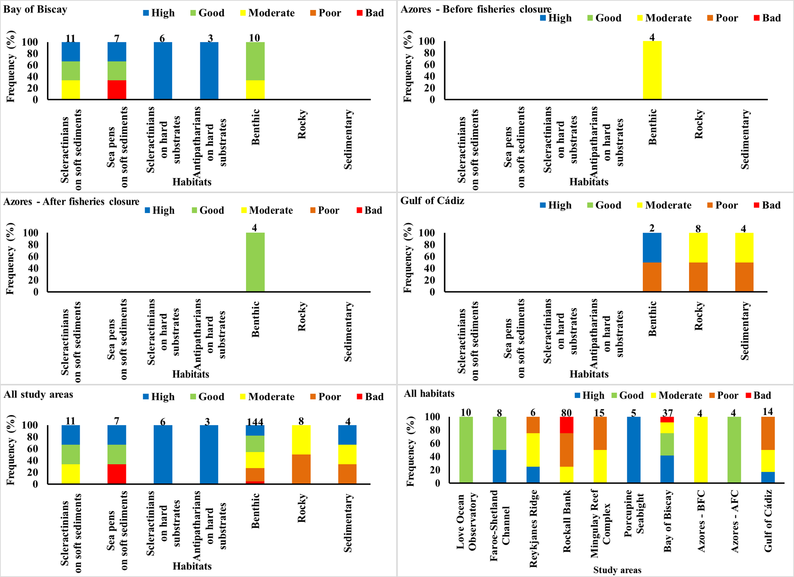
Fig. 1 (cont’d). Environmental status for the seven types of habitats across the study areas. The numbers of indicator values are shown on the top of the bars.
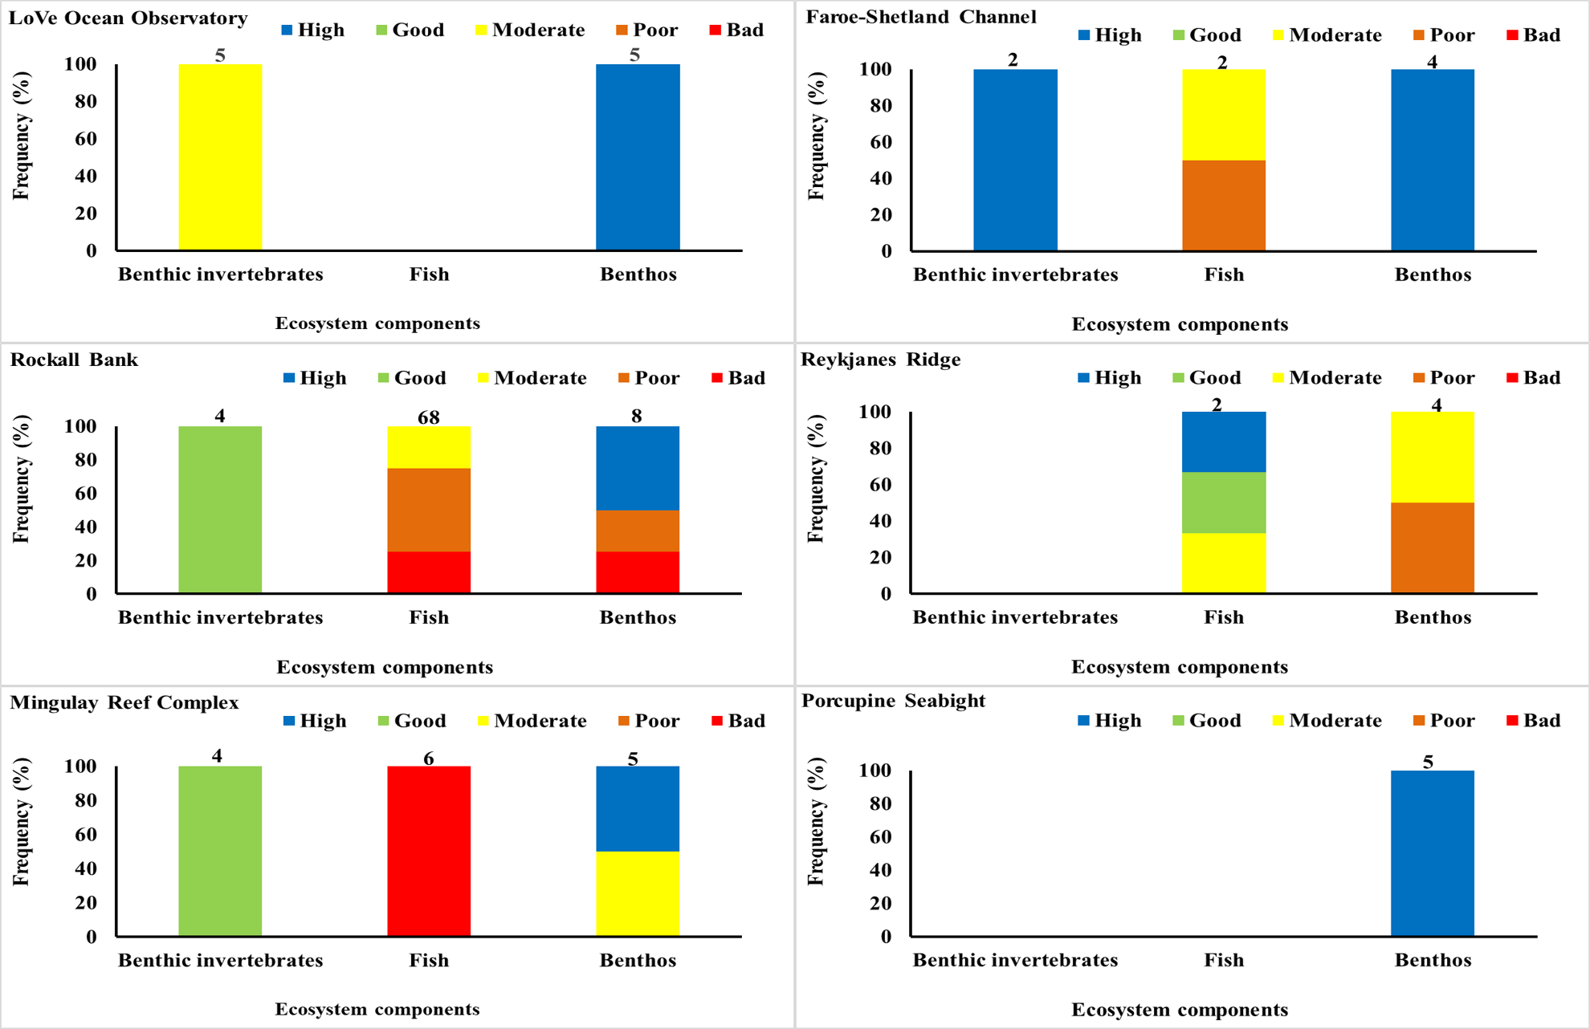
Fig. 2. Environmental status for the three types of ecosystem components across the study areas. The numbers of indicator values are shown on the top of the bars.
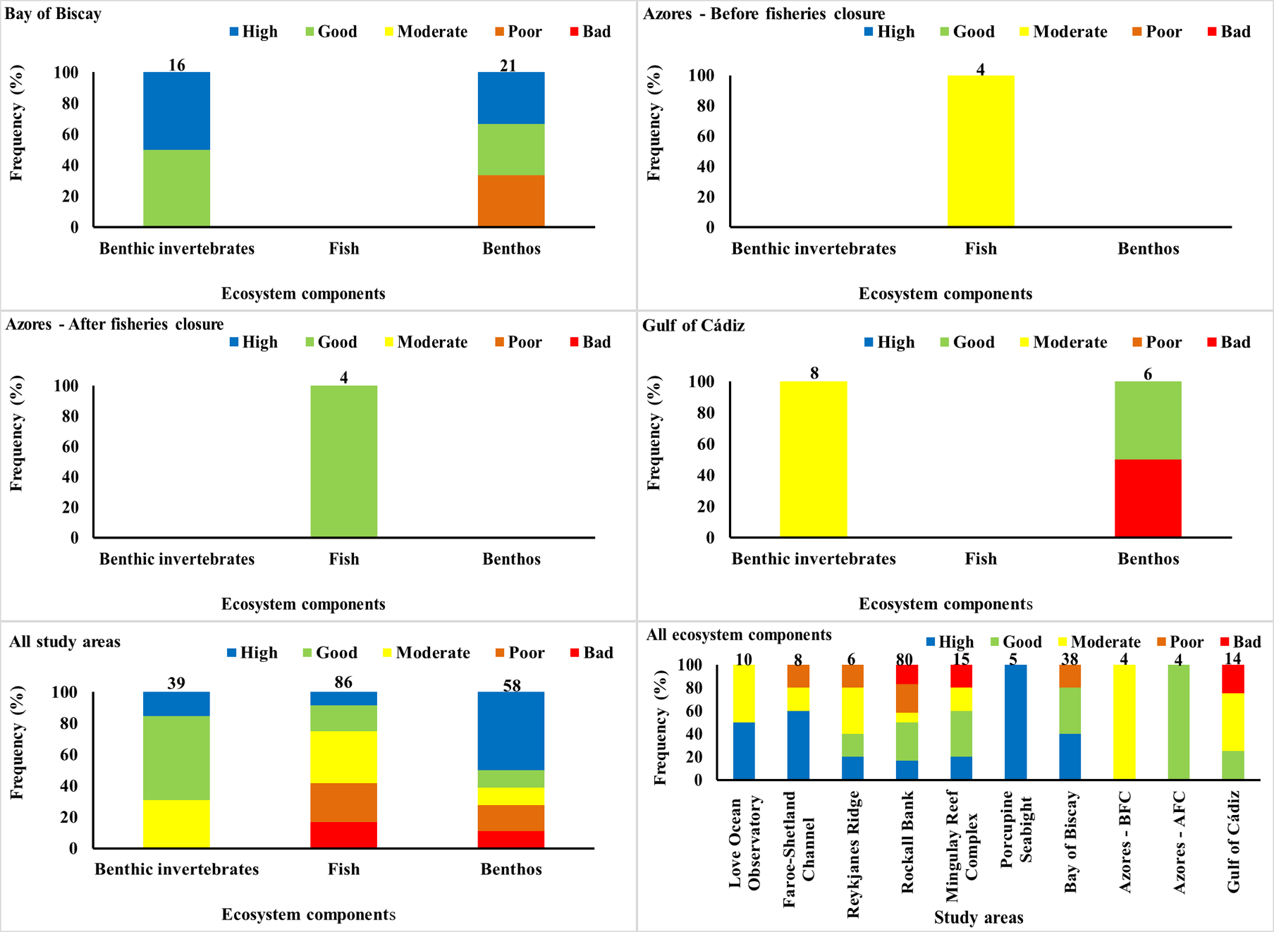
Fig. 2 (cont’d). Environmental status for the three types of ecosystem components across the study areas. The numbers of indicator values are shown on the top of the bars.
Table 1. List of descriptors, indicators, and their measurement units, spatial assessment units/habitats/ecosystems components for each of ATLAS study areas, Good Environmental Status (GES) threshold and method used for the setup of each GES threshold.
Descriptor | Indicator | Indicator measurement units | Study Area - SAU | Habitat | Ecosystem component | Worst status boundary | Moderate/good status  boundary | Best status boundary | Method used for the setup of the boundary values
D1 | Abundance of non-commercial demersal fish and cephalopods (Trisopterus minutus) (1) | (Mean number/30 min trawl) | Rockall Bank SAU-1 | Benthic | Fish | 4 | 5713 | 7141 | Expert judgement (minimum=worst and highest=best over time series; moderate/good=80% of the best)
D1 | Abundance of non-commercial demersal fish and cephalopods (Trisopterus minutus) (1) | (Mean number/30 min trawl) | Rockall Bank SAU-2 | Benthic | Fish | 1 | 1673 | 2091 | Expert judgement (minimum=worst and highest=best over time series; moderate/good=80% of the best)
D1 | Abundance of non-commercial demersal fish and cephalopods (Trisopterus minutus) (1) | (Mean number/30 min trawl) | Rockall Bank SAU-3 | Benthic | Fish | 0 | 36 | 45 | Expert judgement (minimum=worst and highest=best over time series; moderate/good=80% of the best)
D1 | Abundance of non-commercial demersal fish and cephalopods (Trisopterus minutus) (1) | (Mean number/30 min trawl) | Rockall Bank SAU-4 | Benthic | Fish | 0 | 2 | 2 | Expert judgement (minimum=worst and highest=best over time series; moderate/good=80% of the best)
D1 | Abundance of non-commercial demersal fish and cephalopods (Dipturus flossada) (1) | (Mean number/30 min trawl) | Rockall Bank SAU-1 | Benthic | Fish | 0 | 1 | 1 | Expert judgement (minimum=worst and highest=best over time series; moderate/good=80% of the best)
D1 | Abundance of non-commercial demersal fish and cephalopods (Dipturus flossada) (1) | (Mean number/30 min trawl) | Rockall Bank SAU-2 | Benthic | Fish | 0 | 3 | 4 | Expert judgement (minimum=worst and highest=best over time series; moderate/good=80% of the best)
D1 | Abundance of non-commercial demersal fish and cephalopods (Dipturus flossada) (1) | (Mean number/30 min trawl) | Rockall Bank SAU-3 | Benthic | Fish | 0 | 2 | 2 | Expert judgement (minimum=worst and highest=best over time series; moderate/good=80% of the best)
Descriptor | Indicator | Indicator measurement units | Study Area - SAU | Habitat | Ecosystem component | Bad status boundary | GES  boundary | High status boundary | Method used for boundary values setup
D1 | Abundance of non-commercial demersal fish and cephalopods (Dipturus flossada) (1) | (Mean number/30 min trawl) | Rockall Bank SAU-4 | Benthic | Fish | 0 | 1 | 1 | Expert judgement (minimum=worst and highest=best over time series; moderate/good=80% of the best)
D1 | Abundance of non-commercial demersal fish and cephalopods (Ammodytes marinus) (1) | (Mean number/30 min trawl) | Rockall Bank SAU-1 | Benthic | Fish | 0 | 10638 | 13297 | Expert judgement (minimum=worst and highest=best over time series; moderate/good=80% of the best)
D1 | Abundance of non-commercial demersal fish and cephalopods (Ammodytes marinus) (1) | (Mean number/30 min trawl) | Rockall Bank SAU-2 | Benthic | Fish | 0 | 1235 | 1544 | Expert judgement (minimum=worst and highest=best over time series; moderate/good=80% of the best)
D1 | Abundance of non-commercial demersal fish and cephalopods (Ammodytes marinus) (1) | (Mean number/30 min trawl) | Rockall Bank SAU-3 | Benthic | Fish | 0 | 2 | 2 | Expert judgement (minimum=worst and highest=best over time series; moderate/good=80% of the best)
D1 | Abundance of non-commercial demersal fish and cephalopods (Ammodytes marinus) (1) | (Mean number/30 min trawl) | Rockall Bank SAU-4 | Benthic | Fish | 0 | 0 | 0 | Expert judgement (minimum=worst and highest=best over time series; moderate/good=80% of the best)
D1 | Abundance of non-commercial demersal fish and cephalopods (Capros aper) (1) | (Mean number/30 min trawl) | Rockall Bank SAU-1 | Benthic | Fish | 0 | 15 | 19 | Expert judgement (minimum=worst and highest=best over time series; moderate/good=80% of the best)
D1 | Abundance of non-commercial demersal fish and cephalopods (Capros aper) (1) | (Mean number/30 min trawl) | Rockall Bank SAU-2 | Benthic | Fish | 0 | 6 | 8 | Expert judgement (minimum=worst and highest=best over time series; moderate/good=80% of the best)
D1 | Abundance of non-commercial demersal fish and cephalopods (Capros aper) (1) | (Mean number/30 min trawl) | Rockall Bank SAU-3 | Benthic | Fish | 0 | 0 | 0 | Expert judgement (minimum=worst and highest=best over time series; moderate/good=80% of the best)
Descriptor | Indicator | Indicator measurement units | Study Area - SAU | Habitat | Ecosystem component | Bad status boundary | GES  boundary | High status boundary | Method used for boundary values setup
D1 | Abundance of non-commercial demersal fish and cephalopods (Capros aper) (1) | (Mean number/30 min trawl) | Rockall Bank SAU-4 | Benthic | Fish | 0 | 0 | 0 | Expert judgement (minimum=worst and highest=best over time series; moderate/good=80% of the best)
D1 | Abundance of non-commercial demersal fish and cephalopods (Eutrigla gurnardus) (1) | (Mean number/30 min trawl) | Rockall Bank SAU-1 | Benthic | Fish | 0 | 541 | 676 | Expert judgement (minimum=worst and highest=best over time series; moderate/good=80% of the best)
D1 | Abundance of non-commercial demersal fish and cephalopods (Eutrigla gurnardus) (1) | (Mean number/30 min trawl) | Rockall Bank SAU-2 | Benthic | Fish | 2 | 2450 | 3062 | Expert judgement (minimum=worst and highest=best over time series; moderate/good=80% of the best)
D1 | Abundance of non-commercial demersal fish and cephalopods (Eutrigla gurnardus) (1) | (Mean number/30 min trawl) | Rockall Bank SAU-3 | Benthic | Fish | 0 | 13 | 16 | Expert judgement (minimum=worst and highest=best over time series; moderate/good=80% of the best)
D1 | Abundance of non-commercial demersal fish and cephalopods (Eutrigla gurnardus) (1) | (Mean number/30 min trawl) | Rockall Bank SAU-4 | Benthic | Fish | 0 | 4 | 5 | Expert judgement (minimum=worst and highest=best over time series; moderate/good=80% of the best)
D1 | Abundance of non-commercial demersal fish and cephalopods (Gymnammodytes semisquamatus) (1) | (Mean number/30 min trawl) | Rockall Bank SAU-1 | Benthic | Fish | 0 | 457 | 571 | Expert judgement (minimum=worst and highest=best over time series; moderate/good=80% of the best)
D1 | Abundance of non-commercial demersal fish and cephalopods (Gymnammodytes semisquamatus) (1) | (Mean number/30 min trawl) | Rockall Bank SAU-2 | Benthic | Fish | 0 | 1006 | 1258 | Expert judgement (minimum=worst and highest=best over time series; moderate/good=80% of the best)
D1 | Abundance of non-commercial demersal fish and cephalopods (Gymnammodytes semisquamatus) (1) | (Mean number/30 min trawl) | Rockall Bank SAU-3 | Benthic | Fish | 0 | 0 | 0 | Expert judgement (minimum=worst and highest=best over time series; moderate/good=80% of the best)
Descriptor | Indicator | Indicator measurement units | Study Area - SAU | Habitat | Ecosystem component | Bad status boundary | GES  boundary | High status boundary | Method used for boundary values setup
D1 | Abundance of non-commercial demersal fish and cephalopods (Gymnammodytes semisquamatus) (1) | (Mean number/30 min trawl) | Rockall Bank SAU-4 | Benthic | Fish | 0 | 0 | 0 | Expert judgement (minimum=worst and highest=best over time series; moderate/good=80% of the best)
D3 | Body length distribution of fish (Helicolenus dactylopterus/bluemouth) (201-700m depth) (2009 i.e. prior to fisheries closure) (2) | Total length (cm) | Azores SAU-1 | Benthic | Fish | 14 | 25 | 42 | Regional legislation and expert judgement based on survey data
D3 | Body length distribution of fish (Helicolenus dactylopterus/bluemouth) (201-700m depth) (2016 i.e. after fisheries closure) (2) | Total length (cm) | Azores SAU-1 | Benthic | Fish | 14 | 25 | 42 | Regional legislation and expert judgement based on survey data
D3 | Body length distribution of fish (Pagellus bogaraveo/blackspot seabream) (201-650m depth) (2009 i.e. prior to fisheries closure) (2) | Fork length (cm) | Azores SAU-1 | Benthic | Fish | 18 | 30 | 53 | National legislation and expert judgement based on survey data
D3 | Body length distribution of fish (Pagellus bogaraveo/blackspot seabream) (201-650m depth) (2016 i.e. after fisheries closure) (2) | Fork length (cm) | Azores SAU-1 | Benthic | Fish | 18 | 30 | 53 | National legislation and expert judgement based on survey data
D4 | Species richness of non-commercial fish (3) | Species richness per 0.3704 km2 | Rockall Bank SAU-1 | Benthic | Fish | 5 | 19 | 24 | Expert judgement (minimum=worst and highest=best over time series; moderate/good=80% of the best)
D4 | Species richness of non-commercial fish (3) | Species richness per 2.2224 km2 | Rockall Bank SAU-2 | Benthic | Fish | 13 | 27 | 34 | Expert judgement (minimum=worst and highest=best over time series; moderate/good=80% of the best)
D4 | Species richness of non-commercial fish (3) | Species richness per 0.4445 km2 | Rockall Bank SAU-3 | Benthic | Fish | 8 | 26 | 32 | Expert judgement (minimum=worst and highest=best over time series; moderate/good=80% of the best)
Descriptor | Indicator | Indicator measurement units | Study Area - SAU | Habitat | Ecosystem component | Bad status boundary | GES  boundary | High status boundary | Method used for boundary values setup
D4 | Species richness of non-commercial fish (3) | Species richness per 0 km2 (0.1482 km2 [2016]) | Rockall Bank SAU-4 | Benthic | Fish | 20 | 22 | 28 | Expert judgement (minimum=worst and highest=best over time series; moderate/good=80% of the best)
D4 | Species richness of non-commercial fish (3) | Mean species richness / km | Mingulay Reef Complex SAU-1 | Benthic | Fish | 0 | 1 | 5 | Expert judgement
D4 | Species richness of corals (4) | Coral taxa / image | Bay of Biscay SAU-2 | Aggregations of Lophelia pertusa / Madrepora oculata on soft sediments | Benthic Fauna | 0 | 0.5 | 1 | Expert judgement
D4 | Species richness of corals (4) | Coral taxa / image | Bay of Biscay SAU-3 | Aggregations of Lophelia pertusa / Madrepora oculata on soft sediments | Benthic Fauna | 0 | 0.5 | 1 | Expert judgement
D4 | Species richness of corals (4) | Coral taxa / image | Bay of Biscay SAU-2 | Aggregations of Lophelia pertusa / Madrepora oculata on hard subtrates | Benthic Fauna | 0 | 0.25 | 0.5 | Expert judgement
D4 | Species richness of corals (4) | Coral taxa / image | Bay of Biscay SAU-3 | Aggregations of Lophelia pertusa / Madrepora oculata on hard subtrates | Benthic Fauna | 0 | 0.25 | 0.5 | Expert judgement
D4 | Species richness of corals (4) | Coral taxa / image | Bay of Biscay SAU-2 | Aggregations of antipatharians and alcyonaceans on hard substrates | Benthic Fauna | 0 | 1 | 2 | Expert judgement
Descriptor | Indicator | Indicator measurement units | Study Area - SAU | Habitat | Ecosystem component | Bad status boundary | GES  boundary | High status boundary | Method used for boundary values setup
D4 | Species richness of corals (4) | Coral taxa / image | Bay of Biscay SAU-2 | Aggregations of seapens and alcyonaceans on soft sediments | Benthic Fauna | 0 | 0.5 | 1 | Expert judgement
D4 | Species richness of corals (4) | Coral taxa / image | Bay of Biscay SAU_3 | Aggregations of seapens and alcyonaceans on soft sediments | Benthic Fauna | 0 | 0.5 | 1 | Expert judgement
D4 | Species richness of benthos (5) | Spp Richness per 5.39 km2 | Rockall Bank SAU-1 | Benthic | Benthic Fauna | 0 | 15 | 18 | Expert judgement (moderate/good=observed; observed+20%=best)
D4 | Species richness of benthos (5) | Spp Richness per 47.6 km2 | Rockall Bank SAU-2 | Benthic | Benthic Fauna | 0 | 38 | 46 | Expert judgement (moderate/good=observed; observed+20%=best)
D4 | Species richness of benthos (5) | Spp Richness per 17.53 km2 | Rockall Bank SAU-3 | Benthic | Benthic Fauna | 0 | 25 | 30 | Expert judgement (moderate/good=observed; observed+20%=best)
D4 | Species richness of benthos (5) | Spp Richness per 10.11 km2 | Rockall Bank SAU-4 | Benthic | Benthic Fauna | 0 | 39 | 47 | Expert judgement (moderate/good=observed; observed+20%=best)
D4 | Species diversity (Shannon index) of non-commercial fish (6) | Shannon Index | Reykjanes Ridge SAU-1-1 | Benthic | Fish | 0 | 0.43 | 0.57 | Expert judgement (worst=0; mod/good=average over 1995-2017; best=highest over 1995-2017; observed value=average for 2015-2017)
D4 | Species diversity (Shannon index) of non-commercial fish (6) | Shannon Index | Reykjanes Ridge SAU-1-2 | Benthic | Fish | 0 | 1.04 | 1.35 | Expert judgement (worst=0; mod/good=average over 1995-2017; best=highest over 1995-2017; observed value=average for 2015-2017)
D4 | Species diversity (Shannon index) of non-commercial fish (6) | Shannon Index | Rockall Bank SAU-1 | Benthic | Fish | 0.369 | 1.459 | 1.625 | Expert judgement (minimum=worst and highest=best over time series; moderate/good=80% of the best)
D4 | Species diversity (Shannon index) of non-commercial fish (6) | Shannon Index | Rockall Bank SAU-2 | Benthic | Fish | 0.777 | 1.433 | 1.79 | Expert judgement (minimum=worst and highest=best over time series; moderate/good=80% of the best)
Descriptor | Indicator | Indicator measurement units | Study Area - SAU | Habitat | Ecosystem component | Bad status boundary | GES  boundary | High status boundary | Method used for boundary values setup
D4 | Species diversity (Shannon index) of non-commercial fish (6) | Shannon Index | Rockall Bank SAU-3 | Benthic | Fish | 0.385 | 1.15 | 1.33 | Expert judgement (minimum=worst and highest=best over time series; moderate/good=80% of the best)
D4 | Species diversity (Shannon index) of non-commercial fish (6) | Shannon Index | Rockall Bank SAU-4 | Benthic | Fish | 0.32 | 0.621 | 0.776 | Expert judgement (minimum=worst and highest=best over time series; moderate/good=80% of the best)
D4 | Abundance of commercial fish (Trisopterus luscus) (7) | Number of fish/km | Mingulay Reef Complex SAU-1 | Benthic | Fish | 0 | 40.8 | 102 | Expert judgement and scientific literature (Buhl-Mortensen et al., 1995; Soffker et al., 2011)
D4 | Abundance of commercial fish (Micromesistius poutassou) (7) | Number of fish/km | Mingulay Reef Complex SAU-1 | Benthic | Fish | 0 | 6.8 | 17 | Expert judgement and scientific literature (Buhl-Mortensen et al., 1995; Soffker et al., 2011)
D4 | Abundance of commercial fish (Pollachius sp.) (7) | Number of fish/km | Mingulay Reef Complex SAU-1 | Benthic | Fish | 0 | 292.4 | 731 | Expert judgement and scientific literature (Buhl-Mortensen et al., 1995; Soffker et al., 2011)
D4 | Abundance of commercial fish (Helicolenus dactylopterus) (7) | Number of fish/km | Mingulay Reef Complex SAU-1 | Benthic | Fish | 0 | 10.8 | 27 | Expert judgement and scientific literature (Buhl-Mortensen et al., 1995; Soffker et al., 2011)
D4 | Abundance of commercial fish (Scyliorhinus canicula) (7) | Number of fish/km | Mingulay Reef Complex SAU-1 | Benthic | Fish | 0 | 41.6 | 104 | Expert judgement and scientific literature (Buhl-Mortensen et al., 1995; Soffker et al., 2011)
D4 | Biomass of demersal fish (8) | Demersal landings (tonnes) from Scottish waters  per ICES statistical rectangle (2012-2016) | Faroe-Shetland Channel SAU-1 | Benthic | Fish | 2066 | 200 | 38 | Expert judgement
D4 | Biomass of demersal fish (8) | Demersal landings (tonnes) from Scottish waters  per ICES statistical rectangle (2012-2016) | Faroe-Shetland Channel– SAU-2 | Benthic | Fish | 2066 | 200 | 38 | Expert judgement
Descriptor | Indicator | Indicator measurement units | Study Area - SAU | Habitat | Ecosystem component | Bad status boundary | GES  boundary | High status boundary | Method used for boundary values setup
D4 | Biomass of selected fish species: Angler (Monk fish) (Lophius piscatorius) (9) | Mean Biomass (kg) per 30 min trawl | Rockall Bank SAU-1 | Benthic | Fish | 0.004 | 5.1808 | 6.476 | Expert judgement (minimum=worst and highest=best over time series; moderate/good=80% of the best)
D4 | Biomass of selected fish species: Angler (Monk fish) (Lophius piscatorius) (9) | Mean Biomass (kg) per 30 min trawl | Rockall Bank SAU-2 | Benthic | Fish | 0.009 | 2.7824 | 3.478 | Expert judgement (minimum=worst and highest=best over time series; moderate/good=80% of the best)
D4 | Biomass of selected fish species: Angler (Monk fish) (Lophius piscatorius) (9) | Mean Biomass (kg) per 30 min trawl | Rockall Bank SAU-3 | Benthic | Fish | 0.765 | 4.4152 | 5.519 | Expert judgement (minimum=worst and highest=best over time series; moderate/good=80% of the best)
D4 | Biomass of selected fish species: Angler (Monk fish) (Lophius piscatorius) (9) | Mean Biomass (kg) per 30 min trawl | Rockall Bank SAU-4 | Benthic | Fish | 5.072 | 5.1816 | 6.477 | Expert judgement (minimum=worst and highest=best over time series; moderate/good=80% of the best)
D4 | Biomass of selected fish species: Blue-mouth (Helicolenus dactylopterus) (9) | Mean Biomass (kg) per 30 min trawl | Rockall Bank SAU-1 | Benthic | Fish | 0.012 | 3.6272 | 4.534 | Expert judgement (minimum=worst and highest=best over time series; moderate/good=80% of the best)
D4 | Biomass of selected fish species: Blue-mouth (Helicolenus dactylopterus) (9) | Mean Biomass (kg) per 30 min trawl | Rockall Bank SAU-2 | Benthic | Fish | 0.018 | 1.6848 | 2.106 | Expert judgement (minimum=worst and highest=best over time series; moderate/good=80% of the best)
D4 | Biomass of selected fish species: Blue-mouth (Helicolenus dactylopterus) (9) | Mean Biomass (kg) per 30 min trawl | Rockall Bank SAU-3 | Benthic | Fish | 0.279 | 1.4592 | 1.824 | Expert judgement (minimum=worst and highest=best over time series; moderate/good=80% of the best)
Descriptor | Indicator | Indicator measurement units | Study Area - SAU | Habitat | Ecosystem component | Bad status boundary | GES  boundary | High status boundary | Method used for boundary values setup
D4 | Biomass of selected fish species: Blue-mouth (Helicolenus dactylopterus) (9) | Mean Biomass (kg) per 30 min trawl | Rockall Bank SAU-4 | Benthic | Fish | 1.981 | 4.1248 | 5.156 | Expert judgement (minimum=worst and highest=best over time series; moderate/good=80% of the best)
D4 | Biomass of selected fish species: Grey Gurnard (Eutrigla gurnardus) (9) | Mean Biomass (kg) per 30 min trawl | Rockall Bank SAU-1 | Benthic | Fish | 0.045 | 10.492 | 13.115 | Expert judgement (minimum=worst and highest=best over time series; moderate/good=80% of the best)
D4 | Biomass of selected fish species: Grey Gurnard (Eutrigla gurnardus) (9) | Mean Biomass (kg) per 30 min trawl | Rockall Bank SAU-2 | Benthic | Fish | 0.095 | 50.9104 | 63.368 | Expert judgement (minimum=worst and highest=best over time series; moderate/good=80% of the best)
D4 | Biomass of selected fish species: Grey Gurnard (Eutrigla gurnardus) (9) | Mean Biomass (kg) per 30 min trawl | Rockall Bank SAU-3 | Benthic | Fish | 0.002 | 0.4424 | 0.553 | Expert judgement (minimum=worst and highest=best over time series; moderate/good=80% of the best)
D4 | Biomass of selected fish species: Grey Gurnard (Eutrigla gurnardus) (9) | Mean Biomass (kg) per 30 min trawl | Rockall Bank SAU-4 | Benthic | Fish | 0.008 | 0.2712 | 0.339 | Expert judgement (minimum=worst and highest=best over time series; moderate/good=80% of the best)
D4 | Biomass of selected fish species: Haddock (Melanogrammus aeglefinus) (9) | Mean Biomass (kg) per 30 min trawl | Rockall Bank SAU-1 | Benthic | Fish | 0.912 | 13.34 | 16.675 | Expert judgement (minimum=worst and highest=best over time series; moderate/good=80% of the best)
D4 | Biomass of selected fish species: Haddock (Melanogrammus aeglefinus) (9) | Mean Biomass (kg) per 30 min trawl | Rockall Bank SAU-2 | Benthic | Fish | 2.421 | 23.4416 | 29.302 | Expert judgement (minimum=worst and highest=best over time series; moderate/good=80% of the best)
D4 | Biomass of selected fish species: Haddock (Melanogrammus aeglefinus) (9) | Mean Biomass (kg) per 30 min trawl | Rockall Bank SAU-3 | Benthic | Fish | 1.475 | 7.8256 | 9.782 | Expert judgement (minimum=worst and highest=best over time series; moderate/good=80% of the best)
Descriptor | Indicator | Indicator measurement units | Study Area - SAU | Habitat | Ecosystem component | Bad status boundary | GES  boundary | High status boundary | Method used for boundary values setup
D4 | Biomass of selected fish species: Haddock (Melanogrammus aeglefinus) (9) | Mean Biomass (kg) per 30 min trawl | Rockall Bank  SAU-4 | Benthic | Fish | 0.668 | 2.1472 | 2.684 | Expert judgement (minimum=worst and highest=best over time series; moderate/good=80% of the best)
D4 | Biomass of selected fish species: Ling (Molva molva) (9) | Mean Biomass (kg) per 30 min trawl | Rockall Bank SAU-1 | Benthic | Fish | 0.054 | 1.6576 | 2.072 | Expert judgement (minimum=worst and highest=best over time series; moderate/good=80% of the best)
D4 | Biomass of selected fish species: Ling (Molva molva) (9) | Mean Biomass (kg) per 30 min trawl | Rockall Bank SAU-2 | Benthic | Fish | 0.097 | 4.4488 | 5.561 | Expert judgement (minimum=worst and highest=best over time series; moderate/good=80% of the best)
D4 | Biomass of selected fish species: Ling (Molva molva) (9) | Mean Biomass (kg) per 30 min trawl | Rockall Bank SAU-3 | Benthic | Fish | 1.892 | 7.0744 | 8.843 | Expert judgement (minimum=worst and highest=best over time series; moderate/good=80% of the best)
D4 | Biomass of selected fish species: Ling (Molva molva) (9) | Mean Biomass (kg) per 30 min trawl | Rockall Bank SAU-4 | Benthic | Fish | 1.643 | 2.9768 | 3.721 | Expert judgement (minimum=worst and highest=best over time series; moderate/good=80% of the best)
D4 | Biomass of selected fish species: Long Rough Dab (Hippoglossoides platessoides) (9) | Mean Biomass (kg) per 30 min trawl | Rockall Bank SAU-1 | Benthic | Fish | 0.004 | 0.2104 | 0.263 | Expert judgement (minimum=worst and highest=best over time series; moderate/good=80% of the best)
D4 | Biomass of selected fish species: Long Rough Dab (Hippoglossoides platessoides) (9) | Mean Biomass (kg) per 30 min trawl | Rockall Bank SAU-2 | Benthic | Fish | 0.027 | 0.2352 | 0.294 | Expert judgement (minimum=worst and highest=best over time series; moderate/good=80% of the best)
Descriptor | Indicator | Indicator measurement units | Study Area - SAU | Habitat | Ecosystem component | Bad status boundary | GES  boundary | High status boundary | Method used for boundary values setup
D4 | Biomass of selected fish species: Long Rough Dab (Hippoglossoides platessoides) (9) | Mean Biomass (kg) per 30 min trawl | Rockall Bank SAU-3 | Benthic | Fish | 0.123 | 0.5248 | 0.656 | Expert judgement (minimum=worst and highest=best over time series; moderate/good=80% of the best)
D4 | Biomass of selected fish species: Long Rough Dab (Hippoglossoides platessoides) (9) | Mean Biomass (kg) per 30 min trawl | Rockall Bank SAU-4 | Benthic | Fish | 0.147 | 0.42 | 0.525 | Expert judgement (minimum=worst and highest=best over time series; moderate/good=80% of the best)
D4 | Biomass of selected fish species: Megrim (Lepidorhombus whiffiagonis) (9) | Mean Biomass (kg) per 30 min trawl | Rockall Bank SAU-1 | Benthic | Fish | 0.042 | 0.508 | 0.635 | Expert judgement (minimum=worst and highest=best over time series; moderate/good=80% of the best)
D4 | Biomass of selected fish species: Megrim (Lepidorhombus whiffiagonis) (9) | Mean Biomass (kg) per 30 min trawl | Rockall Bank SAU-2 | Benthic | Fish | 0.163 | 0.6872 | 0.859 | Expert judgement (minimum=worst and highest=best over time series; moderate/good=80% of the best)
D4 | Biomass of selected fish species: Megrim (Lepidorhombus whiffiagonis) (9) | Mean Biomass (kg) per 30 min trawl | Rockall Bank SAU-3 | Benthic | Fish | 0.247 | 0.9752 | 1.219 | Expert judgement (minimum=worst and highest=best over time series; moderate/good=80% of the best)
D4 | Biomass of selected fish species: Megrim (Lepidorhombus whiffiagonis) | Mean Biomass (kg) per 30 min trawl | Rockall Bank SAU-3 | Benthic | Fish | 0.295 | 0.7624 | 0.953 | Expert judgement (minimum=worst and highest=best over time series; moderate/good=80% of the best)
D4 | Biomass of selected fish species: Norway Haddock (Sebastes viviparus) (9) | Mean Biomass (kg) per 30 min trawl | Rockall Bank SAU-1 | Benthic | Fish | 0.068 | 5.0664 | 6.333 | Expert judgement (minimum=worst and highest=best over time series; moderate/good=80% of the best)
D4 | Biomass of selected fish species: Norway Haddock (Sebastes viviparus) (9) | Mean Biomass (kg) per 30 min trawl | Rockall Bank SAU-2 | Benthic | Fish | 0.446 | 9.3536 | 11.692 | Expert judgement (minimum=worst and highest=best over time series; moderate/good=80% of the best)
Descriptor | Indicator | Indicator measurement units | Study Area - SAU | Habitat | Ecosystem component | Bad status boundary | GES  boundary | High status boundary | Method used for boundary values setup
D4 | Biomass of selected fish species: Norway Haddock (Sebastes viviparus) (9) | Mean Biomass (kg) per 30 min trawl | Rockall Bank SAU-3 | Benthic | Fish | 0.089 | 1.3536 | 1.692 | Expert judgement (minimum=worst and highest=best over time series; moderate/good=80% of the best)
D4 | Biomass of selected fish species: Norway Haddock (Sebastes viviparus) (9) | Mean Biomass (kg) per 30 min trawl | Rockall Bank SAU-4 | Benthic | Fish | 0.133 | 0.2736 | 0.342 | Expert judgement (minimum=worst and highest=best over time series; moderate/good=80% of the best)
D4 | Biomass of selected fish species: Witch (Glyptocephalus cynoglossus) (9) | Mean Biomass (kg) per 30 min trawl | Rockall Bank SAU-1 | Benthic | Fish | 0.11 | 0.088 | 0.11 | Expert judgement (minimum=worst and highest=best over time series; moderate/good=80% of the best)
D4 | Biomass of selected fish species: Witch (Glyptocephalus cynoglossus) (9) | Mean Biomass (kg) per 30 min trawl | Rockall Bank SAU-2 | Benthic | Fish | 0.043 | 0.2384 | 0.298 | Expert judgement (minimum=worst and highest=best over time series; moderate/good=80% of the best)
D4 | Biomass of selected fish species: Witch (Glyptocephalus cynoglossus) (9) | Mean Biomass (kg) per 30 min trawl | Rockall Bank SAU-3 | Benthic | Fish | 0.171 | 0.3464 | 0.433 | Expert judgement (minimum=worst and highest=best over time series; moderate/good=80% of the best)
D4 | Biomass of selected fish species: Witch (Glyptocephalus cynoglossus) (9) | Mean Biomass (kg) per 30 min trawl | Rockall Bank SAU-4 | Benthic | Fish | 0.268 | 0.8096 | 1.012 | Expert judgement (minimum=worst and highest=best over time series; moderate/good=80% of the best)
D4 | Biomass of selected fish species (Helicolenus dactylopterus/bluemouth) (250-600m depth) (2009 i.e. prior to fisheries closure) (9) | CPUEb (kg fish/1000 hooks) | Azores SAU-1 | Benthic | Fish | 5.29 | 19.55 | 24.44 | Expert judgement (minimum=worst and highest=best over time series; moderate/good=80% of the best) and regional legislation
D4 | Biomass of selected fish species (Helicolenus dactylopterus/bluemouth) (250-600m depth) (2016 i.e. after fisheries closure) (9) | CPUEb (kg fish/1000 hooks) | Azores SAU-1 | Benthic | Fish | 5.29 | 19.55 | 24.44 | Expert judgement (minimum=worst and highest=best over time series; moderate/good=80% of the best) and regional legislation
Descriptor | Indicator | Indicator measurement units | Study Area - SAU | Habitat | Ecosystem component | Bad status boundary | GES  boundary | High status boundary | Method used for boundary values setup
D4 | Biomass of selected fish species (Pagellus bogaraveo/blackspot seabream) (250-600m depth) (2009 i.e. prior to fisheries closure) (9) | CPUEb (kg fish/1000 hooks) | Azores SAU-1 | Benthic | Fish | 8.27 | 65.76 | 82.20 | Expert judgement (minimum=worst and highest=best over time series; moderate/good=80% of the best) and regional legislation
D4 | Biomass of selected fish species (Pagellus bogaraveo/blackspot seabream) (250-600m depth) (2016 i.e. after fisheries closure) (9) | CPUEb (kg fish/1000 hooks) | Azores SAU-1 | Benthic | Fish | 8.27 | 65.76 | 82.20 | Expert judgement (minimum=worst and highest=best over time series; moderate/good=80% of the best) and regional legislation
D6 | Fishing Effort (10) | Nr hauls per Km² per year | Gulf of Cádiz SAU-1 | Rocky | Benthos | 1 | 0.5 | 0 | Expert judgement
D6 | Fishing Effort (10) | Nr hauls per Km² per year | Gulf of Cádiz SAU-1 | Sedimentary | Benthos | 4 | 2 | 0 | Expert judgement
D6 | Fishing Effort (10) | Nr hauls per Km² per year | Gulf of Cádiz SAU-2 | Rocky | Benthos | 1 | 0.5 | 0 | Expert judgement
D6 | Fishing Effort (10) | Nr hauls per Km² per year | Gulf of Cádiz SAU-2 | Sedimentary | Benthos | 4 | 2 | 0 | Expert judgement
D6 | Areal extent of human affected area (11) | % of seafloor | LoVe Ocean Observatory SAU-1 | Benthic | Benthos | 100 | 5 | 0 | Expert judgement  (worst=100% seafloor affected, best=0% seafloor affected)
D6 | Areal extent of human affected area (11) | % of seafloor | LoVe Ocean Observatory SAU-2 | Benthic | Benthos | 100 | 5 | 0 | Expert judgement and comparison with other cold-water coral areas along the Norwegian continental shelf (e.g., Sularevet, Iveryggen, Storneset, Activneset; www.mareano.no)
D6 | Areal extent of human affected area (11) | % of sea floor covered | Faroe-Shetland Channel SAU-1 | Benthic | Benthos | 100 | 10 | 0 | Expert judgement
D6 | Areal extent of human affected area (11) | % | Reykjanes Ridge SAU-1 | Benthic | Benthos | 100 | 10 | 0 | Expert judgement
D6 | Areal extent of human affected area (11) | % | Reykjanes Ridge SAU-2 | Benthic | Benthos | 100 | 10 | 0 | Expert judgement
D6 | Areal extent of human affected area (11) | Area (km²) where surface swept area ratio is > 0.2 (or, one fifth) of the cell | Rockall Bank SAU-1 | Benthic | Benthos | 1274.35 | 1204.52 | 1204.52 | Expert judgement and use of ICES data
Descriptor | Indicator | Indicator measurement units | Study Area - SAU | Habitat | Ecosystem component | Bad status boundary | GES  boundary | High status boundary | Method used for boundary values setup
D6 | Areal extent of human affected area (11) | Area (km²) where surface swept area ratio is > 0.2 (or, one fifth) of the cell | Rockall Bank SAU-2 | Benthic | Benthos | 9595.82 | 8822.76 | 7352.3 | Expert judgement and use of ICES data
D6 | Areal extent of human affected area (11) | Area (km²) where surface swept area ratio is > 0.2 (or, one fifth) of the cell | Rockall Bank SAU-3 | Benthic | Benthos | 4076.61 | 3032.148 | 2526.79 | Expert judgement and use of ICES data
D6 | Areal extent of human affected area (11) | Area (km²) where surface swept area ratio is > 0.2 (or, one fifth) of the cell | Rockall Bank SAU-4 | Benthic | Benthos | 4750.7 | 980.22 | 816.85 | Expert judgement and use of ICES data
D6 | Areal extent of human affected area (11) | % (open to static gear) | Mingulay Reef Complex SAU-2 | Benthic | Benthos | 100 | 75 | 0 | Expert judgement and national legislation
D6 | Areal extent of human affected area (11) | Dimensionless | Porcupine Seabight SAU-1 | Benthic | Benthos | 1 | 0.15 | 0 | Expert judgement and OSPAR recommendation
D6 | Areal extent of human affected area (11) | Dimensionless | Porcupine Seabight SAU-1 | Benthic | Benthos | 1 | 0.15 | 0 | Expert judgement and OSPAR recommendation
D6 | Areal extent of human affected area (11) | Dimensionless | Porcupine Seabight SAU-1 | Benthic | Benthos | 1 | 0.15 | 0 | Expert judgement and OSPAR recommendation
D6 | Areal extent of human affected area (11) | Dimensionless | Porcupine Seabight SAU-1 | Sedimentary | Benthos | 1 | 0.15 | 0 | Expert judgement and OSPAR recommendation
D6 | Areal extent of human affected area (11) | Dimensionless | Porcupine Seabight SAU-1 | Benthic | Benthos | 1 | 0.15 | 0 | Expert judgement and OSPAR recommendation
D6 | Areal extent of human affected area (11) | % | Bay of Biscay SAU-1 | Benthic | Benthos | 500 | 50 | 0 | Expert judgement
D6 | Areal extent of human affected area (11) | % | Bay of Biscay SAU-2 | Benthic | Benthos | 500 | 50 | 0 | Expert judgement
D6 | Areal extent of human affected area (11) | % | Bay of Biscay SAU-3 | Benthic | Benthos | 500 | 50 | 0 | Expert judgement
Descriptor | Indicator | Indicator measurement units | Study Area - SAU | Habitat | Ecosystem component | Bad status boundary | GES  boundary | High status boundary | Method used for boundary values setup
D6 | Areal extent of human affected area (11) | % trawled area | Gulf of Cádiz SAU-1 | Benthic | Benthos | 50 | 30 | 0 | Expert judgement
D6 | Areal extent of human affected area (11) | % trawled area | Gulf of Cádiz SAU-2 | Benthic | Benthos | 50 | 30 | 0 | Expert judgement
D6 | Areal extent of protected sea areas (12) | % of seafloor | LoVe Ocean Observatory SAU-1 | Benthic | Benthos | 0 | 50 | 100 | Expert judgement (worst=0% seafloor protected, best=100% seafloor protected)
D6 | Areal extent of protected sea areas (12) | % | Faroe-Shetland Channel SAU-1 | Benthic | Benthos | 0 | 10 | 100 | Expert judgement
D6 | Areal extent of protected sea areas (12) | % | Faroe-Shetland Channel SAU-2 | Benthic | Benthos | 0 | 10 | 100 | Expert judgement
D6 | Areal extent of protected sea areas (12) | % | Reykjanes Ridge SAU-1 | Benthic | Benthos | 0 | 10 | 15 | Expert judgement and UN Framework Convention on Climate Change Decision
D6 | Areal extent of protected sea areas (12) | % | Reykjanes Ridge SAU-2 | Benthic | Benthos | 0 | 10 | 15 | Expert judgement and UN Framework Convention on Climate Change Decision
D6 | Areal extent of protected sea areas (12) | Area (km²) | Rockall Bank SAU-1 | Benthic | Benthos | 0 | 191.1529 | 1274.353 | Expert judgement and CBD guidance (i.e. CBD plus 5%)
D6 | Areal extent of protected sea areas (12) | Area (km²) | Rockall Bank SAU-2 | Benthic | Benthos | 0 | 2089.7226 | 13931.484 | Expert judgement and CBD guidance (i.e. CBD plus 5%)
D6 | Areal extent of protected sea areas (12) | Area (km²) | Rockall Bank SAU-3 | Benthic | Benthos | 0 | 1125.164 | 7501.094 | Expert judgement and CBD guidance (i.e. CBD plus 5%)
D6 | Areal extent of protected sea areas (12) | Area (km²) | Rockall Bank SAU-4 | Benthic | Benthos | 0 | 2713.6309 | 18090.873 | Expert judgement and CBD guidance (i.e. CBD plus 5%)
D6 | Areal extent of protected sea areas (12) | % (completely closed to all gears) | Mingulay Reef Complex SAU-2 | Benthic | Benthos | 0 | 50 | 100 | National legislation
D6 | Areal extent of protected sea areas (12) | % | Bay of Biscay SAU-1 | Benthic | Benthos | 0 | 10 | 30 | Expert judgement
Descriptor | Indicator | Indicator measurement units | Study Area - SAU | Habitat | Ecosystem component | Bad status boundary | GES  boundary | High status boundary | Method used for boundary values setup
D6 | Number of size cohorts within a population (13) | Number of size cohorts | Faroe-Shetland Channel SAU-1 | Benthic | Benthic Fauna | 1 | 3 | 4 | Expert judgement and scientific literature (Bo et al., 2012)
D6 | Areal extent of biogenic/vulnerable habitats (type, abundance, biomass, condition and areal extent of relevant biogenic substrata) (14) | % of seafloor | LoVe Ocean Observatory SAU-1 | Benthic | Benthos | 0 | 60 | 75 | Expert judgement
D6 | Areal extent of biogenic/vulnerable habitats (type, abundance, biomass, condition and areal extent of relevant biogenic substrata) (14) | % of seafloor | LoVe Ocean Observatory SAU-2 | Benthic | Benthos | 0 | 50 | 100 | Expert judgement (worst=0% seafloor coverage, best=100% seafloor coverage)
D6 | Areal extent of biogenic/vulnerable habitats (type, abundance, biomass, condition and areal extent of relevant biogenic substrata) (14) | Area covered by live coral, coral rubble (km²) | Mingulay Reef Complex SAU-2 | Benthic | Benthos | 0 | 4.12 | 8.25 | Expert judgement and scientific literature (De Clippele et al., 2017)
D6 | Areal extent of biogenic/vulnerable habitats (type, abundance, biomass, condition and areal extent of relevant biogenic substrata) (14) | % | Bay of Biscay SAU-1 | Aggregations of Lophelia pertusa / Madrepora oculata on soft sediments | Benthos | 0 | 0.5 | 1 | Expert judgement
D6 | Areal extent of biogenic/vulnerable habitats (type, abundance, biomass, condition and areal extent of relevant biogenic substrata) (14) | % | Bay of Biscay SAU-2 | Aggregations of Lophelia pertusa / Madrepora oculata on soft sediments | Benthos | 0 | 4 | 8 | Expert judgement
D6 | Areal extent of biogenic/vulnerable habitats (type, abundance, biomass, condition and areal extent of relevant biogenic substrata) (14) | % | Bay of Biscay SAU-3 | Aggregations of Lophelia pertusa / Madrepora oculata on soft sediments | Benthos | 0 | 9 | 17 | Expert judgement
D6 | Areal extent of rocky seafloor/vulnerable habitats (type, abundance, biomass, condition and areal extent of relevant sedimentary communities) (15) | % | Bay of Biscay SAU-2 | Aggregations of Lophelia pertusa / Madrepora oculata on hard subtrates | Benthos | 0 | 2 | 4 | Expert judgement
Descriptor | Indicator | Indicator measurement units | Study Area - SAU | Habitat | Ecosystem component | Bad status boundary | GES  boundary | High status boundary | Method used for boundary values setup
D6 | Areal extent of rocky seafloor/vulnerable habitats (type, abundance, biomass, condition and areal extent of relevant sedimentary communities) (15) | % | Bay of Biscay SAU-3 | Aggregations of Lophelia pertusa / Madrepora oculata on hard subtrates | Benthos | 0 | 2 | 4 | Expert judgement
D6 | Areal extent of rocky seafloor/vulnerable habitats (type, abundance, biomass, condition and areal extent of relevant sedimentary communities) (15) | % | Bay of Biscay SAU-2 | Aggregations of antipatharians and alcyonaceans on hard substrates | Benthos | 0 | 2 | 4 | Expert judgement
D6 | Areal extent of sedimentary seafloor/vulnerable habitats (type, abundance, biomass, condition and areal extent of relevant sedimentary communities) (16) | Area covered by live coral, coral rubble (km²) | Mingulay Reef Complex SAU-2 | Benthic | Benthic Fauna | 0 | 4.12 | 8.25 | Expert judgement and scientific literature (De Clippele et al., 2017)
D6 | Areal extent of sedimentary seafloor/vulnerable habitats (type, abundance, biomass, condition and areal extent of relevant sedimentary communities) (16) | % | Bay of Biscay SAU-1 | Aggregations of seapens and alcyonaceans on soft sediments | Benthos | 0 | 3 | 10 | Expert judgement
D6 | Areal extent of sedimentary seafloor/vulnerable habitats (type, abundance, biomass, condition and areal extent of relevant sedimentary communities) (16) | % | Bay of Biscay SAU-2 | Aggregations of seapens and alcyonaceans on soft sediments | Benthos | 0 | 2 | 7 | Expert judgement
D6 | Areal extent of sedimentary seafloor/vulnerable habitats (type, abundance, biomass, condition and areal extent of relevant sedimentary communities) (16) | % | Bay of Biscay SAU-3 | Aggregations of seapens and alcyonaceans on soft sediments | Benthos | 0 | 3 | 10 | Expert judgement
D6 | Distribution and condition of habitat forming species (17) | Area covered by coral mini-mounds (km²) | Mingulay Reef Complex SAU-2 | Benthic | Benthic Fauna | 0 | 4.12 | 8.25 | Expert judgement and scientific literature (De Clippele et al., 2017)
Descriptor | Indicator | Indicator measurement units | Study Area - SAU | Habitat | Ecosystem component | Bad status boundary | GES  boundary | High status boundary | Method used for boundary values setup
D6 | VMEs and VME indicator taxa (status, areal extent, size-frequency distribution) (18) | VME indicator taxa per km² | Mingulay Reef Complex SAU-2 | Benthic | Benthic Fauna | 0 | 3 | 5 | Expert judgement
D6 | Abundance of coral colonies alive (19) | % of seafloor | LoVe Ocean Observatory SAU-1 | Benthic | Benthic Fauna | 0 | 60 | 75 | Expert judgement and comparison with other cold-water coral areas along the Norwegian continental shelf (e.g., Sularevet, Iveryggen, Storneset, Activneset; www.mareano.no)
D6 | Abundance of coral colonies alive (19) | % of seafloor | LoVe Ocean Observatory SAU-2 | Benthic | Benthic Fauna | 0 | 1.5 | 2 | Expert judgement and comparison with other cold-water coral areas along the Norwegian continental shelf (e.g., Sularevet, Iveryggen, Storneset, Activneset; www.mareano.no)
D6 | Abundance of coral colonies alive (19) | % | Bay of Biscay SAU-2 | Aggregations of Lophelia pertusa / Madrepora oculata on soft sediments | Benthic Fauna | 0 | 0.5 | 35 | Expert judgement
D6 | Abundance of coral colonies alive (19) | % | Bay of Biscay SAU-3 | Aggregations of Lophelia pertusa / Madrepora oculata on soft sediments | Benthic Fauna | 0 | 0.5 | 35 | Expert judgement
D6 | Abundance of corals (excluding reef building corals) (20) | Coral colonies per image | Bay of Biscay SAU-2 | Aggregations of Lophelia pertusa / Madrepora oculata on soft sediments | Benthic Fauna | 0 | 2 | 4 | Expert judgement
D6 | Abundance of corals (excluding reef building corals) (20) | Coral colonies per image | Bay of Biscay SAU-3 | Aggregations of Lophelia pertusa / Madrepora oculata on soft sediments | Benthic Fauna | 0 | 2 | 4 | Expert judgement
D6 | Abundance of corals (excluding reef building corals) (20) | Coral colonies per image | Bay of Biscay SAU-2 | Aggregations of Lophelia pertusa / Madrepora oculata on hard substrates | Benthic Fauna | 0 | 0.5 | 1 | Expert judgement
Descriptor | Indicator | Indicator measurement units | Study Area - SAU | Habitat | Ecosystem component | Bad status boundary | GES  boundary | High status boundary | Method used for boundary values setup
D6 | Abundance of corals (excluding reef building corals) (20) | Coral colonies per image | Bay of Biscay SAU-3 | Aggregations of Lophelia pertusa / Madrepora oculata on hard substrates | Benthic Fauna | 0 | 0.5 | 1 | Expert judgement
D6 | Abundance of corals (excluding reef building corals) (20) | Coral colonies per image | Bay of Biscay SAU-2 | Aggregations of antipatharians and alcyonaceans on hard substrates | Benthic Fauna | 0 | 2 | 5 | Expert judgement
D6 | Abundance of corals (excluding reef building corals) (20) | Coral colonies per image | Bay of Biscay SAU-2 | Aggregations of seapens and alcyonaceans on soft sediments | Benthic Fauna | 0 | 1.5 | 3 | Expert judgement
D6 | Abundance of corals (excluding reef building corals) (20) | Coral colonies per image | Bay of Biscay SAU-3 | Aggregations of seapens and alcyonaceans on soft sediments | Benthic Fauna | 0 | 1.5 | 3 | Expert judgement
D6 | Density of biogenic reef forming species (type, abundance, biomass and areal extent of relevant biogenic substratum per habitat type) (21) | % seafloor | LoVe Ocean Observatory SAU-1 | Benthic | Benthic Fauna | 0 | 60 | 75 | Expert judgement and comparison with other cold-water coral areas along the Norwegian continental shelf (e.g., Sularevet, Iveryggen, Storneset, Activneset; www.mareano.no)
D6 | Density of biogenic reef forming species (type, abundance, biomass and areal extent of relevant biogenic substratum per habitat type) (21) | % seafloor | LoVe Ocean Observatory SAU-2 | Benthic | Benthic Fauna | 0 | 1.5 | 2 | Expert judgment and comparison with protected SAU1 area
D6 | Density of biogenic reef forming species (type, abundance, biomass and areal extent of relevant biogenic substratum per habitat type) (21) | Ind./m² | Faroe-Shetland Channel SAU-1 | Benthic | Benthic Fauna | 0 | 0.25 | 0.50 | Expert judgement and use of OSPAR documentation (deep-sea sponge aggregations)
D6 | Density of biogenic reef forming species (type, abundance, biomass and areal extent of relevant biogenic substratum per habitat type) (21) | Area covered by live coral (km²) | Mingulay Reef Complex SAU-2 | Benthic | Benthic Fauna | 0 | 4.12 | 8.25 | Expert judgement and scientific literature (De Clippele et al., 2017)
Descriptor | Indicator | Indicator measurement units | Study Area - SAU | Habitat | Ecosystem component | Bad status boundary | GES  boundary | High status boundary | Method used for boundary values setup
D6 | Density of biogenic reef forming species (type, abundance, biomass and areal extent of relevant biogenic substratum per habitat type) (Cold-water coral) (21) | Number of colonies/m² | Gulf of Cádiz SAU-1 | Rocky | Benthic Fauna | 0 | 1 | 2 | Expert judgement
D6 | Density of biogenic reef forming species (type, abundance, biomass and areal extent of relevant biogenic substratum per habitat type) (Gorgonian) (21) | Number of colonies/m² | Gulf of Cádiz SAU-1 | Rocky | Benthic Fauna | 0 | 3 | 6 | Expert judgement
D6 | Density of biogenic reef forming species (type, abundance, biomass and areal extent of relevant biogenic substratum per habitat type) (Gorgonian) (21) | Number of colonies/m² | Gulf of Cádiz SAU-2 | Rocky | Benthic Fauna | 0 | 3 | 6 | Expert judgement
D6 | Density of biogenic reef forming species (type, abundance, biomass and areal extent of relevant biogenic substratum per habitat type) (Antipatharian) (21) | Number of colonies/m² | Gulf of Cádiz SAU-1 | Rocky | Benthic Fauna | 0 | 0.5 | 1 | Expert judgement
D6 | Density of biogenic reef forming species (type, abundance, biomass and areal extent of relevant biogenic substratum per habitat type) (Sponges) (21) | Number of colonies/m² | Gulf of Cádiz SAU-1 | Rocky | Benthic Fauna | 0 | 7.5 | 15 | Expert judgement
D6 | Density of biogenic reef forming species (type, abundance, biomass and areal extent of relevant biogenic substratum per habitat type) (Sponges) (21) | Number of colonies/m² | Gulf of Cádiz SAU-2 | Rocky | Benthic Fauna | 0 | 1 | 2 | Expert judgement
D6 | Density of biogenic reef forming species (type, abundance, biomass and areal extent of relevant biogenic substratum per habitat type) (Sea-pens) (21) | Number of colonies/m² | Gulf of Cádiz SAU-1 | Sedimentary | Benthic Fauna | 0 | 3 | 6 | Expert judgement
D6 | Density of biogenic reef forming species (type, abundance, biomass and areal extent of relevant biogenic substratum per habitat type) (Sea-pens) (21) | Number of colonies/m² | Gulf of Cádiz  SAU-2 | Sedimentary | Benthic Fauna | 0 | 2 | 4 | Expert judgement
Descriptor | Indicator | Indicator measurement units | Study Area - SAU | Habitat | Ecosystem component | Bad status boundary | GES  boundary | High status boundary | Method used for boundary values setup
D6 | Ratio of live versus dead/overgrown coral cover (22) | Dimensionless | LoVe Ocean Observatory SAU-1 | Benthic | Benthic Fauna | 0 | 30 | 100 | Expert judgement
D6 | Ratio of live versus dead/overgrown coral cover (22) | Dimensionless | Mingulay Reef Complex SAU-2 | Benthic | Benthic Fauna | 0 | 0.25 | 0.36 | Expert judgement
D6 | Ratio of live versus dead/overgrown coral cover (22) | Dimensionless | Bay of Biscay SAU-1 | Aggregations of Lophelia pertusa / Madrepora oculata on soft sediments | Benthos | 0 | 0.005 | 0.01 | Expert judgement
D6 | Ratio of live versus dead/overgrown coral cover (22) | Dimensionless | Bay of Biscay SAU-2 | Aggregations of Lophelia pertusa / Madrepora oculata on soft sediments | Benthos | 0 | 0.005 | 0.01 | Expert judgement
D6 | Ratio of live versus dead/overgrown coral cover (22) | Dimensionless | Bay of Biscay SAU-3 | Aggregations of Lophelia pertusa / Madrepora oculata on soft sediments | Benthos | 0 | 0.005 | 0.01 | Expert judgement
D10 | Areal extent of litter: Type (e.g. plastic, glass)/abundance/density/weight (23) | Items/km² | Faroe-Shetland Channel SAU-1 | Benthic | Benthos | 6000 | 500 | 0 | Expert judgment and scientific literature (Pham et al., 2014)
D10 | Areal extent of litter: Type (e.g. plastic, glass)/abundance/density/weight (23) | Number of items per minute of video tow | Mingulay Reef Complex SAU-1 | Benthic | Benthos | 1 | 0.5 | 0 | Expert judgment and scientific literature (Pham et al., 2014)
D10 | Areal extent of litter: Type (e.g. plastic, glass)/abundance/density/weight (23) | Number of items per image | Bay of Biscay SAU-1 | Benthic | Benthos | 1 | 0.01 | 0 | Expert judgment
Descriptor | Indicator | Indicator measurement units | Study Area - SAU | Habitat | Ecosystem component | Bad status boundary | GES  boundary | High status boundary | Method used for boundary values setup
D10 | Areal extent of litter: Type (e.g. plastic, glass)/abundance/density/weight (23) | Number of items per image | Bay of Biscay SAU-2 | Benthic | Benthos | 1 | 0.01 | 0 | Expert judgment
D10 | Areal extent of litter: Type (e.g. plastic, glass)/abundance/density/weight (23) | Number of items per image | Bay of Biscay SAU-3 | Benthic | Benthos | 1 | 0.01 | 0 | Expert judgment
D10 | Density of abandoned fishing gear (e.g. lines, nets, etc.) (24) | Number of fishing gear items per image | Bay of Biscay SAU-1 | Benthic | Benthos | 1 | 0.001 | 0 | Expert judgment
D10 | Density of abandoned fishing gear (e.g. lines, nets, etc.) (24) | Number of fishing gear items per image | Bay of Biscay SAU-2 | Benthic | Benthos | 1 | 0.001 | 0 | Expert judgment
D10 | Density of abandoned fishing gear (e.g. lines, nets, etc.) (24) | Number of fishing gear items per image | Bay of Biscay SAU-3 | Benthic | Benthos | 1 | 0.001 | 0 | Expert judgment

