Variability in the global energy budget and transports 1985-2017

Chunlei Liu^{1,2,9}, Richard P. Allan^{2,3}, Michael Mayer^{4,7}, Patrick Hyder⁵, Damien Desbruyères⁶, Lijing Cheng^{8,10}, Jianjun Xu^{1,9}, Feng Xu^{1,9} and Yu Zhang^{1,9}

¹ SIMM, Guangdong Ocean University, Zhanjiang, China
² Department of Meteorology, University of Reading, Reading, UK
³ National Centre for Earth Observation, Reading, UK
⁴ European Centre for Medium-Range Weather Forecasts, Reading, UK
⁵ Met Office, Exeter, UK
⁶ Ifremer, University of Brest, CNRS, IRD, Laboratoire d’Océanographie Physique et Spatiale, Plouzané, France
⁷ Department of Meteorology and Geophysics, University of Vienna, Vienna, Austria
⁸ ICCES, Institute of Atmospheric Physics, Chinese Academy of Sciences, Beijing, China.
⁹ Southern Marine Science and Engineering Guangdong Laboratory, Zhanjiang, China
¹⁰ Center for Ocean Mega-Science, Chinese Academy of Sciences, Qingdao, China, 266071

Corresponding author address: Chunlei Liu, South China Sea Institute of Marine Meteorology, Guangdong Ocean University, Zhanjiang, China
E-mail: liuclei@gdou.edu.cn

Table S1. Three year mean of global mean net radiative fluxes at TOA before and after the gaps for AMIP6 models. Unit is Wm⁻².
AMIP6 Model | 1999 gap |  |  | 1993 gap
 | Before | After | Difference  (After minus Before) | Before | After | Difference  (After minus Before)
BCC-CSM2-MR | 2.18 | 2.25 | 0.07 | 0.75 | 1.94 | 1.20
CESM2 | 3.38 | 3.60 | 0.22 | 3.66 | 3.38 | -0.28
CNRM-CM6-1 | 0.54 | 0.65 | 0.11 | -0.05 | 0.27 | 0.32
EC-Earth3-Veg | -0.19 | 0.12 | 0.31 | -1.31 | -0.32 | 0.99
FGOALS-f3-L | -0.89 | -0.73 | 0.17 | -1.68 | -0.92 | 0.76
HadGEM3-GC31-LL | 0.39 | 0.45 | 0.06 | -1.01 | 0.14 | 1.14
IPSL-CM6A-LR | 2.38 | 2.64 | 0.26 | 1.32 | 2.14 | 0.82
MIROC6 | 0.21 | 0.34 | 0.13 | -0.74 | 0.02 | 0.76
MRI-ESM2-0 | 2.09 | 2.54 | 0.44 | 1.11 | 2.02 | 0.90
SAM0-UNICON | 2.36 | 2.61 | 0.25 | 2.54 | 2.41 | -0.13
Multi-model mean | 1.25 | 1.45 | 0.20 | 0.46 | 1.11 | 0.65

The standard deviation of the multi-model mean difference is 0.12 Wm⁻² at the 1999 gap and 0.51 Wm⁻² at the 1993 gap.

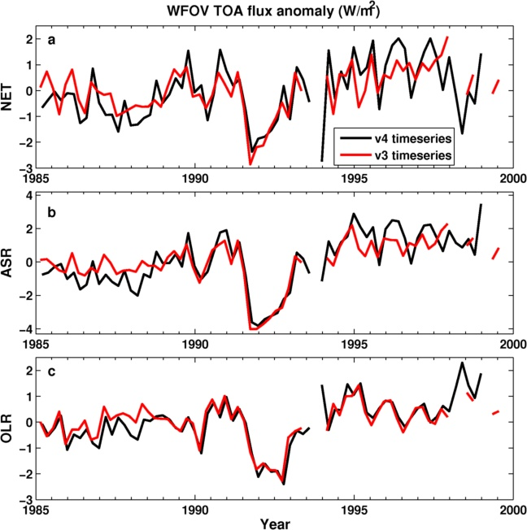

Figure S1. Anomaly time series of TOA radiative fluxes from WFOV v4 and v3 data sets.

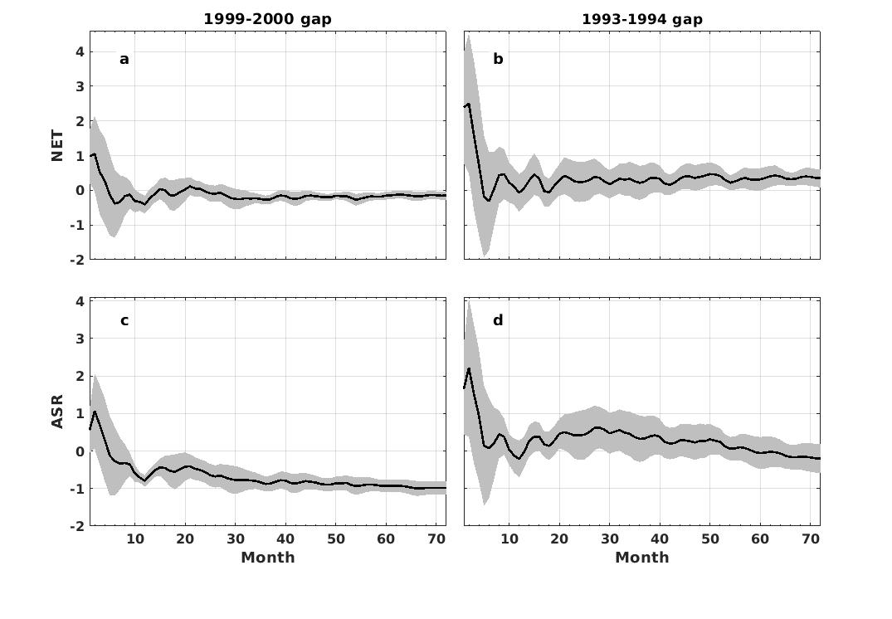

Figure S2. Adjustment of NET and ASR on both sides of 1993-1994 gap and 1999-2000 gap based on AMIP6 ensemble means. X-axis represents how many months are used for the average on both side of the gap. The shading area is the ensemble mean ± one standard deviation of the AMIP6 spread.

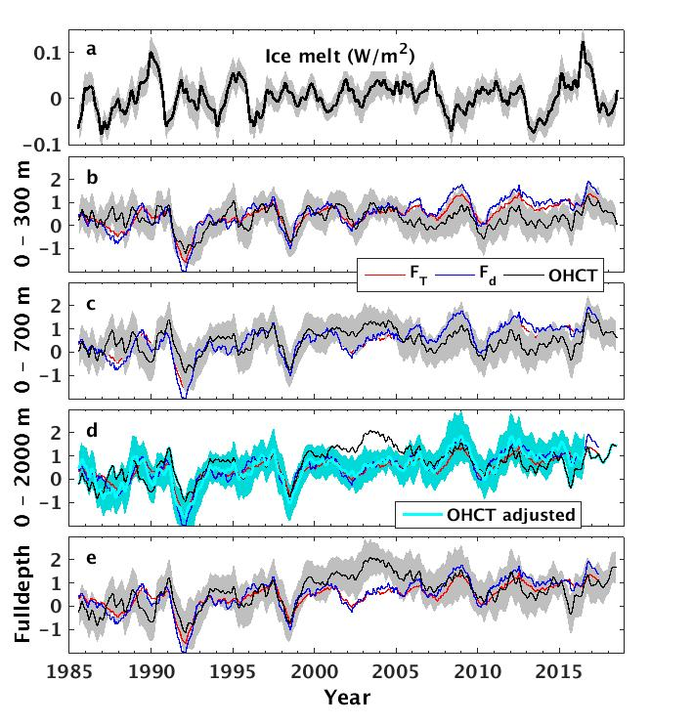

Figure S3. (a) Global mean time series of energy needed for sea ice melt. Solid black line is from five ensemble member mean of ORAS5, and the grey shading area is the mean ± one standard deviation. (b-e) are global mean OHCT for different depths, together with the net TOA radiative flux F_{T} and net ocean surface energy flux F_{d}. The shading area is the ensemble mean OHCT ± one standard deviation. The cyan line in (d) is the adjusted OHCT constrained to the corresponding annual mean of F_{d}. All lines are twelve month running mean.

Estimation of Uncertainty in Global Top of Atmosphere Radiation Reconstruction

- The spread (standard deviation) of three year mean difference between both sides of the gaps from the 10 AMIP6 simulations (Table S1) is 0.1194 Wm⁻² for 1999 gap and 0.5117 Wm⁻² for 1993 gap. The large effect associated with the 1993 gap adjustment is most likely to be explained by the different model simulations of radiative forcing and feedback responses associated with the Mount Pinatubo volcanic eruption.

- Considering the uncertainty over the CERES period (after 2000) is ±0.1 Wm⁻² (Johnson et al. 2016) at the 90% confidence level, the uncertainty over 1994-1999 can be estimated (approximating the 90% confidence range as 1.645 times the standard deviation):

$e_{94-99}=±\sqrt{{(1.645×0.1194)}^{2}+{0.1}^{2}}=±0.22$Wm⁻²

and the uncertainty over 1985-1993 can be estimated as

$e_{85-93}=±\sqrt{{e_{94-99}}^{2}+{(1.645×0.5117)}^{2}}=±0.87$Wm⁻²

- The uncertainty over 1985-1999 at the 90% confidence level can be estimated as a combination of each period weighted by number of years:

$e_{85-99}=(9×e_{85-93}+6×e_{94-99})/15=0.61$ Wm⁻²
- Since the uncertainty applying to the CERES period is systematic and applies to all periods in the same direction, the uncertainty associated with the change from 1985-1999 to after 2000 can be estimated as $\sqrt{{(0.61)}^{2}-{0.1}^{2}}=0.60$ Wm⁻². Therefore the increase of 0.52 Wm⁻² from the 1985-1999 to 2000-2016 period is about the same order of magnitude as the homogeneity uncertainty at the 90% confidence level so can only be considered more likely than not. However, there is high confidence that the imbalance is increasing when combining this information with independent evidence from ocean heat content data (see main text).

