Section S1: Determination of suitable concentrations for long-term exposure.
For both permethrin and coumarin 47, concentration-response lethality curves were established based on the semi-static Fish Embryo acute Toxicity (FET, OECD 236 guideline (OECD, 2013)) test in 96-well plate format (TPP, Switzerland), one egg per well with daily renewal of 50% of the medium. One biological replicate of the FET consisted of 16 zebrafish embryos per concentration exposed to a 5-point 1:2 serial dilution in reconstituted ISO water for embryo rearing. ISO water was prepared according to ISO 7346-2 (1996) (294 mg/L CaCl2∙2 H2O, 123.3 mg/L MgSO4∙7 H2O, 63 mg/L NaHCO3, 5.5 mg/L KCl). Endpoints to determine lethality, i.e., lack of somite, lack of heartbeat, lack of blood circulation and coagulation, were monitored every day from 24 to 96 hours post-fertilization (hpf). Lethal Concentration (LC) inducing 50% (LC₅₀) and 10% (LC₁₀) of lethality were calculated. As a continuation of the FET testing, larvae activity was recorded at the end of the 96 h exposure as described in the main manuscript method section. Water samples were taken at 0, 48, and 96 hours post fertilization (hpf) before medium renewal for chemical analysis. Statistical analyses were performed using Graphpad Prism 5 for FET data to calculate LC values, and using R (package stats v.3.6.1) for behavior data. For the latter, normal distribution of residuals and data homoscedasticity were verified before applying analysis of variance, 2 factors (treatment, light). This was followed by Dunn´s test to identify specific differences. A p-value < 0.05 was considered as a statistically significant difference.
Results from FET and larval behavior are presented in Figure S1 and S2. No effect on lethality was recorded for permethrin-exposed embryos and no effect on larval behavior was observed for coumarin-exposed individuals. Therefore, long-term exposure first included 100 µg/L (~Lowest Observed Adverse Effect Concentration) and 10 µg/L of permethrin, or 500 µg/L (~LC₁₀) and 50 µg/L of coumarin 47. However, after 10 to 12 days of exposure, high mortality rates were observed at 100 µg/L permethrin and 500-50 µg/L coumarin 47. Permethrin-exposed fish showed strong lordosis, tremors and swimming issues and coumarin 47-exposed fish exhibited disorientation and disability to swim and hold the balance in the water column. Finally, for both substances, embryos were exposed to 10 µg/L and 1 µg/L. Selected concentrations didn’t lead to any observable effect on fish survival or growth.
A
B
Figure S1: A. Concentration-response lethality curve after 24 h and 96 h of exposure of zebrafish embryos to coumarin 47 (n=5). LC₅₀ and LC₁₀ for coumarin 47 were of 1.4 mg/L and 0.7 mg/L at 24 hpf and remained stable until 96 hpf. B. Chemical analysis from water samples taken during FET test (n=3). All data are presented as mean±SD.

B
A
Figure S2: A. Average total distance travelled per larvae over 3 successive 5-min recording after 96 h exposure to permethrin (600 – 37.5 µg/L). Data are shown as mean±SEM (n=4). The two highest concentrations induced general hyperactivity. In addition, larvae were hyperactive in LOFF only when exposed to 150- 75 µg/L. No effect was reported at 37.5 µg/L. ***: p<0.001; ****: p<0.0001. B. Chemical analysis from water samples taken during FET test at day 0. Later on, permethrin was under limits of detection (0.03 µg/L) for most analyzed samples. Data are shown as mean±SD (n=3).

Section S2: Chemical analysis of coumarin 47 in water.
Coumarin 47 was analysed by liquid chromatography-high resolution mass spectrometry using a Thermo Ultimate 3000 LC system coupled to an ion trap-Orbitrap instrument (Thermo LTQ Orbitrap XL) with electrospray ionisation (ESI). LC separation was done on a Kinetex C18 EVO column (50 × 2.1 mm, 2.6 µm particle size, Phenomenex, pre-column 4x 2.1 mm and in-line filter 0.2 µm) using a gradient elution with 0.1% of formic acid (eluent A) and methanol containing 0.1% of formic acid (eluent B) at a flow rate of 300 µl/min. After 0.2 min of 20% B, the fraction of B was linearly increased to 100% within 4.8 min and 100% B were kept for 5 min. The eluent flow was diverted to waste and the column was rinsed for 2 min using a mixture of isopropanol + acetone (50:50) / eluent B / eluent A (85%/10%/5%) to remove hydrophobic matrix constituents from the column. Finally, the column was re-equilibrated to initial conditions for 4.0 min. The injection volume was 100 µL and the column was operated at 40°C. The heated ESI source and the transfer capillary were both operated at 300°C. The spray voltage was 3.8 kV, the sheath gas flow rate was 45 a.u. and the auxiliary gas flow rate 1 a.u. Samples were analysed in positive ion mode in full scan (80-500 m/z) at a nominal resolving power of 15,000 (referenced to m/z 400). Quantification of C47 and the two mains metabolites, didesethyl-C47 and desethyl-C47, was done using the [M+H]+ ion extracted in a 7 ppm m/z window by external matrix-matched calibration (0.05 to 20 µg/L prepared in ISO water + 0.01% DMSO) in the QuanBrower of XCalibur (Thermo). The method detection limit for C47 was 0.008 µg/L, those of the two transformation products were 0.02 µg/L. As the calibration was prepared matrix-matched in the exposure medium in the same way as the samples and no further sample preparation step resulting in compound losses was employed for the analysis, the recovery is 100%.

Section S3: Lipidomic analyses method
The UHPLC system used in this work was a 1290 Infinity system from Agilent Technologies (Santa Clara, USA). The system was equipped with a multi sampler (maintained at 10 °C), a quaternary solvent manager and a column thermostat (maintained at 50 °C). Separations were performed on an ACQUITY UPLC® BEH C18 column (2.1 mm × 100 mm, particle size 1.7 µm) by Waters. The mass spectrometer coupled to the UHPLC was a 6545 quadrupole time of flight (Q-TOF) from Agilent Technologies interfaced with a dual jet stream electrospray (dual ESI) ion source. All analyses were performed in positive ion mode and MassHunter B.06.01 (Agilent Technologies) was used for all data acquisition. MS data processing was performed using the open source software MZmine 2.34. The following steps were applied in the processing: 1) Mass detection with a noise level of 750 2) Chromatogram builder with a min time span of 0.08 min, min height of 1000 and a m/z tolerance of 0.006 m/z or 10.0 ppm, 3) Chromatogram deconvolution using the local minimum search algorithm with a 70% chromatographic threshold, 0.05 min minimum RT range, 5% minimum relative height, 1000 minimum absolute height, and a peak duration range of 0.08 - 2.0, 4) Isotopic peak grouper with a m/z tolerance of 5.0 ppm, RT tolerance of 0.05 min, maximum charge of 2 and with the most intense isotope set as the representative isotope, 5) Join aligner with a m/z tolerance of 0.006 009 or 10.0 ppm and a weight for of 2, a RT tolerance of 0.1 min and a weight of 1 and with no requirement of charge state or ID and no comparison of isotope pattern, 6) Peak list row filter with a minimum of 10% of the sample), 7) Gap filling using the same RT and m/z range gap filler algorithm with an m/z tolerance of 0.006 009 m/z or 1011.0 ppm, 7) Identification of lipids using a custom database search with an m/z tolerance of 0.006 009 m/z or 10.0 ppm and a RT tolerance of 0.1 min, 8) Normalization using ISTDs for identified lipids and closest ISTD for unknown lipids. Concentrations were calculated using lipid-class specific calibration curves. Quality control was performed throughout the dataset by including blanks, pure standard samples, extracted standard samples and control plasma samples. %RSD (raw variation) for lipid concentrations in the pooled samples (n = 13) was on average 36% and in control plasma samples (n = 7) 15%. A detailed list of individual feature concentrations obtained per sample is available in Appendix B.

A
B
C
Figure S3: Measured water concentration of A. permethrin (high (PH) and low (PL)) (n=1), B. coumarin 47 high (CH), C. coumarin 47 low (CL) (n=2). PL: Permethrin 1 µg/L; PH: Permethrin 10 µg/L; C47: Coumarin 47; SC: Solvent Control.
Section S4: MANOVA results on morphologic parameters (body length and weight) of zebrafish. The analysis included 3 factors (treatment, generation, sex). Due to the main sex effect, ANOVA 2 factors were further performed on sex-specific datasets male (A) and female (B) followed by post-hoc analysis when applicable.

Df Pillai approx F num Df den Df Pr(>F)
treatment 4 0.11255 4.696 8 630 1.327e-05 ***
generation 2 0.40962 40.565 4 630 < 2.2e-16 ***
sex 1 0.12179 21.773 2 314 1.396e-09 ***
treatment:generation 8 0.16403 3.518 16 630 4.289e-06 ***
treatment:sex 4 0.04257 1.713 8 630 0.09223 .
generation:sex 2 0.01090 0.863 4 630 0.48600
treatment:generation:sex 8 0.07247 1.480 16 630 0.10077
Residuals 315
---
Signif. codes: 0 ‘***’ 0.001 ‘**’ 0.01 ‘*’ 0.05 ‘.’ 0.1 ‘ ’ 1

A.
Response length :
Df Sum Sq Mean Sq F value Pr(>F)
treatment 4 10.93 2.733 1.2614 0.287586
generation 2 163.27 81.633 37.6717 4.484e-14 ***
treatment:generation 8 47.86 5.983 2.7609 0.007021 **
Residuals 156 338.04 2.167
---
Signif. codes: 0 ‘***’ 0.001 ‘**’ 0.01 ‘*’ 0.05 ‘.’ 0.1 ‘ ’ 1

Response weight :
Df Sum Sq Mean Sq F value Pr(>F)
treatment 4 0.044807 0.011202 7.6597 1.163e-05 ***
generation 2 0.180293 0.090146 61.6412 < 2.2e-16 ***
treatment:generation 8 0.044328 0.005541 3.7889 0.0004339 ***
Residuals 156 0.228140 0.001462
---
Signif. codes: 0 ‘***’ 0.001 ‘**’ 0.01 ‘*’ 0.05 ‘.’ 0.1 ‘ ’ 1

Post-hoc analysis revealed a significant effect in the F2 generation:

contrast estimate SE df t.ratio p.value
CH,F0 - SC,F0 -0.00750 0.0141 156 -0.531 1.0000
CL,F0 - SC,F0 0.00168 0.0141 156 0.119 1.0000
PH,F0 - SC,F0 0.00359 0.0141 156 0.254 1.0000
PL,F0 - SC,F0 -0.04089 0.0146 156 -2.804 0.2561
CH,F1 - SC,F1 -0.04216 0.0152 156 -2.767 0.2761
CL,F1 - SC,F1 0.01599 0.0147 156 1.088 0.9989
PH,F1 - SC,F1 0.04279 0.0147 156 2.912 0.2027
PL,F1 - SC,F1 0.00789 0.0147 156 0.537 1.0000
CH,F2 - SC,F2 -0.00509 0.0158 156 -0.321 1.0000
CL,F2 - SC,F2 0.07434 0.0169 156 4.386 0.0019
PH,F2 - SC,F2 0.01501 0.0158 156 0.948 0.9998
PL,F2 - SC,F2 -0.01629 0.0217 156 -0.751 1.0000

B.

Df Pillai approx F num Df den Df Pr(>F)
treatment 4 0.12470 2.6432 8 318 0.0080963 **
generation 2 0.37769 18.5085 4 318 1.094e-13 ***
treatment:generation 8 0.24363 2.7569 16 318 0.0003681 ***
Residuals 159
---
Signif. codes: 0 ‘***’ 0.001 ‘**’ 0.01 ‘*’ 0.05 ‘.’ 0.1 ‘ ’ 1

Response length :
Df Sum Sq Mean Sq F value Pr(>F)
treatment 4 18.89 4.723 1.7780 0.135835
generation 2 195.24 97.618 36.7492 7.598e-14 ***
treatment:generation 8 71.63 8.954 3.3706 0.001346 **
Residuals 159 422.36 2.656
---
Signif. codes: 0 ‘***’ 0.001 ‘**’ 0.01 ‘*’ 0.05 ‘.’ 0.1 ‘ ’ 1

Response weight :
Df Sum Sq Mean Sq F value Pr(>F)
treatment 4 0.03409 0.008523 3.8471 0.0051805 **
generation 2 0.14589 0.072943 32.9255 1.085e-12 ***
treatment:generation 8 0.07160 0.008950 4.0399 0.0002144 ***
Residuals 159 0.35225 0.002215
---
Signif. codes: 0 ‘***’ 0.001 ‘**’ 0.01 ‘*’ 0.05 ‘.’ 0.1 ‘ ’ 1

Post-hoc analyses revealed significant changes in the F2 generation on both length (a) and weight (b):

(a)
contrast estimate SE df t.ratio p.value
CH,F0 - SC,F0 -1.1818 0.601 160 -1.967 0.8141
CL,F0 - SC,F0 -1.0909 0.601 160 -1.816 0.8883
PH,F0 - SC,F0 0.0000 0.601 160 0.000 1.0000
PL,F0 - SC,F0 -1.0909 0.601 160 -1.816 0.8883
CH,F1 - SC,F1 -1.2273 0.644 160 -1.907 0.8464
CL,F1 - SC,F1 -0.0273 0.620 160 -0.044 1.0000
PH,F1 - SC,F1 -0.6273 0.620 160 -1.011 0.9995
PL,F1 - SC,F1 0.2273 0.601 160 0.378 1.0000
CH,F2 - SC,F2 0.8000 0.664 160 1.205 0.9968
CL,F2 - SC,F2 2.6250 0.712 160 3.686 0.0236
PH,F2 - SC,F2 2.0000 0.664 160 3.011 0.1607
PL,F2 - SC,F2 -0.5000 0.915 160 -0.546 1.0000

(b)
CH,F0 - SC,F0 -0.03073 0.0174 159 -1.768 0.9072
CL,F0 - SC,F0 -0.03945 0.0174 159 -2.270 0.6140
PH,F0 - SC,F0 0.04073 0.0174 159 2.343 0.5603
PL,F0 - SC,F0 -0.01464 0.0174 159 -0.842 0.9999
CH,F1 - SC,F1 -0.01139 0.0186 159 -0.612 1.0000
CL,F1 - SC,F1 -0.01560 0.0180 159 -0.869 0.9999
PH,F1 - SC,F1 0.00010 0.0180 159 0.006 1.0000
PL,F1 - SC,F1 0.01477 0.0174 159 0.850 0.9999
CH,F2 - SC,F2 0.00406 0.0195 159 0.208 1.0000
CL,F2 - SC,F2 0.08423 0.0209 159 4.038 0.0071
PH,F2 - SC,F2 0.05816 0.0195 159 2.984 0.1715
PL,F2 - SC,F2 -0.00914 0.0267 159 -0.343 1.0000

B
A
Figure S4: Length (A) and weight (B) of 4-month zebrafish (F0) after exposure to permethrin or coumarin 47 at two different dosages. Data are shown as mean±SD. PL: Permethrin 1 µg/L; PH: Permethrin 10 µg/L; CL: Coumarin 47 1 µg/L; CH: Coumarin 47 10 µg/L; SC: Solvent Control.
B
A
Figure S5: Length (A) and weight (B) of 4-month F1 zebrafish in the different permethrin and coumarin 47 groups compared to the solvent group. Data are shown as mean±SD. *: p<0.05. PL: 1 µg/L Permethrin; PH: 10 µg/L Permethrin; CL: 1 µg/L Coumarin 47; CH: 10 µg/L Coumarin 47; SC: Solvent Control (DMSO 0.01%).
B
A
Figure S6: Length (A) and weight (B) of 4-month F2 zebrafish in the different permethrin and coumarin 47 groups compared to the solvent group. Data are shown as mean±SD. **: p<0.01; ***: p<0.001; ****: p<0.0001. PL: 1 µg/L Permethrin; PH: 10 µg/L Permethrin; CL: 1 µg/L Coumarin 47; CH: 10 µg/L Coumarin 47; SC: Solvent Control (DMSO 0.01%).
Section S5: ANOVA results on the number of eggs spawned per zebrafish female. The analysis included 2 factors (treatment, generation) followed by post-hoc analysis.

Analysis of Variance Table

Response: score
Df Sum Sq Mean Sq F value Pr(>F)
treatment 4 100052 25013 1.4642 0.2115
generation 2 1876882 938441 54.9333 < 2.2e-16 ***
treatment:generation 8 567947 70993 4.1557 7.338e-05 ***
Residuals 655 11189553 17083
---
Signif. codes: 0 ‘***’ 0.001 ‘**’ 0.01 ‘*’ 0.05 ‘.’ 0.1 ‘ ’ 1

Further analysis revealed significant differences in the F0 generation only:

contrast estimate SE df t.ratio p.value
CH,F0 - SC,F0 -4.774 31.6 655 -0.151 1.0000
CL,F0 - SC,F0 43.006 32.7 655 1.313 0.9931
PH,F0 - SC,F0 39.197 27.9 655 1.407 0.9866
PL,F0 - SC,F0 -115.751 28.2 655 -4.111 0.0040
CH,F1 - SC,F1 10.654 25.2 655 0.423 1.0000
CL,F1 - SC,F1 -52.634 25.4 655 -2.072 0.7533
PH,F1 - SC,F1 -6.143 23.9 655 -0.257 1.0000
PL,F1 - SC,F1 -2.667 23.4 655 -0.114 1.0000
CH,F2 - SC,F2 20.827 27.0 655 0.772 1.0000
CL,F2 - SC,F2 11.436 28.7 655 0.399 1.0000
PH,F2 - SC,F2 32.768 24.5 655 1.338 0.9917
PL,F2 - SC,F2 42.010 25.0 655 1.681 0.9383

Figure S7: Average number of eggs spawned per female zebrafish per spawn in the different treatments across generations. PH: Permethrin 10 µg/L; CL: Coumarin 47 1 µg/L; CH: Coumarin 47 10 µg/L; SC: Solvent Control.

Section S6: ANOVA results from larval photomotor response (LPMR) data. The analysis included 3 factors, with interactions: treatment (Control, Treated), light (LON 1, LOFF, LON 2) and generation (F0, F1, F2, F3). A: Permethrin 10 µg/L, B: Permethrin 1 µg/L, C: Coumarin 47 10 µg/L, D: Coumarin 47 1 µg/L. Analyses were performed separately on each treatment due to experimental independence. Due to main effect from the generation in all of the datasets, further analyses were performed on generation-specific data followed by post-hoc analysis when applicable.
A: Treatment Permethrin 10 µg/L.
Analysis of Variance Table

Response: score
Df Sum Sq Mean Sq F value Pr(>F)
treatment 1 20107 20107 95.8456 < 2.2e-16 ***
light 2 834454 417227 1988.7881 < 2.2e-16 ***
generation 3 314067 104689 499.0199 < 2.2e-16 ***
treatment:light 2 1182 591 2.8169 0.059847 .
treatment:generation 3 16818 5606 26.7213 < 2.2e-16 ***
light:generation 6 38330 6388 30.4510 < 2.2e-16 ***
treatment:light:generation 6 5183 864 4.1174 0.000392 ***
Residuals 9018 1891882 210
---
Signif. codes: 0 ‘***’ 0.001 ‘**’ 0.01 ‘*’ 0.05 ‘.’ 0.1 ‘ ’ 1

Further analysis showed significant effects in the F1 and F2 generation:
Summary statistics F1
contrast estimate SE df t.ratio p.value
SC,LOFF - X,LOFF 1.52 0.907 3357 1.676 0.5479
SC,LON 1 - X,LON 1 6.62 0.871 3357 7.599 <.0001
SC,LON 2 - X,LON 2 2.88 0.805 3357 3.583 0.0046

Summary statistics F2
contrast estimate SE df t.ratio p.value
SC,LOFF - X,LOFF 8.63 1.03 2070 8.409 <.0001
SC,LON 1 - X,LON 1 6.72 1.03 2070 6.548 <.0001
SC,LON 2 - X,LON 2 5.98 1.03 2070 5.827 <.0001

B: Treatment with Permethrin 1 µg/L
Analysis of Variance Table

Response: score
Df Sum Sq Mean Sq F value Pr(>F)
treatment 1 472 472 2.3869 0.1224
light 2 631180 315590 1595.8701 < 2.2e-16 ***
generation 3 42513 14171 71.6590 < 2.2e-16 ***
treatment:light 2 14297 7149 36.1488 2.365e-16 ***
treatment:generation 3 19268 6423 32.4778 < 2.2e-16 ***
light:generation 6 8790 1465 7.4080 6.352e-08 ***
treatment:light:generation 6 10229 1705 8.6213 2.277e-09 ***
Residuals 7719 1526464 198
---
Signif. codes: 0 ‘***’ 0.001 ‘**’ 0.01 ‘*’ 0.05 ‘.’ 0.1 ‘ ’ 1
Further analysis showed significant effects in the F1, F2 and F3 generations:
Summary statistics F1
contrast estimate SE df t.ratio p.value
SC,LOFF - X,LOFF 5.1020 0.954 2316 5.347 <.0001
SC,LON 1 - X,LON 1 5.5708 0.954 2316 5.839 <.0001
SC,LON 2 - X,LON 2 3.2998 0.954 2316 3.459 0.0073

Summary statistics F2
contrast estimate SE df t.ratio p.value
SC,LOFF - X,LOFF 7.54 1.19 1737 6.345 <.0001
SC,LON 1 - X,LON 1 -2.79 1.19 1737 -2.349 0.1752
SC,LON 2 - X,LON 2 -1.35 1.19 1737 -1.137 0.8658

Summary statistics F3
contrast estimate SE df t.ratio p.value
SC,LOFF - X,LOFF 3.683 1.17 2295 3.157 0.0201
SC,LON 1 - X,LON 1 -8.070 1.17 2295 -6.917 <.0001
SC,LON 2 - X,LON 2 -5.134 1.17 2295 -4.401 0.0002

C: Treatment Coumarin 47 10 µg/L
Analysis of Variance Table

Response: score
Df Sum Sq Mean Sq F value Pr(>F)
treatment 1 2836 2836 10.4402 0.0012394 **
light 2 684264 342132 1259.4255 < 2.2e-16 ***
generation 3 89440 29813 109.7458 < 2.2e-16 ***
treatment:light 2 2205 1102 4.0584 0.0173220 *
treatment:generation 3 1068 356 1.3105 0.2690575
light:generation 6 6893 1149 4.2292 0.0002963 ***
treatment:light:generation 6 6618 1103 4.0602 0.0004557 ***
Residuals 6270 1703291 272
---
Signif. codes: 0 ‘***’ 0.001 ‘**’ 0.01 ‘*’ 0.05 ‘.’ 0.1 ‘ ’ 1

Further analysis showed significant effects in the F3 generation:
contrast estimate SE df t.ratio p.value
SC,LOFF - X,LOFF 0.01777 0.00787 2154 2.258 0.2120
SC,LON 1 - X,LON 1 -0.03622 0.00787 2154 -4.602 0.0001
SC,LON 2 - X,LON 2 -0.01570 0.00787 2154 -1.995 0.3452

D: Treatment Coumarin 47 1 µg/L
Analysis of Variance Table

Response: score
Df Sum Sq Mean Sq F value Pr(>F)
treatment 1 11219 11219 45.9547 1.335e-11 ***
light 2 612946 306473 1255.3397 < 2.2e-16 ***
generation 3 130345 43448 177.9686 < 2.2e-16 ***
treatment:light 2 1004 502 2.0570 0.1279
treatment:generation 3 12311 4104 16.8087 7.228e-11 ***
light:generation 6 13089 2182 8.9357 9.848e-10 ***
treatment:light:generation 6 1685 281 1.1505 0.3301
Residuals 5583 1363008 244
---
Signif. codes: 0 ‘***’ 0.001 ‘**’ 0.01 ‘*’ 0.05 ‘.’ 0.1 ‘ ’ 1

Further analysis showed effects in the F3 generation:
contrast estimate SE df t.ratio p.value
SC,LOFF - X,LOFF -7.13 1.06 2583 -6.720 <.0001
SC,LON 1 - X,LON 1 -7.12 1.06 2583 -6.714 <.0001
SC,LON 2 - X,LON 2 -3.23 1.06 2583 -3.045 0.0284

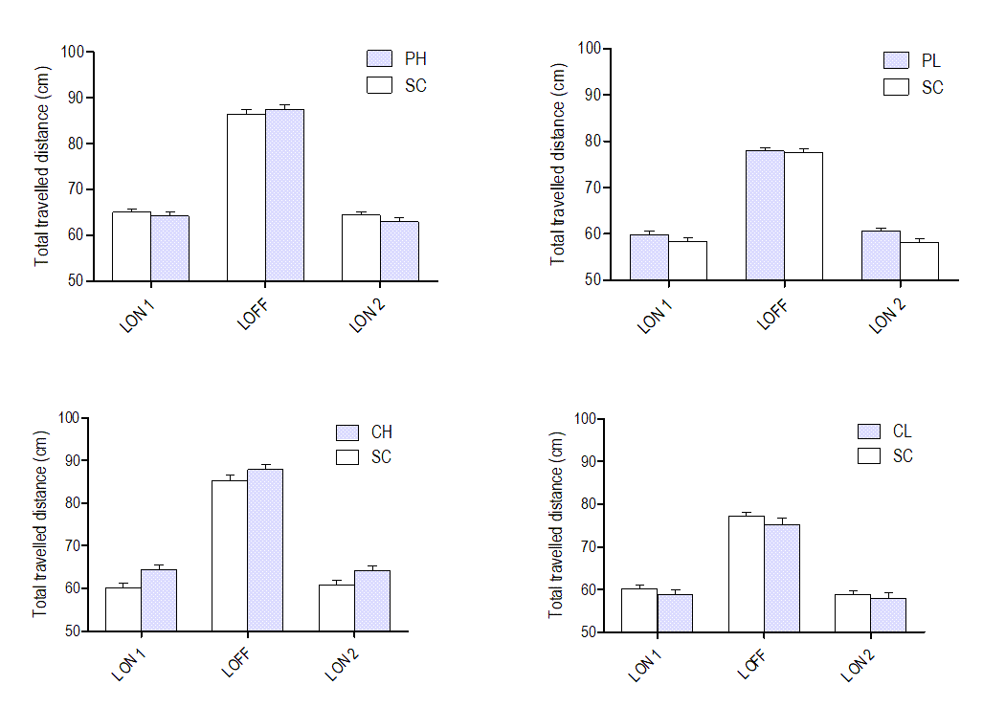Figure S8: Average total distance travelled per larvae over 3 successive periods of 5-min recording in permethrin (A) and coumarin (B) lineages from the F0 generation. Data are shown as mean±SEM. PH: 10 µg/L Permethrin; PL: 1 µg/L Permethrin; CH: 10 µg/L Coumarin 47; CL: 1 µg/L Coumarin 47; SC: Solvent Control (DMSO 0.01%).

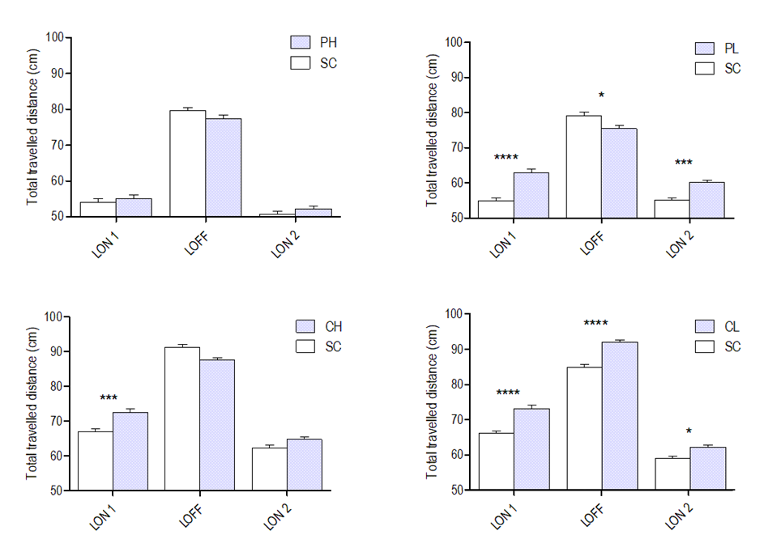
Figure S9: Average total distance travelled per F3 larvae over 3 successive periods of 5-min recording in permethrin (A) and coumarin (B) lineages. Data are shown as mean±SEM. *: p<0.05; ****: p<0.0001. PH: 10 µg/L Permethrin; PL: 1 µg/L Permethrin; CH: 10 µg/L Coumarin 47; CL: 1 µg/L Coumarin 47; SC: Solvent Control (DMSO 0.01%).
Section S7: ANOVA results from lipidomic data, focusing on lysoPC concentration. The analysis included 3 factors, with interactions: treatment (SC, PH, PL), generation (F0, F1, F2) and sex (M, F). PH: Permethrin 10 µg/L, PL: Permethrin 1 µg/L. Analyses were performed separately on each organ due to different concentration normalization. A: Brain, B: Liver, C: Gonads. Due to a main effect on the sex, further analysis was performed on sex-specific datasets followed by post-hoc analysis when applicable.
A.
Analysis of Variance Table

Response: score
Df Sum Sq Mean Sq F value Pr(>F)
treatment 2 3.0474 1.5237 5.7456 0.004332 **
generation 2 19.5340 9.7670 36.8301 9.715e-13 ***
sex 1 2.3274 2.3274 8.7763 0.003805 **
treatment:generation 4 3.0337 0.7584 2.8599 0.027217 *
treatment:sex 2 0.0596 0.0298 0.1123 0.893855
generation:sex 2 1.6742 0.8371 3.1566 0.046799 *
treatment:generation:sex 4 2.3313 0.5828 2.1978 0.074528 .
Residuals 101 26.7843 0.2652
---
Signif. codes: 0 ‘***’ 0.001 ‘**’ 0.01 ‘*’ 0.05 ‘.’ 0.1 ‘ ’ 1

Further analysis revealed no significant effect.
B.
Analysis of Variance Table

Response: score
Df Sum Sq Mean Sq F value Pr(>F)
treatment 2 1.6010 0.80051 6.3652 0.0024831 **
generation 2 0.3212 0.16058 1.2768 0.2833357
sex 1 0.5138 0.51384 4.0858 0.0458643 *
treatment:generation 4 2.6701 0.66753 5.3078 0.0006346 ***
treatment:sex 2 0.7549 0.37747 3.0015 0.0541240 .
generation:sex 2 0.5384 0.26919 2.1405 0.1228506
treatment:generation:sex 4 0.6722 0.16804 1.3362 0.2616420
Residuals 102 12.8278 0.12576
---
Signif. codes: 0 ‘***’ 0.001 ‘**’ 0.01 ‘*’ 0.05 ‘.’ 0.1 ‘ ’ 1

Further analysis revealed significant effects in the F2 generation in males (a) and females (b):
(a)

Analysis of Variance Table

Response: score
Df Sum Sq Mean Sq F value Pr(>F)
treatment 2 0.8681 0.43404 3.6500 0.03329 *
generation 2 0.0897 0.04485 0.3772 0.68776
treatment:generation 4 1.7556 0.43890 3.6909 0.01052 *
Residuals 49 5.8268 0.11891
---
Signif. codes: 0 ‘***’ 0.001 ‘**’ 0.01 ‘*’ 0.05 ‘.’ 0.1 ‘ ’ 1

contrast estimate SE df t.ratio p.value
PH,F0 - SC,F0 -0.04260 0.178 49 -0.239 1.0000
PL,F0 - SC,F0 0.03896 0.178 49 0.219 1.0000
PH,F1 - SC,F1 -0.26146 0.186 49 -1.406 0.8902
PL,F1 - SC,F1 -0.10759 0.186 49 -0.578 0.9996
PH,F2 - SC,F2 -0.09164 0.216 49 -0.424 1.0000
PL,F2 - SC,F2 0.86147 0.216 49 3.986 0.0064

(b)

Analysis of Variance Table

Response: score
Df Sum Sq Mean Sq F value Pr(>F)
treatment 2 1.6715 0.83576 6.3270 0.003435 **
generation 2 0.5740 0.28702 2.1729 0.123890
treatment:generation 4 1.5746 0.39366 2.9802 0.027133 *
Residuals 53 7.0010 0.13209
---
Signif. codes: 0 ‘***’ 0.001 ‘**’ 0.01 ‘*’ 0.05 ‘.’ 0.1 ‘ ’ 1

contrast estimate SE df t.ratio p.value
PH,F0 - PL,F0 -0.1562 0.210 53 -0.745 0.9978
PH,F0 - SC,F0 -0.2378 0.188 53 -1.267 0.9364
PL,F0 - SC,F0 -0.0815 0.188 53 -0.434 1.0000
PH,F1 - SC,F1 -0.1691 0.193 53 -0.874 0.9935
PL,F1 - SC,F1 -0.4438 0.182 53 -2.442 0.2837
PH,F2 - SC,F2 -0.7628 0.203 53 -3.763 0.0116
PL,F2 - SC,F2 0.0842 0.242 53 0.347 1.000

C.
Analysis of Variance Table

Response: score
Df Sum Sq Mean Sq F value Pr(>F)
treatment 2 2.766 1.383 5.9468 0.0036869 **
generation 2 1.090 0.545 2.3446 0.1014126
sex 1 41.698 41.698 179.3321 < 2.2e-16 ***
treatment:generation 4 4.953 1.238 5.3259 0.0006502 ***
treatment:sex 2 0.560 0.280 1.2048 0.3042926
generation:sex 2 0.852 0.426 1.8313 0.1658105
treatment:generation:sex 4 0.396 0.099 0.4258 0.7896865
Residuals 95 22.089 0.233
---
Signif. codes: 0 ‘***’ 0.001 ‘**’ 0.01 ‘*’ 0.05 ‘.’ 0.1 ‘ ’ 1

Further analyses revealed no significant effect.
Table S1: descriptive information on samples included in correlation analyses based on lipidomic data. The worksheet document includes normalized concentrations of lipid groups in nmol/g fish, or nmol/g protein for livers. See excel file.

