Supplementary Materials

Fig. S1. Change in Global Net Primary Production
Fig. S2. Absolute change in NPP across all model experiments
Fig. S3. Impact of Climate change on NPP anomalies for all model experiments
Fig S4. Modelled and observed dissolved iron.
Fig S5. Modelled phytoplankton iron quotas in the Pacific Equatorial Divergence province for all experiments.

Figure S1. Change in Global Net Primary Production. All model experiments (red lines) global NPP in (a) Pg C yr⁻¹ and (b) normalised to 1850-1900. In both panels, previous CMIP5 experiments are in grey lines, showing much larger variability than our experiments..

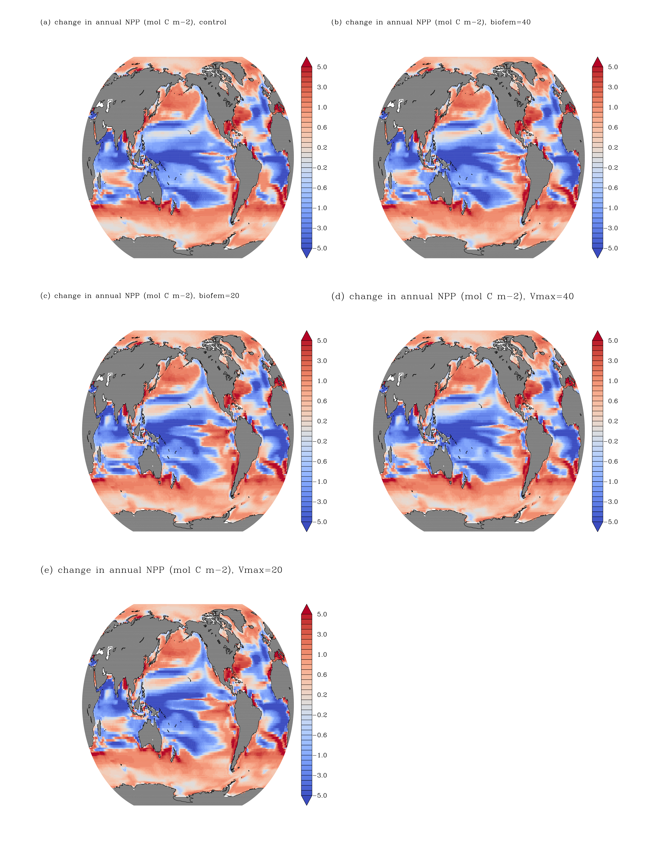Figure S2. Absolute change in NPP across all model experiments. Changes are calculated for the period 2091 to 2100, relative to the period 1986 to 2005. Colour bar is identical to Figure 1A.
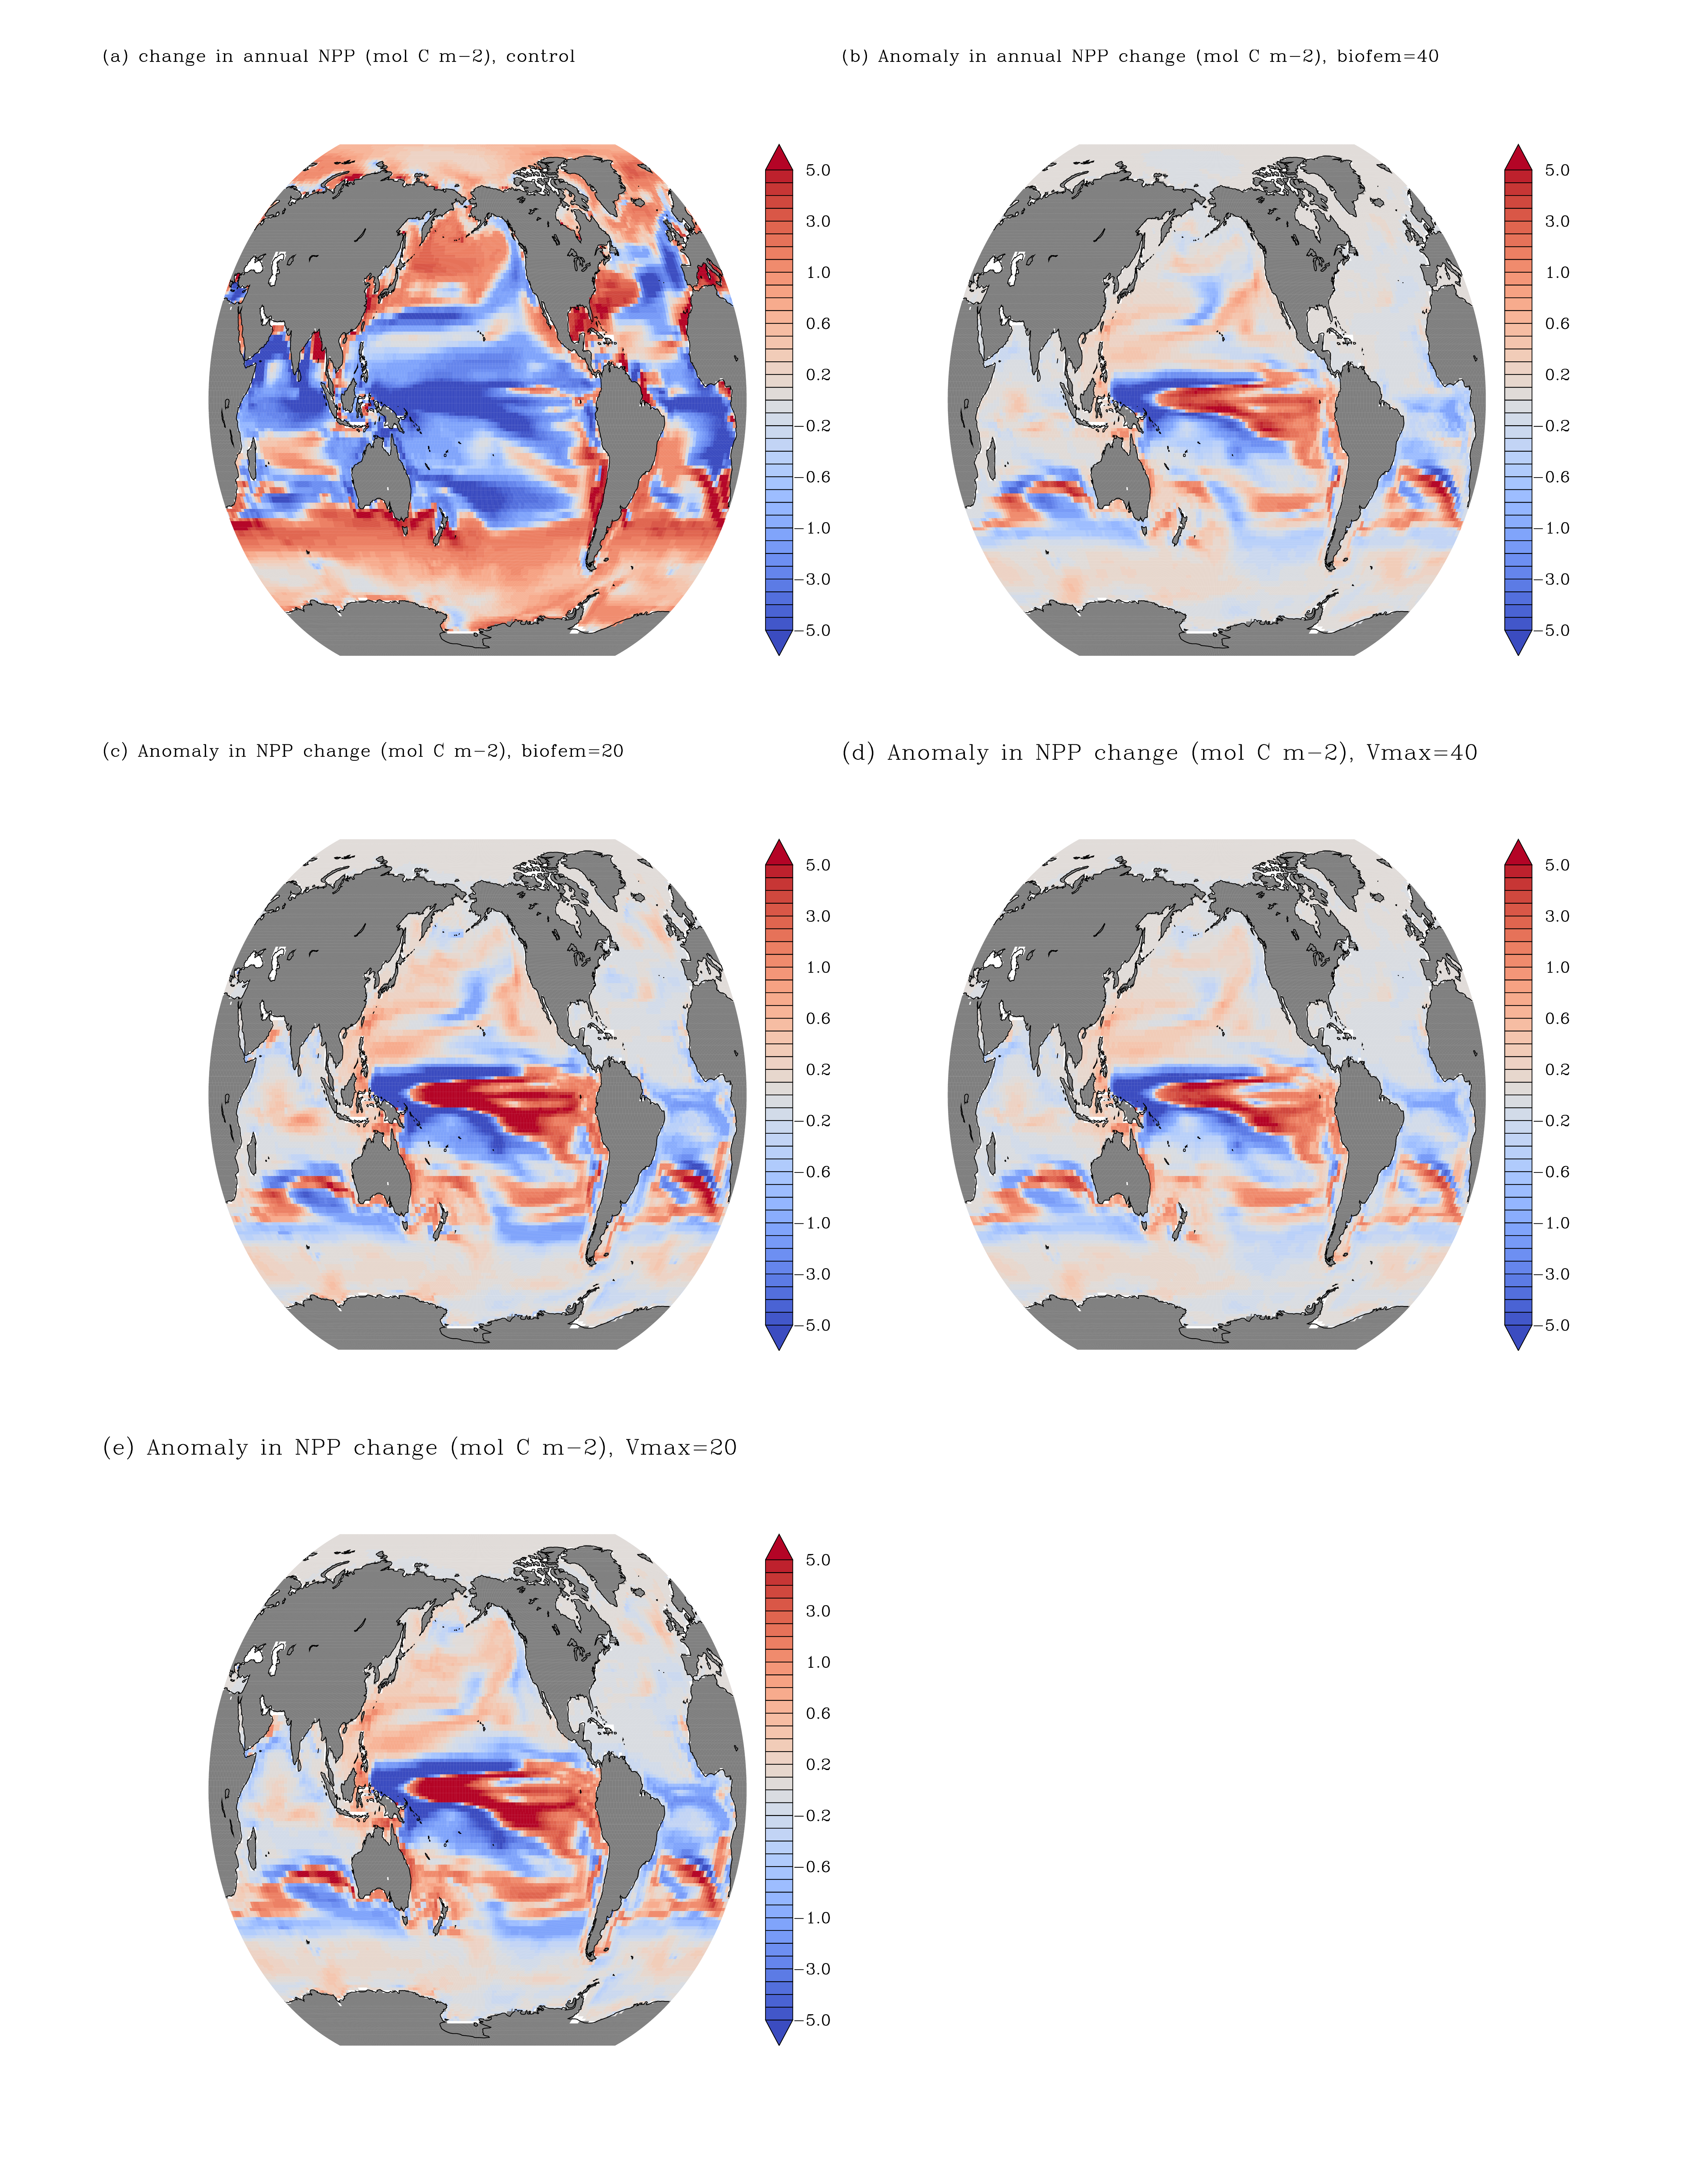
Figure S3. Impact of Climate change on NPP anomalies for all model experiments. (a) Impact of climate change on NPP in the control simulation, anomaly in the impact of climate change on NPP when Bio_{FeMax} is (b) 40, (c) 20, and when (d) V_{max} = 40 and (e) V_{max} =20. Changes are calculated for the period 2091 to 2100, relative to the period 1986 to 2005. Colour bar is identical to Figure 1A.
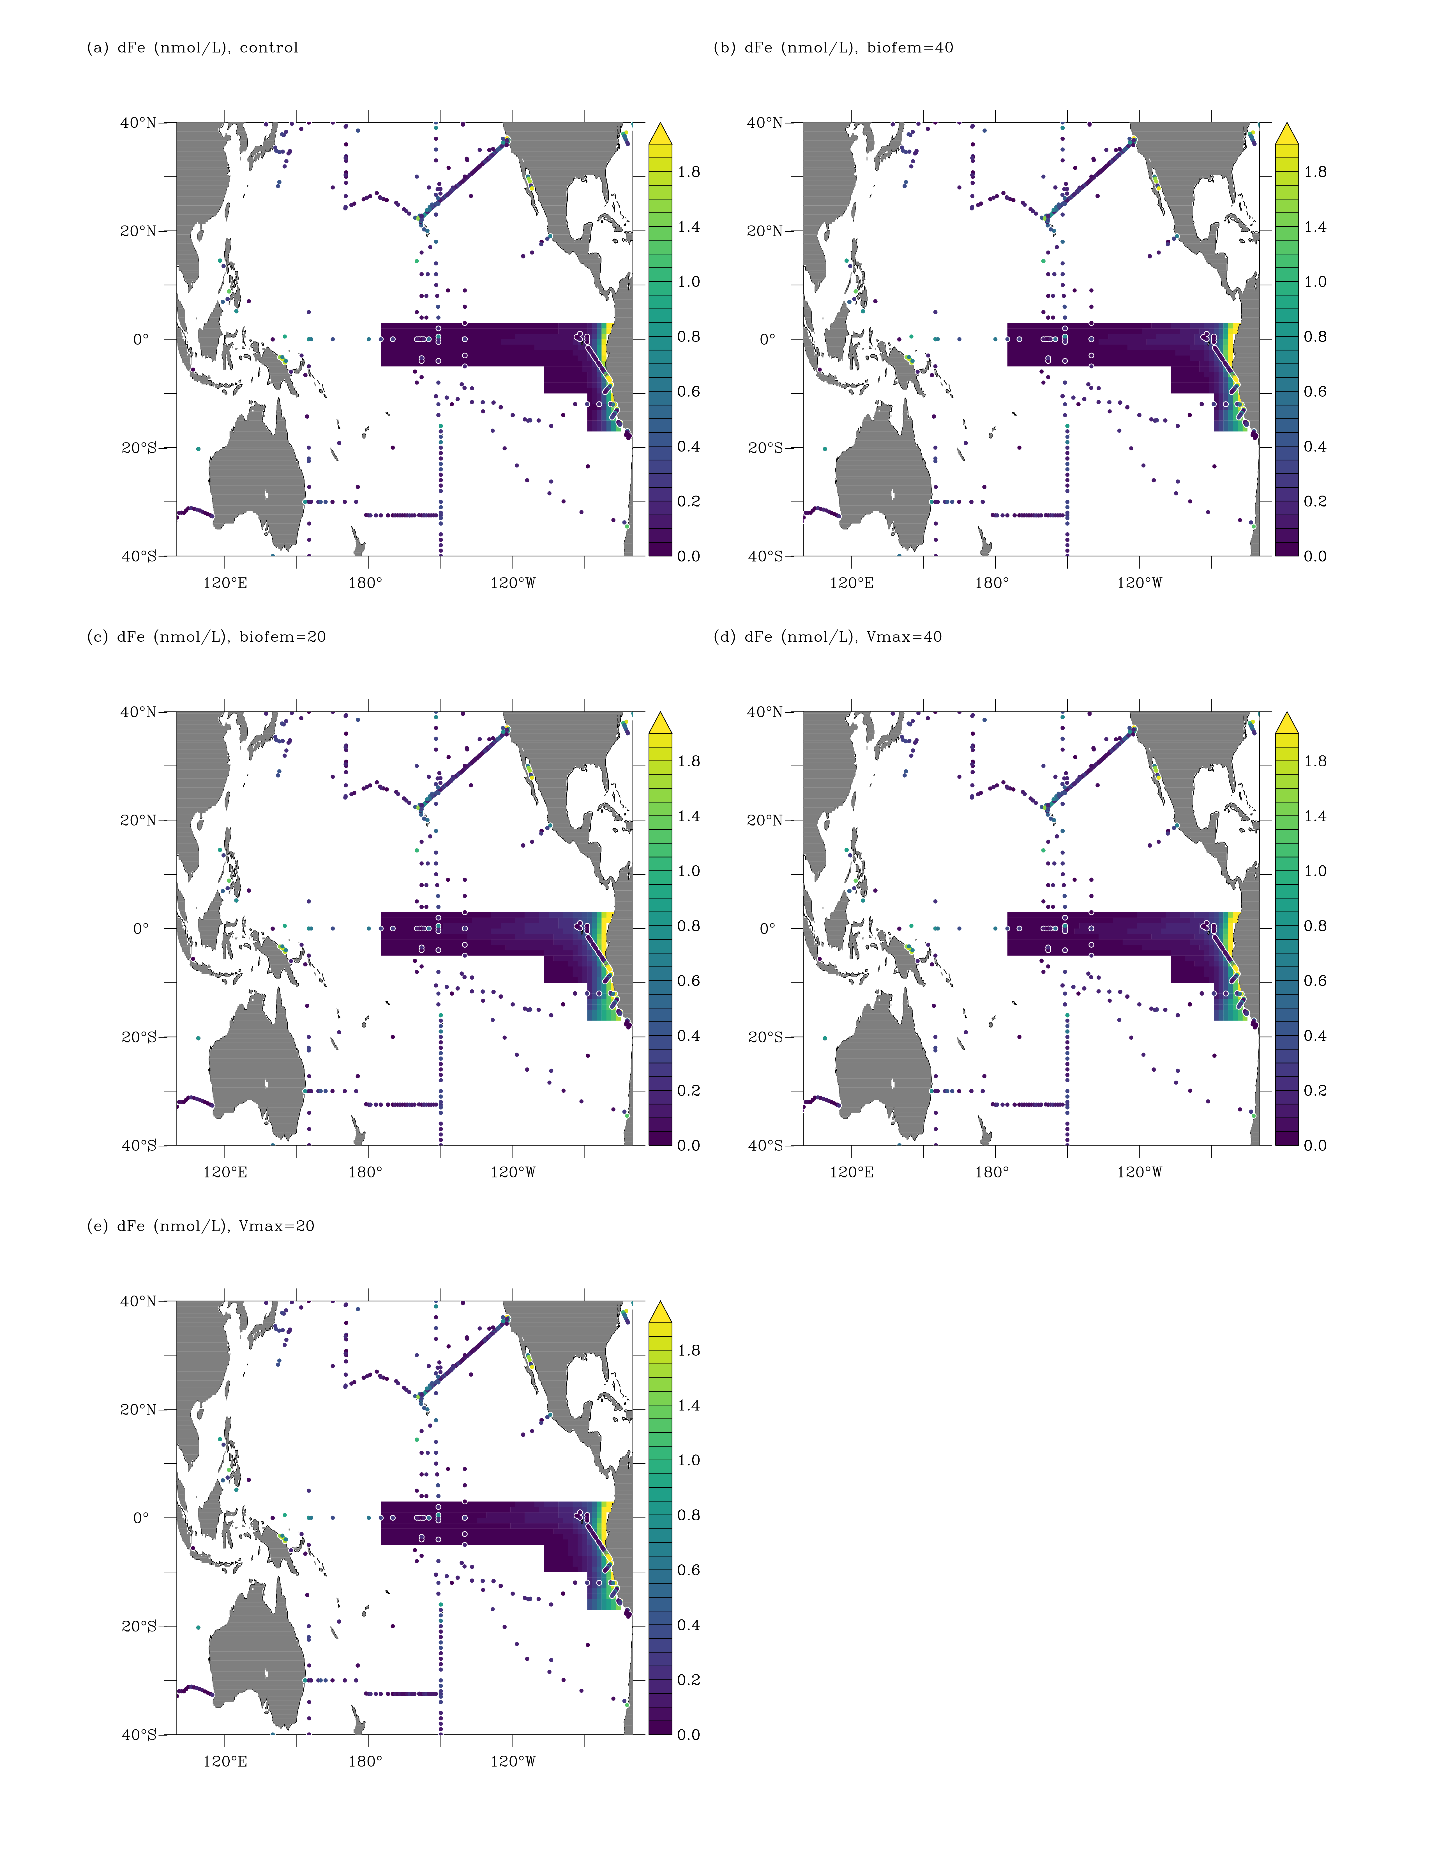Figure S4. Modelled and observed dissolved iron. Dissolved iron concentrations (nmol L⁻¹) in the upper 50m across the models, compared to data. Model output shows annually averaged data within the Pacific Equatorial Divergence province.

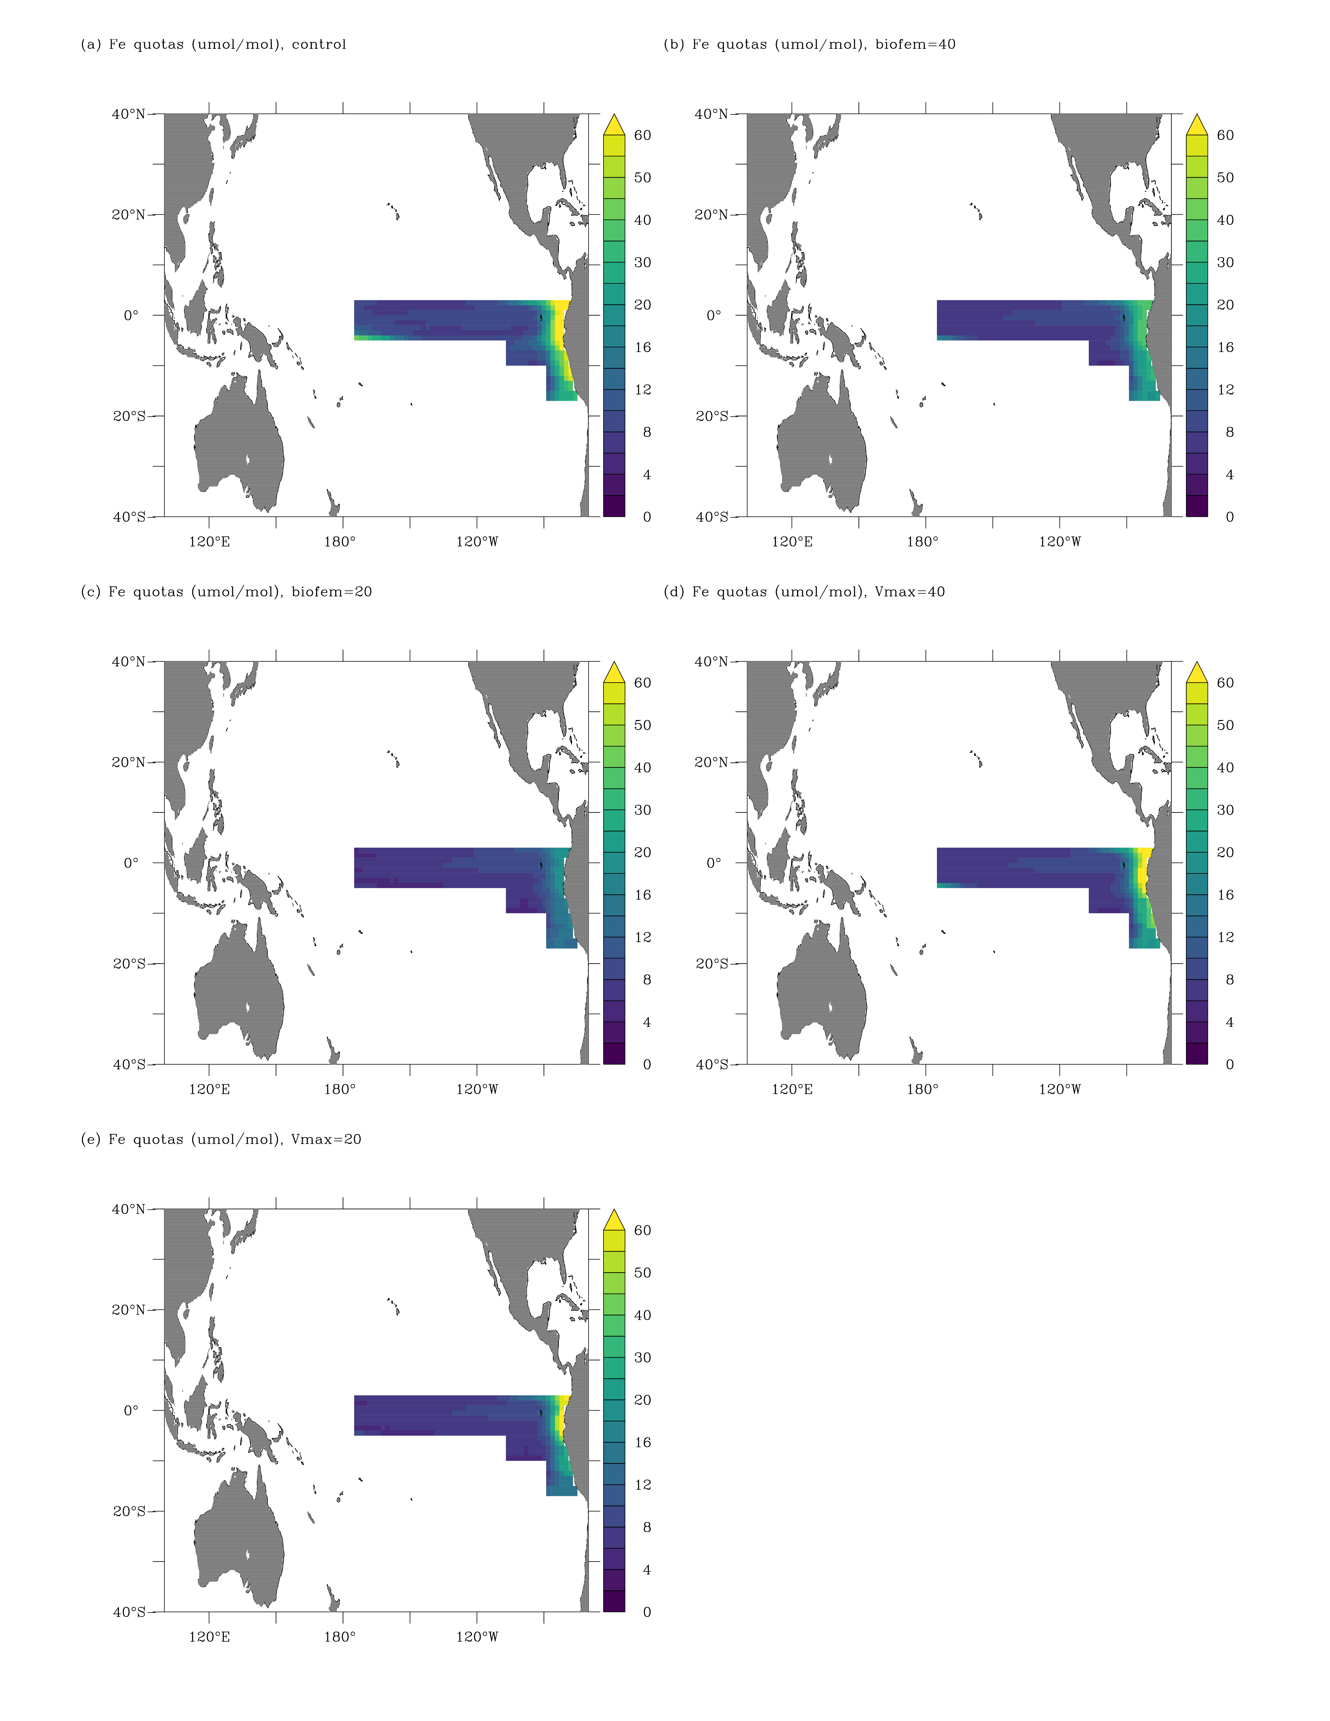
Figure S5. Modelled phytoplankton iron quotas in the Pacific Equatorial Divergence province for all experiments. Iron quotas are calculated from the sum of diatom and nanophytoplankton cellular iron divided by cellular carbon for the uppermost model layer (0-10m).

