Additional file 4

Tracing key genes associated with Pinctada margaritifera albino phenotype from juvenile to cultured pearl harvest stages by multiple whole transcriptome sequencing
P. Auffret, J. Le Luyer, M. Sham Koua, V. Quillien, C-L. Ky

Figure S1.
Figure S1 Summarized REVIGO treemaps plot for gene ontology enrichment analysis between the P. margaritifera albino versus black wild-type phenotype
A. Juvenile dataset, UP-regulated genes in Albino phenotype
B. Juvenile dataset, DOWN-regulated genes in Albino phenotype
C. Mantle dataset, UP-regulated genes in Albino phenotype
D. Mantle dataset, DOWN-regulated genes in Albino phenotype
E. Pearl Sac dataset, UP-regulated genes in Albino phenotype
F. Pearl Sac dataset, DOWN-regulated genes in Albino phenotype
G. Common Mantle – Juvenile DOWN-regulated genes in Albino phenotype
H. Common Mantle – Pearl Sac DOWN-regulated genes in Albino phenotype

A.
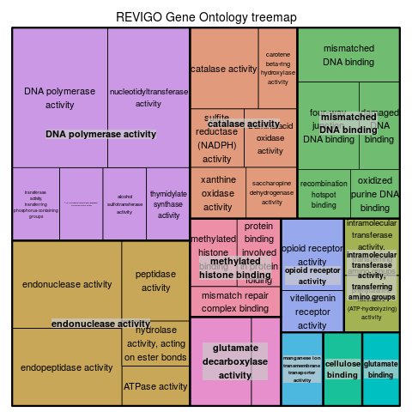

B.
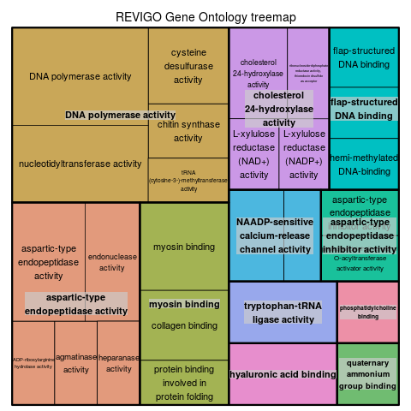
C.
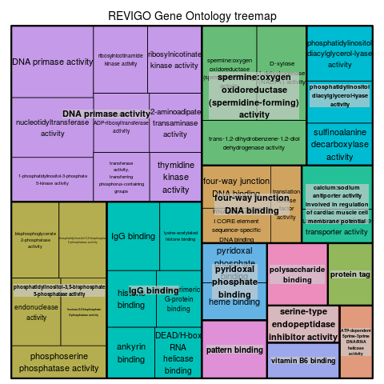

D.
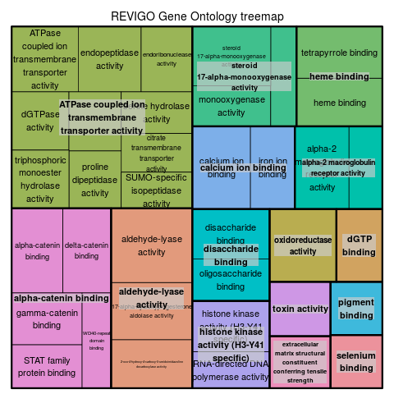

E.
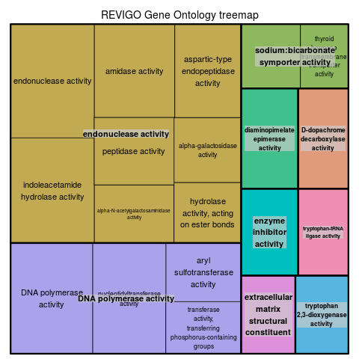

F.
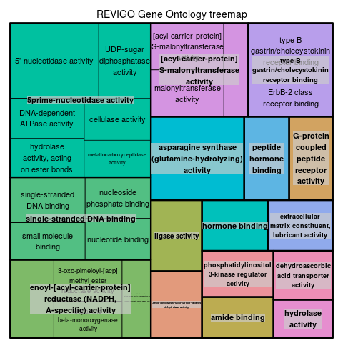

G.
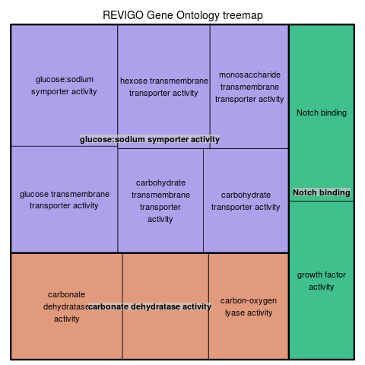

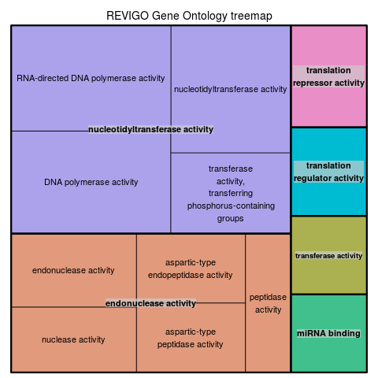
H.
Figure S2.
Figure S2. Signaling pathways (sp) potentially impacted by deregulated genes in albino pearl oyster P. margaritifera versus black-wild type
The pathways plots are obtained from KAAS server using DEGs nucleotide sequences. Green boxes show deregulated genes in albino phenotype versus black wild-type in :
A, B, D, E : Mantle dataset
C, F : Juvenile dataset
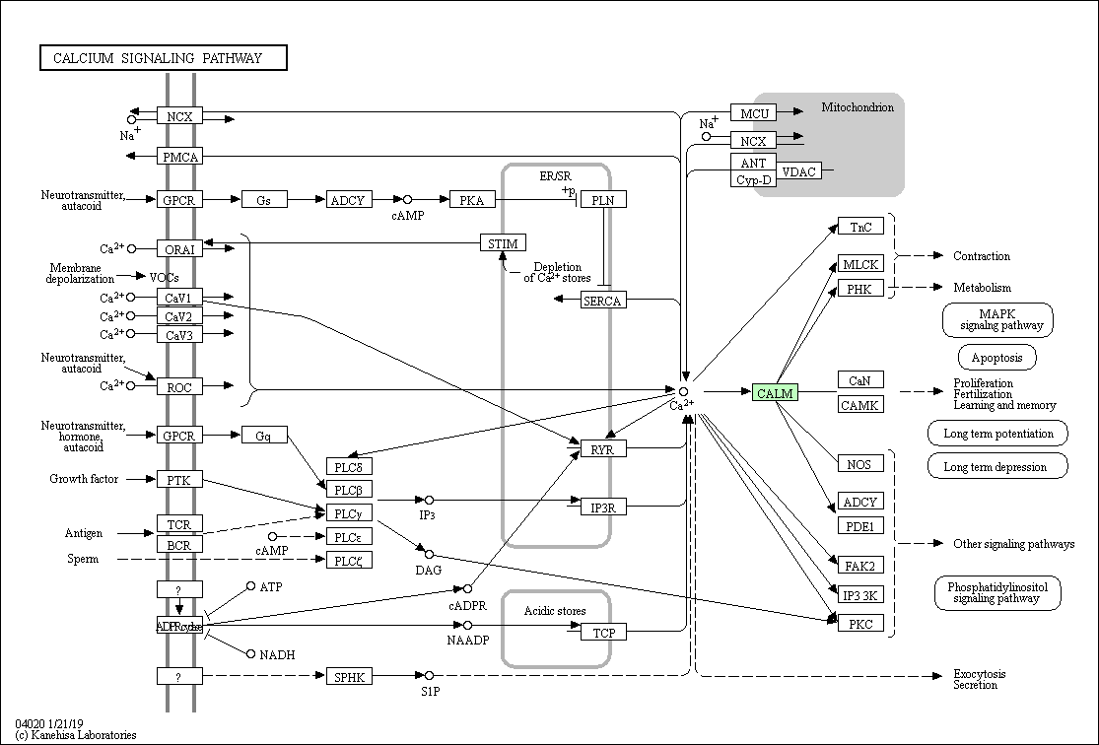
A.
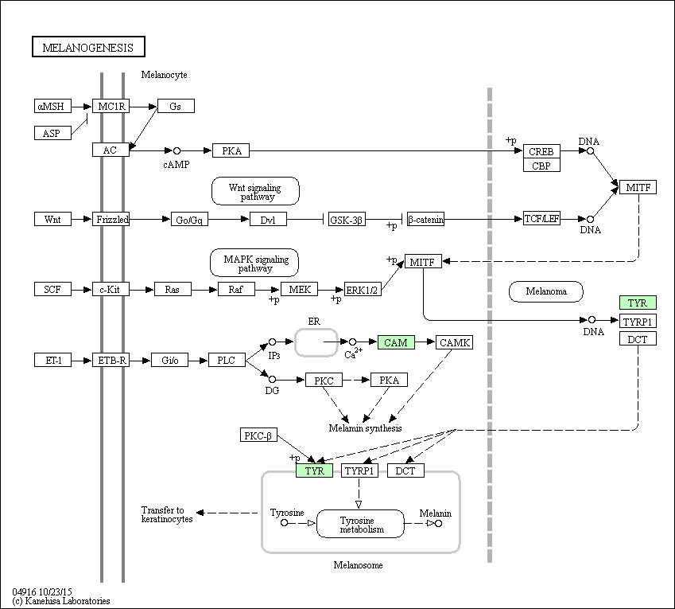
B.

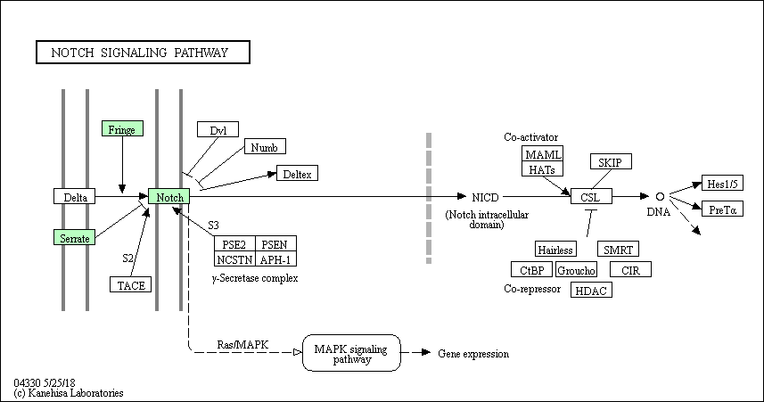
C.

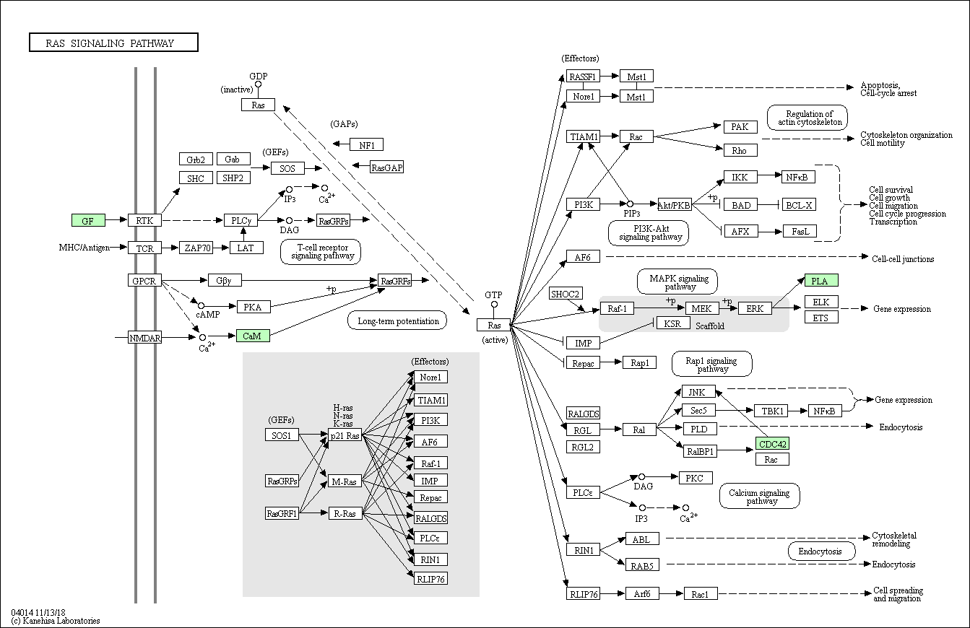
D.

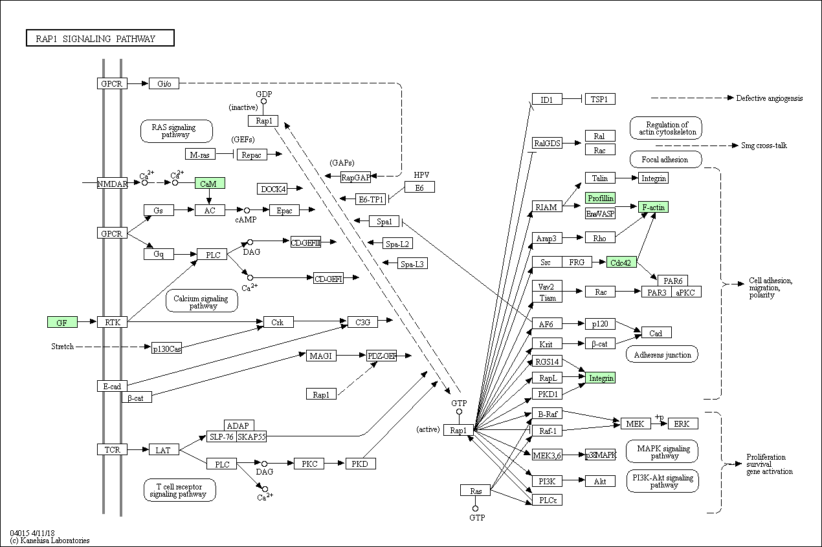
E.

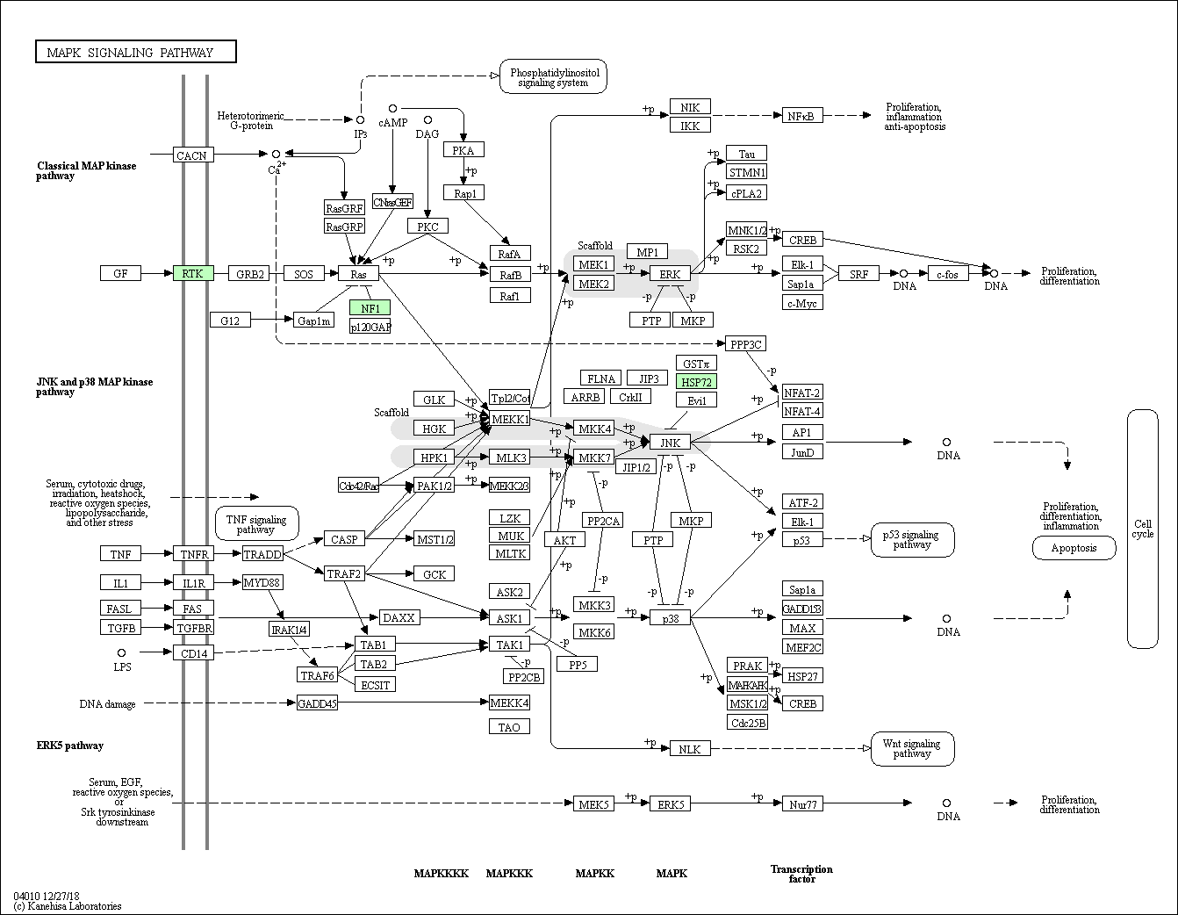
F.

Figure S3.
Figure S3. Composition plots of albino and black wild-type populations of pearl oyster P. margaritifera based on filtered SNPs called with Freebayes in both Juvenile and Mantle datasets

