Irregular BSR: evidence of an on-going reequilibrium of a gas hydrate system

F. Colin, S. Ker, V. Riboulot and N. Sultan

SUPPLEMENTARY MATERIALS

List of Supplementary Figures:
- Supplementary Figure 1: Position map of Supplementary profiles
- Supplementary Figure 2: HR 31a + interpretation
- Supplementary Figure 3: PL01PR13 + interpretation
- Supplementary Figure 4: PL03PR07 + interpretation
- Supplementary Figure 5: PL03PR11 + interpretation
- Supplementary Figure 6: Salinity anomaly
- Supplementary Figure 7: Steady state BGHSZ modeling
- Supplementary Figure 8: Excess pore pressure
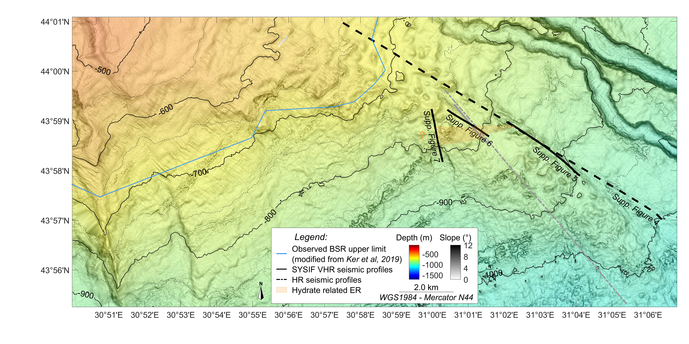
Supplementary Figure 1 – Map of the study area. The location of the supplementary profiles is shown in black. The location of the profiles from the main article is shown in grey.

HR and VHR seismic data
The workflow used to process the high-resolution (HR) and very high resolution (VHR) seismic profiles from the GHASS cruise is presented in the main article. More details regarding the processing of the HR data can be found in Ker et al. (2019) and regarding the processing of the VHR data in Colin et al. (2020). Supplementary Figure 2, Supplementary Figure 3, Supplementary Figure 4, and Supplementary Figure 5 show four examples of the presence of free gas above the regional trend of the bottom-simulating reflector (BSR).
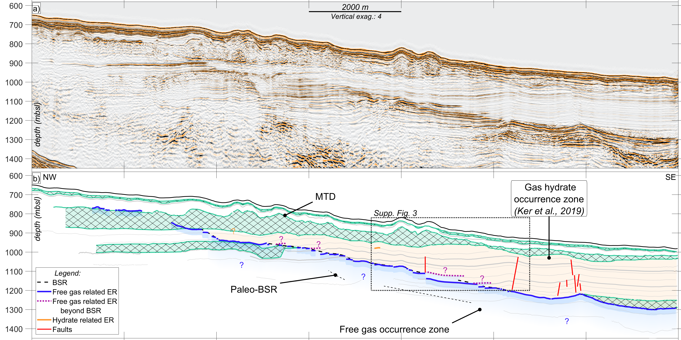
Supplementary Figure 2 – Profile HR 31a from the GHASS cruise (location in Supplementary Figure 1). The profile presents the main geological features of the area. Around 75 meters below seafloor (mbsf), we observe a thick MTD. The top of the free gas occurrence zone is marked by the BSR. The reflector cross-cuts the stratigraphy. The velocity analysis performed to convert this profile to depth was presented in Ker et al. (2019). Their study also reveals the extent of the GHOZ (orange shaded area). We observe the occurrence of enhanced reflections above the regional trend of the BSR (purple reflectors). We can note the presence of a small enhanced reflection on the left side of the black square (orange reflector). We assume that this reflection is part of the roof of a more concentrated GH layer (mapped in Supplementary Figure 1). MTD = mass transport deposit, GHOZ = gas hydrate occurrence zone, BGHSZ = base of the gas hydrate stability zone, ER = enhanced reflection, BSR = bottom-simulating reflector.

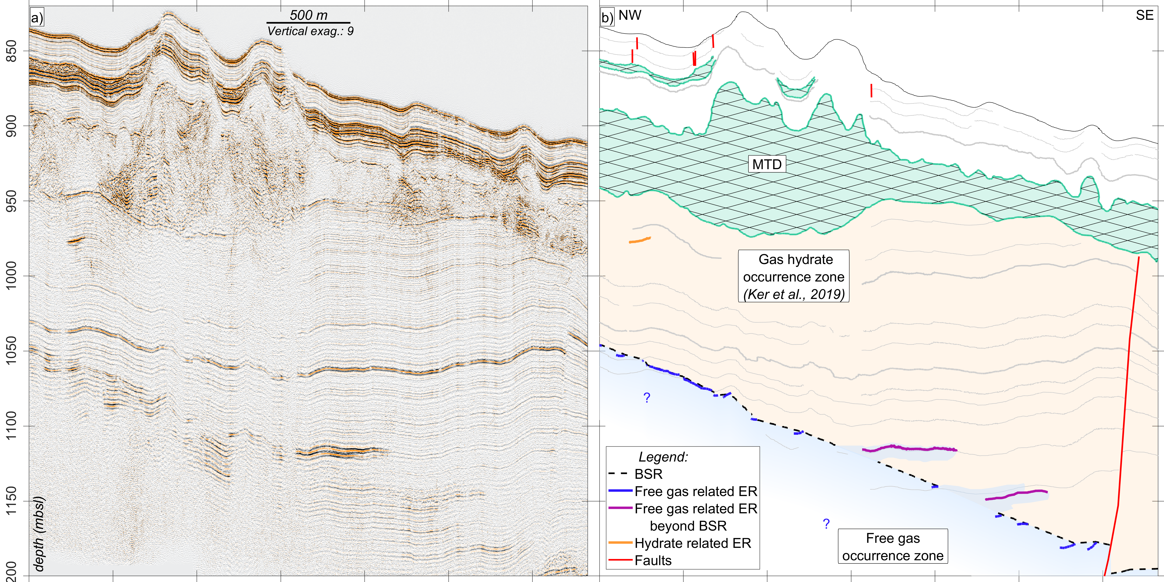
Supplementary Figure 3 – VHR profile PL01PR013 from the GHASS cruise (location in Supplementary Figure 1 and Supplementary Figure 2). This profile offers a higher resolution version of Supplementary Figure 2 (black rectangle). The presence of free gas above the regional trend of the BSR is more apparent (purple reflectors). The GH related enhanced reflection (orange reflector) is more easily discernable. MTD = mass transport deposit, GHOZ = gas hydrate occurrence zone, BGHSZ = base of the gas hydrate stability zone, ER = enhanced reflection, BSR = bottom-simulating reflector.

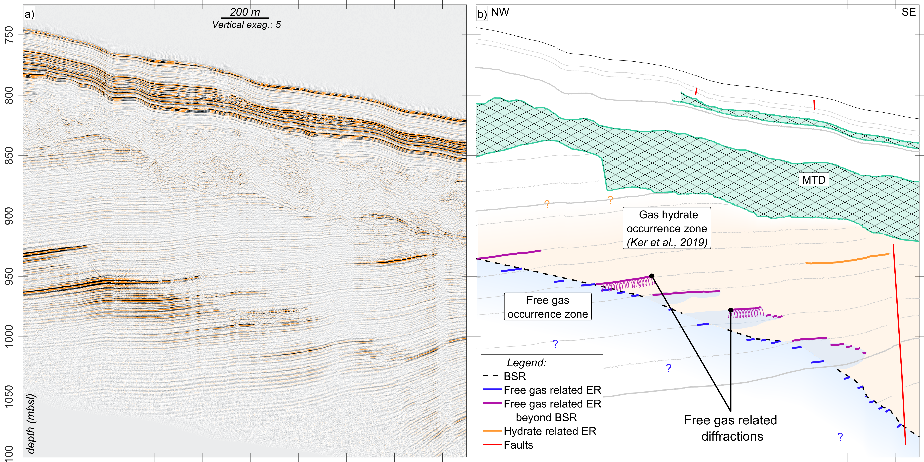
Supplementary Figure 4 – VHR profile PL03PR07 from the GHASS cruise (location in Supplementary Figure 1). This profile is crossing profile PL01PR12 presented in Figure 3 of the article. As such, we observe the same geological features are imaged. However, the different bearing of the profile allows us to confirm that the features observed are unlikely to be imaging artifacts. MTD = mass transport deposit, GHOZ = gas hydrate occurrence zone, BGHSZ = base of the gas hydrate stability zone, ER = enhanced reflection, BSR = bottom-simulating reflector.

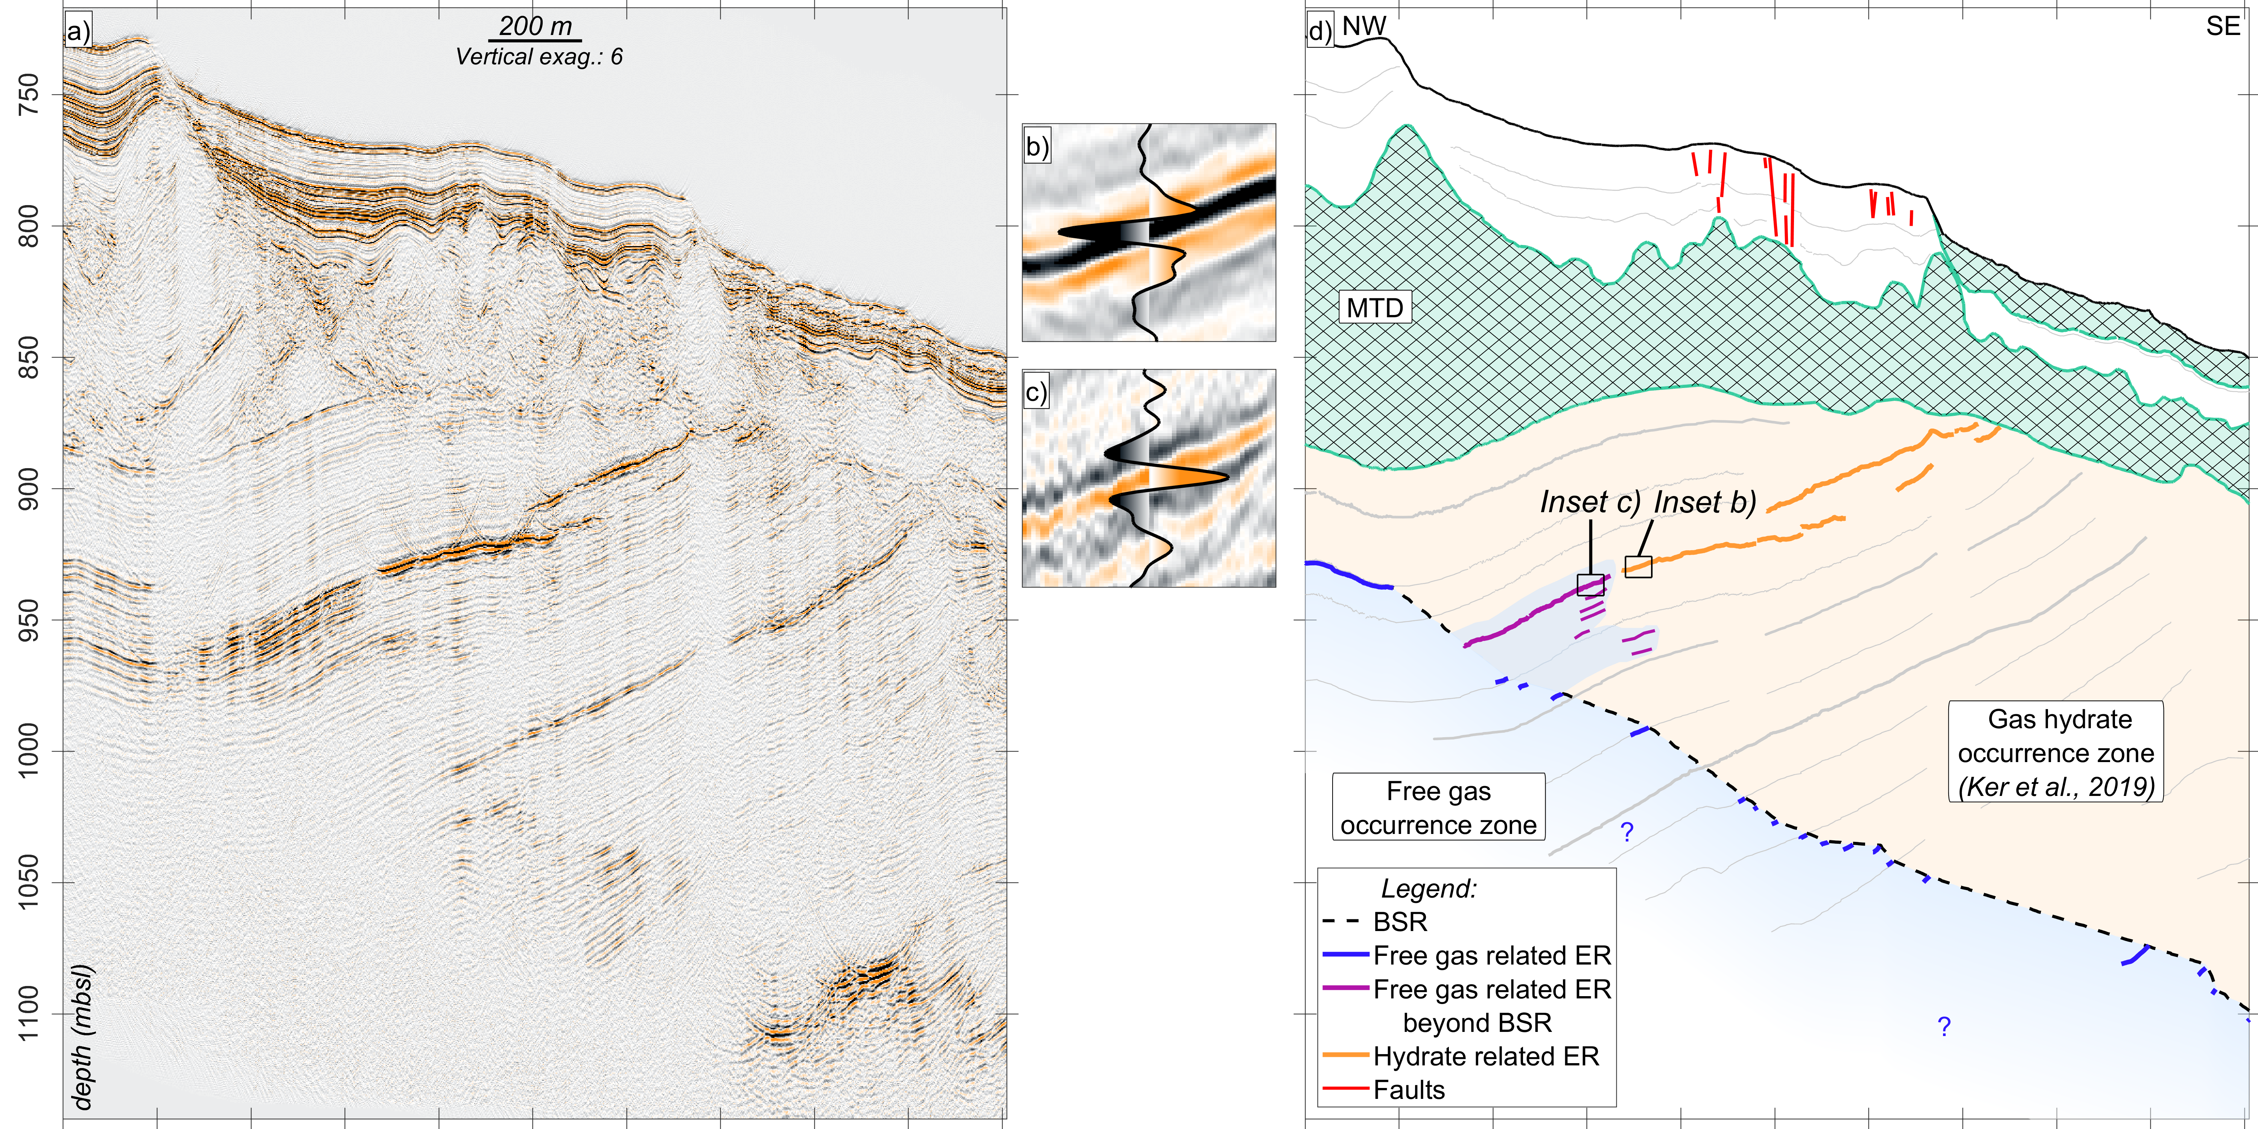
Supplementary Figure 5 – VHR profile PL03PR11 from the GHASS cruise (location in Supplementary Figure 1). In this profile, we observe a single gas patch above the BSR (purple reflectors). We also observe the widest imaged extent of the reflector marking the roof of a more concentrated GH layer (orange reflector). We observe a contact between a gas-charged layer above the BSR and the reflector marking the roof of a more concentrated GH layer. MTD = mass transport deposit, GHOZ = gas hydrate occurrence zone, BGHSZ = base of the gas hydrate stability zone, ER = enhanced reflection, BSR = bottom-simulating reflector.

Steady state system: salinity anomaly
The model presented in Supplementary Figure 6 explores the possibility that salinity anomalies could cause gas hydrates (GH) dissociation in particular layers at the base of the GH stability zone (GHSZ) in a steady state system. The geothermal gradient is set at 18.5 °K/km so that, at equilibrium, the free gas-GH boundary fits the observed depth in our study area (~1020 meters below sea level (mbsl) in 800 m water depth). The salinity profile is typical of the study area: from 22 psu to one psu in the first 25 mbsf and constant at one psu below that. However, a strong salinity anomaly of 22 psu (same as seawater) is added at 150 mbsf (Supplementary Figure 6, right figure). The left diagram from Supplementary Figure 6 (left figure) presents the phase boundary as a function of temperature and depth. GHs is stable when the temperature profile is below the phase boundary (i.e., between 800 m below sea level (mbsl) and 945 mbsl and between 955 mbsl and 1000 mbsl). The high salinity anomaly causes the required temperature for stable GHs to drop by 0.8 °K. If the layer with the salinity anomaly is located close to the BGHSZ, as is the case in this model, the required temperature for GHs can drop below the sediment temperature, thus leading to the incapacity to form GHs. Therefore, we show that a strong salinity anomaly can theoretically prevent the formation of GHs.
However, in the studied case, we observe six free gas charged layers above the regional trend of the BSR within a 140 m interval (Figure 3 of the article). Therefore, six distinct strong salinity anomalies are necessary to explain the different gas-charged reflectors. We argue that no such anomalies have been reported in the literature. Calvert et Batchelor (1978) report two punctual (albeit more than 20 m thick) salinity anomalies at DSDP hole 379A showing an increase of only 3-4 psu. In higher sampled data, Riedel et al. (2020) show no anomalies. In addition, salt diffusion would decrease the amplitude of the salinity anomalies well below the seawater level during the burial of sediment. We find that the possibility of free gas presence above the regional trend of the BSR is theoretically possible in a steady state system but highly unlikely given the salinity anomalies required.

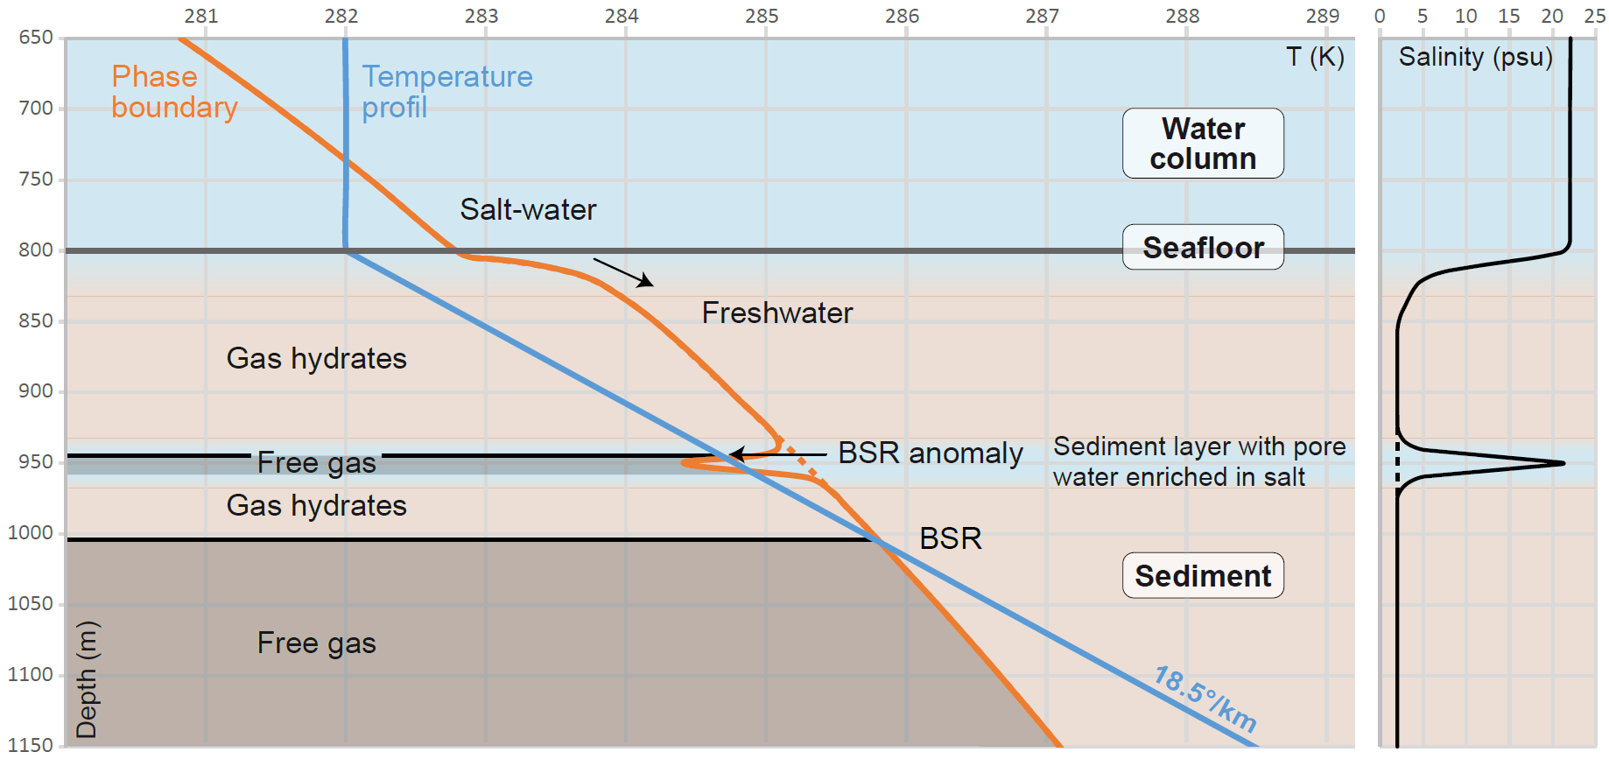
Supplementary Figure 6 – A sediment layer where high salinity is present at 150 mbsf. The increased salinity at this depth brings the sediment outside the GHSZ. In this figure, we use a geothermal gradient of 18.5 °K/km to reproduce a free gas-GH boundary at a depth comparable to the observed BSR on SYSIF profile PL01PR12.

Gas hydrate stability modeling
We compute the base of the gas hydrate stability zone (BGHSZ) in steady state conditions using the 2D gas hydrate (GH) stability model developed by Sultan et al. (2010). As in Ker et al. (2019), we consider pure s‐I methane hydrates. The forthcoming parameters control methane hydrate stability. The pore pressure is given by the hydrostatic condition with a gradient of 9.97 kPa/m. The temperature at the seafloor is 282 °K and increases with depth with a measured geothermal gradient of 24.5 °K/km (Riboulot et al., 2018). The porosity is set constant at 0.42, according to the average value at a depth greater than 20 m from the MeBo drilling (Riedel et al., 2020). In accordance, thermal diffusivity is set constant at 3.35 · 10⁻⁷ m²/s. The salinity derived from the measured chloride profile down to 25 m below seafloor (mbsf) that decreases from 22 psu (practical salinity unit) at the seafloor to 2 psu at 25 mbsf (Riboulot et al., 2018).
We also compute the predicted BGHSZ for past conditions during the last glacial maximum (LGM) period. At this period, the Black Sea was a lake (Constantinescu et al., 2015) with a water temperature at the seafloor estimated to be 277 °K by Soulet et al. (2011). The sea level was 94 m lower than the current one (Lericolais et al., 2009). The salinity profile is considered constant at 1 psu to compute the limit of stability.
The modeling of the BGHSZ at the last glacial maximum (LGM) and at present time shows that the current BSR is located between the modeled depth of the BGHSZ at the LGM and the present one (Supplementary Figure 7).
Supplementary Figure 7 – Results of the modeling of the BGHSZ at the LGM (dashed black line) and present (black line) for profile Bla1-7. LGM = last glacial maximum, BGHSZ = base of the gas hydrates stability zone.

Steady state system: hydrofracturing
To verify our hypothesis concerning the absence of hydrofracturing during hydrate decomposition, we calculate the maximum excess pore pressure generated by GHs dissociating in the presented system. The calculations follow the methodology presented by Sultan (2007). We use the porosity profile presented in Riedel et al. (2020) from a neighboring area, the bulk density varies with the porosity but is taken constant at 2000 kg/m³ deeper than 85 mbsf, coherent with the values measured by Riedel et al. (2020). The threshold for hydrofracturing to occur is set at 95 % of the effective pressure (Sultan, 2007). Supplementary Figure 8a presents the interpreted section of profile PL01PR12, the GH occurrence zone (GHOZ) is represented in orange and the free gas occurrence zone is represented in light blue. The regional trend of the BSR is indicated by the dotted blue line, whereas the local trend of the free gas termination above the BSR is indicated by the dotted purple line. The dotted black line shows the steady state modeling of the base of the GHSZ (BGHSZ). The maximum excess pore pressure generated by GH dissociation, Δu, is estimated at two boundaries: the regional trend of the BSR and the local trend of the free gas termination above the BSR. The results are summarized in Supplementary Figure 8b and Supplementary Figure 8c. Supplementary Figure 8b presents the vertical profile at the position indicated by the dashed black line in Supplementary Figure 8a. The GH equilibrium pressure curve decreases for the first five meters below the seafloor before increasing with depth. The decrease of the equilibrium pressure is caused by the sharp decrease of the salinity in the first 25 m below seafloor, in the Black Sea. The maximum excess pore pressure generated by GH dissociation is indicated by the blue Δu for the depth of the BSR and by the purple Δu for the top of the free gas above the BSR. Supplementary Figure 8c presents the Δu curves for the studied profile as well as the curves corresponding to 95 % of Peff. The maximum excess pore pressure generated by GH dissociation does not exceed the 95 % effective pressure threshold for the free gas above the BSR (purple curves). Δu is greater than 95% of Peff at the depth of the BSR close to the fault. We conclude that hydrofracturing is unlikely to occur in this area because of GH dissociation.

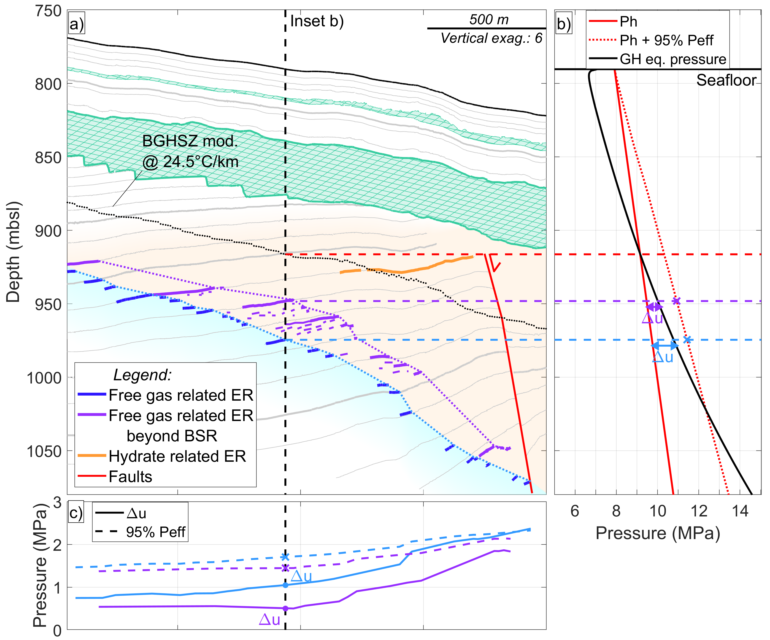
Supplementary Figure 8 – Maximum excess pore pressure generated by GH dissociation. a) Interpretation of SYSIF profile PL01PR12. The dotted light blue line indicates the regional trend of the BSR. The dotted purple line indicates the local trend of the presence of free gas above the BSR. The modeling of the present steady state BGHSZ is shown (dotted black line). The vertical dashed black line indicates the position of the pressure profile in b). b) Hydrostatic pressure (Ph, red), sum of Ph, and 95% of the effective pressure (Peff) and GH stability pressure law (black). 95% of Peff corresponds to the chosen threshold for hydrofracturing (Sultan, 2007). The maximum excess pore pressure generated by GH dissociation at the BSR depth is indicated by the blue Δu and at the top of the free gas reflector above the BSR by the purple Δu. c) Maximum excess pore pressure generated by GH dissociation (plain lines) and 95% pf Peff (dashed lines). We observe that the maximum excess pore pressure generated by GH dissociation does not exceed 95% of Peff. It only does so at the depth of the BSR and close to the fault.

Bibliography
Calvert, S. E., & Batchelor, C. H. (1978). Major and minor element geochemistry of sediments from Hole 379a, Leg 42b, Deep Sea Drilling Project. Initial Reports of the Deep Sea Drilling Project, 42, 527–541. https://doi.org/10.2973/dsdp.proc.42-2.1978
Colin, F., Ker, S., & Marsset, B. (2020). Fine-scale velocity distribution revealed by datuming of VHR deep-towed seismic data: Example of a shallow gas system from the western Black Sea. GEOPHYSICS, 1–50. https://doi.org/10.1190/geo2019-0686.1
Constantinescu, A. M., Toucanne, S., Dennielou, B., Jorry, S. J., Mulder, T., & Lericolais, G. (2015). Evolution of the Danube Deep-Sea Fan since the Last Glacial Maximum: New insights into Black Sea water-level fluctuations. Marine Geology, 367, 50–68. https://doi.org/10.1016/j.margeo.2015.05.007
Ker, S., Yannick, T., Sultan, N., Bernard, C., Scalabrin, C., Ion, G., & Marsset, B. (2019). Anomalously deep BSR related to a transient state of the gas hydrate system in the western Black Sea. Geochemistry, Geophysics, Geosystems, 20, 442–459. https://doi.org/10.1029/2018GC007861
Lericolais, G., Bulois, C., Gillet, H., & Guichard, F. (2009). High frequency sea level fluctuations recorded in the Black Sea since the LGM. Global and Planetary Change, 66(1–2), 65–75. https://doi.org/10.1016/j.gloplacha.2008.03.010
Riboulot, V., Ker, S., Sultan, N., Thomas, Y., Marsset, B., Scalabrin, C., Ruffine, L., Boulart, C., & Ion, G. (2018). Freshwater lake to salt-water sea causing widespread hydrate dissociation in the Black Sea. Nature Communications, 9(1), 1–8. https://doi.org/10.1038/s41467-017-02271-z
Riedel, M., Freudenthal, T., Bergenthal, M., Haeckel, M., Wallmann, K., Spangenberg, E., Bialas, J., & Bohrmann, G. (2020). Physical properties and core-log seismic integration from drilling at the Danube deep-sea fan, Black Sea. Marine and Petroleum Geology, 104192. https://doi.org/10.1016/j.marpetgeo.2019.104192
Soulet, G., Ménot, G., Lericolais, G., & Bard, E. (2011). A revised calendar age for the last reconnection of the Black Sea to the global ocean. Quaternary Science Reviews, 30(9–10), 1019–1026. https://doi.org/10.1016/j.quascirev.2011.03.001
Sultan, N. (2007). Excess Pore Pressure and Slope Failures Resulting From Gas-Hydrates Dissociation and Dissolution. Offshore Technology Conference. Offshore Technology Conference, Houston, Texas, U.S.A. https://doi.org/10.4043/18532-MS
Sultan, N., Marsset, B., Ker, S., Marsset, T., Voisset, M., Vernant, A. M., Bayon, G., Cauquil, E., Adamy, J., Colliat, J. L., & Drapeau, D. (2010). Hydrate dissolution as a potential mechanism for pockmark formation in the Niger delta. Journal of Geophysical Research, 115(B8101), 1–33. https://doi.org/10.1029/2010JB007453

