Supplementary Material
Table S1. eDNA sampling filtrations. Data about filters, stations and dates of sampling are provided.
Location | Code | Sampling Method | Filter | Date | T_start | T_end | latitude_start | longitude_start | latitude_end | longitude_end
Providencia | P_SW | Transect | SPY181729 | 29/06/2018 | 14H07 | 14H45 | 13.34043 | -81.39829 | 13.34043 | -81.39829
Providencia | P_SW | Transect | SPY181719 | 30/06/2018 | 8H57 | 9H39 | 13.34043 | -81.39829 | 13.34043 | -81.39829
Providencia | P_NW_1 | Transect | SPY181732 | 01/07/2018 | 9H25 | 10H09 | 13.36786 | -81.38864 | 13.36786 | -81.38864
Providencia | P_NW_1 | Transect | SPY181724 | 01/07/2018 | 9H25 | 10H09 | 13.36786 | -81.38864 | 13.36786 | -81.38864
Providencia | P_N | Transect | SPY181721 | 02/07/2018 | 9H10 | 9H50 | 13.39172 | -81.38029 | 13.39172 | -81.38029
Providencia | P_N | Transect | SPY181730 | 02/07/2018 | 9H10 | 9H50 | 13.39172 | -81.38029 | 13.39172 | -81.38029
Providencia | P_NE | Transect | SPY181725 | 02/07/2018 | 10H06 | 10H50 | 13.38322 | -81.35909 | 13.38322 | -81.35909
Providencia | P_NE | Transect | SPY181733 | 02/07/2018 | 10H06 | 10H50 | 13.38322 | -81.35909 | 13.38322 | -81.35909
Providencia | P_SE_2 | Transect | SPY181716 | 05/07/2018 | 9H27 | 10H07 | 13.32225 | -81.36716 | 13.32225 | -81.36716
Providencia | P_SE_2 | Transect | SPY180774 | 05/07/2018 | 9H27 | 10H07 | 13.32225 | -81.36716 | 13.32225 | -81.36716
Providencia | P_W_2 | Transect | SPY181728 | 04/07/2018 | 9H56 | 10H34 | 13.36726 | -81.41335 | 13.36726 | -81.41335
Providencia | P_W_2 | Transect | SPY181722 | 04/07/2018 | 9H56 | 10H34 | 13.36726 | -81.41335 | 13.36726 | -81.41335
Providencia | P_SE_1 | Transect | SPY181726 | 03/07/2018 | 10H30 | 11H00 | 13.34073 | -81.35124 | 13.34072 | -81.35561
Providencia | P_SE_1 | Transect | SPY181731 | 03/07/2018 | 10H30 | 11H00 | 13.34073 | -81.35124 | 13.34072 | -81.35561
Providencia | P_E | Transect | SPY181718 | 03/07/2018 | 9H42 | 10H13 | 13.3652 | -81.3475 | 13.36264 | -81.34969
Providencia | P_E | Transect | SPY181727 | 03/07/2018 | 9H42 | 10H13 | 13.3652 | -81.3475 | 13.36264 | -81.34969
Providencia | P_W1 | Transect | SPY181723 | 30/06/2018 | 12H50 | 13H48 | 13.34393 | -81.39777 | 13.34393 | -81.39777
Providencia | P_W1 | Transect | SPY181734 | 30/06/2018 | 12H50 | 13H48 | 13.34393 | -81.39777 | 13.34393 | -81.39777
Providencia | P_NW_2 | Transect | SPY181717 | 04/07/2018 | 9H10 | 9H40 | 13.36541 | -81.41025 | 13.36541 | -81.41025
Providencia | P_NW_2 | Transect | SPY181715 | 04/07/2018 | 9H10 | 9H40 | 13.36541 | -81.41025 | 13.36541 | -81.41025
Gayraca Bay | S_P7 | Transect | SPY181508 | 23/10/2018 | 13H00 | 13H30 | 11,33765 | -74,11044 | 11,33738 | -74,1105
Gayraca Bay | S_P7 | Transect | SPY181538 | 23/10/2018 | 13H00 | 13H30 | 11,33765 | -74,11044 | 11,33738 | -74,1105
Gayraca Bay | S_P1 | Fixed point | SPY181515 | 23/10/2018 | 16H15 | 16H45 | 11,33765 | -74,11044 | 11,33738 | -74,1105
Gayraca Bay | S_P1 | Fixed point | SPY181525 | 23/10/2018 | 16H15 | 16H45 | 11,33765 | -74,11044 | 11,33738 | -74,1105
Gayraca Bay | S_P4 | Fixed point | SPY181501 | 24/10/2018 | 7H40 | 8H10 | 11,33765 | -74,11044 | 11,33738 | -74,1105
Gayraca Bay | S_P4 | Fixed point | SPY181514 | 24/10/2018 | 7H40 | 8H10 | 11,33765 | -74,11044 | 11,33738 | -74,1105
Gayraca Bay | S_P10 | Fixed point | SPY181500 | 25/10/2018 | 11H08 | 11H38 | 11,32828 | -74,11485 | 11,32799 | -74,11439
Gayraca Bay | S_P10 | Fixed point | SPY181516 | 25/10/2018 | 11H08 | 11H38 | 11,32828 | -74,11485 | 11,32799 | -74,11439
Gayraca Bay | S_T9 | Transect | SPY181499 | 25/10/2018 | 12H02 | 12H32 | 11,33078 | -74,1163 | 11,33107 | -74,11662
Gayraca Bay | S_T9 | Transect | SPY181539 | 25/10/2018 | 12H02 | 12H32 | 11,33078 | -74,1163 | 11,33107 | -74,11662
Gayraca Bay | S_P7 | Fixed point | SPY181503 | 25/10/2018 | 14H07 | 14H37 | 11,34072 | -74,1121 | 11,34031 | -74,11184
Gayraca Bay | S_P7 | Fixed point | SPY181530 | 25/10/2018 | 14H07 | 14H37 | 11,34072 | -74,1121 | 11,34031 | -74,11184
Gayraca Bay | S_T2 | Transect | SPY181903 | 25/10/2018 | 14H55 | 15H25 | 11,34196 | -74,11269 | 11,34208 | -74,11231
Gayraca Bay | S_T2 | Transect | SPY181534 | 25/10/2018 | 14H55 | 15H25 | 11,34196 | -74,11269 | 11,34208 | -74,11231
Gayraca Bay | S_T5 | Transect | SPY181889 | 25/10/2018 | 15H48 | 16H18 | 11,32668 | -74,11428 | 11,32873 | -74,11475
Gayraca Bay | S_T5 | Transect | SPY181891 | 25/10/2018 | 15H48 | 16H18 | 11,32668 | -74,11428 | 11,32873 | -74,11475
Gayraca Bay | S_T6 | Transect | SPY181540 | 25/10/2018 | 17H25 | 17H55 | 11,33017 | -74,11576 | 11,32756 | -74,11442
Gayraca Bay | S_T6 | Transect | SPY181504 | 25/10/2018 | 17H25 | 17H55 | 11,33017 | -74,11576 | 11,32756 | -74,11442
Gayraca Bay | S_T3 | Transect | SPY181505 | 26/10/2018 | 6H41 | 7H11 | 11,32842 | -74,1143 | 11,32764 | -74,11383
Gayraca Bay | S_T3 | Transect | SPY181509 | 26/10/2018 | 6H41 | 7H11 | 11,32842 | -74,1143 | 11,32764 | -74,11383

Table S2. Summary table of the species using OBITools for the three different primer sets for Providencia. The second column indicates which species were observed during the underwater visual censuses (UVC), and the third column indicates which species were documented as present in the study area in an existing regional database (R). The last three columns indicate the total number of reads across all stations found for each primer.
Species | UVC- Underwater visual census | R-Present in a regional database | # Reads Chon01 | # Reads teleo | # Reads Vert01t
Carcharhinus perezii |  | R | 531398 | 10654
Rhizoprionodon terraenovae |  | R | 36504 | 147
Sphyrna mokarran |  | R | 18136 | 724
Aetobatus narinari | UVC | R | 1524160 | 50603
Ginglymostoma cirratum | UVC | R | 1280127 | 79486
Urobatis jamaicensis | UVC | R |  | 126501
Chilorhinus suensonii |  | R |  | 18462 | 8187
Kaupichthys hyoproroides |  | R |  | 2574 | 5980
Ariosoma balearicum |  | R |  |  | 168
Moringua edwardsi |  | R |  | 1616 | 35872
Enchelycore carychroa |  | R |  |  | 3856
Gymnothorax miliaris |  | R |  |  | 21561
Gymnothorax vicinus |  | R |  |  | 6490
Uropterygius macularius |  | R |  |  | 7931
Atherinomorus stipes |  | R |  |  | 132604
Tylosurus crocodilus |  | R |  |  | 41374
Starksia atlantica |  | R |  |  | 75916
Starksia nanodes |  | R |  |  | 4862
Selar crumenophthalmus |  | R |  |  | 274
Trachinotus carolinus |  | R |  |  | 571
Rachycentron canadum |  | R |  |  | 614
Kyphosus bigibbus |  |  |  | 32092 | 27631
Kyphosus cinerascens |  | R |  | 30353
Kyphosus vaigiensis |  | R |  | 31130
Harengula jaguana |  | R |  | 1891 | 21932
Jenkinsia lamprotaenia |  | R |  |  | 910956
Opisthonema oglinum |  | R |  | 657 | 10404
Megalops atlanticus |  | R |  | 38355 | 21212
Chaetodipterus faber |  | R |  |  | 4871
Diapterus auratus |  | R |  |  | 1464
Eucinostomus argenteus |  | R |  |  | 16227
Eucinostomus gula |  | R |  |  | 1173
Eucinostomus melanopterus |  | R |  |  | 3626
Gerres cinereus | UVC | R |  |  | 189743
Eleotris amblyopsis |  | R |  | 492
Erotelis smaragdus |  |  |  | 6400
Gnatholepis thompsoni |  | R |  |  | 395683
Lythrypnus crocodilus |  | R |  |  | 5168
Lythrypnus nesiotes |  | R |  |  | 2755
Nes longus |  | R |  | 306
Oxyurichthys stigmalophius |  | R |  | 789
Priolepis hipoliti |  | R |  | 481
Ostichthys trachypoma |  | R |  |  | 114
Sargocentron coruscum |  | R |  |  | 289
Apogon aurolineatus |  | R |  | 2937
Apogon phenax |  | R |  | 5084
Apogon planifrons |  | R |  | 13988
Apogon townsendi |  | R |  | 133
Astrapogon puncticulatus |  | R |  | 10192
Phaeoptyx conklini |  | R |  | 13682
Phaeoptyx pigmentaria |  | R |  | 116147
Bodianus rufus | UVC | R |  | 3055 | 1678
Clepticus parrae | UVC | R |  |  | 82594
Cryptotomus roseus | UVC | R |  | 20924 | 20200
Halichoeres maculipinna | UVC | R |  | 49523 | 47191
Halichoeres bivittatus | UVC | R |  | 358262
Halichoeres garnoti | UVC | R |  | 574848
Halichoeres poeyi | UVC | R |  | 19849
Halichoeres radiatus |  | R |  | 635
Lachnolaimus maximus | UVC | R |  | 6058 | 15229
Scarus guacamaia | UVC | R |  |  | 5771
Scarus iseri | UVC | R |  |  | 40254
Sparisoma aurofrenatum | UVC | R |  |  | 1408
Sparisoma axillare |  |  |  |  | 108001
Sparisoma chrysopterum | UVC | R |  | 74817 | 3807
Sparisoma viride | UVC | R |  |  | 544023
Thalassoma bifasciatum | UVC | R |  | 69030 | 363881
Xyrichtys martinicensis |  | R |  |  | 53863
Xyrichtys novacula |  | R |  |  | 2161
Xyrichtys splendens |  | R |  |  | 72511
Mugil curema |  | R |  |  | 1080
Holacanthus tricolor | UVC | R |  | 14093 | 1354
Pomacanthus arcuatus | UVC | R |  |  | 6688
Abudefduf saxatilis | UVC | R |  | 136065
Abudefduf taurus |  | R |  | 2978
Chromis multilineata | UVC | R |  | 25300
Chromis cyanea | UVC | R |  |  | 14420
Microspathodon chrysurus | UVC | R |  | 78942 | 238727
Stegastes adustus | UVC | R |  |  | 153703
Stegastes partitus | UVC | R |  |  | 390446
Stegastes planifrons | UVC | R |  |  | 8174
Stegastes variabilis | UVC | R |  | 716
Petrotyx sanguineus |  | R |  |  | 13803
Scorpaena brasiliensis |  | R |  |  | 11962
Cephalopholis fulva | UVC | R |  |  | 942
Hypoplectrus gemma |  |  |  | 936
Pseudogramma gregoryi |  | R |  |  | 9232
Eumegistus brevorti |  | R |  | 104
Gempylus serpens |  | R |  | 223
Bothus lunatus |  | R |  |  | 387
Euthynnus alletteratus |  | R |  | 3270
Aulostomus maculatus |  | R |  |  | 11089
Mulloidichthys martinicus | UVC | R |  | 112069 | 124323
Pseudupeneus maculatus | UVC | R |  |  | 1817
Balistes capriscus |  | R |  |  | 21375
Balistes vetula |  | R |  | 17453 | 31930
Canthidermis maculata |  | R |  | 71057 | 127962
Melichthys niger | UVC | R |  | 10976
Diodon hystrix |  | R |  | 4532 | 37486
Aluterus monoceros |  | R |  | 7262 | 3721
Aluterus scriptus | UVC | R |  | 385 | 286
Monacanthus tuckeri |  | R |  |  | 38387
Acanthostracion polygonius | UVC | R |  |  | 14341
Lactophrys bicaudalis |  | R |  |  | 31926
Lactophrys triqueter |  | R |  |  | 1481
Canthigaster rostrata | UVC | R |  |  | 1849671
Sphoeroides spengleri |  | R |  |  | 19765

Table S3. Summary table of the genera using OBITools for the three different primer sets for Providencia. The second column indicates which genera were observed during the underwater visual censuses (UVC), and the third column indicates which genera were documented as present in the study area in an existing regional database (R). The last three columns indicate the total number of reads across all stations found for each primer.
Genus | UVC- Underwater visual census | R-Present in a regional database | # Reads Chon01 | # Reads teleo | # Reads Vert01t
Carcharhinus |  | R | 233243 | 28053
Sphyrna |  | R | 280
Urobatis | UVC | R | 2330873 | 9445
Ginglymostoma | UVC | R | 2946
Acanthurus | UVC | R |  | 147474 | 395956
Albula |  | R |  |  | 15993
Ariosoma |  | R |  | 127
Gymnothorax | UVC | R |  |  | 20123
Atherinomorus |  | R |  |  | 653
Synodus |  | R |  |  | 606
Strongylura |  | R |  |  | 280
Tylosurus |  | R |  |  | 649220
Cheilopogon |  | R |  |  | 133
Hemiramphus |  | R |  |  | 247635
Entomacrodus |  | R |  |  | 7034
Parablennius |  | R |  |  | 15810
Chaenopsis |  | R |  |  | 13183
Arcos |  | R |  | 4105
Malacoctenus | UVC | R |  |  | 286196
Starksia |  | R |  |  | 314
Caranx | UVC | R |  | 618 | 189061
Selar |  | R |  | 148
Trachinotus |  | R |  |  | 75764
Echeneis |  | R |  |  | 8252
Kyphosus | UVC | R |  |  | 159200
Chaetodon | UVC | R |  |  | 5935
Harengula |  | R |  |  | 326
Jenkinsia |  | R |  | 55403 | 4857
Engraulis |  | R |  |  | 724
Anchoa |  | R |  |  | 7126
Poecilia |  | R |  |  | 608
Elops |  | R |  | 3280 | 5358
Gerres | UVC | R |  |  | 1945
Gnatholepis |  | R |  |  | 3343
Nes |  | R |  | 29186
Myripristis | UVC | R |  |  | 1476
Apogon |  | R |  | 55441
Astrapogon |  | R |  | 1590
Clepticus | UVC | R |  |  | 432
Halichoeres | UVC | R |  | 22632 | 739789
Lachnolaimus | UVC | R |  |  | 143
Scarus | UVC | R |  | 58317 | 8757
Sparisoma | UVC | R |  |  | 264140
Thalassoma | UVC | R |  |  | 2158
Xyrichtys |  | R |  |  | 464
Lutjanus | UVC | R |  | 269470 | 1008490
Mugil |  | R |  | 3660 | 12672
Holacanthus | UVC | R |  | 744 | 417
Abudefduf | UVC | R |  | 5470 | 539730
Microspathodon | UVC | R |  | 2950 | 2495
Stegastes | UVC | R |  |  | 13050
Sphyraena | UVC | R |  | 4559 | 51758
Pterois | UVC | R |  |  | 3239
Cephalopholis | UVC | R |  |  | 15179
Diplectrum | UVC | R |  |  | 1046
Hypoplectrus | UVC | R |  |  | 194
Liopropoma |  | R |  |  | 352
Rypticus |  | R |  |  | 18432
Bothus |  | R |  |  | 15770
Cubiceps |  | R |  |  | 368
Auxis |  | R |  | 215 | 2903
Scomberomorus |  | R |  | 4204 | 4677
Thunnus |  | R |  | 8446 | 49512
Mulloidichthys | UVC | R |  |  | 2458
Syngnathus |  | R |  | 2829 | 10512
Balistes |  | R |  |  | 188
Canthidermis |  | R |  |  | 805
Melichthys | UVC | R |  |  | 203037
Diodon | UVC | R |  | 18009 | 151019
Cantherhines | UVC | R |  |  | 10114
Stephanolepis |  | R |  | 310 | 6033
Acanthostracion | UVC | R |  |  | 25458
Canthigaster | UVC | R |  |  | 20991
Epinephelus | UVC | R |  |  | 7068
Rhizoprionodon |  | R | See species table
Aetobatus | UVC | R | See species table
Chilorhinus |  | R | See species table
Kaupichthys |  | R | See species table
Moringua |  | R | See species table
Enchelycore |  | R | See species table
Uropterygius |  | R | See species table
Rachycentron |  | R | See species table
Opisthonema |  | R | See species table
Megalops |  | R | See species table
Chaetodipterus |  | R | See species table
Eucinostomus | UVC | R | See species table
Priolepis |  | R | See species table
Ostichthys |  | R | See species table
Sargocentron |  | R | See species table
Phaeoptyx |  | R | See species table
Bodianus | UVC | R | See species table
Cryptotomus | UVC | R | See species table
Pomacanthus | UVC | R | See species table
Petrotyx |  | R | See species table
Scorpaena |  | R | See species table
Pseudogramma |  | R | See species table
Eumegistus |  | R | See species table
Gempylus |  | R | See species table
Euthynnus |  | R | See species table
Aulostomus |  | R | See species table
Pseudupeneus | UVC | R | See species table
Aluterus | UVC | R | See species table
Monacanthus |  | R | See species table
Lactophrys | UVC | R | See species table
Sphoeroides |  | R | See species table
Chromis |  | R | See species table

Table S4. Summary table of the families using OBITools for the three different primers sets for Providencia. The second column indicates which families were observed during the underwater visual censuses (UVC), and the third column indicates which genera were documented as present in the study area in an existing regional database (R). The last three columns indicate the total number of reads across all stations found for each primer.
Family | UVC- Underwater visual census | R-Present in a regional database | # Reads Chon01 | # Reads teleo | # Reads Vert01t
Carcharhinidae |  | R | 198
Dasyatoidea | UVC | R |  | 64521
Myliobatidae |  | R | 1252
Urotrygonidae | UVC | R | 14101 | 2500
Ginglymostomatidae | UVC | R | 9814
Acanthuridae | UVC | R |  | 275279 | 823561
Albulidae |  | R |  | 19333
Chlopsidae |  | R |  |  | 944
Ophichthidae | UVC | R |  | 5034 | 4517
Muraenidae | UVC | R |  | 67484 | 941
Paralepididae |  | R |  |  | 137
Belonidae |  | R |  | 482289 | 93219
Exocoetidae |  | R |  | 2955 | 458
Hemiramphidae |  | R |  | 148625 | 4008
Blenniidae |  | R |  |  | 2551
Chaenopsidae |  | R |  |  | 11423
Gobiesocidae |  | R |  |  | 1343
Labrisomidae | UVC | R |  |  | 582788
Carangidae | UVC | R |  | 28257 | 312106
Kyphosidae |  | R |  |  | 131
Chaetodontidae | UVC | R |  | 17032
Cichlidae |  | R |  |  | 2685
Clupeidae |  | R |  | 1439 | 12248
Engraulidae |  | R |  | 3190
Cyprinidae |  | R |  | 3793 | 3132
Poeciliidae |  | R |  | 1292
Elopidae |  | R |  | 1111
Megalopidae |  | R |  |  | 103
Gerreidae | UVC | R |  |  | 60854
Eleotridae |  | R |  |  | 2427
Gobiidae | UVC | R |  | 319 | 99437
Holocentridae | UVC | R |  | 72793
Apogonidae |  | R |  | 6880 | 128904
Labridae | UVC | R |  | 5524 | 83232
Haemulidae | UVC | R |  |  | 212850
Lutjanidae | UVC | R |  | 292162 | 1424
Mugilidae |  | R |  | 600
Myctophidae |  | R |  | 18219
Pomacanthidae | UVC | R |  | 7000
Pomacentridae | UVC | R |  | 1544396 | 889
Sciaenidae | UVC | R |  | 1628 | 9271
Ophidiidae |  | R |  |  | 4935
Hexagrammidae |  | R |  |  | 542
Serranidae | UVC | R |  | 12323
Bothidae |  | R |  |  | 57447
Cynoglossidae |  | R |  |  | 1084
Paralichthyidae |  | R |  |  | 1927
Scombridae |  | R |  |  | 252
Sparidae | UVC | R |  |  | 54590
Aulostomidae |  | R |  | 18290
Callionymidae |  | R |  |  | 54975
Fistulariidae | UVC | R |  | 115 | 817
Mullidae | UVC | R |  |  | 210
Balistidae | UVC | R |  | 10195 | 1296
Diodontidae | UVC | R |  |  | 1388
Ostraciidae | UVC | R |  |  | 1768
Tetraodontidae | UVC | R |  | 1372210 | 4963
Sphyrnidae |  | R | See genera/species table
Aetobatidae | UVC | R | See species table
Congridae |  | R | See species table
Moringuidae |  | R | See species table
Atherinidae |  | R | See species table
Rachicentridae |  | R | See species table
Ephipiidae |  | R | See species table
Scorpaenidae | UVC | R | See species table
Gempylidae |  | R | See species table
Monacanthidae | UVC | R | See genera/species table
Synodontidae |  | R | See genera table
Echeneidae |  | R | See genera table
Chaetodontidae |  | R | See genera table
Poeciliidae |  | R | See genera table
Noemidae |  | R | See genera table
Syngnathidae | UVC | R | See genera table

Table S5. Summary table of the species using OBITools for the three different primers for Gayraca. The second column indicates which species were observed during the underwater visual censuses (UVC), and the third column indicates which genera were documented as present in the study area in an existing regional database (R). The last three columns indicate the total number of reads across all stations found for each primer.

Species | UVC- Underwater visual census | R-Present in a regional database | # Reads teleo | # Reads Vert01t
Moringua edwardsi |  | R | 233 | 1274
Enchelycore carychroa |  | R |  | 6263
Gymnothorax miliaris |  | R |  | 3558
Gymnothorax vicinus |  | R |  | 2738
Antigonia capros |  | R | 29 | 463138
Ablennes hians |  | R |  | 50002
Tylosurus crocodilus |  | R |  | 327683
Parexocoetus brachypterus |  | R |  | 82791
Hyporhamphus unifasciatus |  | R |  | 383
Hypsoblennius invemar |  | R |  | 786
Decapterus macarellus |  | R | 3768
Selar crumenophthalmus |  | R |  | 51096
Selene setapinnis |  | R |  | 1494
Coryphaena hippurus |  | R | 2309
Kyphosus bigibbus |  |  | 2849
Kyphosus cinerascens |  | R | 52
Kyphosus vaigiensis |  | R | 82714
Chaetodon ocellatus | UVC | R |  | 19979
Harengula jaguana |  | R | 1309663 | 3745199
Jenkinsia lamprotaenia |  | R | 3237 | 3691
Opisthonema oglinum |  | R | 306590 | 687423
Chaetodipterus faber |  | R |  | 8572
Diapterus auratus |  | R |  | 900
Diapterus rhombeus |  | R |  | 2025
Eucinostomus argenteus |  | R |  | 104148
Eucinostomus dowii |  | R |  | 442
Eucinostomus gula |  | R |  | 4911
Eucinostomus melanopterus |  | R |  | 4276
Gerres cinereus |  | R |  | 36258
Awaous banana |  | R | 2473
Gnatholepis thompsoni |  | R |  | 117288
Lythrypnus crocodilus |  | R |  | 9857
Oxyurichthys stigmalophius |  | R | 419
Priolepis hipoliti |  | R | 2593
Sargocentron coruscum |  | R |  | 2075
Apogon pseudomaculatus |  | R | 203
Phaeoptyx pigmentaria |  | R | 50383
Bodianus rufus | UVC | R | 602921 | 1961600
Clepticus parrae |  | R |  | 34455
Cryptotomus roseus |  | R | 1199 | 3983
Halichoeres maculipinna |  | R | 34142 | 40293
Halichoeres bivittatus |  | R | 94662
Halichoeres garnoti |  | R | 28881
Halichoeres poeyi |  | R | 5280
Halichoeres radiatus |  | R | 20422
Nicholsina usta |  | R | 437 | 870
Scarus iseri | UVC | R |  | 104720
Sparisoma aurofrenatum | UVC | R |  | 72565
Sparisoma axillare |  |  |  | 206834
Sparisoma chrysopterum | UVC | R | 28610 | 11728
Sparisoma viride | UVC | R |  | 106724
Thalassoma bifasciatum |  | R | 385478 | 752854
Mugil incilis |  | R | 11842
Mugil curema |  | R |  | 8489
Holacanthus tricolor | UVC | R | 32220 | 9645
Pomacanthus arcuatus |  | R |  | 1776
Abudefduf taurus |  | R | 52992 | 2051
Abudefduf saxatilis | UVC | R | 118994
Chromis cyanea |  | R |  | 3196
Chromis multilineata |  | R | 77656
Microspathodon chrysurus | UVC | R | 77396 | 186472
Stegastes adustus | UVC | R |  | 188705
Stegastes partitus | UVC | R |  | 58175
Stegastes planifrons | UVC | R |  | 45930
Pterois volitans | UVC | R | 886
Scorpaena brasiliensis |  | R |  | 333
Hypoplectrus gemma |  |  | 4029
Cephalopholis fulva | UVC | R |  | 317
Pseudogramma gregoryi |  | R |  | 4956
Serranus tigrinus |  | R |  | 4715
Euthynnus alletteratus |  | R | 13548
Katsuwonus pelamis |  | R | 771
Aulostomus maculatus |  | R |  | 686
Mulloidichthys martinicus | UVC | R | 172658 | 111386
Pseudupeneus maculatus |  | R |  | 675
Diodon hystrix |  | R | 6780 | 45295
Aluterus monoceros |  | R | 291 | 308
Aluterus scriptus |  | R | 1466 | 700
Monacanthus tuckeri |  | R |  | 9034
Acanthostracion polygonius | UVC | R |  | 14553
Acanthostracion quadricornis |  | R |  | 10362
Lactophrys bicaudalis |  | R |  | 7036
Lactophrys triqueter |  | R |  | 11981
Canthigaster rostrata |  | R |  | 65944
Sphoeroides spengleri |  | R |  | 5841

Table S6. Summary table of the genera using OBITools for the three different primers for Gayraca. The second column indicates which genera were observed during the underwater visual censuses (UVC), and the third column indicates which genera were documented as present in the study area in an existing regional database (R). The last three columns indicate the total number of reads across all stations found for each primer.
Genera | UVC- Underwater visual census | R-Present in a regional database | # Reads teleo | # Reads Vert01t
Acanthurus | UVC | R | 273646 | 695441
Gymnothorax |  | R |  | 24914
Parexocoetus |  | R | 25403 | 6739
Arcos |  | R | 663 | 1775
Synodus |  | R |  | 23054
Ablennes |  | R |  | 207
Tylosurus |  | R |  | 302611
Cheilopogon |  | R |  | 48569
Parexocoetus |  | R |  | 1770
Hemiramphus |  | R |  | 27926
Entomacrodus |  | R |  | 56222
Parablennius |  | R |  | 1319
Malacoctenus |  | R |  | 1536
Caranx | UVC | R | 5204 | 869258
Selar |  | R | 1632 | 503
Uraspis |  | R | 220170
Trachinotus |  | R |  | 16694
Kyphosus |  | R |  | 122331
Chaetodon | UVC | R |  | 71586
Harengula |  | R |  | 29404
Opisthonema |  | R | 120 | 3857
Sardinella |  | R | 61051 | 2466
Engraulis |  | R |  | 16897
Elops |  | R | 16826
Chaetodipterus |  | R |  | 112
Eucinostomus |  | R |  | 34231
Gnatholepis |  | R |  | 681
Lythrypnus |  | R |  | 3596
Tigrigobius |  | R | 624
Myripristis |  | R |  | 351
Ostichthys |  | R |  | 688
Sargocentron |  | R |  | 584
Apogon |  | R | 12060 | 51730
Bodianus | UVC | R |  | 1265
Halichoeres |  | R | 18620 | 117075
Scarus | UVC | R | 171662 | 35709
Sparisoma | UVC | R |  | 1194
Thalassoma |  | R |  | 3288
Lutjanus | UVC | R | 97249 | 114910
Pristipomoides |  | R |  | 7291
Mugil |  | R | 29950 | 26518
Diaphus |  | R |  | 448
Holacanthus | UVC | R | 1274 | 22645
Abudefduf | UVC | R | 4767 | 311664
Chromis |  | R | 1479 | 123
Microspathodon | UVC | R |  | 3348
Stegastes | UVC | R |  | 7752
Sphyraena |  | R | 3274 | 69510
Pterois | UVC | R |  | 355
Cephalopholis | UVC | R |  | 96968
Rypticus |  | R |  | 8188
Achirus |  | R |  | 10940
Auxis |  | R | 76220 | 91187
Scomberomorus |  | R |  | 1752
Diplodus |  | R |  | 119223
Thunnus |  | R | 1573
Mulloidichthys |  | R |  | 575
Chilomycterus |  | R |  | 4418
Diodon | UVC | R | 13905 | 31297
Cantherhines | UVC | R | 8231 | 21820
Acanthostracion | UVC | R |  | 13893
Canthigaster |  | R |  | 526
Sphoeroides |  | R |  | 309
Bothus |  | R |  | 6579
Moringua |  | R | See species table
Enchelycore |  | R | See species table
Antigonia |  | R | See species table
Hyporamphus |  | R | See species table
Hypsoblennius |  | R | See species table
Decapterus |  | R | See species table
Selene |  | R | See species table
Coryphaena |  | R | See species table
Jenkinsia |  | R | See species table
Diapterus |  | R | See species table
Oxyurichthys |  | R | See species table
Priolepis |  | R | See species table
Phaeoptyx |  | R | See species table
Clepticus |  | R | See species table
Cryptotomus |  | R | See species table
Nicholsina |  | R | See species table
Pomacanthus | UVC | R | See species table
Scorpaena |  | R | See species table
Hypoplectrus |  | R | See species table
Pseudogramma |  | R | See species table
Serranus |  | R | See species table
Euthynnus |  | R | See species table
Katsuwonus |  | R | See species table
Aulostomus |  | R | See species table
Pseudupeneus |  | R | See species table
Aluterus |  | R | See species table
Monacanthus |  | R | See species table
Lactophrys |  | R | See species table

Table S7. Summary table of the families using OBITools for the three different primers for Gayraca. The second column indicates which families were observed during the underwater visual censuses (UVC), and the third column indicates which genera were documented as present in the study area in an existing regional database (R). The last three columns indicate the total number of reads across all stations found for each primer.
Family | UVC- Underwater visual census | R-Present in a regional database | # Reads teleo | # Reads Vert01t
Narcinidae |  | R | 625
Acanthuridae | UVC | R | 190209 | 330461
Congridae |  | R | 125
Chlopsidae |  | R |  | 567
Muraenidae |  | R | 32973 | 7553
Belonidae |  | R | 1023552 | 21121
Exocoetidae |  | R | 18346 | 4841
Hemiramphidae |  | R | 74088 | 288
Atherinopsidae |  | R |  | 19146
Belonidae |  | R |  | 85614
Exocoetidae |  | R |  | 1555
Hemiramphidae |  | R |  | 343
Blenniidae |  | R |  | 144691
Gobiesocidae |  | R |  | 13716
Labrisomidae |  | R |  | 27326
Carangidae | UVC | R | 59865 | 632394
Chaetodontidae | UVC | R | 116512 | 273
Clupeidae |  | R | 43651 | 530020
Engraulidae |  | R | 1330 | 5199
Pristigasteridae |  | R |  | 231
Gerreidae |  | R |  | 27073
Gobiidae |  | R | 565 | 96542
Holocentridae |  | R | 76413
Labridae | UVC | R | 67332 | 72105
Haemulidae | UVC | R |  | 33355
Lutjanidae | UVC | R | 36379 | 602
Mugilidae |  | R | 4460
Myctophidae |  | R |  | 3489
Pomacanthidae | UVC | R |  | 110
Pomacentridae | UVC | R | 2290064 | 2867
Sciaenidae |  | R | 1953 | 25960
Scorpaenidae | UVC | R |  | 261
Serranidae | UVC | R | 235 | 158
Achiridae |  | R |  | 136
Bothidae |  | R |  | 17800
Cynoglossidae |  | R |  | 384
Paralichthyidae |  | R |  | 14457
Scombridae |  | R |  | 324
Sparidae |  | R | 46598 | 54226
Aulostomidae |  | R | 51552
Callionymidae |  | R |  | 13450
Fistulariidae |  | R |  | 5419
Mullidae |  | R |  | 399
Syngnathidae |  | R |  | 374
Balistidae |  | R |  | 493
Diodontidae | UVC | R |  | 1372
Monacanthidae |  | R |  | 469
Tetraodontidae |  | R | 25897 | 689
Moringuidae |  | R | See species table
Caproidae |  | R | See species table
Coryphaenidae |  | R | See species table
Kyphosidae |  | R | See genera/species tables
Ephippidae |  | R | See genera/species tables
Apogonidae |  | R | See species table
Ostraciidae | UVC | R | See species table
Sphyraenidae |  | R | See genera table
Achiridae |  | R | See genera table

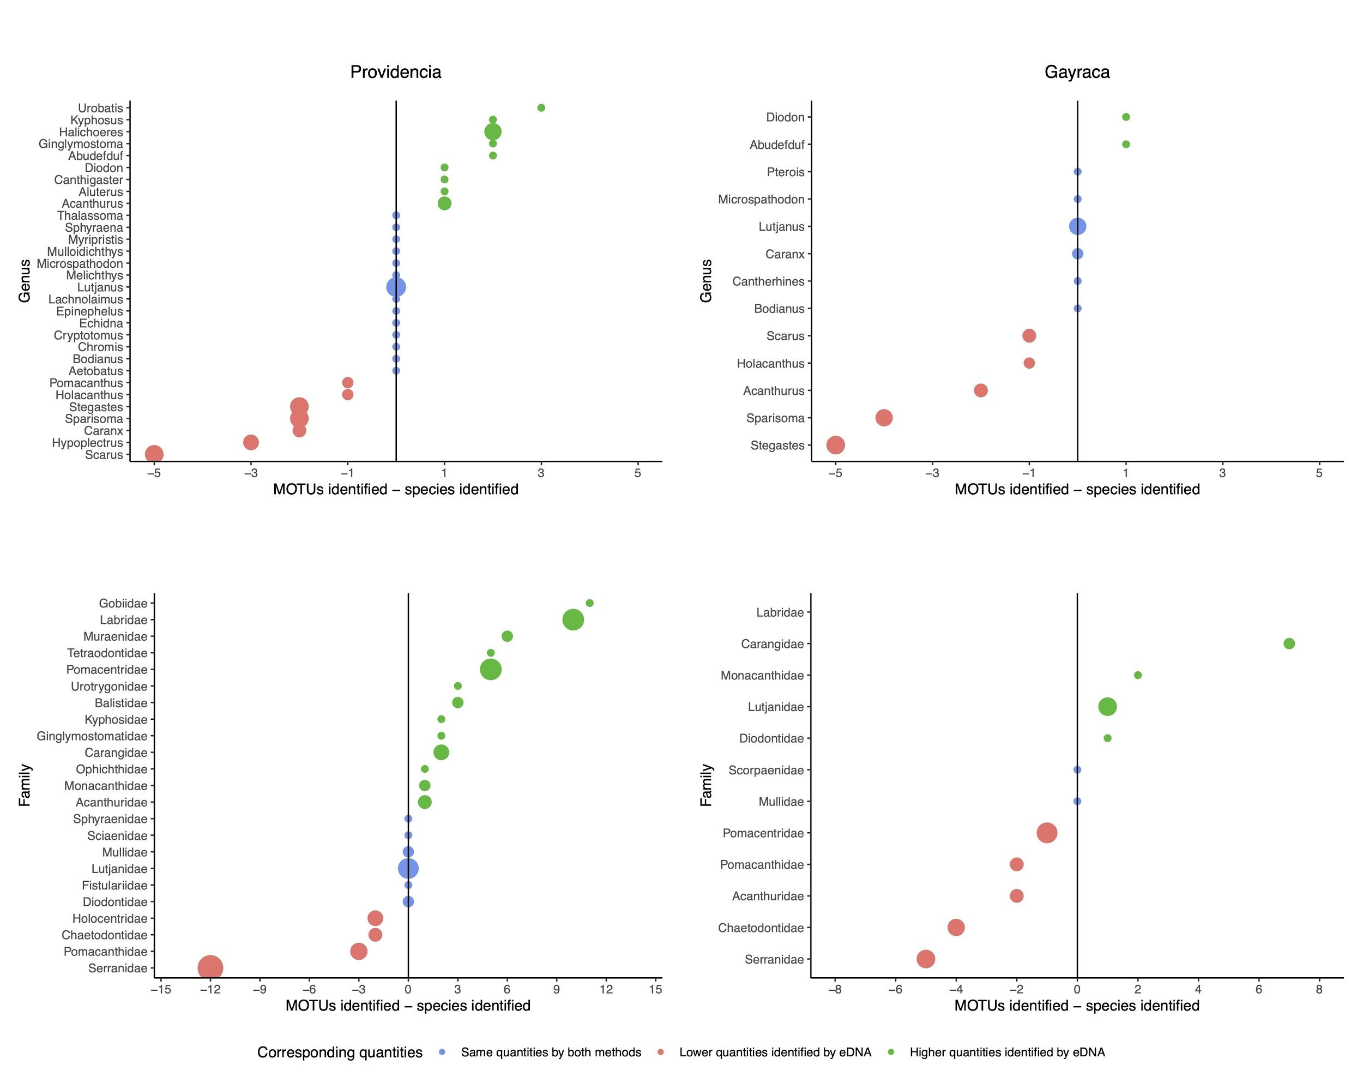
Figure S1. Distribution of MOTU reads and of the number of species per genus (top row) and per family (bottom row) for Providencia (left column) and Gayraca Bay (right column). The size of the dots corresponds to the number of species per genus or family found in the UVCs. The dot size is log+1 scaled. Many more families were detected in the eDNA than in the UVCs.

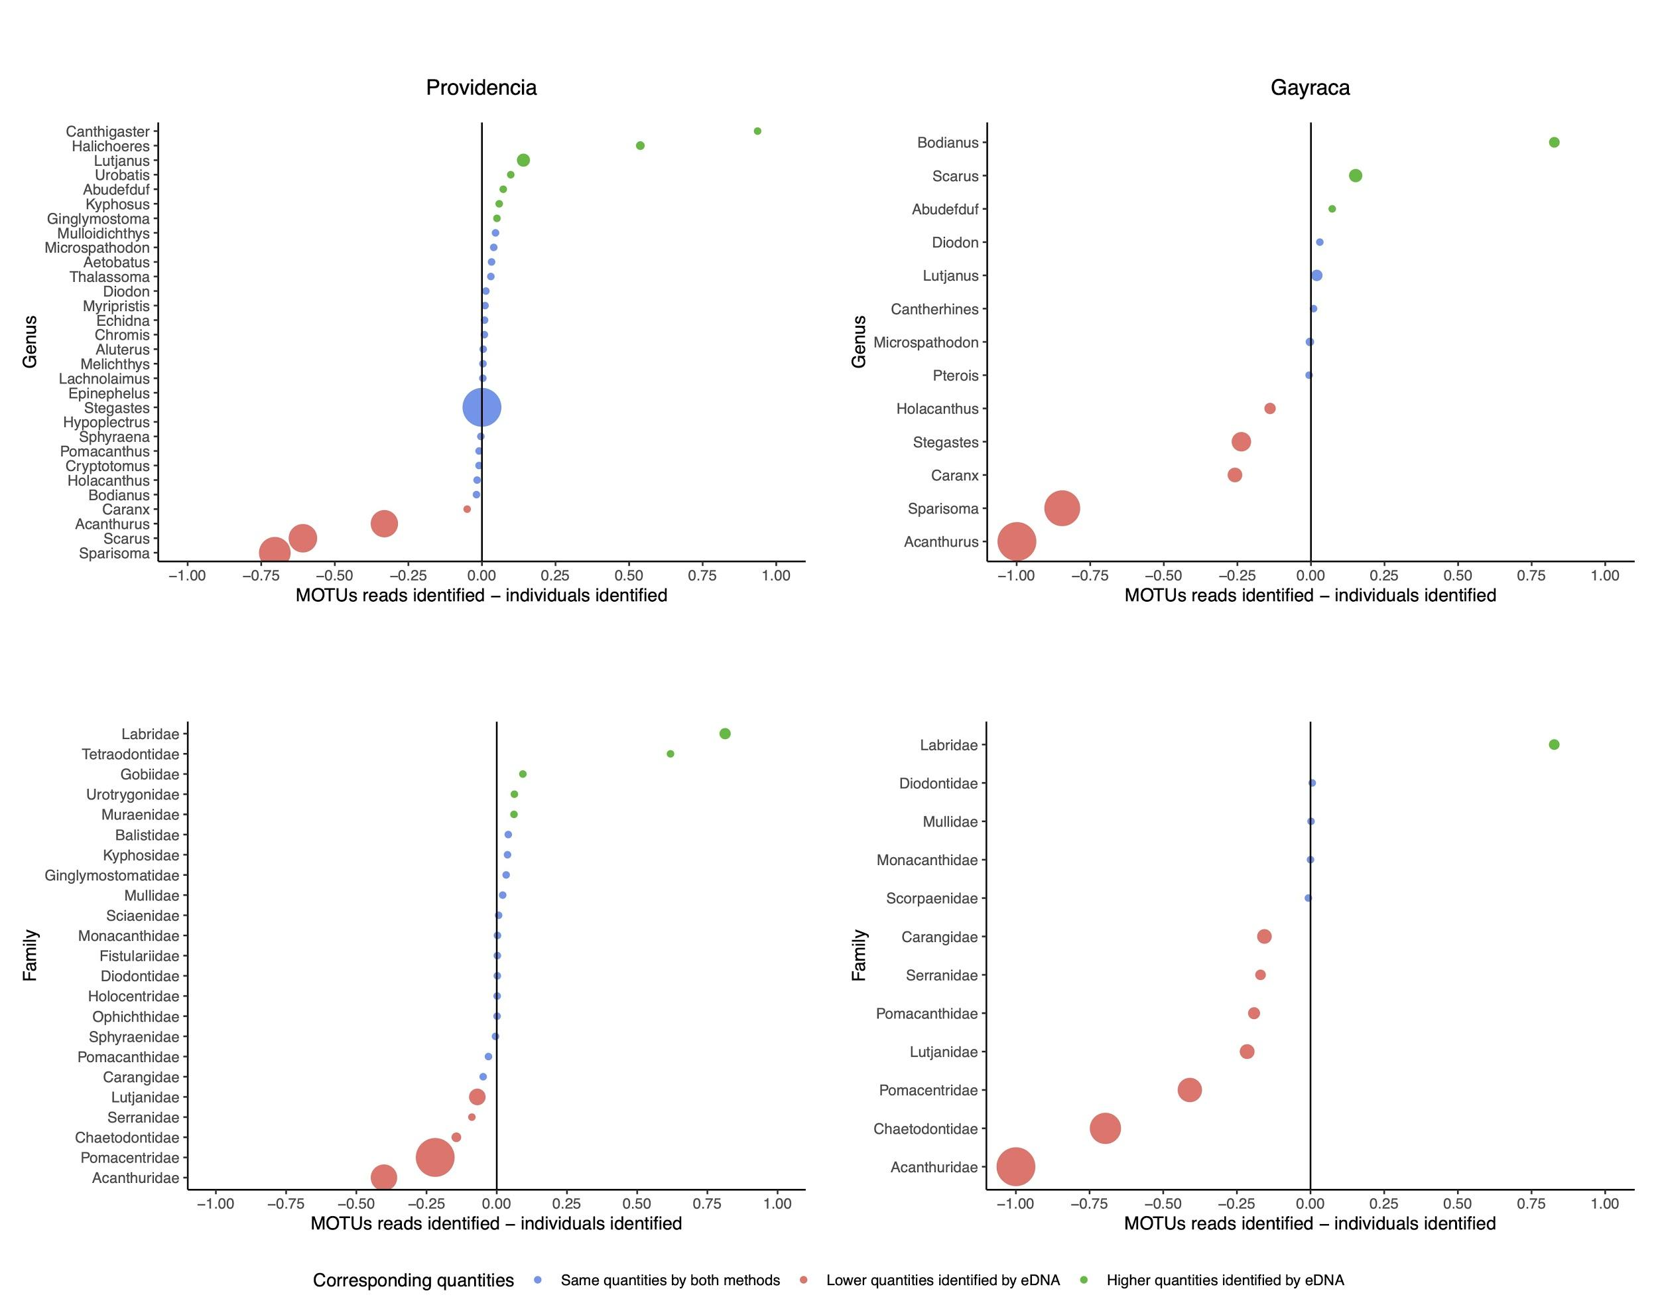
Figure S2. Distribution of MOTU reads and of the number of individuals per genus (top row) and per family (bottom row) for Providencia (left column) and Gayraca Bay (right column). The number of MOTU reads and individuals counted in the UVCs were scaled between zero and one for their comparison. The size of the dots is proportional to the number of individuals per genus or family counted in the UVCs.
Figure S3. (A) Compositional differences (PCoA) from the MOTU presence–absence matrix between the eDNA sampling stations in Providencia. (B) Transects maps of Providencia, where colors correspond to the position of the transect in the ordination space.

