Figure S1: 3D textured meshes of Sab-1, Sab-3 and Sab-4 hummocks over the whole sampling period (from 3rd of December 2016 to 31st of December 2017). The surrounding sea bottom was not removed, and the colonies are shown before cropping for a better visualization of habitat modification due to the variation of hydrodynamics conditions

Figure S2: Annual variation of sea state conditions according to mean daily values of the Douglas scale. Sampling dates of underwater photographs of *Sabellaria* colonies are shown in bold. Red trend line represents loess fitting with confidence bands.

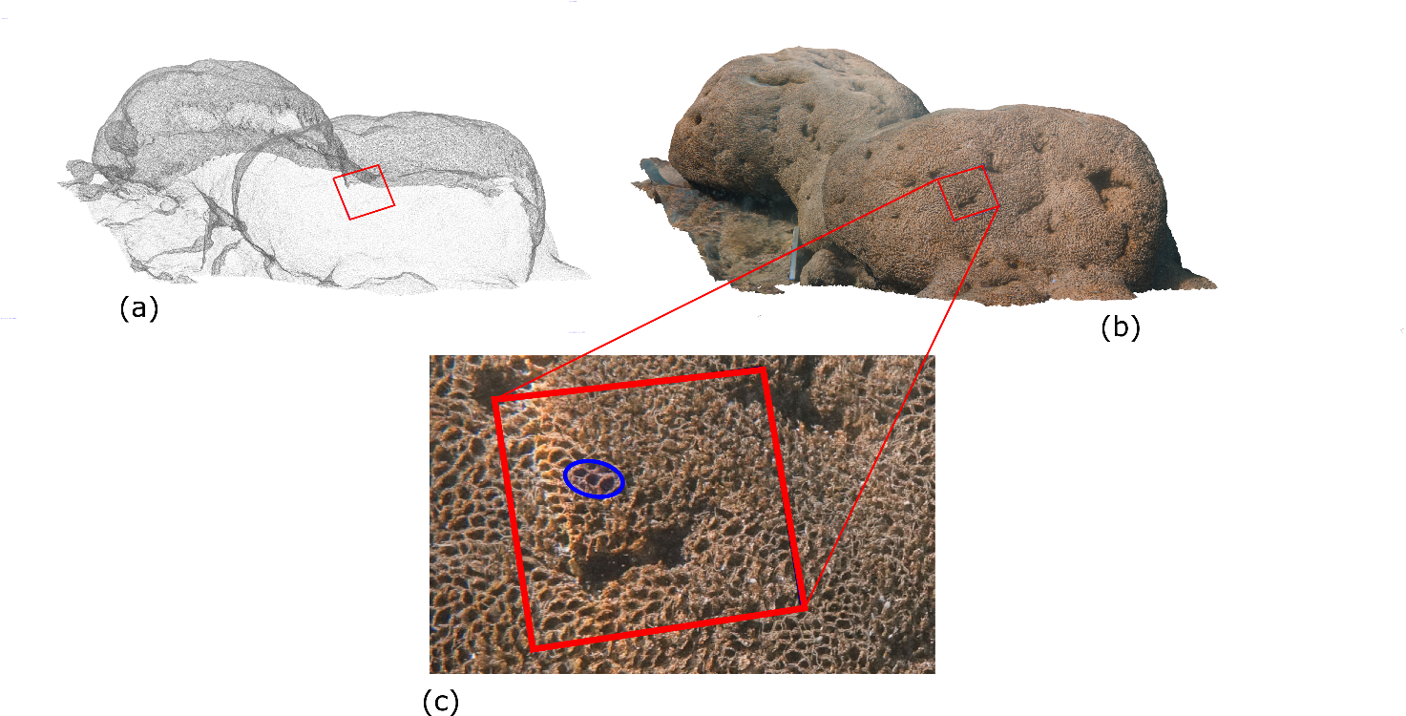

Figure S3: Measurement of the density of worm tubes with virtual 10 x 10 cm frames. (a) 3D mesh of the hummocky (Sab-4). (b) Textured model of the colony. (c) View of the virtual frame (in red) laying on the colony for the count of sandy tubes of Sabellaria worms. Three well defined “sand crown” (indicating living worms) are highlighted by the blue ellipse.

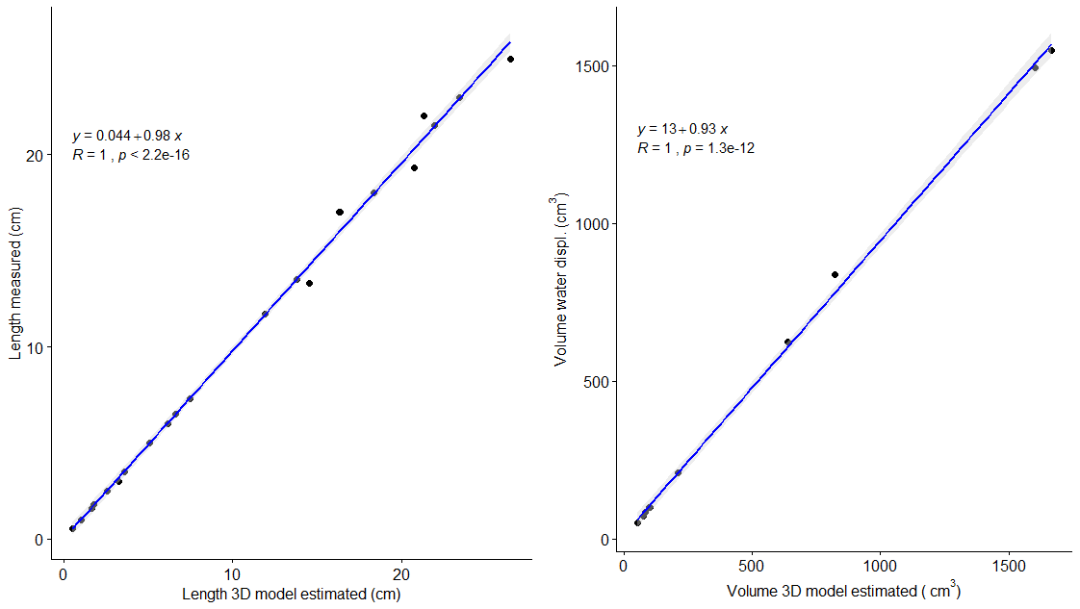

Figure S4: Accuracy of 3D models of pebbles used for testing proportional accuracy and to assess procedural errors expressed in terms of linear length and volume. A strong linear correlation between measured and estimated dimensions was found for both length (cm) and volume (cm3). 3D models slightly overestimated the real dimensions of the objects as indicated by the slopes of the regression plots.

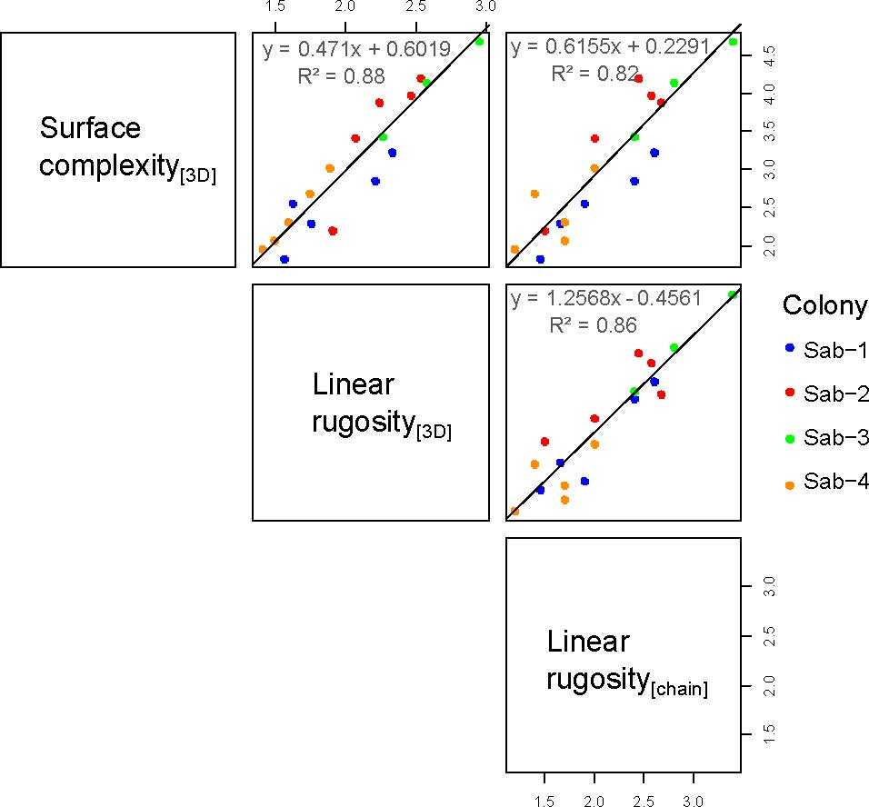

Figure S5: Correlation matrix of model-based surface complexity metrics (3D surface complexity or *SurfC[3D]* and virtual “chain-and-tape” method for the estimation of averaged linear rugosity or *LR[3D]*) against *in-situ* traditional “chain-and-tape” measurements (*LR[chain]*). Note that the length of each chain link was 1 cm.

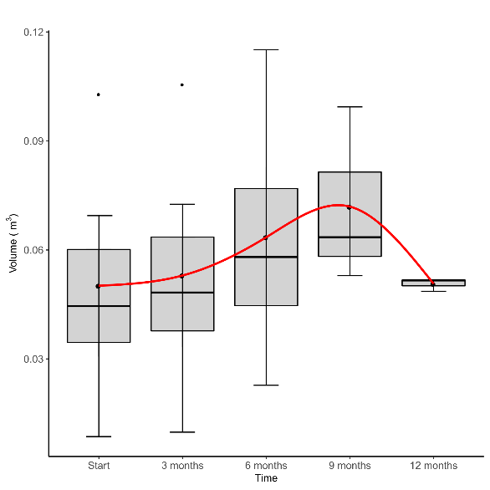

Figure S6: Box plots of volumetric change over the whole sampling period of *Sabellaria* hummocks. Red line represents the smoothed spline where the knots are fixed to the mean *V[3D]* values (pooled data from the four colonies).

**The Bayesian model estimation: implementation details**

The model was estimated using JAGS with the following code stored in the file prog1_3c.txt:

model{

#likelihood definition

for(j in 1:N){

for(i in 1:nv){

Y[j,i]~dnorm(mu[j,i],tauy[idCol[j]])

mu[j,i]=beta0[i,idCol[j]]+beta1[indDougmin[j],i]+beta2[indDougmax[j],i]+beta3[i,time[j]]

##predicted values

Ypred[j,i]~dnorm(mu[j,i],tauy[idCol[j]])

}

}

### priors

Q~dwish(R,k)

R1<-R*0.01

beta0[1:nv,4]~dmnorm(mm,Q)

beta0[1:nv,2]~dmnorm(mm,Q)

beta0[1:nv,3]~dmnorm(mm,Q)

beta0[1:nv,1]<-mm

beta1[1,1:nv]<-mm

beta2[1,1:nv]<-mm

for(i in 2:7){

beta1[i,1:nv]~dmnorm(mm,R1)

}

for(i in 2:6){

beta2[i,1:nv]~dmnorm(mm,R1)

}

for(i in 1:4){

tauy[i]~dgamma(2,2)

}

beta3[1:nv,1]~dmnorm(mm,R1)

beta3[1:nv,2]~dmnorm(mm,R1)

beta3[1:nv,3]<-mm

}

To run this code the following R commands where used:

library(readr)

library(R2jags)

library(ggplot2)

#### read data from file

datI <- read_delim("Sabellaria metrics interpolated.csv", ";", escape_double = FALSE, trim_ws = TRUE)

## select only the necessary variable

dat<-datI[,c(1,2,5,7,9,11,13:19)]

## transform the date variable into a Date class element

dd<-sub("/","-",as.character(datI$Date))

dd<-sub("/","-",dd)

dat$Date<-as.Date(dd,format="%d-%m-%Y")

## response variables

Y=dat[,c(3:7)]

#seasonal factor

pp1<-ifelse(dat$Month%in%c(1,2,11,12),1,ifelse(dat$Month%in% c(3,4,5,6),2,3))

#########

## Define data to be passed to JAGS

tobeloaded<-list(

Y=apply(scale(Y,center=F),2,log), #response standardized and log-tranformed

N=nrow(dat),

nv=5,

indDougmin=dat$Douglas.Scale.min+1, #index to handle mean elements linked to the minimum Douglas scale in the data it starts from 0 hence we need to add 1

indDougmax=dat$Douglas.Scale.max, #index to handle mean elements linked to the maximum Douglas

R=solve(cor(Y,use="complete.obs")), #prior precision matrix

k=15, #Wishart prior degrees of freedom

mm=rep(0,5), # mean of the multivariate normal priors

idCol=as.numeric(factor(dat$Colony)), #colony index

time=pp1 # seasonal effect

)

### MCMC inputs: number of iterations, burn-in and thinning definition

niter=200000

nburn=niter/2

nthin=10

## names of objects to be saved from the JAGS run

partosave<-c("beta0","beta1","beta2","beta3","Q","tauy", "Ypred")

### call to JAGS

fit4b.l<-jags(data=tobeloaded,parameters.to.save=partosave,n.chain=2, n.iter=niter,n.thin=nthin,n.burnin=nburn,jags.seed=1234, model.file="prog1_3c.txt")

### MCMC output elaboration

Ypred<-fit4b.l$BUGSoutput$sims.matrix[,grep("Ypred",colnames(fit4b.l$BUGSoutput$sims.matrix))]

Ypred.est<-apply(Ypred,2,mean) #point estimates

qq<-apply(Ypred,2,quantile,prob=c(0.025,0.975))# 95% credibility intervals

### build data.frames to draw plots using ggplot2

w<-grep(",1]",names(Ypred.est))

V.est<-data.frame(low=qq[1,w],est=Ypred.est[w],up=qq[2,w])

w<-grep(",2]",names(Ypred.est))

Sc.est<-data.frame(low=qq[1,w],est=Ypred.est[w],up=qq[2,w])

w<-grep(",3]",names(Ypred.est))

Nh.est<-data.frame(low=qq[1,w],est=Ypred.est[w],up=qq[2,w])

w<-grep(",4]",names(Ypred.est))

MNh.est<-data.frame(low=qq[1,w],est=Ypred.est[w],up=qq[2,w])

w<-grep(",5]",names(Ypred.est))

SanCr.est<-data.frame(low=qq[1,w],est=Ypred.est[w],up=qq[2,w])

### transform data to compare with estimates

Y1<-apply(scale(dat[,c(3,4,5,6,7)],center=F),2,log)

colony<-factor(dat$Colony)

timeline<-dat$Date

#### Figure S7

ggplot(data=V.est, aes(x=timeline,y=est))+

geom_errorbar(aes(ymin=low,ymax=up),width=0.1,show.legend=F,colour="gray")+

geom_smooth(show.legend = F,colour="blue")+

geom_smooth(aes(y=Y1[,1]),colour="black")+

scale_x_date(date_labels=c("%m-%Y"))+

facet_wrap(~dat$Colony)+

ggtitle(expression(V["[3D]"]))

ggplot(data=Sc.est, aes(x=timeline,y=est,colour=colony))+

geom_errorbar(aes(ymin=low,ymax=up),width=0.1,show.legend=F,colour="gray")+

geom_smooth(show.legend = F,colour="blue")+

geom_smooth(aes(y=Y1[,2]),colour="black")+

scale_x_date(date_labels=c("%m-%Y"))+

facet_wrap(~dat$Colony)+

ggtitle(expression(Scomplex["[3D]"]))

ggplot(data=Nh.est, aes(x=timeline,y=est,colour=colony))+

geom_errorbar(aes(ymin=low,ymax=up),width=0.1,show.legend=F,colour="gray")+

geom_smooth(show.legend = F,colour="blue")+

geom_smooth(aes(y=Y1[,3]),colour="black")+

scale_x_date(date_labels=c("%m-%Y"))+

facet_wrap(~dat$Colony)+

ggtitle(N["[holes]"])

ggplot(data=MNh.est, aes(x=timeline,y=est,colour=colony),show.legend = F)+

geom_errorbar(aes(ymin=low,ymax=up),width=0.1,show.legend=F,colour="gray")+

geom_smooth(show.legend = F,colour="blue")+

geom_smooth(aes(y=Y1[,4]),colour="black")+

scale_x_date(date_labels=c("%m-%Y"))+

facet_wrap(~dat$Colony)+

ggtitle(S["[holes]"])

ggplot(data=SanCr.est, aes(x=timeline,y=est,colour=colony),show.legend = F)+

geom_errorbar(aes(ymin=low,ymax=up),width=0.1,show.legend=F,colour="gray")+

geom_smooth(show.legend = F,colour="blue")+

geom_smooth(aes(y=Y1[,5]),colour="black")+

scale_x_date(date_labels=c("%m-%Y"))+

facet_wrap(~dat$Colony)+

ggtitle("SandCD")

####### Mean components and plots

beta0<-fit4b.l$BUGSoutput$sims.matrix[,grep("beta0",colnames(fit4b.l$BUGSoutput$sims.matrix))]

beta0.pest<-apply(beta0,2,mean)

beta0.ci<-apply(beta0,2,quantile,prob=c(0.025,0.975))

beta1<-fit4b.l$BUGSoutput$sims.matrix[,grep("beta1",colnames(fit4b.l$BUGSoutput$sims.matrix))]

beta1.pest<-apply(beta1,2,mean)

beta1.ci<-apply(beta1,2,quantile,prob=c(0.025,0.975))

beta2<-fit4b.l$BUGSoutput$sims.matrix[,grep("beta2",colnames(fit4b.l$BUGSoutput$sims.matrix))]

beta2.pest<-apply(beta2,2,mean)

beta2.ci<-apply(beta2,2,quantile,prob=c(0.025,0.975))

beta3<-fit4b.l$BUGSoutput$sims.matrix[,grep("beta3",colnames(fit4b.l$BUGSoutput$sims.matrix))]

beta3.pest<-apply(beta3,2,mean)

beta3.ci<-apply(beta3,2,quantile,prob=c(0.025,0.975))

## dataframes to be used with ggplot2

dd<-data.frame(low=beta0.ci[1,],est=beta0.pest,up=beta0.ci[2,])

row.names(dd)<-names(beta0.pest)

dd1<-dd[order(names(beta0.pest)),]

dd1.0<-data.frame(low=beta1.ci[1,],est=beta1.pest,up=beta1.ci[2,])

row.names(dd1.0)<-names(beta1.pest)

dd1.1<-dd1.0[order(names(beta1.pest)),]

dd2<-data.frame(low=beta2.ci[1,],est=beta2.pest,up=beta2.ci[2,])

row.names(dd2)<-names(beta2.pest)

dd2.1<-dd2[order(names(beta2.pest)),]

dd3<-data.frame(low=beta3.ci[1,],est=beta3.pest,up=beta3.ci[2,])

row.names(dd3)<-names(beta3.pest)[1:15]

dd3.1<-dd3[order(names(beta3.pest[1:15])),]

etic<-c("V","Scomp","Nholes","MeanSizeHoles","SanCr")

dd1$Colony<-rep(unique(colony),length=nrow(dd1))

dd1$variable<-factor(rep(etic,each=4))

dd1.1$seastate<-factor(rep(c(0:6),each=5))

dd1.1$variable<-factor(rep(etic,length=nrow(dd1.1)))

dd2.1$seastate<-factor(rep(c(1:6),each=5))

dd2.1$variable<-factor(rep(etic,length=nrow(dd2.1)))

dd3.1$quarter<-factor(rep(c("late autum - winter","spring - early summer","late summer - early autum"),length=nrow(dd3.1)), levels = c("late autum - winter","spring - early summer","late summer - early autum") )

dd3.1$variable<-factor(rep(etic,each=3) )

### labels including expressions in ggplot

mf_labeller<-function(value,val){

value <- as.character(value)

value[val=="V"] <- expression(V["[3D]"])

value[val=="Scomp"] <- expression(S["complex[3D]"])

value[val=="Nholes"] <- expression(N["[holes]"])

value[val=="MeanSizeHoles"] <- expression(S["[holes]"])

value[val=="SanCr"] <- "SandCD"

#value[value=="ff"] <- "Final"

return(value)

}

vv<-mf_labeller(value=dd1$variable, val=dd1$variable )

dd1$vv<-as.character(vv)

vv<-mf_labeller(value=dd1.1$variable, val=dd1.1$variable )

dd1.1$vv<-as.character(vv)

vv<-mf_labeller(value=dd2.1$variable, val=dd2.1$variable )

dd2.1$vv<-as.character(vv)

vv<-mf_labeller(value=dd3.1$variable, val=dd3.1$variable )

dd3.1$vv<-as.character(vv)

pdf("Fig9_a.pdf")

ggplot(dd1,aes(x=Colony,y=est)) +

geom_point()+

geom_errorbar(aes(ymin=low,ymax=up,colour=variable),show.legend = F)+

facet_wrap(~vv, labeller = label_parsed)+ggtitle(expression(paste("Mean effect by variable: ", beta[0])))

dev.off()

pdf("Fig9_c.pdf")

ggplot(dd1.1,aes(x=seastate,y=est)) +

geom_point()+

geom_errorbar(aes(ymin=low,ymax=up,colour=variable),show.legend = F)+

facet_wrap(~vv, labeller = label_parsed) +ggtitle(expression(paste("Minimum Douglas Scale effect: ", beta[1])))

dev.off()

pdf("Fig9_b.pdf")

ggplot(dd2.1,aes(x=seastate,y=est)) +

geom_point()+

geom_errorbar(aes(ymin=low,ymax=up,colour=variable),show.legend = F)+

facet_wrap(~vv, labeller = label_parsed) +ggtitle(expression(paste("Maximum Douglas Scale effect: ", beta[2])))

dev.off()

pdf("Fig9_d.pdf")

ggplot(dd3.1,aes(x=quarter,y=est)) +

geom_point()+

geom_errorbar(aes(ymin=low,ymax=up,colour=variable),show.legend = F)+

theme(axis.text.x = element_text(angle=90))+ggtitle(expression(paste("Seasonal effect: ",beta[3])))+

facet_wrap(~vv, labeller = label_parsed)

dev.off()

## Residual precision estimation

tau<-fit4b.l$BUGSoutput$sims.matrix[,grep("tauy",colnames(fit4b.l$BUGSoutput$sims.matrix))]

tau.est<-apply(tau,2,mean)

apply(tau,2,ts.plot)

tau.ci<-apply(tau,2,quantile,prob=c(0.025,0.975))

dd.tau<-data.frame(low=tau.ci[1,],est=tau.est,up=tau.ci[2,],colony=levels(colony))

ggplot(dd.tau,aes(x=colony,y=est))+

geom_point()+

geom_errorbar(aes(ymin=up,ymax=low),show.legend = F)

#### Residual variance estimation

sigma<-1/tau

sigma.est<-apply(sigma,2,mean)

sigma.ci<-apply(sigma,2,quantile,prob=c(0.025,0.975))

dd.sigma<-data.frame(low=sigma.ci[1,],est=sigma.est,up=sigma.ci[2,],colony=levels(colony))

### Figure S8

ggplot(dd.sigma,aes(x=colony,y=est))+

geom_point()+

geom_errorbar(aes(ymin=up,ymax=low),show.legend = F)+ ggtitle("Residual variance")

|  |  |
| --- | --- |
| (a) | (b) |
| (c) | (d) |
| (e) | |

Fig. S7: Fitting results of the Bayesian model to investigate the effects of sea state (Douglas scale) at colony-level on the main *Sabellaria* metrics extracted from 3D models. Smoothed lines represent the data (black) and the estimates (blue) (a) Volume, (b) Surface complexity, (c) Number of holes (d) Mean number of holes, (e) Sand Crowns. Grey segments delimit 95% credibility intervals.



Fig. S8: Residual variance per colony from the Bayesian model to investigate the effects of sea state (Douglas scale) on the main *Sabellaria* metrics extracted from 3D models and their 95% credibility intervals.