Electronic Supporting Information (ESI)

A comprehensive evaluation of two sample treatment procedures for the determination of emerging and historical halogenated flame retardants in biota

I. Tolosa¹*, D. Huertas¹, S. Choyke¹, S. Sander¹, Y. Aminot^{1,2,}

- IAEA Environment Laboratories, 4a Quai Antoine 1er, 98000 Monaco
- current address: IFREMER, Laboratory of Biogeochemistry of Organic Contaminants, Rue de l’Ile d’Yeu, BP 21105, 44311 Nantes Cedex 3, France
*Corresponding author: I.Tolosa@iaea.org

Table S1. List of halogenated flame retardants investigated in this study. Adapted from Bergman et al., 2012.
CAS number | acronym | Structure | Common and trade names | MW | Log Kow | Koc | pKa | Vapor pressure (Pa)
118-79-6 | TBP | 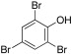 | 2,4,6-Tribromophenol | 330.8 | 4.4 | pH-dep. | 6.34 ± 0.23 | 2.00E-01
3278-89-5 | TBP-AE | 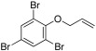 | 2,4,6-Tribromophenyl allyl ether | 370.8 | 5.04 | 13,100 | na | 2.40E-02
87-83-2 | PBT | 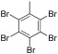 | Pentabromotoluene | 486.62 | 6.25 | 60,200 | na | 6.00E-04
85-22-3 | PBEB | 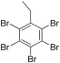 | Pentabromoethylbenzene | 500.65 | 6.76 | 1.14E + 05 | na | 1.56E-04
183658-27-7 | EHTBB | 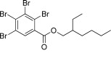 | 2-Ethylhexyl 2,3,4,5-tetrabromobenzoate | 549.92 | 7.73 | 3.82E + 05 | na | 3.71E-07
608-90-2 | PBB | 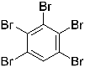 | Pentabromobenzene | 472.59 | 5.4 |  | 6.5e-4
87-82-1 | HBB | 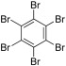 | Hexabromobenzene | 551.49 | 6.11 | 50,300 | na | 1.14E-04
59447-55-1 | PBB-Acr | 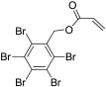 | Pentabromobenzyl acrylate | 556.67 | 5.6 | 26,500 | na | 3.64E-07
26040-51-7 | BEH-TEBP | 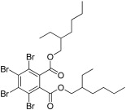 | Bis(2-ethylhexyl) tetrabromophthalate | 706.14 | 9.34 | 2.88E + 06 | na | 1.55E-11
79-94-7 | TBBPA | 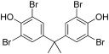 | Tetrabromobisphenol A | 543.87 | 9.69 | 4.47E + 06 | 7.5/8.5 ± 0.1 | 1.88E-05
37853-61-5 | TBBPA-BME | 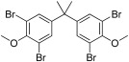 | Tetrabromobisphenol A bismethyl ether | 571.92 | 10.35 | 1.00E + 07 | na | 2.25E-06
37853-59-1 | BTBPE | 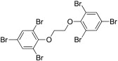 | 1,2-Bis(2,4,6-tribromophenoxy)ethane | 687.64 | 8.31 | 7.92E + 05 | na | na
84852-53-9 | DBDPE | 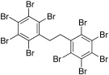 | Decabromodiphenyl ethane | 971.22 | 11.1 | 1.00E + 07 | na | na
 | PBDE | 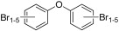 | Polybrominated diphenyl ethers
3322-93-8 | DBE-DBCH  (α, β) | 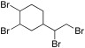 | 4-(1,2-Dibromoethyl)-1,2-dibromocyclohexane | 427.8 | 4.82 | 10,000 | na | 2.97E-03
51936-55-1 | DBHCTD | 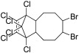 | 5,6-Dibromo-1,10,11,12,13,13-hexachloro-11-tricyclo[8.2.1.02,9]tridecene | 540.76 | 7.62 | 3.32E + 05 | na | 8.27E-07
3194-55-6 | HBCDD  ( α, β, γ) | 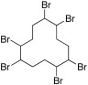 | 1,2,5,6,9,10-Hexabromocyclododecane | 641.7 | 7.92 | 4.86E + 05 | na | 1.04E-07
31107-44-5 | DDC-DBF  (Dec 602) | 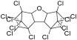 | 1,2,3,4,6,7,8,9,10,10,11,11-Dodecachloro-1,4,4a,5a,6,9,9a,9b-octahydro-1,4:6,9-dimethanodibenzofuran; Dechlorane 602 | 613.62 | 8.3 | 7.78E + 05 | na | 1.48E-09
13560-89-9 | DDC-CO  (syn and anti) | 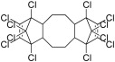 | Dodecachlorodimethanodibenzocyclooctane; Dechlorane Plus | 653.72 | 10.12 | 7.67E + 06 | na | 1.37E-11
13560-92-4 | DDC-Ant  (Dec 603) | 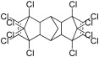 | 1,2,3,4,5,6,7,8,12,12,13,13-Dodecachloro-1,4,4a,5,8,8a,9,9a,10,10a-decahydro-1,4:5,8:9,10-Trimethanoanthracene; Dechlorane 603 | 637.68 | 9.14 | 2.24E + 06 | na | 9.16E-10

Table S2. GPC injection program.

Mobile phase | 100 % DCM
Flow rate | 1 mL/min
Injection loop | 2000 µL
Injection volume | 950 µL
Injection solvent | 100 % DCM
Columns | 2 Agilent PLGel columns in series: PLgel particle diameter 5 µm, pore size 50 Å, 300 x 7.5 mm
Column temp | 20 °C
Detection | PDA 254 nm

Table S3. Partisil injection program.

Mobile phase | Gradient containing hexane, DCM, and methanol
Flow rate | 0.5 mL/min
Injection loop | 2000 µL
Injection volume | 400 µL
Injection solvent | 100 % hexane
Column | 1 Interchim Partisil column: PAC5, particle diameter 5 µm, 250 x 4.0 mm with pre-column of the same phase
Column temp | 20 °C
Detection | PDA 254 & 235 nm

Table S4. Mobile phase composition of the HPLC fractionation on the Partisil column.
Time (min) | %Hexane | %DCM | %Methanol
0 | 100 | 0 | 0
10 | 100 | 0 | 0
15 | 80 | 20 | 0
20 | 0 | 100 | 0
30 | 0 | 100 | 0
35 | 0 | 95 | 5
60 | 0 | 95 | 5
65 | 0 | 100 | 0
70 | 100 | 0 | 0

Table S5. GC mass spectrometer optimised parameters, range of calibration concentrations, correlation coefficient (r) and instrumental limit of detection (ILOD) defined as 3 times the signal-to-noise (S/N) ratio calculated from MassHunter software using the root-mean-square (RMS) algorithm and a noise standard deviation multiplier of 5.

Compound | Target Transition | Collision Energy eV | Confirmation Transition | Collision Energy eV | Confirmation Transition 2 | Collision Energy eV | Calibrate concentration  (ng ml⁻¹) | r | ILOD (pg)
TCMX | 244.0 -> 209.0 | 15 | 171.0 -> 136.0 | 15 |  |  |  |  | 0.1
BDE 17 | 406.0 -> 246.0 | 20 | 406.0 -> 167.0 | 25 | 408.0 -> 248.0 | 22 | 6.25-400 | 0.999 | 0.5
BDE 28 | 406.0 -> 246.0 | 20 | 406.0 -> 167.0 | 25 | 408.0 -> 248.0 | 22 | 6.25-400 | 0.998 | 0.7
BDE 71 | 484.0 -> 324.0 | 32 | 325.0 -> 217.0 | 30 | 327.0 -> 219.0 | 30 | 6.25-400 | 0.998 | 1.2
BDE 47 | 484.0 -> 324.0 | 32 | 325.0 -> 217.0 | 30 | 327.0 -> 219.0 | 30 | 6.25-400 | 0.998 | 0.8
BDE 66 | 484.0 -> 324.0 | 32 | 325.0 -> 217.0 | 30 | 327.0 -> 219.0 | 30 | 6.25-400 | 0.996 | 1.5
BDE 100 | 404.0 -> 297.0 | 20 | 564.0 -> 404.0 | 35 | 406.0 -> 299.0 | 35 | 6.25-400 | 0.994 | 0.7
BDE 99 | 404.0 -> 297.0 | 20 | 564.0 -> 404.0 | 35 | 406.0 -> 299.0 | 35 | 6.25-400 | 0.997 | 0.8
BDE 85 | 404.0 -> 297.0 | 20 | 564.0 -> 404.0 | 35 | 406.0 -> 299.0 | 35 | 6.25-400 | 0.995 | 2
BDE 154 | 484.0 -> 324.0 | 20 | 644.0 -> 484.0 | 40 |  |  | 6.25-400 | 0.996 | 2.2
BDE 153 | 484.0 -> 324.0 | 20 | 644.0 -> 484.0 | 40 |  |  | 6.25-400 | 0.997 | 1.7
BDE 138 | 644.0 -> 484.0 | 20 | 484.0 -> 324.0 | 40 |  |  | 6.25-400 | 0.997 | 3.6
BDE 183 | 562.0 -> 455.0 | 17 | 722.0 -> 562.0 | 45 |  |  | 6.25-400 | 0.993 | 8.3
BDE 190 | 564.0 -> 457.0 | 45 |  |  |  |  | 6.25-400 | 0.996 | 13
BDE 209 | 799.4 -> 799.4 | 15 | 799.4 -> 639.7 | 45 | 797.5 -> 637.7 | 45 | 62.5-2000 | 0.991 | 19
TBP-AE | 369.8 -> 210.0 | 10 | 369.8 -> 131.0 | 25 |  |  | 10-400 | 0.999 | 0.9
DBE-DBCH-α | 267.1 -> 105.1 | 15 | 187.1 -> 105.1 | 15 |  |  | 10-400 | 0.999 | 1.1
DBE-DBCH-β | 267.1 -> 105.1 | 15 | 187.1 -> 105.1 | 15 |  |  | 10-400 | 0.999 | 1.5
PBB | 474.2 -> 313.9 | 10 | 474.2 -> 392.8 | 45 | 474.2 -> 474.2 | 30 | 6.25-400 | 0.993 | 1.6
PBT | 485.6 -> 246.9 | 20 | 485.6 -> 406.8 | 55 |  |  | 10-400 | 0.998 | 0.2
PBEB | 499.7 -> 484.8 | 20 | 499.7 -> 324.8 | 50 |  |  | 10-400 | 0.999 | 0.5
HBB | 552.2 -> 552.2 | 10 | 552.2 -> 391.5 | 45 | 552.2 -> 472.5 | 25 | 6.25-400 | 0.996 | 7.9
PBB-Acr | 476.9 -> 448.9 | 5 | 476.7 -> 369.8 | 15 |  |  | 6.25-400 |  | 20
Dec 602 | 272.0 -> 236.9 | 15 | 272.0 -> 140.9 | 35 | 272.0 -> 234.9 | 15 | 6.25-400 | 0.999 | 0.1
DBHCTD | 268.1 -> 107.1 | 5 | 344.8 -> 236.8 | 10 |  |  | 10-400 | 0.996 | 0.1
EHTBB | 420.9 -> 392.8 | 20 | 420.9 -> 311.9 | 40 |  |  | 10-400 | 0.990 | 3.5
TBBPA-BME | 556.9 -> 291.0 | 25 | 556.9 -> 273.1 | 55 | 556.9 -> 382.1 | 30 | 10-400 | 0.993 | 1.2
Dec 603 | 262.8 -> 262.8 | 15 | 262.8 -> 192.9 | 35 | 262.8 -> 190.9 | 35 | 6.25-400 | 0.997 | 0.3
BTBPE | 356.9 -> 251.9 | 15 | 356.9 -> 277.9 | 25 |  |  | 10-400 | 0.997 | 11
BEH-TEBP | 464.9 -> 220.9 | 40 | 464.9 -> 380.7 | 55 |  |  | 10-400 | 0.999 | 12.5
DDC-CO syn | 272.0 -> 236.9 | 15 | 272.0 -> 117.0 | 45 | 272.0 -> 234.9 | 15 | 6.25-400 | 0.999 | 0.1
DDC-CO anti | 272.0 -> 236.9 | 15 | 272.0 -> 117.0 | 45 | 272.0 -> 234.9 | 15 | 6.25-400 | 0.998 | 0.1
DBDPE | 487.1 -> 326.8 | 45 | 487.1 -> 407.6 | 20 | 487.1 -> 405.7 | 20 | 62.5-2000 | 0.998 | 46
¹³C₁₂ BDE 77 | 498.0 -> 338.0 | 30 |  |  |  |  |  |  | 0.1
¹³C₁₂ BDE 118 | 578.0 -> 416.0 | 35 |  |  |  |  |  |  | 0.4
¹³C₁₂ BDE 183 | 574.0 -> 574.0 | 5 |  |  |  |  |  |  | 0.5

Table S6. LC mass spectrometer optimised parameters (MRM mode, dwell time of 24 ms), range of calibration concentrations, correlation coefficient (r) and instrumental limit of detection (ILOD) defined as 3 times the signal-to-noise (S/N) ratio.
Compound | Cone voltage (V) | Target transition | Collision energy (eV) | Confirmation transition 1 | Collision energy (eV) | Confirmation transition 2 | Collision energy (eV) | Calibrate concentration  (ng ml⁻¹) | r | ILOD  (pg)
Bisphenol A | 45 | 227>212 | 18 | 227>133 | 25 | / | / | 3.9-2000 | 0.999 | 1
TBP | 50 | 328.9>78.8 | 30 | 328.9>80.8 | 30 | / | 30 | 3.9-2000 | 0.998 | 0.7
TBBPA | 60 | 540.7>417.8 | 40 | 542.6>419.7 | 40 | / | / | 3.9-2000 | 0.996 | 0.2
α-HBCDD | 20 | 640.8>80.8 | 20 | 642.8>80.8 | 20 | 640.8>78.8 | 20 | 3.9-2000 | 0.998 | 0.4
β-HBCDD | 20 | 640.8>80.8 | 20 | 642.8>80.8 | 20 | 640.8>78.8 | 20 | 3.9-2000 | 0.998 | 0.3
γ-HBCDD | 20 | 640.8>80.8 | 20 | 642.8>80.8 | 20 | 640.8>78.8 | 20 | 3.9-2000 | 0.998 | 0.3
¹³C₁₂TBBPA | 60 | 554.8>459.9 | 40 |  |  | / | /
d₁₈ α-HBCDD | 20 | 657.8>80.8 | 20 | 659.9>80.8 | 20 | / | /
d₁₈ β-HBCDD | 20 | 657.8>80.8 | 20 | 659.9>80.8 | 20 | / | /
d₁₈ γ-HBCDD | 20 | 657.8>80.8 | 20 | 659.9>80.8 | 20 | / | /

Table S7. Summary of percent recovery, repeatability, reproducibility and MDL of the two treatment procedures for 4 g of sample. MDL calculated as the average of blanks with 3 times standard deviation.

 |  |  |  | H₂SO₄-SILICA |  |  |  |  | GPC-PARTISIL
 | Average  Recoveries (%) |  | Repeatability  RSD (%)  n=3 |  | Reproducibility RSD(%)  n=7 | MDL  (ng g-1 dw) | Average  Recoveries (%) | Repeatability  RSD(%)  n=3 |  | Reproducibility  RSD(%)  n=7 | MDL  (ng g⁻¹ dw)
BDE 17 |  | 84 | 4 |  | 22 | 0.01 | 89 | 9 |  | 20 | 0.02
BDE 28 |  | 84 | 8 |  | 23 | 0.01 | 95 | 11 |  | 23 | 0.03
BDE 71 |  | 95 | 6 |  | 15 | 0.01 | 106 | 11 |  | 20 | 0.04
BDE 47 |  | 100 | 6 |  | 16 | 0.06 | 109 | 9 |  | 28 | 0.06
BDE 66 |  | 102 | 6 |  | 9 | 0.01 | 120 | 10 |  | 19 | 0.05
BDE 100 |  | 96 | 5 |  | 45 | 0.06 | 117 | 9 |  | 44 | 0.06
BDE 99 |  | 102 | 3 |  | 30 | 0.07 | 117 | 9 |  | 27 | 0.07
BDE 85 |  | 112 | 6 |  | 20 | 0.05 | 126 | 10 |  | 20 | 0.05
BDE 154 |  | 100 | 4 |  | 19 | 0.04 | 113 | 9 |  | 24 | 0.05
BDE 153 |  | 117 | 5 |  | 25 | 0.03 | 126 | 11 |  | 15 | 0.05
BDE 138 |  | 124 | 3 |  | 43 | 0.04 | 147 | 11 |  | 41 | 0.06
BDE 183 |  | 121 | 11 |  | 19 | 0.05 | 99 | 8 |  | 17 | 0.05
BDE 190 |  | 135 | 15 |  | 23 | 0.12 | 223 | 9 |  | 34 | 0.11
BDE 209 |  | 173 | 21 |  | 25 | 8.6 | 118 | 126 |  | 58 | 11.8
TBP-AE |  | 0 | - |  | - | - | 123 | 12 |  | 12 | 0.05
DBE-DBCH-α |  | 144 | 8 |  | 27 | 0.17 | 134 | 18 |  | 24 | 0.36
DBE-DBCH-β |  | 138 | 5 |  | 24 | 0.73 | 126 | 14 |  | 21 | 1.01
PBB |  | 108 | 6 |  | 23 | 0.48 | 125 | 14 |  | 29 | 1.31
PBT |  | 106 | 7 |  | 22 | 0.02 | 118 | 9 |  | 28 | 0.04
PBEB |  | 106 | 9 |  | 22 | 0.02 | 116 | 10 |  | 27 | 0.09
HBB |  | 97 | 15 |  | 17 | 0.48 | 126 | 13 |  | 28 | 0.24
PBB-Acr |  | 0 | - |  | - | - | 213 | 5 |  | 36 | 0.82
Dec 602 |  | 70 | 4 |  | 15 | 0.03 | 70 | 14 |  | 13 | 0.24
DBHCTD |  | 86 | 6 |  | 30 | 0.04 | 119 | 5 |  | 26 | 0.23
EHTBB |  | 122 | 11 |  | 30 | 0.11 | 179 | 20 |  | 24 | 0.26
TBBPA-BME |  | 0 | - |  | - | - | 100 | 18 |  | 11 | 0.04
Dec 603 |  | 108 | 6 |  | 21 | 0.09 | 93 | 15 |  | 29 | 0.11
BTBPE |  | 261 | 8 |  | 18 | 0.12 | 329 | 18 |  | 45 | 0.31
BEH-TEBP |  | 0 | - |  | - | - | 235 | 27 |  | 33 | 0.76
DDC-CO syn |  | 125 | 8 |  | 20 | 0.06 | 108 | 18 |  | 31 | 0.08
DDC-CO anti |  | 126 | 8 |  | 18 | 0.07 | 95 | 19 |  | 44 | 0.26
DBDPE |  | 99 | 3 |  | 22 | 7.6 | 91 | 57 |  | 47 | 10.8
Bisphenol A |  | 0 | - |  | - | - | 0 | - |  | - | -
TBP |  | 4007 | 37 |  | 207 | 0.02 | 896 | 41 |  | 106 | 0.03
TBBPA |  | 239 | 26 |  | 38 | 0.01 | 113 | 32 |  | 21 | 0.01
α-HBCDD |  | 81 | 16 |  | 30 | 0.004 | 25 | 34 |  | 54 | 0.011
β-HBCDD |  | 122 | 36 |  | 25 | 0.003 | 106 | 7 |  | 6 | 0.015
γ-HBCDD |  | 58 | 10 |  | 34 | 0.003 | 57 | 24 |  | 31 | 0.002

Table S8. Concentrations (ng g⁻¹ dw) of the target HFRs in IAEA reference materials (under preparation or certified for other elements, (e.g, trace elements, radionuclides, and other POPs)) and NIST 2974a.
 | MUSSEL | FISH | FISH | FISH | MUSSEL | FISH | CLAM | MUSSEL | MUSSEL
 | North S | Aquac. | North S | Med. S | Med. S | North S. | Caledonia | measured | Certified¹
 | 2002 | 2000 | 2010 | 2004 | 2003 | 2010 | 2009 | values | values
 | IAEA-432 | IAEA-406 | IAEA-415 | IAEA-435 | IAEA-437 | IAEA-442 | IAEA-451 | NIST 2974a | NIST 2974a
Lipids, mg g⁻¹ dw | 63 | 119 | 139 | 164 | 66 | 135 | 67
BDE 17 | <0.02 | 0.09 | <0.02 | 0.38 | 0.04 | <0.02 | 0.06 | 0.59 | 0.534±0.062
BDE 28 | <0.03 | 0.54 | 0.18 | 1.47 | 0.19 | 0.13 | 0.05 | 0.94 | 0.905±0.051¹
BDE 71 | 0.07 | 1.06 | 0.52 | 0.79 | 0.31 | 0.55 | <0.26 | 1.88
BDE 47 | 0.28 | 7.33 | 1.53 | 23.3 | 1.85 | 1.93 | 1.00 | 17.9 | 14.3±2.8
BDE 66 | 0.10 | 0.79 | <0.05 | 1.72 | <0.05 | <0.05 | <0.05 | 0.42 | 0.34±0.14
BDE 100 | 0.15 | 0.80 | <0.06 | 4.97 | 0.37 | 0.26 | <0.06 | 1.99 | 2.83±0.56
BDE 99 | 0.17 | 1.87 | 0.40 | 0.60 | 0.94 | 0.37 | 0.89 | 5.24 | 4.78±0.24¹
BDE 85 | 0.10 | 0.11 | <0.05 | <0.05 | <0.05 | <0.05 | <0.05 | 0.31 | 0.358±0.054
BDE 154 | <0.05 | 0.32 | <0.05 | 3.81 | 0.18 | <0.05 | <0.05 | 0.27 | 0.297±0.014
BDE 153 | <0.05 | 0.41 | 0.15 | 0.54 | 0.07 | <0.05 | 0.13 | 0.25 | 0.201±0.014¹
BDE 138 | <0.06 | <0.06 | <0.06 | <0.06 | <0.06 | <0.06 | <0.06 | <0.06
BDE 183 | 0.08 | <0.05 | <0.05 | <0.05 | <0.05 | <0.05 | <0.05 | 0.21
BDE 190 | <0.11 | 0.74 | 0.20 | 0.32 | 0.17 | 0.11 | 0.28 | 0.23
BDE 209 | <11.8 | <11.8 | <11.8 | <11.8 | <11.8 | <11.8 | <11.8 | <11.8 | 1.99±0.11¹
∑TetraBDE (71, 47& 66) | 0.45 | 9.17 | 2.05 | 19.6 | 2.16 | 2.49 | 1.00
∑PentaBDE (100, 99&85) | 0.42 | 2.68 | 0.40 | 5.07 | 1.31 | 0.63 | 0.89
∑BDE -28,47,99, 100,153, & 154 | 0.72 | 11.27 | 2.26 | 26.7 | 3.60 | 2.70 | 2.07
TBP-AE | <0.05 | <0.05 | <0.05 | <0.05 | <0.05 | <0.05 | <0.05
DBE-DBCH-α | 1.94 | 1.19 | 13.67 | 8.82 | 7.15 | 52.05 | 2.49
DBE-DBCH--β | 1.44 | <1.01 | 9.37 | 6.52 | 5.18 | 36.19 | 1.69
PBB | <1.31 | <1.31 | <1.31 | <1.31 | <1.31 | <1.31 | <1.31
PBT | <0.04 | <0.04 | <0.04 | <0.04 | <0.04 | <0.04 | <0.04
PBEB | <0.09 | <0.09 | <0.09 | <0.09 | <0.09 | <0.09 | <0.09
HBB | <0.24 | <0.24 | <0.24 | <0.24 | <0.24 | <0.24 | <0.24
PBB-Acr | <0.82 | <0.82 | <0.82 | <0.82 | <0.82 | <0.82 | <0.82
Dec 602 | <0.24 | <0.24 | <0.24 | <0.24 | <0.24 | <0.24 | <0.24
DBHCTD | <0.23 | <0.23 | <0.23 | <0.23 | <0.23 | <0.23 | <0.23
EHTBB | <0.26 | <0.26 | <0.26 | <0.26 | <0.26 | <0.26 | <0.26
TBBPA-BME | <0.04 | <0.04 | <0.04 | <0.04 | <0.04 | <0.04 | <0.04
Dec 603 | 0.16 | 0.29 | <0.11 | <0.11 | <0.11 | 0.15 | 0.37
BTBPE | <0.31 | <0.31 | <0.31 | <0.31 | <0.31 | <0.31 | <0.31
BEH-TEBP | <0.76 | <0.76 | <0.76 | <0.76 | <0.76 | <0.76 | 1.41
DDC-CO syn | <0.08 | <0.08 | <0.08 | 0.10 | <0.08 | <0.08 | <0.08
DDC-CO-anti | <0.26 | <0.26 | <0.26 | <0.26 | <0.26 | <0.26 | <0.26
DBDPE | <10.8 | <10.8 | <10.8 | <10.8 | <10.8 | <10.8 | <10.8
Bisphenol A | <0.04 | 0.20 | 0.06 | 0.32 | 0.18 | <0.04 | <0.04
TBP | 8.8 | 2.7 | 0.68 | 0.03 | 6.9 | 0.67 | 27.3
TBBPA | <0.01 | <0.01 | <0.01 | <0.01 | <0.01 | <0.01 | 0.04
α-HBCDD | 0.02 | <0.01 | 0.04 | 0.49 | 0.49 | <0.01 | <0.01 | 0.55 | 0.555±0.074
β-HBCDD | <0.02 | <0.02 | <0.02 | <0.02 | <0.02 | <0.02 | <0.02 | <0.02 | 0.063±0.020
γ-HBCDD | <0.002 | <0.002 | <0.002 | <0.002 | <0.002 | <0.002 | <0.002

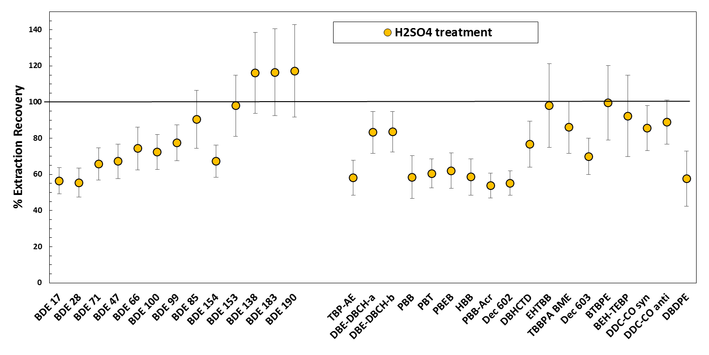
Fig. S1. Recoveries of the HFRs standard solutions after sulphuric acid treatment. The values are the mean of 3 replicates and the error bars represent the ± standard deviation.

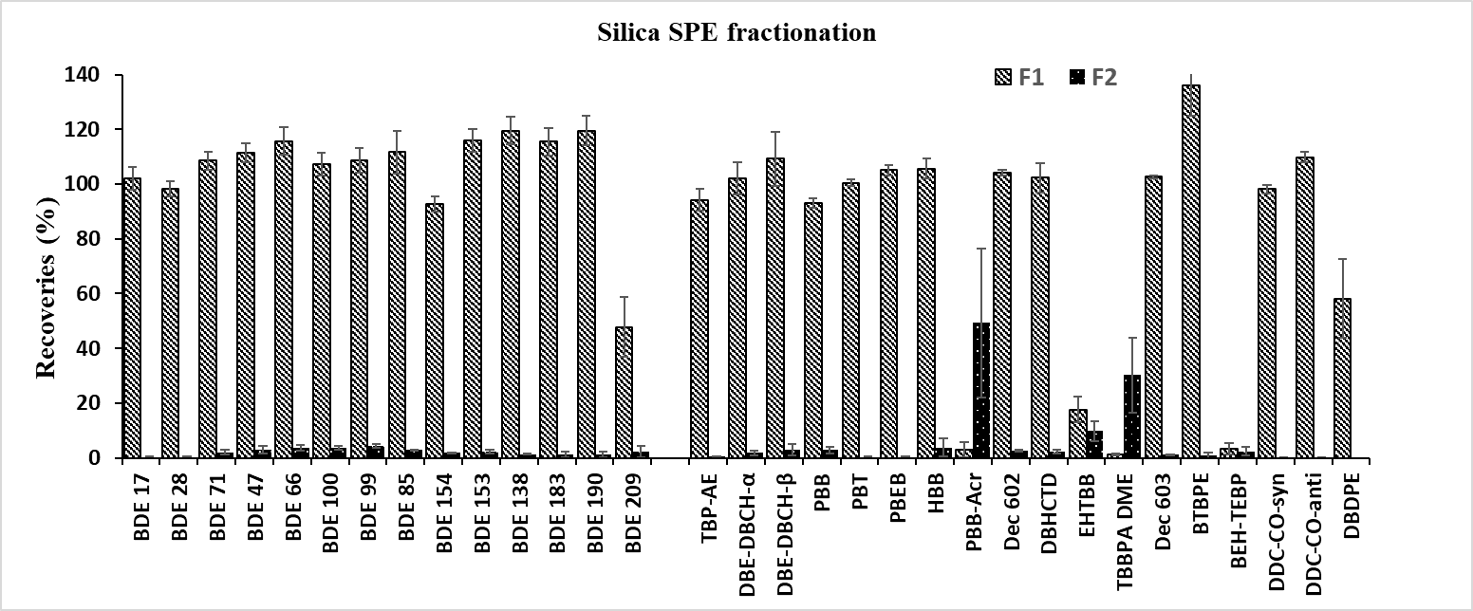

Fig. S2. Recoveries of the HFRs standard solutions after silica SPE fractionation: first fraction: 10 mL hexane:DCM (70:30); second fraction : 10 mL DCM:Methanol (50:50). The values are the mean of 3 replicates and the error bars represent the ± standard deviation.

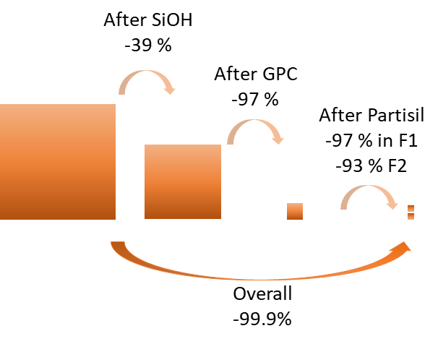
Fig. S3. Lipid removal efficiency after clean-up procedure of silica gel SPE, GPC, and Partisil HPLC column fractionation.

