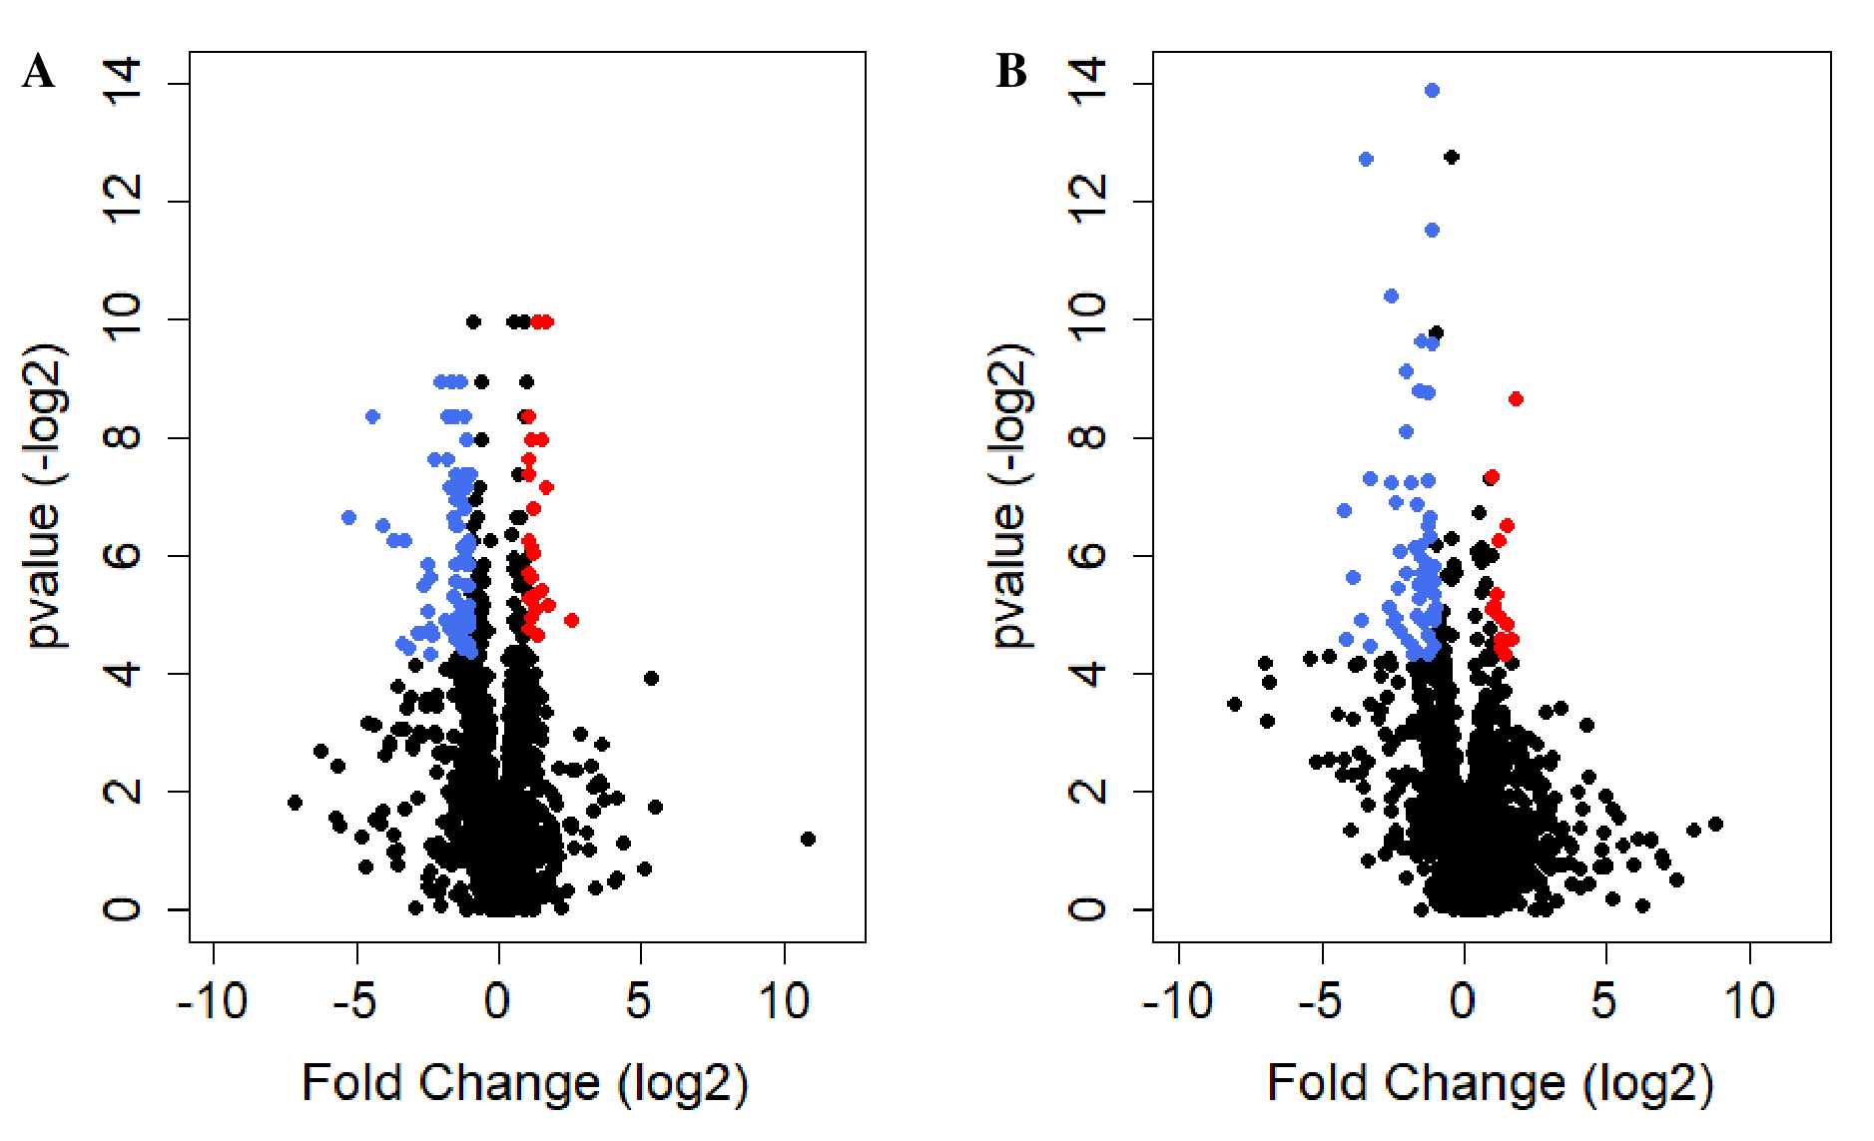
Supplementary Figure 1. Parameters of proteomic analyses. Volcano plot showing differentially accumulated proteins in (A) B₁₂ limitation vs nitrogen limitation and (B) in B₁₂ limitation vs B₁₂ resupply. Enriched proteins (p < 0.05 and fold change > 2.0) are shown in red and depleted proteins (p < 0.05 and fold change < -2.0) are shown in blue.

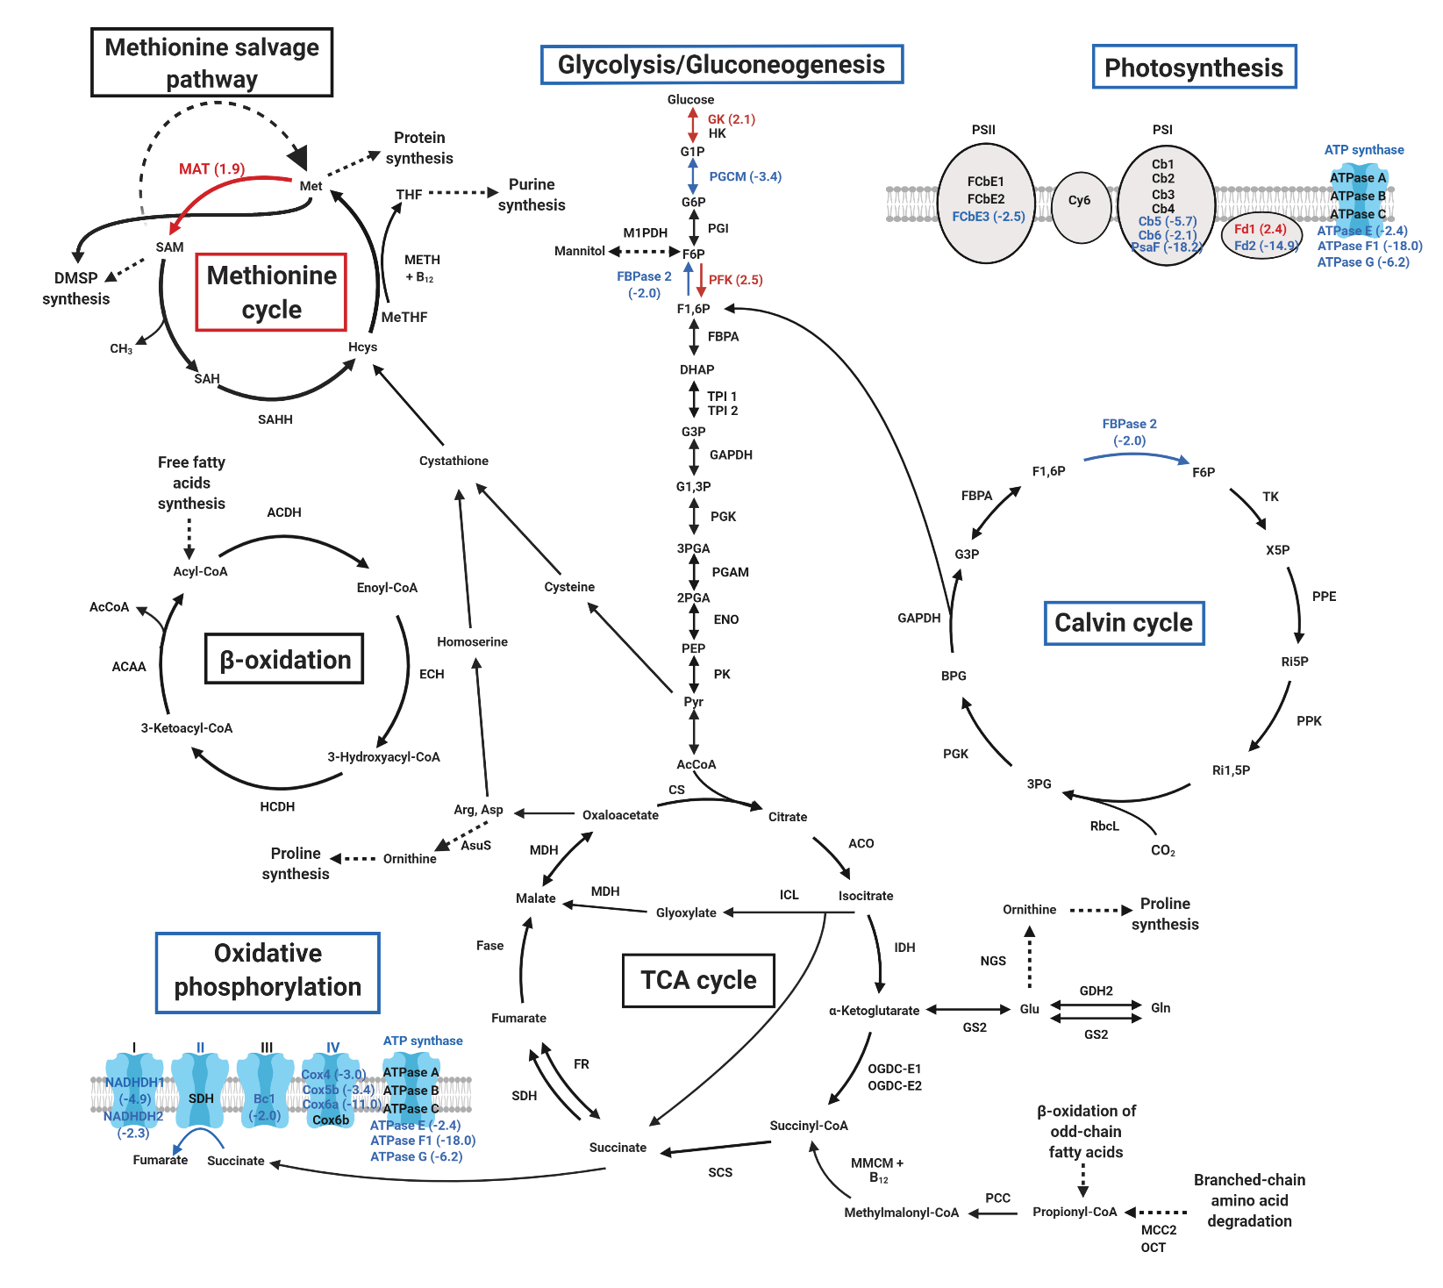
Supplementary Figure 2. Overview of major pathways differentially impacted in B₁₂ limitation vs. B₁₂ resupply. Enriched proteins (p < 0.05 and fold change > 2.0) are shown in red and depleted proteins (p < 0.05 and fold change < -2.0) are shown in blue (protein abbreviations are shown in Supplementary Table 3).

