Journal of Geophysical Research - Oceans
Supporting Information for
Eddy-induced acceleration of Lagrangian floats
Tianyu Wang^{1,2,3}, Sarah T. Gille⁴, Matthew R. Mazloff⁴, Nathalie V. Zilberman⁴, and Yan Du^{1,2,3}

¹State Key Laboratory of Tropical Oceanography, South China Sea Institute of Oceanology, Chinese Academy of Sciences, Guangzhou, China.
²University of Chinese Academy of Sciences, Beijing, China.
³Southern Marine Science and Engineering Guangdong Laboratory, Guangzhou, China
⁴Scripps Institution of Oceanography, University of California San Diego, La Jolla, CA, USA.

Contents of this file
Text S1
Figures S1-S2

Text S1. Metrics to assess sensitivity to isotropic diffusivity
To quantify the effect of the horizontal and vertical viscosity of 10⁻⁵ m² s⁻², we evaluate the dispersion of particle acceleration with varying isotropic diffusivities (K_{h}) relative to particle acceleration when K_{h} =0 m² s⁻². Here we define dispersion based on the difference in acceleration. The values indicate the impact of K_{h} on the particle motion. We expect the dispersion to rise for large K_{h}, since this will replicate the effect of a large random walk (Hunter et al. 1993). The results (shown in Figure S2) indicate that K_{h} must be larger than 10 m² s⁻² to have a dominant influence on the flow. When K_{h}=10⁵ m² s⁻², the trajectories are completely dominated by viscous processes, leading to large differences in particle acceleration rates. However, when K_{h} is <1 m² s⁻², particle trajectories are dominated by the background advective flow. Therefore, the results at K_{h}=10⁻⁵ m² s⁻² and K_{h}=0 m² s⁻² are inferred to be statistically equivalent. Though the effect of a non-zero K_{h} is statistically small, it is nevertheless important: the diffusion term represents sub-grid-scale eddy motions and therefore allows floats to deviate from a purely deterministic trajectory.

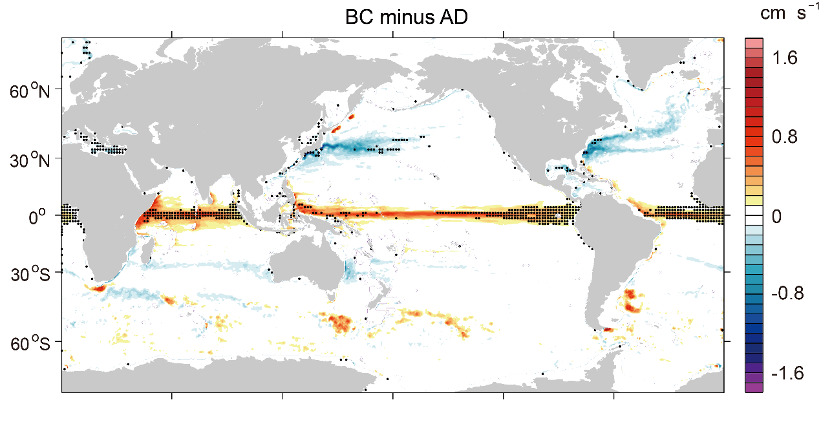
Figure S1. Speed differences (unit: cm/s) between B-C derived velocities V_{B-C} and A-D derived velocities V_{A-D}. Black dots denote regions where the mean speed differences are greater than 10% of the mean velocity.

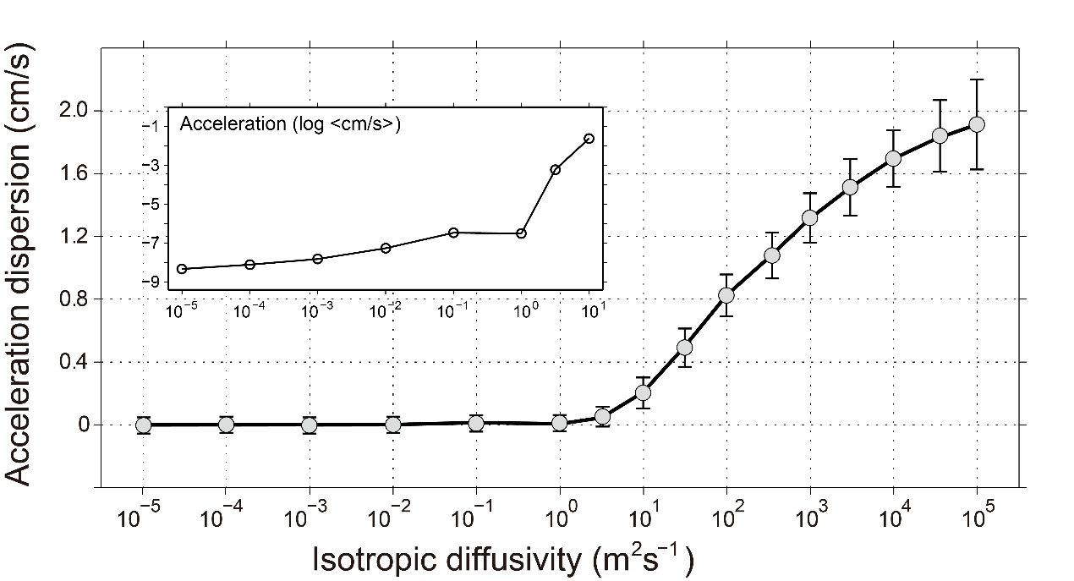
Figure S2. Acceleration dispersion (defined by the difference between the acceleration at a specified K_{h} and that at K_{h}=0 m² s⁻¹) as a function of K_{h}. The inset shows the same quantity on a log-log axis

