Organic carbon export and loss rates in the Red Sea

Malika Kheireddine¹, Giorgio Dall’Olmo^{2,3}, Mustapha Ouhssain¹, George Krokos⁴, Hervé Claustre⁵, Catherine Schmechtig⁶, Antoine Poteau⁵, Peng Zhan⁴, Ibrahim Hoteit⁴, and Burton H. Jones¹

¹ King Abdullah University of Science and Technology (KAUST), Red Sea Research Center (RSRC), Biological and Environmental Sciences & Engineering Division (BESE), Thuwal, 23955-6900, Saudi Arabia
² Plymouth Marine Laboratory, Plymouth, UK
³ National Centre for Earth Observation, Plymouth, UK
⁴King Abdullah University of Science and Technology (KAUST), Earth Science and Engineering, Thuwal, 23955-6900, Kingdom of Saudi Arabia
⁵ Sorbonne Université, & CNRS UMR 7093, Laboratoire d’Océanographie de Villefranche, F-06230 Villefranche-sur-mer, France
⁶ Sorbonne Université, & CNRS, UMS 3455, OSU Ecce-Terra, Paris Cedex 5, France

* Correspondence:
Malika Kheireddine
malika.kheireddine@kaust.edu.sa

Contents of this file
Text S1 (Oxygen calibration)
Figure S1
Text S2 (Oceanographic cruises and sampling)
Table S1
Figure S2
Text S3 (Particulate backscattering coefficient vs. particulate organic carbon relationship)
Table S2
Figure S3
Text S4 (General circulation and particle trajectories models)
Text S5 (Physical characteristics along the float trajectory)
Figure S4
Figure S5
Text S6 (Temporal variability of the spiciness metric)

Figure S6
Text S7 (Arrhenius activation energy plots)
Figure S7
Text S8 (Temperature vs. oxygen relationship)
Figure S8
Text S9 (Mesopelagic carbon budget)
Figure S9

Oxygen calibration --- Float oxygen correction term were determined by performing a linear regression on float’s oxygen percent saturation versus oxygen percent saturation using the dataset from the World Ocean Atlas climatology (WOA09).
Figure S1: Float’s percent oxygen saturation vs. WOA’s percent oxygen saturation used to calculate the correction factor for calibration of oxygen measurements. The solid line is the 1:1 line.
Oceanographic cruises and sampling --- Samples were collected during four research cruises performed across the Red Sea between October 2014 and January 2016 on board of the R/V Thuwal. Two cruises named, as CRS-01 and CRS-04, took place in the central Red Sea (CRS) during fall and winter, specifically from 16 - 28 October 2014 and from 17 - 28 January 2016, respectively. One cruise, Duba-01, was conducted in the northern Red Sea (NRS) in spring during the periods of 17 - 28 April 2015. A cruise to Jazan took place in the southern Red Sea (SRS) in winter from 8 - 21 February 2015. A total of 30 stations were sampled: 12 in the NRS, 10 in the
CRS and 8 in the SRS (Fig. S2, Table S1).
Table S1: Location and dates of the sampling cruises performed between 2014 and 2016 in the Red Sea.
Campaign | Platform | Location | Abbreviation | Period | Number of stations
Nutrient cycle cruise 1 | RV Thuwal | Central Red Sea | CRS-01 | 16-28 Oct. 2014 | 8
Jazan cruise | RV Thuwal | Southern Red Sea | Jazan | 8 -21 Feb. 2015 | 8
Duba cruise | RV Thuwal | Northern Red Sea | Duba-01 | 17- 28 Apr. 2015 | 10
Nutrient cycle cruise 4 | RV Thuwal | Central Red Sea | CRS-04 | 17-28 Jan. 2016 | 4
Total |  |  |  |  | 30

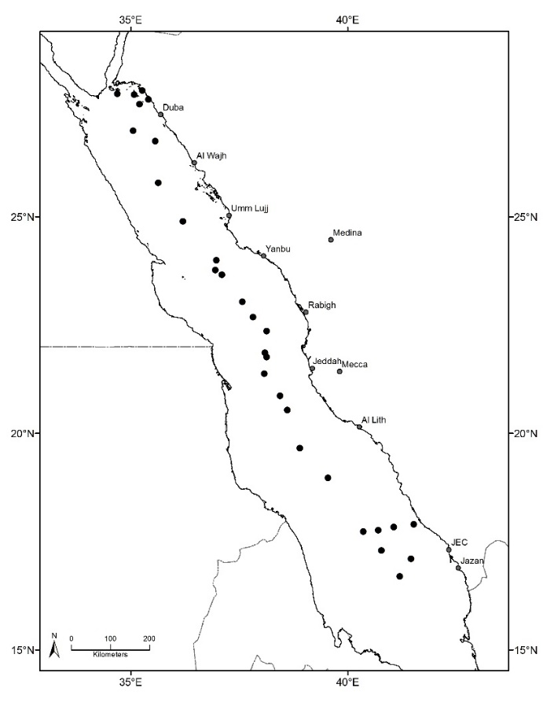
Figure S2: Map showing the locations of stations sampled during 4 cruises between October 2014 and January 2016 in the Red Sea (see Table S1). Map Produced using ArcGIS.
Discrete seawater samples for determining concentration of particulate organic carbon, POC, were collected using a rosette system equipped with 10 L Niskin bottles at typically 10 depths within the upper 200 m depth of the water column (5, 10, 20, 40, 50, 60, 70, 80, 150 and 200 m). The concentration of particulate organic carbon, POC, was determined using a method consistent with established JGOFS protocols (Knap et al., 1996). Seawater samples (2.8 L) were filtered through 25 mm diameter precombusted (450°C, 4,5 hours) Whatman GF/F filters (0.7 μm porosity), transferred to clean containers and stored in liquid nitrogen during the cruise and subsequently at -20 °C in the laboratory until analysis. Organic carbon content of each filter, following acidification to remove inorganic carbon, was determined with standard CHN analyser (Perkin Elmer 2400 Series II CHNS/O elemental analyzer) involving high temperature combustion of sample filters (Parsons et al., 1984).
Particulate backscattering coefficient vs. particulate organic carbon relationship --- The ECO BB-9 backscattering sensor used in this study provides the volume scattering function at an angle of 124° and wavelength of 412, 440, 488, 510, 532, 595, 650, 676 and 715 nm (β (124°, λ)). The β (124°, λ) represents the sum of the particle scattering plus the water molecular scattering for each wavelength. To retrieve the volume scattering function of particles β_{p} (124°, λ), the volume scattering function of water β_{w} (124°, λ) (with β_{w} (124°, λ) obtained according to the relationship in Zhang et al. (2009) is subtracted from β (124°, λ). The particulate backscattering coefficient, b_{bp} (λ) (m⁻¹), is determined by estimating the sole measurement of β_{p} (124°, λ) using an X factor:
b_{bp} (λ) = 2πX β_{p} (124°, λ)
The X factor has been determined by Sullivan et al. (2013) to be ± 1.076 at any wavelength. The spectral slope of b_{bp} (λ) was used to estimate b_{bp} at 700 nm. The BB-9 instrument was calibrated by WET Labs on a yearly basis.
Our particulate organic carbon (POC) versus b_{bp} relationship is comparable to those reported in previous studies (Table S2).
Table S2: Comparisons of the POC vs. b_{bp} slope used in this study with those from previous studies.
 | This study | Stramski et al., 2008 | Cetinic et al., 2012 | Rasse et al., 2017
POC vs. b_{bp} slope | 40233 | 53607 | 35422 | 43317

However, we noted that the b_{bp} (700) coefficient for a given [POC] is significantly different for [POC] < 10 mg m⁻³ than those derived from the average relationship of Cetinic et al. (2012) (Fig. S3). This suggests that is indicative of changes in backscattering efficiency with the nature of particles as reported in previous studies (Stramski et al., 1999; Cetinic et al., 2012; Rembauville et al., 2017).
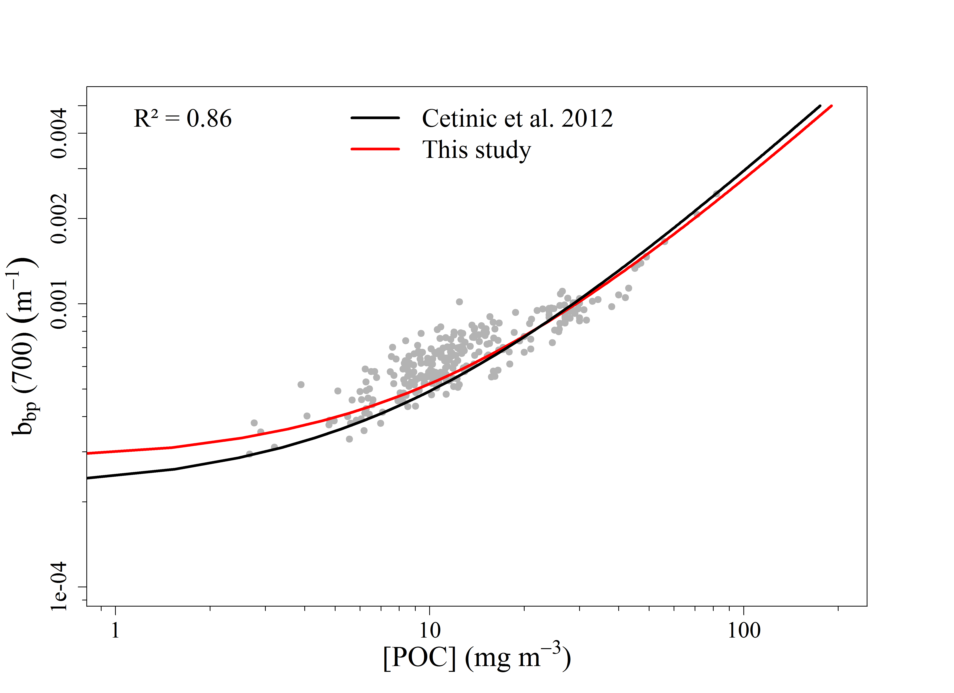
Figure S3: Relationship between b_{bp} (700) and POC. The red line represent the best fit (power law function) between b_{bp} (700) and POC. The regression formula is in the form of a power law as [POC] = A (700) + B where A = 40233 and B = -11. The determination coefficient, R², is also shown. The regression is significant for p<0.0001. The relationship from Cetinic et al. (2012) (black line) is displayed for comparison.
General circulation and particle trajectories models --- The MIT general circulation model (MITgcm) is a primitive-equation oceanic general circulation model solving the Navier-Stokes equations under the Boussinesq approximation. The model domain extended from 10°N to 30°N and from 30°E to 50°E, including the entire Red Sea basin, the Gulf of Suez, the Gulf of Aqaba and the Gulf of Aden. The model was implemented with 50 vertical levels, with the vertical resolution varying between 4 m at the surface and 300 m near the bottom. The horizontal resolution was 1 km, which has been reported to be fine enough to resolve the mesoscale dynamics in the Red Sea (Zhan et al., 2016; Dreano et al., 2017; Gittings et al., 2018). The model is extensively used and validated for various studies in the Red Sea, including the overturning circulation (Yao et al., 2014a, b; Papadopoulos et al., 2015), eddies (Zhan et al., 2014, 2016; Toye et al., 2017), and connectivity (Nanninga et al., 2015; Zhan et al., 2015). The atmospheric forcing model was forces with high resolution downscaled from the ERA-Interim reanalysis, provided by the European Centre for Medium-Range Weather Forecasting's (ECMWF) (Dee et al., 2011). Using the Advanced Research version of Weather Research and Forecasting (WRF) model (Skamarock et al., 2008), the downscaling was performed with a two-way nested domain of horizontal resolutions of 15 and 5 km over the Red Sea and adjacent regions (Yesubabu et al., 2016; Dasari et al., 2017; Langodan et al., 2016a, b, 2017a, b). The open-ocean boundary conditions with the Indian Ocean were provided on a monthly basis by the Operational Mercator global ocean analysis and forecast system, based on the NEMO ocean model at 1/12 degree horizontal resolution and 50 vertical layers (Madec et al., 2008). The model was initialized from a state of no-motion using annual mean temperature and salinity from the World Ocean Atlas 2013. After a 5 year spin-up period using the 2001 atmospheric forcing, the model was integrated from January 2001 to December 2016 with a time step of 90 s.
The Connectivity Modeling System (CMS) is a multi-scale probabilistic model of particle dispersal based on a stochastic Lagrangian framework. Given a full field of velocity from the MITgcm outputs, the CMS calculates particle locations and tracks their pathways following a multiple and multi-grid approach. In this study, the trajectories of passive particles were calculated with CMS based on daily averaged three-dimensional velocity fields as simulated by the Red Sea MITgcm.
Physical characteristics along the float trajectory --- Each of the four mesopelagic layers studied were characterized by temperatures and salinities that corresponded to the RSOW and RSDW masses (Fig. S4 and S5).
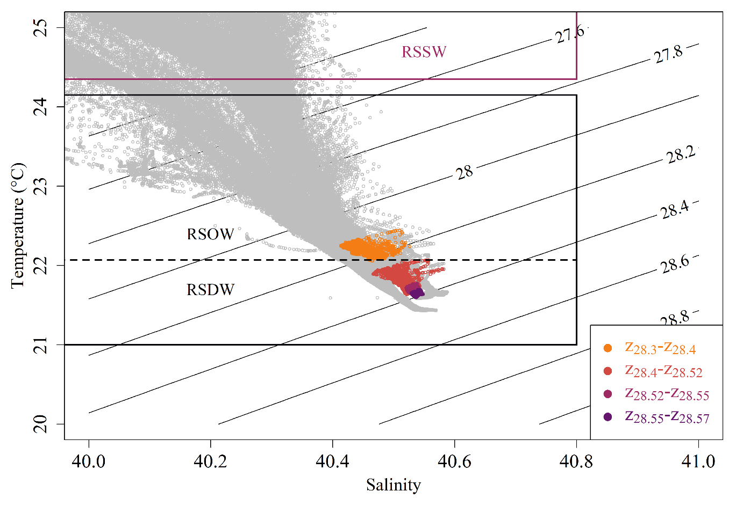
Figure S4: Temperature-salinity characteristics derived from a compilation of historical stations collected in the Red Sea with the addition of the 2016 Argo data. The coloured data points correspond to the data collected within each isopycnal layer: i.e., 28.30 – 28.40 kg m⁻³, 28.40 – 28.52 kg m⁻³, 28.52 – 28.55 kg m⁻³ and 28.55 – 28.57 kg m⁻³, respectively, along the float trajectory. The purple square correspond to the surface layers (RSSW) and the black are to the deep layers (namely the RSOW and the RSDW).
The historical data presented in Figure S4 comes from sections taken along the axis of the Red Sea from a summer 2001 survey performed in the Red sea. A total of 96 profiles of temperature, salinity and density were obtained during the cruise. Location of the stations performed during the cruise can be found in Sofianos & Johns (2007).

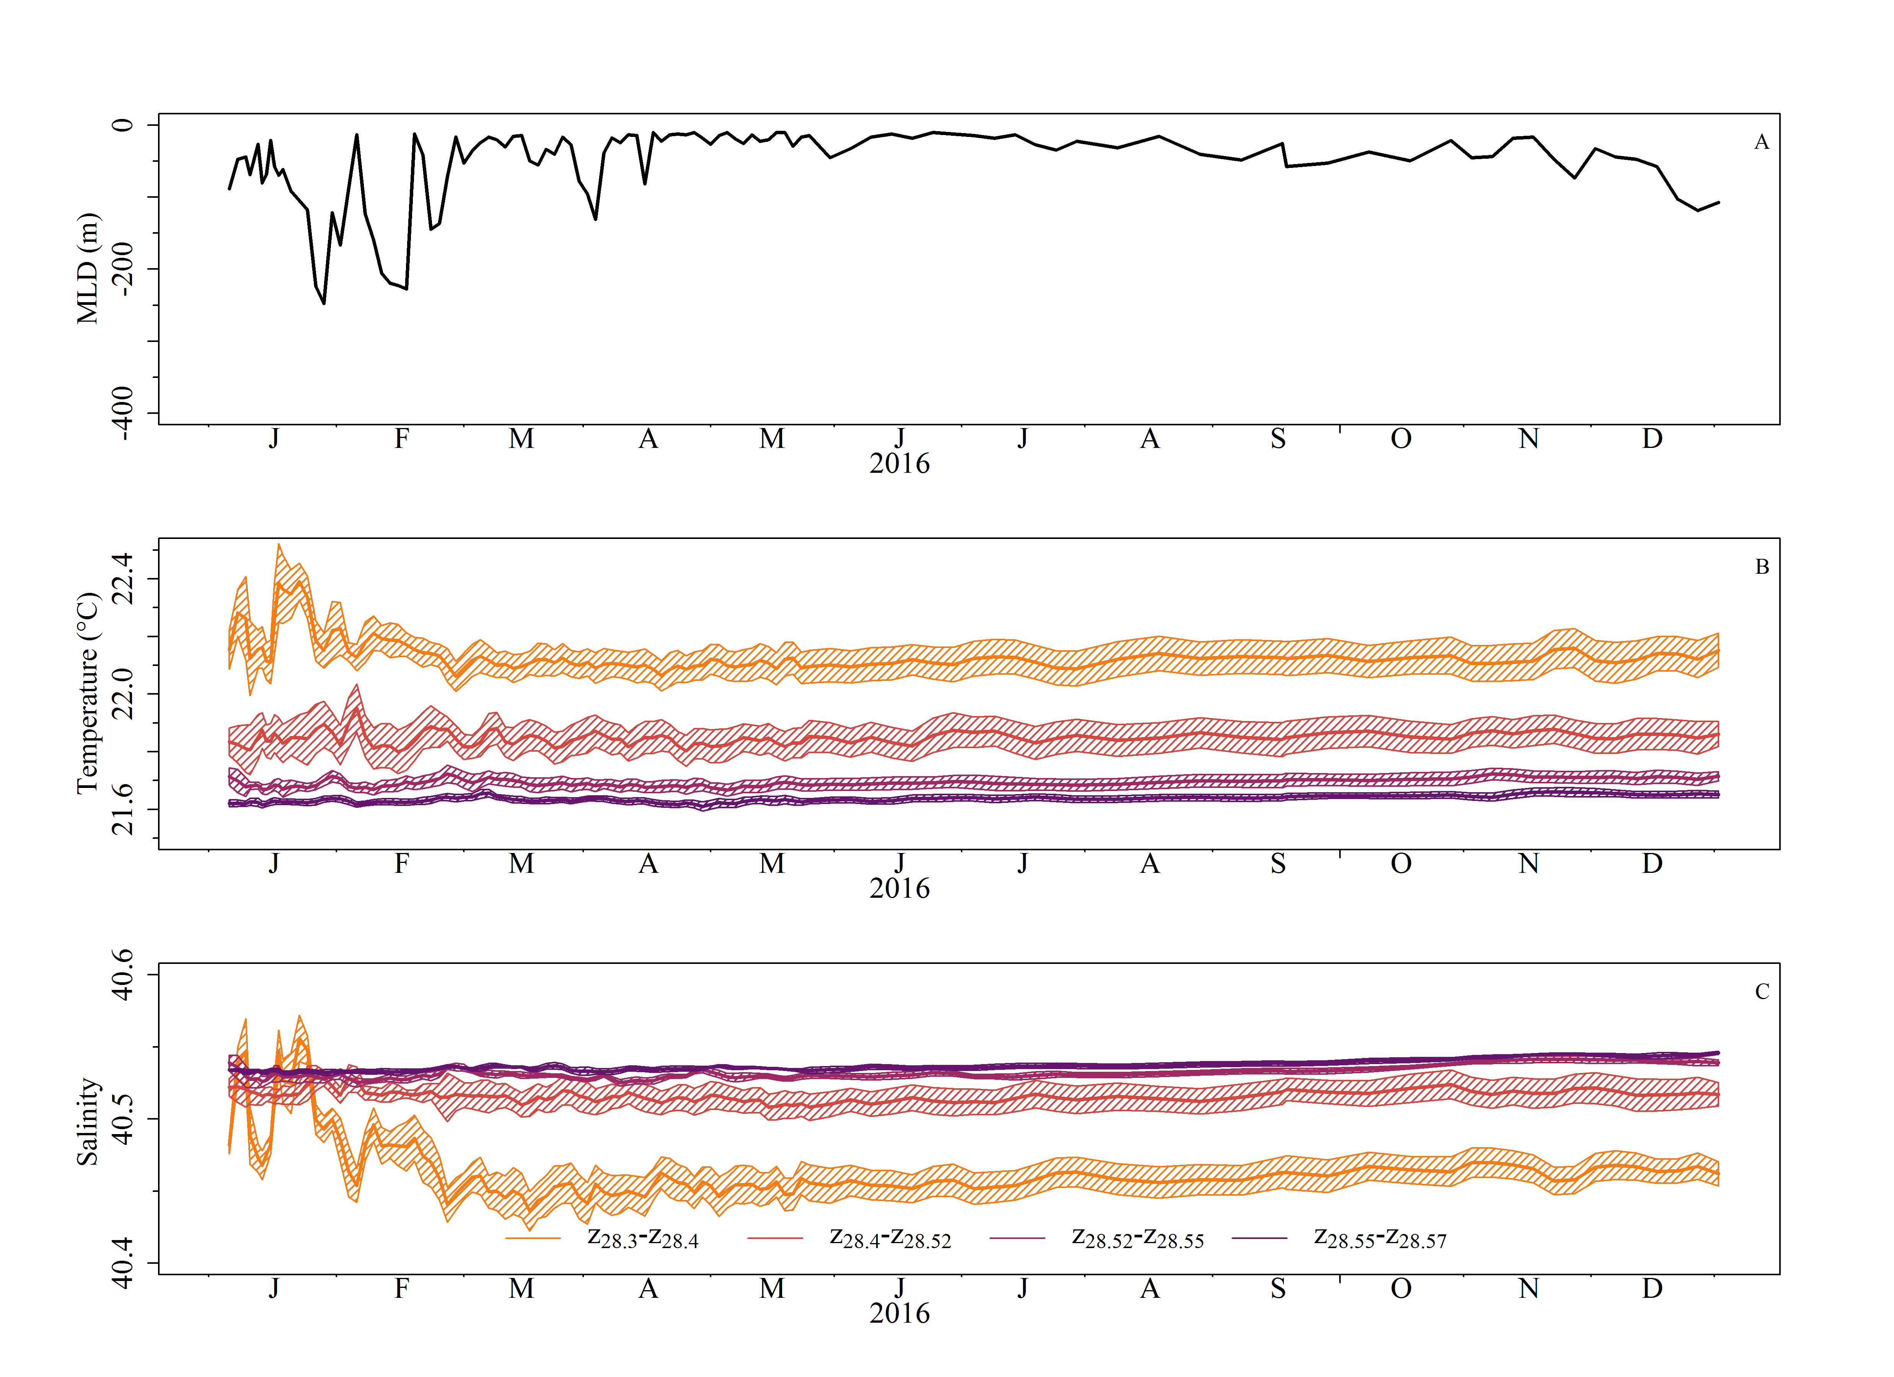
Figure S5: Time series of the mixed layer depth (MLD) (A), mean ± standard deviation of temperature (B) and salinity (C) within isopycnal layers 28.30 – 28.40 kg m⁻³, 28.40 – 28.52 kg m⁻³, 28.52 – 28.55 kg m⁻³ and 28.55 – 28.57 kg m⁻³, respectively, during the float deployment.

Temporal variability of the spiciness metric --- In this study, the spiciness metric was used to reveal the underlying isopycnal mixing that could alter the variability of biogeochemical properties on isopycnal layers (28.30–28.57 kg m⁻³) of the mesopelagic zone (Fig. S6). We found that the isopycnal layer 28.30–28.40 kg m⁻³ was not homogeneously distributed from late June to December. This suggests that this isopycnal layer could be affected by intrusion of waters extending downward from the surface or by advection. However, we also observed that the spiciness anomalies within this layer were not correlated with POC or AOU, and therefore should not affect the results of this study.
Figure S6: Time series of the vertical distributions of spiciness for the data collected by the float in 2016. Grey lines are the isopycnals 28.3, 28.4, 28.52, 28.55 and 28.57 kg m⁻³. The black and cyan lines represent the mixed layer depth (MLD) and the productive layer (z_{p}), respectively. The symbols *, **, *** and **** represent the isopycnal layers used in the rest of the analysis: 28.30 – 28.40 kg m⁻³, 28.40 – 28.52 kg m⁻³, 28.52 – 28.55 kg m⁻³ and 28.55 – 28.57 kg m⁻³, respectively.

Arrhenius activation energy plots --- We found higher $E_{a}$ (> 1760 kJ mol⁻¹) compared to those reported for other regions of the global ocean (60.8 – 758.1 kJ mol⁻¹. While our carbon loss rates (not $E_{a}$) are within the same range than those reported for the Red Sea in Brewer and Peltzer (2017) (Fig. S7), we also found higher $E_{a}$ than the one reported for the Red Sea in their study ( > 1760 kJ mol⁻¹ vs. 392.5 kJ mol⁻¹).
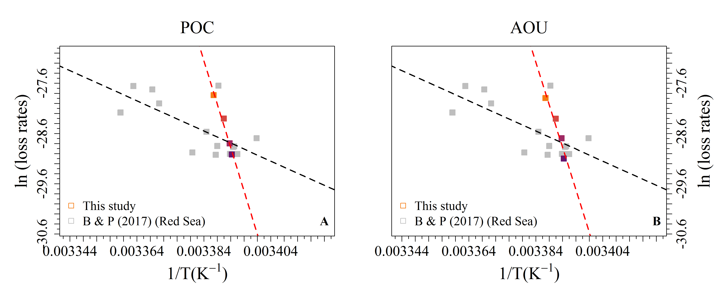
Figure S7: Arrhenius activation energy plots for $L_{z_{iS}}$ (A) and $L_{z_{i}}^{AOU}$ (B) over gradual isopycnal layers of the mesopelagic zone associated to the OUR loss rates for Red Sea waters reported in Brewer & Peltzer (2017).

Temperature vs. oxygen relationship --- oxygen measurements are strongly correlated with temperature measurements.
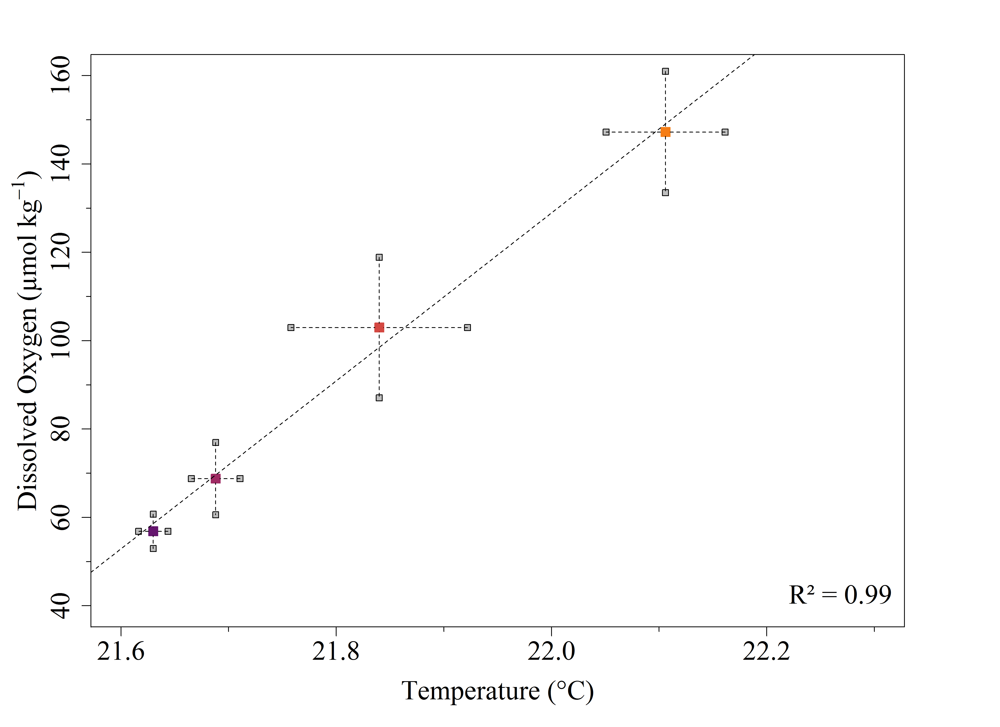
Figure S8: Temperature vs. oxygen measurements over gradual isopycnal layers of the mesopelagic zone. Error bars represent one standard deviation. The solid line is the 1:1 line.

Mesopelagic carbon budget --- We found that the POC exported via small particles was balanced by its consumption (sum of the fast and slow small-particle POC losses) over the seasonal cycle (Fig. S9).

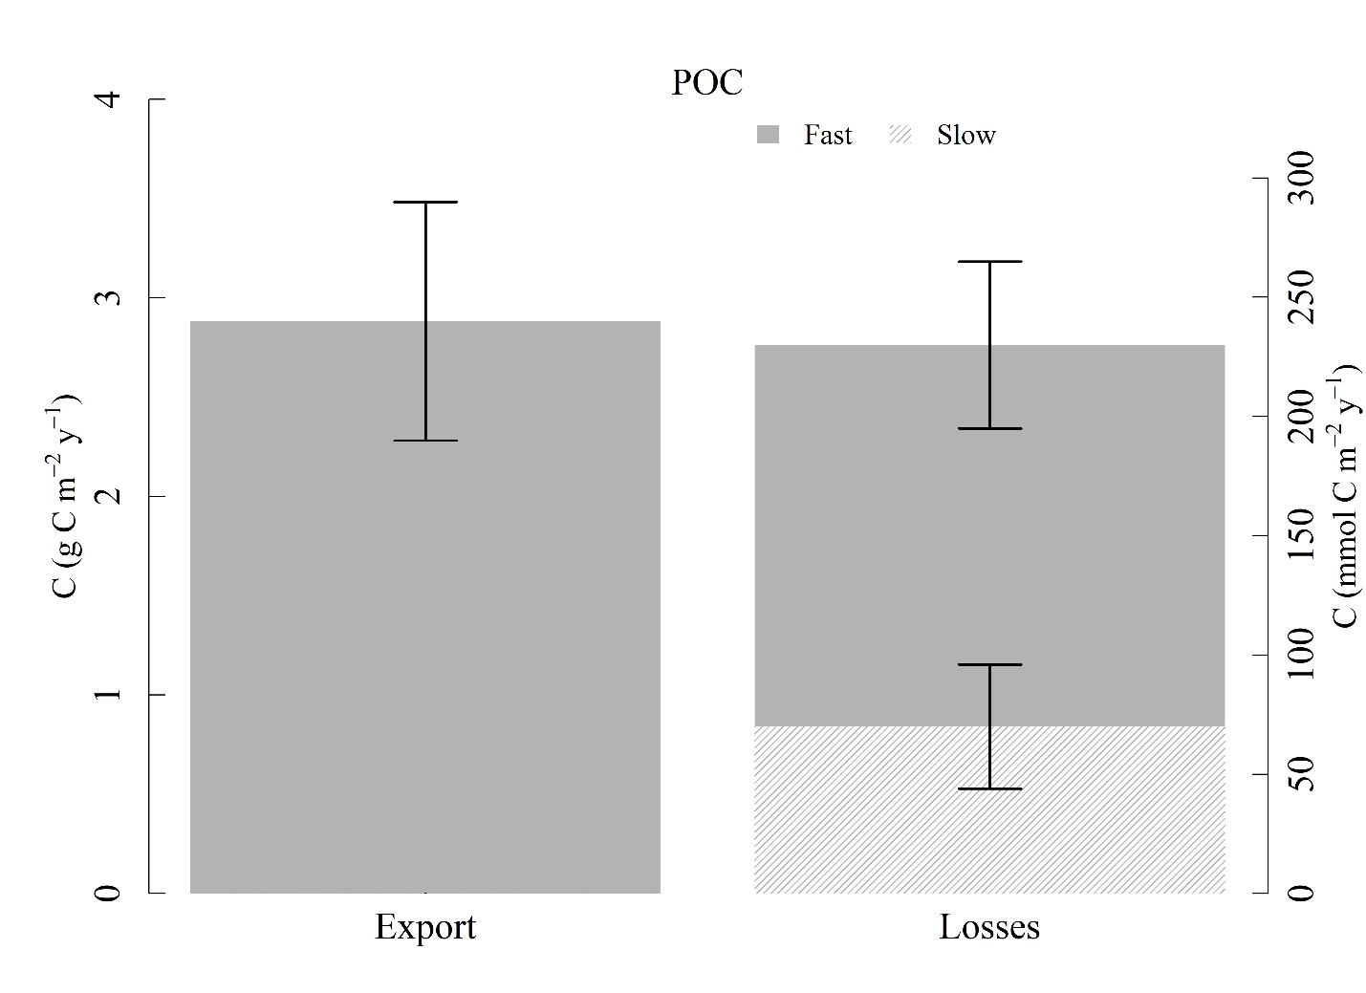
Figure S9 : Seasonal export and loss rates (fast and slow) of POC in the mesopelagic zone. Error bars represent upper and lower estimates.

References
Brewer, P. G., and E. T. Peltzer (2017), Depth perception: the need to report ocean biogeochemical rates as functions of temperature, not depth, Philosophical Transactions of the Royal Society a-Mathematical Physical and Engineering Sciences, 375(2102). doi: 10.1098/rsta.2016.0319.
Cetinic, I., M. J. Perry, N. T. Briggs, E. Kallin, E. A. D'Asaro, and C. M. Lee (2012), Particulate organic carbon and inherent optical properties during 2008 North Atlantic Bloom Experiment, Journal of Geophysical Research-Oceans, 117. doi: 10.1029/2011jc007771.
Dasari, H. P., R. Attada, O. Knio, and I. Hoteit (2017), Analysis of a severe weather event over Mecca, Kingdom of Saudi Arabia, using observations and high-resolution modelling, Meteorological Applications, 24(4), 612-627. doi: 10.1002/met.1662.
Dee, D. P., et al. (2011), The ERA-Interim reanalysis: configuration and performance of the data assimilation system, Quarterly Journal of the Royal Meteorological Society, 137(656), 553-597. doi: 10.1002/qj.828.
Dreano, D., K. Tsiaras, G. Triantafyllou, and I. Hoteit (2017), Efficient ensemble forecasting of marine ecology with clustered 1D models and statistical lateral exchange: application to the Red Sea, Ocean Dynamics, 67(7), 935-947. doi: 10.1007/s10236-017-1065-0.
Gittings, J. A., D. E. Raitsos, G. Krokos, and I. Hoteit (2018), Impacts of warming on phytoplankton abundance and phenology in a typical tropical marine ecosystem, Scientific Reports, 8. doi: 10.1038/s41598-018-20560-5.
Knap, A.H., A. Michaels, A.R. Close, H. Ducklow, A.G. Dickson (1996), Protocols for the Joint Global Ocean Flux Study (JGOFS) Core Measurements. JGOFS Report Nr. 19
Langodan, S., Y. Viswanadhapalli, and I. Hoteit (2016), The impact of atmospheric data assimilation on wave simulations in the Red Sea, Ocean Engineering, 116, 200-215. doi: 10.1016/j.oceaneng.2016.02.020.
Langodan, S., Y. Viswanadhapalli, H. P. Dasari, O. Knio, and I. Hoteit (2016), A high-resolution assessment of wind and wave energy potentials in the Red Sea, Applied Energy, 181, 244-255. doi: 10.1016/j.apenergy.2016.08.076.
Langodan, S., L. Cavaleri, A. Pomaro, Y. Vishwanadhapalli, L. Bertotti, and I. Hoteit (2017), The climatology of the Red Sea-part 2: the waves, International Journal of Climatology, 37(13), 4518-4528. doi: 10.1002/joc.5101.
Langodan, S., L. Cavaleri, Y. Vishwanadhapalli, A. Pomaro, L. Bertotti, and I. Hoteit (2017), The climatology of the Red Sea-part 1: the wind, International Journal of Climatology, 37(13), 4509-4517. doi: 10.1002/joc.5103.
Nanninga, G. B., P. Saenz-Agudelo, P. Zhan, I. Hoteit, and M. L. Berumen (2015), Not finding Nemo: limited reef-scale retention in a coral reef fish, Coral Reefs, 34(2), 383-392. doi: 10.1007/s00338-015-1266-2.
Papadopoulos, V. P., et al. (2015), Factors governing the deep ventilation of the Red Sea, Journal of Geophysical Research-Oceans, 120(11), 7493-7505. doi: 10.1002/2015jc010996.
Rasse, R., G. Dall'Olmo, J. Graff , T. K. Westberry, V. van Dongen-Vogels and M. J. Behrenfeld, (2017), Evaluating Optical Proxies of Particulate Organic Carbon across the Surface Atlantic Ocean, Front. Mar. Sci., 4:367. doi: 10.3389/fmars.2017.00367.
Rembauville, M., N. Briggs, M. Ardyna, J. Uitz, P. Catala, C. Penkerc'h, A. Poteau, H. Claustre, and S. Blain (2017), Plankton Assemblage Estimated with BGC-Argo Floats in the Southern Ocean: Implications for Seasonal Successions and Particle Export, Journal of Geophysical Research-Oceans, 122(10), 8278-8292. doi: 10.1002/2017jc013067.
Skamarock, W. C., and J. B. Klemp (2008), A time-split nonhydrostatic atmospheric model for weather research and forecasting applications, Journal of Computational Physics, 227(7), 3465-3485. doi: 10.1016/j.jcp.2007.01.037.
Stramski, D., R. A. Reynolds, M. Babin, S. Kaczmarec, M. R. Lewis, R. Röttgers, A. Sciandra, M. S. Twardowski, B. A. Franz, and H. Claustre (2008), Relationships between the surface concentration of particulate organic carbon and optical properties in the eastern South Pacific and eastern Atlantic Oceans, Biogeosciences, 5, 171-201. doi: 10.0.20.74/bg-5-171-2008.
Stramski, D., R. A. Reynolds, M. Kahru, and B. G. Mitchell (1999), Estimation of particulate organic carbon in the ocean from satellite remote sensing, Science, 285(5425), 239-242. doi: 10.1126/science.285.5425.239.
Sofianos, S. S., and W. E. Johns (2007), Observations of the summer Red Sea circulation, Journal of Geophysical Research-Oceans, 112(C6). doi: 10.1029/2006jc003886.
Toye, H., P. Zhan, G. Gopalakrishnan, A. R. Kartadikaria, H. Huang, O. Knio, and I. Hoteit (2017), Ensemble data assimilation in the Red Sea: sensitivity to ensemble selection and atmospheric forcing, Ocean Dynamics, 67(7), 915-933. doi: 10.1007/s10236-017-1064-1.
Yao, F. C., I. Hoteit, L. J. Pratt, A. S. Bower, A. Kohl, G. Gopalakrishnan, and D. Rivas (2014), Seasonal overturning circulation in the Red Sea: 2. Winter circulation, Journal of Geophysical Research-Oceans, 119(4), 2263-2289. doi: 10.1002/2013jc009331.
Yao, F. C., I. Hoteit, L. J. Pratt, A. S. Bower, P. Zhai, A. Kohl, and G. Gopalakrishnan (2014), Seasonal overturning circulation in the Red Sea: 1. Model validation and summer circulation, Journal of Geophysical Research-Oceans, 119(4), 2238-2262. doi: 10.1002/2013jc009004.
Yesubabu, V., C. V. Srinivas, S. Langodan, and I. Hoteit (2016), Predicting extreme rainfall events over Jeddah, Saudi Arabia: impact of data assimilation with conventional and satellite observations, Quarterly Journal of the Royal Meteorological Society, 142(694), 327-348. doi: 10.1002/qj.2654.
Zhan, P., A. C. Subramanian, F. C. Yao, and I. Hoteit (2014), Eddies in the Red Sea: A statistical and dynamical study, Journal of Geophysical Research-Oceans, 119(6), 3909-3925. doi: 10.1002/2013jc009563.
Zhan, P., F. C. Yao, A. R. Kartadikaria, Y. Viswanadhapalli, G. Gopalakrishnan, and I. Hoteit (2015), Far-Field Ocean Conditions and Concentrate Discharges Modeling Along the Saudi Coast of the Red Sea, in Intakes and Outfalls for Seawater Reverse-Osmosis Desalination Facilities: Innovations and Environmental Impacts, edited by T. M. Missimer, B. Jones and R. G. Maliva, pp. 501-520.
Zhan, P., A. C. Subramanian, F. C. Yao, A. R. Kartadikaria, D. Q. Guo, and I. Hoteit (2016), The eddy kinetic energy budget in the Red Sea, Journal of Geophysical Research-Oceans, 121(7), 4732-4747. doi: 10.1002/2015jc011589.
Zhang, X. D., L. B. Hu, and M. X. He (2009), Scattering by pure seawater: Effect of salinity, Optics Express, 17(7), 5698-5710. doi: 10.1364/oe.17.005698.

