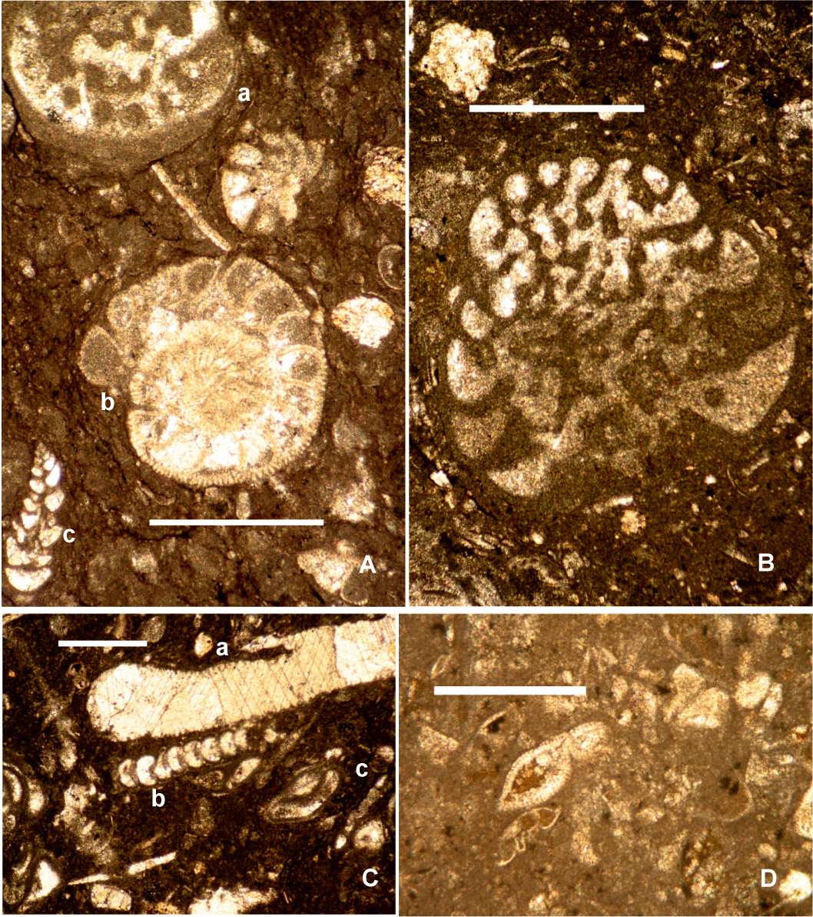

S1 Fig. Photomicrograph of the stratigraphical significant foraminifera found in Pointe Toiny limestones, Scale bars = 1mm. A) a) Coleiconus christianaensis Robinson, b) Medocia sp., c) Textularia sp., sample PON8. B) Coleiconus christianaensis Robinson, sample PON1. C) a) Halimeda sp., b) Praerhapydionina sp., c) Turborotalia possagnoensis (Tourmakine and Bolli), sample PON4. D Planorotalites pseudoscitula (Glaessner), sample PON1.

