**Title: European small pelagic fish distribution under global change scenarios**

**SUPPLEMENTARY MATERIAL 1:**

**Supplementary Table 1:** Overview of the modelling algorithms considered in our ensemble modelling procedure.

In accordance with the best practices in species distribution modelling (Araújo et al. 2019; Feng et al. 2019), detailed information on the observation data processing, the environmental variable pre-selection and the model evaluation procedures are available in Schickele et al. (2020). All statistical algorithms – but NPPEN – were used according to the pre-tuning and fitting methods (i.e. adapted for ensemble modelling) provided in Biomod2 (Thuiller et al. 2016)

|  |  |  |  |  |  |  |
| --- | --- | --- | --- | --- | --- | --- |
| Models | Requires absence data | Sensitive to missing data | Predictor interactions | Highly non-linear response | Method overview | References |
| GLM : Generalised Linear Models | yes | yes | yes | no | Regression; link function between model and predicted values | (Nelder and Wedderburn 1972) |
| GAM : Generalised Additive Models | yes | yes | yes | yes | Regression; ensemble of smooth functions for each predictor | (Hastie and Tibshirani 1986) |
| GBM: General Boosting Models | yes | no | yes | yes | Machine learning; function estimation over a function space using negative gradient method | (Friedman 1999) |
| ANN: Artificial Neural Network | yes | yes | yes | yes | Machine learning; stepwise and self-learning method | (Lawrence 1994) |
| RF: Random Forest | yes | no | yes | yes | Machine learning; ensemble of classification trees | (Breiman 2001) |
| MARS: Multiple Adaptative Regression Spline | yes | yes | yes | yes | Regression; non-linear ensemble of regression models | (Friedman 1991) |
| FDA: Flexible Discriminant Analysis | yes | yes | yes | yes | Machine learning; blends linear regression and MARS | (Hastie, Tibshirani, and Buja 1994) |
| NPPEN: Non-Parametric Probabilistic Ecological Niche model | no | yes | yes | yes | Mahalanobis distance and Multiple Permutation Procedure | (Beaugrand et al. 2011; Mahalanobis 1936; Mielke, Berry, and Brier 1981) |

**References :**

La mise à jour automatique des citations est désactivée. Pour voir la bibliographie, cliquez sur Actualiser dans l'onglet Zotero.

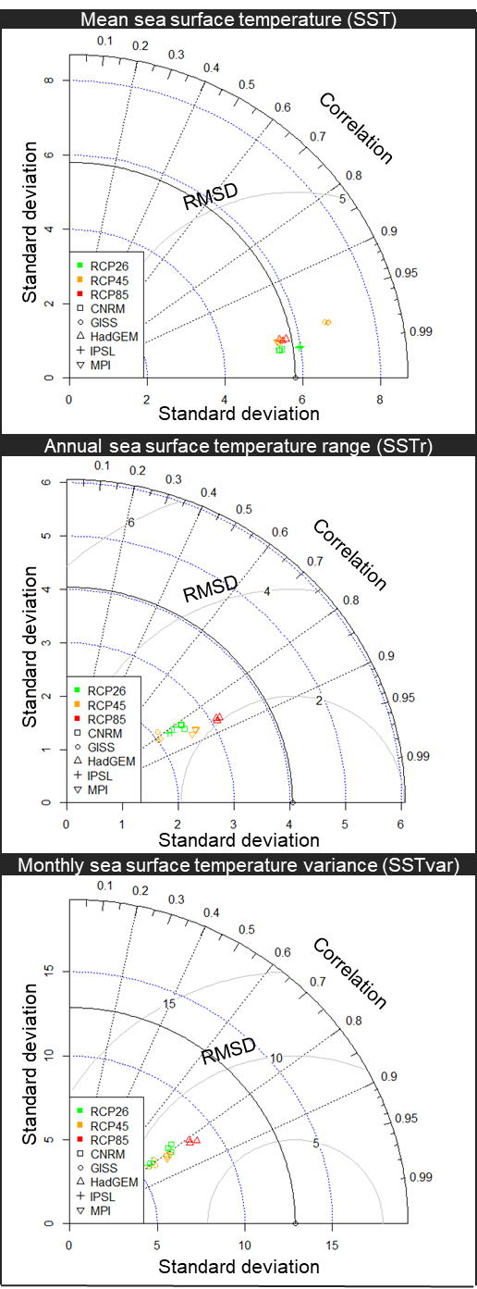

**SUPPLEMENTARY MATERIAL 2:**

**Supplementary figure 1:** Taylor diagrams quantifying the difference between observation-based contemporary data (grey circle on the bottom of each diagram) and GCM-based (General Circulation Model) future climate conditions. for mean Sea Surface Temperature (SST), annual range of SST, and monthly variance of SST.

**SUPPLEMENTARY MATERIAL 3:**

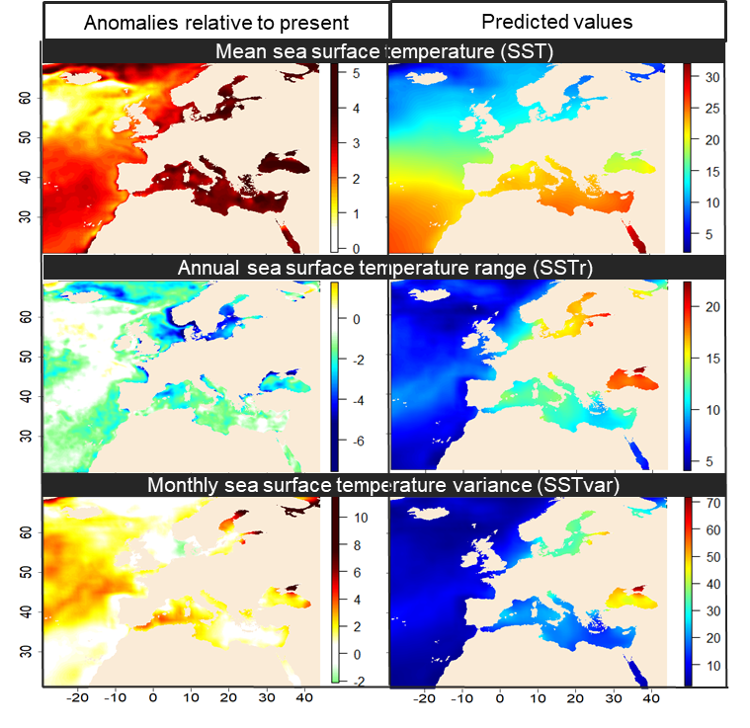

**Supplementary figure 2:** Left panels: anomalies for the three temperature-related parameters between 1990-2017 and 2090-2099 for scenario RCP8.5: mean Sea Surface Temperature (SST; upper panel), annual range of SST (middle panel), and monthly variance of SST (lower panel). Right panels: expected values for the period 2090-2099 under scenario RCP8.5.

**SUPPLEMENTARY MATERIAL 4:**

**Supplementary Table 2:** Percentage of Small Pelagic Fish (SPF) captured by fishing fleet (i.e. defined by its country of origin; in column) within each European Exclusive Economic Zones (EEZ; in line) in 2014. For clarity, fishing fleets representing less than 1 % of the capture were not represented and the percentages of capture were coloured according to their importance. The SPF considered are Atlantic horse mackerel *Trachurus trachurus*, European pilchard *Sardina pilchardus*, European sprat *Sprattus sprattus*, European anchovy *Engraulis encrasicolus*, Mediterranean horse mackerel *Trachurus mediteraneus*, round sardinella *Sardinella aurita* and bogue *Boops boops*. Data were retrieved from:

SAUP. 2020. “Sea Around Us.” Retrieved July 22, 2020 (http://www.seaaroundus.org/data/).



**SUPPLEMENTARY MATERIAL 5:**

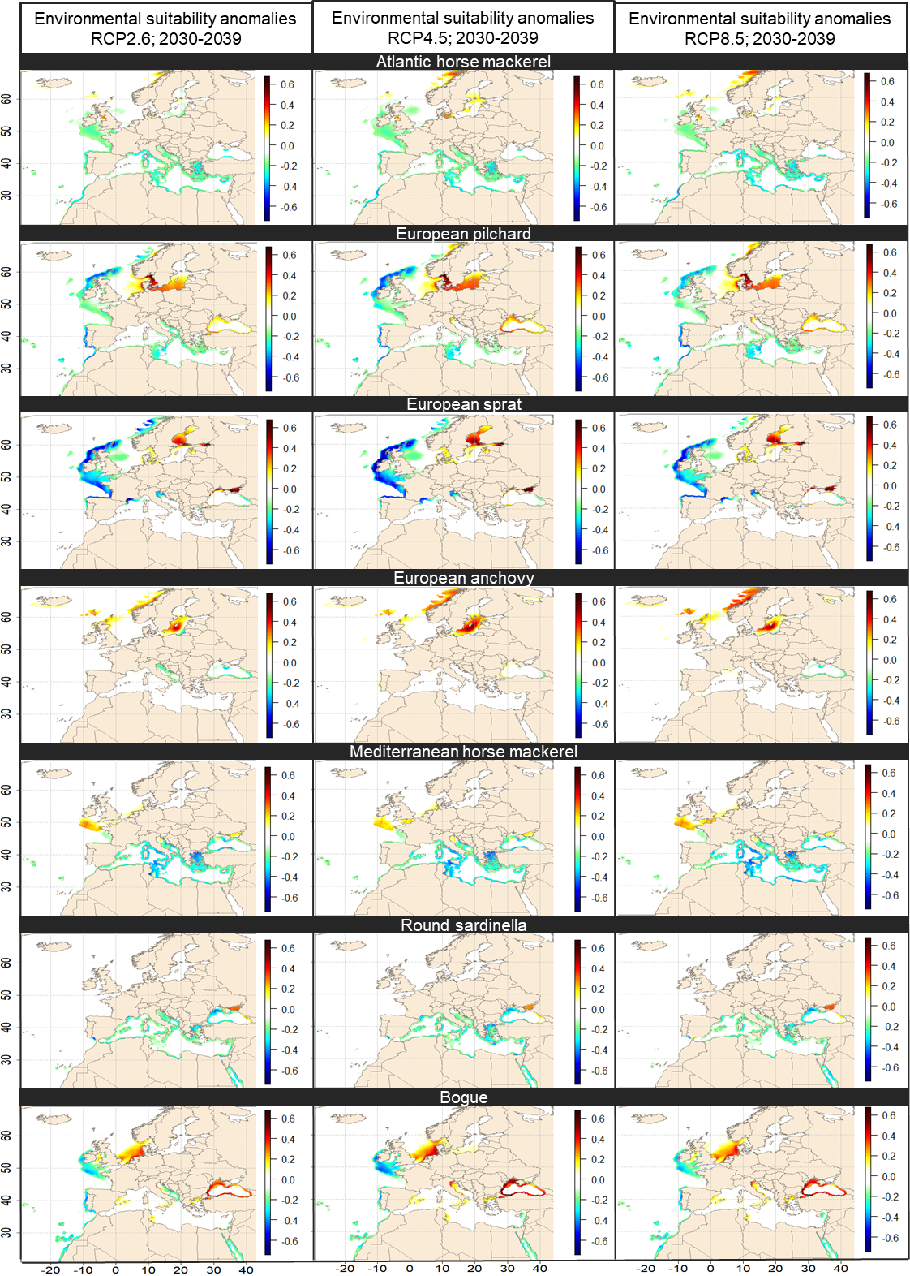

**Supplementary figure 3**: Changes in the Environmental Suitability Index (ESI) for the seven SPF species expressed as anomalies between the period 1990-2017 and the period 2030-2039 for RCP2.6 (left panel), RCP4.5 (middle panel) and RCP8.5 (right panel).

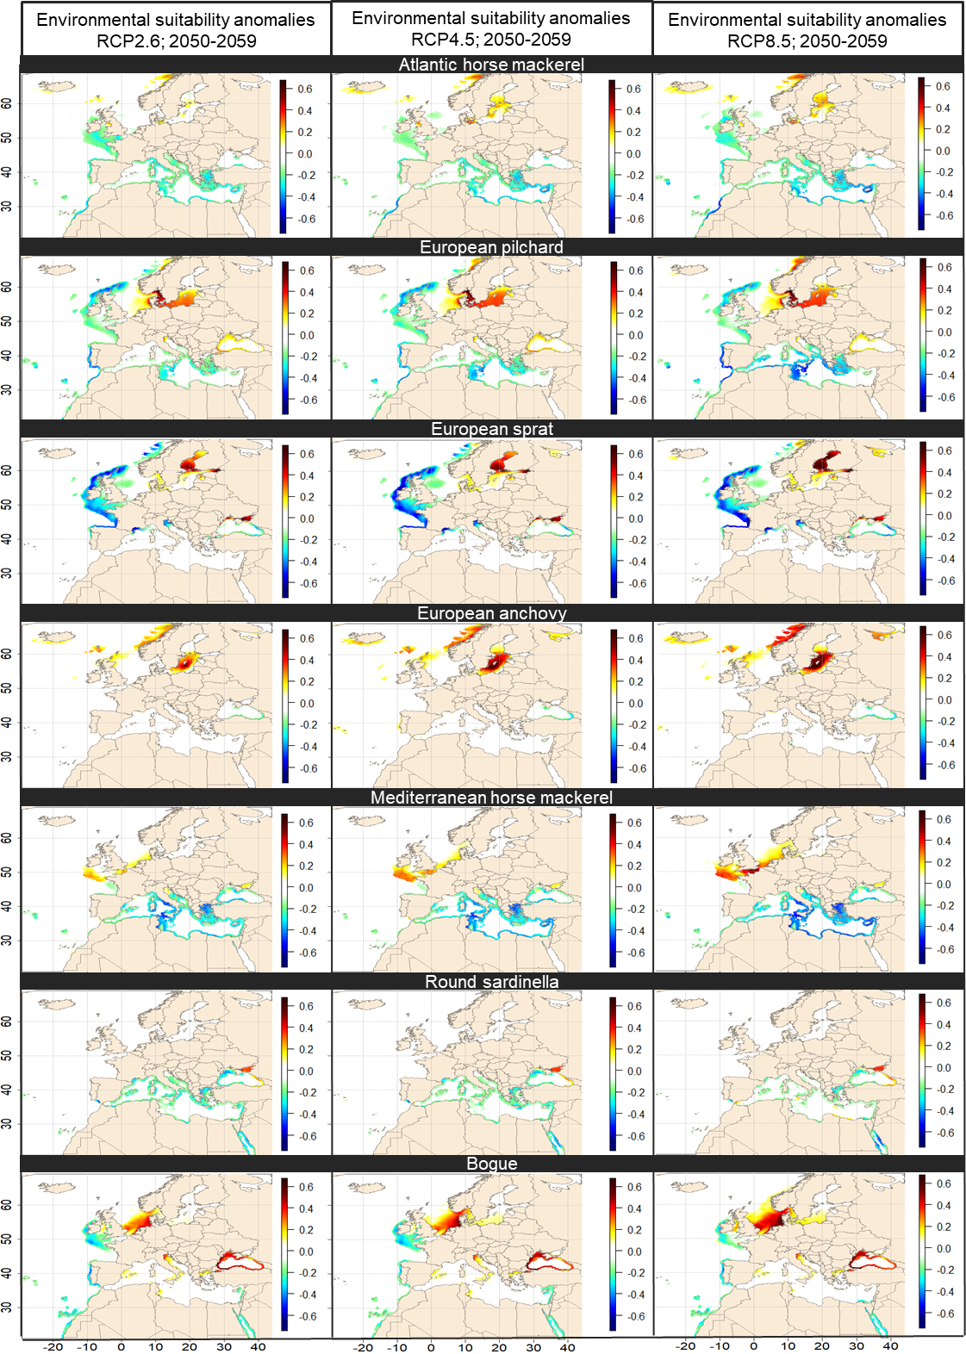

**Supplementary figure 4**: Changes in the Environmental Suitability Index (ESI) for the seven SPF species expressed as anomalies between the period 1990-2017 and the period 2050-2059 for RCP2.6 (left panel), RCP4.5 (middle panel) and RCP8.5 (right panel).

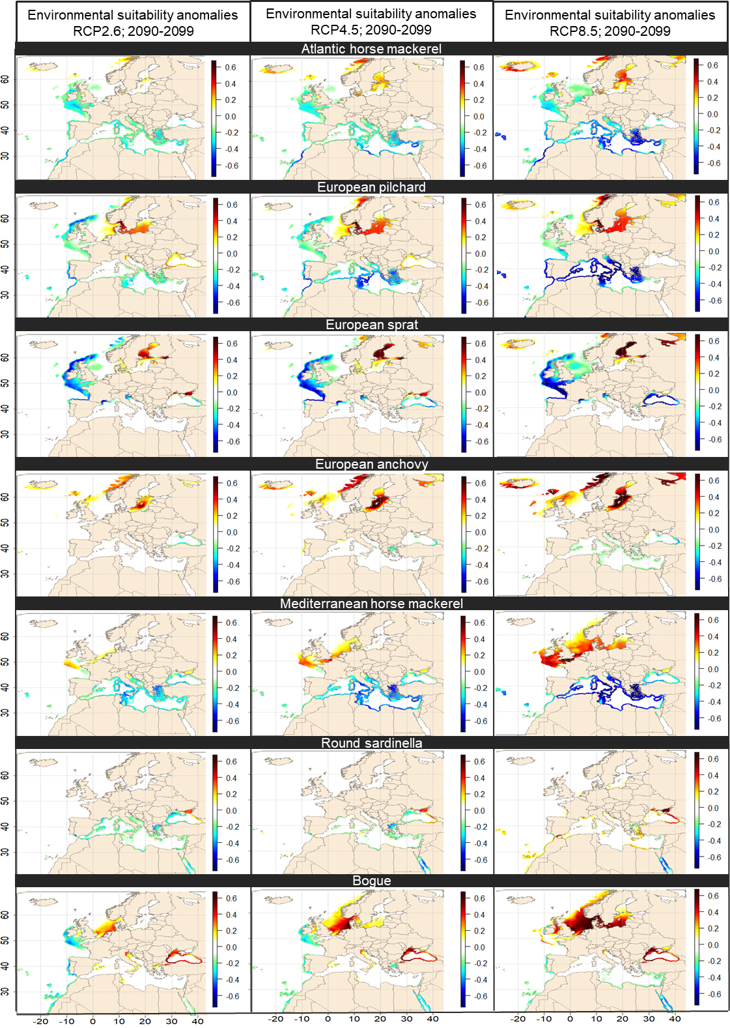

**Supplementary figure 5**: Changes in the Environmental Suitability Index (ESI) for the seven SPF species expressed as anomalies between the period 1990-2017 and the period 2090-2099 for RCP2.6 (left panel), RCP4.5 (middle panel) and RCP8.5 (right panel).