Supplementary Methods 1: Validation of the threshold used to determine queen conch departures from the inlet.
Classification of dead individuals
Three queen conchs were classified as “dead” over the course of the study. The three individuals exhibited very little variation in their daily average distance to the root time series over long period of time which is inconsistent with the typical spatial scale of queen conch foraging movement in Xel-Há (Stieglitz & Dujon, 2017). This suggest that the animals were not moving and were dead. In addition, the premature loss of detection for two of the three animals suggests that their shell became buried (or lost due to illegal fishing).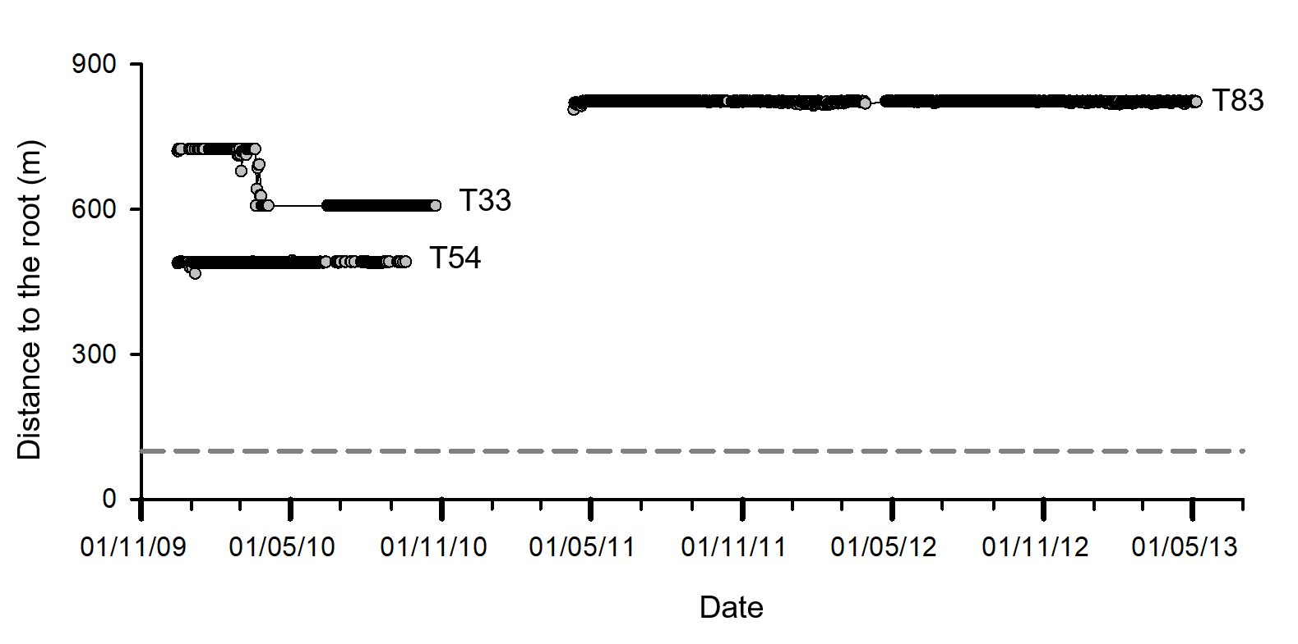
Supplementary Figure 1: Daily average distance to the root time series for the three queen conchs classified as dead. The grey horizontal dashed line represents the 100-m threshold used as criteria to determine if an individual departed the inlet.
Validation of the threshold used to determination the departures
Using the daily average distance to the root, we determined whether each queen conch departed from the inlet during the study course. Departure from the inlet was characterised by a decrease in the daily average distance to the root interpreted as a movement toward the mouth of the inlet. We considered that an individual departed from the inlet when its distance from the root decreased to <100 m followed by complete lack of detections that lasted up to the end of the study period. Queen conchs that did not meet those two criteria were considered to be resident over the study duration. The threshold was validated by visualizing a histogram of the distance to the root on the last day of detection for each queen conch tagged during the study (Supplementary Figure 2). All the queen conchs that departed the inlet had a distance to the root <100 m on the last day they were detected. Over the duration of the study nine conchs reached a distance to the root <100 m but were still detected at the end of the study when the receiver network was removed. Therefore they were considered to be resident.
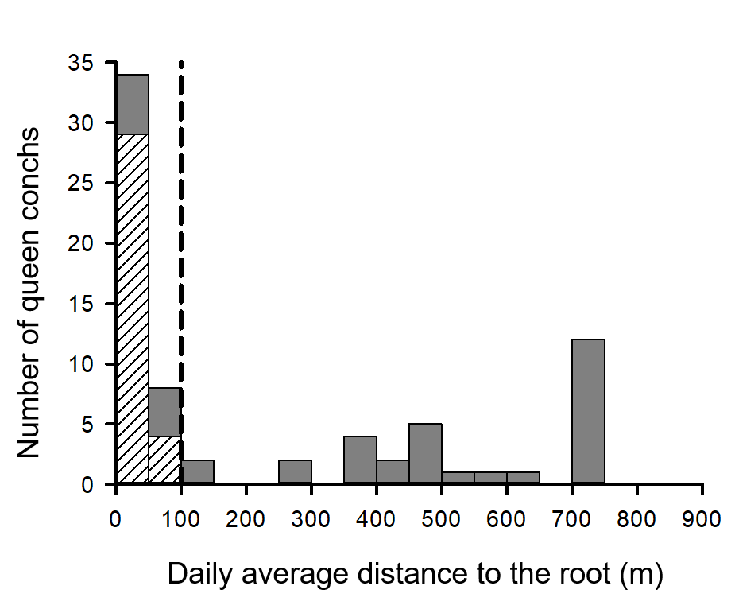
Supplementary Figure 2: Distance to root on the last day of detection for the 66 queen conchs tracked in this study. The queen conchs that departed the inlet are represented in white and the residents in grey. The vertical black dashed line represents the 100-m threshold used as one criteria to determine if an individual departed the inlet.
Reference:
Stieglitz TC, Dujon AM. 2017. A groundwater-fed coastal inlet as habitat for the Caribbean queen conch Lobatus gigas – an acoustic telemetry and space use analysis. Marine Ecology Progress Series 571:139–152.

