Supplementary Information

This document contains the supplementary material (additional methods and analyses) associated to the following article.

Title: Are we ready to track climate-driven shifts in marine species across international boundaries? - A global survey of scientific bottom trawl data

Authors: Aurore Maureaud*, Romain Frelat, Laurène Pécuchet, Nancy Shackell, Bastien Mérigot, Malin L. Pinsky, Kofi Amador, Sean C. Anderson, Alexander Arkhipkin, Arnaud Auber, Iça Barri, Richard J. Bell, Jonathan Belmaker, Esther Beukhof, Mohamed Lamine Camara, Renato Guevara-Carrasco, Junghwa Choi, Helle Torp Christensen, Jason Conner, Luis A. Cubillos, Hamet Diaw Diadhiou, Dori Edelist, Margrete Emblemsvåg, Billy Ernst, Tracey P. Fairweather, Heino O. Fock, Kevin D. Friedland, Camilo B. Garcia, Didier Gascuel, Henrik Gislason, Menachem Goren, Jérôme Guitton, Didier Jouffre, Tarek Hattab, Manuel Hidalgo, Johannes N. Kathena, Ian Knuckey, Saïkou Oumar Kidé, Mariano Koen-Alonso, Matt Koopman, Vladimir Kulik, Jacqueline Palacios León, Ya’arit Levitt-Barmats, Martin Lindegren, Marcos Llope, Félix Massiot-Granier, Hicham Masski, Matthew McLean, Beyah Meissa, Laurène Mérillet, Vesselina Mihneva, Francis K.E. Nunoo, Richard O'Driscoll, Cecilia A. O'Leary, Elitsa Petrova, Jorge E. Ramos, Wahid Refes, Esther Román-Marcote, Helle Siegstad, Ignacio Sobrino, Jón Sólmundsson, Oren Sonin, Ingrid Spies, Petur Steingrund, Fabrice Stephenson, Nir Stern, Feriha Tserkova, Georges Tserpes, Evangelos Tzanatos, Itai van Rijn, Paul A.M. van Zwieten, Paraskevas Vasilakopoulos, Daniela V. Yepsen, Philippe Ziegler, James Thorson

*corresponding author: aurore.aqua@gmail.com

Supplementary S1: Metadata collection
Table S1.1: Summary of the collection of scientific bottom trawl surveys organized per continent. Surveys are classified according to their availability: publicly available (PA, blue), partly publicly available (PPA, orange), available upon request (AUR, purple), not publicly available (NPA, red), incomplete metadata (IM, black) and unavailable metadata (UM, grey). The table specifies the total number of samples, temporal coverage and depth range in meters, with N/A indicating lacking information, information on the data providers. The column ‘Length’ indicates if length measurements of individuals are available.

No. | Survey | Continent | Area | Number of hauls | Years | Number of years | First year of sampling | Depth range | Area covered (km²) | Provider/link to access | Availability | Length | Technical description
1 | AI | North America | Aleutian Islands | 3282 | 2002-2018 | 8 | 1983 | 22-488 | 72,300 | NOAA access | PA |  | NOAA link
2 | BSS | North America | Bering Sea Slope | 1136 | 2002-2016 | 6 | 2002 | 202-1200 | 36,000 | NOAA access, Jerry Hoff (wayne.palsson@noaa.gov) | PA | AUR | NOAA link
3 | DFO-HS | North America | Hecate Strait | 1134 | 2005-2017 | 7 | 2005 | 18-340 | 18,000 | DFO, access | PA | PA | DFO link
4 | DFO-NF | North America | Newfoundland | 14446 | 2001-2019 | 18 | 1995 | 36-1494 | 462,000 | DFO, Mariano Koen-Alonso (Mariano.Koen-Alonso@dfo-mpo.gc.ca) | AUR | AUR
5 | DFO-QCS | North America | Queen Charlotte Sound | 2145 | 2003-2017 | 9 | 2003 | 44-574 | 29,000 | DFO, access | PA | PA | DFO link
6 | DFO-WCHG | North America | West Coast Haida Gwaii | 764 | 2006-2016 | 7 | 2006 | 161-1328 | 5,900 | DFO, access | PA | PA | DFO link
7 | DFO-WCVI | North America | West Coast Vancouver Island | 986 | 2004-2016 | 7 | 2004 | 43-803 | 12,800 | DFO, access | PA | PA | DFO link
8 | EBS | North America | Eastern Bering Sea | 6761 | 2001-2018 | 18 | 1982 | 19-207 | 432,800 | NOAA access, Lyle Britt (lyle.britt@noaa.gov) | PA | AUR | NOAA link
9 | GOA | North America | Gulf of Alaska | 6299 | 2001-2017 | 9 | 1984 | 11-514 | 313,900 | NOAA access, Wayne Palsson (wayne.palsson@noaa.gov) | PA | AUR | NOAA link
10 | GMEX | North America | Gulf of Mexico | 2653 | 2008-2017 | 10 | 1982 | 8-195 | 167,100 | Gulf States Marine Fisheries and Ocean Adapt | PA
11 | GSL-N | North America | Gulf of St. Lawrence North | 3477 | 2001-2019 | 5 | 1990 | 38-524 | 138,100 | DFO, access 2004-2019, access 1990-2005 | PA | PA | DFO link 2004-2019, DFO link 1990-2005
12 | GSL-S | North America | Gulf of St. Lawrence South | 2598 | 2001-2017 | 14 | 1971 | 14-378 | 80,000 | DFO access and Nicolas Rolland (Nicolas.Rolland@dfo-mpo.gc.ca) | PPA | AUR
13 | LEJANAS-FLEM | North America | Flemish Cap | 3250 | 2001-2019 | 18 |  | 80-1462 | 52,500 | Esther Róman-Marcote (esther.roman@ieo.es) | AUR | AUR
14 | LEJANAS-3L | North America | Newfoundland NAFO area 3L | 1454 | 2003-2019 | 15 |  | 104-1478 | 21,800 | Esther Róman-Marcote (esther.roman@ieo.es) | AUR | AUR
15 | LEJANAS-3NO | North America | Newfoundland NAFO area 3NO | 2182 | 2001-2019 | 18 |  | 36-1666 | 33,200 | Esther Róman-Marcote (esther.roman@ieo.es) | AUR | AUR
16 | NBS | North America | Northern Bering Sea | 286 | 2010-2017 | 2 | 1982 | 11-79 | 162,600 | NOAA access,  Lyle Britt (lyle.britt@noaa.gov) | PA | AUR | NOAA link
17 | NEUS | North America | Northeast US | 9216 | 2001-2018 | 18 | 1963 | 14-422 | 239,800 | OceanAdapt | PA | PA
18 | SCS | North America | Scotian Shelf | 3298 | 2001-2018 | 18 | 1970 | 0-282 | 195,100 | OceanAdapt, Donald Clark (Don.Clark@dfo-mpo.gc.ca) | PA | AUR
19 | SEUS | North America | Southeast US | 5422 | 2001-2018 | 18 | 1989 | 2-13 | 11,000 | OceanAdapt | PA
20 | WCANN | North America | West Coast Annual | 11302 | 2003-2018 | 16 | 2003 | 24-1428 | 156,300 | OceanAdapt,  Aimee Keller (Aimee.Keller@noaa.gov) | PA | AUR | NOAA link
21 | BAS-NR | Europe | Barents Sea, Norwegian data | 17895 | 2001-2019 | 18 | 1980 | 29-3395 | 1,054,000 | IMR access | PPA | PPA | AUR
22 | BAS-RU | Europe | Barents Sea, Russian data | N/A | N/A | N/A | N/A | N/A | N/A | Andrey V. Dolgov (dolgov@pinro.ru) | IM | N/A | N/A
23 | BITS | Europe | Baltic Sea | 9713 | 2001-2019 | 18 | 1991 | 3-190 | 183,200 | ICES access | PA | PA | ICES link
24 | CGFS | Europe | English Channel | 1444 | 2001-2016 | 16 | 1988 | 8-72 | 27,300 | ICES access | PA | PA | ICES link  SIH link
25 | EVHOE | Europe | Bay of Biscay | 2488 | 2001-2018 | 18 | 1997 | 13-587 | 204,400 | ICES access | PA | PA | ICES link  SIH link
26 | FAR-BANK | Europe | Faroe Islands | 946 | 2001-2018 | 18 | 1983 | 96-636 | 5,000 | Petur Steingrund (Peturs@hav.fo) | NPA | NPA
27 | FAR-DEEP | Europe | Faroe Islands | 424 | 2014-2019 | 6 | 2014 | 144-1058 | 7,700 | Petur Steingrund (Peturs@hav.fo) | NPA | NPA
28 | FAR-SHELF | Europe | Faroe Islands | 5686 | 2001-2019 | 19 | 1983 | 59-530 | 37,000 | Petur Steingrund (Peturs@hav.fo) | NPA | NPA
29 | GRL-DE | Europe | Greenland | 1528 | 2001-2017 | 17 | 1981 | 0-880 | 51,400 | Heino O. Fock (heino.fock@thuenen.de) | AUR | AUR
30 | GRL-GHLE | Europe | Greenland | 1077 | 2001-2017 | 7 |  | 153-1481 | 39,500 | Helle Siegstad (helle@natur.gl) | AUR | AUR
31 | GRL-GHLW | Europe | Greenland | 1282 | 2001-2019 | 10 |  | 202-1493 | 75,700 | Helle Siegstad (helle@natur.gl) | AUR | AUR
32 | GRL-SFE | Europe | Greenland | 966 | 2007-2017 | 5 |  | 139-655 | 75,400 | Helle Siegstad (helle@natur.gl) | AUR | AUR
33 | GRL-SFW | Europe | Greenland | 4646 | 2001-2019 | 19 |  | 43-800 | 194,000 | Helle Siegstad (helle@natur.gl) | AUR | AUR
34 | ICE-GFS | Europe | Iceland | 16470 | 2001-2019 | 19 | 1985 | 19-1420 | 283,300 | Jón Sólmundsson (jon.solmundsson@hafogvatn.is) | AUR | AUR | https://www.hafogvatn.is/static/research/files/hv2020-08.pdf
35 | IE-IGFS | Europe | Irish Sea | 2452 | 2003-2018 | 16 | 2003 | 10-741 | 197,000 | ICES access | PA | PA | ICES link
36 | MEDITS-COR | Europe | Corsica | 339 | 2001-2016 | 15 | 1994 | 64-572 | 1,700 | IFREMER access and Georges Tserpes (gtserpes@hcmr.gr) | PA | PA | SIH link
37 | MEDITS-CRO | Europe | Croatia | 892 | 2002-2016 | 15 | 1996 | 3-703 | 36,800 | Georges Tserpes (gtserpes@hcmr.gr) | AUR | AUR | MEDITS website
38 | MEDITS-CYP | Europe | Cyprus | 285 | 2005-2016 | 11 | 2006 | 11-848 | 4,600 | Georges Tserpes (gtserpes@hcmr.gr) | AUR | AUR | MEDITS website
39 | MEDITS-GOL | Europe | Gulf of Lions | 1027 | 2001-2016 | 16 | 1994 | 22-866 | 11,300 | IFREMER access and Georges Tserpes (gtserpes@hcmr.gr) | PA | PA | SIH link
40 | MEDITS-GRC | Europe | Greece | 1501 | 2001-2016 | 16 | 1994 | 12-877 | 195,300 | Georges Tserpes (gtserpes@hcmr.gr) | AUR | AUR | MEDITS website
41 | MEDITS-ITA | Europe | Italia | 10912 | 2001-2016 | 16 | 1994 | 1-964 | 351,900 | Georges Tserpes (gtserpes@hcmr.gr) | AUR | AUR | MEDITS website
42 | MEDITS-MLT | Europe | Malta | 538 | 2005-2016 | 13 | 2000 | 45-1513 | 29,200 | Georges Tserpes (gtserpes@hcmr.gr) | AUR | AUR | MEDITS website
43 | MEDITS-SVN | Europe | Slovenia | 32 | 2001-2016 | 16 | 1996 | 22-25 | 12 | Georges Tserpes (gtserpes@hcmr.gr) | AUR | AUR | MEDITS website
44 | MEDITS-ESP | Europe | Spain | 2630 | 2001-2016 | 16 | 1994 | 22-2689 | 116,700 | Georges Tserpes (gtserpes@hcmr.gr) | AUR | AUR | MEDITS website
45 | NIGFS | Europe | Northern Ireland | 1249 | 2005-2018 | 14 | 2005 | 10-99 | 33,000 | ICES access | PA | PA | ICES link
46 | NOR-BTS | Europe | Norwegian Sea | 8342 | 2001-2019 | 19 | 1980 | 18-1385 | 606,300 | IMR access | PPA | PPA | AUR
47 | NS-IBTS | Europe | North Sea | 13698 | 2001-2019 | 19 | 1965 | 10-415 | 512,600 | ICES access | PA | PA | ICES link
48 | PT-IBTS | Europe | Portugal | 1289 | 2002-2017 | 15 | 2002 | 19-705 | 31,100 | ICES access | PA | PA
49 | ROCKALL | Europe | Rockall Plateau | 323 | 2001-2009 | 8 | 1999 | 140-236 | 6,800 | ICES access | PA | PA | ICES link
50 | SCOROC | Europe | Rockall Plateau | 331 | 2011-2018 | 8 | 2011 | 122-460 | 21,000 | ICES access | PA | PA | ICES link
51 | SCOWCGFS | Europe | Scotland Shelf Sea | 993 | 2011-2019 | 8 | 2011 | 40-500 | 113,200 | ICES access | PA | PA | ICES link
52 | SP-ARSA | Europe | Gulf of Cadiz | 1180 | 2001-2018 | 18 | 1996 | 19-770 | 7,400 | ICES access, Marcos Llope (marcos.llope@ieo.es) | PPA | PPA
53 | SP-NORTH | Europe | North of Spain | 2373 | 2001-2018 | 18 | 1990 | 71-468 | 21,400 | ICES access, Marcos Llope (marcos.llope@ieo.es) | PPA | PPA
54 | SP-PORC | Europe | Porcupine Survey (Scotland) | 1460 | 2001-2018 | 18 | 2001 | 187-787 | 47,800 | ICES access, Marcos Llope (marcos.llope@ieo.es) | PPA | PPA
55 | SWC-IBTS | Europe | Scotland Shelf Sea | 1322 | 2001-2010 | 10 | 1985 | 10-500 | 113,500 | ICES access | PA | PA | ICES link
56 | WBLS | Europe | Western Black Sea | 345 | 2014-2019 | 5 | 1955 | 20-88 | 4,000 | Elitsa Petrova (elitssa@yahoo.com), Feriha Tserkova & Vesselina Mihneva | NPA | NPA
57 | ALG | Africa | Algeria | 229 | 2001-2006 | 6 | 2000 | 22-928 | 9,900 | Wahid Refes (wrefes@hotmail.com) | IM
58 | GIN | Africa | Guinea | 954 | 2002-2017 | 10 |  | 4-560 | 47,300 | Mohammed Lamine Camara (mlcamara.kennedy@gmail.com) | NPA
59 | GNB | Africa | Guinee Bissau | 504 | 2002-2019 | 5 |  | 5-713 | 18,500 | Iça Barri (barry.baary@hotmail.com) | NPA
60 | MEDITS-MAR | Africa | Morocco – Mediterranean ecosystem | 53 | 2006 | 1 |  | 23-787 | 8,500 | Hicham Masski (hmasski@gmail.com) | IM
61 | MAR-NORTH | Africa | Morocco – Northern Mud Shelf | 82 | 2010 | 1 |  | 20-3618 | 26,500 | Hicham Masski (hmasski@gmail.com) | IM
62 | MAR-SOUTH | Africa | Morocco – Saharan bank | 446 | 2000-2004 | 4 |  | 6-105 | 35,600 | Hicham Masski (hmasski@gmail.com) | IM
63 | MRT | Africa | Mauritania | 4319 | 2001-2016 | 17 | 1982 | 4-816 | 72,600 | Meissa Beyah (bmouldhabib@gmail.com) | NPA
64 | NAM | Africa | Namibia | 3250 | 2001-2018 | 16 |  | 82-785 | 124,900 | John Kathena (john.kathena@mfmr.gov.na) | NPA
65 | NAM-NANSEN | Africa | Nansen Namibia | 574 | 2002-2019 | 18 |  | 132-659 | 114,600 | FI-Inquiries@fao.org | NPA
66 | AGO-NANSEN | Africa | Nansen Angola | 3145 | 2001-2019 | 18 |  | 23-733 | 56,400 | FI-Inquiries@fao.org | NPA
67 | COD-NANSEN | Africa | Nansen Democratic Rep. Congo | 78 | 2002-2016 | 8 |  | 31-744 | 600 | FI-Inquiries@fao.org | NPA
68 | GHA-NANSEN | Africa | Nansen Ghana | 574 | 2002-2019 | 10 |  | 21-579 | 52,300 | Kofi Amador (kofi.amador@gmail.com) and  FI-Inquiries@fao.org | NPA
69 | GIN-NANSEN | Africa | Nansen Guinea | 147 | 2006-2019 | 10 |  | 26-507 | 31,800 | FI-Inquiries@fao.org | NPA
70 | GNB-NANSEN | Africa | Nansen Guinea-Bissau | 117 | 2006-2019 | 10 |  | 25-535 | 17,000 | FI-Inquiries@fao.org | NPA
71 | CIV-NANSEN | Africa | Nansen Ivory Coast | 224 | 2002-2019 | 6 |  | 22-95 | 7,000 | FI-Inquiries@fao.org | NPA
72 | ZAF | Africa | South Africa | 5297 | 2001-2019 | 17 |  | 18-997 | 217,900 | Tracey P. Fairweather (traceyf@daff.gov.za) | AUR | AUR
73 | ZAF-NANSEN | Africa | Nansen South Africa | 1834 | 2001-2019 | 11 |  | 86-661 | 181,500 | FI-Inquiries@fao.org | NPA
74 | SEN | Africa | Senegal | 1577 | 2001-2016 | 10 |  | 9-3001 | 184,600 | Hamet Diaw Diadhiou (hamet_diadhiou@yahoo.fr) | NPA
75 | SEN-NANSEN | Africa | Nansen Senegal | 193 | 2001-2017 | 5 |  | 14-833 | 24,600 | FI-Inquiries@fao.org | NPA
76 | TUN | Africa | Tunisia | 424 | 2001-2006 | 6 |  | N/A | 68,700 | Tarek Hattab (Tarek.Hattab@ifremer.fr) | IM
77 | AUS-GABTS | Oceania | Great Australian Bight Trawl Sector | 679 | 2005-2018 | 8 | 2005 | 85-220 | 7,300 | Ian Knuckey (ian@fishwell.com.au) & Matt Koopman (mmatt@fishwell.com.au) | NPA | NPA
78 | AUS-SESSF | Oceania | Southern and Eastern Australia | 1373 | 2008-2016 | 5 | 2008 | 36-989 | 37,000 | Ian Knuckey (ian@fishwell.com.au) & Matt Koopman (mmatt@fishwell.com.au) | NPA | NPA
79 | NZ-CHAT | Oceania | New-Zealand Chatham Rise | 1825 | 2001-2018 | 16 | 1964 | 40-1291 | 189,500 | GBIF access 2008-present, access 1964-2008,  Richard O’Driscoll (richard.odriscoll@niwa.co.nz) | PPA | AUR | https://fs.fish.govt.nz/Doc/24639/FAR-2018-41-Trawl-Survey-TAN1801.pdf.ashx
80 | NZ-SA | Oceania | New-Zealand Sub-Antarctic | 1263 | 2001-2018 | 14 | 1964 | 57-994 | 77,900 | GBIF access 2008-present, access 1964-2008,  Richard O’Driscoll (richard.odriscoll@niwa.c78o.nz) | PPA | AUR | https://fs.fish.govt.nz/Doc/24637/FAR-2018-39-Trawl-Survey-TAN1614.pdf.ashx
81 | NZ-WCSI | Oceania | New-Zealand, West coast South Island | 544 | 2003-2017 | 7 | 1  992 | 13-391 | 28,200 | GBIF access 2008-present, access 1964-2008,  Fabrice Stephenson (Fabrice.Stephenson@niwa.co.nz) | PPA | AUR | https://fs.fish.govt.nz/Doc/24603/FAR-2018-18-WCSI-Trawl-Survey-2017.pdf.ashx
82 | NZ.ECSI | Oceania | New-Zealand, East coast South Island | 749 | 2007-2018 | 7 | 1991 | 0-392 | 26,500 | GBIF access 2008-present, access 1964-2008,  Fabrice Stephenson (Fabrice.Stephenson@niwa.co.nz) | PPA | AUR | https://fs.fish.govt.nz/Doc/24664/FAR-2019-03-Inshore-trawl-survey-KAH1803.pdf.ashx
83 | CHI-YS | Asia | China, Yellow Sea | 60 | N/A | N/A |  | 13-85 | 143,900 | Xiujuan Shan | IM
84 | IND | Asia | India | N/A | N/A | N/A | N/A | N/A | N/A | http://fsi.gov.in/LATEST-WB-SITE/fsi-db-frm.htm  http://fsi.gov.in/LATEST-WB-SITE/fsi-ev-act-frm.htm | UM | N/A | N/A
85 | IS-TAU | Asia | Israel, Tel Aviv University | 68 | 2009-2015 | 7 | 2009 | 15-120 | 200 | Jonathan Belmaker (jonathan.belmaker@gmail.com) | NPA |  | https://link.springer.com/article/10.1007/s00227-016-2950-7
86 | IS-MOAG | Asia | Israel, Israeli Ministry of Agriculture | 894 | 2008-2019 | 10 | 1990 | 22-240 | 2,500 | Oren Sonin (Orens@moag.gov.il) & Dori Edelist (blackreefs@gmail.com) | NPA |  | https://onlinelibrary.wiley.com/doi/full/10.1111/ddi.12002
87 | IS-NM | Asia | Israel, national monitoring | 34 | 2014-2018 | 5 |  | 20-80 | 40 | Nir Stern (nirstern@ocean.org.il) | NPA |  | https://www.sviva.gov.il/infoservices/reservoirinfo/doclib2/publications/p0801-85p0900/p088859b.pdf
88 | JAP | Asia | Japan | N/A | N/A | N/A | N/A | N/A | N/A | N/A | UM | N/A | N/A
89 | KOR | Asia | Korea | 3223 | 2001-2019 | 18 | 1995 | 2-4595 | 237,500 | Junghwa Choi (shrimpchoi@gmail.com) | NPA
90 | MAL | Asia | Malaysia | N/A | N/A | N/A | N/A | N/A | N/A | Abdul Wahab Abdullah (wahab@dof.gov.my) | UM | N/A | N/A
91 | NWP | Asia | Russia, North Pacific Ocean | 21988 | 2001-2019 | 18 | 1950 | 2-6203 | 1,705,000 | Vladimir Kulik (vladicon82@gmail.com) | NPA
92 | WBS | Asia | Russia, Western Bering Sea | 18101 | 2001-2017 | 11 | 1950 | 2-1753 | 222,000 | Vladimir Kulik (vladicon82@gmail.com) | NPA |  | https://www.nature.com/articles/s41598-018-34819-4  https://www.scirp.org/journal/paperinformation.aspx?paperid=62909  https://archive.org/details/IJOERDEC201519/mode/2up  http://www.sciencepublishinggroup.com/journal/paperinfo.aspx?journalid=162&doi=10.11648/j.ijema.20140206.12  https://link.springer.com/article/10.1134/S1063074011070078
93 | CHL | South America | Chile | 2252 | 2004-2016 | 13 | 2004 | 38-482 | 45,200 | Daniela Yepsen (daniela.yepsen@gmail.com) | AUR | AUR
94 | COL | South America | Colombian Caribbean | 276 | 2001-2016 | 8 |  | 8 | 26,400 | Camilo B. Garcia (cbgarciar@unal.edu.co) | NPA
95 | FLK | South America | Falkland Islands | 1544 | 2001-2019 | 18 |  | 2-956 | 172,300 | Alexander Arkhipkin (AArkhipkin@fisheries.gov.fk) Jorge E. Ramos (JERamos@fisheries.gov.fk) & Alexander | AUR | AUR | https://www.fig.gov.fk/fisheries/
96 | PER | South America | Peru | 1714 | 2001-2015 | 15 | 1965 | 20-576 | 51,100 | Jacqueline Palacios León ( jpalacios@imarpe.gob.pe)  Renato Guevara-Carrasco (rguevara@imarpe.gob.pe) | NPA |  | http://www.imarpe.gob.pe/imarpe/
97 | ARG | South America | Argentina | N/A | N/A | N/A | N/A | N/A | N/A |  | IM
98 | POKER | Antarctica | Kerguelen Islands | 853 | 2006-2017 | 4 | 2006 | 70-962 | 170,500 | Félix Massiot-Granier (felix.massiot-granier@mnhn.fr) | AUR | AUR
99 | HIMI | Antarctica | Heard & McDonald Islands | 3644 | 2001-2019 | 19 | 1997 | 150-1100 | 83,100 | Philippe Ziegler (Philippe.Ziegler@awe.gov.au) https://data.aad.gov.au/metadata/records/HIMI_RSTS_Strata | AUR | AUR | https://www.ccamlr.org/en/wg-fsa-2019/03  (available upon request)

Table S1.2: Summary of metadata collection per availability status.
Availability status | Number of hauls | Proportion
Publicly available | 116,298 | 41%
Partly publicly available | 16,758 | 6%
Available upon request | 72,685 | 25%
Not publicly available | 76,692 | 27%
Incomplete metadata | 1,492 | 1%
Unavailable metadata | N/A | N/A
Total | 283,925 | 100%

Supplementary S2: Additional surveys not included
In this section, we list the surveys we found but did not match our selection criteria. This is a partial list of many other bottom trawl surveys that might exist. The table lists coastal, sporadic and past surveys we found but did not include. Among them, some were already publicly available, or available upon request. The rest of the surveys are colored in black because they are, to our knowledge, not available for public use. We did not assign the red color as we did not request the metadata from the data providers and only identified that these surveys exist.

Table S2.1: Summary of surveys we found and which did not meet the selection criteria. The color code is similar to the rest of the chapter.

Survey | Continent | Area | Number of years | Provider/Contact | Availability | Reasons for exclusion
DFO-BC-SOG | North America | British Columbia, Strait of Georgia | <5 | NOAA | PA | Too coastal, not enough years
NEAMAP | North America | Northeast US inner shelf |  | NOAA | AUR | Too coastal
SEAMAP | North America | Southeast US inner shelf |  | NOAA | PA | Too coastal
CHUK | North America | Chukchi Sea |  | NOAA | NA | Sporadic survey, last year 2012
FR-CGFS | Europe | Western English Channel | 2 | IFREMER | AUR | Only 2 years old
 | Europe | Scottish surveys | ? | ? | NA | Old survey
AUS-SA | Oceania | Southeast Australia |  | CSIRO | PA | Old survey
AUS-NA | Oceania | Northwest Australia |  | CSIRO | NA | Old survey
TAI | Asia | Taiwan | 4 | OBIS | PA | Old survey, and not ongoing
VIET | Asia | Vietnam | 2 | Sten Munch-Petersen | NA | Not ongoing, only 2 years
FREN-GUI | South America | French Guinea | 2 | Vincent Vallée | NA | Not regular, not ongoing
BRAZ | South America | Brasil |  | Arnaud Bertrand | NA | Not regular
MEX-PC | South America | Mexico, Pacific Coast |  | Manuel J. Zetina-Rejón & Romeo Saldívar-Lucio | NA | Not regular
BOH-CH | Asia | Bohai Sea, China |  | https://www-sciencedirect-com.proxy.findit.dtu.dk/science/article/pii/S0165783619303327  Dr Xiujuan Shan  older years: https://www.sciencedirect.com/science/article/abs/pii/S0272771403002452?via%3Dihub | NA | Only 3 years
NC | Oceania | New-Caledonia |  |  | NA | Old & sporadic surveys
SP-AFR | Africa | Spanish surveys: Unesco doc. |  | https://unesdoc.unesco.org/ark:/48223/pf0000231430 | NA | Old and sporadic surveys
FIRST | Asia | Southeast Asian surveys |  | https://www.sciencedirect.com/science/article/abs/pii/S0165783606000579?via%3Dihub | PA | Old surveys
NAN | World | Nansen | <4 | FI-Inquiries@fao.org | NA
 | Africa | Benin, Togo, Ivory Coast |  | EUMOA surveys, Jérôme Guitton | NA | Sporadic
NZ-EEZ | Oceania | New Zealand EEZ |  | GBIF access 2008-present, access 1964-2008,  Fabrice Stephenson (Fabrice.Stephenson@niwa.co.nz) | AUR | Sporadic, not enough years
PIGE | Antarctica | Kerguelen Islands | <4 | Félix Massiot-Granier (felix.massiot-granier@mnhn.fr) | AUR | Only one year (2015)
 | Africa | Angola | <4 | Ignacio Sobrino (ignacio.sobrino@ieo.es) | NA | only one year (2003)
 | Africa | Mozambique | <4 | Ignacio Sobrino (ignacio.sobrino@ieo.es) |  | only 3 years (2007,2008,2009)

Supplementary S3: Productive and fished areas covered by surveys

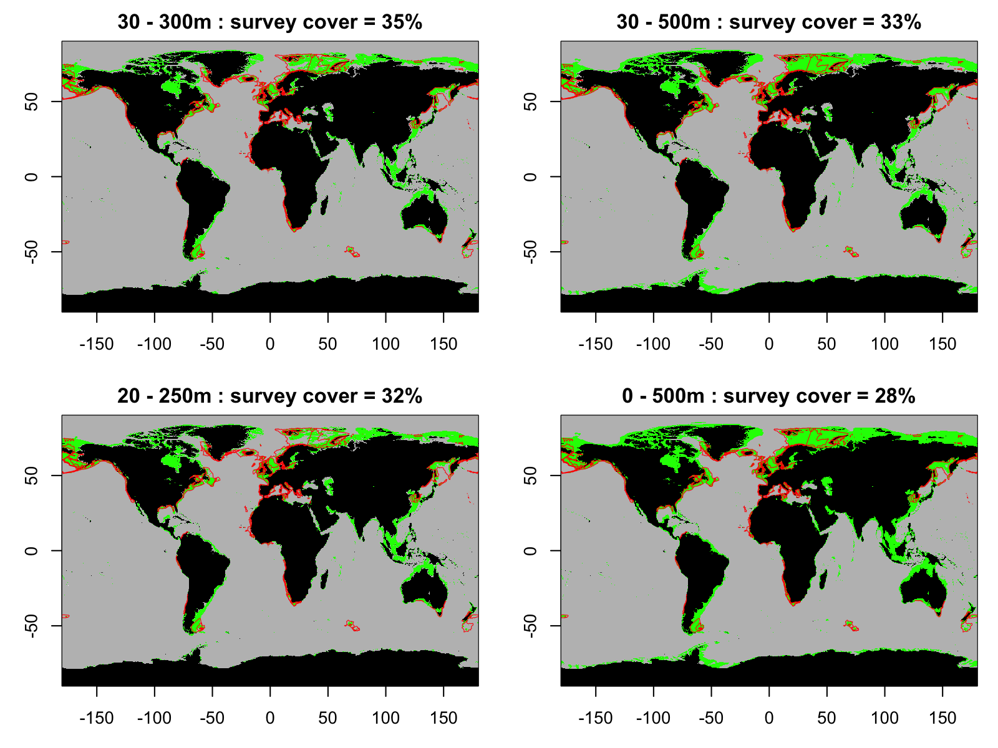
Figure S3.1: Map combining continental shelves and slopes (in green) and the outline of the convex hull (red) derived from the surveys. Each sub-panel combines different depth thresholds defining the continental shelf and slope. The proportion indicates the overlap between the convex hull and the green areas. The depth data was extracted from GEBCO (https://www.gebco.net/).

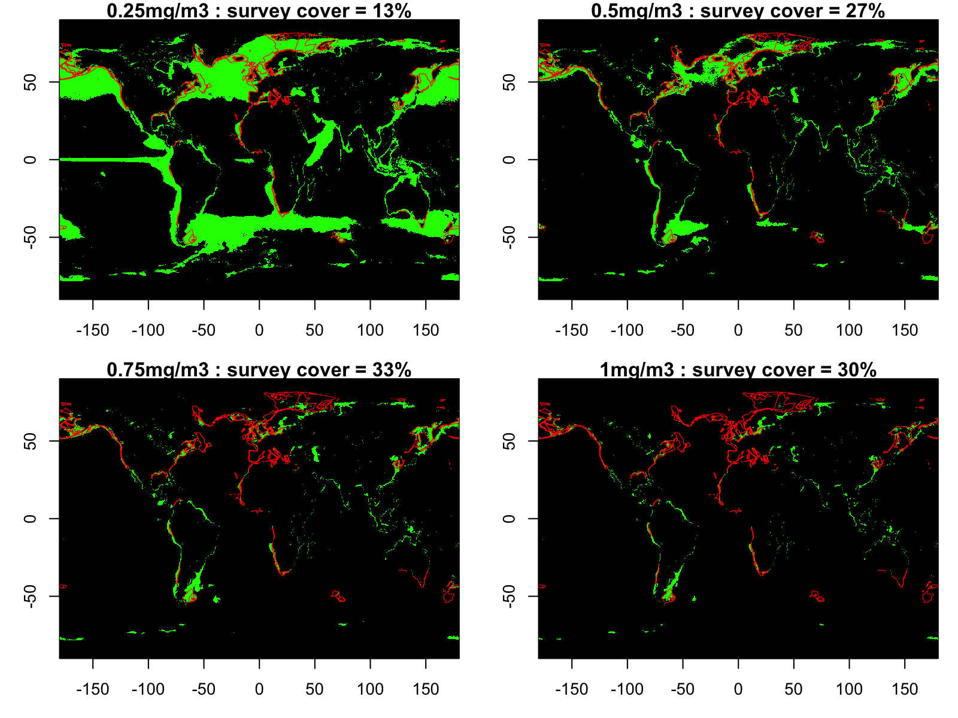
Figure S3.2: Map combining the chlorophyll a concentration and the outline of the convex hull derived from the surveys. Each sub-panel combines different chlorophyll a concentration thresholds defining productive sites. The proportion indicates the overlap between the convex hull and the grid cells identified as ‘productive’. Red lines show the outline of the survey convex hulls; green shading shows grid cells matching a given threshold for chlorophyll a concentration. The chlorophyll a data were extracted from GlobColour¹.
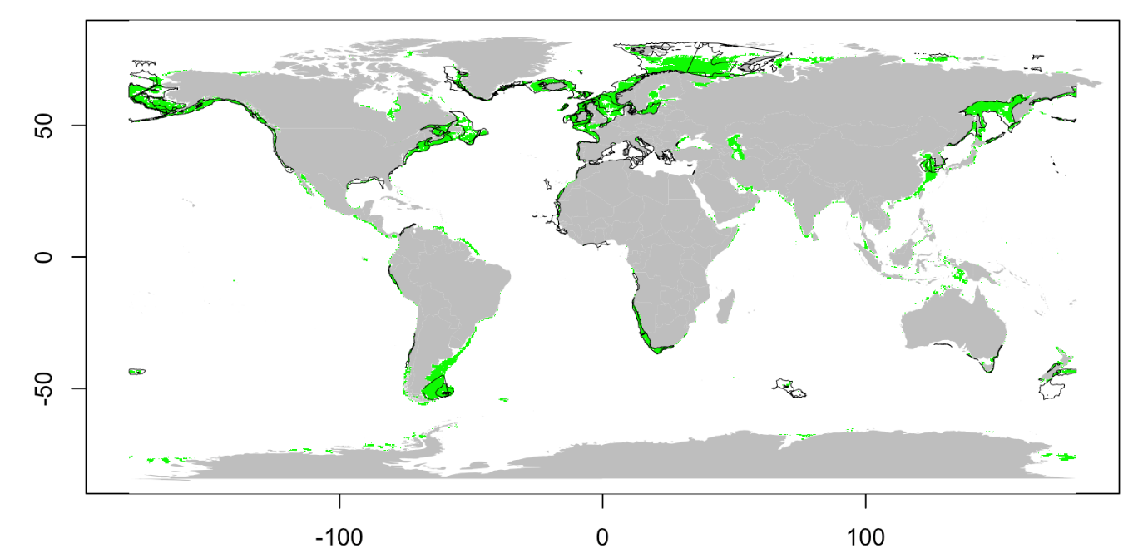
Figure S3.3: Map showing areas on the continental shelves and slopes (defined as depth 30-500 m) and high chlorophyll a concentration (using threshold >0.5 mg/m³) in green, and the outline of the convex hull derived from the surveys (black). The overlap indicates a coverage of 62% of productive shelves by the surveys.

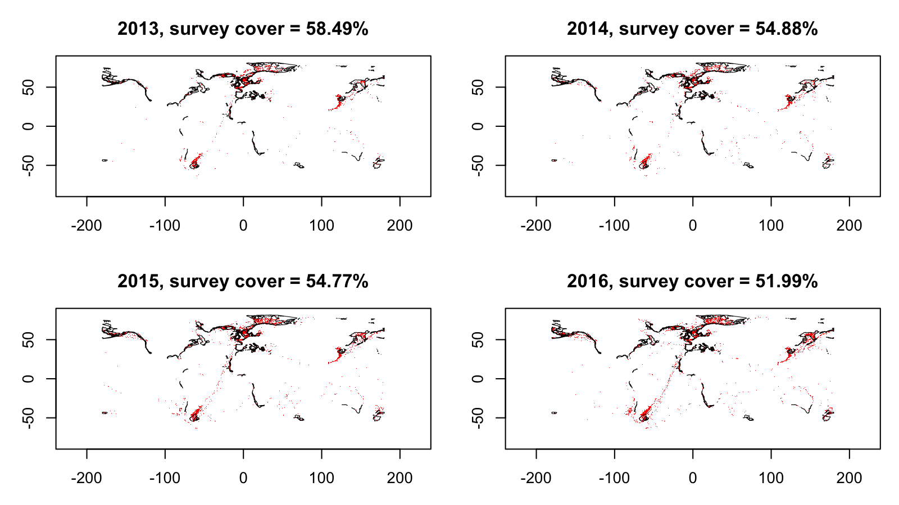
Figure S3.4: Map combining the fished sites (red) and the outline of the convex hull derived from the surveys (black). Each sub-panel represents a different year (from 2013 to 2016), from which the Global Fishing Watch data² was extracted.

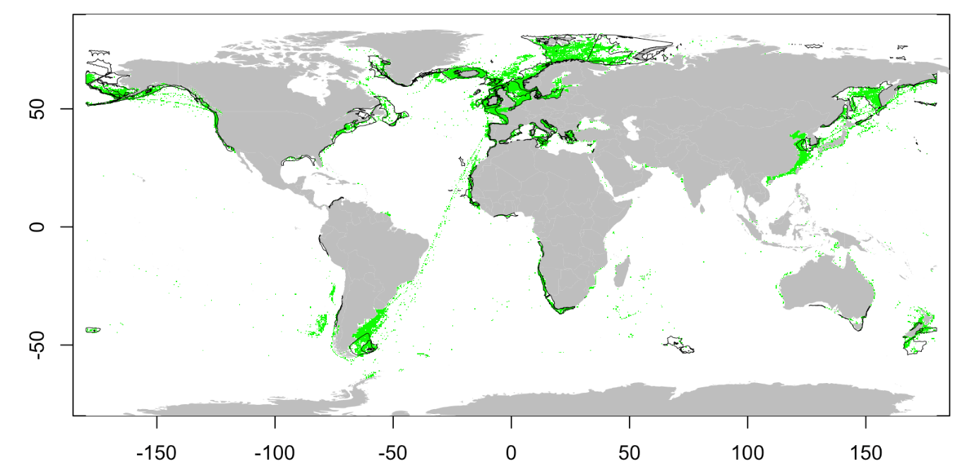
Figure S3.5: Map combining the fished areas (green), and the outline of the convex hull from the surveys (black). The overlap indicates a coverage of 54% of trawled fished areas by the surveys (where all years are combined).

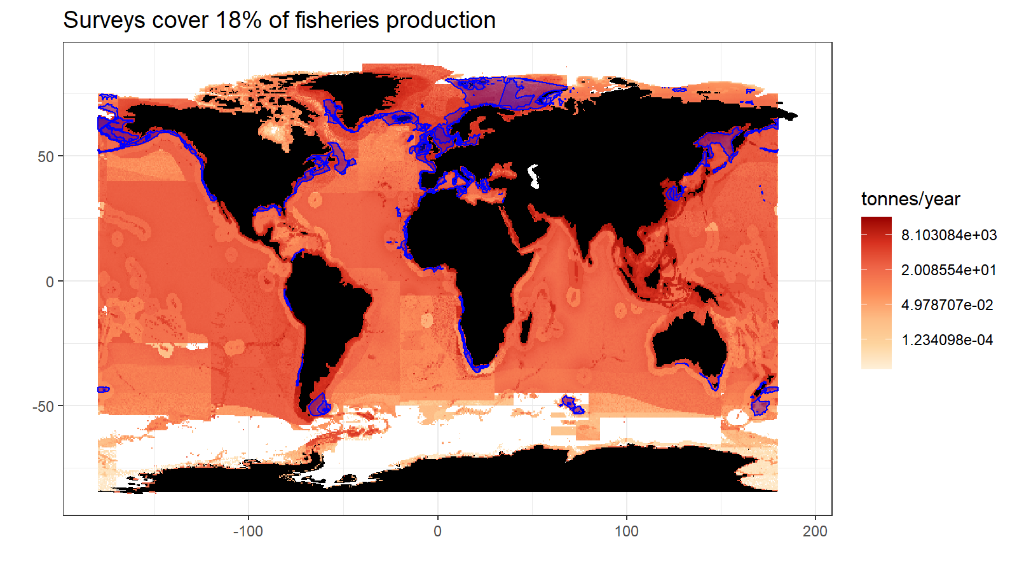
Figure S3.6: Map combining the average total fisheries production in tons/year, and the convex hull from the surveys (blue). Landings data were averaged on the time-period in each 30-min spatial grid cell to estimate an average fisheries production estimate (in tons/year). When calculating the ratio between the total fisheries production overlapping with survey areas (blue area) and the total worldwide fisheries production, we found that the surveys cover areas that are responsible for 18% of the total fisheries landings.

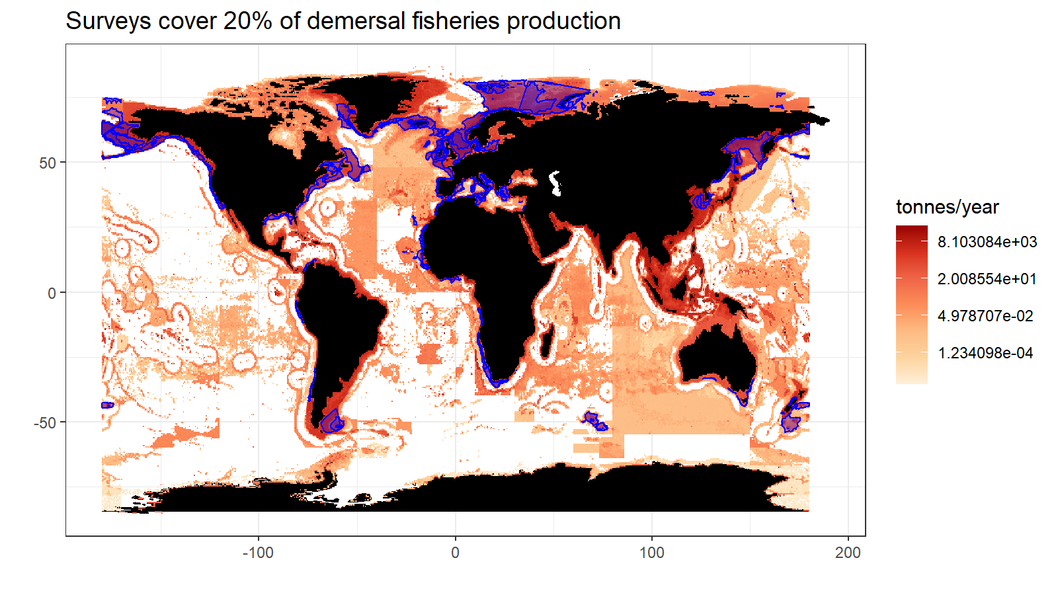
Figure 3.7: Map combining the average demersal fisheries production in tons/year, and the convex hull from the surveys (blue). Landings data were averaged on the time-period in each 30-min spatial grid cell to estimate an average fisheries production estimate (in tons/year). When calculating the ratio between the total fisheries production overlapping with survey areas (blue area) and the total worldwide fisheries production, we found that the surveys cover areas that are responsible for 20% of the demersal fisheries landings. Demersal catch were obtained by including multiple functional groups from the global fisheries catch database (Watson, 2017): demersals, bathydemersals, flatfishes, benthopelagics, reef associated fish, sharks and rays, shrimps, lobsters, crabs, and other demersal invertebrates.

Supplementary S4: Additional maps
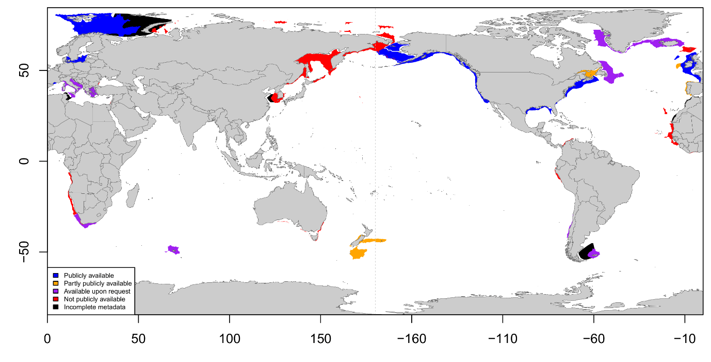
Figure S4.1: Worldwide location of ongoing bottom trawl scientific surveys, centered around Asia. Surveys are classified according to their availability: publicly available (blue), partly publicly available (orange), available upon request (purple) and private (red).
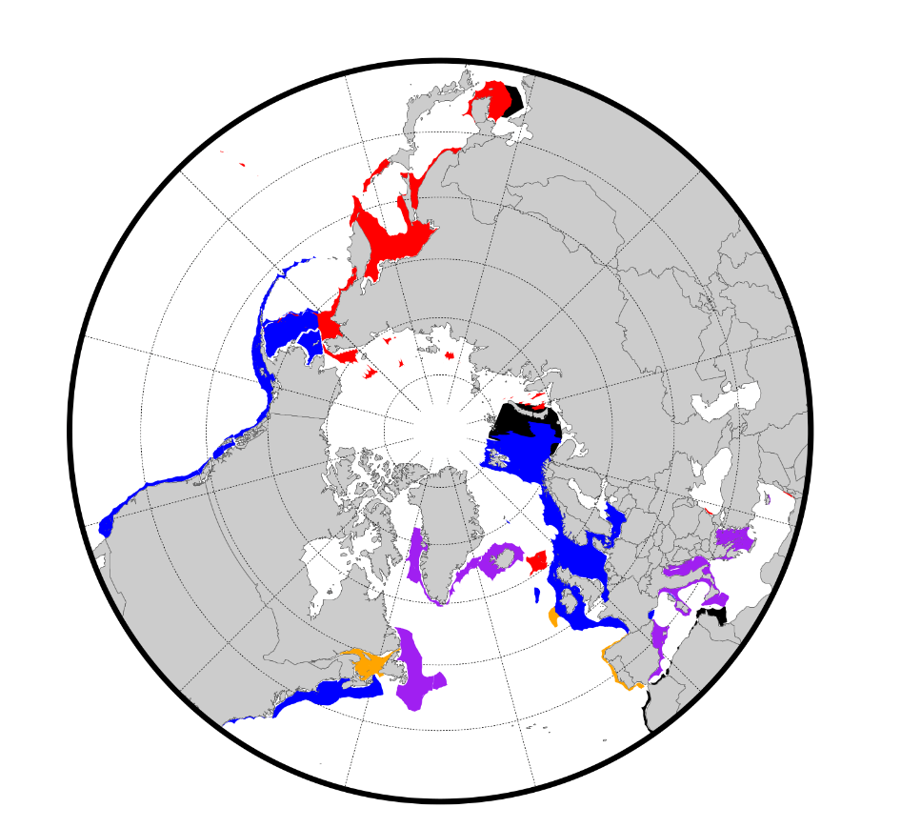
Figure S4.2: Location of ongoing bottom trawl scientific surveys in northern seas from a polar view. Surveys are classified according to their availability: publicly available (blue), available upon request (purple), partly publicly available (orange), not publicly available (red) and incomplete metadata (black).

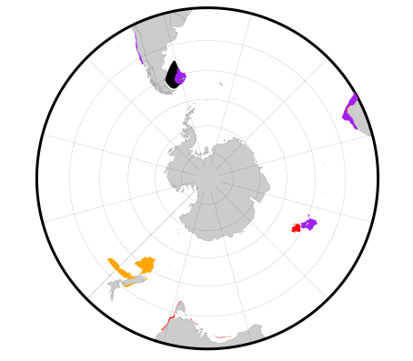
Figure S4.3: Location of ongoing bottom trawl scientific surveys in southern seas from a polar view. Surveys are classified according to their availability: publicly available (blue), available upon request (purple), partly publicly available (orange), not publicly available (red) and incomplete metadata (black).
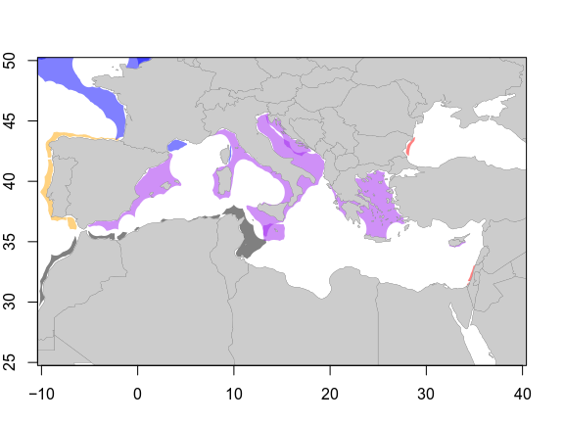
Figure S4.4: Location of ongoing bottom trawl scientific surveys in the Mediterranean Sea. Surveys are classified according to their availability: publicly available (blue), partly publicly available (orange), available upon request (purple), not available (red) and incomplete metadata (black).

Supplementary S5: Species range
File ‘SI.Appendix5.pdf’: Species range maps (from AquaMaps) where the probability of presence is higher than 0.5 (orange) with the survey convex hull overlayed (grey).

Table S5.1: List of main FAO fishing areas (http://www.fao.org/fishery/area/search/) included to identify the main demersal commercial species in FishStat, indicated by their scientific name and ASFIS 3-letter code (http://www.fao.org/fishery/collection/asfis/).

FAO code | Area | Included/Excluded | Scientific name | ASFIS code | Range in several FAO?
18 | Arctic Sea | Included | Gadus morhua | COD | yes
 |  |  | Melanogrammus aeglefinus | HAD | yes
 |  |  | Reinhardtius hippoglossoides | GHL | yes
21 | Northwest Atlantic | Included | Gadus morhua | COD | yes
 |  |  | Melanogrammus aeglefinus | HAD | yes
 |  |  | Reinhardtius hippoglossoides | GHL | yes
27 | Northeast Atlantic | Included | Gadus morhua | COD | yes
 |  |  | Pollachius virens | POK | yes
 |  |  | Melanogrammus aeglefinus | HAD | yes
31 | Western Central Atlantic | Included | Mugil cephalus | MUF | yes
 |  |  | Lutjanus campechanus | SNR | yes
 |  |  | Ocyurus chrysurus | SNY | yes
34 | Eastern Central Atlantic | Included | Polydactylus quadrifilis | TGA | no
 |  |  | Brachydeuterus auritus | GRB | no
 |  |  | Trichiurus lepturus | LHT | yes
37 | Mediterranean and Black Sea | Included | Merluccius merluccius | HKE | yes
 |  |  | Boops boops | BOG | yes
 |  |  | Merlangius merlangus | WHG | yes
41 | Southwest Atlantic | Included | Merluccius hubbsi | HKP | no
 |  |  | Micropogonias furnieri | CKM | yes
 |  |  | Macruronus magellanicus | GRM | yes
47 | Southeast Atlantic | Included | Merluccius capensis | HKK | no
 |  |  | Thyrsites atun | SNK | yes
 |  |  | Lophius vomerinus | MVO | no
48 | Antarctic Atlantic | Excluded | N/A | N/A | N/A
51 | Western Indian Ocean | Included | Harpadon nehereus | BUC | yes
 |  |  | Trichiurus lepturus | LHT | yes
 |  |  | Otolithes ruber | LKR | yes
57 | Eastern Indian Ocean | Included | Harpadon nehereus | BUC | yes
 |  |  | Cephalopholis boenak | CVK | yes
 |  |  | Trichiurus lepturus | LHT | yes
58 | Antarctic Indian Ocean | Included | Dissostichus eleginoides | TOP | yes
 |  |  | Macrourus carinatus | MCC | yes
 |  |  | Champsocephalus gunnari | ANI | yes
61 | Northwest Pacific | Included | Trichiurus lepturus | LHT | yes
 |  |  | Gadus chalcogrammus | ALK | yes
 |  |  | Larimichthys polyactis | CRY | no
67 | Northeast Pacific | Included | Gadus chalcogrammus | ALK | yes
 |  |  | Merluccius productus | NHA | yes
 |  |  | Gadus macrocephalus | PCO | yes
71 | Western Central Pacific | Included | Cephalopholis boenak | CVK | yes
 |  |  | Plectropomus leopardus | EMO | yes
 |  |  | Mene maculata | MOO | yes
77 | Eastern Central Pacific | Included | Lutjanus peru | LWP | no
 |  |  | Merluccius productus | NHA | yes
 |  |  | Mugil cephalus | MUF | yes
81 | Southwest Pacific | Included | Macruronus novaezelandiae | GRN | yes
 |  |  | Micromesistius australis | POS | yes
 |  |  | Thyrsites atun | SNK | yes
87 | Southeast Pacific | Included | Merluccius gayi gayi | PHA | no
 |  |  | Normanichthys crockeri | NRC | no
 |  |  | Macruronus magellanicus | GRM | yes
88 | Antarctic Pacific | Excluded | N/A | N/A | N/A

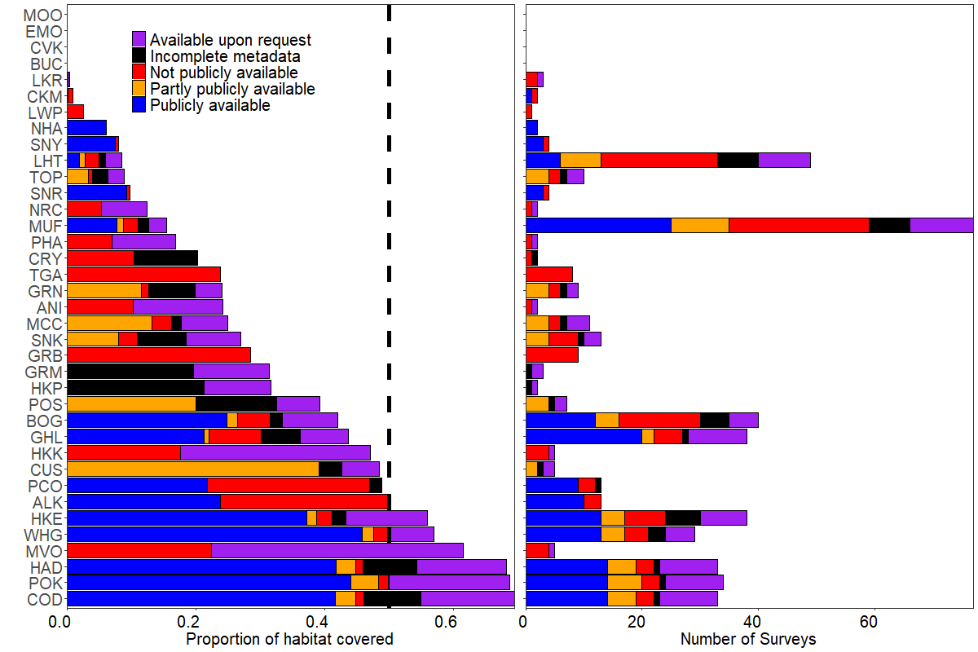
Figure S5.1: Main commercial demersal species and the corresponding coverage by the surveys: proportion of AquaMaps habitat covered by the surveys (left panel) and number of surveys behind the proportion covered (right panel). ‘*’ next to species Latin names indicate if the species appeared as a main commercial species in multiple FAO areas. Colors indicate the availability status attributed to each survey. We use a threshold of 0.1 to define presence of species.
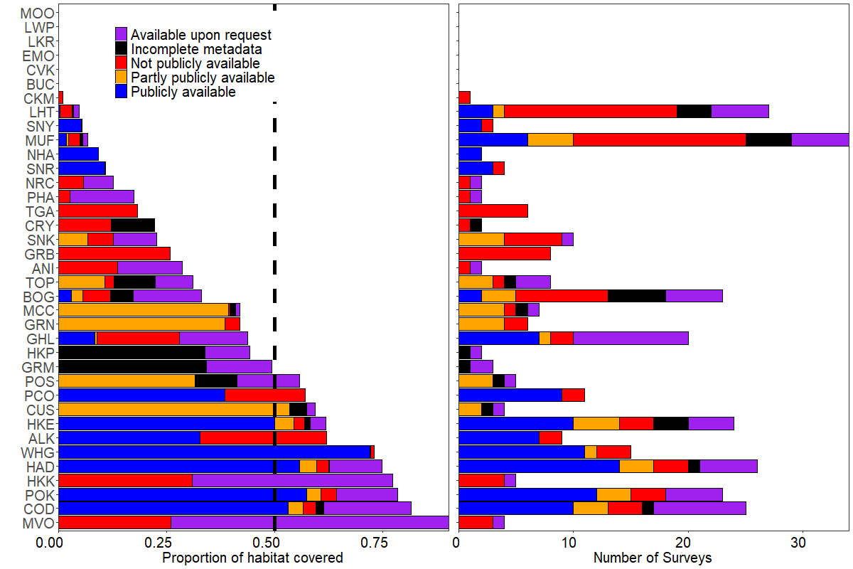
Figure S5.2: Main commercial demersal species and the corresponding coverage by the surveys: proportion of AquaMaps habitat covered by the surveys (left panel) and number of surveys behind the proportion covered (right panel). ‘*’ next to species Latin names indicate if the species appeared as a main commercial species in multiple FAO areas. Colors indicate the availability status attributed to each survey. We use a threshold of 0.9 to define presence of species.

Table S5.2: Comparison of results when using various thresholds to determine the probability of presence from Aquamaps models.

Threshold | 0.5 | 0.1 | 0.9
Max coverage (%) | 79 | 70 | 90
Min. number of surveys | 4 | 5 | 4
Max. number of surveys | 31 | 38 | 26
Mean number of surveys | 18 | 29 | 14

Supplementary S6: Transboundary demersal stocks

Using the RAM Legacy Stock Boundary Database (Free et al., 2019), built up from the RAM Legacy Stock Assessment Database (https://www.ramlegacy.org/) and is publicly available (https://marine.rutgers.edu/~cfree/ram-legacy-stock-boundary-database). Stock boundaries were inferred from either management areas or Exclusive Economic Zones (EEZs). A stock boundary determined by an EEZ might miss on the fact that the stock, while being manage by a country, may still be transboundary. For this reason, we selected species with stock boundaries delimited by management areas, and best documented stocks in the database. Determining a stock boundary should be based on ecological information on population boundaries with genetic data for instance. Still, these boundaries and stocks might not be inferred from an ecological point of view (but for instance an economic/political one) and should be better evaluated.

Supplementary S7: Spatio-temporal modeling

The model incorporates 10 surveys including the eastern Bering Sea, northern Bering Sea, Bering Sea slope, Gulf of Alaska, Aleutian Islands, British Columbia (West Coast of Vancouver Island, Queen Charlotte, Hecate Strait and West Coast Haida Gwaii) and California Current. Between 2001 and 2018, the analysis involves 33,667 samples.

Table S7.1: Summary of nations conducting surveys used for the arrowtooth flounder modeling case study.
Survey | Country
Eastern Bering Sea (EBS) | US
Northern Bering Sea (NBS) | US
Bering Sea Slope (BSS) | US
Gulf of Alaska (GOA) | US
Aleutian Islands (AI) | US
West Coast of Vancouver Island (WCVI) | Canada
Queen Charlotte (QCS) | Canada
Hecate Strait (HC) | Canada
West Coast Haida Gwaii (WCHG) | Canada
California Current (WCANN) | US

We fitted a Poisson-link delta spatio-temporal model (Thorson, 2017) with the vector-autoregressive spatio-temporal model package (VAST) (Thorson, 2019; Thorson & Barnett, 2017), with a gamma distribution for positive biomass catch rates. For each of the two components of the delta-model (presence-absence and biomasses), we estimated an annual intercept, a Gaussian Markov random field (GMRF) representing spatial variation in expected densities across all years (“spatial variation”), as well as a separate GMRF for each year representing annual variation in spatial densities (“spatio-temporal variation”).

We estimate density at 500 “knots” and use bilinear interpolation to predict spatial and spatio-temporal variables at locations between those knots. We also specify that spatial correlations decline as a function of distance and directional orientation (“geometric anisotropy” (Thorson et al., 2015)). We then use a generalization of the delta-method to calculate standard errors (Kass & Steffey, 1989), and the epsilon bias-correction estimator to account for retransformation bias (Thorson & Kristensen, 2016) when calculating total abundance and center-of-gravity within each survey region. VAST uses Template Model Builder (Kristensen et al., 2016) to implement the Laplace approximation to the marginal likelihood, and we used the gradient of this approximation to identify the maximum likelihood estimate of all parameters within the R statistical environment (R Core Team, 2018).

In the model, the following parameters were estimated: the variance of spatial and spatio-temporal variation for each delta-model component (four variance parameters), the decorrelation rate for each component (two scale-range parameters), the variance of residual (sampling) variation (one parameter), the intercept for each delta-model component in each year (36 parameters), geometric anisotropy (2 parameters), and the degree of autocorrelation in spatio-temporal variation for each delta-model component (2 parameters).

We improve computational efficiency for calculating the probability of spatial and spatio-temporal variables by using the stochastic partial differential equation (SPDE) (Lindgren et al., 2011), and use the mesh generated by R-INLA (Rue et al., 2009).

To further improve computational speed when implementing the epsilon-estimator given a predictive-process framework, we reduce the number of locations used to measure distribution by identifying 2000 “extrapolation-cells” that approximate the total area sampled by these seven surveys.

We confirm that the model has converged by checking that the absolute gradient of the marginal likelihood with respect to fixed effects is low (<0.0001) and the Hessian is positive definite. We also checked standard model residuals (spatial Pearson residuals, quantile-quantile plots, and the ratio of predicted and observed encounter probabilities), to show that the model has satisfactory fit (i.e., that residuals show little evidence of residual spatial processes).

To check the accuracy of the model, we specifically compared estimated abundance with stock-assessment estimates for the Aleutian Islands and Bering Sea (Spies et al., 2018 Fig. 6.26), the Gulf of Alaska (Spies & Palsson, 2018 Table 7.1), and the California Current (Sampson et al., 2017 Fig. 26) and confirm that results have similar scale and trends to those single-region estimates. By contrast, the assessment in British Columbia (Grandin & Forrest, 2017) estimates separate abundance indices for each sub-area within the British Columbia bottom trawl domain, and also includes indices only for 2003-2014. It is therefore difficult to compare indices from the British Columbia assessment document directly with our results for that region.

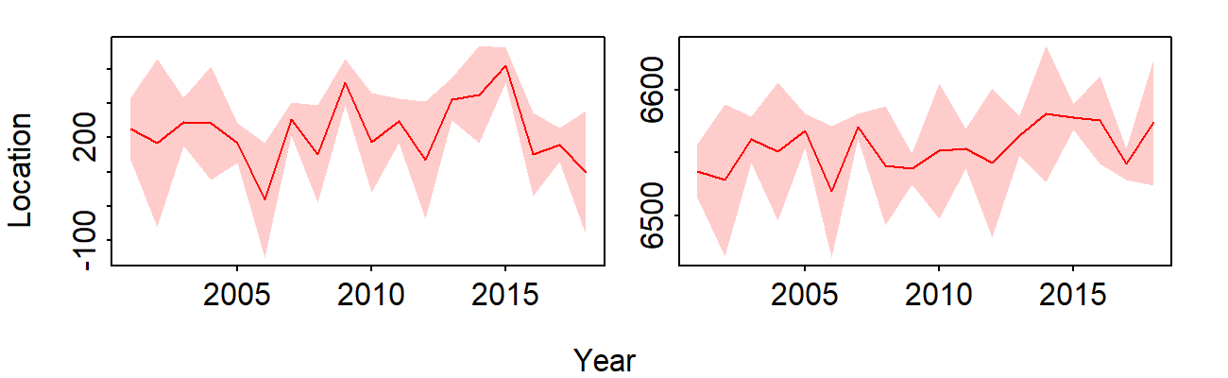
Figure S7.1: Center of gravity (y-axis) in each year 2001-2018 (x-axis) showing location (red lines) in kilometers east of UTM zone 3 (left panel) and kilometers north of the equator (right panel), as well as a predictive interval (red shading: +/- one standard error).

Supplementary References

Free, C. M., Thorson, J. T., Pinsky, M. L., Oken, K. L., Wiedenmann, J., & Jensen, O. P. (2019). Impacts of historical warming on marine fisheries production. Science, 363(6430), 979–983. https://doi.org/10.1126/science.aau1758
Grandin, C. J., & Forrest, R. E. (2017). Arrowtooth Flounder (Atheresthes stomias) Stock Assessment for the West Coast of British Columbia (No. 025; DFO Can. Sci. Advis. Sec. Res. Doc., p. v + 87p.).
Kass, R. E., & Steffey, D. (1989). Approximate Bayesian Inference in Conditionally Independent Hierarchical Models (Parametric Empirical Bayes Models). Journal of the American Statistical Association, 84(407), 717–726. JSTOR. https://doi.org/10.2307/2289653
Kristensen, K., Nielsen, A., Berg, C. W., Skaug, H., & Bell, B. M. (2016). TMB: Automatic Differentiation and Laplace Approximation. Journal of Statistical Software, 70(1), 1–21. https://doi.org/10.18637/jss.v070.i05
Lindgren, F., Rue, H., & Lindström, J. (2011). An explicit link between Gaussian fields and Gaussian Markov random fields: The stochastic partial differential equation approach. Journal of the Royal Statistical Society: Series B (Statistical Methodology), 73(4), 423–498. https://doi.org/10.1111/j.1467-9868.2011.00777.x
R Core Team. (2018). R: A Language and Environment for Statistical Computing. R Foundation for Statistical Computing. https://www.R-project.org/
Rue, H., Martino, S., & Chopin, N. (2009). Approximate Bayesian inference for latent Gaussian models by using integrated nested Laplace approximations. Journal of the Royal Statistical Society: Series B (Statistical Methodology), 71(2), 319–392. https://doi.org/10.1111/j.1467-9868.2008.00700.x
Sampson, D. B., Hamel, O. S., Bosley, K., Budrick, J., Cronin-Fine, L., Hillier, L. K., Hinton, K. E., Krigbaum, M. J., Miller, S., Privitera-Johnson, K. M., Ramey, K. L., Rodomsky, B. T., Solinger, L. K., & Whitman, A. D. (2017). 2017 Assessment Update for the US West Coast Stock of Arrowtooth Flounder.
Spies, I., & Palsson, W. (2018). Assessment of the arrowtooth flounder stock in the Gulf of Alaska.
Spies, I., Wilderbuer, T. K., Nichol, D. G., Hoff, J., & Palsson, W. (2018). Assessment of the arrowtooth flounder stock in the Eastern Bering Sea and Aleutian Islands.
Thorson, J. T. (2017). Three problems with the conventional delta-model for biomass sampling data, and a computationally efficient alternative. Canadian Journal of Fisheries and Aquatic Sciences, 75(9), 1369–1382. https://doi.org/10.1139/cjfas-2017-0266
Thorson, J. T. (2019). Guidance for decisions using the Vector Autoregressive Spatio-Temporal (VAST) package in stock, ecosystem, habitat and climate assessments. Fisheries Research, 210, 143–161. https://doi.org/10.1016/j.fishres.2018.10.013
Thorson, J. T., & Barnett, L. A. K. (2017). Comparing estimates of abundance trends and distribution shifts using single- and multispecies models of fishes and biogenic habitat. ICES Journal of Marine Science, 74(5), 1311–1321. https://doi.org/10.1093/icesjms/fsw193
Thorson, J. T., & Kristensen, K. (2016). Implementing a generic method for bias correction in statistical models using random effects, with spatial and population dynamics examples. Fisheries Research, 175, 66–74. https://doi.org/10.1016/j.fishres.2015.11.016
Thorson, J. T., Shelton, A. O., Ward, E. J., & Skaug, H. J. (2015). Geostatistical delta-generalized linear mixed models improve precision for estimated abundance indices for West Coast groundfishes. ICES Journal of Marine Science, 72(5), 1297–1310. https://doi.org/10.1093/icesjms/fsu243
Watson, R. A. (2017). A database of global marine commercial, small-scale, illegal and unreported fisheries catch 1950–2014. Scientific Data, 4, 170039. https://doi.org/10.1038/sdata.2017.39

