**Supplementary Material**

***The use and performance of survey-based pre-recruit abundance indices for possible inclusion in stock assessments of coastal-dependent species***

O. Le Pape, Y. Vermard, J. Guitton, E.J. Brown, K.E. van de Wolfshaar, R.N. Lipcius, J.G. Støttrup, K.A. Rose

**Supp Mat. 1: Information on the 78 stocks with juvenile coastal-dependence assessed by ICES.**

Supplementary Table 1: Characteristics of the 78 stocks of species that rely on coastal habitats at the juvenile stage that were assessed by ICES in 2017-2018. Characteristics were: DLS Category, whether recruitment forecasts used in the assessment, whether a survey exists and whether the survey-based pre-recruit prediction were used in the assessment, the reason a survey was not used, the spatial area covered by the survey, and the sampling gear used in the survey.

|  |  |  |  |  |  |  |  |
| --- | --- | --- | --- | --- | --- | --- | --- |
| **Stock Description** | **DLS category** | **Use of forecast in stock assessment** | **Existence of a pre-recruit survey** | **Use of pre-recruit indice to forecast recruitment** | **Reason to reject the use of the survey indices in forecast** | **Area of pre-recruit survey** | **Method of survey** |
| Anchovy (Engraulis encrasicolus) in Subarea VIII (Bay of Biscay) | 1 | Yes | Yes | Yes |  | Stock scale, including nurseries | Accoustic |
| Cod (Gadus morhua) in Division Va (Iceland grounds) | 1 | Yes | Yes | Yes |  | Stock scale, not including nurseries | Trawl |
| Cod (Gadus morhua) in NAFO Subarea 1, inshore (Inshore west Greenland cod) | 1 | Yes | Yes | Yes |  | Stock distribution partially covered but including nurseries | Net |
| Cod (Gadus morhua) in Subarea IV and Divisions VIId and IIIa West (North Sea, Eastern English Channel, Skagerrak) | 1 | Yes | Yes | Yes |  | Stock scale, including nurseries | Trawl |
| Cod (Gadus morhua) in Subdivisions 22–24 (Western Baltic Sea) | 1 | Yes | Yes | Yes |  | Stock scale, including nurseries | Trawl |
| Herring in Subarea IV and Divisions IIIa and VIId (North Sea autumn spawners) | 1 | Yes | Yes | Yes |  | Stock scale, including nurseries | Trawl |
| Herring in Subdivisions 25 - 29 (excluding Gulf of Riga) and 32 | 1 | Yes | Yes | Yes |  | Stock scale, not including nurseries | Accoustic |
| Mackerel in the Northeast Atlantic (combined Southern, Western and North Sea spawning components) | 1 | Yes | Yes | Yes |  | Stock scale, including nurseries | Trawl |
| Plaice in Division VIIa (Irish Sea) | 1 | Yes | Yes | Yes |  | Stock scale, not including nurseries | Trawl |
| Plaice Subarea IV (North Sea) | 1 | Yes | Yes | Yes |  | Stock distribution partially covered but including nurseries | Trawl |
| Sole in Subarea IV (North Sea) | 1 | Yes | Yes | Yes |  | Stock distribution partially covered but including nurseries | Trawl |
| Sprat in Subdivisions 22 - 32 (Baltic Sea) | 1 | Yes | Yes | Yes |  | Stock scale, including nurseries | Accoustic |
| Whiting in ICES Division VIIb, c, e-k | 1 | Yes | Yes | Yes |  | Stock distribution partially covered but including nurseries | Trawl |
| Whiting Subarea IV (North Sea) and Division VIId (Eastern Channel) | 1 | Yes | Yes | Yes |  | Stock scale, including nurseries | Trawl |
| Cod (Gadus morhua) in Division VIa (West of Scotland) | 1 | Yes | Yes | No | Incomplete | Stock scale, including nurseries | Trawl |
| Cod (Gadus morhua) in Divisions VIIe–k (Western English Channel and Southern Celtic Seas) | 1 | Yes | Yes | No | A priori considered as not appropriate or not reliable | Stock distribution partially covered and not including nurseries | Trawl |
| Cod (Gadus morhua) in Subareas I and II (Northeast Arctic) | 1 | Yes | Yes | No | A priori considered as not appropriate or not reliable | Stock distribution partially covered and not including nurseries | Trawl |
| Herring in Division IIIa and Subdivisions 22 - 24 (Western Baltic spring spawners) | 1 | Yes | Yes | No | Not investigated | Stock distribution partially covered but including nurseries | Net |
| Herring in Division Va (Icelandic summer-spawners) | 1 | Yes | Yes | No | A priori considered as not appropriate or not reliable | Stock distribution partially covered but including nurseries | Accoustic |
| Herring in Subareas I, II, V and Divisions IVa and XIVa (Norwegian spring-spawning herring) | 1 | Yes | Yes | No | Not investigated | Stock distribution partially covered but including nurseries | Accoustic |
| Plaice in Division VIId (Eastern Channel) | 1 | Yes | Yes | No | Not investigated | Stock distribution partially covered but including nurseries | Trawl |
| Saithe in Division Va (Icelandic saithe) | 1 | Yes | Yes | No | Tested, rejected because of lack of reliability | Stock scale, including nurseries | Trawl |
| Saithe in Division Vb (Faroe Saithe) | 1 | Yes | Yes | No | A priori considered as not appropriate or not reliable | Stock scale, not including nurseries | Trawl |
| Saithe in Subareas I and II (Northeast Arctic) | 1 | Yes | Yes | No | A priori considered as not appropriate or not reliable | Stock distribution partially covered but including nurseries | Accoustic |
| Sandeel in the Central Eastern North Sea (SA 3) | 1 | Yes | Yes | No | A priori considered as not appropriate or not reliable | Stock scale, including nurseries | Other |
| Sandeel in the Central Western North Sea (SA 4) | 1 | Yes | Yes | No | A priori considered as not appropriate or not reliable | Stock scale, including nurseries | Other |
| Sandeel in the Dogger Bank area (SA 1) | 1 | Yes | Yes | No | A priori considered as not appropriate or not reliable | Stock scale, including nurseries | Other |
| Sandeel in the South Eastern North Sea (SA 2) | 1 | Yes | Yes | No | A priori considered as not appropriate or not reliable | Stock scale, including nurseries | Other |
| Sole in Division IIIa and Subdivisions 22-24 (Skagerrak, Kattegat, and the Belts) | 1 | Yes | Yes | No | Incomplete | Stock distribution partially covered but including nurseries | Trawl |
| Sole in Division VIIa (Irish Sea) | 1 | Yes | Yes | No | Tested, rejected because of lack of reliability | Stock distribution partially covered but including nurseries | Trawl |
| Sole in Division VIId (Eastern Channel) | 1 | Yes | Yes | No | Tested, rejected because of lack of reliability | Stock distribution partially covered but including nurseries | Trawl |
| Sole in Divisions VIIf, g (Celtic Sea) | 1 | Yes | Yes | No | Tested, rejected because of lack of reliability | Stock distribution partially covered but including nurseries | Trawl |
| Sole in Divisions VIIIa,b (Bay of Biscay) | 1 | yes | yes | No | A priori considered as not appropriate or not reliable | Stock scale, not including nurseries | Trawl |
| Striped red mullet (Mullus surmuletus) in Subarea 4 and divisions 7.d and 3.a | 1 | Yes | Yes | No | Not investigated | Stock distribution partially covered but including nurseries | Trawl |
| Whiting (Merlangius merlangus) in Division 7.a (Irish Sea) | 1 | Yes | Yes | No | Not investigated | Stock distribution partially covered but including nurseries | Trawl |
| Cod (Gadus morhua) in Division VIIa (Irish Sea) | 1 | Yes | No | No |  |  |  |
| Cod (Gadus morhua) in Subdivision Vb1 (Faroe Plateau) | 1 | Yes | No | No |  |  |  |
| Herring (Clupea harengus) in Divisions VIa and VIIb,c (West of Scotland, West of Ireland) | 1 | Yes | No | No |  |  |  |
| Herring in Division VIIa North of 52° 30’ N (Irish Sea) | 1 | Yes | No | No |  |  |  |
| Herring in Division VIIa South of 52° 30’ N and VIIg,h,j,k (Celtic Sea and South of Ireland) | 1 | Yes | No | No |  |  |  |
| Herring in Subdivision 28.1 (Gulf of Riga) | 1 | Yes | No | No |  |  |  |
| Herring in Subdivision 30 & 31 (Bothnian Sea and Bothnian Bay) | 1 | Yes | No | No |  |  |  |
| Plaice in Subdivisions 21, 22, and 23 (Kattegat, Belts, and Sound) | 1 | Yes | No | No |  |  |  |
| Saithe in Subarea IV (North Sea) Division IIIa West (Skagerrak) and Subarea VI (West of Scotland and Rockall) | 1 | Yes | No | No |  |  |  |
| Sole in Division VIIe (Western Channel) | 1 | Yes | No | No |  |  |  |
| Whiting in Division VIa (West of Scotland) | 1 | Yes | No | No |  |  |  |
| Plaice in Division VIIe (Western Channel) | 3 | Yes | No | No |  |  |  |
| Plaice in Divisions VIIh-k (Southwest of Ireland) | 3 | Yes | No | No |  |  |  |
| Sole in Divisions VIIh-k (Southwest of Ireland) | 3 | Yes | No | No |  |  |  |
| Anchovy (Engraulis encrasicolus) in Division IXa (Atlantic Iberian Waters) | 3 | No | Yes | No |  | Stock distribution partially covered but including nurseries | Accoustic |
| Cod (Gadus morhua) in Division IIIa East (Kattegat) | 3 | No | Yes | No |  | Stock scale, including nurseries | Trawl |
| Cod (Gadus morhua) in ICES Subarea XIV and NAFO Subdivision 1F (East Greenland, South Greenland) | 3 | No | Yes | No |  | Stock distribution partially covered but including nurseries | Trawl |
| Cod (Gadus morhua) in NAFO Subdivision 1A-E (Offshore West Greenland) | 3 | No | Yes | No |  | Stock scale, including nurseries | Trawl |
| Cod (Gadus morhua) in Subareas I and II (Norwegian coastal waters cod) | 3 | No | Yes | No |  | Stock distribution partially covered and not including nurseries | Accoustic |
| Cod (Gadus morhua) in Subdivision Vb2 (Faroe Bank) | 3 | No | Yes | No |  | Stock distribution partially covered but including nursery | Trawl |
| European eel in the Northeast Atlantic | 3 | No | Yes | No |  | Stock distribution partially covered but including nurseries | Other |
| Flounder in Subdivisions 26 and 28 (Eastern Gotland and Gulf of Gdansk) | 3 | No | Yes | No |  | Stock distribution partially covered but including nurseries | Trawl |
| Sprat in Division IIIa (Skagerrak - Kattegat) | 3 | No | Yes | No |  | Stock distribution partially covered but including nurseries | Net |
| Brill (Scophthalmus rhombus) in Subdivisions 22–32 (Baltic Sea) | 3 | No | No | No |  |  |  |
| Cod (Gadus morhua) in Subdivisions 25–32 (Eastern Baltic Sea) | 3 | No | No | No |  |  |  |
| Dab in Subdivisions 22 - 32 (Baltic Sea) | 3 | No | No | No |  |  |  |
| Flounder in Subdivisions 22 and 23 (Belts and Sound) | 3 | No | No | No |  |  |  |
| Flounder in Subdivisions 24 - 25 (Southern Baltic Sea) | 3 | No | No | No |  |  |  |
| Flounder in Subdivisions 27 and 29 to 32 (Northern Baltic Sea) | 3 | No | No | No |  |  |  |
| Plaice in Divisions VIIf,g (Celtic Sea) | 3 | No | No | No |  |  |  |
| Plaice in Subdivisions 24 - 32 (Baltic Sea) | 3 | No | No | No |  |  |  |
| Sprat in Divisions VIId,e | 3 | No | No | No |  |  |  |
| Turbot in Subdivisions 22 - 32 (Baltic Sea) | 3 | No | No | No |  |  |  |
| Pollack (Pollachius pollachius) in subareas 6–7 (Celtic Seas and the English Channel) | 4 | No | No | No |  |  |  |
| Whiting in Subarea VIII and Division IXa | 5 | No | Yes | No |  | Stock scale, not including nurseries | Trawl |
| Pollack in Subarea IV and Division IIIa | 5 | No | No | No |  |  |  |
| Pollack in Subarea VIII and Division IXa | 5 | No | No | No |  |  |  |
| Sandeel in Division IIIa East (Kattegat, SA6) | 5 | No | No | No |  |  |  |
| Sandeel in the Shetland area (SA 7) | 5 | No | No | No |  |  |  |
| Sandeel in the Viking and Bergen Bank area (SA 5) | 5 | No | No | No |  |  |  |
| Whiting in Division IIIa (Skagerrak - Kattegat) | 5 | No | No | No |  |  |  |
| Sandeel (Ammodytes spp.) in Division 6.a (West of Scotland) | 6 | No | No | No |  |  |  |
| Seabass (Dicentrarchus labrax) in Divisions IVb and c, VIIa, and VIId–h (Central and South North Sea, Irish Sea, English Channel, Bristol Channel, Celtic Sea) | 6 | No | No | No |  |  |  |

**Supp. Mat. 2: Possible effect on correlation of survey indices being used in the stock assessments**

For 10 of the 14 stocks analyzed, the survey-based index of recruitment was also used in the stock assessment. We correlated the survey index with the estimated recruits from the stock assessment. Thus, there is the potential that the correlation coefficients can be inflated because the two estimates (survey and assessment) are not truly independent.

We note that this was not a potential problem for four of the 14 stocks that did not use the survey indices in their assessments. In a first approach, for the remaining 10 stocks, we did not use the last two years of estimated recruitment from the assessment in the correlations (see Methods section). The last two years were either manually deleted by us (5 stocks), or were naturally deleted because there was at least a 2-year lag between the age of fish in the surveys compared to the age at recruitment in the stock assessment (i.e., there were no survey estimates available to match recruitment for the last two years of the assessment). Others have discussed this issue and concluded that the most influence of the survey index for recruitment would occur at the end of the time series (Hilborn and Walters, 1992). The reasoning is that there is other information available (e.g., catch and survey indices for several age groups) that influences the fitting of the stock assessment modeling until near the very end of the assessment period, when the recruitment estimates can play a major role in the fitting.

We used two pieces of evidence that support this use of the correlation results (with the last 2 years deleted, either manually or naturally) with the stocks that used the survey indices in their assessments. These are:

(1) Supp. Figure 1 shows the actual time series of value of the survey and assessment estimates of recruitment. The top row of four stocks are those with independent survey and assessment estimates of recruitment. The correlations for these four stocks (0.799, 0.920, 0.829, and 0.846, mean = 0.85) are well within the range of the remaining 10 stocks that did include the survey index in their assessment. The range for the four stocks with manual deletion of the last two years was 0.629-0.911 (mean = 0.80) and the range for the six stocks with natural deletion was 0.643-0.891 (mean = 0.75).

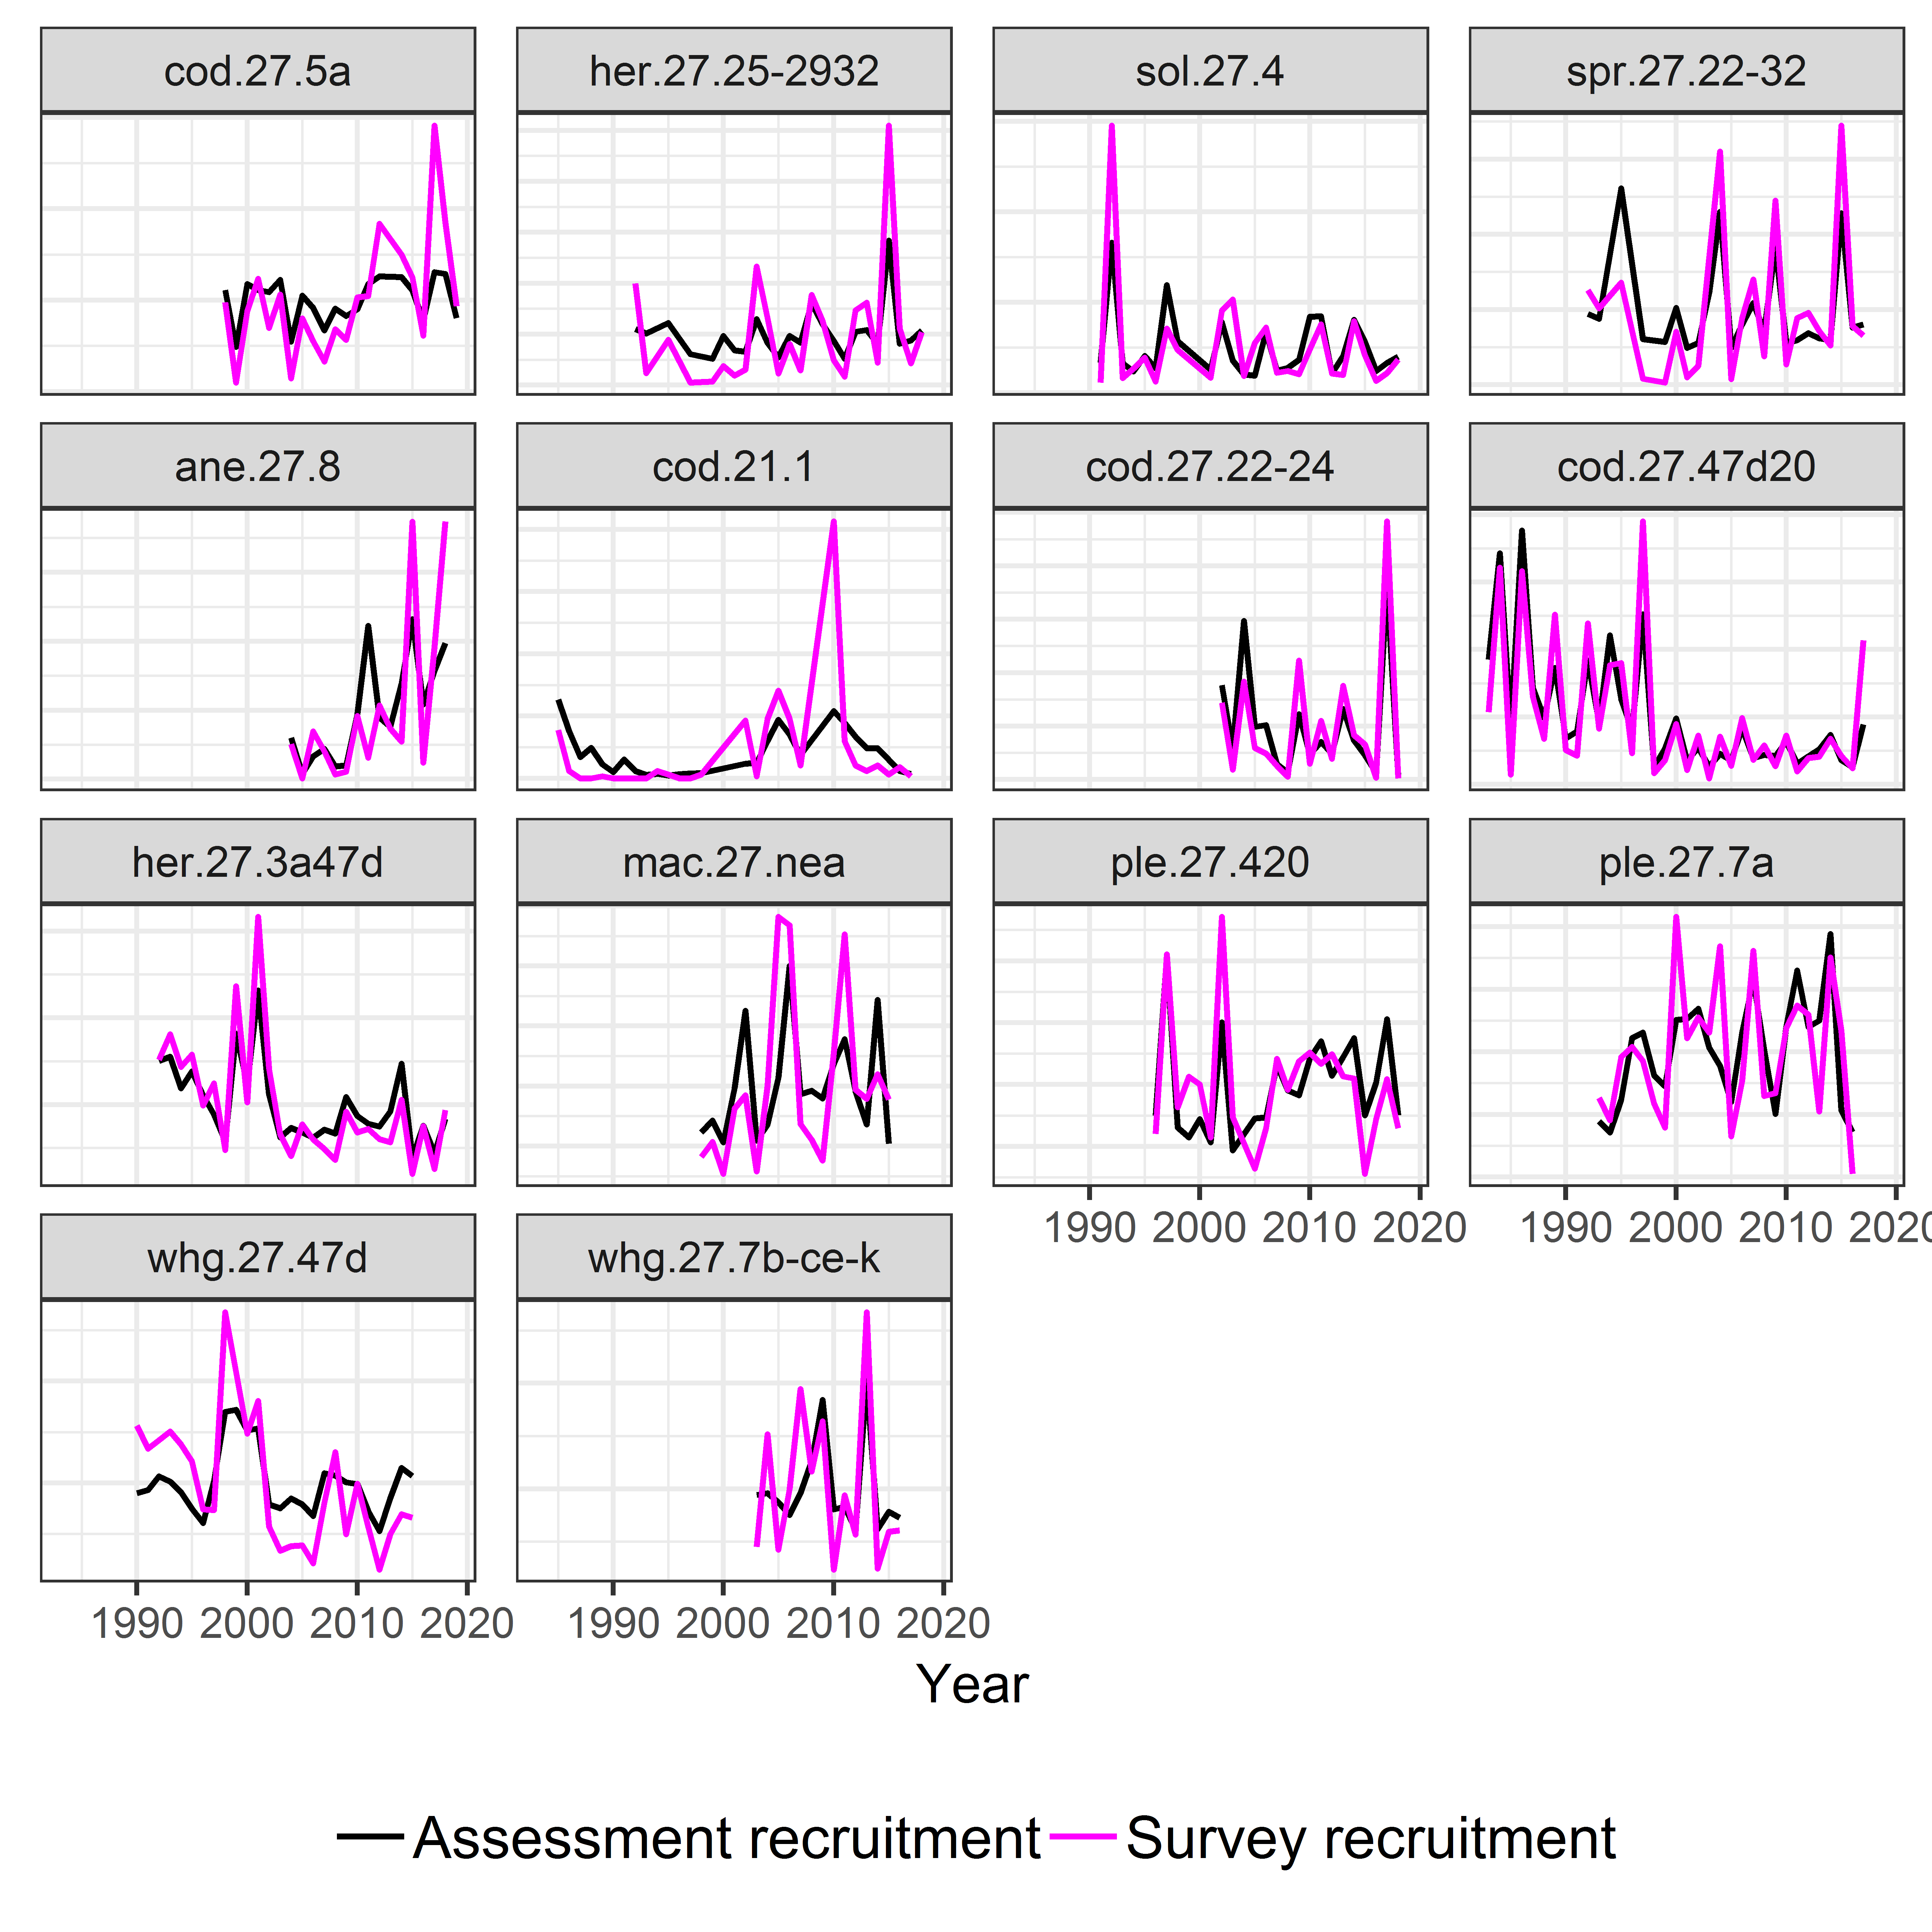

Supplementary Figure 1: Recruitment estimates from stock assessments (black) and Recruitment indices from surveys (magenta) for all 14 stocks with juvenile survey indices available. Survey indices were each normalized by dividing by their mean value. The top four panels are those stocks for which the juvenile index was not used in the assessment.

(2) We performed an analysis that used a windowing approach to compute correlations between survey and assessment estimates of recruitment in 5-year segments. The idea was to determine if different time periods, especially the last few, cause noticeably higher correlations. One would expect that the if the latter years were causing inflated correlations, then the correlation coefficient values would therefore always be very high in the last few 5-year segments of each stock because those years would increasing dominate the last few time windows.

To further confirm that this windowing approach would, in fact, detect such a pattern, we generated two hypothetical time series that were related but with noise until 5 years from the end of the time series, and then forced the two time series to track each other with very little noise (Supp. Figure 2). The same sliding 5-year window analysis was applied to this generated data. This would mimic the situation of concern that the last years the stock assessment estimates were most heavily influenced by survey indices. Supp. Figure 3 shows the correlation coefficients for the 5-year windows and the variation in the correlation until the near the end of the time period, when the synchronous time series cause a rapid increase in the correlation coefficient in the last few windows.

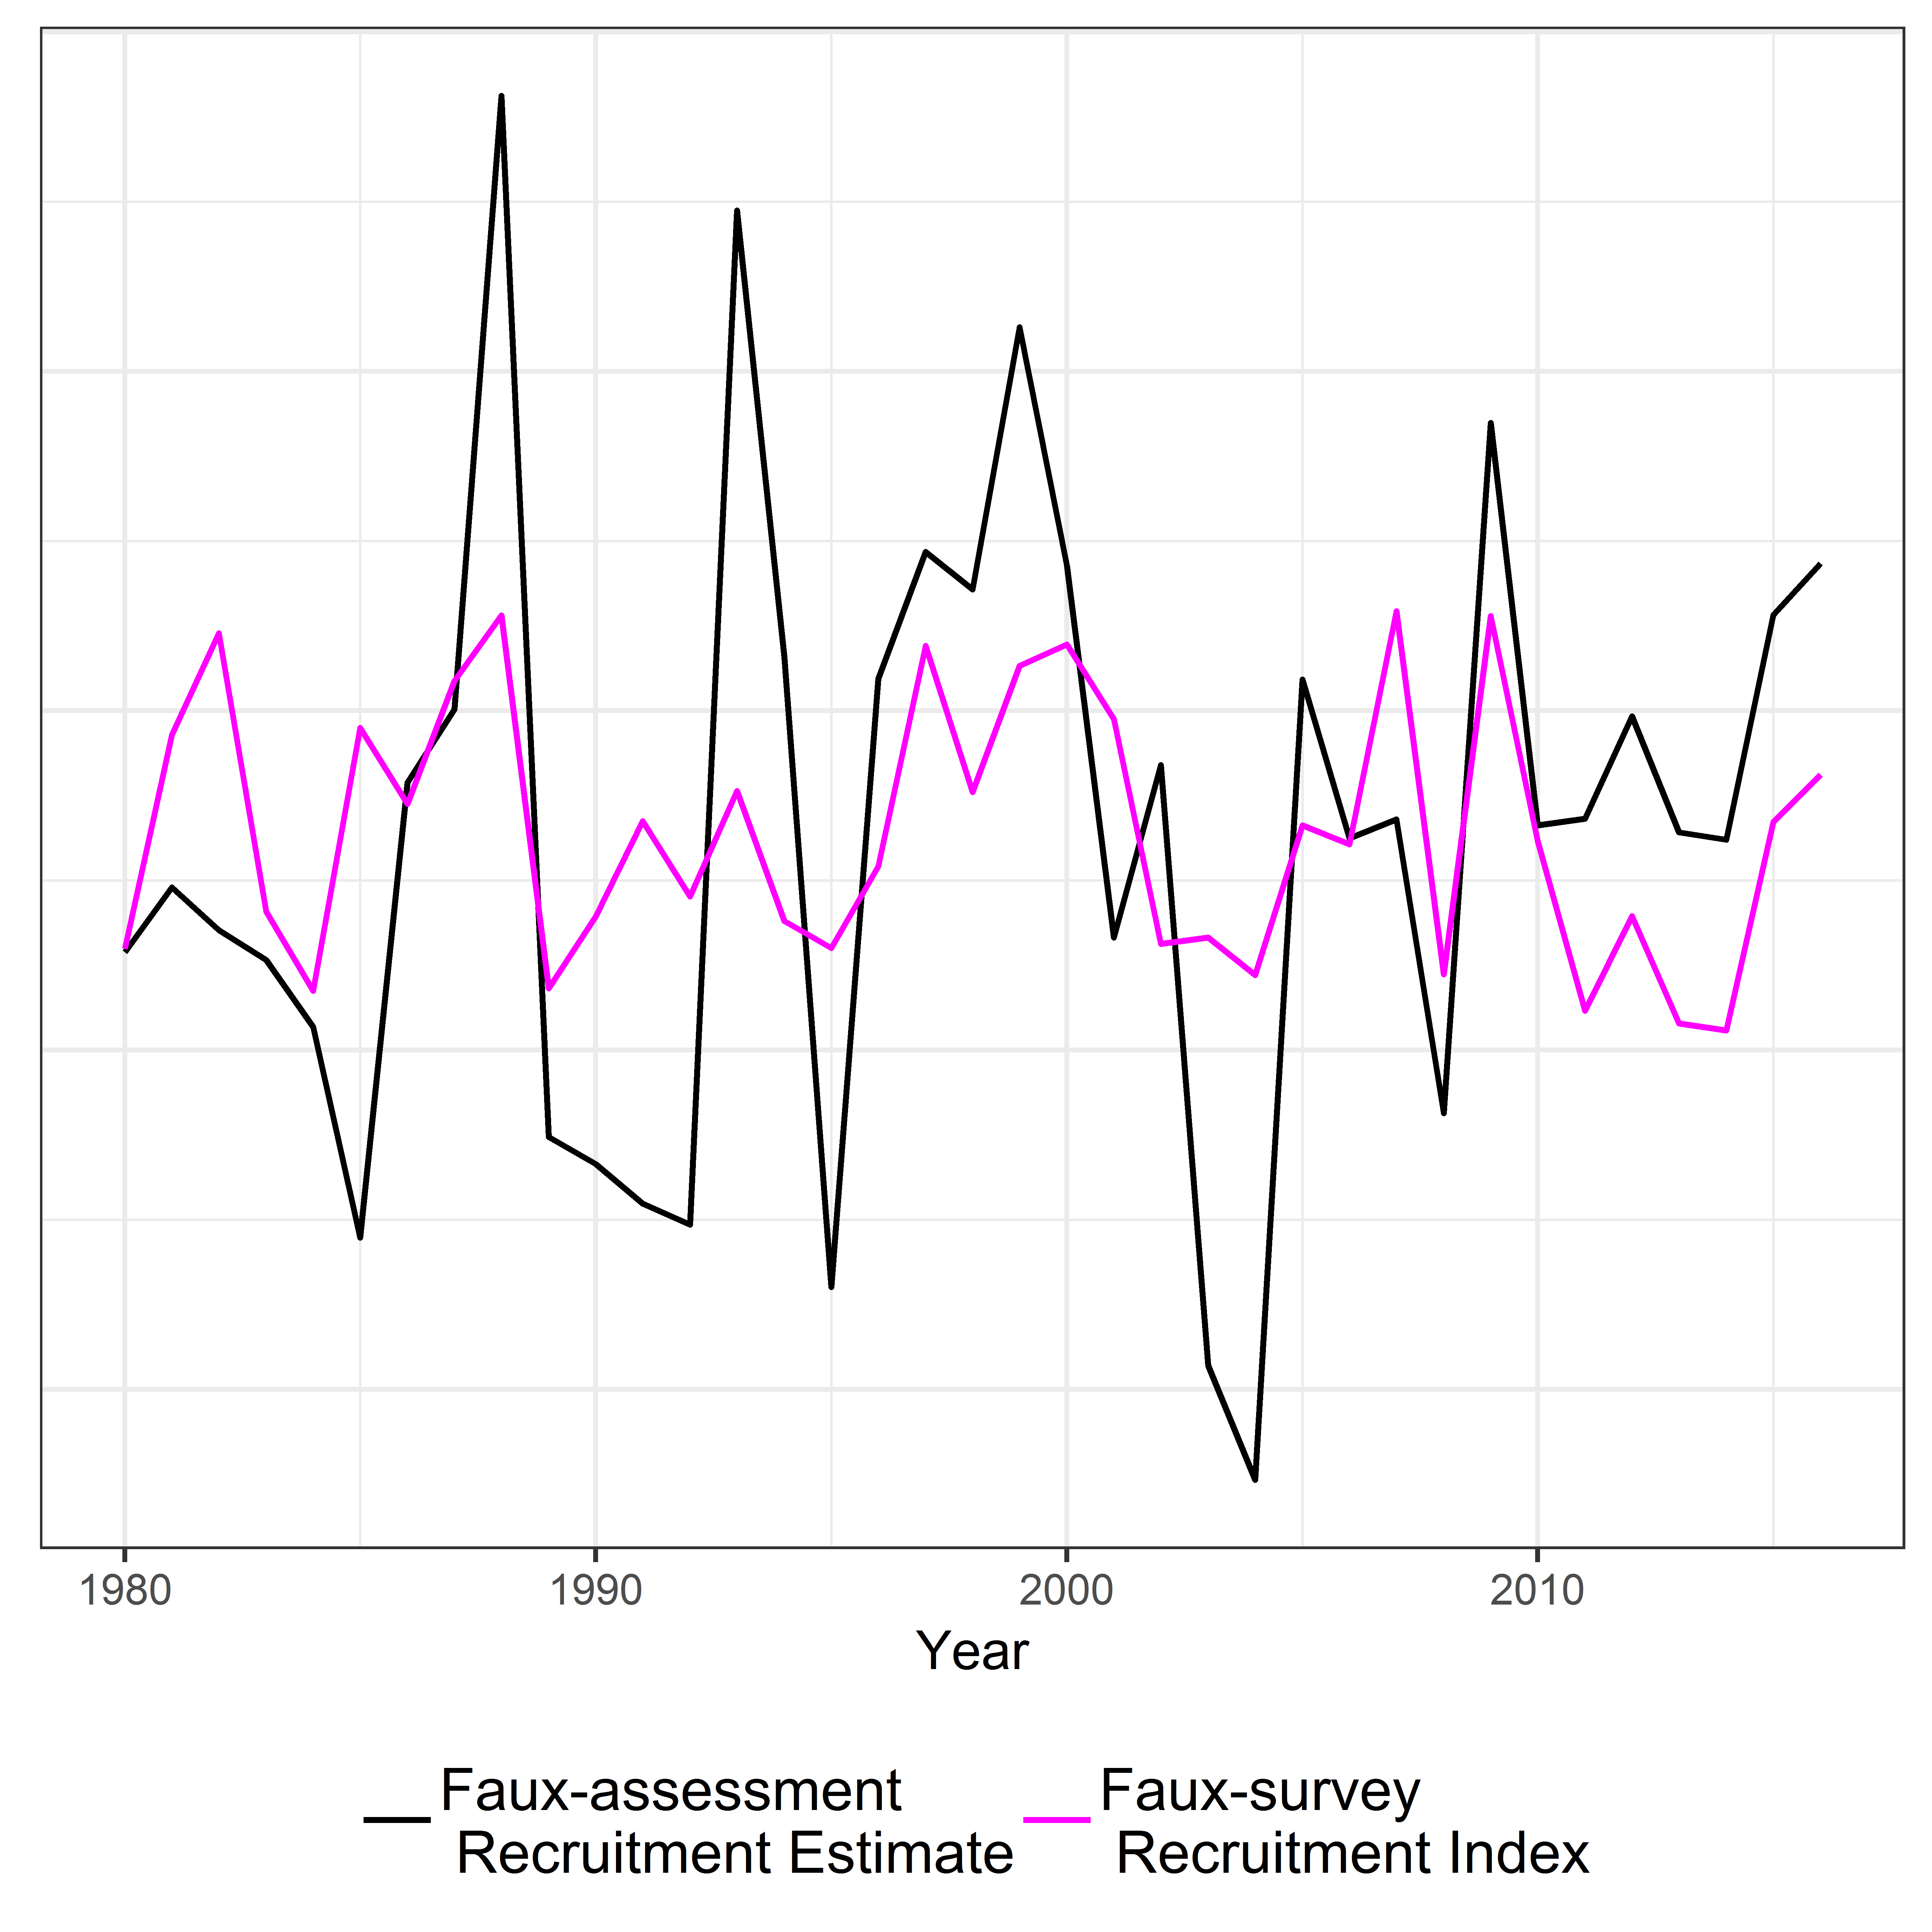

Supplementary Figure 2: Simulated time-series data for juvenile survey recruitment index (purple) and stock assessment recruitment estimate (black). The survey estimate was generated by random noise imposed on the recruitment index, until the last 5 years of the time series when both variables vary together.

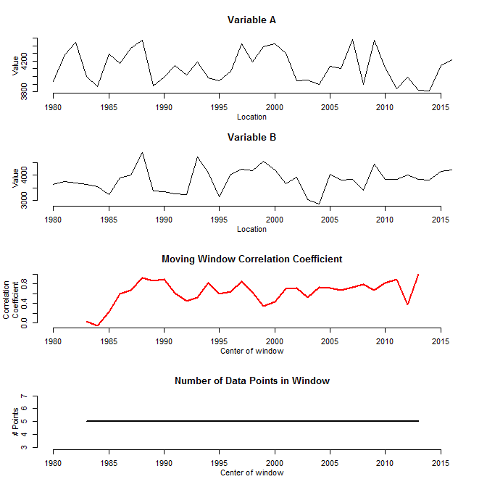

Supplementary Figure 3: Correlations between the two hypothetical time series (see Supp. Figure 2) for 5-year time windows. Note the increase in correlation at the end of the time series that is expected as the synchrony of the time series becomes very high.

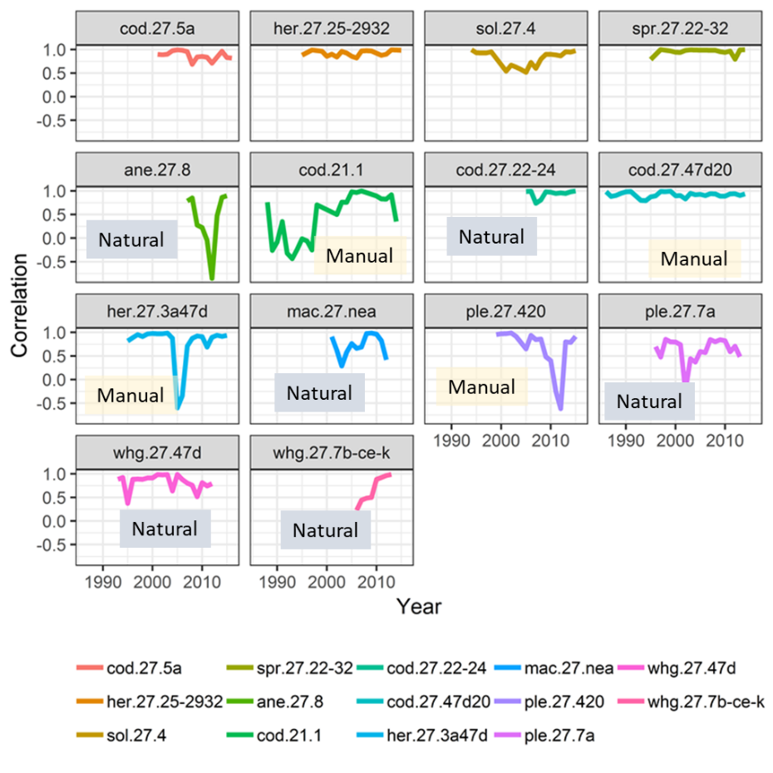Having shown that the windowing would detect the influence of synchrony on the correlation between the two time series, Supp. Figure 4 shows the results of applying the 5-year windowing approach to the 14 time series of survey and assessment recruitment estimates. We used the time series with natural and manual deletions to assess the influence of the last few years for the results as reported in the paper. The four stocks with independent estimates of recruitment (top row) showed constantly high correlation coefficients. Many of the remaining stocks (natural or manual deletions) did show high correlations in last few 5-year segments, but these always had similarly high correlations in earlier 5-year segments or showed variation with high correlation values in multiple 5-year windows throughout the time period. The exception was the stock (whg.27.7b-ce-k) with a very short time series, where the correlations showed steadily rising values. Also, the correlations varied across 5-year segments suggest that was no consistent degree of forced agreement for the 10 stocks that used the survey indices in their assessment. These results indicate that while there is not strong evidence of a high influence (inflated correlation only near the end of the time period), caution is appropriate because may stocks did show high correlations at the end.

Supplementary Figure 4. Results of 5-year sliding window correlation analyses for all 14 stocks that have juvenile survey indices available. These results used the manually and naturally truncated time series. The top row is the four stocks that did not use the survey in their assessments. The remaining stocks did not use the last 2 years, either because of natural or manual deletion.