Supplementary Material
Table S1. List of activities and pressures handled by the working groups for the filling of the activity-pressure matrix.
Groups | Number of participants | List of Activities | list of Pressures
A1/P1 | 5 | A1: All fishing and aquaculture activities, maritime transport, all marine and coastal leisure activities | P1: All physical pressures, hydrological changes, underwater noises
A1/P2 | 9 |  | P2: All chemical and biological pressures
A2/P1 | 9 | A2: All coastal defense and developments activities, aggregate extraction, navy activities, artificial reefs, wrecks | P1: All physical pressures, hydrological changes, underwater noises
A2/P2 | 12 |  | P2: All chemical and biological pressures

Table S2. Confidence index associated with each evaluation of the activity-pressure matrix ($CI_{}_{Ai/Pj}$).
$CI_{}_{Ai/Pj}$ value | Definition
1 (very low) | Individual evaluation by a non-expert, without comparative literature or data
2 (low) | Individual evaluation by a non-expert, based on existing matrices and literature
3 (medium) | Evaluation by a group of experts carried out during one workshop
4 (good) | Evaluation from existing published activity-pressure matrices
5 (very good) | Evaluation by a group of experts carried out during several workshops or from the reports of the scientific teams involved in the MSFD Good Environmental Status evaluation

Table S3. Criteria for building the confidence index of the multi-source benthic habitats mapping ($CI_H_{k}$).
Criteria | Definition | Positive answer | Negative answer
Typology (H_typ) | Does the data source contain habitats mapped with the Eunis typology? | 1 | 0
Date (H_dat) | Is the data source less than 10 years old? | 1 | 0
Validation (H_val) | Has the data source been validated? | 1 | 0
Scale (H_sca) | Is the scale greater than or equal to 1/50000 (1 cm for 500 m)? | 1 | 0
Ground truth (H_gro) | Has mapping been verified in the field? | 1 | 0
$$CI_H_{k}$$ | $$CI_H_{k}=H_typ+H_dat+H_val+H_sca+H_gro$$ | value between 0 and 5

Table S4. Criteria for building the confidence index of human activities datasets ($CI_A_{i}$).
Criteria | Definition | Positive answer | Negative answer
Spatial resolution (A_spa) | Is the cartography based on data describing precisely the location of the activity?  The criteria value is 1 if the spatial resolution of the dataset is greater than or equal to the resolution of the mesh. | 1 | 0
Temporal resolution (A_tem) | Can the dataset describe the intensity of the activity per year over at least two years, making it possible to calculate an inter-annual average over a known period between 2010 and 2017?  The criteria value is 1 if annual data are available for at least two years between 2010 and 2017. | 1 | 0
Structuring (A_str) | Is the dataset structured and homogeneous across the study area in terms of spatial, temporal and thematic dimensions?  The criteria value is 1 if the preparation of the dataset does not involve harmonization and structuring requiring hypotheses on the spatial, temporal and thematic dimensions. | 1 | 0
Intensity (A_int) | Does the dataset include an estimate of the activity intensity calculated and / or measured by the data producers, considered to have sufficient expertise on the activity?  The criteria value is 1 if the intensity estimate is directly included in the dataset and directly usable without the need to perform calculations involving additional assumptions. | 1 | 0
Completeness (A_com) | Can the dataset be considered exhaustive for the presence and distribution of the activity?  The criteria value is 1 if our knowledge of the activity and potential data sources do not reveal a significant lack of data on one or more areas. | 1 | 0
$$CI_A_{i}$$ | $CI_A_{i}=A_spa+A_tem+A_str+A_int+A_com$ | value between 0 and 5

Table S5. Building of the sensitivity scores of the habitat-pressure sensitivity matrix ($CI_µ_{j,k}$).
$CI_µ_{j,k}$ value | Qualitative confidence index from the original benthic habitats sensitivity evaluation (La Rivière et al., 2015)
1* | low
3 | medium
5 | strong
null | « » no confidence index if sensitivity is not evaluated (NE)
*: For a number of mapped benthic habitats that did not have a sensitivity assessment in the original sensitivity matrix, we calculated a sensitivity index ${(µ}_{j,k}')$ from habitats of the same nature for which we had a sensitivity index $(µ_{j,k})$. These sensitivity indices were calculated by aggregating the sensitivity scores of these "child" habitats with two methods as describe in the supplementary Figure S4. For these benthic habitats the value of the confidence index ($CI_µ_{j,k})$ is fixed at 1.

Table S6. List of data sets used to produce the multisource mapping of benthic habitats
Data source level 1 | Number of geographical feature (polygons) | Area (km²) | Percentage of the total area | Percentage of the number of geographical feature
AERMC - Andromède Océanologie (medtrix.fr convention 2016-078) | 131 007 | 354.7 | 0.0944 | 6.3054
Agence des aires marines protégées - PNM Iroise | 1 744 | 10.9 | 0.0029 | 0.0839
Agence des aires marines protégées - PNM Iroise - Semantic | 12 | 0.5 | 0.0001 | 0.0006
Agence des aires marines protégées - PNM Iroise - UBO/IUEM/LEMAR | 55 | 1.5 | 0.0004 | 0.0026
BIO-LITTORAL | 9 | 0.025 | 0.0000 | 0.0004
BIO-LITTORAL - KEMM | 793 | 3.7 | 0.0010 | 0.0382
CARTHAM : Agence des aires marines protégées, 2012 | 121 327 | 11 848.9 | 3.1542 | 5.8395
CARTHAMED - Corse : Agence des aires marines proteges - Univ. Corse - CNRS, 2015 | 1 297 514 | 1 595.7 | 0.4248 | 62.4494
DIREN Basse-Normandie | 4 962 | 3.4 | 0.0009 | 0.2388
EMODnet EUSeaMap, 2017 | 487 843 | 360 620.8 | 95.9991 | 23.4799
HEIMa : AESN - Fondation Total - SyMEL - Conservatoire du littoral, 2016 | 14 151 | 34.9 | 0.0093 | 0.6811
Ifremer | 120 | 3.6 | 0.0010 | 0.0058
Ifremer - CNRS - BRGM - EPHE | 26 | 0.075 | 0.0000 | 0.0013
Ifremer Dyneco | 3 395 | 452.5 | 0.1205 | 0.1634
LIENSs - CNRS - Univ. de La Rochelle - IODDE | 20 | 0.150 | 0.0000 | 0.0010
REBENT - Ifremer - DIREN Bretagne - UBO/IUEM/GEOMER - CEVA | 11 | 0.001 | 0.0000 | 0.0005
REBENT - Ifremer - Dreal Bretagne | 9 030 | 512.5 | 0.1364 | 0.4346
REBENT - Ifremer - UBO/IUEM/LEMAR CNRS UMR6539 - CEVA - CNRS UMR-5178 BOME | 305 | 26.4 | 0.0070 | 0.0147
REBENT - Ifremer - UMR8586 PRODIG CNRS - EPHE - DIREN - CEVA | 3 163 | 11.1 | 0.0030 | 0.1522
REBENT - Ifremer Dyneco | 1 516 | 63.9 | 0.0170 | 0.0730
REBENT - UBO/IUEM/LEMAR CNRS UMR6539 - Ifremer | 3 | 23.6 | 0.0063 | 0.0001
REBENT DCE | 17 | 0.490 | 0.0001 | 0.0008
SMEL - M2C/CNRS | 133 | 0.054 | 0.0000 | 0.0064
TBM | 460 | 25.7 | 0.0069 | 0.0221
UBO/IUEM/LEMAR CNRS UMR6539 | 41 | 3.1 | 0.0008 | 0.0020
UBO/IUEM/OSU Observatoire domaine côtier | 47 | 51.5 | 0.0138 | 0.0022

Table S7. Definition of the different types of relationships between typologies of benthic habitats (HabRef v.4 database).
Link | Type of relationship | Definition
= | equal | the input habitat is strictly equal to the output habitat
< | output habitat contains input habitat | the input habitat is a part of the output habitat
> | input habitat contains output habitat | the output habitat is a part of the input habitat
# | overlap | a part of the input habitat is equal to a part of the output habitat
(#) | special overlap | a part of the input habitat does not correspond to any output habitat
NC | no match | the input habitat does not match any output habitat
? | unknow | the type of relationship must be specified

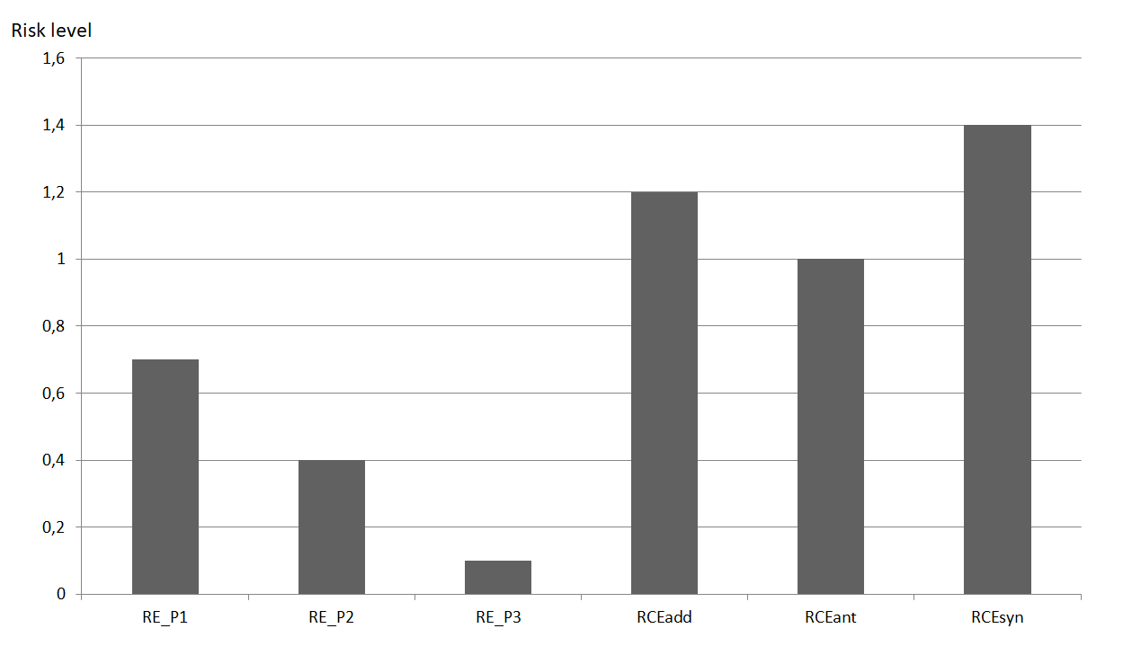
Figure S1. Example of application of the 3 multi pressure effect models used in X1 factor. RE_P1, RE_P2 and RE_P3 correspond to the risk of effect of the pressure 1, 2 and 3. RCEadd: risk of effect with the additive model, RCEant: risk of effect with the antagonistic model, RCEsyn: risk of effect with the synergistic model.
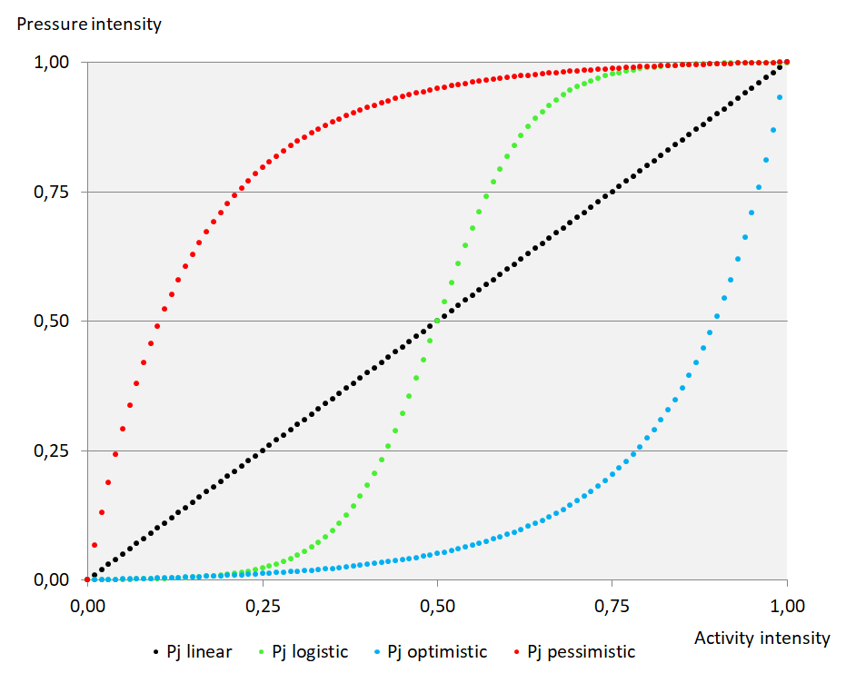
Figure S2. Representative curves of the 4 functions used in X2 factor

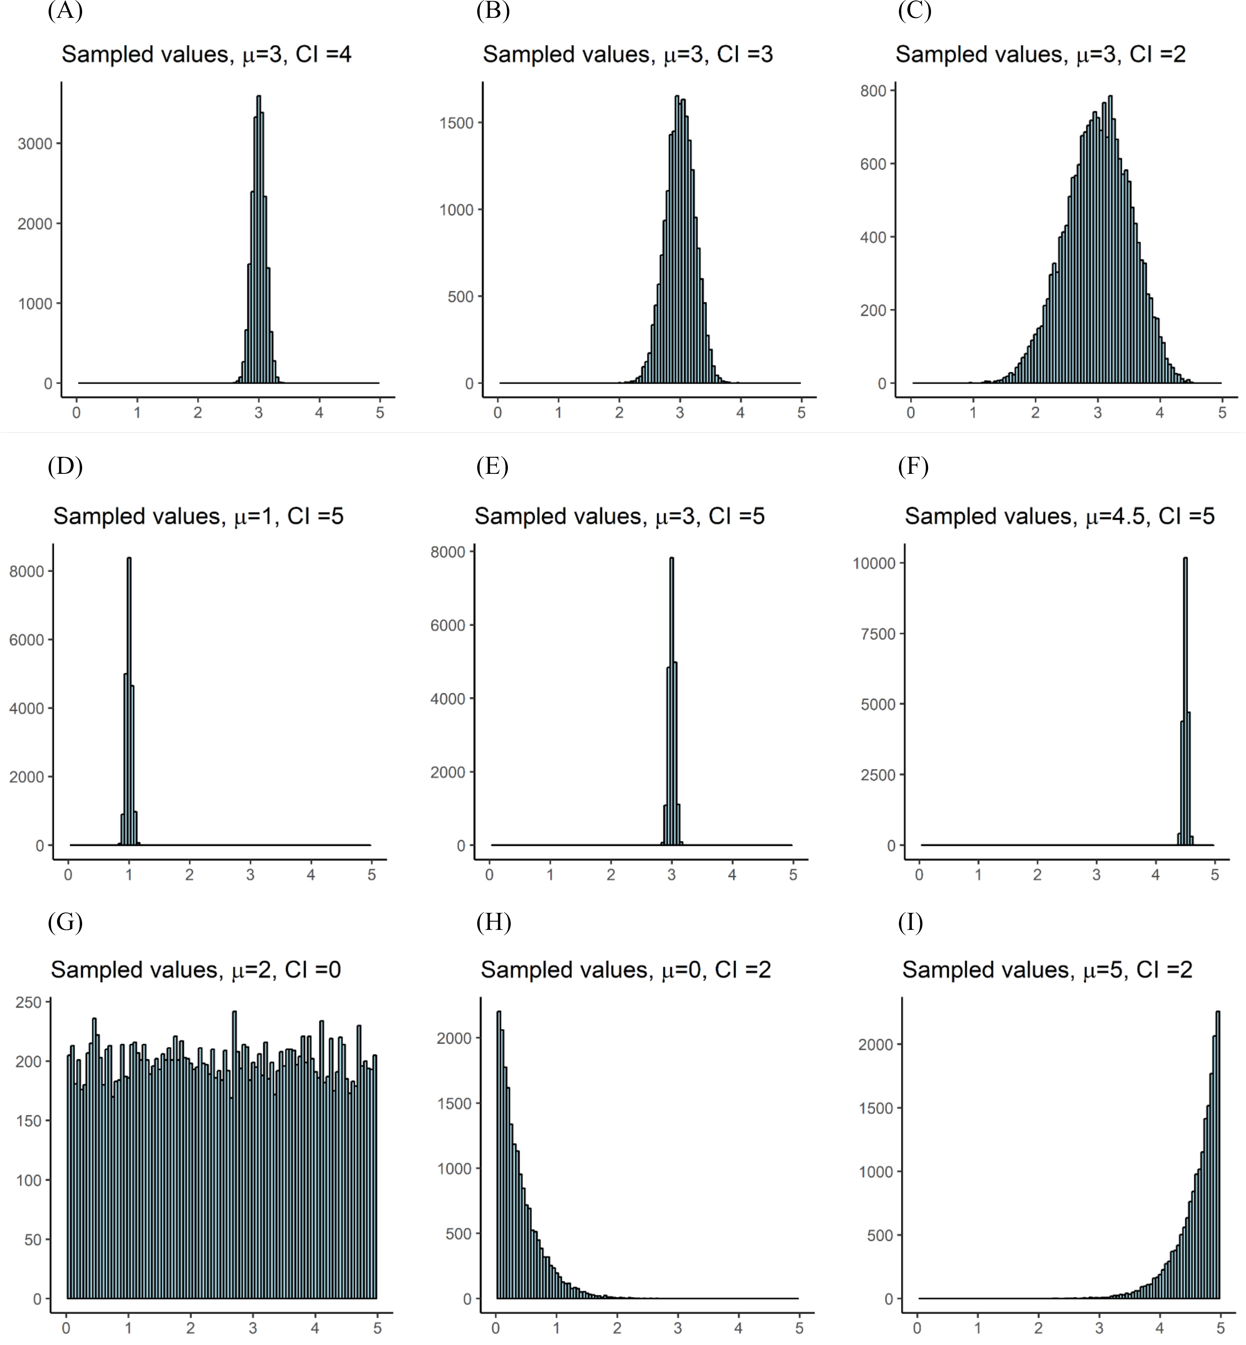
Figure S3. Example of sensitivity index calculation according to the original value of $µ_{jk}$ and $CI_µ_{j,k}$. Graphics A to C: same sensitivity value but different confidence index. Graphics D to F: different sensitivity values but same confidence index. Graphics G to I, special cases with $CI_µ_{j,k}=0$ (G) or $µ_{jk}=0$ (H) or $µ_{jk}=5$ (I)

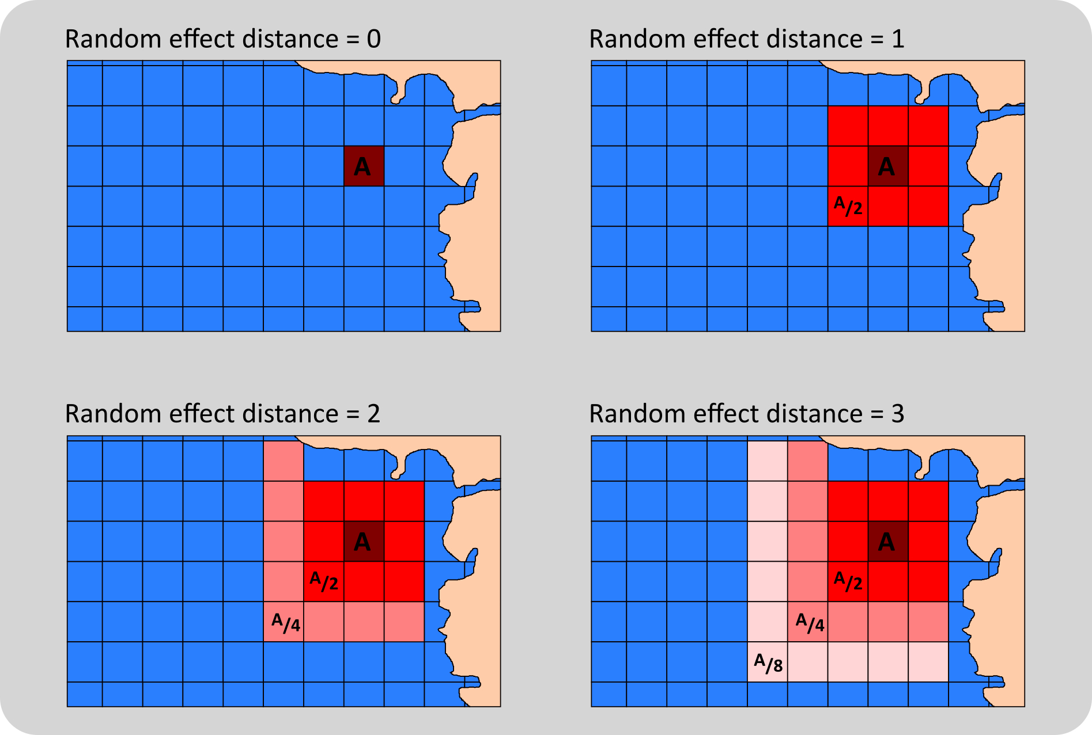
Figure S4. Method of mapping the intensity of a human activity with a random effect distance (A/2: intensity of activity is divided by 2, A/4: intensity of activity divided by 4, A/8: intensity of activity divided by 8, grid cells containing terrestrial areas are excluded).

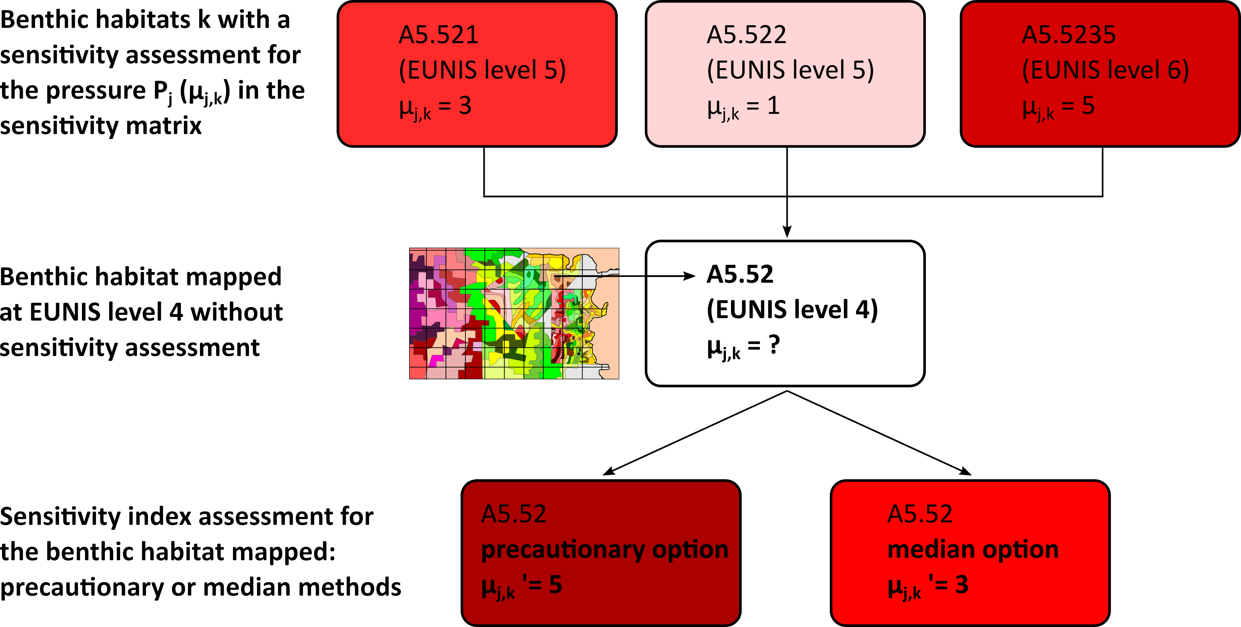
Figure S5. Methodology for assigning sensitivity index for benthic habitats mapped at EUNIS level 4 and not subject to a sensitivity assessment in the original sensitivity matrix.

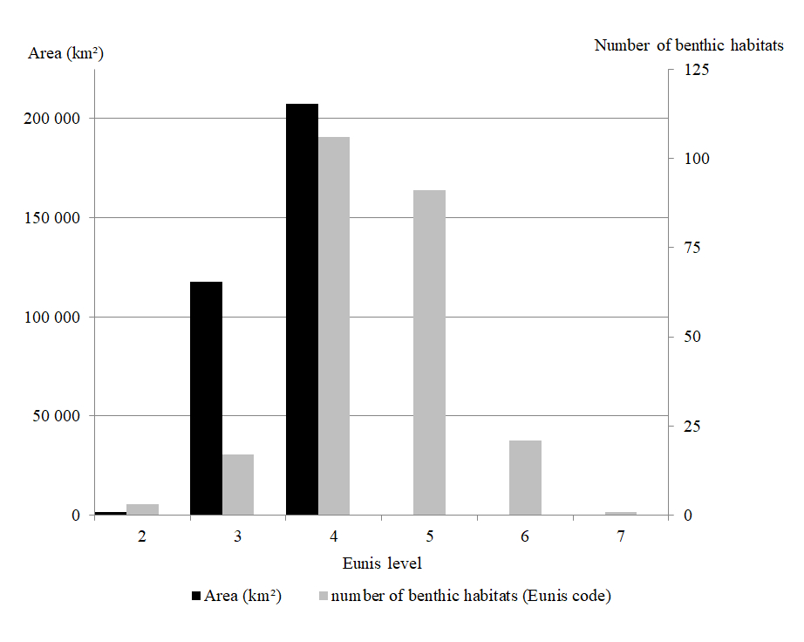
Figure S6. Description of the multi-source benthic habitats mapping. Covered area (km²) and number of benthic habitats (number of different EUNIS codes) per EUNIS level.

Appendix 1. example of SQL query used to integrate descriptive data of benthic habitats in the regular square grid
create table e_hab_synthese.gr_hab_carp_v10_2019 as select
a.geom, a.id2, a.id_gimel, a.coord, a.zone, a.type_cel, a.pays, a.srm, a.facade, a.sect_cod,
a.surfmer, a.surfter, (a.surfmer + a.surfter) as surf_cel,
sum((st_area(st_transform(st_intersection(a.geom, b.geom),2154)))) as surfhab_cel,
sum((st_area(st_transform(st_intersection(a.geom, b.geom),2154))) / st_area(st_transform(a.geom,2154)) *100) as surfhab_pcel,
b.cod_eunis, b.validation, b.date_supp, b.date_val, b.ech_num, b.method_val,
b.source1, b.source2, b.source3,
b.cod_iq, b.val_iq, b.ech_iq, b.terrain_iq, b.date_iq, b.hab_iq
from g_grille.grille_carpediem_1m_2019 as a
join e_hab_source.cart_hab_multisource_v16_fr00 as b on st_Intersects(a.geom,b.geom) and a.pays like 'fr%'
group by
a.geom, a.id2, a.id_gimel, a.coord, a.zone, a.type_cel, a.pays, a.srm, a.facade, a.sect_cod,
a.surfmer, a.surfter, b.cod_eunis, b.validation, b.date_supp, b.date_val, b.ech_num, b.method_val, b.source1, b.source2, b.source3, b.cod_iq, b.val_iq, b.ech_iq, b.terrain_iq, b.date_iq, b.hab_iq

