Supplement S2. Specific PCR for the detection of Endozoicomonas-like organisms (ELO) using the set of primers IMC-F and IMC-R described in Cano et al., 2018. Agarose gels showing a fragment of either 407 bp (first round of PCR, figure B) or 282 bp (second round of PCR, figures A and C) of the 16S rRNA gene. A) wedge clam Donax trunculus (samples ID from 1 to 5) and smooth clam Callista chione (samples ID from 6 to 9) collected in Italy; B) king scallop Pecten maximus collected in France (samples ID 9 to 15); and C) common cockle Cerastoderma edule collected in the United Kingdom (samples ID 16 to 19). DNA was extracted either from formalin-fixed paraffin-embedded tissues in duplicate (A) or from ethanol fixed tissues (B and C). Positive DNA of king scallop Pecten maximus gill tissue was used as positive control (+ve). Water was used as negative control (-ve). 650 ng of a 100 bp DNA ladder (Promega) was used as molecular weight marker (M).
Samples ID: 1: 16002-1; 2: 16002-2; 3: 16002-3; 4: 16002-4; 5: 16002-5; 6: 16021-1; 7: 16021-2; 8: 16021-3; 9: 16021-4; 10: 09-065-12 gills; 11: 09-65-25 gills; 12: 09-114-02 gills; 13: 09-114-01 gills; 14: 09-114-6 digestive gland; 15: 09-065-01 gills; 16: PM30170-1 gills; 17: PM30170-2 gills; 18: PM30170-3 gills; 19: PM30170-4 gills. Metadata associated can be found in the supplemental table S1.

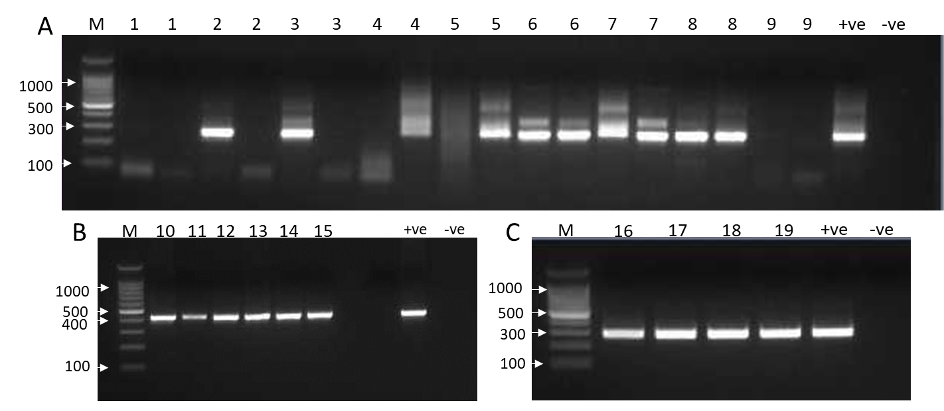

Supplement S3. Maximum-likelihood tree showing phylogenetic relationships among the 16S rRNA gene of PCR sequenced products and a selection of Endozoicomonas-like organisms (ELO) and other symbiotic bacteria. Sequence shows the name of the host, sample ID, country of origin, and tissue (G: gill, DG: digestive gland, V: variety of tissues).
