Supplementary Material

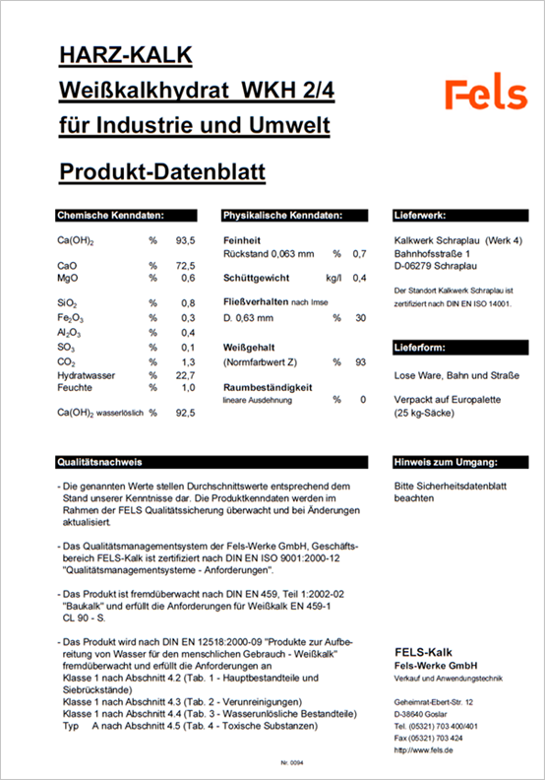
Figure S1. Technical data sheet of the composition of powdered hydrated lime from Fels-Werke GmbH used for the preparation of slaked lime (Ratio of 1 liter of seawater mixed with 1.2 liters of powder).

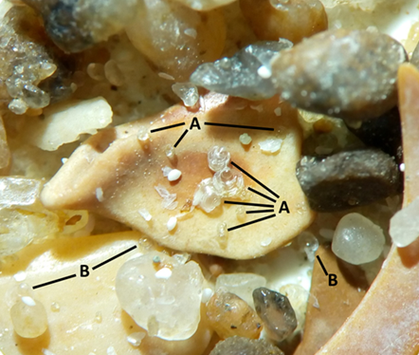
Figure S2. Photograph of Ostrea edulis settled larvae on fine gravel sediment under a magnification of 8x. Larvae of O. edulis settled on a piece of shell are connected to points (A) by black lines; to points (B) are connected larvae settled on grains of sand or gravel.

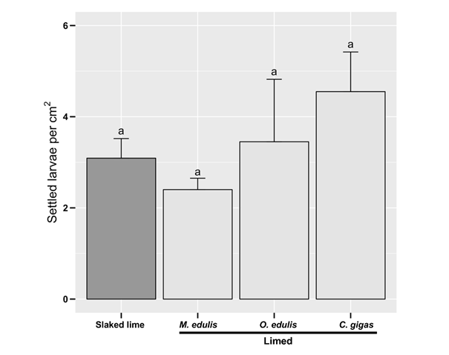
Figure S3. Comparison of the settlement rate (orientations combined) of Ostrea edulis larvae between slaked lime (on tile) and marine bivalve shells coated with slaked lime in laboratory. Homogenous groups are marked with similar letter (ANOVA, F = 3.329, p = 0.077).

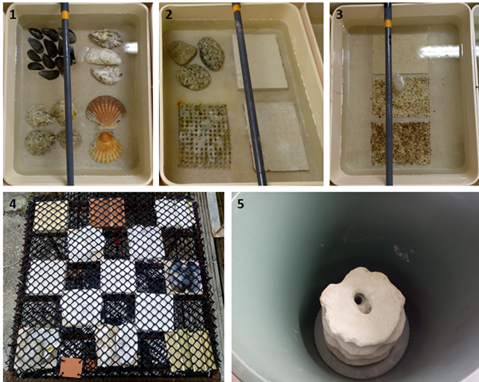
Figure S4. Overview of the different substrates of a single replica in their experimental structures. Photographs (1-3) correspond to the experiment 1. Categories from left to right: the shells, the inorganics, and the sediments. Photograph (4) correspond to the field experiment (all tested categories), and (5) corresponds to experiment 2 conducted on 3D reefs.

Table S1. Composition of the clay raw materials from the company Korallenwelten®.
Component | Proportion (%)
SiO₂ | 64.15
Al₂O₃ | 12.56
TiO₂ | 1.15
Fe₂O₃ | 1.06
Na₂O | 0.13
K₂O | 1.55
CaO | 11.36*
MgO | 8.03*
SO₃ | -
The clay from a clay deposit in Westerwald (Hessen, Germany) is supplemented with magnesium oxide and calcium oxide.

Table S2. Composition of the dolomite sand used for the 3D-ReefVival-Experimental-Reefs® printed by Boskalis Nederland BV.
Component | Proportion (%)
CaO | 30.66
MgO | 21.60
Fe₂O₃ | 0.02
Al₂O₃ | 0.02
SiO₂ | 0.08
Loss 105-1100°C | 47.35

TABLE S3. List and distribution of the 20 substrates tested within the three experiments. Abbreviations: 1 = First laboratory experiment, 2 = Second laboratory experiment, 3 = Field experiment.
Substrate categories | Materials | Experiments
 |  | 1 | 2 | 3
1) Shells | Crassostrea gigas | X |  | X
 | Mytilus edulis | X |  | X
 | Ostrea edulis | X |  | X
 | Pecten maximus | X
2) Inorganic | Baked clay | X |  | X
 | Electro mineral accretion | X
 | Granite | X
 | Slaked lime | X |  | X
3) Sediments | Fine gravel | X
 | Coarse sand | X
 | Medium/Fine sand | X
4) 3D structures | 3D-ReefVival-Experimental-Reefs® |  | X
5) Of plant origin | Phyllostachys edulis |  |  | X
 | Picea abies |  |  | X
 | Juniperus communis |  |  | X
6) Limed | Coated C. gigas shells |  |  | X
 | Coated M. edulis shells |  |  | X
 | Coated O. edulis shells |  |  | X
 | Coated P. edulis |  |  | X
 | Coated P. abies |  |  | X

