Supplementary material
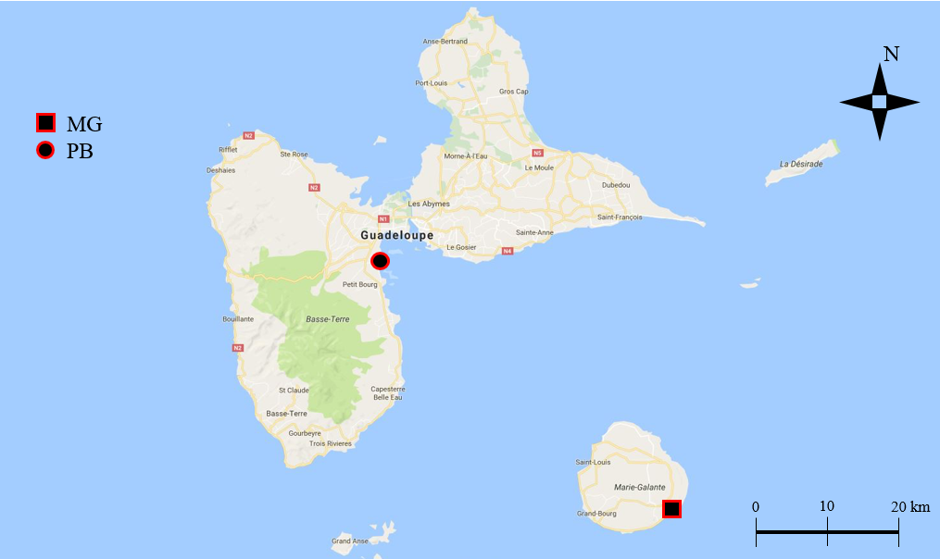
Figure SM1: Map of Guadeloupe archipelago (Caribbean Island) with the two sampled beaches, Viard in Petit-Bourg (PB) on the Main Island and Capesterre in Marie-Galante Island (MG).

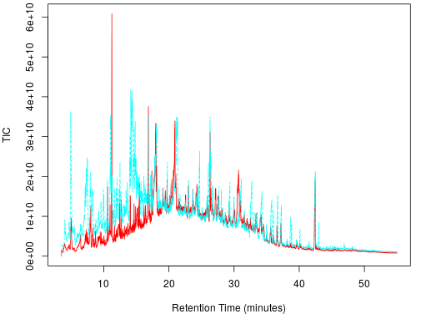
Figure SM2: GC chromatograms as relative abundance expressed as the total ion current intensity with the retention time (RT, minute) for MG (red chromatogram) and PB (blue chromatogram).

Figure SM3: Number of deformed zebrafish larvae after 48h-exposure to MPs leachates from Marie-Galante and Petit-Bourg. E3 medium was used as negative control (NC) and DCA used as positive control (PC). Mean ± SD, n=30, Kruskall Wallis test, (*, p < 0.05)

*
*

Figure SM4: Environmental MPs did not induce growth retardation in zebrafish early life stages. Zebrafish embryos were exposed after hatching, for two days to E3 medium (control), MG and PB samples at 10 and 50 g/L and positive control (PC). Head length (mm) and total length (mm) were measured. (Mean +/- SD, n=12), Kruskall Wallis (*, p < 0.05).

Table SM1: Characteristics and GPS coordinates of the sampled beaches in Guadeloupe (France).
Sample | GPS Coordinates | Place | Date | Description
MG (Marie Galante) | 15°53'28.6"N 61°13'15.5"W | Capesterre beach, Marie-Galante Island | 7th October 2017 | Beach in the South-east part of the well preserved Marie-Galante island near the city centre of Capesterre (3,300 inhabitants)
PB (Petit Bourg) | 16°09'59.6"N 61°35'06.2"W | Viard beach, Guadeloupe Basse-Terre Island | 5th October 2017 | Beach in the East coast of Basse-Terre closed to the main industrial zone and harbour of Pointe-à-Pitre (315,000 inhabitants for the all urban area)

Table SM2: GC/MS parameters for the Q Exactive GC Orbitrap instrument

Gas chromatograph conditions |  |  | Mass spectrometer conditions
Analytical column: TG-5SILMS  30 m * 0.25 mm * 0.25 µm |  |  | Ionization mode: EI 70 eV
Injection port type: Split/Splitless |  |  | MS transfer line temperature: 280 °C
Injector temperature: 250 °C |  |  | Ion source temperature: 280 °C
Injection type: Splitless |  |  | Function type: Full scan
Syringe volume: 10 µL |  |  | Full scan range: m/z 53.4-800
Injection volume: 1 µL |  |  | AGC target: 1e6
Rinse solvent: Hexane/Toluene |  |  | Maximum IT: auto
Carrier Gas type: Helium |  |  | Solvent delay: 3.5 min
Carrier Gas flow: 2 mL.min⁻¹ |  |  | Runtime: 55min
Oven temperature ramp:
Temperature | Hold time | Rate
70 °C | 0 min
205 °C | 0 min | 8 °C.min⁻¹
325 °C | 8 min | 4 °C.min⁻¹
Table SM3: Fold change comparison between PB and MG samples. Confidence level were selected according to Schymanski et al., 2014.
