[Global Biogeochemical Cycles]
Supporting Information for
[Characteristics of the surface water DMS and pCO₂ distributions and their relationships in the Southern Ocean, southeast Indian Ocean and northwest Pacific Ocean]
[Miming Zhang^{1,} C. A. Marandino², Liqi Chen^{1,} Heng Sun¹, Zhongyong Gao¹, Keyhong Park³, Intae Kim⁴, Bo Yang⁵, Tingting Zhu⁶, Jinpei Yan¹, Jianjun Wang¹]
[1. Key Laboratory of Global change and Marine-Atmospheric Chemistry, Third Institute of Oceanography, State Oceanic Administration, Siming District, Xiamen, Fujian 361005, PR China
2. Forschungsberech Marine Biogeochemie, GEOMAR Helmholtz-Zentrum für Ozeanforschung Kiel, Düsternbrooker Weg 20, 24105 Kiel, Germany
3. Division of polar ocean science, Korea Polar Research Institute, Incheon, 21990, South Korea
4. Marine Radionuclide Research Center, Korea Institute of Ocean Science and Technology, Ansan 15627, South Korea
5. School of Oceanography, University of Washington, Seattle WA, 98195, USA
6. State Key laboratory of Information Engineering in Surveying, Mapping and Remote Sensing (LIESMARS), Wuhan University, Wuhan, 430079, PR China]

Contents of this file
Figure S1- S2
Data set S1-S2

Introduction
In this file, we provide the original filed surface water DMS measurements data in the West-east transect and South-north transect respectively. We also explain the reason why we used the monthly satellite derived Chl a data instead of 8-day average Chl a data in West-east transect (Figure S1). In addition, we also present the correlations between monthly, 8-day Chl a data and DMS in Fiugure S2 to demonstrate the using of Chl a to predict surface water DMS in SO SIZ is not the best choice.

Text for Figure S1
In the West-east transect, we used the monthly data, because most of the 8-day derived Chl a data was missing during the sampling period. In order to assess the validity of this approach, we compared the monthly Chl a data and 8-day Chl a data (Figure S1). We found that there is general agreement between them. Thus, we chose the monthly Chl a data over the West-east transect in order to have better coverage.
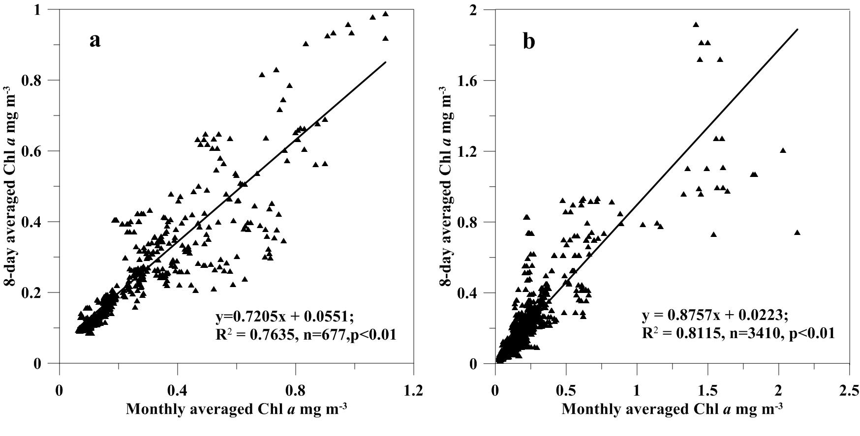
Figure S1, the comparison between 8-day average Chl a and Monthly average Chl a data in the West-east transect (a) and South-north transect (b).

Text for Figure S2
We show in Figure S2 that there is a very low correlation between Chl a and DMS in both the monthly data and 8 day average data, indicating that Chl a is not the best choice for reconstructing the surface DMS concentration in SO SIZ.
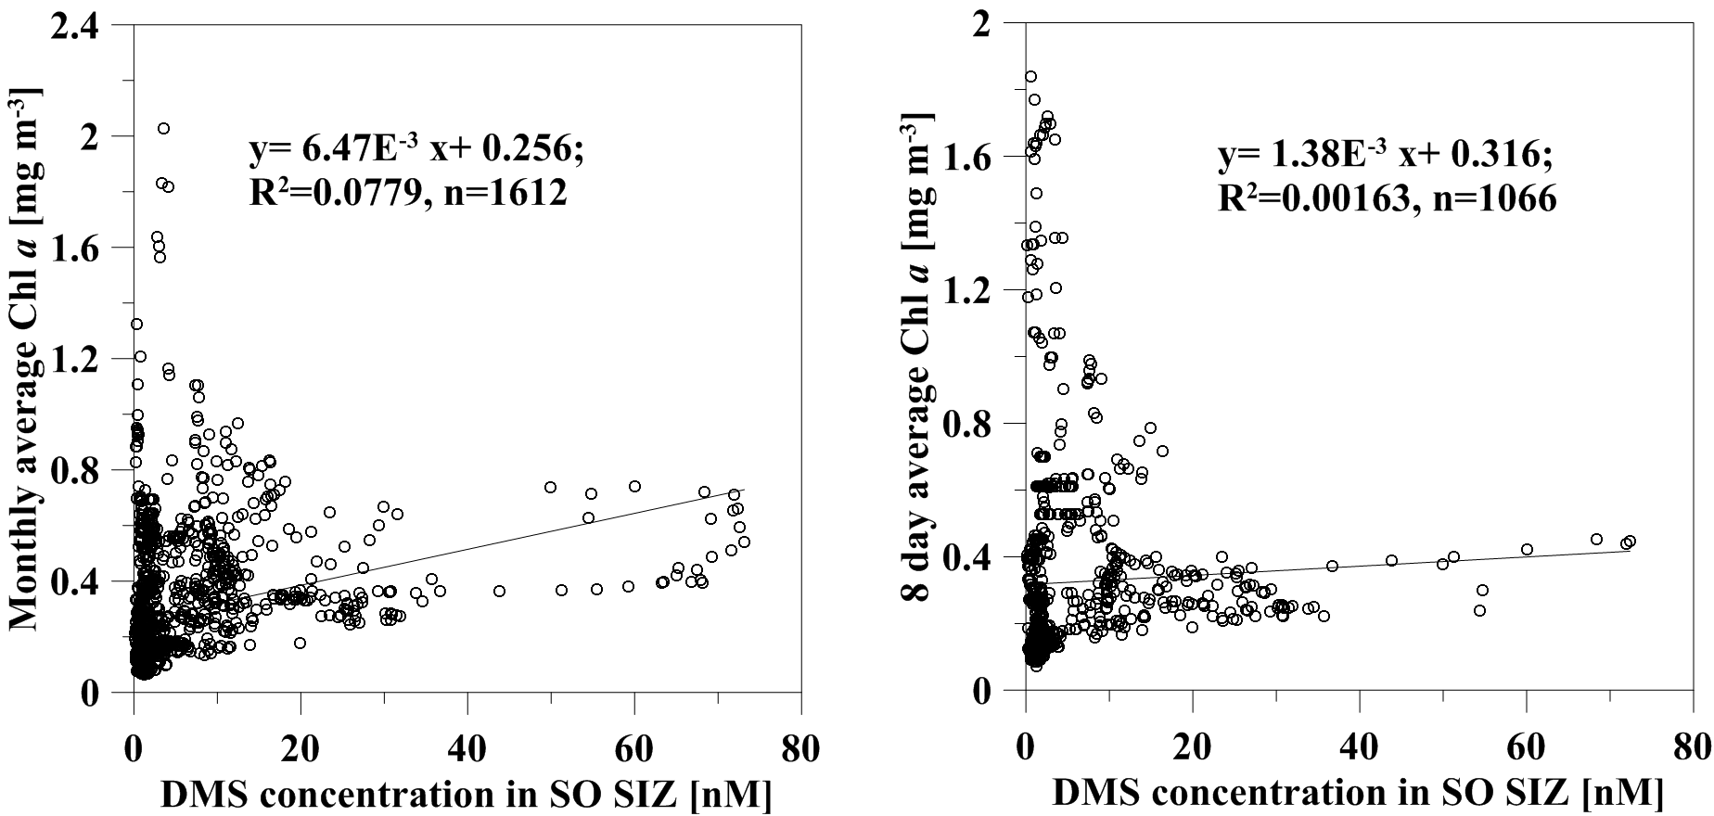Figure S2, the correlations between monthly Chl a (a), 8 day Chl a (b) and DMS in SO SIZ.

Text for Data Set S1-S2
We uploaded two excel files about the original DMS data obtained in the Chinese 30th Antarctic Research Expedition. The sampling period is from Feb 7, 2014 to April 11, 2014. In the dataset files, the sampling time, location, concentrations of DMS, surface seawater temperature, surface seawater salinity, wind speeds, the calculated DMS sea-to-air fluxes, remote sensing Chl a data and sea ice concentrations were detailed presented. All the data was checked and calibrated.

Data Set S1. DS01, DMS data in West-east transect.

Data Set S2. DS02, DMS data in South-north transect.

