Global Biogeochemical Cycles
Supporting Information for
The impact of changing wind speeds on gas transfer and its effect on global air-sea CO₂ fluxes
R. Wanninkhof¹, J. Triñanes^{2,3}
¹Atlantic Oceanographic and Meteorological Laboratory, 4301 Rickenbacker Causeway, Miami FL 33149 USA
²Laboratory of Systems, Technological Research Institute, Universidad de Santiago de Compostela, Campus Universitario Sur, Santiago de Compostela, 15782, Spain
³Atlantic Oceanographic and Meteorological Laboratory, National Oceanic and Atmospheric Administration, Miami, FL, USA and the Cooperative Institute for Marine and Atmospheric Studies, Rosenstiel School of Marine and Atmospheric Science, University of Miami, Miami, FL, USA

Contents of this file

Text S1 to S3
Figures S1 to S2
Tables S1

Introduction
Supplement 1 provides the temperature trend of solubility and Schmidt number of CO₂ that are used to determine the global air-sea CO₂ fluxes as described in the main text. Supplement 2 provides statistical information on the trend calculations for the global ocean and specific regions discussed in the text. Supplement 3 gives the trends in the enhancement factor of wind speed variability.

Supplementary material

Supplement 1

Plot of solubility, s, Schmidt number of CO₂, Sc_{CO2}, and the product (Sc_{CO2})^{-1/2} s. Both Sc and s of CO₂ are strong decreasing functions with temperature. However, the effect of temperature on s and (Sc_{C02})^{-1/2} is opposite. Therefore, the product of k and s only has a weak dependence on temperature.

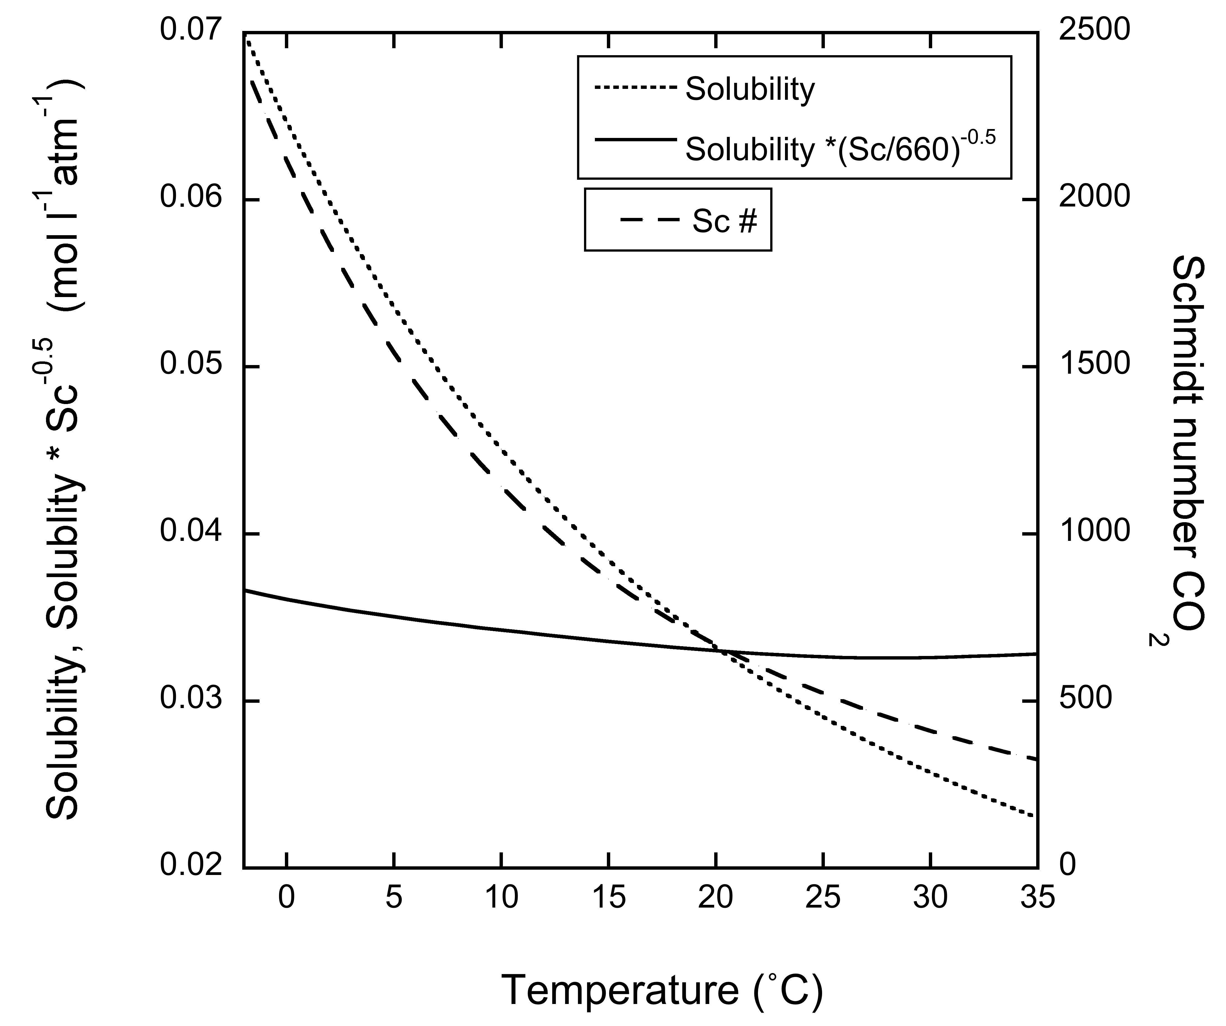
Figure S1. Schmidt number, Sc (right axis), solubility, s (left axis), and (Sc^{-0.5} s) (left axis) of CO₂ versus temperature.

Supplement 2

Table S1 provides a summary of the trends in wind parameters, gas exchange coefficient, Γ, and air-sea flux of CO₂ for the global ocean and select regions discussed in the text. The normal font provides the linear trend of the parameters, while the italicized text indicates the root-mean-square error (St error) of the deviation from the linear fit.

Table S1. Summary of the trends in wind parameters, gas exchange coefficient, Γ, and flux for the global ocean and select regions discussed in the text.
Region | <u>  m s⁻¹dec⁻¹ | <u²>  (m s⁻¹)² dec⁻¹ | <u³>  (m s⁻¹)³dec⁻¹ | Γ (quadr)  mol m⁻² µatm | Γ (hybrid)  mol m⁻² µatm | Flux (quadr)  Pg C y⁻¹dec⁻¹ | Flux (hybrid)  Pg C y⁻¹dec⁻¹
Global | 0.14 | 2.16 | 30.5 | .0015 | .0014 | 0.0155 | -0.00137
St error | 0.018 | 0.288 | 4.2 | 2.12 10⁻⁴ | 2.05 10⁻⁴ | 0.0089 | 0.0095
>62°S | 0.053 | 1.27 | 26.1 | 5.92 10⁻⁴ | 7.4 10⁻⁴ | -0.0011 | -0.0011
St error | 0.030 | 21.6 | 25.8 | 1.93 10⁻⁴ | 2.1 10⁻⁴ | 8.9 10⁻⁴ | 9.29 10⁻⁴
50-62°S | 0.11 | 2.77 | 58.5 | 0.0020 | 0.0025 | -0.0036 | -0.0029
St error | 0.05 | 1.16 | 21.3 | 8.4 10⁻⁴ | 9.4 10⁻⁴ | 0.0019 | 0.0019
Eq Pac (14°S-14°N) | 0.28 | 3.49 | 35.76 | 0.0023 | 0.0018 | 0.043 | 0.033
St error | 0.039 | 0.46 | 4.79 | 3.20 10⁻⁴ | 2.45 10⁻⁴ | 0.0055 | 0.0041
N Atl (>50°N) | 0.06 | 1.47 | 32.18 | 7.29 10⁻⁴ | 0.001 | -0.0028 | -0.0041
St error | 0.053 | 1.20 | 24.04 | 7.49 10⁻⁴ | 9.20 10⁻⁴ | 0.0024 | 0.0028

Supplement 3

The effect of trends in wind speed variability

The enhancement factor, R, is the increase in k attributed to variability in the 6-hourly winds [Wanninkhof et al., 2002]. It is expressed as R = <u₁₀²>/<u₁₀>² as an indicator of the variability of the wind. Larger enhancement factors indicate greater variability in the 6-hourly winds, which leads to higher gas transfer. The annual global pattern of R is shown in Figure S2. The trade wind regions show low R due to the prevailing steady winds. Coastal regions show larger R, particularly along the coasts of the North Pacific and polar regions, where temperature contrasts between land/ice and water can cause large changes in wind speed. Of note is the large R over the Gulf of Tehuantepec off the west coast of Mexico.

Trends in R (Figure S2b) are appreciably less than the trends observed for winds, and negative trends prevail. This indicates slightly less variability in the wind for large parts of the ocean over time. The regions with the greatest positive trend in wind speed (Figure 3b, main text) generally show a decreasing trend in R, suggesting a small offset in the increasing gas transfer associated with the decreasing magnitude of the enhancement. However, the linear trends in R over the time period do not lead to significant changes in k. The change in variability over time is implicitly accounted for by using <u₁₀>, <u₁₀²>, and <u₁₀³> in equations (2) and (3) in the main text.

Figure S2. (a) Map of the annual average enhancement factor, R = <u₁₀²>/<u₁₀>², for 2014; (b) Linear trend in R*1000 for 1988-2014.

