Supplemental Table 1: List of indicator species collected along the eastern Australian coastline and associated stable isotope values (‰) used to develop the latitudinal δ¹³C value model to predict habitat range for the great hammerhead shark Sphyrna mokorran. SD = standard deviation. NA = Not available
Species name | N | δ¹³C (SD) | δ¹⁵N (SD) | Enrichment-adjusted δ¹³C (SD)
Abudefduf bengalensis | 11 | -18.8 (1.6) | 11.3 (1.1) | -20.8 (2.0)
Abudefduf sexfasciatus | 52 | -18.0 (1.7) | 9.8 (0.9) | -19.4 (1.9)
Abudefduf sp. | 7 | -19.5 (0.7) | 10.2 (0.7) | -21.0 (0.7)
Abudefduf vaigiensis | 131 | -19.2 (0.8) | 10.5 (1) | -20.8 (0.9)
Acanthurus triostegus | 12 | -19.5 (0.3) | 7.6 (1.3) | -19.9 (0.6)
Acanturus dussumieri | 22 | -19.0 (1.3) | 8.6 (1.6) | -19.9 (1.3)
Ambassis jacksoniensis | 7 | -19.2 (0.1) | 11.3 (0.2) | -21.2 (0.1)
Atypichthys strigatus | 60 | -17.7 (0.9) | 12.3 (0.8) | -20.1 (0.8)
Brachaluteres jacksonianus | 4 | -16.5 (1.3) | 11.4 (1.7) | -18.6 (0.7)
Chaetodon auriga | 21 | -16.7 (2.0) | 10.3 (1.5) | -18.3 (2.2)
Chaetodon citrinellus | 1 | -16.9 (NA) | 9.6 (NA) | -18.2 (NA)
Chaetodon flavirostris | 11 | -16.8 (1.9) | 10.8 (1.8) | -18.6 (2.1)
Chaetodon kleinii | 1 | -17.5 (NA) | 9.6 (NA) | -18.8 (NA)
Chaetodon melannotus | 1 | -12.8 (NA) | 8.0 (NA) | -13.4 (NA)
Chaetodon rainfordi | 1 | -13.2 (NA) | 8.0 (NA) | -13.9 (NA)
Chaetodon tricinctus | 4 | -15.2 (0.4) | 8.6 (0.2) | -16.1 (0.4)
Chaetodon vagabundus | 8 | -14.5 (3.2) | 9.1 (1.3) | -15.6 (3.6)
Chrysiptera brownriggii | 12 | -15.6 (0.6) | 8.8 (0.2) | -16.5 (0.7)
Dascyllus aruanus | 4 | -12.7 (0.2) | 9.0 (0.5) | -13.7 (0.3)
Emmelichthys nitidus | 9 | -19.6 (0.4) | 12.0 (0.2) | -23.54 (0.4)
Gerres oyena | 4 | -18.4 (0.6) | 12.2 (0.1) | -20.8 (0.6)
Girella tricuspidata | 15 | -16.1 (1.8) | 12.3 (1.3) | -18.5 (1.3)
Hyporhamphus melanochir | 4 | -17.8 (0.9) | 11.6 (0.2) | -19.9 (0.8)
Labroides dimidiatus | 1 | -19.9 (NA) | 7.0 (NA) | -20.1 (NA)
Mobula alfredi | 11 | -17.4 (0.5) | 8.9 (1.1) | -18.4 (0.5)
Microcanthus strigatus | 77 | -18.0 (1.2) | 12.6 (0.6) | -20.5 (1.0)
Neoplatycephalus conatus | 1 | -17.4 (NA) | 13.7 (NA) | -20.4 (NA)
Nototodarus gouldi | 11 | -18.4 (0.4) | 11.8 (0.8) | -20.7 (0.5)
Prionus arenarius | 5 | -16.9 (0.3) | 13.1 (0.5) | -19.6 (0.3)
Pagrus auratus | 25 | -18.0 (1.2) | 13.4 (0.9) | -20.9 (1.4)
Pentaceros richardsoni | 7 | -17.7 (0.4) | 14.1 (0.2) | -20.8 (0.4)
Parma microlepis | 29 | -16.5 (1.0) | 12.5 (1.4) | -19.0 (0.8)
Pempheris affinis | 19 | -18.9 (0.6) | 12.1 (0.3) | -21.3 (0.5)
Platycephalus aurimaculatus | 28 | -18.3 (0.7) | 13.7 (0.9) | -23.5 (0.7)
Platycephalus bassensis | 19 | -18.1 (0.6) | 13.5 (0.5) | -23.1 (0.7)
Pomacentrus bankanensis | 3 | -14.7 (1.8) | 13.6 (0.6) | -17.7 (1.5)
Pomacentrus chrysurus | 6 | -15.2 (1.0) | 7.0 (0.2) | -15.5 (1.0)
Pomacentrus coelestis | 14 | -18.4 (0.7) | 7.9 (1.8) | -18.9 (1.3)
Pomacentrus moluccensis | 8 | -15.5 (2.3) | 7.0 (0.4) | -15.7 (2.2)
Pomacentrus wardii | 4 | -17.8 (0.5) | 7.9 (0.5) | -18.4 (0.6)
Scomber australascius | 1 | -15.6 (NA) | 10.9 (NA) | -17.4 (NA)
Sarda australis | 11 | -17.5 (0.2) | 13 (0.3) | -20.2 (0.1)
Sillago ciliata | 8 | -18.8 (2.0) | 11.8 (1.0) | -21.0 (2.1)
Scorpis lineolata | 5 | -18.0 (0.6) | 12.0 (0.6) | -20.4 (0.5)
silverside - hardyhead sp.? | 19 | -18.3 (1.6) | 11.2 (0.3) | -20.3 (1.6)
Sufflamen chrysopterum | 1 | -17.5 (NA) | 11.0 (NA) | -19.3 (NA)
Thyrsites atun | 7 | -19.2 (0.4) | 12.6 (1.0) | -23.5 (0.8)
Trichogaster fasciata | 1 | -15.9 (NA) | 13.0 (NA) | -18.6 (NA)
Trachurus novaezelandiae | 24 | -18.9 (1.0) | 12.6 (0.6) | -21.4 (0.9)
Trachinops taeniatus | 9 | -19.9 (1.4) | 12.8 (0.3) | -22.5 (1.3)
Uroteuthis etheridgei | 6 | -17.3 (0.9) | 12.8 (1.1) | -20.0 (1.2)

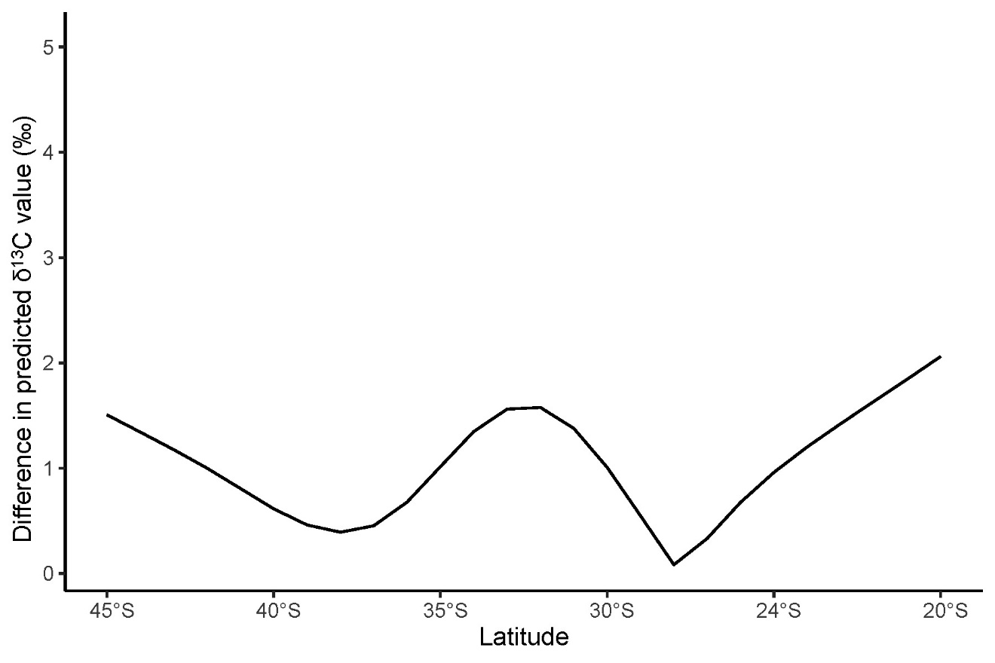
Figure 1: Difference between predicted δ¹³C values from the sample-driven and mechanistic models.

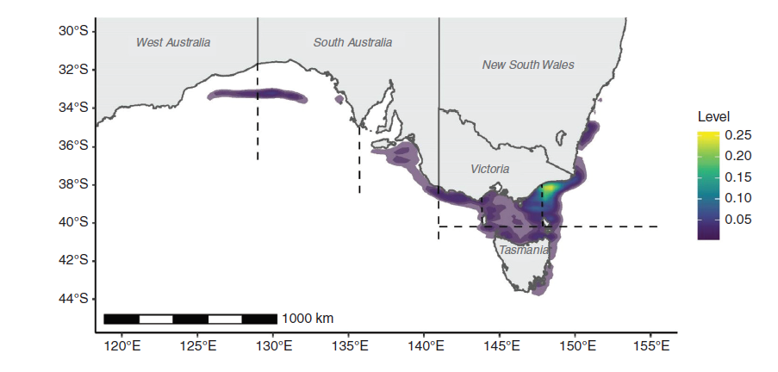
Figure 2: Density of catch records used to indicate geographic range for sawsharks (Pristiophorus nudipinnis and P. cirratus), reproduced from Raoult et al. (2020). These data do not include catches in New South Wales state waters that occur as far north as the Queensland border.

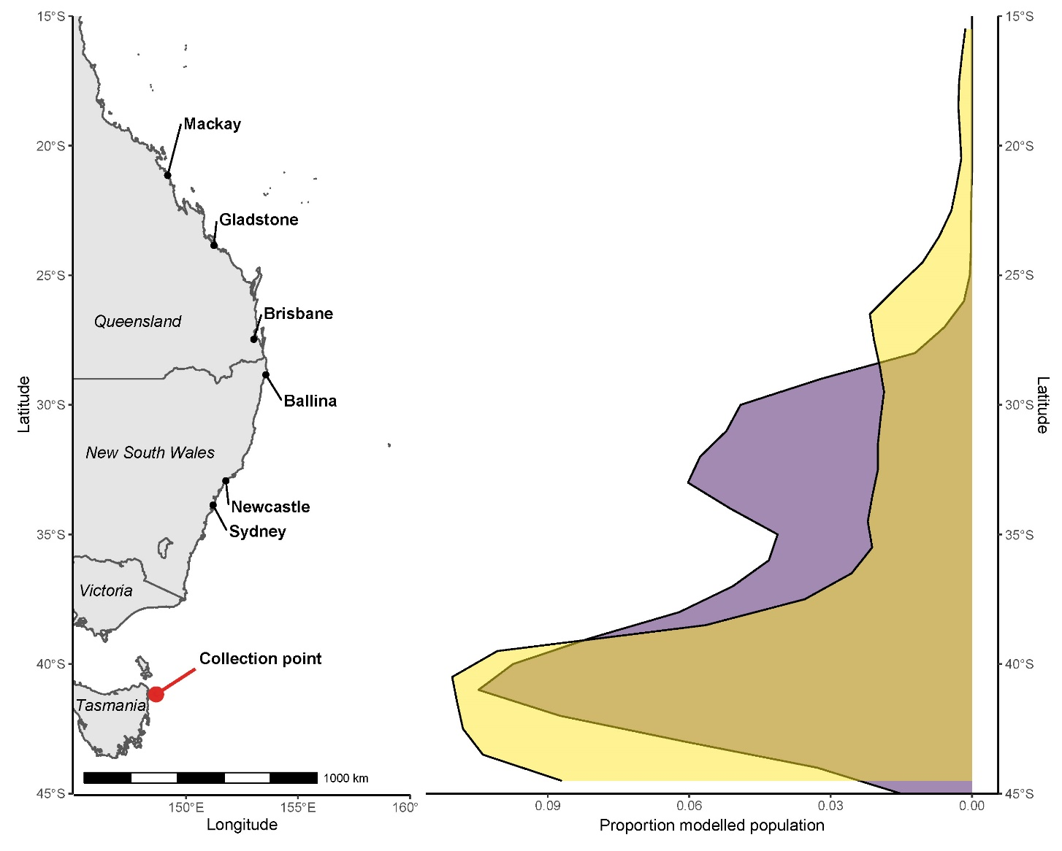
Figure 3: Modelled population habitat of southern sawsharks (Pristiophorus nudipinnis and P. cirratus) inferred from δ¹³C stable isotope values of muscle tissues of sawsharks and the various marine species used to produce a latitude - δ¹³C value relationship (purple). Distribution of population from latitudinally summed mechanistic (NEMO-MEDUSA) results included for comparison (yellow). Area where sawshark samples were collected indicated in red.
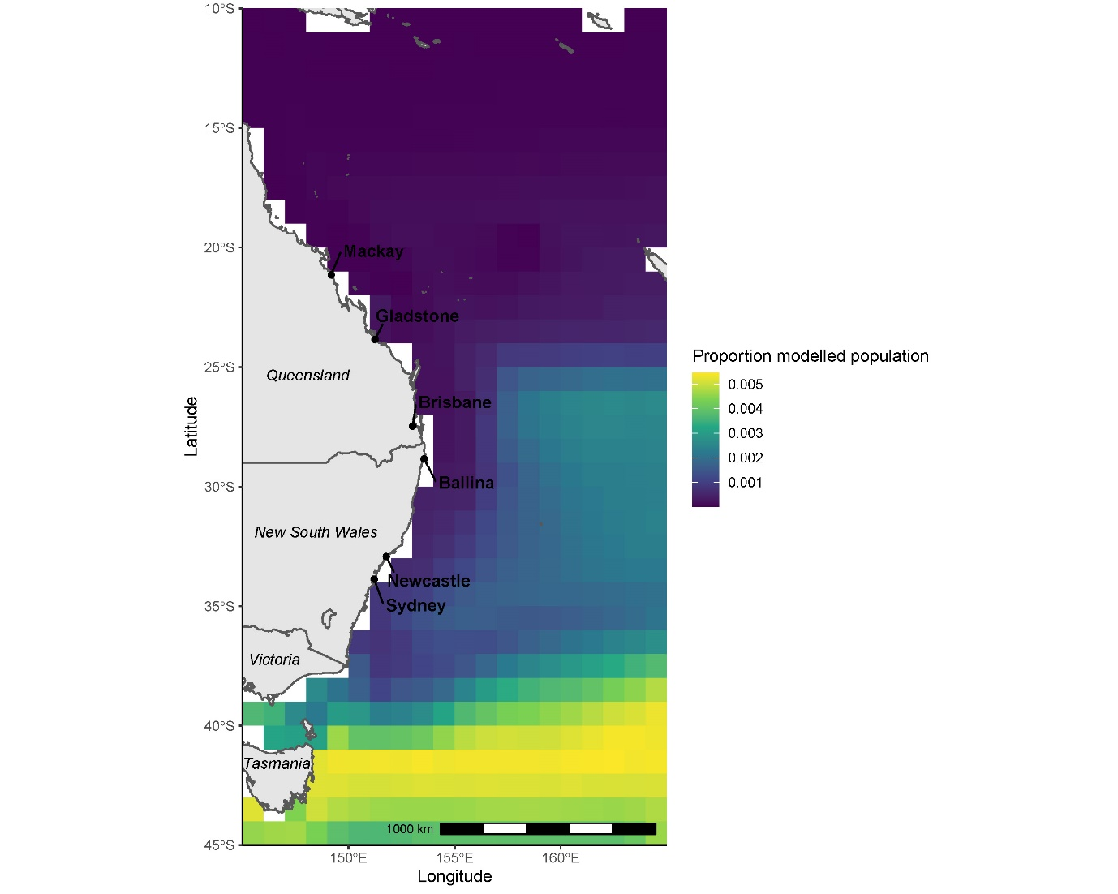
Figure 4: Modelled population habitat of sawsharks (Pristiophorus nudipinnis and P. cirratus) inferred from δ¹³C stable isotope values of muscle tissues of sawsharks and NEMO-MEDUSA global data.

