Appendix A: Fisheries observer data
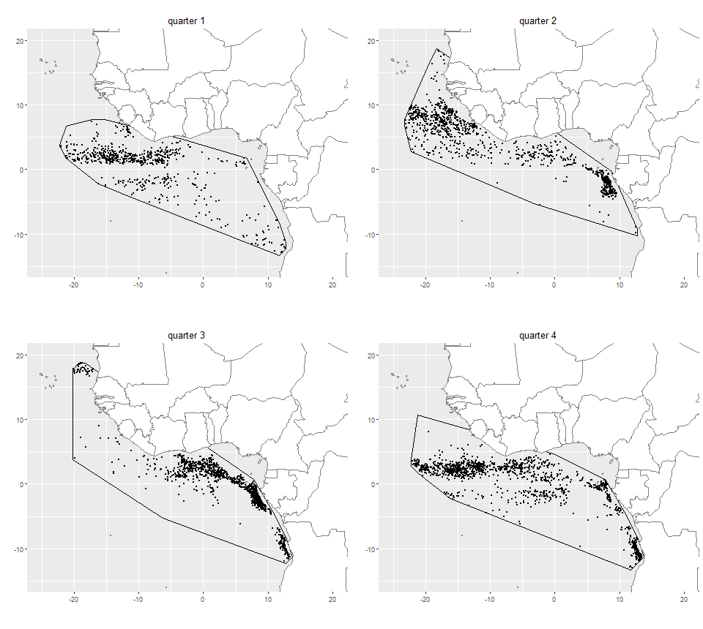
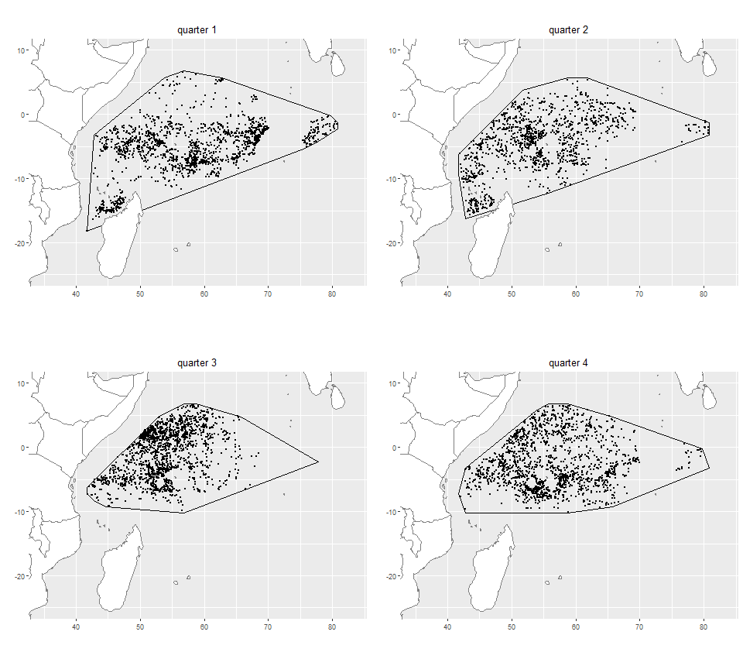
Figure A-1: Spatio-temporal distribution of observed fishing sets on floating objects (FOBs) (black dots) in the Atlantic and Indian oceans. Black polygons represent convex hulls around the fisheries observer data in each quarter. There were 4331 and 6154 FOBs fishing sets in the Atlantic and Indian oceans, respectively.
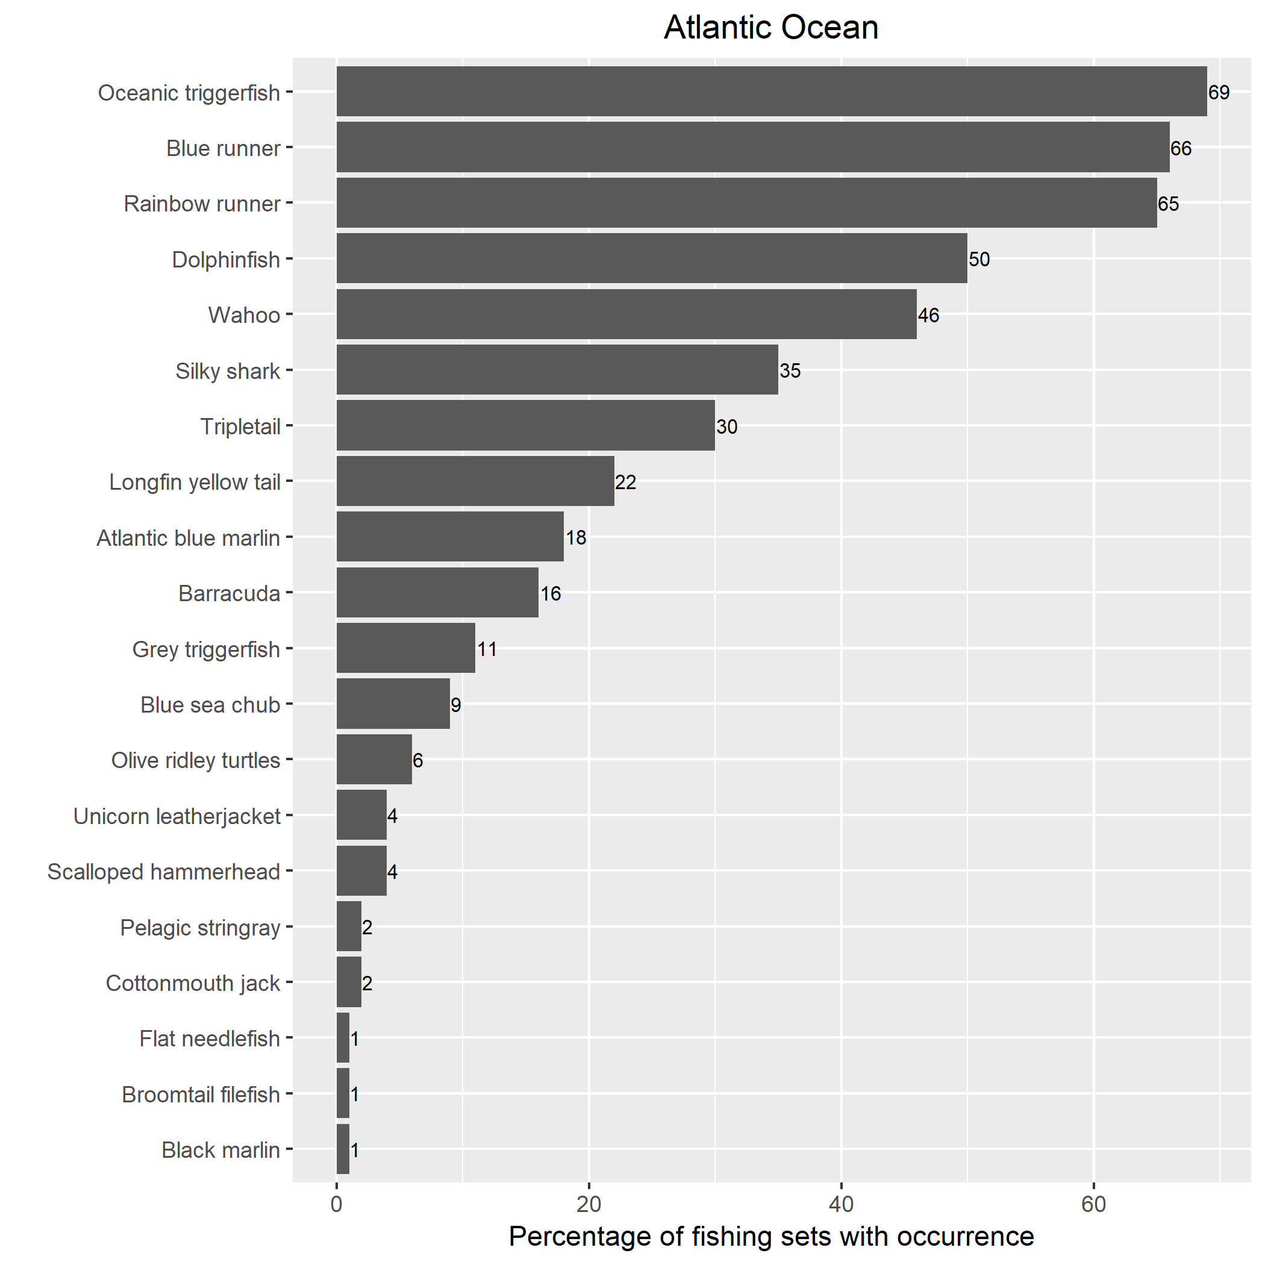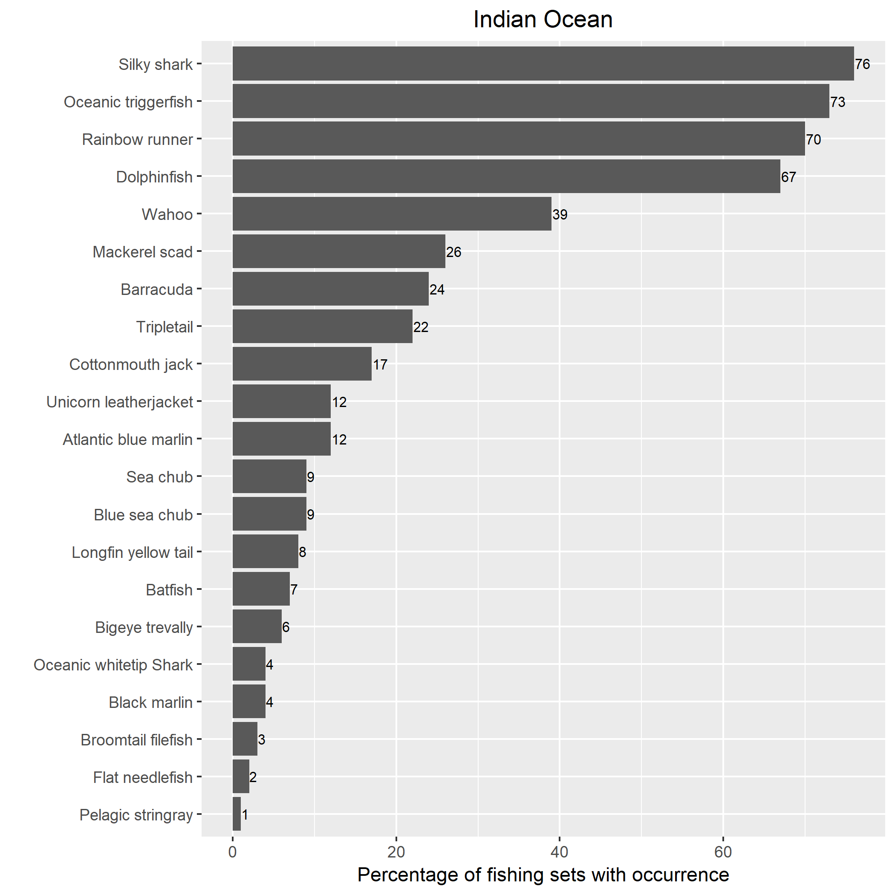
Figure A-2: Ranked occurrence of species in the bycatch at FOBs in the Atlantic and Indian oceans (only species that occurred in > 1% of observed sets were included). Silky shark, oceanic triggerfish, rainbow runner, wahoo, and dolphinfish were the dominant species in both oceans (the blue runner is endemic to the Atlantic).

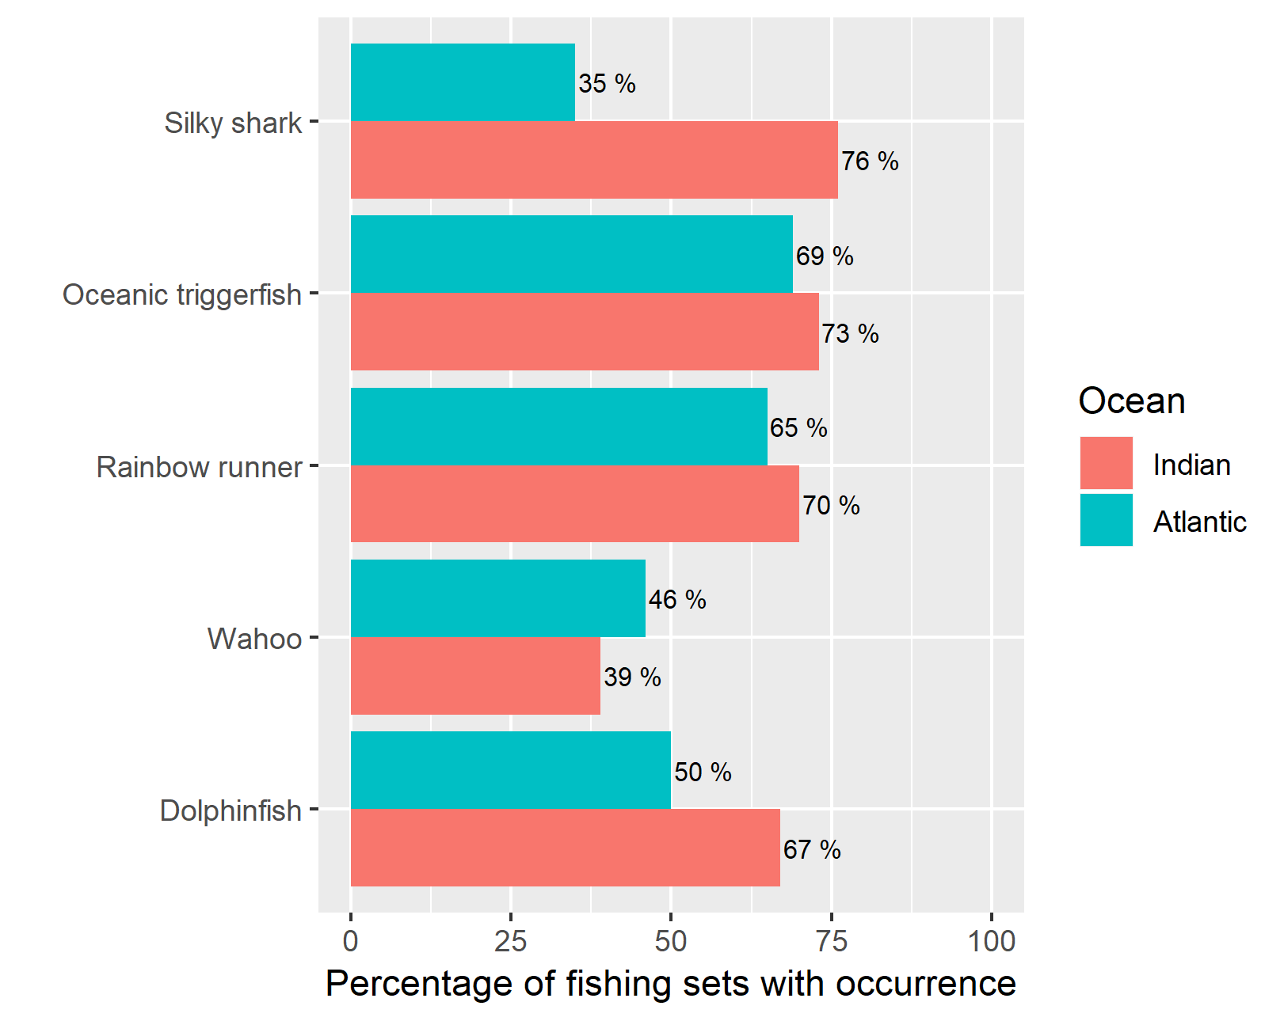
Figure A-3: Comparison of study species occurrences in the bycatch at FOBs between Atlantic and Indian oceans.

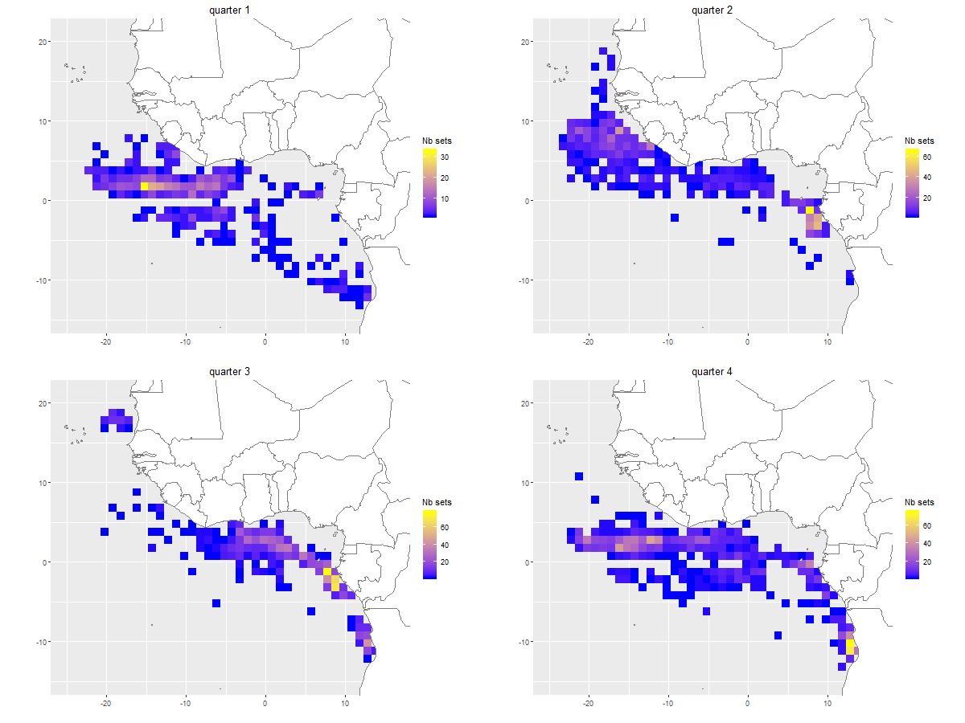
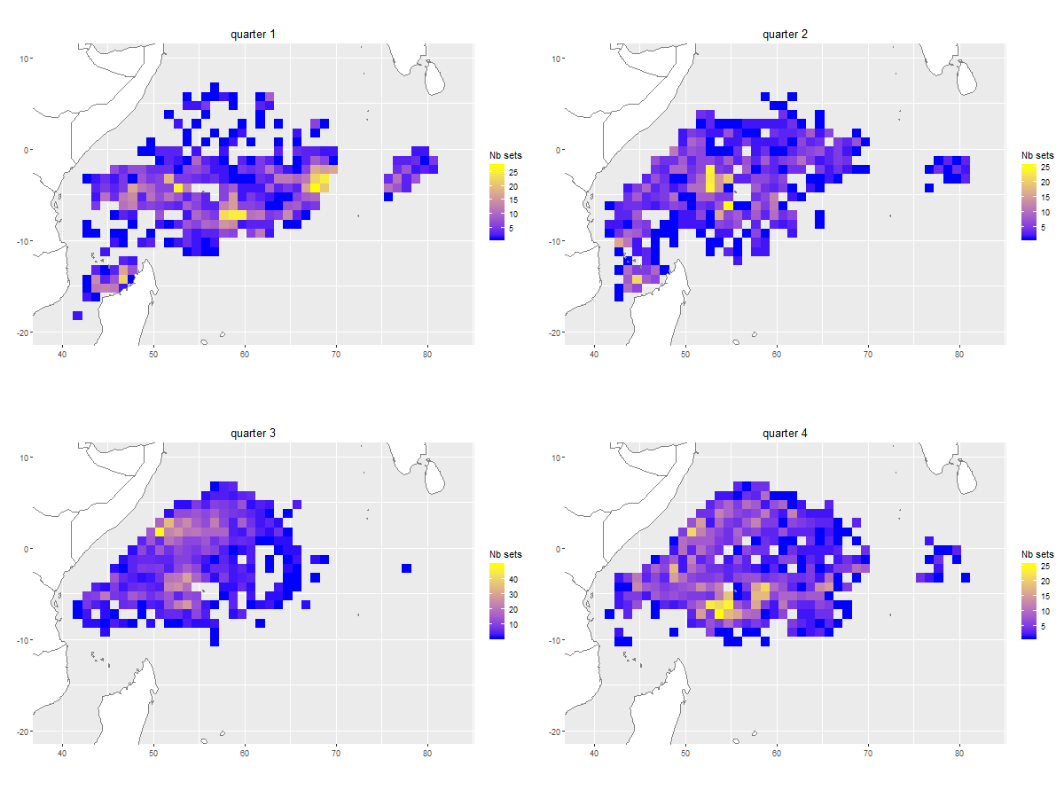
Figure A-4: Number of observed FOBs fishing sets per 1° x 1° x month strata aggregated per quarter in the Atlantic and Indian oceans. There were 1132 1° x 1° x month strata occupied by fishing sets in the Atlantic Ocean and 2001 in the Indian Ocean.
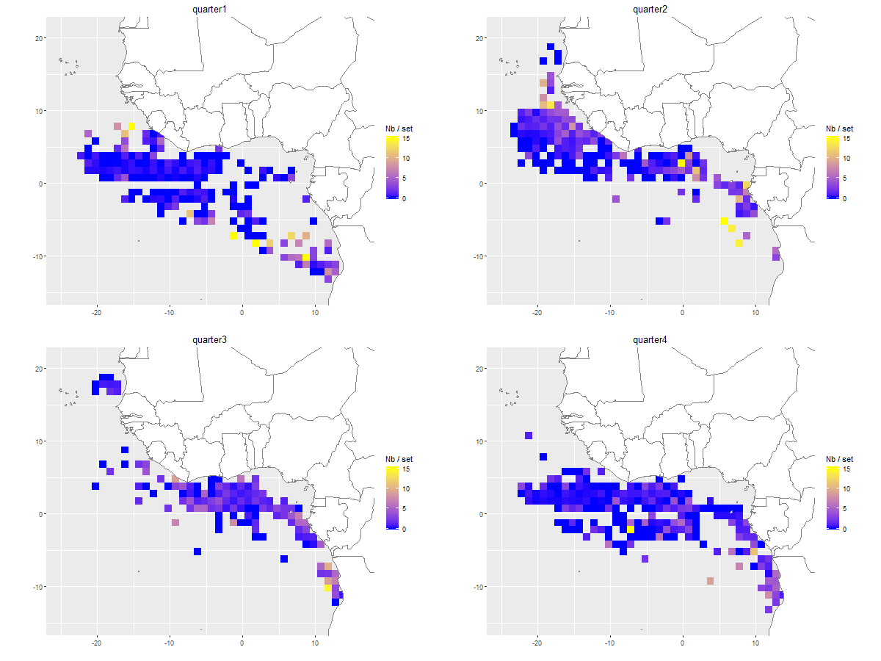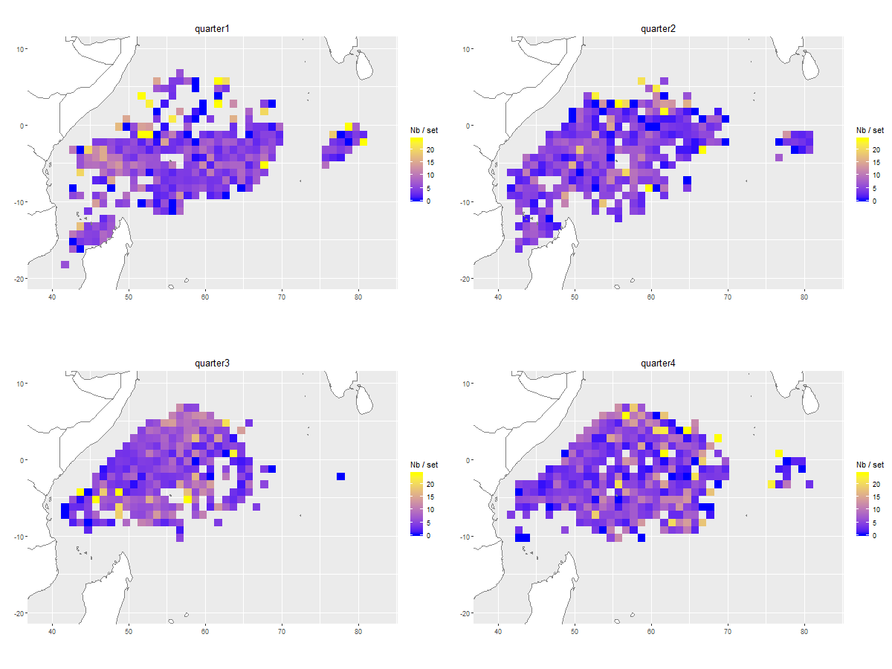
Figure A-5: Observed captured numbers of silky sharks (FAL) per FOB fishing set per 1 x 1° x month strata aggregated per quarter in each ocean. Observation maps use the same color scales as their corresponding prediction maps in Appendix D, with observed values squeezed into the range of predictions values to facilitate visual comparison.
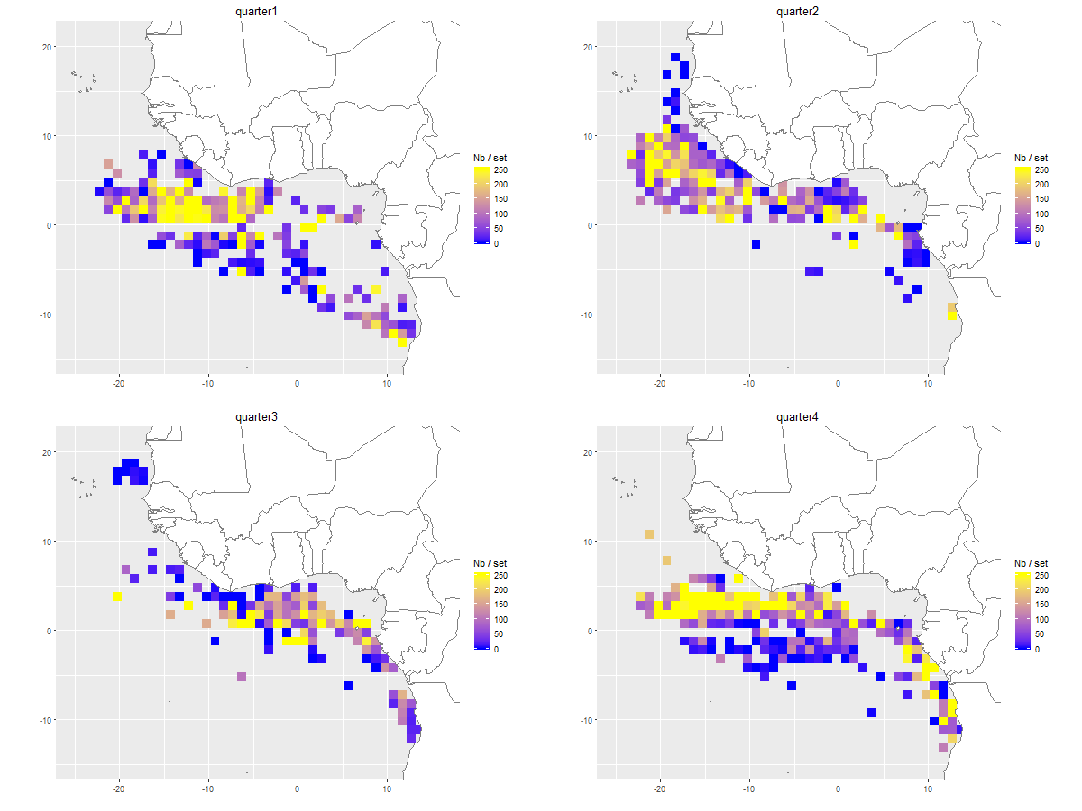
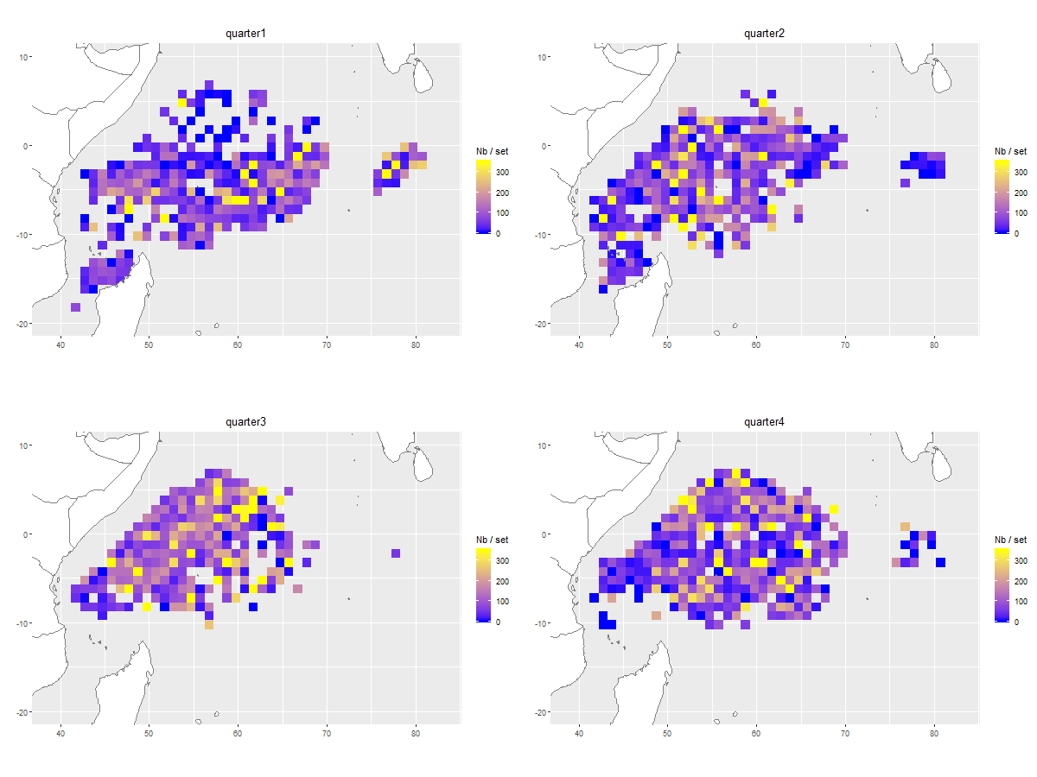
Figure A-6: Observed captured numbers of oceanic triggerfishes (CNT) per FOB fishing set per 1 x 1° x month strata aggregated per quarter in each ocean. Observation maps use the same color scales as their corresponding prediction maps in Appendix D, with observed values squeezed into the range of predictions values to facilitate visual comparison.
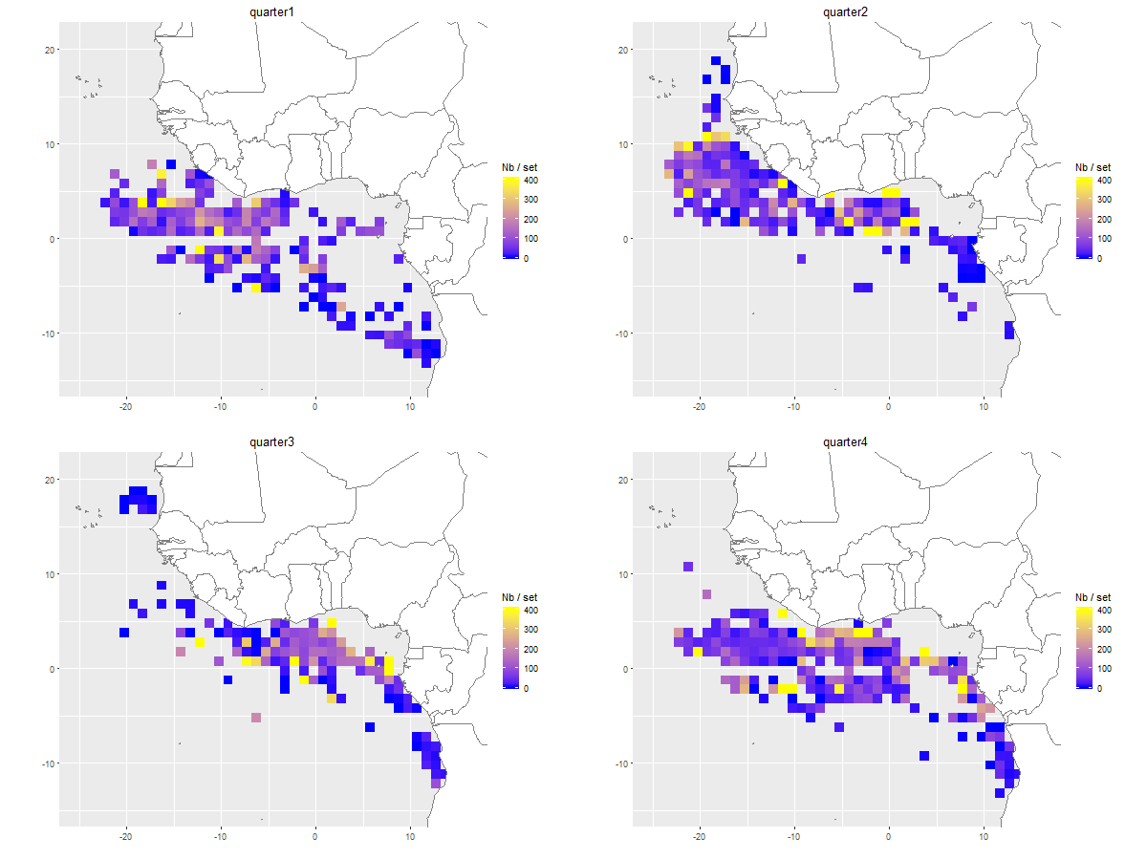
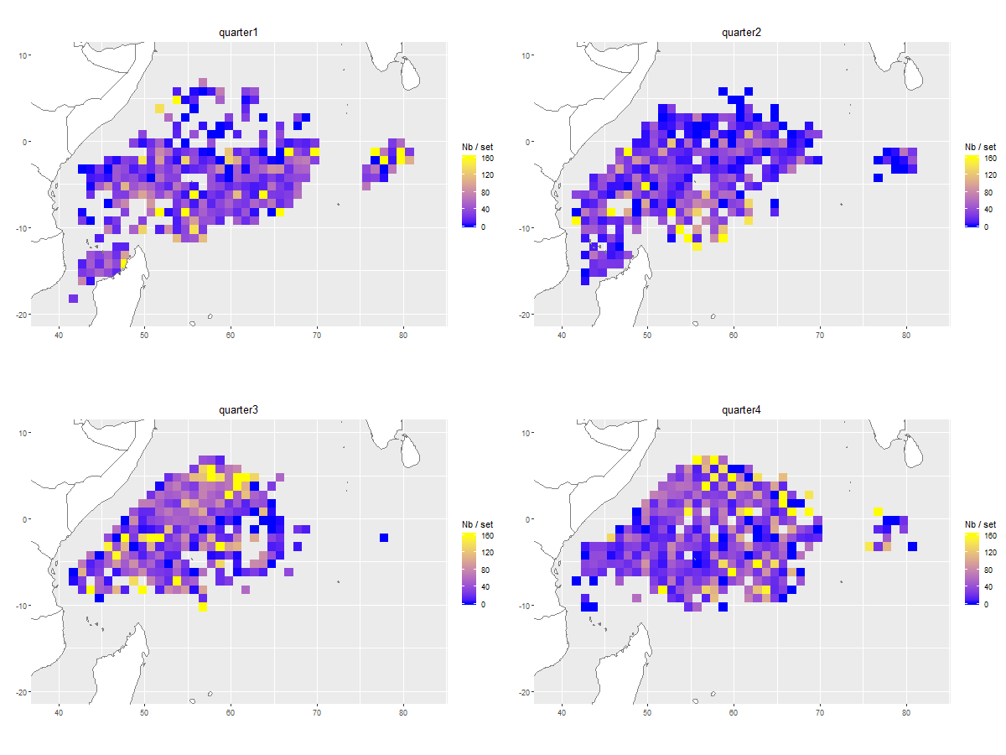
Figure A-7: Observed captured numbers of rainbow runners (RRU) per FOB fishing set per 1 x 1° x month strata aggregated per quarter in each ocean. Observation maps use the same color scales as their corresponding prediction maps in Appendix D, with observed values squeezed into the range of predictions values to facilitate visual comparison.
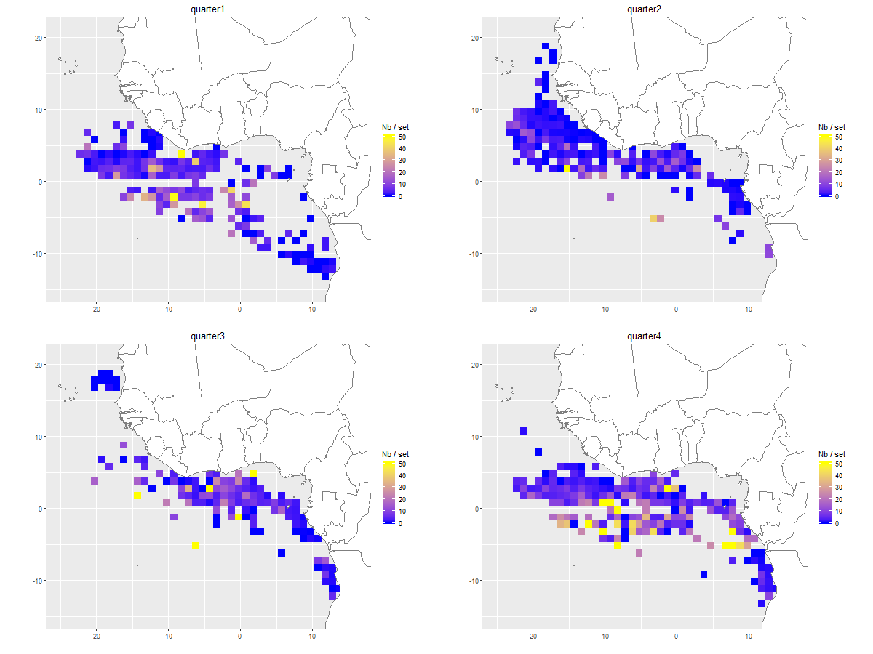
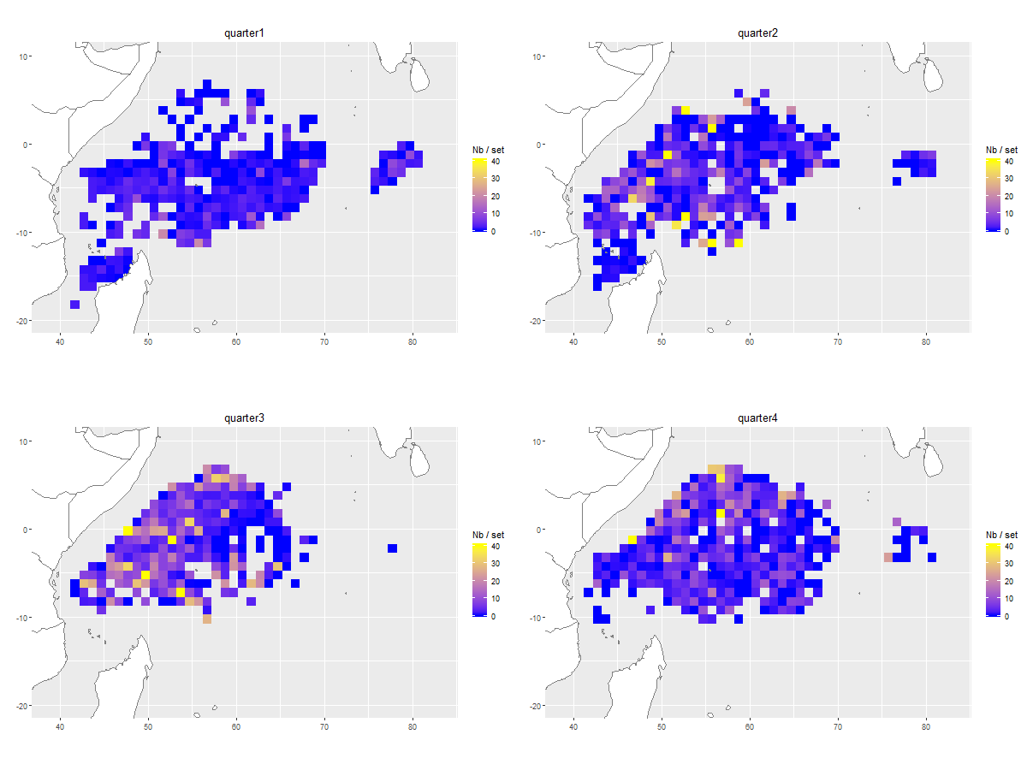
Figure A-8: Observed captured numbers of wahoos (WAH) per FOB fishing set per 1 x 1° x month strata aggregated per quarter in each ocean. Observation maps use the same color scales as their corresponding prediction maps in Appendix D, with observed values squeezed into the range of predictions values to facilitate visual comparison.
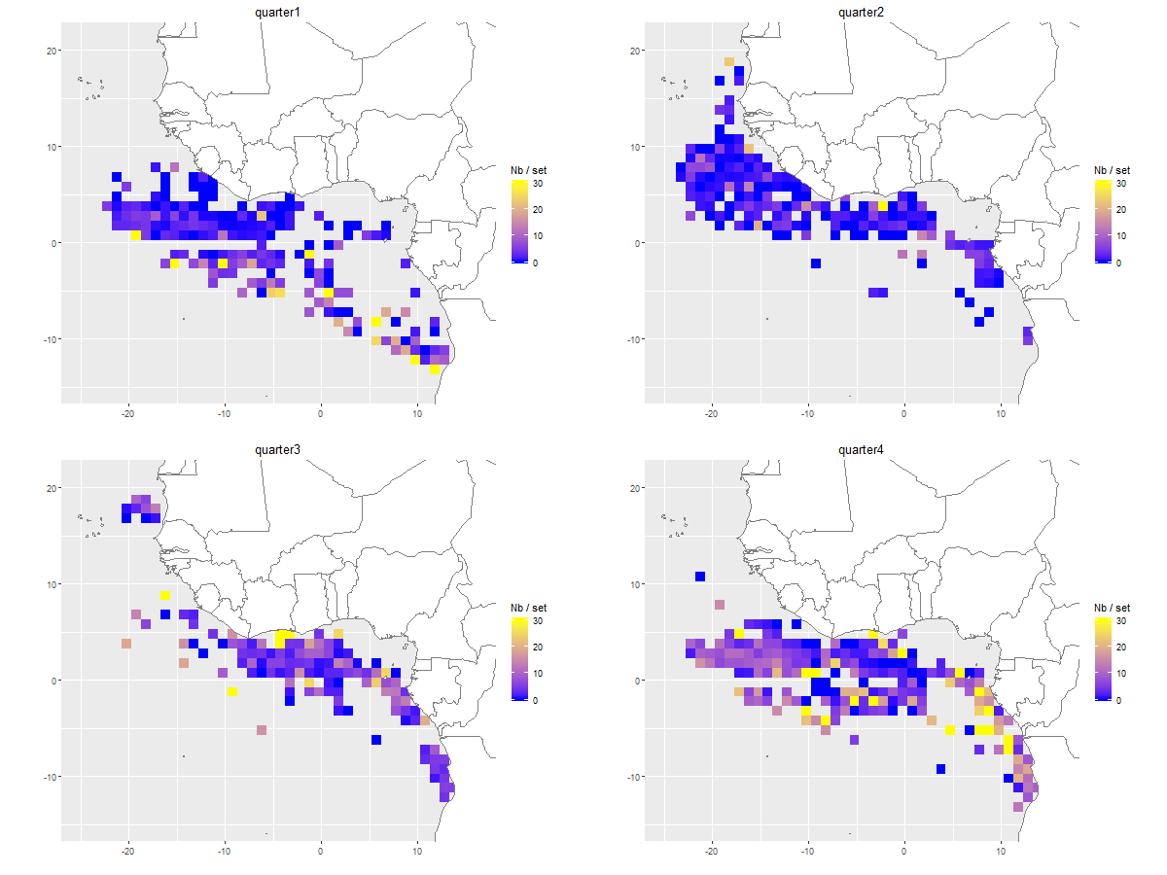
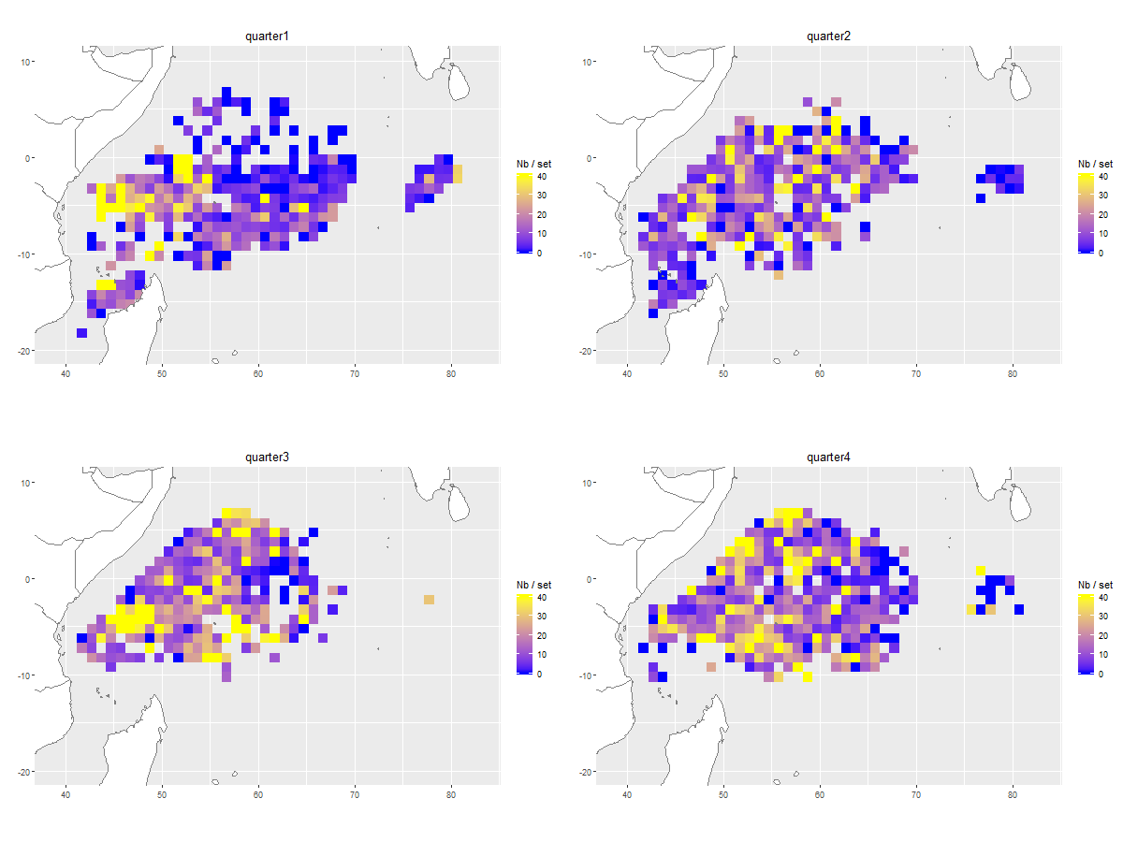
Figure A-9: Observed captured numbers of dolphinfishes (DOL) per FOB fishing set per 1 x 1° x month strata aggregated per quarter in each ocean. Observation maps use the same color scales as their corresponding prediction maps in Appendix D, with observed values squeezed into the range of predictions values to facilitate visual comparison.

