Appendix B: Environmental covariates

Table B-1: Description of environmental covariates included in this study
Covariate | Unit | Product name and source | Product distributor | Original spatial resolution | Original temporal resolution | Ecological relevance to tropical pelagic fishes
Depth | m | ETOPO1 1 Arc-Minute Global Relief Model¹ | NOAA | 1 arc minute (1/60°) | . | Seafloor depth does not have a direct biological influence on pelagic fishes, but it reflects the coastal-offshore gradients in the study regions. Depth also reflect the variations of the seafloor (such as shelf edges and seamounts) that can affect surface oceanography.
Chlorophyll-a concentration (CHL) | mg.m⁻³ | Global Ocean Biogeochemistry Analysis and weekly forecast² | CMEMS | 0.5° | Weekly | CHL is an indicator of the biomass of phytoplankton, and—through trophic relationships—of zooplankton and micronekton, which constitute potential prey resources of our study species.
Sea surface temperature (SST) | °C | MODIS-A Level-3 Standard Mapped SST³ | NASA | 9 km | Monthly | SST affects fish distributions via direct physiological effects on metabolism (high SST causes metabolic stress).
Mixed layer depth (MLD) | m | Global Ocean Physics Reanalysis GLORYS12V1⁴ | CMEMS | 1/12° | Monthly | Variations in the depth of the mixed layer affect the vertical distribution of our study species, as they mostly use waters above the thermocline.
Surface salinity (SAL) | Practical salinity unit | Global Ocean Physics Reanalysis GLORYS12V1⁴ | CMEMS | 1/12° | Monthly | Salinity affects fish distributions via physiological effects on osmoregulation processes. Low salinity may also indicate the proximity of a large river associated with high productivity and thus potentially favorable foraging areas.
Total kinetic energy (TKE) | m⁻².s⁻² | Global ocean gridded L4 sea surface heights and derived variables reprocessed⁵ | CMEMS | 1/4° | Daily | Geostrophic currents drive the formation of eddies associated with enhanced primary production and prey aggregation, potentially providing foraging opportunities for our study species.
Floating objects density (FOBs_DENS) | . | See main text for processing details | . | . | . | Floating objects aggregate epipelagic fishes through behaviourally-mediated processes.

Product sources :
1 : https://data.nodc.noaa.gov/cgi-bin/iso?id=gov.noaa.ngdc.mgg.dem:316
2 : http://marine.copernicus.eu/services-portfolio/access-to-products/?option=com_csw&view=details&product_id=GLOBAL_ANALYSIS_FORECAST_BIO_001_014
3 : https://oceancolor.gsfc.nasa.gov/atbd/sst/
4 : http://marine.copernicus.eu/services-portfolio/access-to-products/?option=com_csw&amp;view=details&amp;product_id=GLOBAL_REANALYSIS_PHY_001_030 (from January 2014 to June 2018) and http://marine.copernicus.eu/services-portfolio/access-to products/?option=com_csw&view=details&product_id=GLOBAL_ANALYSIS_FORECAST_PHY_001_024 (from July 2018 to December 2018)
5 : http://marine.copernicus.eu/services-portfolio/access-to-products/?option=com_csw&view=details&product_id=SEALEVEL_GLO_PHY_L4_REP_OBSERVATIONS_008_047

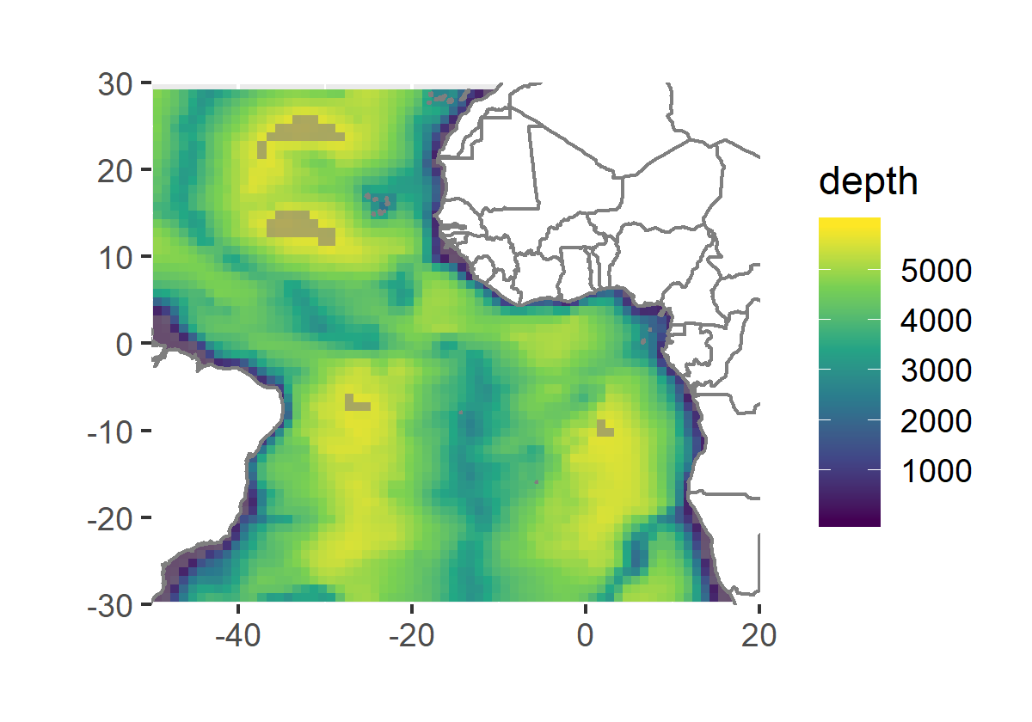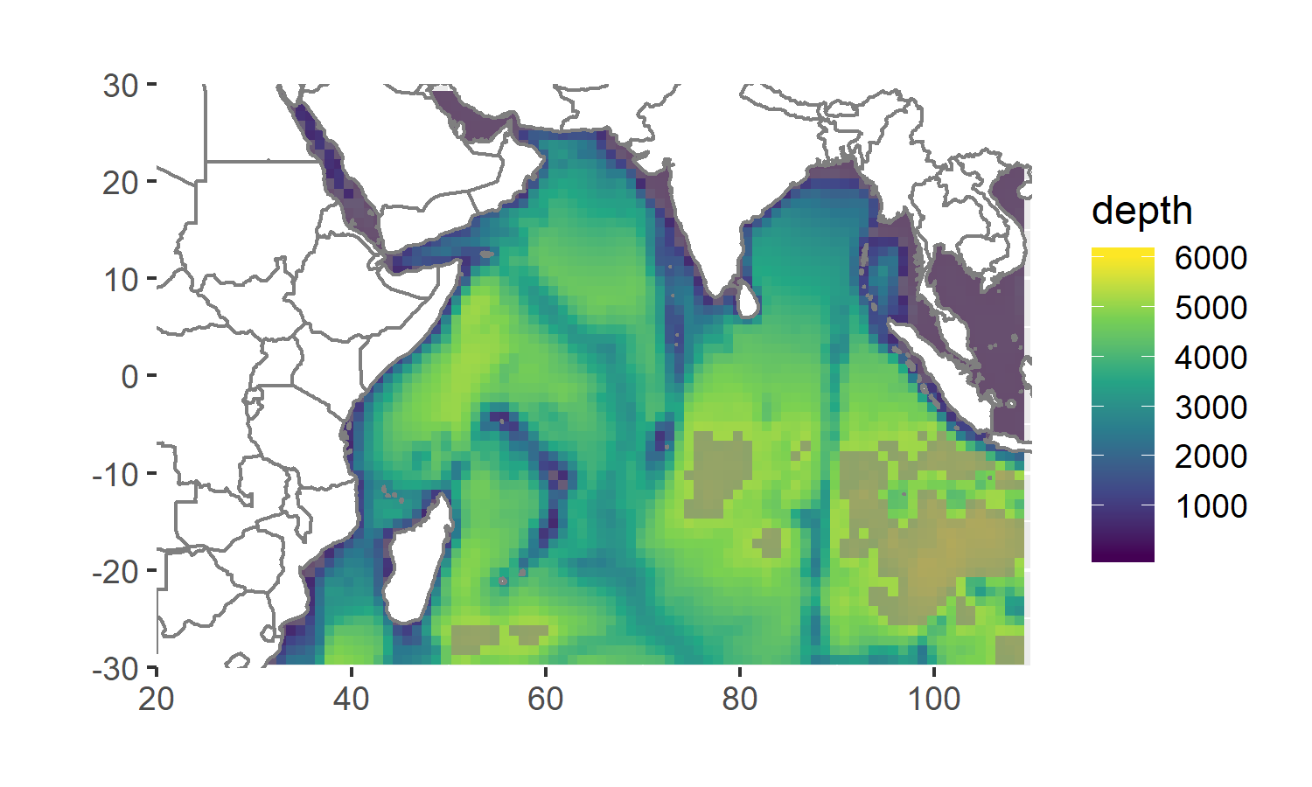
Figure B-1: Maps of depth in the Atlantic and Indian oceans at a 1° x 1° spatial resolution. Areas where depth values lie beyond the range of depth values associated with the observed sets appear in transparent grey.

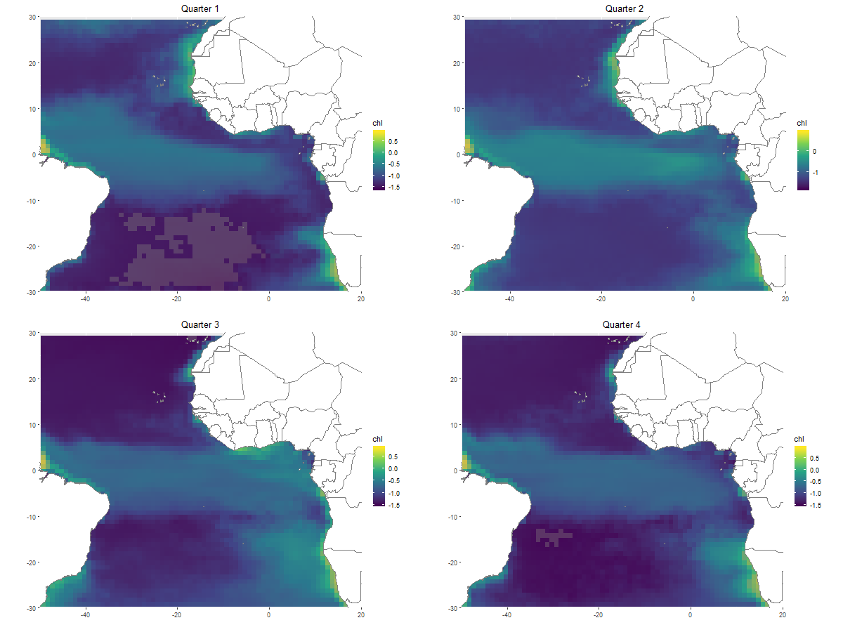
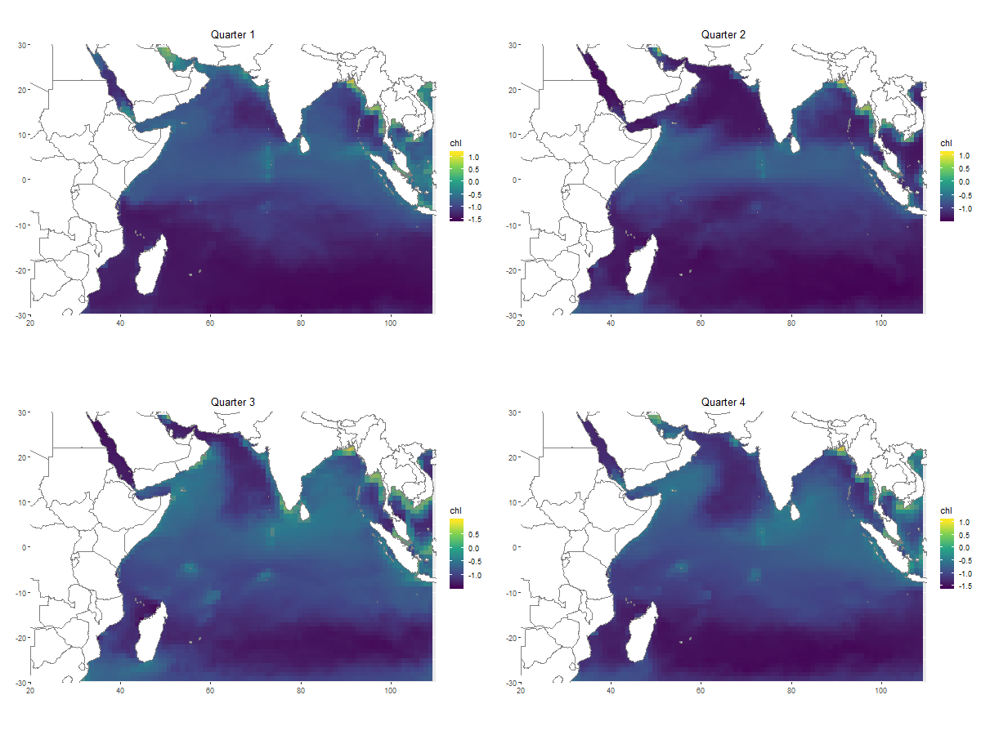
Figure B-2: Maps of chlorophyll-a concentration (CHL) (log-transformed) in the Atlantic and Indian oceans at a 1° x 1° spatial resolution. For vizualization, maps are presented at a quarterly climatological resolution. Areas where CHL values lie beyond the range of CHL values associated with the observed sets appear in transparent grey.

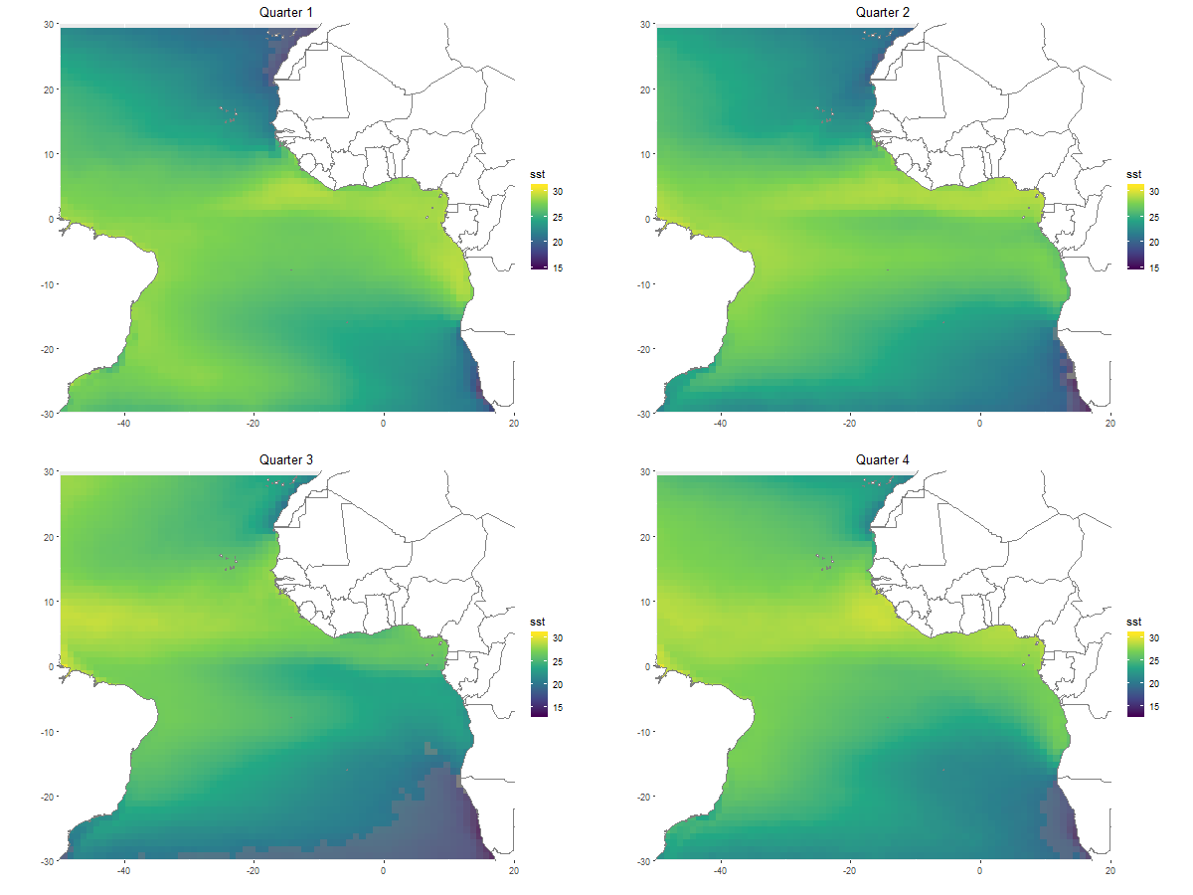
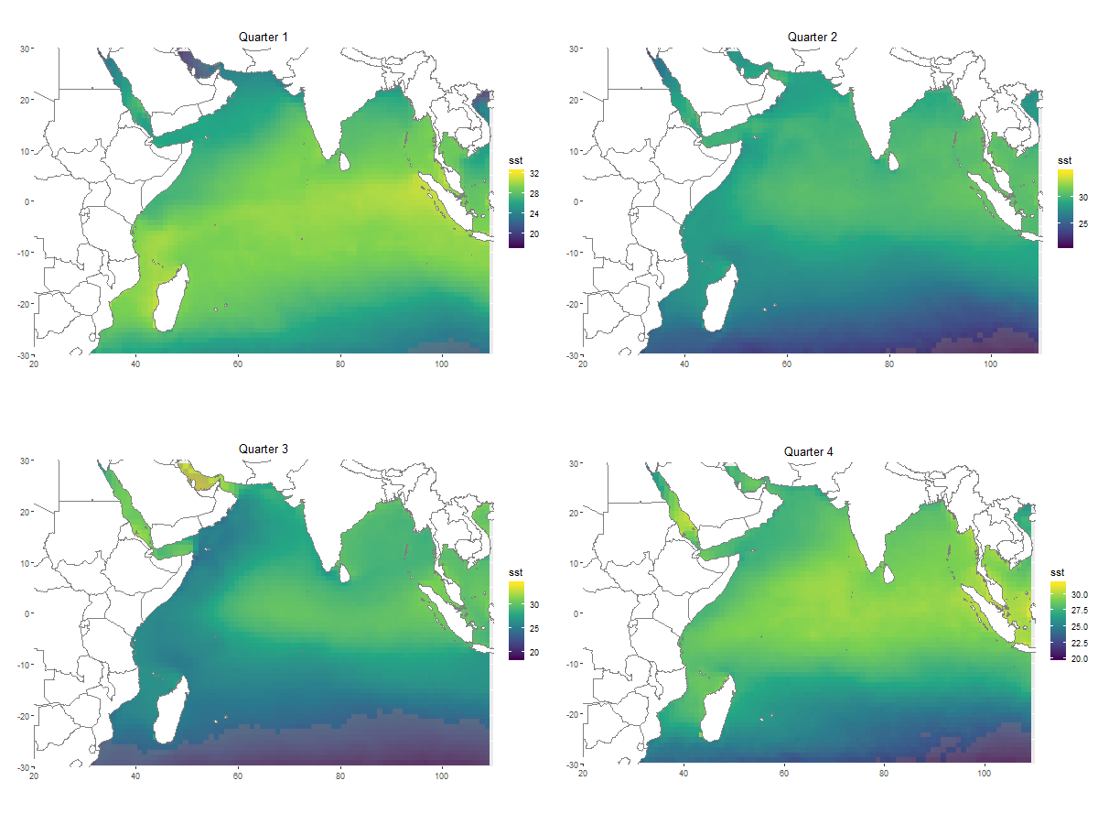
Figure B-3: Maps of sea surface temperature (SST) in the Atlantic and Indian oceans at a 1° x 1° spatial resolution. For vizualization, maps are presented at a quarterly climatological resolution. Areas where SST values lie beyond the range of SST values associated with the observed sets appear in transparent grey.
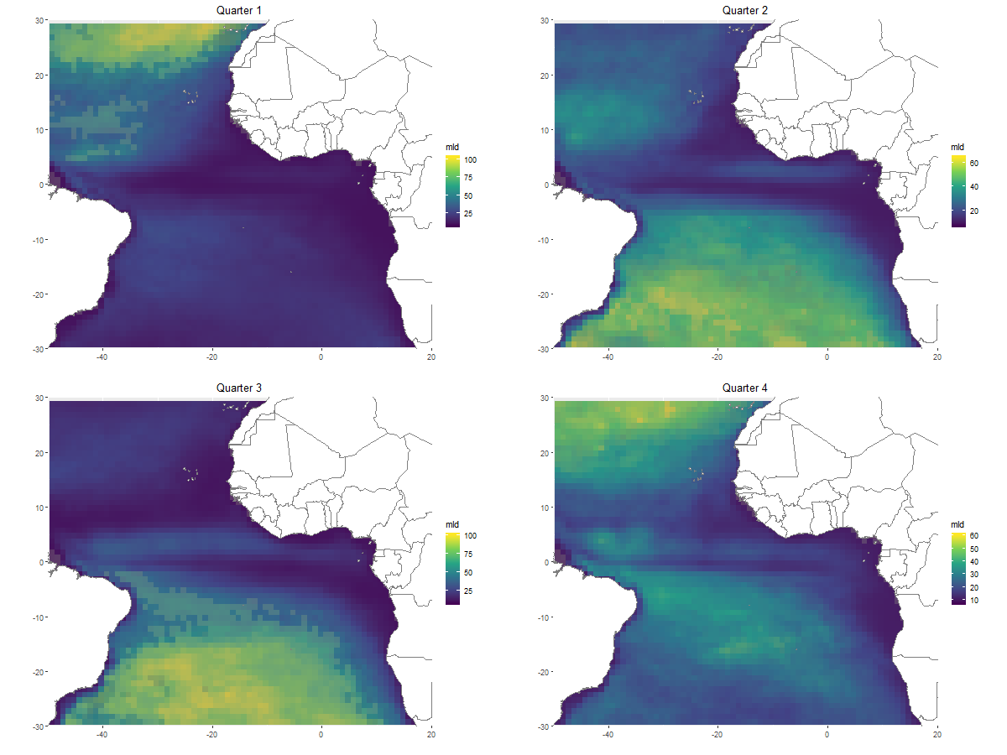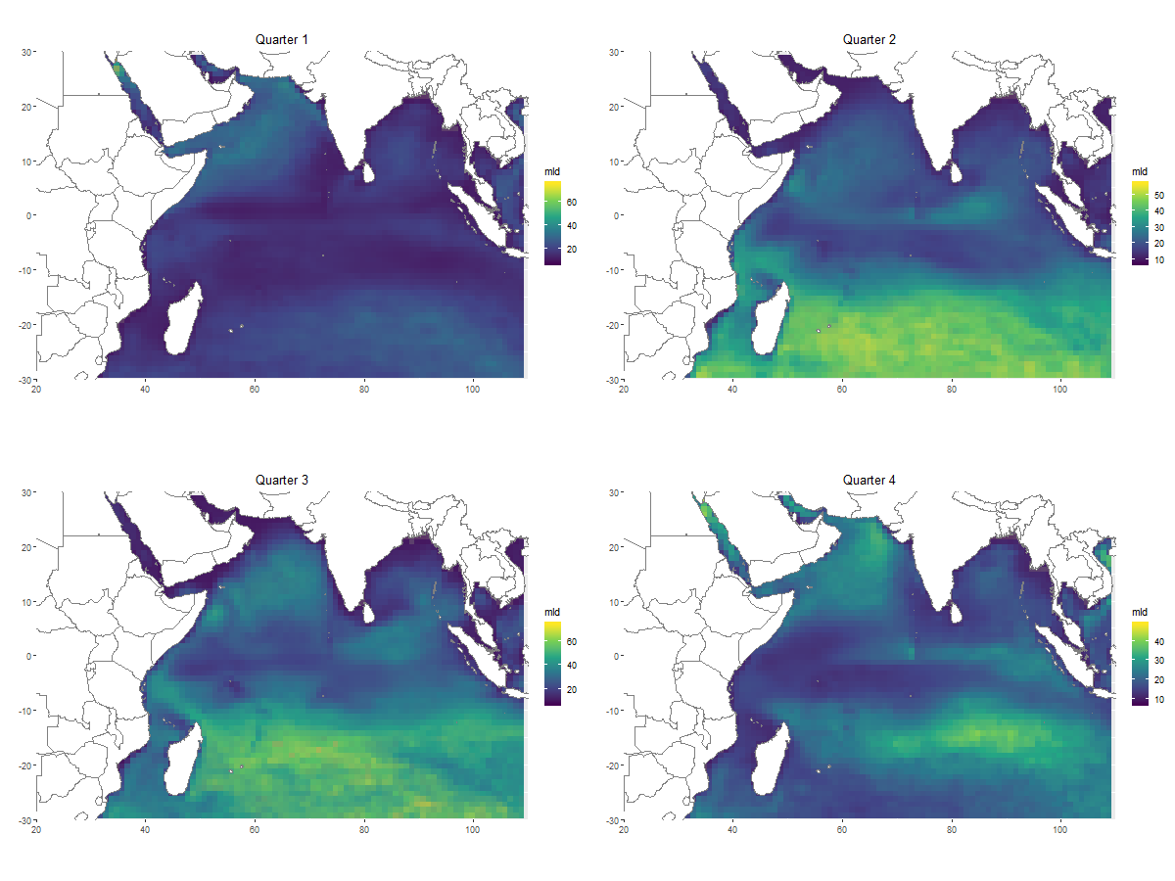
Figure B-4: Maps of mixed layer depth (MLD) in the Atlantic and Indian oceans at a 1° x 1° spatial resolution. For vizualization, maps are presented at a quarterly climatological resolution. Areas where MLD values lie beyond the range of MLD values associated with the observed sets appear in transparent grey.
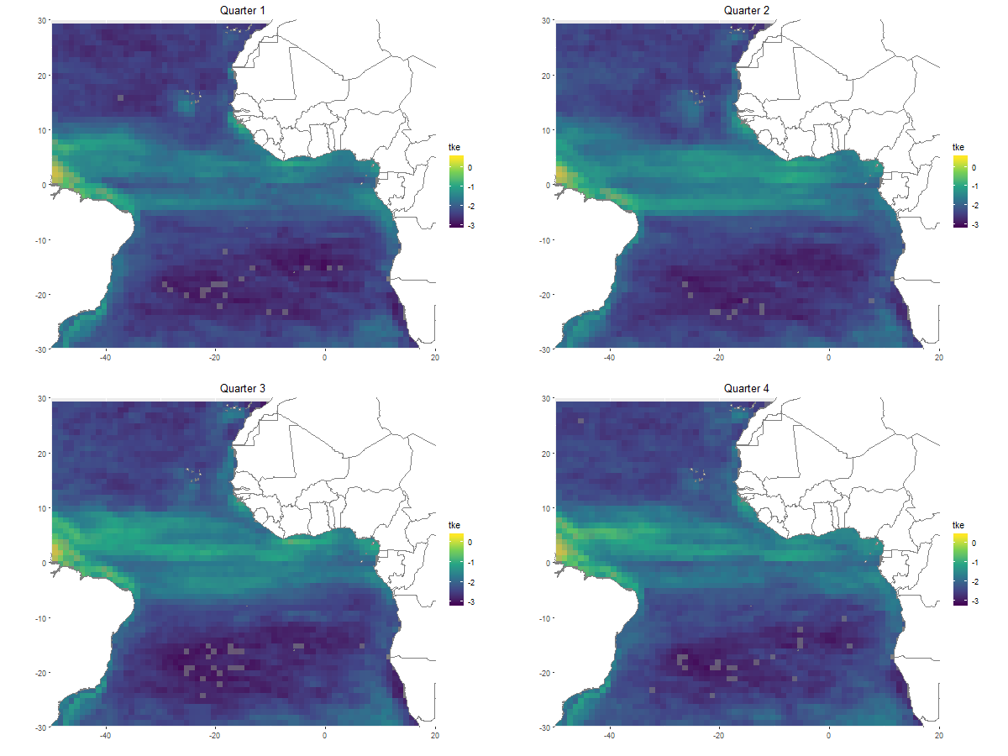
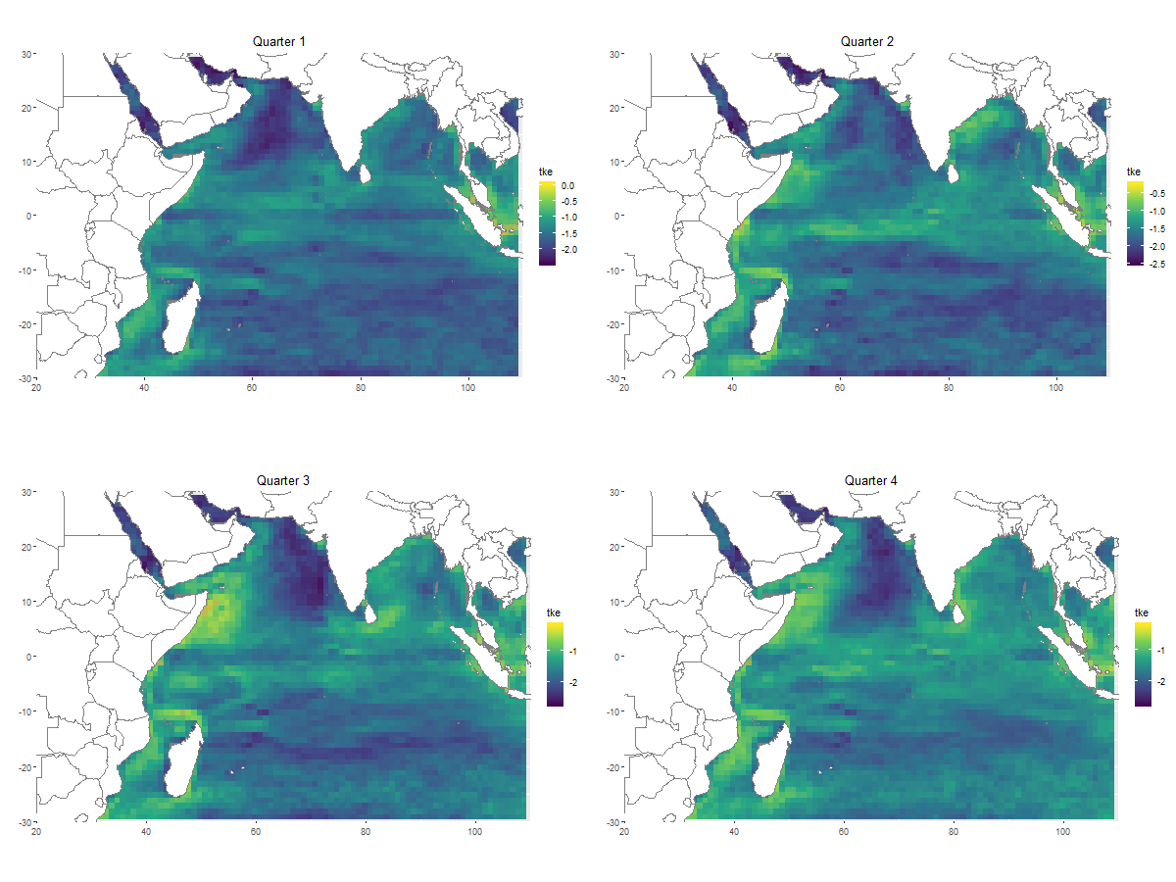
Figure B-5: Maps of total kinetic energy (log-transformed) (TKE) in the Atlantic and Indian oceans at a 1° x 1° spatial resolution. For vizualization, maps are presented at a quarterly climatological resolution. Areas where TKE values lie beyond the range of TKE values associated with the observed sets appear in transparent grey.
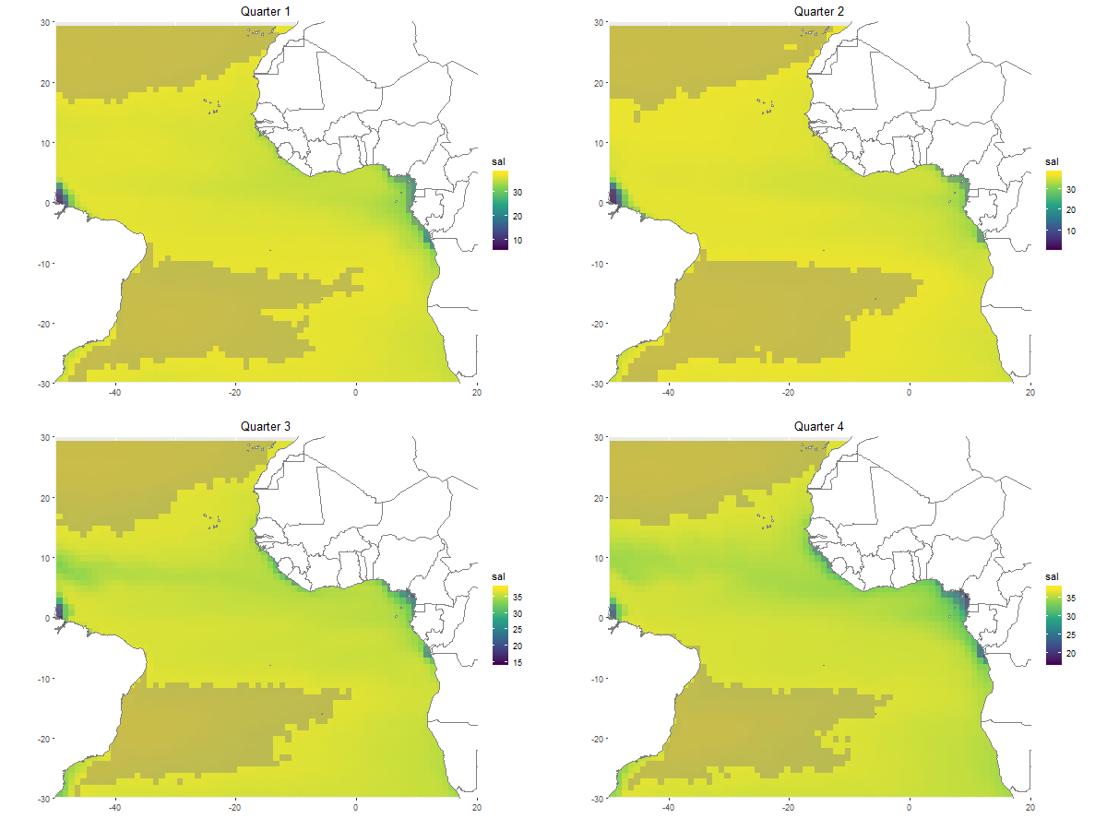
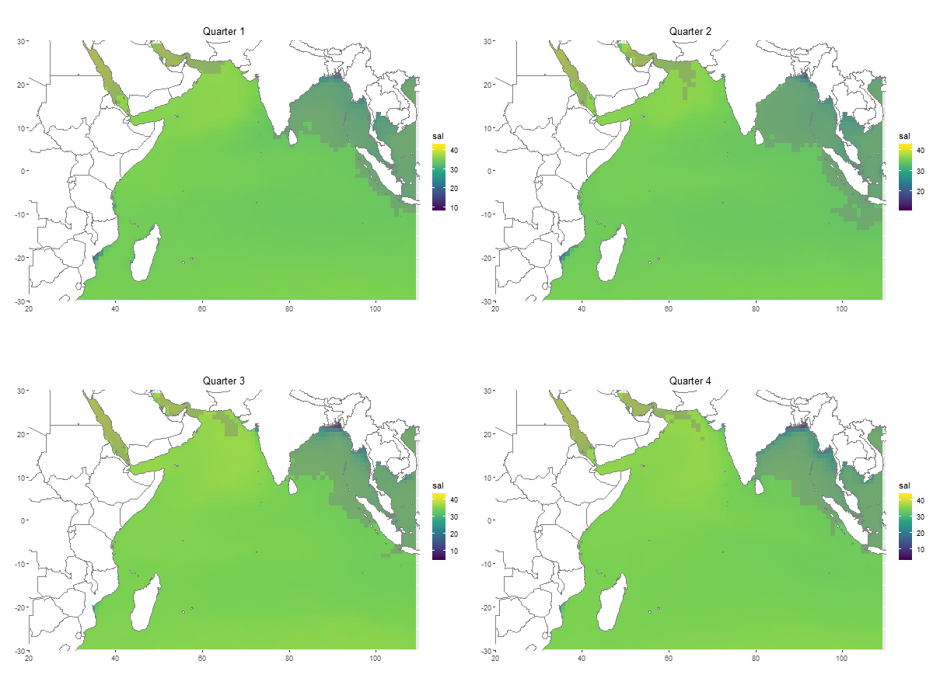
Figure B-6: Maps of salinity (SAL) in the Atlantic and Indian oceans at a 1° x 1° spatial resolution. For vizualization, maps are presented at a quarterly climatological resolution. Areas where SAL values lie beyond the range of SAL values associated with the observed sets appear in transparent grey.
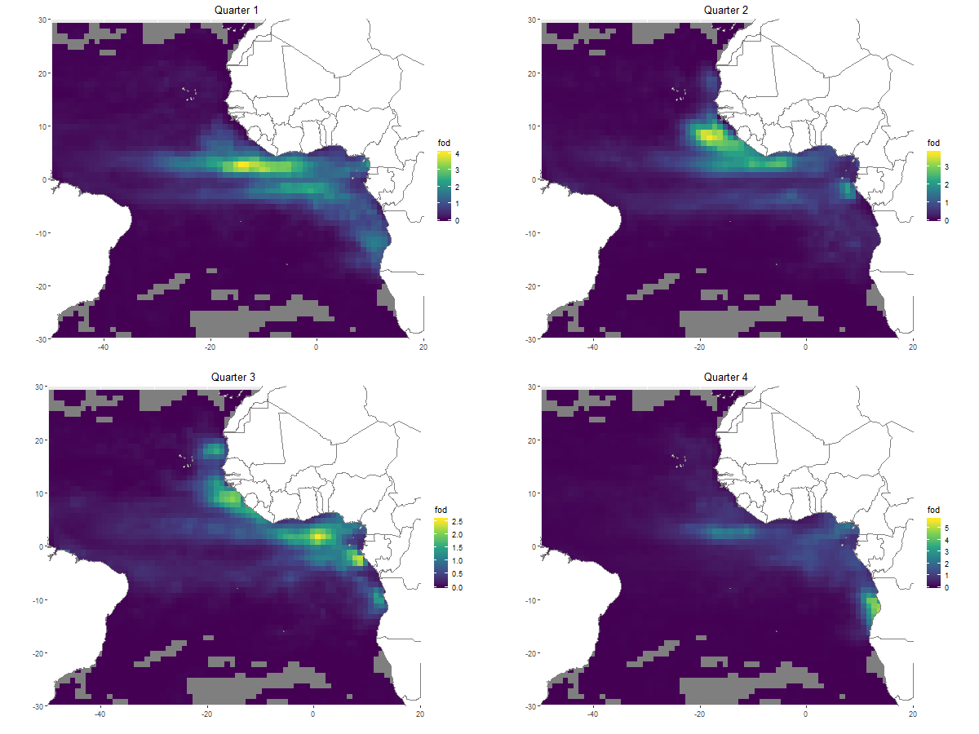
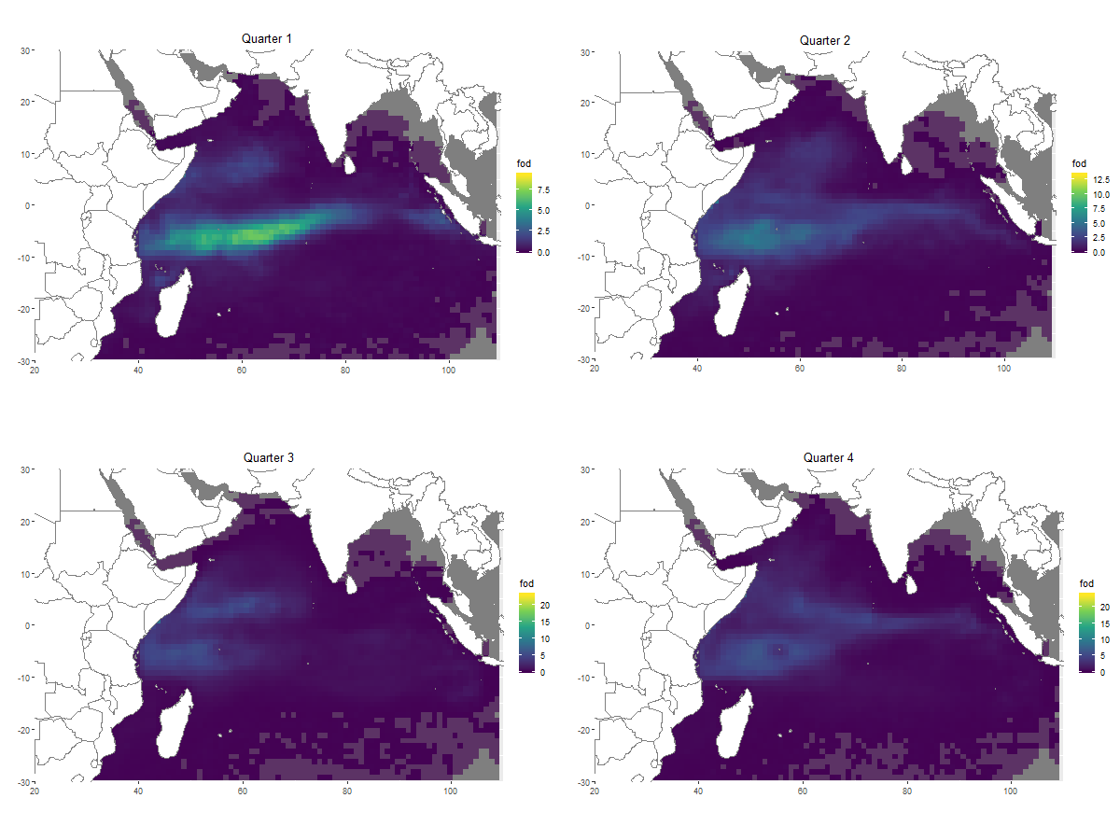
Figure B-7: Maps of floating objects density (FOBs_DENS) in the Atlantic and Indian oceans at a 1° x 1° spatial resolution. For vizualization, maps are presented at a quarterly climatological resolution. Areas where FOBs_DENS values lie beyond the range of FOBs_DENS values associated with the observed sets appear in transparent grey.

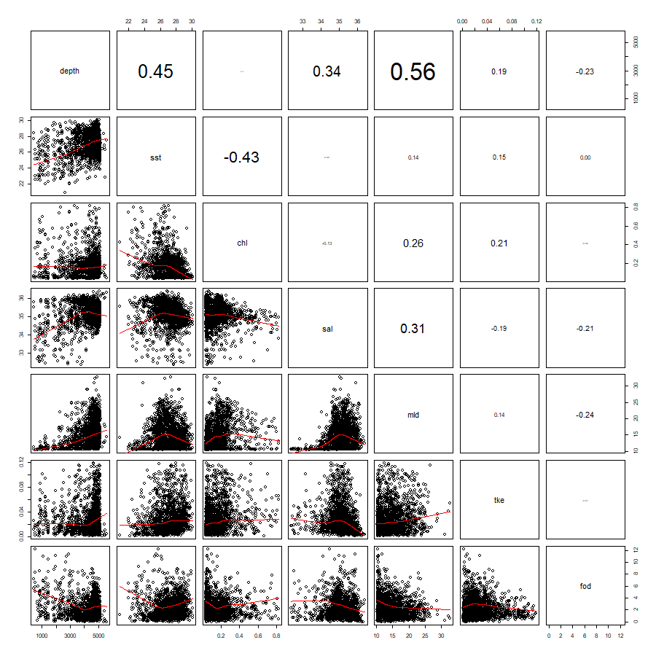
Figure B-8: Spearman’s rank correlation coefficients with text size proportional to correlations (upper panels) and scatterplots (lower panels) between all pairs of environmental covariates in Atlantic Ocean fishing sets.
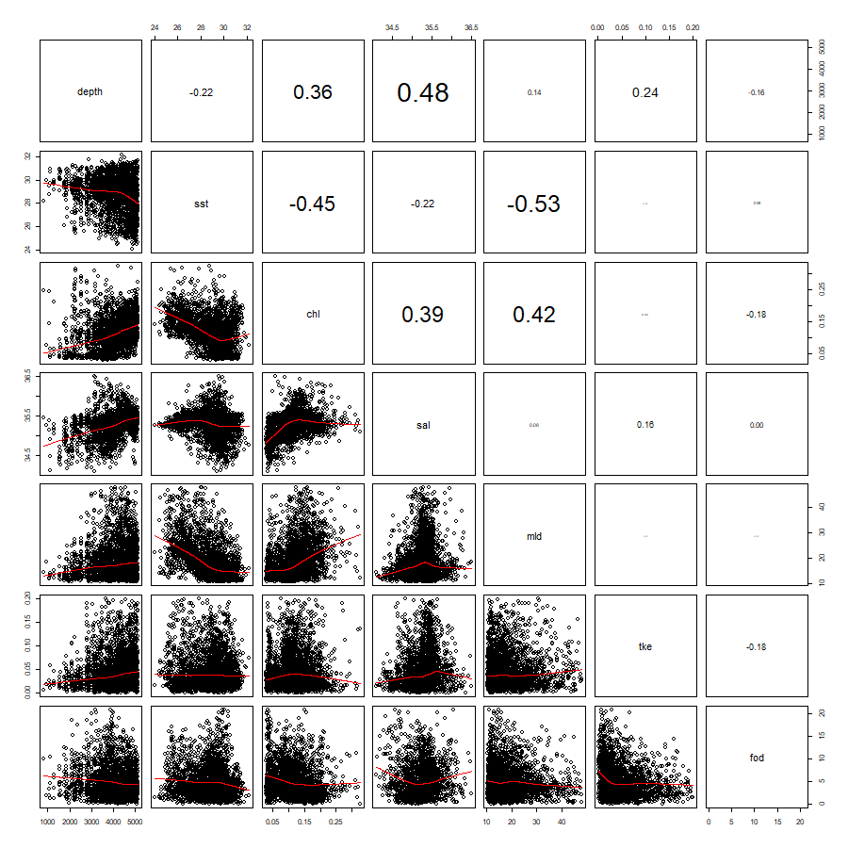
Figure B-9: Spearman’s rank correlation coefficients with text size proportional to correlations (upper panels) and scatterplots (lower panels) between all pairs of environmental covariates in Indian Ocean fishing sets.

