Appendix C: Model residual diagnostics

This appendix shows the diagnostic plots of residuals for all models.
- Plots of randomized quantile residuals versus the linear predictor:
Plots of randomized quantile residuals versus the linear predictor were generated using the statmod package (Smyth, 2019). Plots include a lowess regression (red line) to illustrate any trend in the points. Expanding y-range indicates non-constant variance (heteroskedasticity) in the model.
For all models, plots of randomized quantile residuals versus the linear predictor did not show any problems of heteroscedasticity, or display particular patterns.
- Quantile-quantile plots:
Quantile-quantile (Q-Q) plots of deviance residuals were generated using the qq.gam function in the mgcv package with 100 simulations (Augustin et al. 2012) (Wood, 2019). Grey lines are possible simulated Q-Q plots under the assumption that the model is correct. The red reference line indicates perfect agreement between residual and theoretical residual distributions. Points lying away from the red line suggest limited model fit for the corresponding quantiles. Zeros appear to the left of the Q-Q plot in alignment with the reference line.
Overall, Q-Q plots indicated a satisfying fit to the data despite a tendency to underestimate the extreme high bycatch values observed in some fishing sets (especially for oceanic triggerfish and rainbow runner). This tendency to under-estimate high bycatch values is inherent to GAMs (Wood, 2017) and the consequence of limiting the basis size of smooth functions for preventing overfitting. This under-estimation may have affected the sizes of the bycatch hotspots (by potentially affecting the threshold used for detecting hotspots) but not their locations.
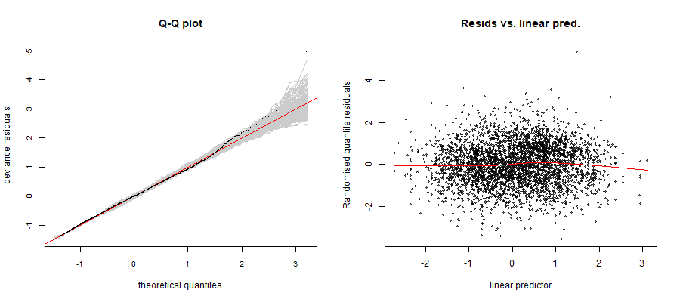
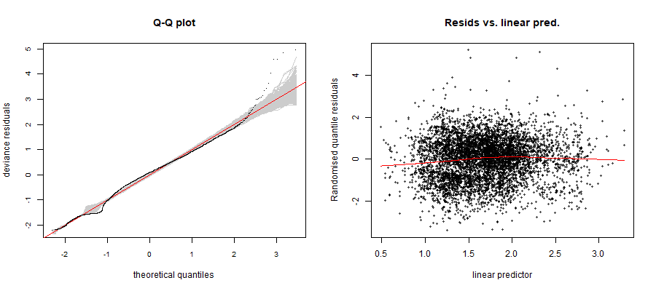
Figure C-1: Diagnostic plots of residuals for silky shark (FAL) in the Atlantic (top) and Indian (bottom) oceans. Left: Q-Q plot of deviance residuals. Right: plot of randomized quantile residuals versus the linear predictor.

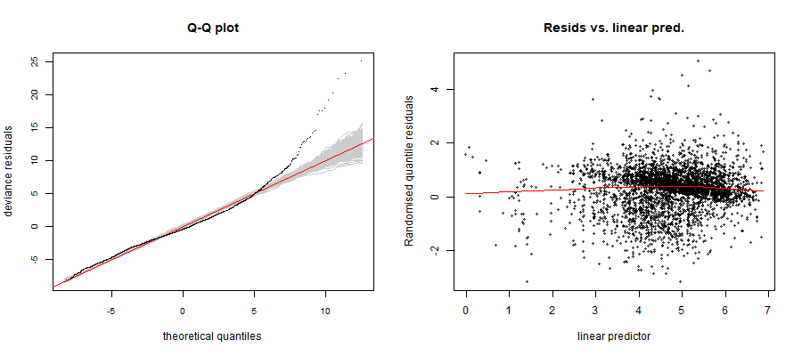
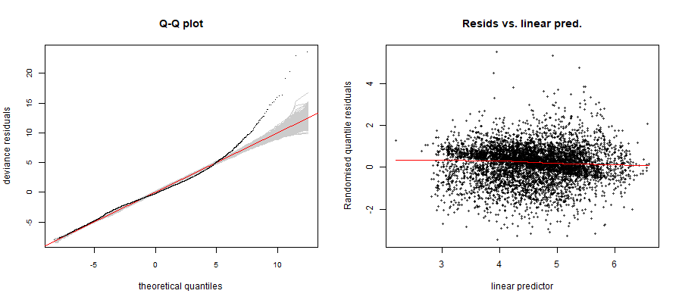
Figure C-2: Diagnostic plots of residuals for oceanic triggerfish (CNT) in the Atlantic (top) and Indian (bottom) oceans. Left: Q-Q plot of deviance residuals. Right: plot of randomized quantile residuals versus the linear predictor.

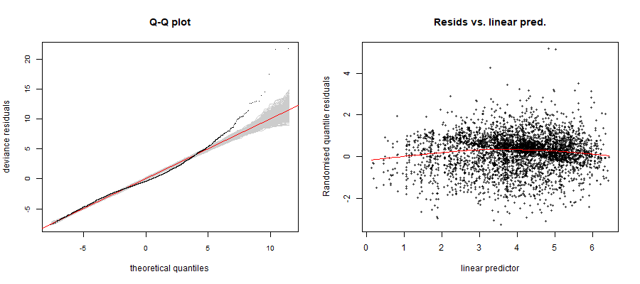
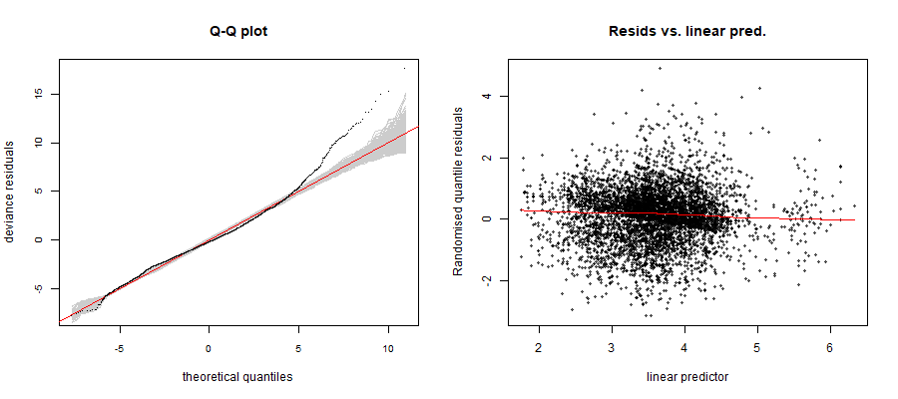
Figure C-3: Diagnostic plots of residuals for rainbow runner (RRU) in the Atlantic (top) and Indian (bottom) oceans. Left: Q-Q plot of deviance residuals. Right: plot of randomized quantile residuals versus the linear predictor.

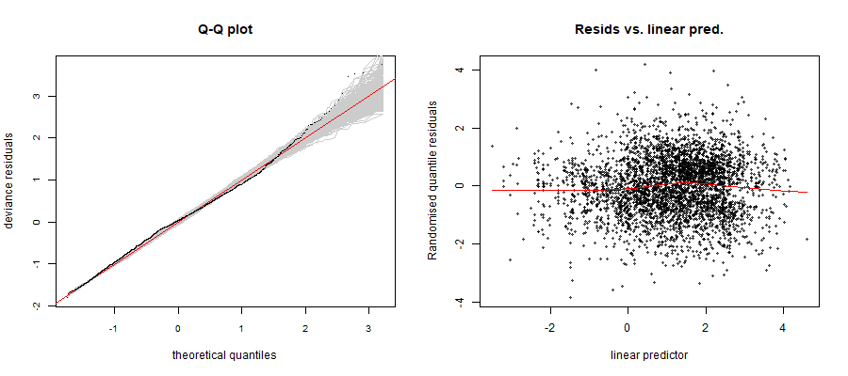
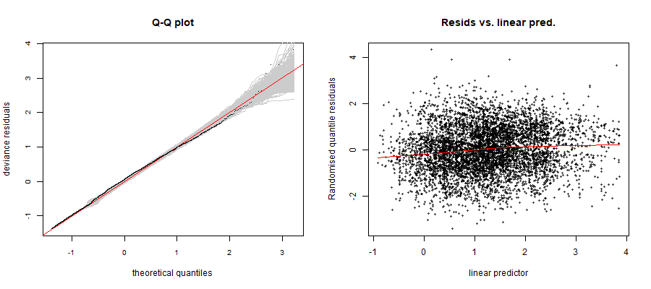
Figure C-4: Diagnostic plots of residuals for wahoo (WAH) in the Atlantic (top) and Indian (bottom) oceans. Left: Q-Q plot of deviance residuals. Right: plot of randomized quantile residuals versus the linear predictor.

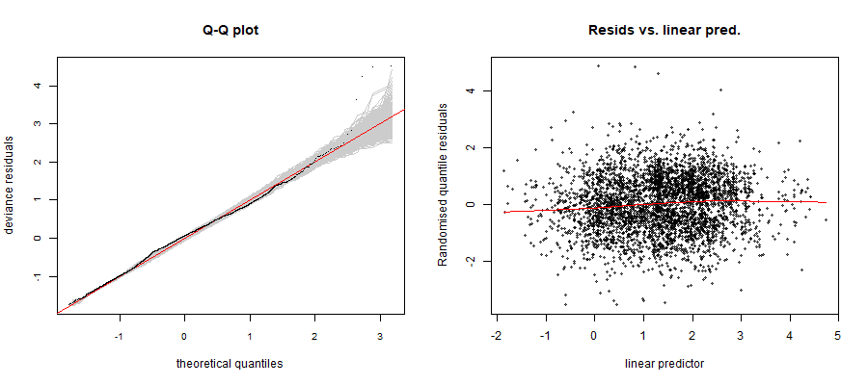
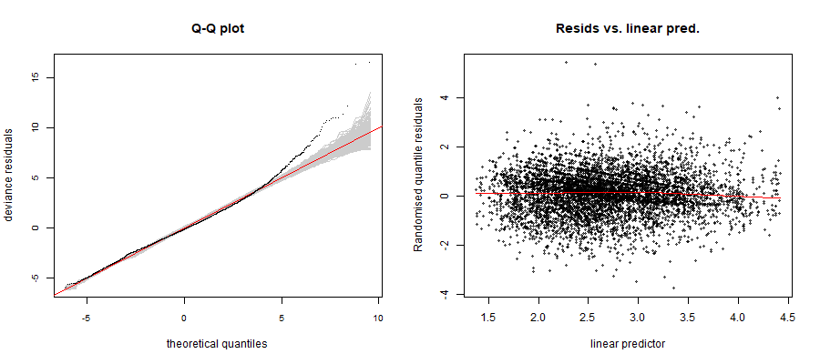
Figure C-5: Diagnostic plots of residuals for dolphinfish (DOL) in the Atlantic (top) and Indian (bottom) oceans. Left: Q-Q plot of deviance residuals. Right: plot of randomized quantile residuals versus the linear predictor.

References
Smyth, G. K. (2019). Statmod: Statistical Modeling R package version 1.4.32. Https://cran.r-project.org/web/packages/statmod/index.html.
Wood, S. N. (2017). Generalized Additive Models: An Introduction with R (Second Edition). CRC Press Book.
Wood, S. N. (2019). Mgcv: Mixed GAM Computation Vehicle with Automatic Smoothness Estimation. R package version 1.8–27. Http://CRAN.R-project.org/package=mgcv.

