Appendix D: Species-specific bycatch predictions and associated uncertainties

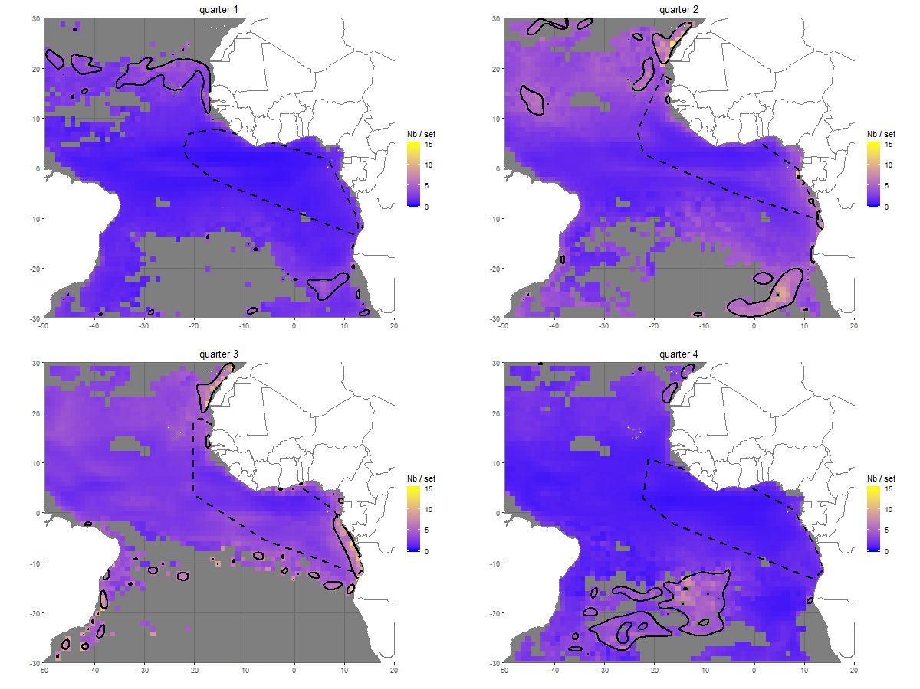
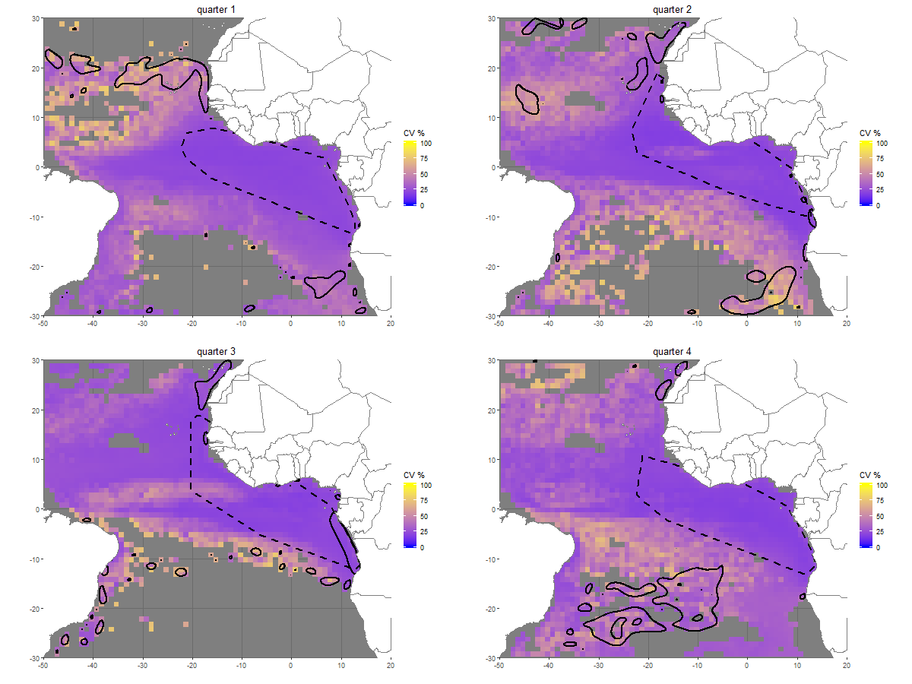
Figure D-1: Quarterly predicted silky shark (FAL) bycatch (individuals per FOB fishing set) and associated coefficients of variation (CVs) (%) in the Atlantic Ocean. Quarter 1: January-March, quarter 2: April-June, quarter 3: July-September, quarter 4: October-December. Hotspots (defined as cells exceeding the 90th percentile of predicted bycatch) are overlaid in black. Dashed polygons represent the spatial extent of the observed sets data for each quarter. The same color scale is used for CVs across species and oceans to facilitate comparisons. Corresponding observation maps are provided in Appendix A.
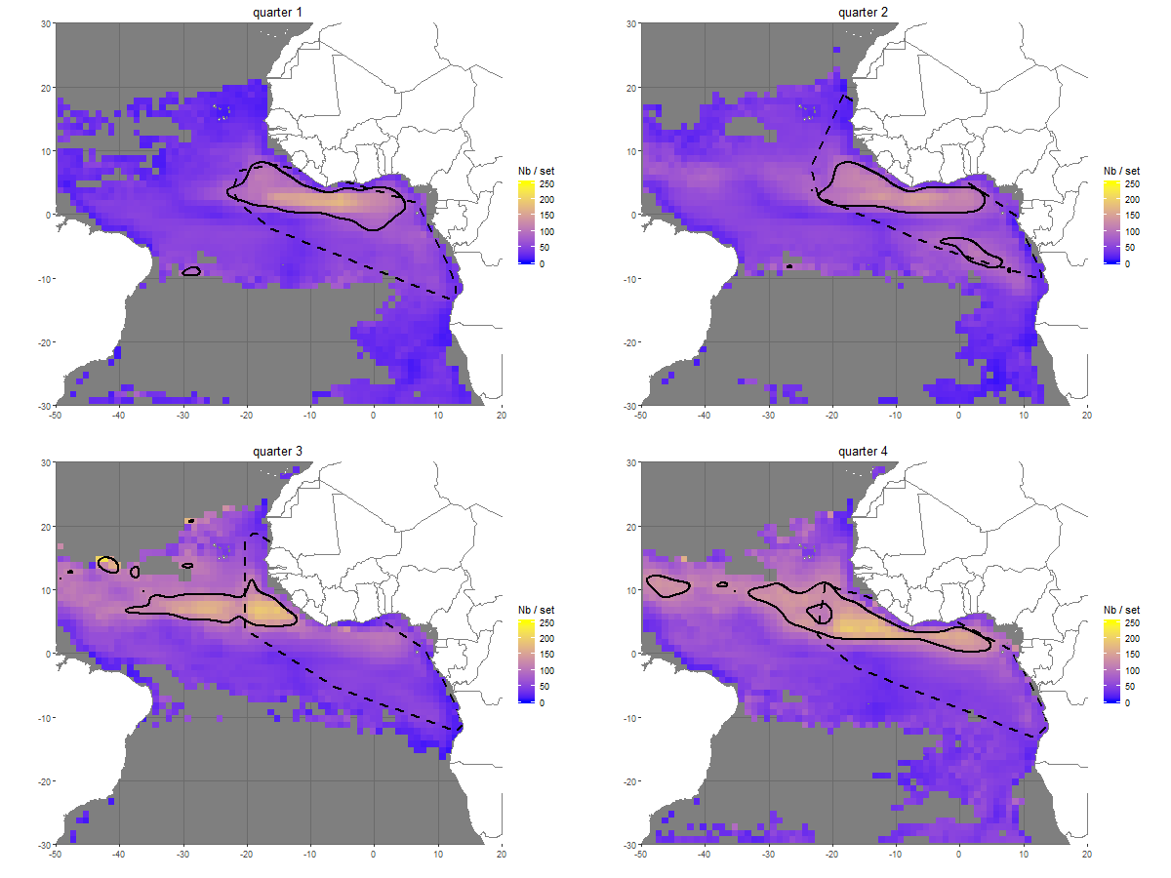
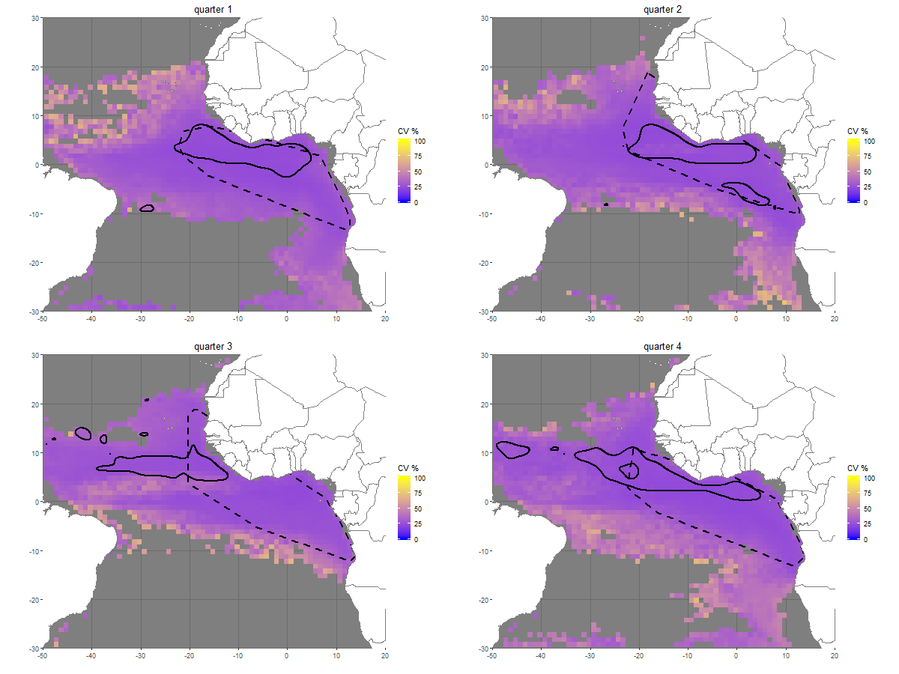
Figure D-2: Quarterly predicted oceanic triggerfish (CNT) bycatch (individuals per FOB fishing set) and associated coefficients of variation (CVs) (%) in the Atlantic Ocean. Quarter 1: January-March, quarter 2: April-June, quarter 3: July-September, quarter 4: October-December. Hotspots (defined as cells exceeding the 90th percentile of predicted bycatch) are overlaid in black. Dashed polygons represent the spatial extent of the observed sets data for each quarter. The same color scale is used for CVs across species and oceans to facilitate comparisons. Corresponding observation maps are provided in Appendix A.
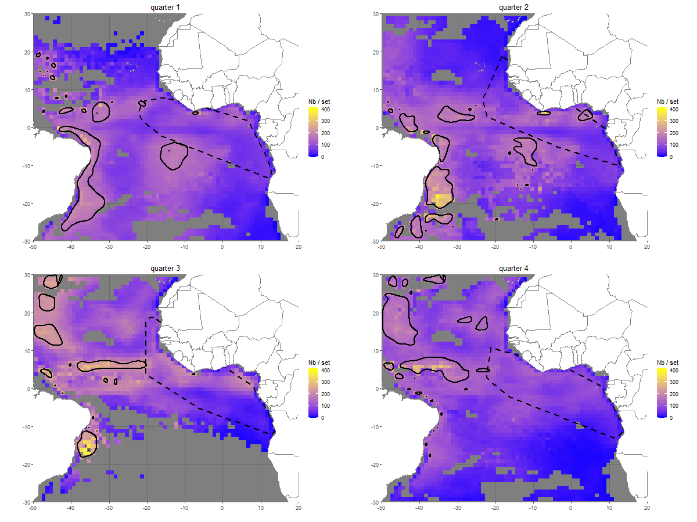
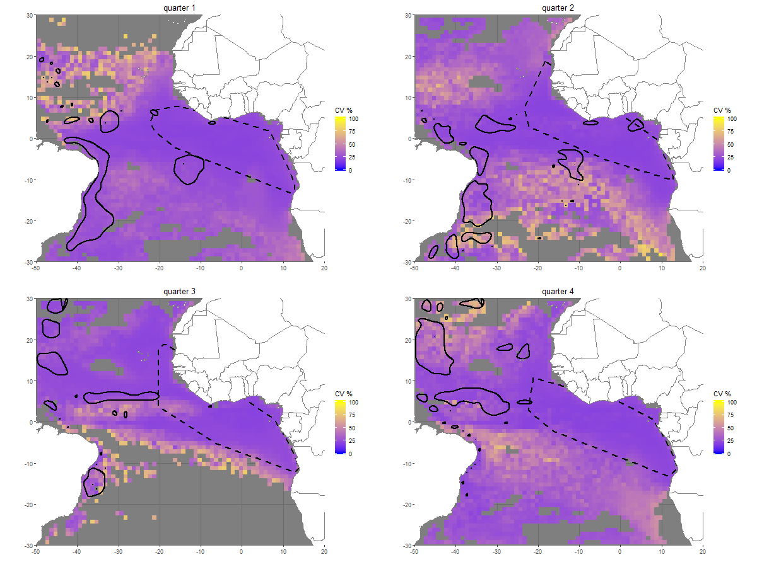
Figure D-3: Quarterly predicted rainbow runner (RRU) bycatch (individuals per FOB fishing set) and associated coefficients of variation (CVs) (%) in the Atlantic Ocean. Quarter 1: January-March, quarter 2: April-June, quarter 3: July-September, quarter 4: October-December. Hotspots (defined as cells exceeding the 90th percentile of predicted bycatch) are overlaid in black. Dashed polygons represent the spatial extent of the observed sets data for each quarter. The same color scale is used for CVs across species and oceans to facilitate comparisons. Corresponding observation maps are provided in Appendix A.
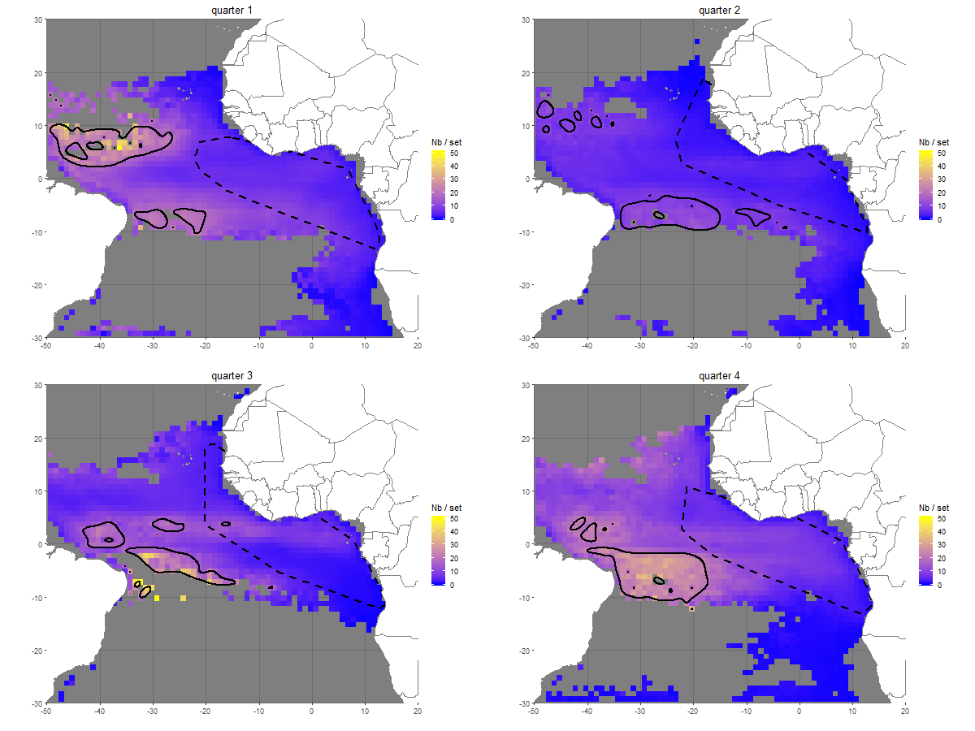
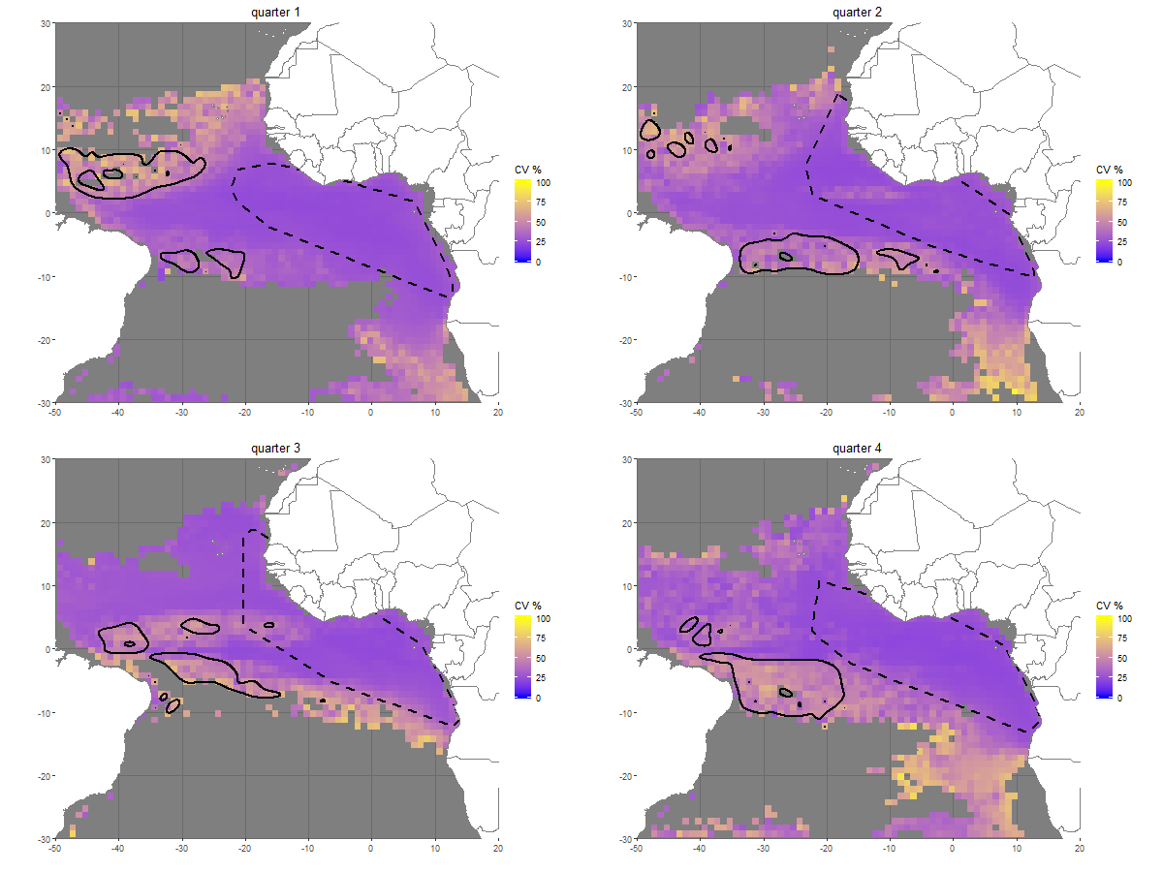
Figure D-4: Quarterly predicted wahoo (WAH) bycatch (individuals per FOB fishing set) and associated coefficients of variation (CVs) (%) in the Atlantic Ocean. Quarter 1: January-March, quarter 2: April-June, quarter 3: July-September, quarter 4: October-December. Hotspots (defined as cells exceeding the 90th percentile of predicted bycatch) are overlaid in black. Dashed polygons represent the spatial extent of the observed sets data for each quarter. The same color scale is used for CVs across species and oceans to facilitate comparisons. Corresponding observation maps are provided in Appendix A.
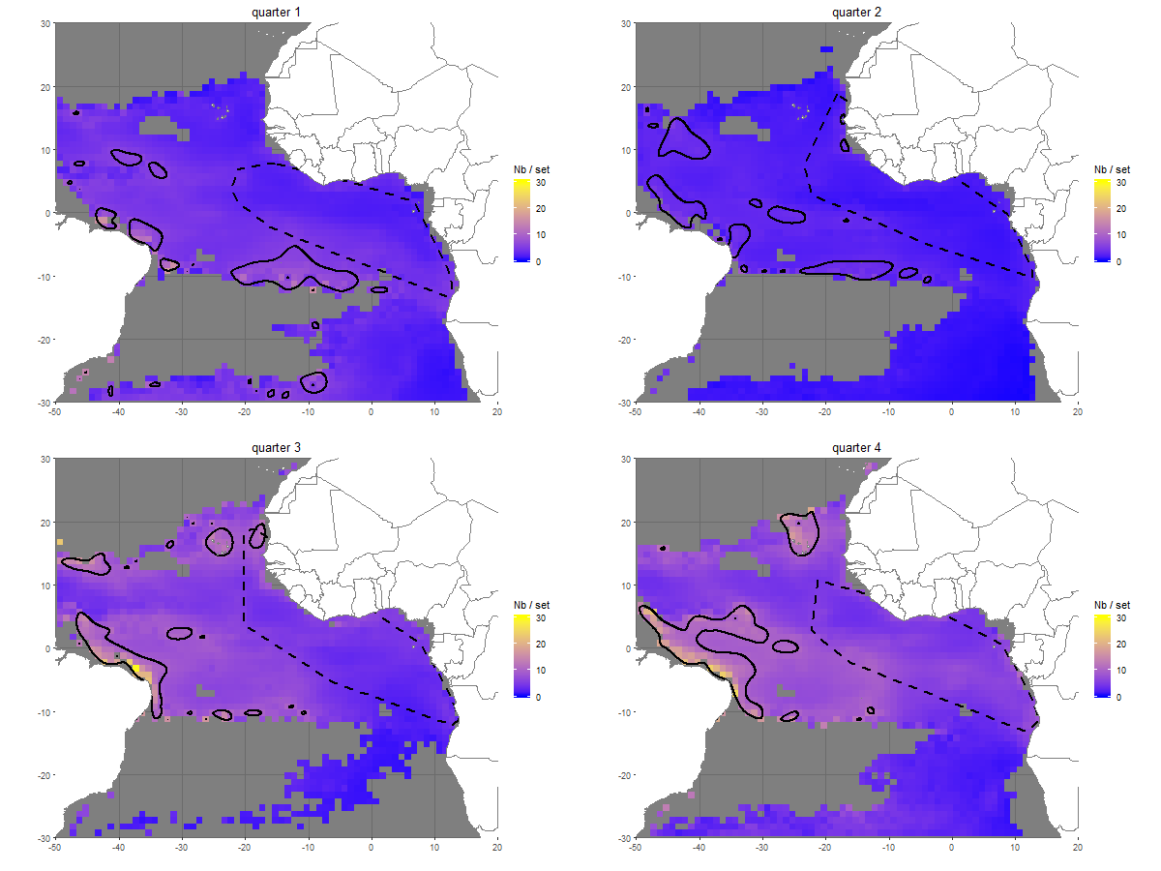
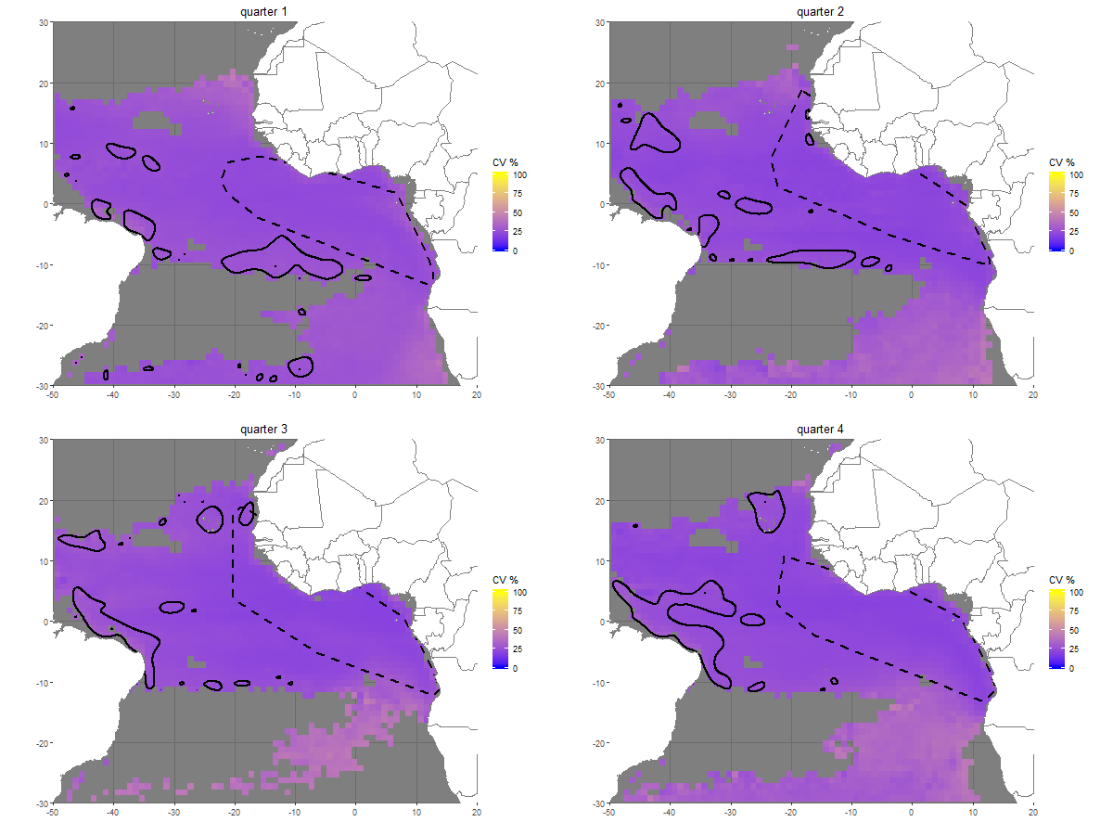
Figure D-5: Quarterly predicted dolphinfish (DOL) bycatch (individuals per FOB fishing set) and associated coefficients of variation (CVs) (%) in the Atlantic Ocean. Quarter 1: January-March, quarter 2: April-June, quarter 3: July-September, quarter 4: October-December. Hotspots (defined as cells exceeding the 90th percentile of predicted bycatch) are overlaid in black. Dashed polygons represent the spatial extent of the observed sets data for each quarter. The same color scale is used for CVs across species and oceans to facilitate comparisons. Corresponding observation maps are provided in Appendix A.

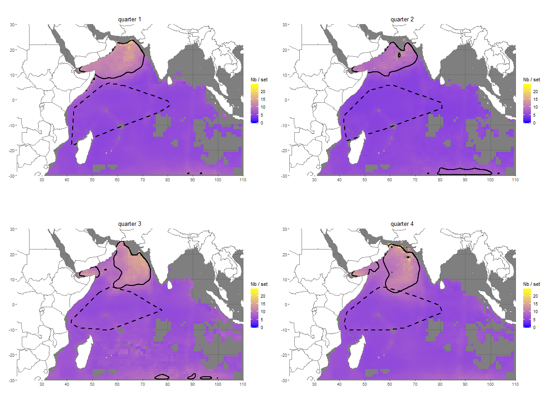
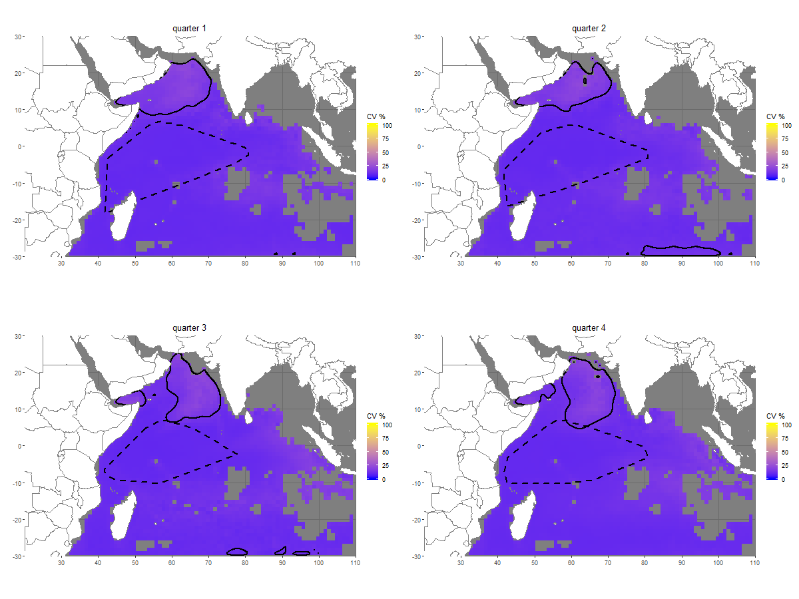
Figure D-6: Quarterly predicted silky shark (FAL) bycatch (individuals per FOB fishing set) and associated coefficients of variation (CVs) (%) in the Indian Ocean. Quarte r 1: January-March, quarter 2: April-June, quarter 3: July-September, quarter 4: October-December. Hotspots (defined as cells exceeding the 90th percentile of predicted bycatch) are overlaid in black. Dashed polygons represent the spatial extent of the observed sets data for each quarter. The same color scale is used for CVs across species and oceans to facilitate comparisons. Corresponding observation maps are provided in Appendix A.
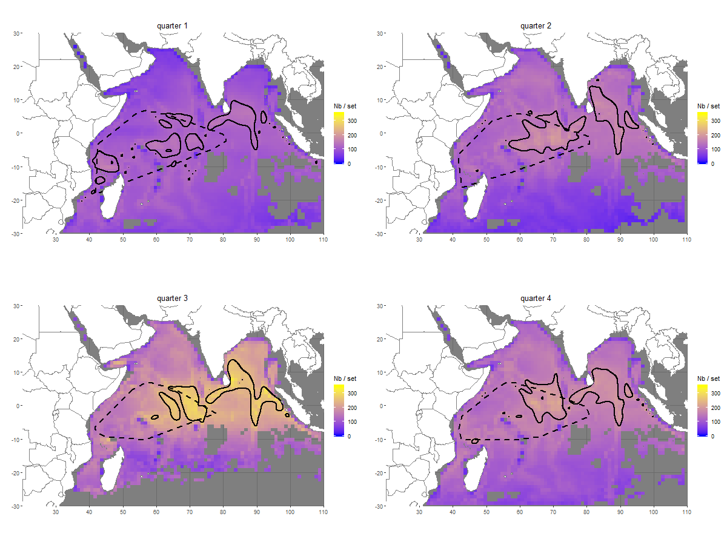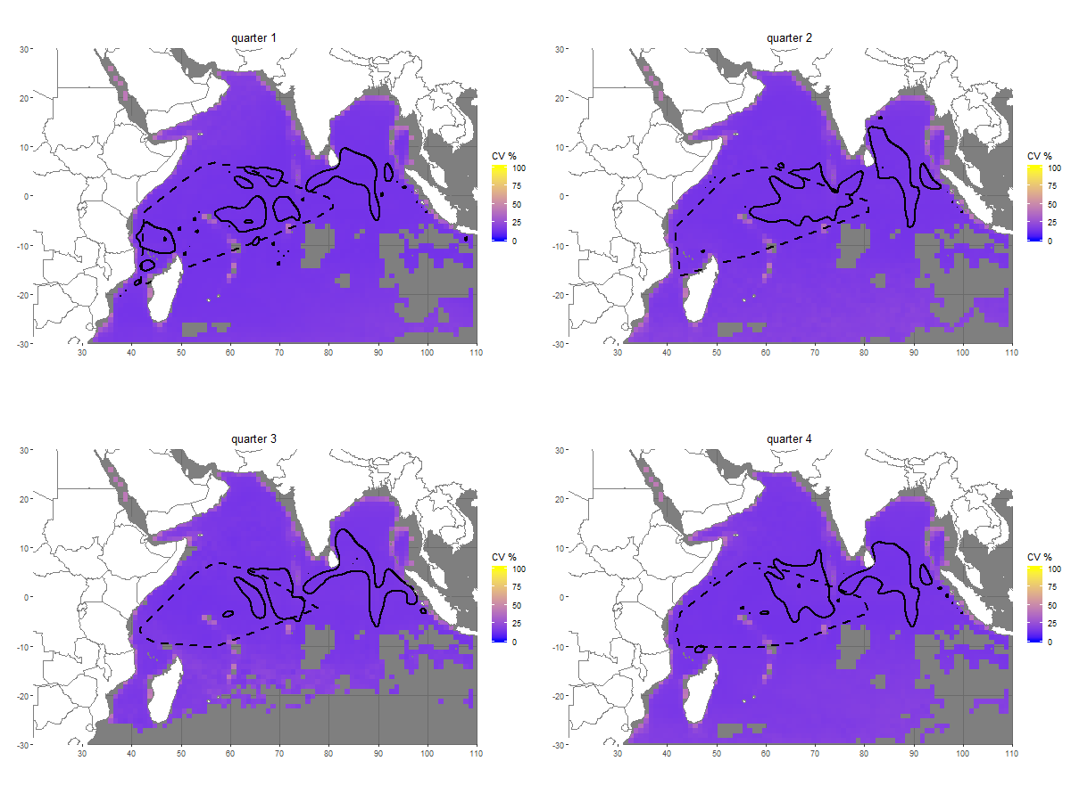
Figure D-7: Quarterly predicted oceanic triggerfish (CNT) bycatch (individuals per FOB fishing set) and associated coefficients of variation (CVs) (%) in the Indian Ocean. Quarter 1: January-March, quarter 2: April-June, quarter 3: July-September, quarter 4: October-December. Hotspots (defined as cells exceeding the 90th percentile of predicted bycatch) are overlaid in black. Dashed polygons represent the spatial extent of the observed sets data for each quarter. The same color scale is used for CVs across species and oceans to facilitate comparisons. Corresponding observation maps are provided in Appendix A.

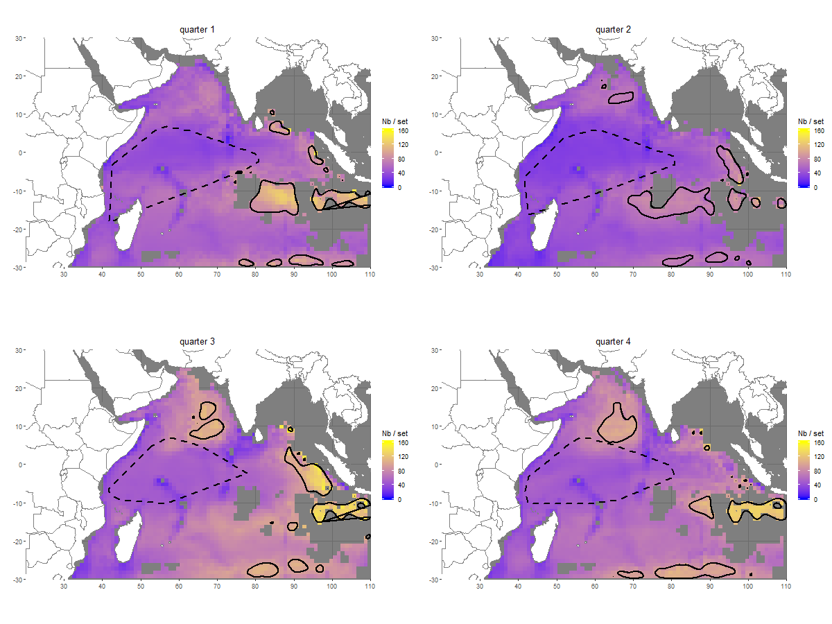
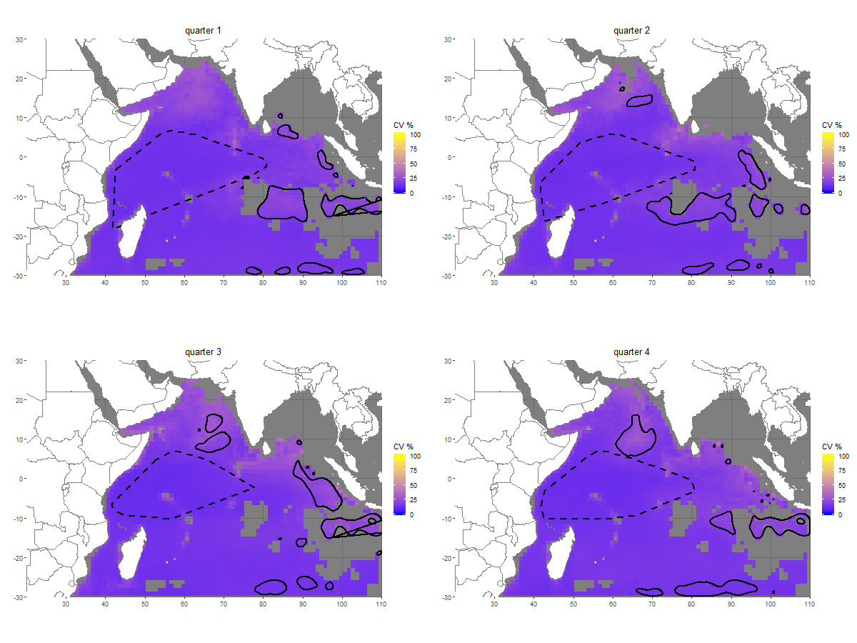
Figure D-8: Quarterly predicted rainbow runner (RRU) bycatch (individuals per FOB fishing set) and associated coefficients of variation (CVs) (%) in the Indian Ocean. Quarter 1: January-March, quarter 2: April-June, quarter 3: July-September, quarter 4: October-December. Hotspots (defined as cells exceeding the 90th percentile of predicted bycatch) are overlaid in black. Dashed polygons represent the spatial extent of the observed sets data for each quarter. The same color scale is used for CVs across species and oceans to facilitate comparisons. Corresponding observation maps are provided in Appendix A.
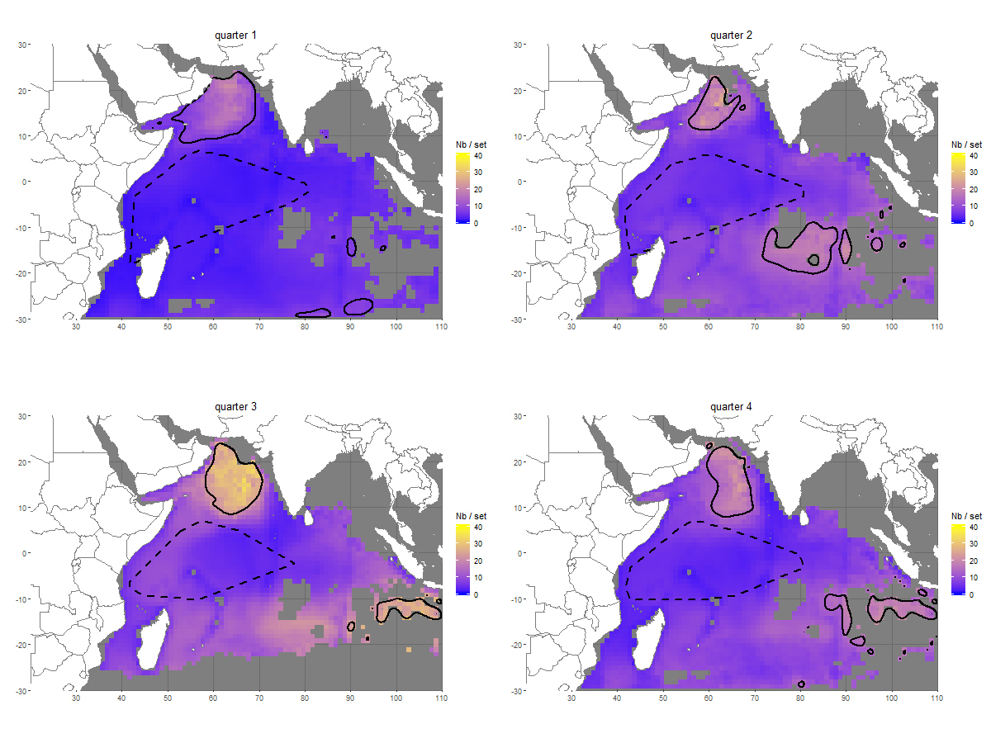
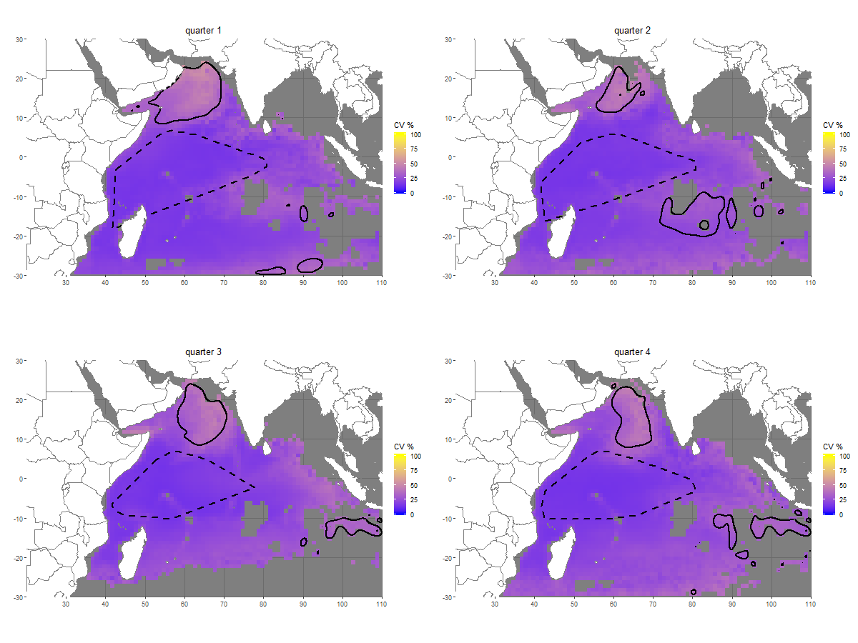
Figure D-9: Quarterly predicted wahoo (WAH) bycatch (individuals per FOB fishing set) and associated coefficients of variation (CVs) (%) in the Indian Ocean. Quarter 1: January-March, quarter 2: April-June, quarter 3: July-September, quarter 4: October-December. Hotspots (defined as cells exceeding the 90th percentile of predicted bycatch) are overlaid in black. Dashed polygons represent the spatial extent of the observed sets data for each quarter. The same color scale is used for CVs across species and oceans to facilitate comparisons. Corresponding observation maps are provided in Appendix A.
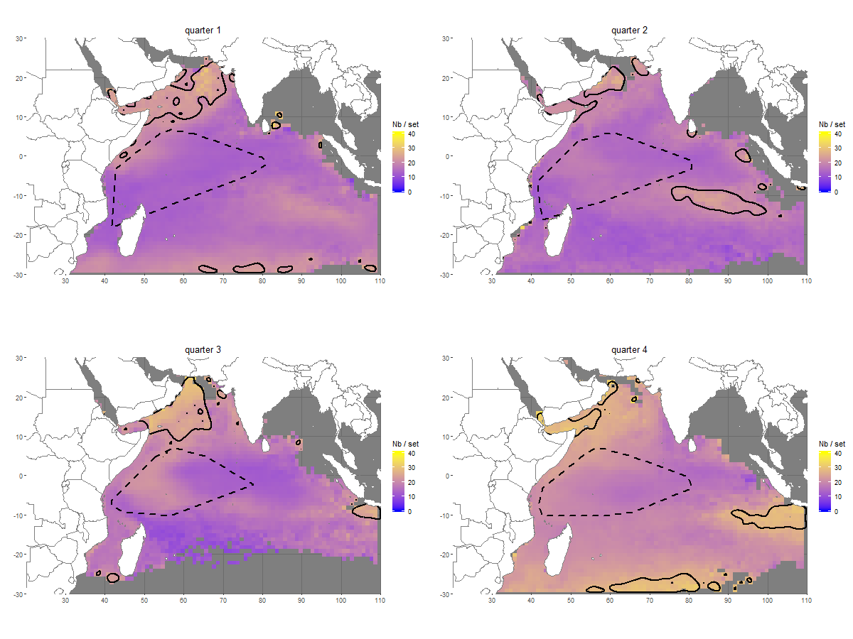
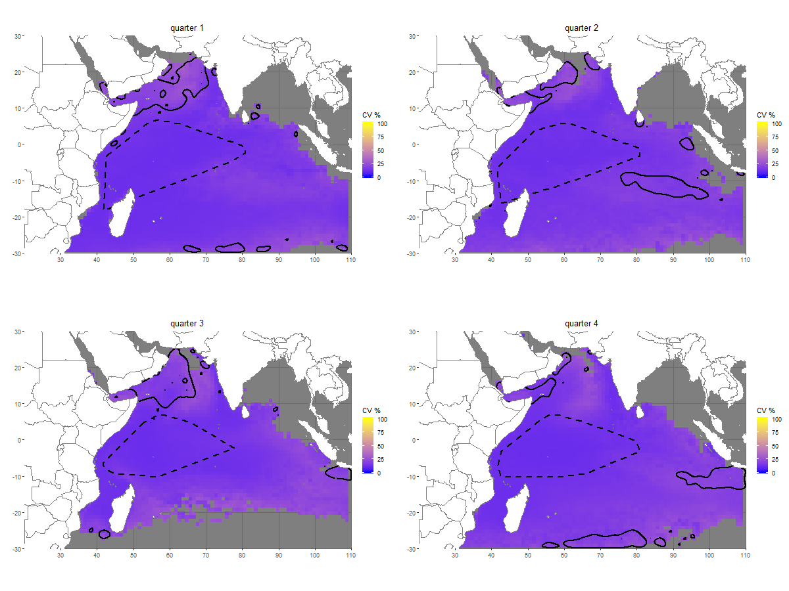
Figure D-10: Quarterly predicted dolphinfish (DOL) bycatch (individuals per FOB fishing set) and associated coefficients of variation (CVs) (%) in the Indian Ocean. Quarter 1: January-March, quarter 2: April-June, quarter 3: July-September, quarter 4: October-December. Hotspots (defined as cells exceeding the 90th percentile of predicted bycatch) are overlaid in black. Dashed polygons represent the spatial extent of the observed sets data for each quarter. The same color scale is used for CVs across species and oceans to facilitate comparisons. Corresponding observation maps are provided in Appendix A.

