Trophic ecology, habitat, and migratory behaviour of the viperfish Chauliodus sloani reveal a key mesopelagic player
Leandro Nolé Eduardo^{1,2*}, Flávia Lucena-Frédou¹, Michael Maia Mincarone³, Andrey Soares¹, François Le Loc’h⁴, Thierry Frédou¹, Frédéric Ménard⁵, Arnaud Bertrand^{1,2,6}

¹ Universidade Federal Rural de Pernambuco, Departamento de Pesca e Aquicultura, Recife, PE, Brazil.
² Institut de Recherche pour le Développement (IRD), MARBEC, Univ. Montpellier, CNRS, Ifremer, IRD, Sète, France.
³ Universidade Federal do Rio de Janeiro, Instituto de Biodiversidade e Sustentabilidade, Caixa Postal 119331, Macaé, RJ, 27910-970, Brazil.
⁴ IRD, Univ. Brest, CNRS, Ifremer, LEMAR, IUEM, F-29280 Plouzane, France.
⁵ Aix Marseille Univ., Université de Toulon, CNRS, IRD, MIO, UM110, Marseille, France.
⁶ Universidade Federal de Pernambuco, Departamento de Oceanografia, Recife, PE, Brazil.

SUPPLEMENTARY MATERIAL

Supplementary Material 1 – Number of trawls per depth strata and period of the day.
Depth Strata | Day | Night
10-100 | 3 | 3
100-200 | 3 | 1
200-300 | 3 | -
300-400 | 1 | 1
400-500 | 3 | 1
500-600 | 1 | 1
600-700 | 1 | 1
700-800 | 2 | -
800-900 | 1 | 1
900-1000 | 2 | 2

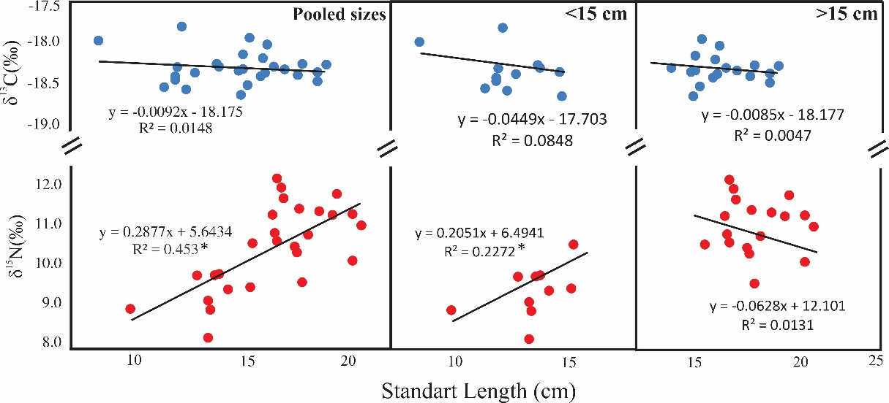

Supplementary Material 2 – Results of least-squares regression analysis between standard length (cm) and δ¹⁵N and δ¹³C values of the viperfish Chauliodus sloani.* relationships presenting significant statistical differences (p <0.05).
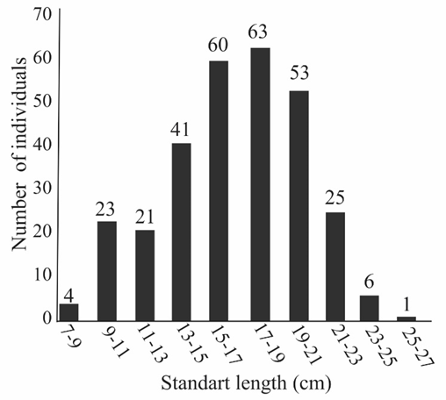

Supplementary Material 3– Histogram of the number of individuals per length. Numbers above bars represent the number of individuals in each size class.

